**Mobileye Data Services™**

Proposal for [Client Name]

**Prepared by:**

Your Name

Mobileye, an Intel Company

**Submitted to:**

Client Name

Company Name

**Thursday, October 8, 2020**

**Thursday, October 8, 2020**

Dear [Client Name],

Thank you for considering Mobileye, an Intel Company, for your road survey and pavement condition assessment needs.

Mobileye, an Intel Company, is pleased to present you with a proposal for the following services, subject to the Terms set out later in this proposal:

*[Insert something here about the client needs and what they are responsible for]*

*[Insert here a short summary of the proposal with key USPs, e.g. as below]*

* A full survey of your road network and infrastructure assets (Mobileye Road Asset Survey)
* Unique change detection technology to provide you with up-to-date information about your assets on a *monthly* basis instead of [once every two years] [insert here what they are used to].
* A full assessment of the condition of your roads (Mobileye Pavement Condition Assessment)

The data will be provided in the form of GIS layers. You can view these GIS layers on ArcGIS or another GIS platform of your choice.

We are committed to delivering on your expectations for [road condition and asset data] with the highest level of quality, while maintaining data value through quick, efficient delivery.

Should you have any questions, please reach out to us by email or phone. If you wish to accept this proposal, simply sign your approval at the bottom.

Sincerely,

Name

Title

Email

Phone

[Please make sure to update the Table of Contents after finalizing the proposal]

Table of Contents

Why Mobileye? 3

Project Scope 4

Project Summary 5

Project Timeline 6

Specifications 7

Mobileye Road Asset Survey 7

Mobileye 8 Connect™, Collision Avoidance System & Data Collection Enabler 9

About Mobileye Technology 10

Mobileye Road Experience Management™ (REM™) Technology 10

How We Survey the Road Infrastructure and Road Assets 10

How We Survey Mobility, Traffic and Road Condition in Near Real-time 11

Mobileye’s Surveying Accuracy 12

Your Investment 13

Terms & Conditions 15

Signature 18

Why Mobileye?

Mobileye, an Intel Company, is a global leader in the development of computer vision and machine learning, data analysis, localization, and mapping for advanced driver assistance systems and autonomous driving solutions.

Over 25 automakers including Audi, BMW, FCA, General Motors, Honda, Hyundai/Kia, Nissan, Volkswagen, and more rely on Mobileye to make their vehicles safer and supply advance driver assistance systems.

Mobileye technology uses a single camera to scan the road ahead and detect potential dangers – it identifies lane markings, for example, and alerts drivers if the vehicle has departed from the lane, providing functions such as Lane Departure Warning and Lane Keep Assist.

Over 50 million vehicles around the world have Mobileye inside. The robust performance of our technology has been stress-tested over millions of driving miles as part of the stringent validation processes of safety-critical automotive products.

Leveraging the same technology, Mobileye reinvented road surveying for asset management and road maintenance. Mobileye’s EyeQ® chip and algorithms have been trained to identify, tag, and classify road assets, to assess pavement condition and to capture mobility data, as equipped vehicles travel on their regular routes.

To support transportation authorities, utility companies, and businesses, we turn the roadscape data captured by these vehicles into relevant, up-to-date GIS layers. Our breakthrough change detection technology for asset inventory, paired with near-real-time pavement and mobility data, allows our customers to increase the efficiency of maintenance operations and reduce costs, improve mobility, and make the roads better for all**.**

Project Scope

Mobileye will survey [Corridor/road name if this is a well-defined motorway].

Total highway/motorway centerline miles: [XXX miles/kms].

[Insert here details about the road, provide # of centerline miles/km, and an image if possible]

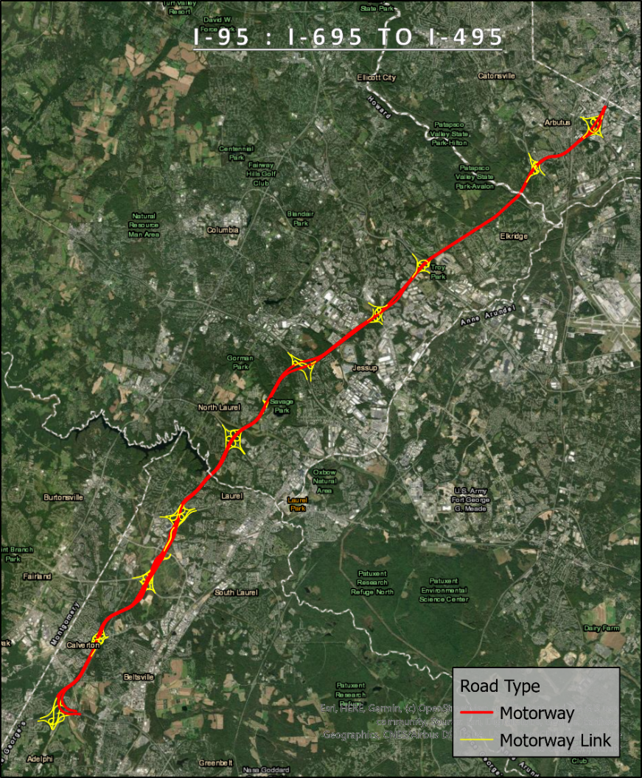

Project Summary

We recommend the following solution for [Client name]:

* A 12-month license to four Mobileye data products: [Insert here the specific products included in your proposal]
* The installation of XX forward-facing Mobileye 8 Connect collision avoidance and data collection enabler systems.

[Insert here the specific products included in your proposal]

[Product Name]

[Product Description]

**Mobileye Road Network Survey**

Reccurring, fully automated survey of the road network and infrastructure assets.

**Mobileye Utility Asset Survey**

Recurring, fully automated surveys of above-ground utility installations.

**Mobileye Pavement Condition Monitoring**

Ongoing, fully automated road condition surveys.

**Mobileye Mobility Intelligence**

Aggregated mobility information updated at a high refresh rate and delivered in the form of GIS layers per road segment.

**Mobileye Live Traffic**

Near real-time information about traffic flow and traffic obstructions.

Project Timeline

Please find below a proposed timeline for this project.

Specifications

[Insert here the specific products and features in your proposal – examples below – please copy and paste [from the GIS Word Document](https://mobileye.sharepoint.com/:w:/r/sites/DataStory/_layouts/15/Doc.aspx?sourcedoc=%7Bc678aa00-4cab-480f-befb-aaf442409f2f%7D&action=view&wdAccPdf=0)]

## Mobileye 8 Connect™, Collision Avoidance System & Data Collection Enabler

Mobileye 8 Connect is an AI-powered, aftermarket collision avoidance system that helps both prevent collisions and improve driver performance.

Mobileye collision avoidance system warns drivers of potential hazards in real time with audio and visual warnings, giving them time to prevent or mitigate a collision. Vehicles retrofitted with Mobileye 8 Connect, collision avoidance system and data collection enabler, collect data as field workers drive from location to location during their workday.

**Features**

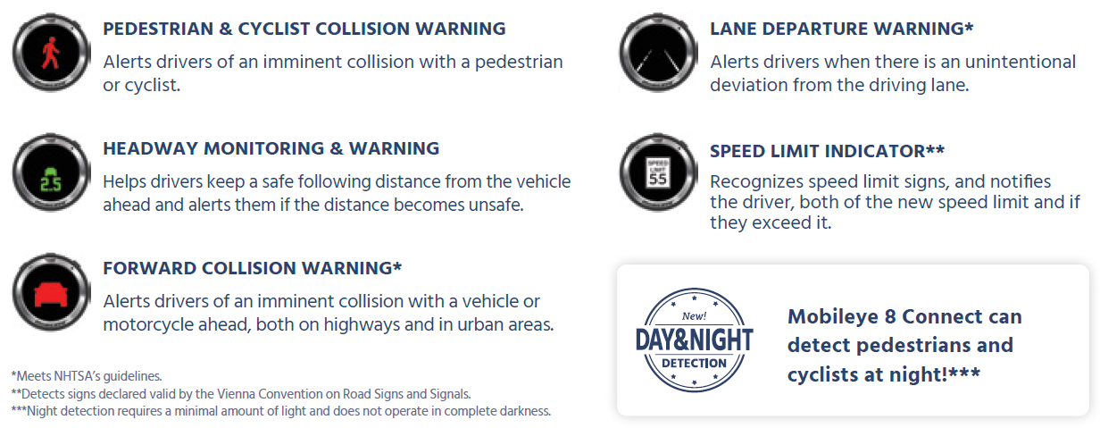

**Components**

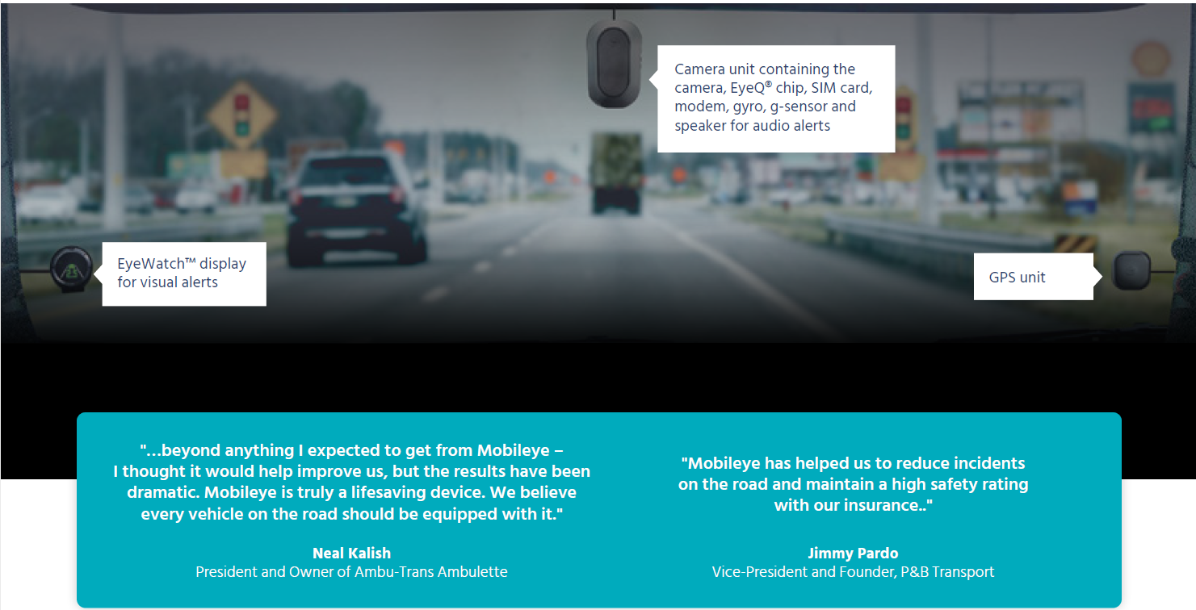

About Mobileye Technology

## Mobileye Road Experience Management™ (REM™) Technology

Mobileye’s award-winning Road Experience Management (REM) technology powers end-to-end mapping for autonomous vehicles and is the foundation of our data services.

## How We Survey the Road Infrastructure and Road Assets

Mobileye-equipped vehicles detect road infrastructure assets as they travel on their regular routes. Detection and measurement algorithms in Mobileye’s vision systems capture, identify, measure, tag and classify these road assets. The relevant metadata is packed into small capsules called Road Segment Data (RSD) and transmitted to the cloud. Mobileye’s real-time geometrical and semantic analysis facilitates very small communication bandwidth, around 10KB/km on average.

The data is aggregated, clustered, and aligned in the cloud, resulting in a high definition map, called the Mobileye Roadbook™. A certain number of drives – approx. 20 passes per lane - is necessary to trigger this process.

Data layers are extracted from the RoadBook in the form of GeoJson files so that they can be integrated into any GIS platform.

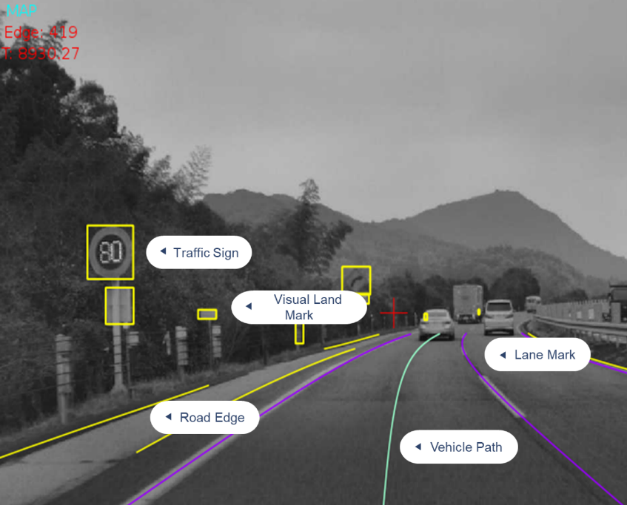

*As vehicles travel the road, detection and measurement algorithms in Mobileye’s vision systems capture, identify, measure, tag and classify road assets.*

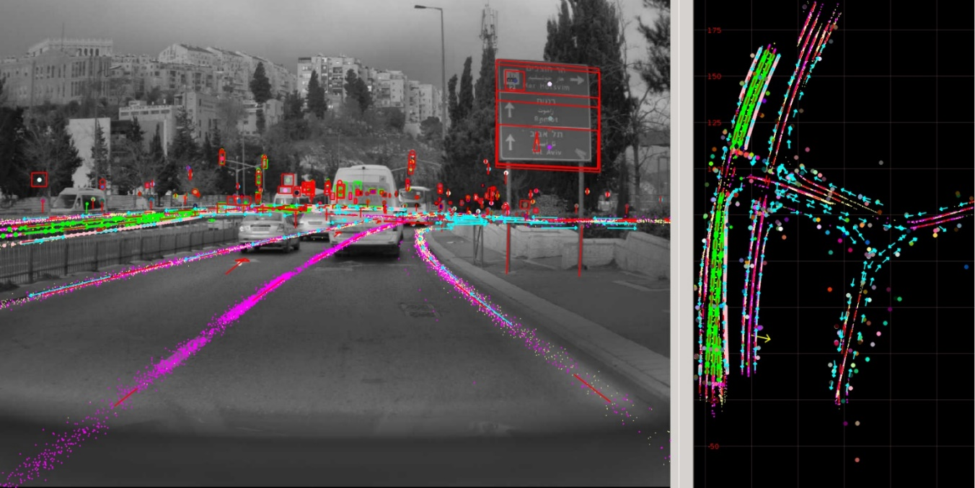

*Aggregation, clustering, and alignment of the observations, resulting in a high definition map.*

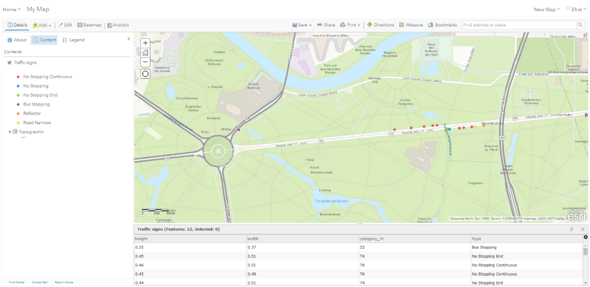

*Data layers are extracted from the RoadBook in the form of GeoJson files compatible with any GIS platform.*

## How We Survey Mobility, Traffic and Road Condition in Near Real-time

Mobileye-equipped vehicles detect vehicles, pedestrians, cyclists, surface distress etc. on the road ahead. Detection and measurement algorithms in Mobileye’s vision systems capture mobility and pavement information and continuously transmit this data stream to the cloud.

The observations are aggregated and averaged per road segment, over a set period of time. The datasets are delivered in the form of GIS layers per road segment. A certain number of drives is necessary to trigger this aggregation process.

Some observations are time-sensitive and are valuable to our customers when delivered in real-time. A new detection prompts a validation and clustering process to make sure only new relevant observations trigger a notification. The data is delivered through Restful API.

## Mobileye’s Surveying Accuracy

Mobileye technology provides positional information which allows its customers to efficiently survey their assets and accurately measure the relative distance between them

Absolute (global) accuracy

* The 50th percentile corresponding to the median accuracy is less than 1.5-meter for the latitude and less than 2 meters for the longitude.
* The 90th percentile corresponding to the accuracy of 90% of the detected assets is less than 2.8 meters for the latitude and less than 4 meters for the longitude.

Relative (local) accuracy

* Mobileye technology allows neighboring reference locations in the HD Map to be positioned within an accuracy of 30 cm or less relative to each other. This is valid for 90% of the observations.

Your Investment

Terms & Conditions

**[Insert here the legal terms and conditions]**

**TERMS FOR PROVISION OF DATA**

These Terms for Provision of Data (the “**Terms**”) apply to **Mobileye Vision Technologies Ltd.** and/or its affiliates’ provision of Data to you.

1. Definitions

|  |  |
| --- | --- |
| **Confidential Information** | Any Mobileye device, graphics, source code, object code, software, data, written information, or information in other tangible forms; these Terms; the Data; and the fact that Mobileye has disclosed Data to you; except where the foregoing (1) is independently developed by you without the use of Confidential Information; (2) is known, or that becomes known, to the general public without breach of these Terms; or (3) was known to you at the time of disclosure by Mobileye or on Mobileye’s behalf |
| **License Fees** | As set out in Schedule B to these Terms |
| **License Period** | As set out in Schedule C to these Terms |
| **Licensed Use** | As set out in Schedule D to these Terms |
| **Project** | As set out in Schedule E to these Terms |
| **Road** | As set out in Schedule A to these Terms |

1. **License Grant**
   1. Subject to and conditional upon your compliance with these Terms, Mobileye shall provide you with data concerning the Road of the type, in the manner and at the frequency and for the time set out in Schedule A to these Terms (the “**Data**”), and hereby grants you, during the License Period, a non-exclusive, non-transferable, non-assignable, non-sublicensable, limited and revocable license for the Data (but not for any technology used to generate, store or transmit data), solely for and to the extent permitted by the Licensed Use; and except as may be expressly permitted by the Licensed Use, you may not:
      1. transfer, share, sublicense, distribute, sell or market the Data to third parties;
      2. create any product or service, for supply to third parties, which has benefitted from, relied on or made any use of Data (including where you have created your products or services by modifying, reformatting, or analyzing the Data);
      3. copy, modify, edit, adapt, enhance, improve, revise or create derivative works from any of the Data;
      4. create, develop, use, make available or otherwise exploit any data derived from the Data;
      5. remove any Mobileye titles, trademark symbols, copyright symbols or other legends from the Data;
      6. use the Data in any way that is prejudicial to Mobileye’s reputation;
      7. seek to bypass or disable any protections that may be put in place to provide security for the Data or to protect against unlicensed use of it; or
      8. reverse engineer or otherwise tamper with the Data.
   2. You shall notify Mobileye promptly in writing of any actual or suspected errors in connection with the Data.
   3. You shall use adequate technological and security measures to ensure that the Data are secure from unauthorised use or access.
   4. Where you use the Data in a tangible medium, you shall ensure that appropriate acknowledgement of its Mobileye provenance is made.
2. **Auditing.** You shall maintain accurate and complete records of your use of the Data. Mobileye may request details of operations and documentation to ensure your compliance with these terms.
3. **Ownership.** Vis-à-vis you, Mobileye owns and retains all right, title and interest (including all intellectual property rights) in and to the Data including all text, graphics, software, data, information, images, sound, video, audio-visual works, and data associated with it, as well as any copies. Except as expressly stated herein, no license, right or interest in any Mobileye intellectual property rights is granted hereunder. You irrevocably assign to Mobileye all right, title and interest in any corrections, enhancements, improvements or other feedback or ideas you make available to Mobileye in connection with your use of the Data. You shall mark any copies of the Data in any tangible medium with a notice that they belong to Mobileye.
4. **License Fees and Manner of Payment.** In return for the License, you shall pay Mobileye the License Fees annually, each Agreement year in advance of commencement of Data provision for that Agreement year, in accordance with Mobileye’s invoices, without any deduction or set-off for or on account of any taxes, levies, imports, duties, charges, fees and withholdings of any nature now or hereafter imposed by any governmental, fiscal or other authority; and, to the extent that you are compelled to make any such deduction or set-off, you will pay Mobileye such additional amount as is necessary to ensure that Mobileye receives the full amount which it would have received but for the deduction.
5. **Term and Termination.**
   1. The License is for the License Period.
   2. To the extent that Mobileye is obliged to provide you with Data at a particular frequency, Mobileye may cease providing Data at any time upon 90 days’ notice to you. This will not affect the License for Data which Mobileye has already provided to you.
   3. Mobileye may terminate the License prior to the end of the License Period where either (i) you breach section ‎2.1 above, with immediate effect, or (ii) you are in material breach of any Term which breach is either incapable of being remedied or is not remedied within 30 days of Mobileye’s written request to do so. Upon such early termination of the License, you shall (i) immediately cease use of the Data and (ii) return or destroy all copies of it.
   4. At the end of the License Period (if not perpetual), you shall (i) immediately cease use of the Data and (ii) return or destroy all copies of it.
   5. In any event, these Terms shall survive termination or expiration of the License for as long as you retain any Data.

1. **Confidentiality & Export Control** 
   1. You shall retain Confidential Information in confidence, use it only for the purpose of these Terms, and not disclose it to any third party except as expressly permitted by your Licensed Use; and use reasonable care to protect Mobileye’s Confidential Information from unauthorized disclosure.
   2. Where you are required by law to disclose Confidential Information you may disclose whatever Confidential Information you are specifically required to disclose, provided, however, that you first notify Mobileye in writing of this and cooperate with Mobileye if it so desires to seek an appropriate protective order.
   3. In the event of any unauthorized disclosure or use of Confidential Information, Mobileye may seek injunctive or other equitable relief, in addition to any other rights and remedies it may have, from any competent jurisdiction the necessity of proving actual damages or posting any bond or other security.
   4. To the extent Mobileye and you have executed a non-disclosure agreement (“**NDA**”) the provisions of the NDA shall continue to apply, and in the event of contradiction between this section and the NDA with respect to your confidentiality undertakings to Mobileye, the stricter terms shall prevail.
   5. You agree to comply fully with all relevant United States and European export control laws and regulations (collectively, “**Export Control Laws**”) and in particular, shall not, directly or indirectly, export, re-export, divert, or transfer Confidential Information (i) to any destination or person to whom/which this is restricted or prohibited by Export Control Laws nor (ii) to any of the following countries: Iran, North Korea, Lebanon, Sudan, Syria, Cuba and Iraq.

1. **DISCLAIMER OF WARRANTY.** THE DATA IS PROVIDED “AS IS” AND “AS AVAILABLE” WITHOUT ANY WARRANTY, AND MOBILEYE HEREBY DISCLAIMS ALL WARRANTIES, WHETHER EXPRESS, IMPLIED OR STATUTORY, INCLUDING AS TO THE DATA’S MERCHANTABILITY, FITNESS FOR A PARTICULAR USE, ACCURACY, COMPLETENESS, TIMELINESS, QUALITY OR LACK OF INFRINGEMENT. ALL WARRANTIES, CONDITIONS OR OTHER TERMS IMPLIED BY LAW ARE EXCLUDED TO THE EXTENT PERMITTED. MOBILEYE SHALL NOT BE LIABLE FOR ANY CLAIMS, LOSSES OR DAMAGES OF ANY KIND, WHETHER DIRECT, INDIRECT, INCIDENTAL, SPECIAL OR CONSEQUENTIAL, SUFFERED BY ANY PERSON INCLUDING YOU AND YOU AGREE TO INDEMNIFY AND DEFEND MOBILEYE FROM AND AGAINST ANY SUCH LIABILITY.
2. **Data Protection Privacy.** Each party will process, control and transfer any personal data it has access to in the context of these Terms in accordance with applicable data protection laws. You acknowledge Mobileye’s Privacy Policy, as may be amended from time to time, available for review at [www.mobileye.com](http://www.mobileye.com).
3. **Governing Law and Jurisdiction.** These Terms shall be governed, construed and interpreted in accordance with the laws of England and Wales without regard to its conflict of laws principles. Each of the parties hereto consents to the exclusive jurisdiction and venue of the competent courts of London, England.
4. **General.** 
   1. The provisions of these Terms constitute the entire agreement between the parties with respect to the subject matter hereof, and these Terms supersede all prior and contemporaneous agreements or representations, oral or written, regarding such subject matter.
   2. You may not assign, sell, transfer, delegate or otherwise dispose of, whether voluntarily or involuntarily, by operation of law or otherwise, these Terms or any or its rights or obligations under these Terms.
   3. In the event that any provision of these Terms is held invalid the remaining parts of these Terms will continue to be enforceable.

Signature

**I have read the above and agree to it.**

I have the right to sign on behalf of **Client Name, Address**

Name: Date and Signature

**Schedule A: Road and Data (e.g. type, manner/format of provision, frequency and duration of provision)**

The Road is a XXkm section of the XXX, shown on the map below.

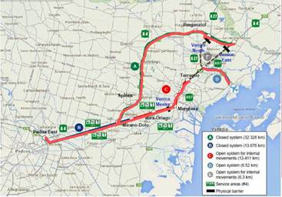

The Data will be provided in GeoJson format. (Note: Mobileye does not supply a GIS platform; you must use your own.)

The Data is as follows:

[Insert here what is included in the offer and details about its delivery]

**Schedule B: License Fees**

A total of XXXXin stages as follows:

* Initial payment of XXX upon signature; and
* Balancing payment of XXXX 60 days thereafter.

**Schedule C: License Period**

Until one month after Mobileye’s last provision of Data.

**Schedule D: Licensed Use (for the License Period)**

1. Access and view the Data.
2. Store the Data.
3. Internally test and evaluate the Data.
4. Use the Data to draw inferences, e.g. as to (i) traffic ‘hot-spots’; and (ii) locations where street improvements are desirable (altogether, the “**Inferences**”) and use the Inferences to satisfy an express written obligation imposed by a formal written enactment of a relevant legislative authority to which you are subject, provided that you shall not receive any direct or indirect payment, credit or money’s worth for the Inferences of the use of the Inferences other than any charge which you are entitled to impose in accordance with the relevant legislation.
5. Share Data with such third parties as agreed from time to time by Mobileye at its discretion (“**Authorized Third Party/ies**”), to the extent necessary to enable such third parties to evaluate the Data on your behalf and produce a report for you describing that evaluation, on the following conditions:
6. The applicable restrictions included in these Terms are applied to the Authorized Third Party/ies;
7. Any applicable rights reserved in the Terms in relation to Data for Mobileye’s benefit are reserved;
8. Any applicable obligations imposed on you in the Terms are imposed on the Authorized Third Party/ies;
9. Save as provided in the Terms, any right for the Authorized Third Party/ies to use Data shall terminate automatically on termination or expiry of the License Term;
10. Mobileye has rights to enforce directly the terms of the agreement between you and the Authorized Third Party/ies;
11. You shall be jointly and severally liable with any Authorized Third Party for the act or omission of that Authorized Third Party and you shall enforce the terms of any relevant agreement, up to and including obtaining judgement in court and taking such other action as Mobileye may request in respect of any breach; and
12. Upon request, you will provide Mobileye with a copy of any such report.

**Schedule E: Project**

None in particular