November 7, 2020

Dear reviewers,

I would like to express my sincere thanks to the two reviewers for the opportunity to revise and resubmit my dissertation. I was challenged by your wise comments and found them helpful in refining my thoughts and arguments. I worked hard to address each and every comment that you raised, and revised my manuscript respectively. In this respect, I revised the Introduction and the General Discussion to better clarify the theoretical rationale and highlight the key concepts and hypotheses. I now emphasize the moderation role of moral relevance (rather than personal relevance). I believe this resulted in a much-improved version, stronger and clearer than the original one, and I am grateful for that.

Below I describe how I have addressed each of the comments that were raised.

**Reviewer 1**

1. **Perhaps the most notable limitation of the entire dissertation is its claims about the relations between personal relevance and (a) moral conviction, (b) ideology, and (c) the moral foundations.**

Thank you for this comment. Upon reading your comments, I realized that in the previous version of my dissertation, I was not sufficiently coherent and clear in delineating my theoretical model and my key theoretical concepts. Therefore, I have extensively revised the dissertation's Introduction (pp. 9-11) and the General Discussion (pp.83-83) to clarify the theoretical argument. I clarify the key concepts (a) moral conviction, (b) moral foundations, (c) ideology, and I describe the relationships between these concepts. My focus is on the unique role of moral relevance in predicting ties between moral conviction and emotions. I argue that moral relevance – namely, the match between one's moral foundations and the moral foundations violated in an event, as developed in the revised dissertation (pp. 22-23), may contribute to the understanding of ties between moral convictions and emotions. I will carefully try to explain that in the following paragraphs (reply to comments 2-5).

1. **An overarching assertion of this dissertation is that moral conviction does a less meaningful or less direct job of tapping into personal relevance than either ideology or commitment to moral foundations. In my view, that claim is exactly inverted – both conceptually and methodologically...The definition of moral conviction, however, does not allow for the possibility that a person might feel strong moral conviction about an issue but NOT view that position as related to significant personal values.**

**It is not clear how the dissertation defines personal relevance. In places, that term is used to refer to personal practical importance and in other places, the terms is used to refer to “significant personal values.” The former definition is separable from moral conviction. The latter definition is not.**

I agree that, in the sense of significant personal values, 'personal relevance' cannot be distinct from moral conviction, both conceptually and methodologically. As the reviewer stated, in the previous version of the dissertation, I failed to clearly differentiate 'personal relevance' from 'moral relevance'. In the revised version, I focus on the role of moral relevance in explaining the ties between moral convictions and emotions (pp.22-26). I use the term 'moral relevance', based on Graham, Haidt, & Nosek (2009) definition, indicating how relevant various foundations are for people when making moral judgments. I define strong moral relevance as indicating a match between one's moral foundations and the moral foundations violated in an event. I suggest that it is only when an event is both morally *related* (connected to one's strong moral conviction) and morally *relevant* (violates endorsed moral foundation) that general moral conviction will intensify emotional reaction to a specific event.

1. **The dissertation argues – using a real-world example – that “some people who perceive an issue as morally convicted react with emotional intensity, while others who see the issue as equally related to their moral conviction do not.” This claim is not necessarily supported by the real-world examples. Is there otherwise empirical support for this claim? ... In this same line of argument, the dissertation states, “as I have shown, these moral convictions are not necessarily linked to intense emotions.” But this is not established in the introduction of the dissertation.**

Thank you for this comment, it made me realize that in the previous version of the dissertation it was not clear enough the distinction I made between moral conviction about broad issues or topics ( such as abortion, same-sex marriage, gun control, economy, social security, unemployment, income inequality), versus general moral conviction that is related to specific events. I apologize if the distinction was not sufficiently clear, as I now explain in the revised version (pp.17-18), my focus is on general moral convictions related to specific events. I argue that some people who perceive a broad issue as related to their moral conviction might react with emotional intensity to a specific event while others, who see the issue as equally related to their moral conviction, will not. For example, would knowing that a person has a moral conviction opposing abortion (i.e., they perceive their objection position about abortion as related to fundamental questions of right and wrong) enables us to predict how intensely they would react to a specific daily life abortion-related event? Would a person, holding a strong moral conviction opposing abortion, respond with equally intense emotions to both a woman who chooses to have an abortion because she is sick, and a woman who chooses to have one because she wanted a boy rather than a girl? Perhaps not.

I suggest that past research examining moral conviction ties with emotion or/and action tendencies, have documented a strong relationship between moral convictions and emotions when using expansive, general, and stable moral convictions. These studies focused on broad issues such as; abortion (Mullen & Skitka, 2006), the Iraq War, legalization of physician-assisted suicide (Skitka & Wisneski, 2011), Israeli-Palestine conflict (Reifen Tagar, Morgan, Skitka & Halperin, 2014), desire for punishment in victims (Hofmann, Brandt, Wisneski, & Skitka, 2018), and everyday morality issues (Hofmann, Wisneski, Brandt, & Skitka, 2014). In these studies, the strength of the moral conviction is examined regarding a general issue, for example, "my attitude about [legalized abortion/the death penalty/the legalization of marijuana/building new nuclear power plants] reflects something about my core moral values and convictions", or “deeply connected to my beliefs about fundamental right and wrong”. In the revised Introduction, I propose that this design, the 'general moral convictions' approach[1], is a most common approach in studies from 2004-2020 testing ties between moral conviction and emotional or behavioral reactions (Appendix A pp.101). However, in daily life, people do not only encounter general and broad moral issues. People, also, frequently encounter concrete and focused moral events, which are more nuanced, context-dependent, multifaceted, and rich in details and values (Graham et al., 2011; Smetana, 1983; Turiel, 1983). Moreover, emotions are immediate and discrete reactions to specific events, and they depend critically on the interpretation of the event in the given context (e.g., Arnold, 1960; Frijda, 1986; Lazarus, 1968; Oatley & Johnsoniaird, 1987; Ortony, Clore, & Collins, 1988; Roseman, 1984; Scherer, 1984, 1988; Weiner, 1985). Emotional reactions to a general moral issue (e.g., abortion) will likely differ from emotional reactions to a specific concrete event (e.g., a specific case of a woman choosing to have an abortion due to a specific reason). Therefore, I suggest that since general moral convictions can manifest themselves in different events in everyday life, knowing an individual's general moral conviction may or may not be sufficient to predict emotional reaction to specific events, even when the event is related to the broader domain of the moral conviction. Building on the Moral Foundations Theory [MFT] (Haidt & Graham, 2007; Haidt & Joseph, 2004), I suggest that general moral conviction related to a specific event leads to intense emotion only when the moral violation that is most prominent in the event is relevant to one's endorsed foundations.

1. **Throughout the dissertation, the author also makes the claim that ideology and commitment to moral foundations are somehow more directly related to personal relevance than is moral conviction. That claim is also problematic both conceptually and methodologically.**

Following the rational presented above, it is now clear that, as the reviewer suggested, it is not that ideology and endorsed moral foundations are more directly related to personal relevance than is moral conviction. Rather, it is that political ideology relates to different moral emphases, and reflects personal commitment to moral foundations. Theory and supporting research claim that liberals and conservatives consider different moral foundations as important and relevant (Haidt, Graham, & Craig, 2009; Haidt, Graham, & Joseph, 2009). Liberals more strongly endorse the individualizing foundations, and conservatives endorse all five foundations, but compared to liberals, conservatives endorse more strongly the binding' foundations (Graham et al., 2009). These differences in moral relevancy of endorsed moral foundations could potentially explain variations, across the left-right political spectrum, in the intensity of emotions associated with moral convictions in reaction to a specific moral event. I now demonstrate it in the resonant example of Elor Azaria[2] moral event in the context of the Israeli-Palestine conflict (pp. 28). In this case individuals holding strong moral convictions supporting prisoner of war rights were expected to react emotionally intense to the event. However, though holding moral convictions supporting prisoner of war rights, some Israelis reacted emotionally intense while others did not. I suggest that, the varied emotional intensities in response to that event was due to differences in moral relevance. When the case was reported highlighting the prisoner's rights of the [Palestinian](https://en.wikipedia.org/wiki/Palestinian_People) assailant, those who prioritize individualizing foundations (i.e., leftists) experienced intense anger towards Elor Azaria. Those who prioritize binding foundations (i.e., rightists), though holding moral convictions supporting prisoner of war rights did not experienced intense anger towards Elor Azaria.

1. **My most fundamental methodological concern was the preliminary/pilot study. In this study, the dissertation states that it is established that some news stories reflect primarily binding foundations whereas other news stories reflect primarily individuating foundations. But, as shown in the relevant table, both the individuating news stories and the binding news stories were similar in the degree to which participants perceived them as relevant to the binding foundations. In other words, it probably makes sense to think of the stimuli materials as including a set of news stories that is both binding and individuating, and another set of news stories that is primarily individuating.**

The preliminary study was designed to validate four moral-political conflict scenarios that were developed as research stimuli. I aimed to show that (1) each scenario is perceived by most Israeli Jews as violating either binding or individualizing foundation, and (2) to rule out the possibility that the association of the scenario to either binding or individualizing moral violation is moderated by political ideology. My results show that, as expected, political ideology did not moderate the classification of each scenario as reflecting either binding or individualizing foundation.

Nevertheless, as the reviewer appointed, the results also show that the “binding scenarios” appear to have been perceived as equally relevant to both the individuating and the binding foundations. The reviewer suggests that it might be due to the possibility that the stimuli materials are not distilled enough, and that binding set of scenarios are, to begin with, stories that are mixed with both binding and individuating concerns. I suggest that the unexpected findings are not a result of imperfections in the stimuli materials, rather, posteriori, are expected and could be explained by the leading theoretical approaches to morality. I now added a Discussion to the Preliminary Study 1 (pp.44-45) in order to provide an explanation for the finding, as briefly I set out below.

A common approach to morality, is that morality, in general, is first and foremost about protecting individuals (Turiel, 1983). This approach claims that morality can be reduced to the individualizing foundations and that all moral violations are fundamentally represented, and could be explained, by either justice/fairness moral foundation as Lawrence Kohlberg asserted (Kohlberg, 1971), or by the harm foundation , as suggested by the harm-based approach to morality (Gray, Young, & Waytz, 2012; Schein & Gray, 2015). In other words, from this perspective, the binding moral violations are tangled with individualizing concerns, and

could be understood and perceived as inherently violating justice or harm violations as well. For example, the Mahmoud Abbas's speech at the UN General Assembly accusing Israel of conducting a “war of genocide”, might be perceived as both disgracing for the Israeli nation *and* personally offensive. If so, then it is expected that the individualizing foundations dominance will appear even when examining the effects of binding foundations.

From the MFT perspective, it is assumed that liberals prioritize concerns related to the individualizing foundations as being more relevant than conservatives, whereas conservatives

endorse all five foundations (Haidt, Graham & Joseph, 2009). Moreover, Graham, Haidt & Nosek (2009) points out that participants across the political spectrum agree that individualizing concerns are very relevant to moral judgment. In other words, it might be that participants from the right, endorsing all of the five foundations, rated the binding scenarios as indicating both binding and individualizing moral concerns.

Moreover, though following the explanation presented above, the results could be explained theoretically, in order to strengthen and support the theoretical claim I conducted a new preliminary study. The second preliminary study was designed to ensure that moral-political conflict scenarios that were developed as research stimuli, and were used in studies 1-3, are indeed equally perceived as featuring a moral violation in general both be rightists and leftists. I aimed to show that (1) each scenario is perceived by most Israeli Jews as presenting a moral violation, and (2) to rule out the possibility that the association of the scenarios as featuring a moral violation is moderated by political ideology. The study is fully presented in the revised dissertation (pp.45-48). The results show (pp. 47) that, as expected, for the binding violation scenarios and one of the individualizing violation scenario (IDF shelling caused the death of four Palestinian children) there was no significant difference between rightists and leftists in perceiving the scenarios as featuring moral violations. As for the Sick Child scenario (who has been expelled with her family to the Gaza Strip by the Israeli authorities), there was a significant difference between rightists and leftists, such that lefties perceives the scenario as featuring moral violations more than rightists. This result might be due to the fact that in the context of the scenario, the Israeli Citizenship law was presented as a cause for expelling the Palestinian child's family, thereby unintentionally drawing attention to law concerns rather than moral concerns.

**Reviewer 2**

**Theoretical comments**

1. **The description of what it means for someone to hold an attitude with moral conviction and how that relates to the values described in moral foundation theory is inconsistent with how the terms are described in the literature...** **how can a person both acknowledge that an attitude is morally relevant while also not associating it with moral beliefs? They seem conceptually one in the same.**

Thank you for this comment. This response is similar to the response to Reviewer's 1 comment # 1 and comment # 3.

Upon reading it, I realized that in the previous version of my dissertation, I was not sufficiently coherent and clear in delineating my theoretical model and my key theoretical concepts. Therefore, I have extensively revised the dissertation's Introduction (pp. 9-11) and the General Discussion (pp.83-83) to clarify the theoretical argument. I clarify the key concepts (a) moral conviction, (b) the moral foundations, (c) ideology, and I refine the relationships between these concepts. In the new version, I try to explain why moral foundation and moral conviction are *not* "conceptually one**", r**ather, moral foundation and moral conviction appear to be complementary, but distinct, approach to morality. As presented in Skitka, Hanson, Morgan, Wisneski (2020) review, these two concepts offer differing theoretical perspectives of morality, as well as different tools and practical implications. I carefully try to explain it in the revised introduction (pp.22-25), and will elaborate on it in the following paragraphs.

Another preliminary clarification is needed; in the previous version, I argued that holding an attitude with strong moral conviction is not necessarily sufficient to amplify emotions and subsequent action tendencies. I want to clarify that my focus is on *general moral convictions related to specific events.* I apologize if my focus was not sufficiently clear in the previous version of the dissertation. As I now explain in the revised Introduction (pp.17-18), I suggest that there is a distinction between general moral conviction about broad issue or topic ( such as abortion, same-sex marriage, gun control, economy, social security, unemployment, income inequality), versus general moral conviction that is related to a specific event. For example, would knowing that a person has a moral conviction opposing abortion (i.e., they perceive their objection position about abortion as related to fundamental questions of right and wrong) enables us to predict how intensely they would react to a specific daily life abortion-related event? Would a person, holding a strong moral conviction opposing abortion, respond with equally intense emotions to both a woman who chooses to have an abortion because she is sick, and a woman who chooses to have one because she wanted a boy rather than a girl? Perhaps not.

Given this distinction, I posit that general moral conviction may or may not be sufficient to predict emotional reaction to specific events, even when the event is related to the broader domain of the moral conviction.

1. **The use of the terms “personal relevance” and “moral relevance” as they relate to moral conviction also struck me as confusing... Describing personal/moral relevance as something distinct from moral conviction in the introduction seemed odd. How can stating that an attitude is a reflection of your core moral beliefs not also signify personal (and moral) relevance?**

Thank you for this comment, it made me realize that in the previous version of the dissertation, I often mistakenly undifferentiated 'personal relevance' from 'moral relevance'. In light of the reviewer's comment, I agree that, in the sense of significant personal values, 'personal relevance' cannot be distinct from moral conviction, both conceptually and methodologically.

However, as for 'moral relevance', I argue that moral relevance – namely, the match between one's moral foundations and the moral foundations violated in an event, as developed in the revised dissertation (pp. 22-23), may contribute to the understanding of ties between moral convictions and emotions.

In the revised version, I focus on the role of moral relevance in explaining the ties between moral convictions and emotions (pp.22-26). I use the term 'moral relevance', based on Graham, Haidt, & Nosek (2009) definition, indicating how relevant various foundations are for people when making moral judgments. I define strong moral relevance as indicating a match between one's moral foundations and the moral foundations violated in an event. I suggest that it is only when an event is both morally *related* (connected to one's strong moral conviction) and morally *relevant* (violates endorsed moral foundation) that general moral conviction will intensify emotion.

1. **Turning to moral foundations theory...when a person says that an attitude reflects their moral beliefs (i.e., is high in moral conviction), what they are saying is that it is associated with some specific aspect of their morality such as concerns about harm/care, loyalty, etc. They are essentially two sides of the same coin... The result of this association between moral conviction and the content of people’s moral beliefs (i.e., moral foundation) is that the hypotheses in the current paper become somewhat tautological**

As I suggested, moral convictions and moral foundations are not "essentially two sides of the same coin", rather they appear to be different approaches to morality (Skitka, Hanson, Morgan, Wisneski, 2020). One key difference between the moral conviction approach and the MTF approach, which is relevant to my claim, is their theoretical (and thereby methodological) focus. In the literature, moral conviction is defined and measured as the extent to which people’s evaluations of an issue or event are grounded in fundamental right and wrong, moral or immoral (Skitka, Bauman, & Mullen, 2008). In other words, moral conviction refers to the subjective assessment of anything one sees as moral. Accordingly, the moral conviction measure focuses on the degree to which people define their thoughts about things as reflecting something moral (Skitka, Hanson, Morgan, Wisneski, 2020). Different from that, the MFT posit that morality is innate and universal, and, at the same time, highly dependent on cultural institutions and practices (Graham et al., 2011). The MFT posit a functionalist approach to morality and defines moral systems by their function: "Moral systems are... psychological mechanisms that work together to suppress or regulate selfishness and make social life possible" (Graham, Nosek, Haidt, Iyer, Koleva, & Dittto, 2011). Accordingly, the MFT a priori define what counts as being in the moral domain, and what counts normatively as a moral violation (Graham, Haidt, & Nosek, 2009). Each of the moral foundation represents a set of intuitions that have evolved to resolve certain social dilemmas. Thus, from the MTF perspective, morality is a matter of *evolved social systems*, beyond human's mind, and it's focus is on *moral contents*.

Moreover, moral foundations alone are likely to be imperfect predictors of issues and events about which people, selectively, develop moral convictions and subsequent reactions because in reality, most often, people do not develop a consistent personal moral position regarding abstract moral topics. For example, one could endorse 'fairness' as a prioritized foundation but think and feel differently about gender discrimination, immigrants' rights, LGBT rights, etc. Accordingly, studies find only weak correlations between generalized pro-life stance on issues such as opposition to abortion, capital punishment, and voluntary euthanasia (e.g., Darwin, 1982; Lester, 2000). This implies that there is not an inherent match between what might be morally convicted in the eye of the beholder and what would seem as a moral violation in an event. As Haidt (2007) asserts, "Moral reasoning [moral conviction] can correct and override moral intuition [moral foundation]".

Additionally, holding a moral conviction regarding an issue or event does not necessarily imply that there is moral foundation linked to it. Moral conviction by definition, allows people to subjectively moralize any issue or event. Indeed, in the cycle of everyday life, people quite intermittently identify daily experiences as moral or immoral. In an ecological momentary assessment study, Hofmann, Wisneski, Brandt, & Skitka (2014) found that almost 30% of people's everyday life experiences were related to moral/immoral acts. Moreover, Jarudi, Kreps & Bloom (2008) demonstrated that even everyday objects (like refrigerators) are often moralized by people. We could assume that not all of the personal moral experiences are related to moral violations nor that they are of great practical importance for a person. For example, one might consider raising cats as morally convicted. Nevertheless, raising cats might not be linked to any normative moral violation. The reason that both moral conviction and moral foundation might be needed for predicting emotional reactions to specific moral events is because emotions signal what is most dear to our well-being, and both concepts together 'capture' what is most important to us in a nuanced event. That is why, I hypothesize that an event will induce intense emotions, only if the event itself violates either one foundation or another, and this interacts with one's moral conviction.

I am aware of different theoretical approaches to morality (universalist moral theories such as neo-Kantianism) indicating that morality proceeds "top-down", meaning abstract moral principles that are applied to specific cases. From this perspective, we would expect that when people deeply value moral foundation (e.g. harm/care) they reactively implement their commitment to the foundation by morally convicting issues and events (e.g., morally opposing nuclear-armament). Some research suggests that 'top-down' moral theories are too abstract and cannot imply to all concrete daily details of individuals moral life (Gilligan, 1982; Tronto, 1995). As Tronto says, ‘‘in these theories, moral standards are largely governed by universalized rules, such as the principle of fairness. The danger of such theories, as many commentators have noticed, is that these formal criteria may ignore and not provide any account of the concrete details of the moral and political life of individuals’’ (Tronto, 1995, pp.143).

1. **In terms of the specific context of the current studies, it is possible that leftists in Israel might base their moral conviction of the Israel-Palestinian conflict on concerns related to the harm/care foundation whereas rightists would base their sense of moral conviction on concerns related to loyalty or other “binding” foundations. Thus, it is unlikely that the specific scenarios used in the current work were viewed as equally morally relevant for leftists and rightists equally. The binding foundation violating scenarios violated the morals of rightist, but not leftist while the individuating foundation scenarios violated the morals of leftists, but not rightists.**

As presented above, I suggest that moral convictions are not 'based on' one or other moral foundation, rather that people's moral position might be based on moral conviction *and/or* concerns related to moral foundation. Therefore, I hypothesized that in event regarding the Israeli-Palestinian conflict, Israeli Jews will experience intense emotions, only if the event itself violate either one foundation or another, *and* this interacts with one's moral conviction. For example, one might hold strong moral conviction supporting the end of the Israeli- Palestinian conflict, and be mostly concerned with Palestine human rights (as some of the Left parties in Israel), while other could equally hold the same moral conviction and be mostly concerned with preserving the unity of the Israeli society (as some of the Center parties in Israel). In a case of a specific moral violation regarding the Israeli-Palestinian conflict, though equally morally supporting the end of the Israeli- Palestinian, each of these ones probably will react differently.

Thus 'theoretically' the scenarios used in the dissertation could be potentially equally viewed by rightists and leftists as violating either binding or individualizing moral violation. Nevertheless, I hypothesized, that these violation are *not* equally morally relevant for leftists and rightists. I expected that in the binding scenarios there will be a match between rightists' moral foundations and the moral foundations violated in an event. As for leftists, I expected that only in the individualizing scenarios there will be a match between their moral foundations and the moral foundations violated in an event. As shown in the preliminary study, and further strengthen by Study Preliminary study 2, the results supported my predictions.

**Methodological comments**

**Preliminary Study**

1. **I would have liked, however, if it was also shown that the scenarios were also perceived as equally relevant to morality, in general, among those on the left and those on the right. This could have helped speak to the issues raised in the “Theoretical” section above. For example, how do we know that leftists didn’t perceive the harm/care scenarios as more moral relevant than rightist and so moral conviction predicted emotion for them in those condition?**

I thank the reviewer for suggesting that I test whether the scenarios were also perceived as equally relevant to morality, in general, among those on the left and those on the right. Though this was not my aim in the preliminary study, measuring 'general morality' of the scenarios could support the theoretical claim. To address this concern, I conducted a new preliminary study (Preliminary Study 2) to test whether both leftists and rightists perceived all the scenarios as presenting a moral violation in general. The study is fully presented in the revised dissertation (pp.45-48), and is presented below.

In preliminary study 2, participants were randomly assigned to read one of five scenarios, three of the articles described violations of binding foundations, two scenarios of which were used in the Preliminary Study 1 and the scenario used in Study 1b, a scenario that was not validated in the Preliminary Study (warning of a rise in calls in the Palestinian media denying Israel’s right to exist).Two other scenarios described violations of individualizing foundations (specifically, the harm–care foundation). After reading a scenario, participants were asked to indicate on a 6-point scale (from 1 = *not at all* to 6 = *very much*) the extent to which the scenario they read presents a moral violation towards the Israeli/Palestine society in general or specific Israelis/Palestinian in particular? To test whether the scenarios are perceived both by rightists and lefties as presenting moral violation, in general, I conducted an independent-samples t-test. As can be seen in table 2 (pp.48), for the binding violation scenarios and one of the individualizing violation scenario (IDF shelling caused the death of four Palestinian children) there was no significant difference between rightists and leftists in perceiving the scenarios as featuring moral violations. For the president Mahmoud Abbas speech; rightists (M=4.84, SD=0.96) and leftists (M=4.35, SD=1.05); t (34)=1.45, p = 0.47, for the of illegal incursions by Palestinians into Jerusalem lands owned by Jews; rightists (M=4.83, SD=1.34) and leftists (M=4.23, SD=1.36); t (35)=1.3, p = 0.8, and for Palestinian media calling for the destruction of the State of Israel; rightists (M=5.58, SD=0.77) and leftists (M=4.87, SD=1.3); t (32)=1.45, p = 0.09), IDF shelling; rightists (M=3.4, SD=1.7) and leftists (M=3.67, SD=1.7); t (32)=-0.41, p = 0.9. For the Sick Child scenario (who has been expelled with her family to the Gaza Strip by the Israeli authorities), there was a significant difference between rightists and leftists, such that lefties perceives the scenario as featuring moral violations more than rightists; rightists (M=3.39, SD=1.55) and leftists (M=5.11, SD=0.83); t (39)=-4.53, p = 0.003. This result might be due to the fact that in the context of the scenario, the Israeli Citizenship law was presented as a cause for expelling the Palestinian child's family, thereby unintentionally attention was drawn to law concerns rather than moral concerns.

1. **Also, is it problematic at all that the “binding scenarios” appear to have been perceived as roughly equally relevant to both the individuating and the binding foundations?**

Thank you for this comment. This response is similar to the response to Reviewer's 1 comment # 5.

My aim at conducting the preliminary study was to validate four moral-political conflict scenarios that were developed as research stimuli. As shown, political ideology did not moderate the assesment of each scenario as featuring either binding or individualizing foundation. Nevertheless, as the reviewer appointed, it appears to be that the “binding scenarios” were perceived as equally relevant to both the individuating and the binding foundations. Though not expected, these findings are could be explained by the two main theoretical approaches to morality.

A common approach to morality, is that morality, in general, is first and foremost about protecting individuals (Turiel, 1983). This approach claims that morality can be reduced to the individualizing foundations and that all moral violations are fundamentally represented, and could be explained, by either justice/fairness moral foundation as Lawrence Kohlberg asserted (Kohlberg, 1971), or by the harm foundation , as suggested by the harm-based approach to morality (Gray, Young, & Waytz, 2012; Schein & Gray, 2015). In other words, from this perspective, the binding moral violations are tangled with individualizing concerns, and

could be understood and perceived as inherently violating justice or harm violations as well. For example, the Mahmoud Abbas's speech at the UN General Assembly accusing Israel of conducting a “war of genocide”, might be perceived as both disgracing for the Israeli nation *and* personally offensive. If so, then it is expected that the individualizing foundations dominance will appear even when examining the effects of binding foundations.

From the MFT perspective, it is assumed that liberals prioritize concerns related to the individualizing foundations as being more relevant than conservatives, whereas conservatives

endorse all five foundations (Haidt, Graham & Joseph, 2009). Moreover, Graham, Haidt & Nosek (2009) points out that participants across the political spectrum agree that individualizing concerns are very relevant to moral judgment. In other words, it might be that participants from the right, endorsing all of the five foundations, rated the binding scenarios as indicating both binding and individualizing moral concerns.

1. **Study 1**
2. **Why was the binding scenario switched in study 1b? I was surprised to see this after pilot testing was done to ensure the scenarios were relevant to the intended foundations.**
3. **Why were the samples in studies 1a and 1b analyzed separately? Combining them would allow you to statistically test whether the relationships differed between leftists and rightists.**

My research design was based on the validated moral scenarios, focusing on moral violations in the context of the Israeli–Palestinian conflict (Preliminary Study). Nevertheless, at that time I ran Study 1B research questioner, the political discourse in Israel was concentrated with an exposure of the official Palestine authority (PA) TV tendency to demonize the state of Israel and

warning of a rise in calls in the Palestinian media denying Israel’s right to exist[3]. At that time it seemed to me most relevant to use a real-life moral-political issue, that was of great interest to the Jewish Israeli public. In retrospect, and in light of the reviewer's comment, I suspect that such change in the selected scenario may have impaired the methodological sequence. Eventually, using the new political relevant scenario made it impossible for me to combine the statistical analysis of Studies 1a and 1b.

In retrospect, to validate the scenario used in Study IB, I added it to the new preliminary study I conducted testing whether both leftists and rightists perceived all the scenarios as presenting a moral violation in general (Preliminary Study 2, pp. 45-48). As shown, the Palestinian Media scenario was perceived both by rightists and lefties as presenting moral violation in general.

1. **Across all studies, no alternative emotions are included beyond anger and empathy. How do you know that the rightist and leftists didn’t experience other emotions related to the scenarios that moral conviction did predict? It would have provided a much stronger test of the hypotheses to show that moral conviction didn’t predict a wider variety of possible emotions.**

In this investigation, I focused on two moral emotions – namely, anger and empathy. I apologize if the rationale for focusing on these emotions was not sufficiently clear in the dissertation. As I now clarify (Introduction pp. 13), the scope of this research concerns *other oriented moral group-based emotions.* Anger and empathy are other-oriented emotional responses that are closely tied to the moral foundations. Anger is associated with issues of harm, fairness, equity, and just. Empathy is associated with the desire to take care of the needy and vulnerable (Frijda, 2004). These emotions are considered powerful and prevalent in intractable conflicts (Bar-Tal, 2007; Halperin, 2011; Halperin & Gross, 2011), strongly associated with morally motivated behavior and lead people and societies to be motivated to take political and social actions - hence were chosen for this investigation.

1. **Studies 2 and 3**
2. **More detail is needed about who the participants and how the data was collected. How were participants recruited? Where did they come from? How much were they compensated? How much time elapsed between the time-points in study 2?**

I apologize if my description of the participants and procedure was confusing. As I now clarify in the revised manuscript (Method, pp. XX), Study 2 was conducted as a part of a large-scale survey conducted in Germany, the United States, and Israel. The Israeli sample was a representative sample of the right and left Jewish political spectrum in Israel.

Israeli participants were recruited from an online panel maintained by Midgam, a commercial survey company. The panel consists of individuals who have self-selected to participate in Internet surveys. Participants were compensated NIS 20.00 for each of their participation. The participants were contacted for responses via email at three different time points and. The questionnaire was structured in three layer that were administered separately in a short-term interval:

Part 1 - between 14/09/2014 to 27/09/2014.

Part 2 - between 23/09/2014 to 12/10/2014.

Part 3 - between 20/10/2014 to 05/11/2014.

The participants in Study 3 were recruitedfrom an online panel of respondents maintained by IPanel ([www.ipanel.co.il](http://www.ipanel.co.il)), a commercial survey company. The panel consists of individuals who have self-selected to participate in Internet surveys. Participants were compensated NIS 20.00 for each of their participation. The participants were contacted for responses via email and

completed an on-line survey.

1. **In terms of the correlation matrices, what does political ideology mean when you split the sample into rightists and leftists? I assume it reflects political extremity? This should be made clearer.**

Following the reviewers’ comment, I realized that my political measure description was not clear. In the revised description of the measure (pp. 54) I detailed that after participants rated themselves on the political measure (a single item that assessed their subjective political position on foreign policy and security), I converted the political ideology discrete variable in to an categorical variable. It is now clear that participants that identified themselves as either extremely liberal, liberal, or moderated liberal (values 1-3) were given the numerical label 3, participants that identified themselves as political center (value 4) were given the numerical label 2, participants that identified themselves as either extremely conservative, conservative, or moderated conservative (values 5-7) were given the numerical label 1. Because political ideology was used in this study as a shared moral-belief system, I included in my analysis only participants who were labeled as either right (1) or left (3). Therefore the political ideology measure does not reflect political extremity, rather it refers to the categorical division of the participants to left and right.

1. **Also, how does splitting the sample like this affect the interpretation of the means and SD s in these tables? What do those reflect?**

Following the clarification above, Table 2 (pp.47) presents the means and SD reflecting the categorical division of left and right participants.

1. **When reporting results using the Hayes macro, more detail is needed about what the model looked like. Not everyone knows what, for example, Hayes model 1 looks like. Some description or figure is needed to show the reader what exact model was tested.**

As the reviewer suggested, in the revised manuscript I added both a Statistical Analysis description to each of the studies (pp. xx), and a figure of Hayes model 1 (pp.55). I now clarify the simple moderation path, testing the moderation effect of endorsed moral foundations, as reflected by political ideology, on the ties between general moral conviction (about the Israeli-Palestine conflict) and emotions (anger, empathy). I now clarify that Hayes model 1 was used for testing the interaction effect between moral conviction (*X*) and moral foundation (*M*) and testing whether or not such an effect is significant in predicting emotions (*Y*).

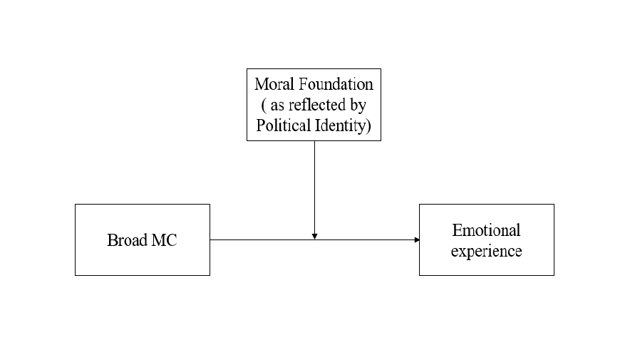

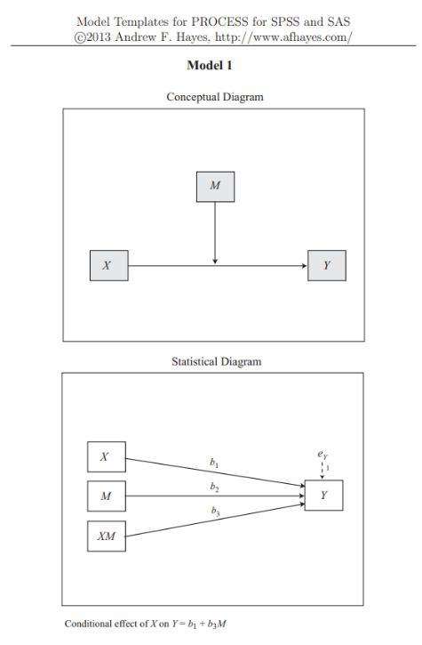

Additionally, in the revised manuscript I added a description and a figure of Hayes model 8 (pp.56). I now clarify the full simple moderation-mediation model, testing the moderation effect of endorsed moral foundations, as reflected by political ideology, on the ties between general moral conviction (about the Israeli-Palestine conflict) and emotions (anger, empathy), and subsequent political action tendency. I now clarify that Hayes model 8 was used for testing the mediation effect between moral conviction (*X*) emotions (*M*) and political action tendency (*Y*) as a function of the interaction effect of moral foundation as reflected by political ideology (*W*).

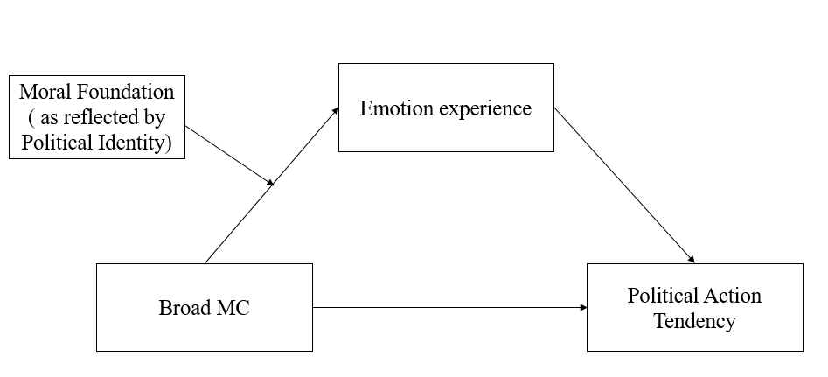 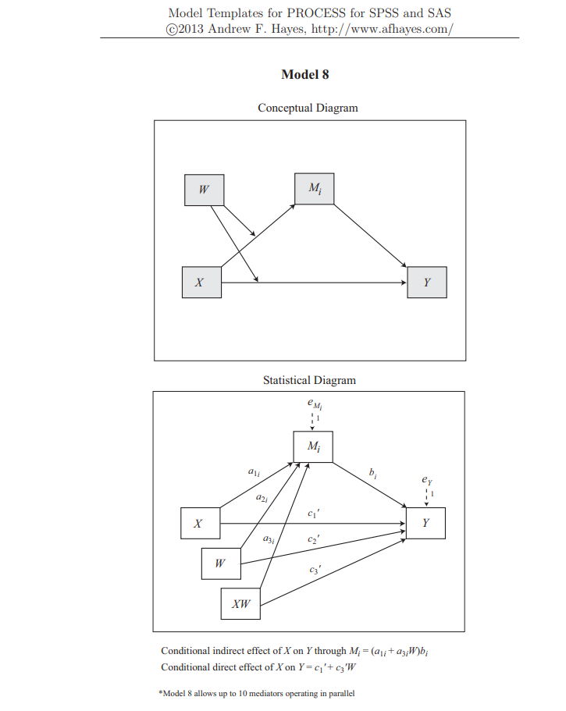

1. **In the regression models, it’s not appropriate to interpret the effects of individual variables as “direct effects” when the interaction term is in the model. In these cases, those relationships represent the simple effect of the one variable at the value of zero of the other variable (usually the mean if the variables are all mean centered).**

Thank you for this comment. Though it is not appropriate to interpret the effects of individual variables as “direct effects” when the interaction term is in the model, in this case all the variables were centered thereby it might be possible to interpret the effects as "direct or main effects". A main effect, when all the variables were centered, is simply the effect of one variable at the mean of the others. Since the variables are mean-centered then this is precisely what the individual effects represent. I revised the descriptions and the Tables presenting the effects of the moderation model predicting intensity of emotions, so that the interpretation of the effects of individual variables is now clearer. This can be seen in the results of Study 2 (pp.56-64) and Study 3 (pp.68-80).

1. **I am concerned about whether the regression analyses were conducted and interpreted properly. Either way, more detail in general is needed about how the regression models were run. Were all variables entered at the same time or in steps? Were the interactions followed up at one SD above and below the mean? If so, then this should be stated explicitly. Similarly, were the variables centered? Without know this information, it makes it nearly impossible to effectively interpret the regression results. ....Again, I may be interpreting this all wrong as it is difficult to know what was done without more detail.**

Following the comment, I rewrote the Method chapter in Study 2 and Study 3 and added a Statistical Analysis for each study. I detailed how the regression models were run. I clarified that "Multiple regression analyses were conducted on the data, using moderation model (the Hayes PROCESS model 1) all variable were centered, and entered at the first step. In order to interpret the interactions, simple slope analysis was conducted." (pp. 46). Additionally I added figures of Hayes model 1 and model 8 to visualize my theoretical model (pp. 47) and the results. Additionally, as clarified in comment #5, the interaction was not followed up at -/+ 1 SD, because the moderator was categorical presenting the categorical division of the participants to either right (1) or left (3).

.

1. **More description of what the indirect effects “looked like” is needed beyond whether they were significant or not.**

In the revised dissertation I changed the descriptions of the effects and the tables presenting the indirect effects of the moderation model. This could be also seen in the presented figures.

1. **There seems to be typo in Table 13. The 95% CI for PO (-1.55, -2.08) does not contain the point estimate for the regression coefficient (.26).**

I apologize for this typo (which was corrected in the manuscript). This should be:

|  |  |  |  |  |  |
| --- | --- | --- | --- | --- | --- |
| Variable | *b* | 95% *CI* | *SE* | *t* | *p* |
| Political Ideology | -0.26 | [-1.55, 2.08] | 0.92 | -0.29 | 0.77 |
|  | | |  |  |  |

1. In literature this approach is referred as domain-specific moral convictions (Skitka, Bauman & Sargis, 2005), and defined as nominated topics or broad issues of the day, that were identified by the experimenter or by participants as charged with moral conviction. Though referred as 'specific ', domain-specific moral convictions deal with expansive and stable moral content areas, thereby I prefer to conceive them as general moral convictions.
2. On March 24, 2016, a [Palestinian](https://en.wikipedia.org/wiki/Palestinian_People) assailant who stabbed an [Israeli soldier](https://en.wikipedia.org/wiki/Israel_Defense_Forces) was shot, wounded and "neutralized"; He was then shot again in the head by Elor Azaria, an [Israeli Defense Forces](https://en.wikipedia.org/wiki/Israeli_Defense_Forces) (IDF) soldier, as he lay wounded on the ground. 
3. <https://palwatch.org/page/5010>