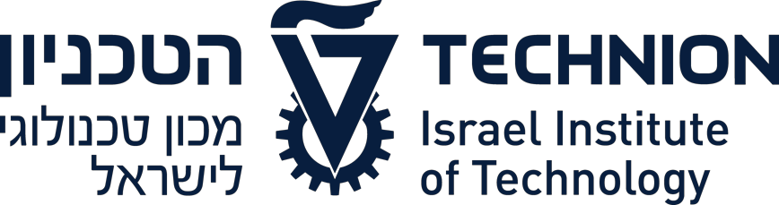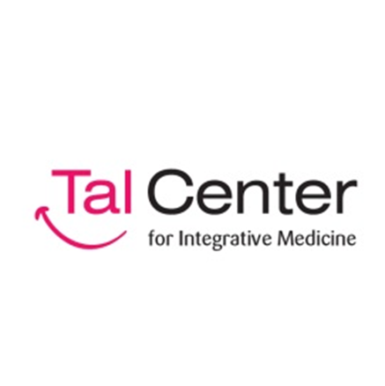

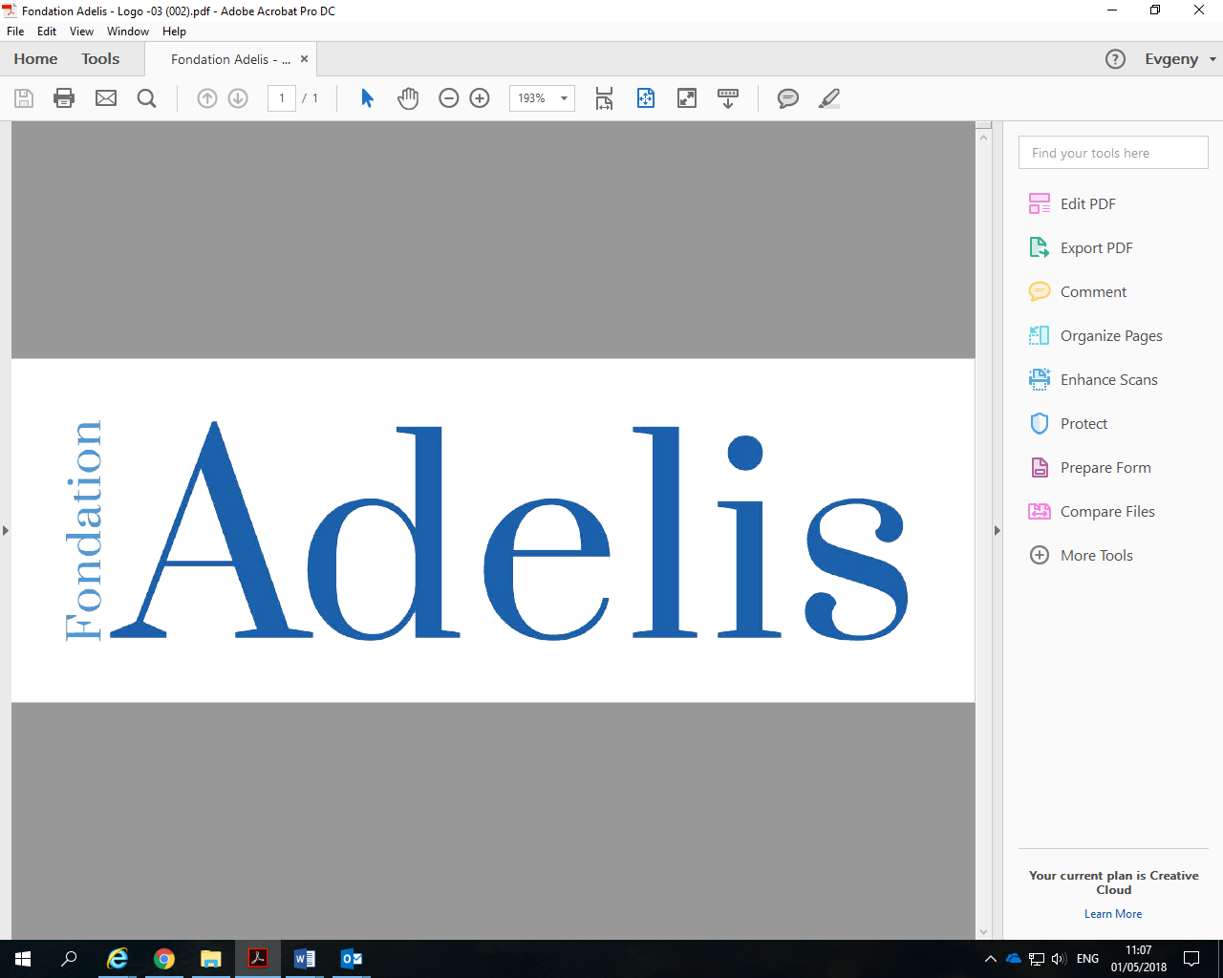

**Technion and Tal-Center Collaboration**

**Impact of Integrative Medicine**

**on**

**Chemotherapy-Induced Peripheral Neuropathy**

**A Multi-Centered Randomized Controlled Trial**

Prof. Elad Schiff

Bnai Zion Medical Center

Prof. Eran Ben-Arye

Clalit Health Services, Lin Medical Center, Haifa

Dr. Dorit Gamus

Tal Center for Integrative Oncology, Sheba Medical Center

**Introduction**

The March 2018 report, highlighted the establishment of the study – being the recruitment of practitioners and study coordinators together with the finalizing of the treatment protocol and receiving approval for its execution by the Internal Review Boards (Helsinki) for each institution.

We are now in the active phase of the trial itself and continue to strengthen our multicenter collaboration. The project is ambitious in terms of recruiting a fragile population undergoing active oncological treatments.

**Patient Recruitment**

A recruitment process was established in each center for identifying potential patients for the study. Each center developed its logistics to receive referrals from oncologists and hematologists. This required presentations by primary investigators in each site to the Oncological and Hematological Departments in order to introduce the project and request referrals.

The many in those departments – senior nurse, physicians, and administrative staff were informed about the project and encouraged to refer appropriate patients.

Patients were highly enthusiastic about the study. Indeed, the only reason that patients were assigned to the control group (being standard care without complementary treatment) was that they could not attend twice weekly complementary treatments due to geographical distance from the medical center.

For each patient enrolled in the study there was, and continues to be, a strict screening process to assess eligibility. As a rule of thumb, for each patient enrolled to the study, an additional three patients are screened. This speaks for the intensity of the process and the work put into every patient.

The following table details the number of recruitments per site to treatment group (complementary medicine on top of standard of care) or control group (standard care alone):

|  |  |  |
| --- | --- | --- |
| **Site** | **Control Group** | **Treatment Group** |
| Bnai Zion Medical Center | 7 | 12 |
| The Tal Center for Integrative Oncology, Institute of Oncology, Chaim Sheba Medical Center, Ramat Gan | 2 | 7 |
| Integrative Oncology Program, The Oncology Service, Lin and Carmel Medical Centers, Clalit Health Services, Haifa and Western Galilee District | 6 | 18 |
| **TOTAL** | 15 | 37 |

As we plan to have a total of 40 patients in the Control Group and 80 patients in the Treatment group, we have now recruited 37.5% and 46% of patients respectively to each group.

We are steadily approaching the goals we established.

**Collaboration between Participants**

A full day meeting was held on August 28th at the Integrative Oncology Program, The Oncology Service, Lin and Carmel Medical Centers. Champions from each center met together to discuss barriers and facilitators to patient recruitment in each center. We gained insight on these aspects from mutual experiences, as well as learning about patient retention in the study. Acupuncturists discussed treatment strategies, and specific "tips" from best-case series.

The primary investigators in each site reviewed deviations in the protocol, and study proceedings. Guidance for study personnel was distributed thereafter.

In addition to the above meeting, Dr. Zahi Arnon from Bnai Zion, and Daphna Wolf from Lin Medical Center developed a video and handouts to practitioners who apply guided imagery in the augmented complementary medicine group. This guided imagery intervention was developed through several meetings, and represent state-of-the-art mind-body interventions for neuropathy management.

The close work between the three centers is truly unique for such studies in Israel, and this accomplishment fulfils one of the most important goals of the Adelis Foundation- sharing knowledge and experience between leaders that can benefit human kind!

Recently, Dr. Noah Samuels has stepped down from his position as director of the Tal Center for Integrative Oncology, and Dr. Dorit Gamus will lead the Tal Center **research** site. We are making every effort to establish a smooth transition so that the study flow will continue.

The Technion and the Tal Center

extend appreciation to



for its support of this collaborative project

**Technion and Tal-Center Collaboration**

**Impact of Integrative Medicine**

**on**

**Chemotherapy-Induced Peripheral Neuropathy**

**A Multi-Centered Randomized Controlled Trial**

**Technion Financial Statement as of December 2018**

|  |  |  |
| --- | --- | --- |
|  | **$** | **$** |
| **INCOME** |  |  |
|  |  |  |
| Donation received from The Adelis Foundation |  | 98, 376 |
|  |  |  |
| **EXPENDITURE** |  |  |
|  |  |  |
| Employment of Laboratory Worker | 19,676 |  |
|  |  |  |
| Employment of Acupuncture Practitioners  (Bnei Zion) | 39,418 |  |
|  |  |  |
| Employment of Dr. Gressel | 39,197 |  |
|  |  |  |
| **Total Expenditure** |  | 98,292 |
|  |  |  |
| **Balance of Fund Available** |  | **$84** |

**Technion and Tal-Center Collaboration**

**Impact of Integrative Medicine**

**on**

**Chemotherapy-Induced Peripheral Neuropathy**

**A Multi-Centered Randomized Controlled Trial**

**Tal Center Financial Statement as of December 2018**

|  |  |  |
| --- | --- | --- |
|  | **$** | **$** |
| **INCOME** |  |  |
|  |  |  |
| Donation received from The Adelis Foundation |  | 98, 376 |
|  |  |  |
| **EXPENDITURE** |  |  |
|  |  |  |
| Employment of Acupuncture Practitioner  (Tal Center) | 6,972 |  |
|  |  |  |
| Statistician Fees | 680 |  |
|  |  |  |
| Von Frey Sensory Testing Kits (x4) | 2,113 |  |
|  |  |  |
| Administrative Costs | 1,891 |  |
|  |  |  |
| **Total Expenditure** |  | 11,656 |
|  |  |  |
| **Balance of Fund Available** |  | **$86,720** |