Application Number: 2427/20

Yossi Yagil

Changes in Execution Probability Function Over the Recent Decade – Evidence from the Tel Aviv Stock Exchange

**Research Program**

1. **Scientific Background**

Many stock exchanges around the world are making major investments to improve their trading environment in order to increase the tradability of the assets (Amihud, Mendelson and Lauterbach (1997)). In the recent decade, the Tel Aviv stock exchange (TASE) has introduced several structural amendments. For example, the transition from 3 to 5 orders in the order book (in 2014), adding the commands FOK (Fill or Kill) and IOC (Immediately or cancel) (in 2012), changing the trade hours in order to parallelize the NYSE trading hours (in 2013), increasing the number of stocks in the main stock index from 25 to 35 biggest companies (in 2017). In addition, the TASE performed technologic changes in the trading environment, especially in the internet speed.

A question of interest is whether investments do improve the trading mechanisms. In line with market microstructure research, we will investigate how the relationship between execution probability and the order price has changed over different trading environments. The execution probability and the tradability of the market have tow-way impact. On the one hand, high tradability increases the likelihood that there would be a trader that may wish to trade with the order. On the other hand, a trading environment with high execution probability would be attractive to the market traders, which consequently can raise the tradability level.

Several empirical studies of limit order markets have analyzed the impact of different structural regulation changes on limit order book. Huang, Rosenbaum and Saliba (2019), for example, investigated the European regulation named: "Markets in Financial Instruments Directive II" (MiFID II). This reform changed the tick size regime. By taking data from Paris Stock Exchange, the researchers explore the limit order book (LOB) of some 14 assets three months before MiFID II and three months under MiFID II. By comparing these two periods, they found that the constrained bid-ask spread is equal to the sum of the tick value and the intrinsic bid-ask spread that corresponds to the case of a vanishing tick size, which also enables them to value quantitatively the queue position of a limit order in the book. Laruelle, Rosenbaum and Savku (2019), also investigated MiFID II regulation and analyzed the changing of the transaction cost paid by investors. By comparing the periods before and after the tick size changes of 269 assets traded on Euronext, they found that MiFID II reduced the transaction cost and clearly induced an improvement to market quality. Our model will employ a similar method of comparing the market's parameters of the periods before and after the regulation have been passed and will attempt to test the impact of other structural amendments on the execution probability.

During trading days in capital markets, traders send their open interests to a queuing system. These orders include quantity, and the maximum or minimum price they wish to buy/sell (respectively). The queuing system is trying to match the offers according to "first in first out" queue stands at each possible price. The buy (or sell) order would be denied if there are no sell (buy) orders in that price, or if there is not a sufficient supply (demand) quantity in that price. Otherwise, the order will fully (or partially) be executed, and all (or part) of the order's quantity will change hands. This structure creates a tradeoff between the order price, the execution probability and the winner's curse risk, which is defined in the literature as execution cost.

The objective of this research is to characterize the sale and buy probability function of different financial assets traded on TASE. By detecting the recent 10 years documentation of the sale and buy orders that were fulfilled, partial fulfilled or not fulfilled at all, we will attempt to define the relationships between the sale probability and the level of the sale\buy order prices for given market conditions.

Most of the book order researches focus only on the orders that have been executed. Using a theoretical dynamic model, Foucault, Kadan and Kandel (2005), show how traders with different liquid preferences minimize their trading costs by choosing their limit orders level. Ainsworth and Lee (2014), empirical tested the waiting cost in the ex-day period on the Australian Securities Exchange. In those two researches, the trading cost is represented by the waiting time between the submitted and the executed. In our study we will also refer to the orders that were not executed, distinguishing them from the orders that were partial fulfilled. Such distinction will allow a more representative examination of the execution cost.

There are many researches that examine the evidence of different stock exchanges order books in various countries. Using an empirical model, Hollifield, Miller and Sandas (2004) analyzed the execution probability-order price trade off. By a three-month follow up of the order book of Ericsson stocks that are traded on the Stckholm Stock Exchange, they found evidence against the monotonicity of estimated relationship. In the present study we expand existing body of research to more stocks and longer time periods having different characteristics. We will attempt here to capture how the execution function is influenced by parameters both related to the asset (quality, firm's size, asset value, tradability and intensity), and parameters related to the book order and market price tendency (bull or bear).

There are several theoretical studies (Guerrieri and Shimer (2014), Chang (2012) etc.) that show how markets overcome the adverse selection problem by adding an additional trade element- the sale probability, which is defined as the ratio of the number of transactions made at some price divided by the number of the sale orders made at the same price of a certain asset. In these studies, the sale probability is endogenously determinate in equilibrium. This creates a tradeoff between the price level and the sale probability, which allows to trade different assets qualities in different markets instead of trading in one market (a pooling equilibrium as in Akerlof model's). By choosing a market with low sale probability and high price level, the seller signals that she/he holds a high-quality asset. Sellers with lower quality assets will be prepared to increase the probability of selling their assets by choosing a market with lower price. Paradoxically, in this environment, high quality assets may be associated with a low sale probability. Intuitively, it is common to assume that high quality assets would be more tradable. By taking longer time periods we will explore whether and how the quality of the asset influences the execution probability function under different trade conditions.

1. **Research objectives & expected significance**

Using advanced econometric methods, we will formulate the execution probability function which depends on a wide range of parameters. By using hypothesis tests, we will explore how the execution probability has changed over the recent decade due to changes in trading conditions. Further, we will conduct a similar analysis of execution probabilities in the London Stock Exchange (LSE) and the New York Stock Exchange (NYSE). Finally, we will conduct a comparison of dually listed assets within these markets. These comparisons may capture the differences of the execution probability function in different markets.

The significance of this research is to provide the policy makers tools to test the structural amendments that have been enacted, and suggest recommendations for future structural amendments accordingly.

The execution probability function may also be useful for individual investors who wish to minimize their execution cost due to liquidity preferences. An expected execution probability may be an important indicator for investors’ investment strategy.

1. **Detailed description of the proposed research**

This study is based on data from the quotes, orders and transactions documentation in the TASE, LSE and NYSE between the years 2010 – 2019. This dataset contains all order placements and cancellations, making it possible to reconstruct the limit order book and other parameters at any point of time. To reduce the variability of the orders we will deduct the order that were canceled after 10 minutes or less. The execution probability orders would be defined by the part of the quantities-order that have been executed.

* 1. **Working hypotheses**

Hypothesis 1: High quality assets would be more tradable, and their execution probability would be higher.

Hypothesis 2: Under adverse selection conditions, the relationship between the quality of the asset and the execution probability will reverse.

Hypothesis 3: Tradability and execution affect one another. When structural amendments influence execution probability positively, the increase in assets tradability will be greater.

Hypothesis 4: Dually listed assets may have different execution probability functions in different markets.

* 1. **Research design & methods**

**Analysis methods**:

In order to analyze the data and be able to predict the execution probability, we will use ordered logit model. The dependent variable of the supply (demand) function will be divided into four categories according to the level of success of the sell (buy) order. The independent variables will be financial and market indicators. Hence, given the market data, we will be able to predict the optimal sell (buy) order price.

In order to test the effect of regulations on execution probabilities function, following Huang, Rosenbaum and Saliba (2019) and Laruelle, Rosenbaum and Savku (2019), we will compare the estimated function of 3 months before the regulation and 3 months under the regulation.

In recent years applications of neural network architectures are used for financial predictions. Following Huang, Capretz and Ho (2019), as part of our analysis we will construct a feed – forward neural network (FNN) based on fundamental analysis in order to classify stocks according to tendency prediction.

* 1. **Preliminary results**

Our preliminary results are based on data of the first week of January 2016.

**Result 1:** Present two ordered logit models that analyze the effect of market and stock indicators on execution probabilities of TA25 call option.

The supply equation asses the effect of the following variables; order sell price, most recent transection price, tendency, volatility, order submission time, the percentile of the order price relative to the available five sell orders in the order book, the percentile of the order price relative to the available five buy orders in the order book, on sell execution probability. Table 1 present our results of the ordered logit estimation, where the dependent variable is split into two categories, neither one of the call options were sold, and all the call options were sold.

The demand equation asses the effect of the following variables; order buy price, most recent transection price, volume, volatility, order submission time, the percentile of the order price relative to the available five sell orders in the order book, the percentile of the order price relative to the available five buy orders in the order book, on sell execution probability. Table 2 present our results of the ordered logit estimation.

In both models the coefficients are significant. These results provide us with a benchmark model that will be tested for different trading environment to identify the effect of regulations on traders behavior.

**Result 2:** Present an order logit model that analyses the effect of market and stock indicators on execution probabilities of Leumi bank stock.

The supply equation asses the effect of the following variables; order sell price, tendency, volatility, order submission time, TA25 call option tendency, TA25 call option volatility, on sell execution probability. Table 3 present our results of the ordered logit estimation.

**Result 3:** Present an order logit model that analyses the effect of market and stock indicators on execution probabilities of Mizrahi Tefahot bank stock.

The supply equation asses the effect of the following variables; order sell price, tendency, volatility, volume, order submission time, TA25 call option tendency, TA25 call option volatility, TA25 call option volume, on sell execution probability. Table 4 present our results of the ordered logit estimation.

A comparison of results 3 and 4 shows that high quality assets have higher execution probabilities. Bank Leumi, the second biggest bank in Israel, is considered to be a higher quality stock in compare to Bank Mizrahi Tefahot, the fourth biggest bank in Israel. This result supports Hypothesis 1. In this research we will analyze the effect of unexpected shocks on execution probabilities of stocks with different qualities[1].

* 1. **Manpower and infrastructure**

For this type of extensive research, we expect to employ a very large data base. For example, the expected amount of orders on an average day in TASE for an average stock from the Tae Aviv 25 stocks index (TA25) is around 10,000. We plan to explore several assets over a decade. This means that we need the following, among others: an access to those data recourses, very advanced computers, special software and research assistants for processing the data.

* 1. **Expected results**

By using innovative estimation methods, we expect to find a statistically significant relationship between the execution probability and the other parameters, especially the structural amendments enacted over the recent decade. By studying the execution probability, we expect to provide tools to market makers and policy makers for inducing improvements in market quality.

**Figures**

**Table 1:** TA25 Call option sell execution probability equation.

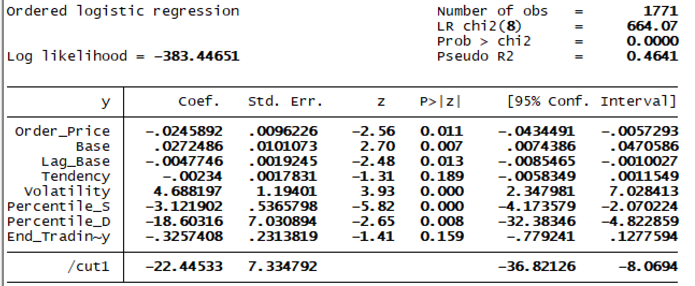

**Table 2:** TA25 Call option buy execution probability equation.

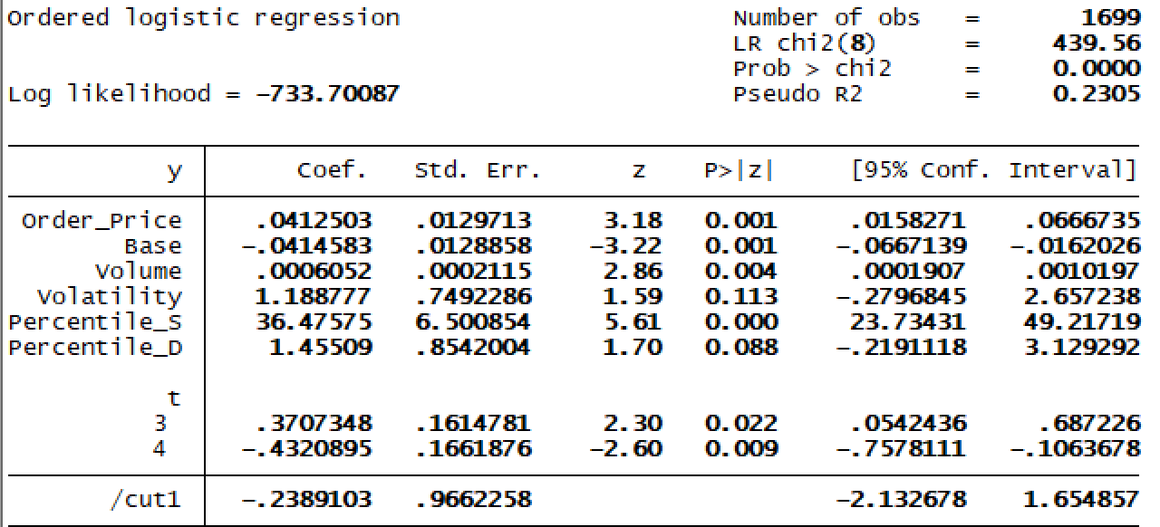

**Table 3:** Leumi Bank sell execution probability equation.

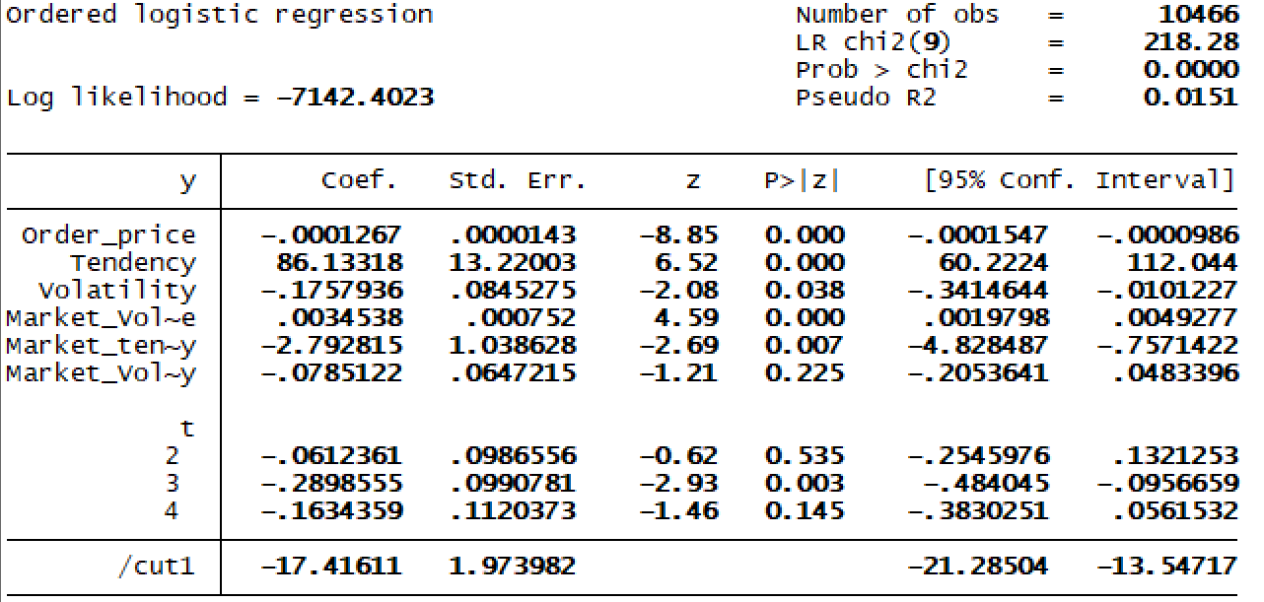

**Table 4:** Mizrahi Tefahot Bank sell execution probability equation.

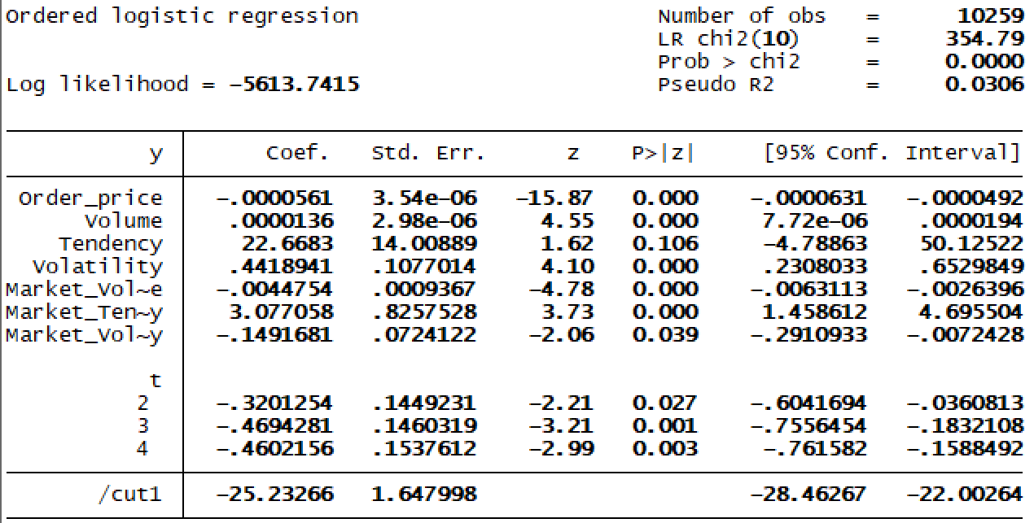

**Bibliography**

1. Foucault, T., Kadan, O. and Kandel, E., 2005. Limit order book as a market for liquidity. *The review of financial studies*, *18*(4), pp.1171-1217.
2. Amihud, Y., Mendelson, H. and Lauterbach, B., 1997. Market microstructure and securities values: Evidence from the Tel Aviv Stock Exchange. *Journal of Financial Economics*, *45*(3), pp.365-390.
3. Hollifield, B., Miller, R.A. and Sandås, P., 2004. Empirical analysis of limit order markets. *The Review of Economic Studies*, *71*(4), pp.1027-1063.
4. Ahn, H.J., Cai, J., Hamao, Y. and Ho, R.Y., 2002. The components of the bid–ask spread in a limit-order market: evidence from the Tokyo Stock Exchange. *Journal of Empirical finance*, *9*(4), pp.399-430.
5. Akerlof George A. (1970): "The Market for "Lemons": Quality Uncertainty and the Market Mechanism", *Quarterly Journal of Economics*, 84(3), 488-500.
6. Chang, B., 2017. Adverse selection and liquidity distortion. *The Review of Economic Studies*, *85*(1), pp.275-306.
7. Guerrieri, V. and Shimer, R., 2014. Dynamic adverse selection: A theory of illiquidity, fire sales, and flight to quality. *American Economic Review*, *104*(7), pp.1875-1908.
8. Huang, W., Lehalle, C.A. and Rosenbaum, M., 2015. Simulating and analyzing order book data: The queue-reactive model. *Journal of the American Statistical Association*, *110*(509), pp.107-122.
9. Lehalle, C.A. and Mounjid, O., 2017. Limit order strategic placement with adverse selection risk and the role of latency. *Market Microstructure and Liquidity*, *3*(01), p.1750009.
10. Bloomfield, R., O’hara, M. and Saar, G., 2005. The “make or take” decision in an electronic market: Evidence on the evolution of liquidity. *Journal of Financial Economics*, *75*(1), pp.165-199.
11. Guéant, O., Lehalle, C.A. and Fernandez-Tapia, J., 2012. Optimal portfolio liquidation with limit orders. *SIAM Journal on Financial Mathematics*, *3*(1), pp.740-764.
12. Kaufman, P.J., 2013. *Trading Systems and Methods,+ Website* (Vol. 591). John Wiley & Sons.
13. Ainsworth, A. and Lee, A.D., 2014. Waiting costs and limit order book liquidity: Evidence from the ex-dividend deadline in Australia. *Journal of Financial Markets*, *20*, pp.101-128.
14. Huang, Y., Capretz, L.F. and Ho, D., 2019. Neural Network Models for Stock Selection Based on Fundamental Analysis. *arXiv preprint arXiv:1906.05327*.*
15. Huang, W., Rosenbaum, M. and Saliba, P., 2019. From Glosten-Milgrom to the whole limit order book and applications to financial regulation. *Available at SSRN 3343779*.*
16. Laruelle, S., Rosenbaum, M. and Savku, E., 2018. Assessing MiFID 2 Regulation on Tick Sizes: A Transaction Costs Analysis Viewpoint. *Available at SSRN 3256453*.*

* These three unpublished papers will be available upon request from the ISF.

1. See Hypothesis 2.