**Responsibility to the Land: To Work It and To Keep It**

**Educator Information**

* **Essential Questions**
  + What can we learn from Jewish texts about our relationship with the environment?
  + How can Jews both in and out of Israel participate in working and protecting the land?
* **Learning Outcomes**
* Students will be able to explain how Jews in Israel and in the Diaspora have worked to reclaim and develop the Land of Israel.
* Students will be able to connect Jewish attitudes towards the environment to classical Jewish texts.
* Students will understand that people must take responsibility to take care of the Land of Israel and preserve it for future generations.
* Students will be able to discuss some of the current environmental issues facing Israel.

**Lesson Information**

|  |  |
| --- | --- |
| Short description of lesson | This is a lesson that can be used leading up to Tu B’Shvat. It can also be used as part of a unit on the environment or on the early pioneers in Israel.  The lesson guides the students through Jewish texts and resources from the National Library of Israel which discuss taking care of the land and preserving it for future generations. Guiding questions are provided to assist the students in analyzing the texts and resources.  At the end of the lesson, students have a choice of creative projects which allow them to implement what they have learned and design a poster. |
| Age group | Middle school |
| Length of activity | 2 class periods |
| Primary sources from the NLI collections | * Five Roles of JNF, 1930s <http://bit.ly/2Ewmjco> * Watering Plants, Kibbutz Ginegar <http://bit.ly/2Ez6RfA> * Tu B’Shvat Tree Planting, Israel <http://bit.ly/2oLqZ5q> * Tree Planting Certificate, Twentieth Century <http://bit.ly/2EullgR> * Protected Trees and Shrubs, JNF <http://bit.ly/2Ewqi8Q> |

**Lesson Plan**

**Day 1**

1. **Introduction** (10 minutes)  
   Teachers introduce the idea of responsibility for the land.

Jews around the world are responsible for taking care of the Land of Israel and preserving it for future generations. In this lesson, we will look back at the work of the early pioneers, learn about the accomplishments of the KKL-JNF, and consider ways to protect the environment.

In lessons leading up to Tu B’Shvat, it could be a good time to review the values and traditions of the holiday.

1. **Individual or pair work** (30-40 minutes)

Students will analyze primary sources from the collections of the National Library of Israel and answer questions found on the printed worksheet <link>.  
Students can work alone or in pairs.

**Day 2**

**1. Class discussion** (15 minutes)The teacher will lead a discussion based on the worksheet completed in the previous lesson.

* 1. According to the texts that you read, what is our responsibility to the land?
  2. What are some of the ways that we can fulfill this responsibility?
  3. What environmental challenges did the early pioneers face?
  4. How did the KKL-JNF address the environmental challenges?
  5. How did Tu B’Shvat develop in Israel in the early 1900s?
  6. How did Jews living outside of Israel participate in taking care of the land?
  7. What are Israel’s environmental challenges today?
  8. How are they being addressed?   
     (Teachers may need to add information about current KKL-JNF projects and the environmental work of other organizations and individuals.)

**2. Creative activity** (30 minutes)Students choose from one of the following choices.   
They may use traditional art supplies or, if they have computer access, they can work on Canva. Students share or display their work when they have finished.

Choose one of the following ideas. Use [Canva](http://www.canva.com/).com or paper and art material to create your poster.

* Design an updated poster featuring KKL-JNF's accomplishments.
* Design a tree certificate for KKL-JNF.
* Create a poster promoting efforts to protect the environment.
* Choose a text from the Sefaria library concerning Tu B’Shvat or the environment and illustrate it. (Search in [topics](https://www.sefaria.org/topics) to discover texts)

<Text of Lesson on Sefaria>

**Responsibility to the Land: To Work It and To Keep It**

**Summary**   
This is a lesson that can be used in a lesson prior to Tu B’Shvat. It can also be used as part of a unit on the environment or on the early pioneers in Israel.

The lesson guides the students through Jewish texts and resources from the National Library of Israel which discuss taking care of the land and preserving it for future generations. Guiding questions are provided to assist the students in analyzing the texts and resources.

At the end of the lesson, students have a choice of creative projects which allow them to implement what they have learned and design a poster.

Tags: Nature, Ecology, Trees, Land, Environment, Jewish National Fund, JNF, Tu B’Shvat, National Library of Israel, NLI, Israel

**Description of the Land of Israel**

**When God told Moses that He was going to take the Israelites out of Egypt and bring them to Canaan, these are the words that He used to describe the land:**

[שמות ג׳:ח׳](https://www.sefaria.org/Exodus%203:8)

(ח)... אֶל־אֶ֤רֶץ טוֹבָה֙ וּרְחָבָ֔ה אֶל־אֶ֛רֶץ זָבַ֥ת חָלָ֖ב וּדְבָ֑שׁ ...

[Exodus 3:8](https://www.sefaria.org/Exodus%203:8)

(8) ... to a good and spacious land, a land flowing with milk and honey...

* What image of the land do you have from the description? What do you think it means to be flowing with milk and honey?

**Caring for the Land of Israel in the Bible and the Talmud**

**In the description of the creation of the world in the book of Genesis, God explains our responsibility to the environment in this way:**

[בראשית ב׳:ט״ו](https://www.sefaria.org/Genesis%202:15)

(טו) וַיִּקַּ֛ח ה' אֱלֹקִ֖ים אֶת־הָֽאָדָ֑ם וַיַּנִּחֵ֣הוּ בְגַן־עֵ֔דֶן לְעָבְדָ֖הּ וּלְשָׁמְרָֽהּ׃

[Genesis 2:15](https://www.sefaria.org/Genesis%202:15)

(15) The Lord God took the man and put him into the garden of Eden to work it and to keep it.

* How do you understand this verse?  
  What are human’s two responsibilities towards the Garden of Eden?  
  What is the difference between the two?  
  How can this be connected to our responsibility to the environment today?

The Talmud also deals with the importance of maintaining the land and making sure it is viable for future generations.

[תענית כ״ג א:ט״ו](https://www.sefaria.org/Taanit%2023a:15)

יומא חד הוה אזל באורחא חזייה לההוא גברא דהוה נטע חרובא אמר ליה האי עד כמה שנין טעין אמר ליה עד שבעין שנין אמר ליה פשיטא לך דחיית שבעין שנין אמר ליה האי [גברא] עלמא בחרובא אשכחתיה כי היכי דשתלי לי אבהתי שתלי נמי לבראי

[Taanit 23a:15](https://www.sefaria.org/Taanit%2023a:15)

One day, he was walking on the road and saw a certain man [Honi] that was planting a carob tree. He said to him, “How many years until this [tree] will be laden [with fruit]?” He said to him, “Until seventy years.” He said to him, “Is it obvious to you that you will live [another] seventy years?” He said to him, “That man found the world with carob trees. In the same way as my fathers planted for me, I will also plant for my children.”

* Write the story of Honi in your own words.
* Will Honi live to eat the fruit that will grow on the tree that he is planting?  
  If not, why does he plant the tree?
* What does the story about Honi tell us about Jewish attitudes toward the environment?

**Caring for the Land of Israel in the Nineteenth Century**

When the early pioneers came to the Land of Israel in the late 1800s, they found a land that hadn’t been looked after.

The American writer Mark Twain, traveling to Israel in 1867, described the land in this way:

A desolate country whose soil is rich enough, but is given over wholly to weeds – a silent mournful expanse.... A desolation is here that not even imagination can grace with the pomp of life and action....We never saw a human being on the whole route....There was hardly a tree or a shrub anywhere. Even the olive and the cactus, those fast friends of the worthless soil, had almost deserted the country.” (Mark Twain, *The Innocents Abroad* [London, 1881])

* What was Mark Twain’s impression of the environment in the Land of Israel in 1867?  
  What aspects of the environment does he describe?  
  What state were they in?

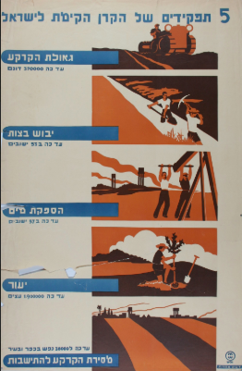**Caring for the Land of Israel with the Arrival of the Zionist Pioneers**

The Keren Kayemet L’Yisrael - Jewish National Fund (KKL-JNF) was founded in 1901 for the purpose of purchasing and taking care of land in the Land of Israel.  
Study the poster below and answer the questions that follow.

National Library of Israel, [Five Roles of JNF, 1930s](http://bit.ly/2Ewmjco)

Translation:

*The Five Roles of the Jewish National Fund*

*Land Reclamation – 370,000 dunams thus far*

*Draining the Swamps – in 53 settlements thus far*

*Water Supply – in 57 settlements thus far*

*Afforestation – 1,900,000 trees thus far*

*Delivery of Land for Settlement – 38,000 people in villages and cities thus far*

* Describe the poster.
* What do the different pictures show?
* What message was the JNF conveying to the public?
* What, according to the poster, were the JNF’s achievements prior to the 1930s?
* How was JNF fulfilling God’s command in Genesis?

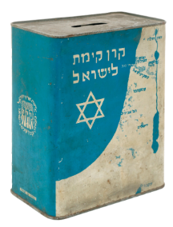

**Caring for the Land of Israel around the Jewish World**

JNF is known around the world by the Blue Box that was used to collect money.

* Search the internet for information about the JNF Blue Box.  
  When was it first introduced?  
  What was the goal of the Blue Box?  
  How was it designed?
* Does your family have a blue JNF collection box?

Ask your parents or grandparents – maybe they remember having one.

Reclaiming the land by planting trees became the work of Jews in Israel and around the world.   
People young and old donated money to pay for the trees in Israel and the KKL-JNF and other organisations and individuals planted them.

**Planting Trees in Israel**  
Trees were planted throughout the year, but the holiday of Tu B’Shvat became a special time for planting trees in Israel.

Look at the photograph below and answer the questions that follow.

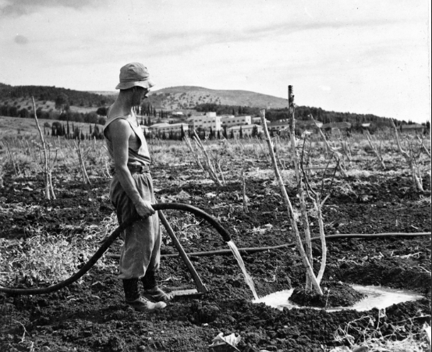

National Library of Israel, [Watering Plants, Kibbutz Ginegar](http://bit.ly/2Ez6RfA)

This is a photograph of a man named Raphael Stern from Kibbutz Ginegar, which is located in the Jezreel Valley and was founded in 1922.

* What is Raphael Stern doing?
* How is he dressed?
* Describe the surroundings.
* What do you think Kibbutz Ginegar looks like now?
* Find Ginegar on [Google Earth](https://earth.google.com/web/).   
  Describe the surroundings today. How has it changed?
* Do you think Raphael Stern could have imagined today’s Ginegar when he was watering this tree?
* In what way is Raphael Stern similar to Honi?

Look at another photograph from the same time period and answer the questions that follow.  
This is a photograph of children planting trees, presumably on Tu B’Shvat.

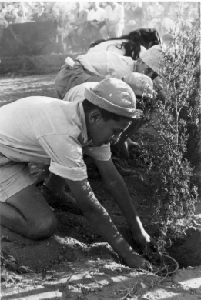

National Library of Israel [Tu B’Shvat Tree Planting, Israel](http://bit.ly/2oLqZ5q)

* Have you ever planted a tree in Israel?  
  Have you ever planted a tree somewhere else?
* Is planting a tree in Israel different from planting anywhere else?  
  What is the difference?
* If you aren’t able to physically plant a tree in Israel on Tu B’Shvat, how can you still participate in the experience?  
  Have you ever purchased a JNF tree to be planted in Israel?

**Donating Trees for Planting in Israel**

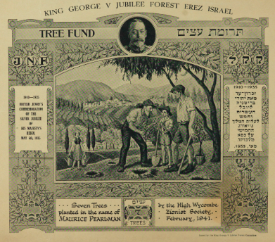For those who couldn’t plant a tree in Israel with their own hands, there was another way to participate in the work of reclaiming the land.

Study the item below and answer the questions that follow.

National Library of Israel, [Tree Planting Certificate, Twentieth Century](http://bit.ly/2EullgR)

* What is this?
* Describe the drawing in the centre of the certificate.  
  Who are the people?   
  What are they doing?   
  What is the background?
* Describe the frame.  
  What features are included?
* Who is the man in the picture in the top-centre?
* What is the written on the certificate?
* When was this certificate printed?  
  When was the forest first planted?
* Have you ever received a JNF tree certificate? Has anyone ever planted a tree in your honour? Why do you think they chose to honour you in that way?

**Preservation of the Environment in the State of Israel**

Below are a poster published by the KKL-JNF and a poster published by the city of Tel Aviv.   
Both are promoting care of the environment.

Look at the posters and answer the questions that follow.

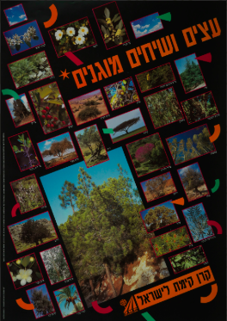

National Library of Israel, [Protected Trees and Shrubs, JNF](http://bit.ly/2Ewqi8Q)

Translation:

*Protected Trees and Shrubs*

*Keren Kayemet L'Yisrael (Jewish National Fund)*

* What photographs are included in the design?
* Translate some of the names of trees. Are you familiar with any of the trees?
* What message does this poster convey?
* How does this poster illustrate a shift in JNF’s focus from the early days of the organisation?
* Why do you think their focus shifted? Why do you think the city of Tel Aviv printed this poster?

**Creative Ideas**

Choose one of the following ideas. Use [Canva](http://www.canva.com/) or paper and art material to create your poster.

* Design an updated poster featuring KKL-JNF’s accomplishments.
* Design a tree certificate for KKL-JNF.
* Create a poster promoting efforts to protect the environment.
* Choose a text from the Sefaria library concerning Tu B’Shvat or the environment and illustrate it. (Search in [topics](https://www.sefaria.org/topics) to discover texts)

See the education [website](http://web.nli.org.il/sites/nlis/en/education/pages/results.aspx#query=any,contains,%D7%97%D7%99%D7%A0%D7%95%D7%9A&query=lsr14,exact,Tu%20Bishvat) of the National Library of Israel for additional Tu B’Shvat resources and teaching material.