**Name of Lesson Plan** **Rosh Hashanah Customs**

**Short description** <for catalogue result page> A study of Rosh Hashanah customs or mitzvot through the analysis of primary sources, classical Jewish texts, and oral histories. The customs to be studied are Shana Tova cards, tashhlich, symbolic foods (*simanim*), and the shofar.

**Lesson Information**

**Introduction of Lesson**

The festival of Rosh Hashanah has many customs associated with it. In this lesson students will analyse a variety of primary sources, study classical Jewish texts, and read oral histories in order to learn about common Rosh Hashanah customs.

**Age Group**

* Primary school
* Junior high

**Rosh Hashana Customs – A Variety of Teaching Customs**

The materials can be used in various ways. Below are several suggestions.

1. **Stand-Alone Lessons**The Rosh Hashanah customs can be taught as stand-alone lessons and teachers can choose whichever they wish to teach.  
   Teacher might want to end each of the lessons with a creative activity, giving the students the opportunity to produce something new based on the information acquired during the lesson.   
   Suggested activities:
   1. **Symbolic foods** – Write your own food puns, in Hebrew or English, that reflect your wishes for the new year.
   2. **Shofar** – Make an infographic about the shofar. Include when it is used and the different types of notes that are blown. Suggested website: [Venngage](https://venngage.com/) and [Canva](https://www.canva.com/).
   3. **Tashlich** – What actions from the past year would you like to throw away? Write them on a piece of paper, tear up the paper, and throw it away. Reflect on how it made you feel.
   4. **Shana Tova Cards** – Students design their own Shana Tova cards, using the ideas about illustrations and texts discussed in the lesson.
2. **Station Activity**Teachers set up various stations for each activity. Students move from station to station, building up their knowledge about the Rosh Hashanah customs at each.
   1. Set up separate stations for each activity.   
      Each station will include primary sources from the NLI, classic Jewish texts, and selections from oral histories.
   2. Students move between stations, learning about each custom and summarising them on the worksheet provided (Summary of Customs <link>).
   3. Students participate in a creative activity (see above) at each station. Alternatively, at the end of the rotation, each student chooses one creative activity to work on.
3. **Students become teachers**  
   The students choose one of the customs to learn about in depth and to prepare a learning activity for others to learn from. The students can thus teach each other about the customs or invite guests, such as parents or another class in the school, to the classroom to learn about the customs.
   1. The teacher presents the four customs to the students.
   2. Students choose a custom that they would like to learn about in depth.
   3. Students form groups to learn about the custom and to create an activity which teaches others about the custom and will form one of various station activities.   
      The worksheet, “Overview of Station,” <link> can be used by the students as they prepare.
   4. Invite parents, other students in the school, or the students in the classroom to visit the stations.   
      Students in the class take turns staffing the station and visiting the other stations.   
      Visitors spend ten minutes at each station.   
      At the end of the activity, the teacher leads a discussion on what the visitors learned from the different stations.

<logo, separate page, not to be separately uploaded to manof, landscape layout>

**Summary of Customs**

|  |  |  |  |
| --- | --- | --- | --- |
| Custom | What is the custom? | What are the origins or reasons behind the custom? | Three things learned from the station |
| Food/*Simanim* |  |  |  |
| Shana Tova Cards |  |  |  |
| Tashlich |  |  |  |
| Shofar |  |  |  |

<logo, separate page, not to be separately uploaded to manof, >  
**Make Your Own Learning Station About Rosh Hashanah Customs**

Name of Custom ___________________________________

|  |
| --- |
| What visitors to the station will know by the end of their visit: |
| Materials needed for station: |
| Outline of time spent at station: |
| Description of activity: |
| Teachers’ approval (signature) |

<logo, separate page, to be separately uploaded to manof as standalone lesson >

**A Tasty New Year – Symbolic Rosh Hashanah Foods**

**Introduction**

A variety of symbolic foods, called *simanim*, are eaten at the beginning of the Rosh Hashanah dinner. The foods are each accompanied by a short wish for the new year which includes a pun based on the name or characteristics of the food. The most well-known example is apples dipped in honey and eaten with the wish to be blessed with a sweet new year.

**Simanim in Jewish Texts**

Below is an explanation of *simanim* and the practice of eating a selection of foods with their accompanying blessings. Read the texts and answer the questions below.

|  |  |
| --- | --- |
| [**Machzor Rosh Hashanah Sefard, Rosh Hashanah Customs 1-19**](https://www.sefaria.org/Machzor_Rosh_Hashanah_Sefard,_Rosh_Hashanah_Customs.1-19)  *It is customary to eat apples dipped in honey and to say afterwards:* May it be Your will, our God and God of our ancestors that we should have a good and sweet new year.  *When eating the head of a sheep or fish say:* May it be Your will, our God and God of our ancestors that we should be as a head and not a tail.  *When eating dates say:* May it be Your will, our God and God of our ancestors that our enemies be destroyed.    *When eating a pomegranate say:* May it be Your will, our God and God of our ancestors that our merits increase, as the seeds of the pomegranate. | [**מחזור ראש השנה ספרד, מנהגי ליל ראש השנה א׳-י״ט**](https://www.sefaria.org/Machzor_Rosh_Hashanah_Sefard,_Rosh_Hashanah_Customs.1-19)  ונוהגין לאכול תפוח מתוק בדבש ואחר שיאכל יאמר זה: **יְהִי** רָצוֹן מִלְּפָנֶיךָ יְהֹוָה אֱלֹהֵינוּ וֵאלֹהֵי אֲבוֹתֵינוּ שֶׁתְּחַדֵּשׁ עָלֵינוּ שָׁנָה טוֹבָה וּמְתוּקָה:  נוהגין לאכול גם ראש איל או כבש זכר לאילו של יצחק או ראש של דג ויאמר זה: באכילת ראש כבש או דג אומר: **יְהִי** רָצוֹן מִלִּפְנֵי אָבִינוּ שֶׁבַּשָּׁמַיִם, שֶׁנִּהְיֶה לְרֹאשׁ וְלֹא לְזָנָב.  באכילת התמרים אומר: **יְהִי** רָצוֹן מִלִּפְנֵי אָבִינוּ שֶׁבַּשָּׁמַיִם שֶׁיִּתַּמּוּ שׂוֹנְאֵינוּ וְאוֹיְבֵינוּ.  באכילת הרימון אומר: **יְהִי** רָצוֹן מִלְּפָנֶיךָ יְהֹוָה אֱלֹהֵינוּ וֵאלֹהֵי אֲבוֹתֵינוּ, שֶׁתַּרְבֶּה זְכֻיּוֹתֵינוּ כְּרִמּוֹן: |

1. What foods are customary to eat on Rosh Hashana?

2. What wishes (*Yehi Ratzon* prayer) go along with the foods?

3. Which of the *simanim*, if any, do you eat on Rosh Hashanah?

4. Write a Rosh Hashanah pun based on a food in the style of those listed above.   
The pun can be written in Hebrew or English and should reflect your wishes for the new year.

**Simanim in National Library Resources**

Below are two sources from the collection of the National Library of Israel.   
Answer the questions below the pictures.

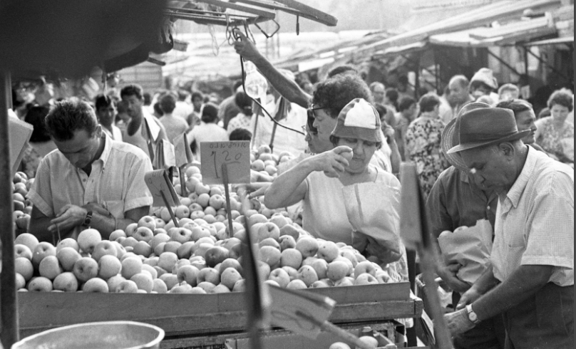

[Carmel Market Before Rosh Hashanah, 1969](http://beta.nli.org.il/en/archives/NNL_ARCHIVE_AL004822001/NLI), National Library of Israel

1. What is being sold in the photograph?
2. What type of market (*shuk)* are the people shopping at?
3. What other foods might be available at the *shuk* before Rosh Hashanah?
4. Have you ever shopped in an outdoor market?  
   If so, how does it compare to shopping at a supermarket?   
   Which do you prefer?   
   If not, would you like to? Why?

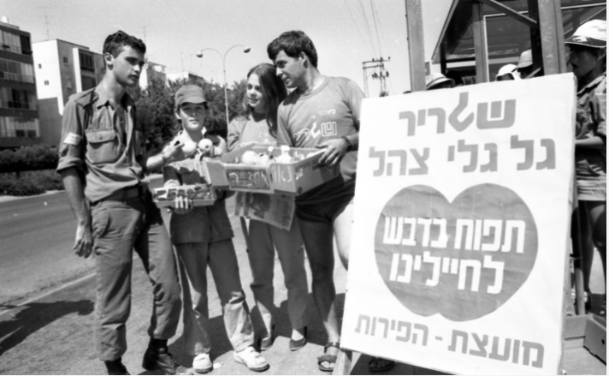

[Giving Apples to Soldiers for Rosh Hashanah, 1984](http://rosetta.nli.org.il/delivery/DeliveryManagerServlet?dps_pid=IE63536502), National Library of Israel

1. What are each of the people in the photograph doing?
2. Why were apples and honey given to soldiers?   
   Which holiday was soon to be celebrated?
3. How do you think receiving the apples and honey made the soldiers feel?
4. Why do you think the young people distributing the apples and honey wanted to participate in this project?   
   How do you think it made them feel?
5. What can you learn about the connection between the Israeli public and the soldiers in the IDF from the photograph?

**Celebrating Rosh Hashanah in Historical Records**

Read the following passages and answer the questions below.

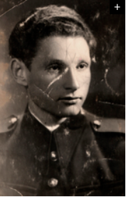Rosh Hashanah in Czechoslovakia as told by Heinrich Zinger and recorded by Centropa.

Before Rosh Hashanah the shofar played after the morning prayer for the whole month of Tishri and Elul at the synagogue. On the eve of the holiday Jews had to offer an apology to those they hurt even if the hurt was unintentional. On Rosh Hashanah my father put on a white shirt and went to the synagogue with my mother. It was mandatory to wear white clothes. When we grew up we also went to the synagogue with our parents. My father had a special prayer book for Rosh Hashanah and Yom Kippur. My mother cooked traditional Jewish food: chicken, chicken broth and gefilte fish. We ate apples dipping them in honey and my mother explained that we did this to express our hope for a year full of sweetness ahead.

**Rosh Hashanah in Turkey as told by Yasef Romano from Istanbul and recorded by** [**Centropa**](https://www.centropa.org/biography/yasef-romano#Family%20background)

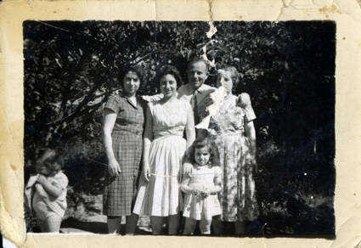My wife’s family [Luna Romano] celebrated every holiday with all the details… [towards] Rosh hashana borekitas, tatli de muez(walnut sweets), tezpisti, mekikler (a kind of muffin), so many, many things were made… My wife’s mother would make a special  
 pastry from pumpkins for Rosh hashana… She would cook the pumpkin with  
 sugar and make a special pastry. She would also cook leeks. Because these  
 are the first vegetables to come out. Rosh hashana has a special meal….  
Carp really was prepared deliciously. I still remember the delicious taste.   
My wife’s mother would make any sweets you can think of in Rosh hashana.  
 We had a cupboard, that cupboard would fill up with sweets.

* Which special food did you read about in Heinrich's and Yasaf's stories?
* What is common to both of the family's traditions?
* Which of the traditions described by Henrich and Yasaf does your family also follow?

**Wrapping it up!**

Which is your favourite symbolic food? Why?

<logo, separate page, to be separately uploaded to manof as standalone lession >

**Rosh Hashanah’s Theme Music**

**Introduction**

A central *mitzvah* (commandment) of Rosh Hashanah is the blowing of the shofar. The sound of the shofar, a ram’s horn that is played like a trumpet, is a defining symbol of the festival and evokes strong memories for many people.

**Shofar in the Torah**

Read the text below and answer the questions that follow.

|  |  |
| --- | --- |
| [**Leviticus 23:24**](https://www.sefaria.org/Leviticus.23.24)  Speak to the Israelite people thus: In the seventh month, on the first day of the month, you shall observe complete rest, a remembrance of the shofar blast on a holy occasion. <new <Chabad translation> | [**ויקרא כ״ג:כ״ד**](https://www.sefaria.org/Leviticus.23.24)  דַּבֵּ֛ר אֶל־בְּנֵ֥י יִשְׂרָאֵ֖ל לֵאמֹ֑ר בַּחֹ֨דֶשׁ הַשְּׁבִיעִ֜י בְּאֶחָ֣ד לַחֹ֗דֶשׁ יִהְיֶ֤ה לָכֶם֙ שַׁבָּת֔וֹן זִכְר֥וֹן תְּרוּעָ֖ה מִקְרָא־קֹֽדֶשׁ׃ |

The verse from Leviticus commands the observance of Rosh Hashanah, which is commemorated by blowing the shofar.

1. Look at the verse in Hebrew, two additional names for Rosh Hashanah can be found in this verse.   
   What are the additional names?
2. What is the connection between memory and the sound of the shofar?   
   What does the sound of the shofar remind you of?

**Shofar in the Talmud**

The following text is from the Babylonian Talmud, Tractate Rosh Hashanah.

Read the text below and answer the questions that follow.

|  |  |
| --- | --- |
| [**Rosh Hashanah 16a:16**](https://www.sefaria.org/Rosh_Hashanah.16a.16)  Similarly, Rabbi Abbahu said: Why does one sound a blast with a shofar made from a ram’s horn on Rosh Hashanah? The Holy One, Blessed be He, said: Sound a blast before Me with a shofar made from a ram’s horn, so that I will remember for you the binding of Isaac, son of Abraham, and I will ascribe it to you as if you had bound yourselves before Me. | ראש השנה ט״ז א:ט״ז  אמר רבי אבהו למה תוקעין בשופר של איל אמר הקדוש ברוך הוא תקעו לפני בשופר של איל כדי שאזכור לכם עקידת יצחק בן אברהם ומעלה אני עליכם כאילו עקדתם עצמכם לפני |

1. What question is Rabbi Abbahu asking?
2. According to this text, what will the shofar remind God of? Once God is reminded, what will happen?
3. For whose benefit do you think we blow the shofar?   
   For us?   
   For God?   
   For both?   
   Explain your answer.

**Shofar in Primary Sources**

Below are three primary sources from the collection of the National Library of Israel. Answer the questions following each picture.

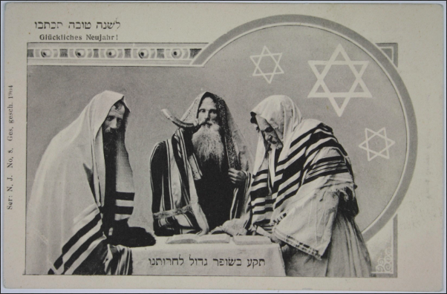

[Shana Tova, Germany, 1904](http://bit.ly/2LlMnul), National Library of Israel

* + - 1. Do you think that this is good illustration for a Shana Tova card?   
         Explain your answer.
      2. Compare the illustration to the shofar blowing service at your synagogue.   
         What is the same?   
         What is different?

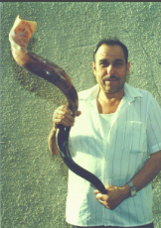

[Large Shofar, 1994](http://beta.nli.org.il/en/archives/NNL_ARCHIVE_AL004031635/NLI), National Library of Israel

1. Compared to the shofar depicted in the Shana Tova card above, what is special about this shofar?
2. The man holding the shofar is the craftsman who turned the ram’s horn into a shofar.

How do you think he feels as he holds the shofar up to be photographed?

1. What sound do you think this type of shofar makes?

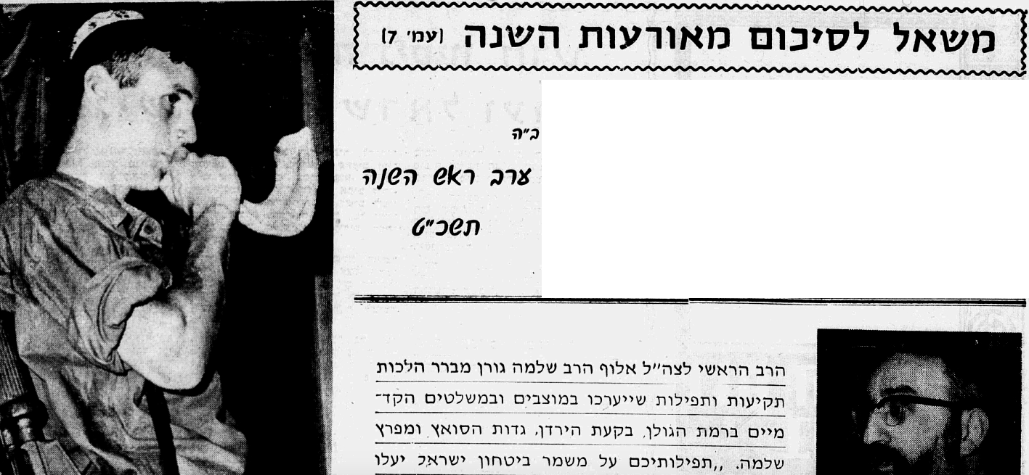

[Shofar Blowing in the IDF, 1968](http://www.jpress.nli.org.il/Olive/APA/NLI/SharedView.Article.aspx?href=HZH/1968/09/22&id=Ar01400&sk=F638D133), National Library of Israel

Partial translation of article:

***The Shofar Sounds of those Protecting the Security of Israel***

*The IDF Chief Rabbi, Major General Rabbi Shlomo Goren, clarifies religious laws regarding shofar blowing and prayers which will take place in outposts in the Golan Heights, the Jordan Valley, the Suez,and the Gulf of Solomon. “Your prayers, while guarding Israel, will rise up to the One who hears the teruah of His people Israel with mercy,”- said the Rabbi in his meeting with the soldiers who are on the front lines facing the enemy’s cannons.*

1. Why types of questions might soldiers on active duty have about fulfilling the mitzvah of shofar?
2. Why might a soldier on guard duty not be able to hear the shofar?
3. What comforting words does Rabbi Goren say about soldiers who are unable to hear the shofar on Rosh Hashanah?   
   Do you agree with Rabbi Goren?

**Wrapping it up!**

How do you feel when you hear the shofar?

Do the sounds of the shofar connect you to Rosh Hashanah or *teshuva* (repentance)?

What do you think of when you hear the shofar?

# 

**Tashlich – Casting Away One’s Sins**

**Introduction**

Tashlich, the ceremony of symbolically tossing one’s sins into a body of water, usually takes place on the first day of Rosh Hashanah, although it can be done until Hoshana Raba at the end of the festival of Sukkot. The ceremony consists of reciting prayers asking God to treat us with mercy. Some people throw pieces of bread representing their sins into the water; others forbid this practice seeing it as superstitious.

**Tashlich in Jewish Texts**

The following text is from the *Kitzur Shulhan Arukh*m which was composed in Uzhgorod (c.1844–c.1864) by Shlomo Ganzfried. The *Kitzur Shulhan Arukh* is a summary of the*Shulhan Arukh* of Joseph Karo and states what is permitted and what is forbidden without ambiguity, emphasizing the customs of the Jews of Hungary at that time.

Read the description of the tashlich ceremony and answer the questions following.

|  |  |
| --- | --- |
| [**Kitzur Shulchan Aruch 129:21**](https://www.sefaria.org/Kitzur_Shulchan_Aruch.129.21)  After the *Minchah* service, you should go to a river [or stream]...  There is another reason [for this custom]; for on this day we proclaim the kingship of the Holy One, blessed is He, over us, and it was the custom to anoint kings near a river bank as a sign that their kingdom may endure without end*.* It is preferable that [this river] should be outside the city limits and it should contain fish (as a reminder that we are compared to living fish who are caught in a net). We too, are caught in the net of death and judgment, and as a result [we will be inclined] to think more of repenting. Another reason is to symbolize that the evil eye shall have no power over us, just as [it has no power] over fish, and that we may be fruitful and multiply as the fish. Others say the reason is that fish have no eyelids, and their eyes are always open, the purpose is thus to arouse the compassion of the All-Seeing Eye above us.) But if there is no river that contains fish you may go to any river, or to a well, and you should recite the verses, *Mi keil kamocha* (Who, Almighty, is like you) etc. as it is written in the prayer books in the text of *tashlich*. You should then shake the ends of your clothes, symbolizing your resolve to cast away your sins, and to examine and scrutinize your ways, from now on; so that your clothes will be white and innocent of all sin. If the first day of Rosh Hashanah is on Shabbat you go [to the stream for *tashlich*] on the second day. | [**קיצור שלחן ערוך קכ״ט:כ״א**](https://www.sefaria.org/Kitzur_Shulchan_Aruch.129.21)  לְאַחַר תְּפִלַּת מִנְחָה, הוֹלְכִין אֶל הַנָּהָר...  וְעוֹד יֵשׁ טַעַם, מִפְּנֵי שֶׁאָנוּ מַמְלִיכִין הַיּוֹם אֶת הַקָּדוֹשׁ בָּרוּךְ הוּא עָלֵינוּ, וְהַדֶּרֶךְ הוּא לִמְשֹׁחַ אֶת הַמְּלָכִים אֵצֶל הַנָּהָר, לִרֶמֶז שֶׁתִּמָּשֵׁךְ מַלְכוּתָם) וְטוֹב שֶׁיִּהְיֶה מִחוּץ לָעִיר וְיֶשׁ בּוֹ דָּגִּים (לְזֵכֶר שֶׁאָנוּ מְשׁוּלִים כְּדָגִים חַיִּים הַלָּלוּ שֶׁנֶּאֱחָזִים בַּמְּצוֹדָה, כָּךְ אָנוּ נֶאֱחָזִים בִּמְצוּדַת הַמָּוֶת וְהַדִּין, וּמִתּוֹךְ כָּךְ נְהַרְהֵר יוֹתֵר בִּתְשׁוּבָה. עוֹד טַעַם, סִימָן שֶׁלֹּא תִשְׁלֹט בָּנוּ עַיִן רָעָה כְּמוֹ בְּדָגִים, וְנִפְרֶה וְנִרְבֶּה כְּדָגִים. וְיֵשׁ אוֹמְרִים, הַטַּעַם, כִּי לְדָגִים אֵין גְּבִינִים [עַפְעַפַּיִם] וְעֵינֵיהֶם תָּמִיד פְּתוּחוֹת, כְּדֵי לְהִתְעוֹרֵר עֵינָא פְּקִיחָא דִּלְעֵילָא) וְאִם אֵין שָׁם נָהָר שֶׁיֵּשׁ בּוֹ דָּגִּים, הוֹלְכִין לְנָהָר אַחֵר אוֹ לִבְאֵר, וְאוֹמְרִים הַפְּסוּקִים מִי אֵל כָּמוֹךָ וְכוּ' כַּכָּתוּב בַּסִּדּוּרִים בְּסֵדֶר תַּשְׁלִיךְ. וּמְנַעֲרִים שׁוּלֵי הַבְּגָדִים, וְהוּא לְרֶמֶז בְּעָלְמָא, לִתֵּן לֵב לְהַשְׁלִיךְ אֶת הַחֲטָאִים וּלְחַפֵּשׂ וְלַחֲקֹר דְּרָכָיו מֵהַיּוֹם וָהָלְאָה, שֶׁיִּהְיוּ בְּגָדָיו לְבָנִים וּנְקִיִּים מִכָּל חֵטְא. אִם חָל יוֹם רִאשׁוֹן בַּשַׁבָּת הוֹלְכִין בְּיוֹם שֵׁנִי (תקפג ובסידור). |

* + - 1. List at least three features of the tashlich ceremony, as described in the *Kitzur Shulhan Arukh*.
      2. The *Kitzur Shulhan Arukh* mentions several reasons for performing the ceremony in as described. Explain one of the reasons.

**Tashlich in Primary Sources**

Below are three primary sources from the Natial Library of Israel.

Answer the questions following each picture.

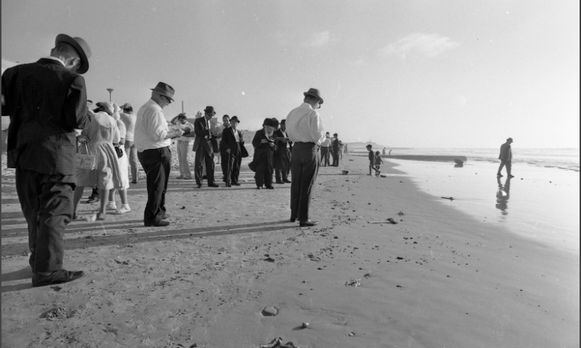

Tel Aviv, 1971, Dan Hadani Archive, National Library of Israel

1. Which elements of the description in the *Kitzur Shulhan Arukh* can you see in the photograph?

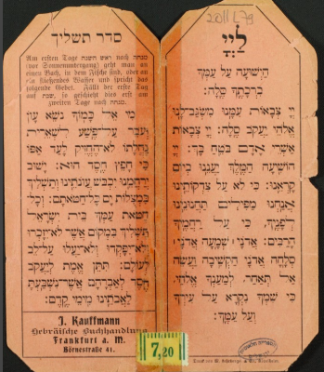

[Tashlich Ceremony, early 1900s](http://beta.nli.org.il/he/sheets/NNL_ALEPH003144941/NLI#$FL14649793), National Library of Israel

1. How do you think this booklet was used?
2. What languages are used in the booklet? Where do you think it was used?
3. The text from the *Kitzur Shulhan Arukh* mentions using a prayer book during the ceremony. Why might someone prefer using this booklet?

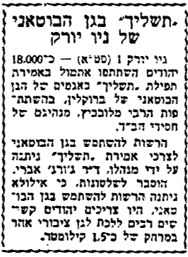

[Tashlich in the Brooklyn Botanic Gardens, *HaTzofeh* 1962](http://www.jpress.nli.org.il/Olive/APA/NLI/SharedView.Article.aspx?href=HZH/1962/10/02&id=Ar00117&sk=C19AF02D), Jpress – National Library of Israel

Translation:

*Tashlich in the New York Botanic Gardens*

*New York - Approximately 18,000 Jews participated yesterday in saying the Tashlich prayer at the lakes in the Brooklyn Botanic Gardens, with the participation of the Lubavitcher Rebbe, the leader of the chassidic Chabad movement.*

*Permission to use the Botanic Gardens for the purpose of saying “Tashlich” was given by its director, Dr. George Avery. It was explained to the authorities that if they were not given permission to use the Botanic Garden, it would be very difficult for the Jews to walk to another public park 1.5 kilometers away.*

1. How did the tashlich ceremony in the Botanic Gardens differ from the one pictured above on the beach in Tel Aviv?
2. What do the locations of all three resources tell you about the prevalence of tashlich?

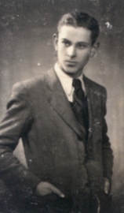

**Tashlich in Oral History**

Below are sections of two oral histories, recorded by Centropa, which describe the tashlich ceremony as practiced in Ukraine and Romania.

Read the descriptions and answer the concluding question below.

For Yom Kippur everyone strictly fasted. Before the Yom Kippur holiday, everyone left town and went to the river, threw in crumbs for the fish and prayed. It’s called *tashlich* (tashlich – an expression describing the symbolic casting away of sins. Devout Jews gather by a river and recite prescribed passages that speak of God’s willingness to forgive a repentant sinner). Because there were a lot of Jews living in the town, they didn’t go to the river all together, but in groups. In every group there would be someone who would lead prayers.

--Nikolai Mesko Salamonovic , Ukraine

On the second day of Rosh Hashanah you went to a course of water – that was the custom, it was something traditional – and you shook your pockets clean, you threw in the water everything you had in your pockets – meaning you cast away all the sins you committed during the year, you throw them into the water. People go Tashlich – meaning we are going there to shake our sins. In the morning, after the religious service was over at the synagogue, the Jews of Dorohoi went to do the taslich by the hundreds. We went at the town outskirts to the Jijia river, to a place they call Trestienii Bridge, and everyone shook their pockets clean there."

--Simon Meer, Romania

1. What did you learn about tashlich from the oral histories?
2. Which resource is most similar to the descriptions of tashlich in the oral histories?  
   What are the similarities?

**Wrapping it up!**

When tashlich was first developed, some rabbis objected to the ceremony. They were afraid that instead of being introspective and repentant, people would simply throw bread into the water to rid themselves of their sins.

What do all of the resources and oral histories tell you about who won that argument?