**The Effect of Airbnb Announcements on its Competitors’ Stock Prices**

# Abstract

The sharing economy model that was developed in the last decade has a major effect on different aspect of life. The purpose of this research is to test the effect of a sharing economy product on its competitors. Specifically, this study used the event study approach to examine how Airbnb announcements affected hotel stock prices. The data were collected from the Airbnb site (announcements), and the stock prices were collected from Yahoofinance.com and Investing.com. A total of 180 announcements and 1114 related stocks were examined. The results show that general Airbnb announcements have a negative effect on hotel stock prices. In addition, the effect of the announcement is stronger closer to the announcement date.

Keywords

Event study approach; Airbnb; Hotel companies; Market efficiency; Announcements

Funding: not applicable

Conflict of interests: not applicable

Availability of data and material: https://figshare.com/articles/dataset/Airbnb/14308835

**JEL Classifications:** G10, G14, G30

# Introduction

The technological progress and socioeconomic conditions has led to the development of a new business model called the sharing economy (Belk, 2014; Botsman & Rogers, 2010). This model gives the customers a potential way to save money and offer ways of earning money to those (Lamberton & Rose, 2012). The most significant example in the tourism industry is Airbnb (Gansky, 2010; Sundararajan, 2013). Airbnb uses the digital marketplaces to connect people with vacant accommodations and people who look for temporary accommodations (spesificaly tourists) (Botsman & Rogers, 2011; Zervas, Proserpio, & Byers, 2017). The company was founded in 2008 by Brian Chesky and Joe Gebbia and offers 5.6 million listings in 100,000 cities and 220 countries and in 2020 earned $3.4 billion in revenues (Airbnb, n.d.).

There are numerous researches on the effect of Airbnb taking different perspectives, such as hotel company revenues, occupancy and prices (Pairolero, 2016; Zervas et al., 2017; Guttentag and Smith, 2017; Neeser, 2015) or the employment as it has an affect the real estate market, rental prices and local communities.

Because Airbnb offers a wider variety of accommodations and considerably lower prices, it has the potential to generate an increase in the number of tourists and more economic activities. In addition, tourists that use Airbnb spend twice as much on their vacations as conventional tourists. On the other hand, Airbnb generates competition with the hospitality industry. The combined effects of Airbnb (expanded economic activities and new sources of income for locals on the one hand and lowered hospitality income, disruptions for the local community and negative social effects on the other) have motivated governments and local municipalities to give serious consideration to the issue of Airbnb. In order to make educated decisions, these government bodies need a better understanding of the effects of Airbnb.

In testing how Airbnb affects the market value of hotel companies around the world, the current study adopts an uncommon perspective. It seeks to test how a sharing economy product affects its competitors by examining the effect of official Airbnb announcements during the period 2017 through 2019. The research sample includes 180 Airbnb announcements and 1114 related stocks . Each announcement is relevant to several hotel companies around the world. The practical purpose of this research is to provide hotel company owners and government and municipal agencies an updated picture of how Airbnb announcements affect the stock market.

The following section include the literature review, section 3 includes materials and methods, section 4 is the results and section 5 is the conclusion.

# Literature Review

A great deal of research has focused on different aspects of the effect of Airbnb, and many papers have been written on the use of the event study approach. Yet the current paper is one of the first to use the event study approach to measure the effect of Airbnb. The literature review covers a variety of research in each of these areas.

## 2.1 The Effects of Airbnb

Due to the growing importance of the sharing economy in general and of Airbnb in particular, a great deal of research has focused on the economic effects of accommodation services based on the sharing economy.

Pairolero (2016) and Zervas et al. (2017) focused on the impact of Airbnb on incumbent firms. They assumed that because Airbnb served over 50 million guests since it was founded in 2008 and exhibited market capitalization eclipsing $30 billion, Airbnb would have a measurable and quantifiable impact on hotel revenues in selected areas. They estimated that the entry of Airbnb into the Texas market has had a quantifiable negative impact on local hotel room revenues. The substitution patterns they found strongly suggest that Airbnb provides a viable, but imperfect, alternative for certain traditional types of overnight accommodation. The fact that Airbnb is a substitute for hotel accommodation was supported by Guttentag and Smith (2017), who found that nearly two-thirds of Airbnb users used this platform as a hotel substitute.

Neeser, Peitz, and Stuhler (2015) measured the impact of Airbnb on the hotel industry in Norway, Finland and Sweden. They found that on average Airbnb did not significantly affect hotel revenues per available room, but its presence did contribute to reducing the average price of a room. They also found that Airbnb was more appealing to international tourists than to locals. On the other hand, Choi, Jung, Ryu, Kim, and Yoon (2015) did not find Airbnb listings to be related to hotel revenues. However, the data they used were up to 2013, a period during which Airbnb was less active in Korea.

## 2.3 Event Studies and the Hospitality Industry

Many studies applied the event studies approach to tests differential effects on hotel stocks. For instance, Nicolau (2002) test the effect of new hotel openings on share prices using event studies. The results indicate geographic is important, specifically Mediterranean countries, urban Europe and Latin America have excess returns over the base alternative—Asia. Nicolau (2020) tested the effect quality certification on the market value, finding that quality certificates had a positive effect on the stock value. The event study approached was used by Bloom and Jackson (2016) to test the effect of announcements regarding changes in the Chief Executive Officer (CEO) of hospitality companies on their stock values. The result indicated there is a significant negative abnormal returns during the periods before and after the announcement of a CEO transition.

Focusing on the effect of Airbnb announcement on hotel stock prices Yan (2017) used articles from April 2014 through December 2016 and weekly data for seven hotel company stocks (Hilton, La Quinta, Choice Hotel International, Wyndham Hotel Corporation, Hyatt Hotel Corporation and Intercontinental Hotel Group). Yan built an index of the hotel stocks and compared it to the performance of S&P 500. The research indicated that when an article about Airbnb was published the stock prices decline, but the tone of the message and the number of articles had no effect. Taking a different angle and focusing on the restaurant industry Kim et al (2020) used the event study methodology to test the effect of firm characteristics on the firms' value during epidemic diseases outbreaks.

The uniqueness of this is the uses of event study approach to test the effect of Airbnb announcements on the prices of hotel company stocks and the hypothesis is that Airbnb announcements has a negative effect on hotels stock prices.

# Materials and Methods

## 3.1 Data

The data collected covered the period from 2017 until 2019 and included all the events posted on Airbnb website. The stock prices were collected from Yahoofinance.com and Investing.com.This research assumes that Airbnb announcements effect the hospitality industry in the areas it exists. Consequently, trade data on the hotel companies in the area were collected for each announcement on the Airbnb site. In total there were 180 announcements and 1114 hotel stocks.

he total number of announcements increased over the years. In 2017 there was an average of 1.5 announcements per month. In 2018 this number increased to 10, and in 2019 it reached 14 announcements per month.

## ***3.2*** Methodology

The current study tests the way information available through official channels influence the financial markets, and if it is possible for investors to achieve abnormal returns. Especially, the study examines the efficiency of the stock market’s response to announcements on Airbnb. It is assumed that Airbnb announcements influence the tourism industry in general and the hospitality industry in particular. So, trade data for all the hotel companies in the area were collected for each announcement from the Airbnb site.

In this paper the event study methodology, also known as residual analysis was used to effect of Airbnb announcements on stock prices. This method use information on stock returns before an event (estimation window) to examine the stock returns around the event (event window). For each announcement, the first day of trade was defined as the event day. In the current study, the estimation window began 331 days before the announcement and ended 31 days before the day of the announcement (day of the event). The event window is defined as the period starting 30 days before the event and ending 30 days after the event, in accordance with the Market Model (MM).

# Results

In this section we use event studies to test the influence of announcements from the Airbnb site on the stock market. The test is based on 1114 events following 180 announcements on the Airbnb site.

Exhibits 1 and exhibits 2 describe the CAAR-30,+30 for the 61 days surrounding the announcement, beginning on day -30 before the announcement and ending on day 30 after the announcement.

|  |  |  |  |  |  |
| --- | --- | --- | --- | --- | --- |
| Exhibits 1: The influence of Airbnb announcements on the hotel stock prices | | | | | |
| The following exhibits describes the effect of Airbnb announcements on abnormal return for the entire sample. Cumulative average abnormal return (CAAR), median cumulative abnormal return (CAR), percentage of positive abnormal returns, t-statistics and number of observations are reported for the event windows | | | | | |
|
|  | (-30, -2) | (-1) | (0) | (+1,+2 ) | (+3, +30) |
|  |  |  |  |  |  |
| CAAR | 0.24% | -0.11%* | -0.13%** | -0.18%** | -0.05% |
| Median CAR | 0.13% | -0.09% | -0.10% | -0.16% | -0.21% |
| Percent Positive | 51.55% | 48.97% | 49.89% | 45.17% | 44.22% |
| t-statistics | 0.68 | -1.71 | -2.02 | -1.94 | -0.16 |
| N | 1114 | 1114 | 1114 | 1114 | 1114 |

*** 99% significance level; ** 95% significance level; * 90% significance level

Exhibits 2: The influence of Airbnb announcements on the hotel stock prices for the entire sample

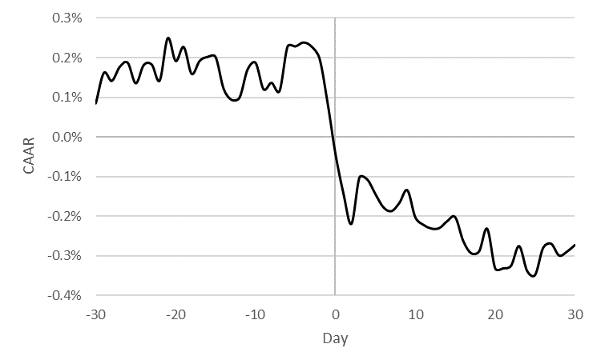

The dataset shows that during the first 29 days, the CAAR-30,-2 does not differ significantly from zero. On the following day prior to the Airbnb announcement, AAR-1 is significantly lower, by ‑0.11% (t = -1.71). During this period, the median AR-1 equaled -0.09%, and 48.97% of the companies had a positive AR. This result shows that investors can achieve abnormal returns using internal information from Airbnb announcements.Abnormal returns also continue to decline on the day of the event, with AAR0 decreasing on this day to -0.13% (t = -2.02), where the median AR0 equaled -0.1% and 49.89% of the companies had a positive AR. This indicates that the announcements generally brings new informative information to the investors.

During the next two days (+1,+2) following the event, the CAAR+1,+2 continues to decrease by -0.18% (t = -1.94). In the following interval (+ 3, + 30), the publication of announcements did not show a statistically significant impact on the stocks return. This indicate that investors may establish an average profit strategy by shorting the stocks return at the time of publication and closing the position at the end of the two days following publication of the announcement. The results accord with a previous study (Yan 2017) that found when an article about Airbnb was published the hotel stock prices declined

In conclusion, it can be assumed that announcements related to AIRBNB announcements affect the stocks return during four days, beginning one day prior the publication of the announcement and lasting up to two days following the publication. The decrease in the CAAR for hotel companies led to a decrease in the market value of the firms, potentially affecting company cash flow and lowering the feasibility that potential investors will invest in the companies.

Exhibits 3 show the percentage of daily change in CAAR-3,+2 from three days before the announcement (day -3) to two days after the announcement (day 2).

Exhibits 3: Percentage of daily change in CAAR

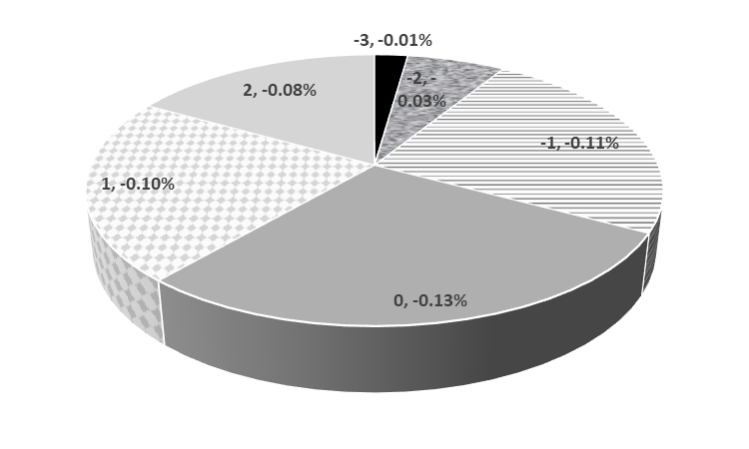

Exhibits 3 implies that the decreased abnormal return is effective three days prior to the event, with a -0.01% decrease in AAR. Such a decrease may be justified by the fact that Airbnb announcement-related information reaches the control core of website owners, who may invest and earn abnormal returns even prior to Airbnb’s publication of the announcement on the sites. As publication day approaches, more investors who are closely associated with the website are exposed to the information, leading to a decreased abnormal return. Two days prior to the event, AAR decreases by -0.03%, and on the day preceding the event, AAR further decreases by -0.11%, for a total decrease of -0.15% during the interval preceding the event. On the day Airbnb publicizes the announcement on the website and reveals the information to all investors, AAR further decrease by -0.13%. Even on the two days following publication, AAR further decreases by -0.1% on the first day following the event and by -0.08% on the second day following the event. Therefore, investors can usually establish a strategy for earning abnormal profits from an Airbnb announcement event. For example, for general announcements investors can react by short selling hotel company stocks on the day of the announcement and close their position on the second day after the announcement, yielding a profit of 0.23% after deducting transaction costs.

# 

# Conclusion

Technological development and the changing socioeconomic conditions in the world have led to the development of a new business model known as the “sharing economy” Airbnb is a prime example of th sharing economy and strongly effects the hospitality industry. This research apply the event study method to test the influence of Airbnb announcements on hotel stock prices. Data were collected the Airbnb site (announcements), from Yahoofinance.com and Investing.com. The number of announcements included was 180. Each announcement influenced a different number of stocks. The effect of the announcement on the hotel stock returns was tested.

Examination of the effect of general Airbnb announcements on hotel stock prices indicated that during the first 29 days, CAAR does not significantly differ from zero. On the following day prior to the Airbnb announcement, CAAR-1 is significantly lower. This finding shows that investors can achieve abnormal returns using internal information in Airbnb announcements. In addition, the effect is stronger when the date of the announcements is closer.

In addition, the decrease in the CAAR of hotel companies led to a decrease in the firms’ market value, potentially affecting company cash flow and lowering the feasibility that potential investors will invest in these companies. These findings are in line with those of Nicolau (2002) and Nicolau and Sellers (2010), who found that news announcements have a significant effect on the stock market.

This included only announcements from the Airbnb site. This is a reliable source of information, but it limits the size and objectivity of the sample. In the future research should focus on information from other sources regarding Airbnb. Moreover it is important to see how Airbnb affect the stock market in the ear after COVID-19.

# References

Airbnb (n.d). *Fast facts.* Retrieved fromhttps://press.Airbnb.com/fast-facts

Belk, R. (2014). You are what you can access: Sharing and collaborative consumption online. *Journal of Business. Research., 67*(8), 1595–1600.

Bloom, B. A., & Jackson, L. A. (2016). Abnormal stock returns and volume activity surrounding lodging firms' CEO transition announcements. *Tourism Economics*, *22*(1), 141-161.‏

Botsman, R., & Rogers, R. (2010). *What’s Mine is Yours: The Rise of Collaborative Consumption.* New York, NY:Harper Collins.

Buso, 2019 <https://www.calcalist.co.il/real_estate/articles/0,7340,L-3761967,00.html>

Choi, K. H., Jung, J., Ryu, S. Y., Kim, S. D., & Yoon, S. M. (2015). The relationship between Airbnb and the hotel revenue: in the case of Korea. *Indian Journal of Science and Technology*, *8*(26), 1-8.‏

Fang, B., Ye, Q., Law, R. (2016). Effect of sharing economy on tourism industry employment. *Annals of Tourism Research, 57,* 264–267.

Gansky, L. (2010). *The Mesh: Why the Future of Business is Sharing.* New York, NY: Portfolio Penguin.

Guttentag, D. A., & Smith, S. L. (2017). Assessing Airbnb as a disruptive innovation relative to hotels: Substitution and comparative performance expectations. *International Journal of Hospitality Management*, *64*, 1-10.‏

Kim, J., Kim, J., Lee, S. K., & Tang, L. R. (2020). Effects of epidemic disease outbreaks on financial performance of restaurants: Event study method approach. Journal of Hospitality and Tourism Management, 43, 32-41.‏

Lamberton, C. P., & Rose, R. L. (2012). When is ours better than mine? A framework for understanding and altering participation in commercial sharing systems. *Journal of. Marketing*, *76*(4), 109–125.

Neeser, D., Peitz, M., & Stuhler, J. (2015). Does Airbnb hurt hotel business: Evidence from the Nordic countries. *Universidad Carlos III de Madrid*, 1-26.‏

Nguyen, T. H., Shirai, K., & Velcin, J. (2015). Sentiment analysis on social media for stock movement prediction. *Expert Systems with Applications*, *42*(24), 9603-9611.‏

Nicolau, J. L. (2002). Assessing new hotel openings through an event study. *Tourism Management*, *23*(1), 47-54.‏

Nicolau, J. L., & Sellers, R. (2010). The quality of quality awards: diminishing information asymmetries in a hotel chain. *Journal of Business Research*, *63*(8), 832-839.‏

Pairolero, N. (2016). Assessing the effect of Airbnb on the Washington DC housing market. Retrieved from http://dx.doi.org/10.2139/ssrn.2734109

‏

Sundararajan, A. (2013, January). From Zipcar to the sharing economy. *Harvard Business Review.* Retrieved from <https://hbr.org/2013/01/from-zipcar-to-the-sharing-eco/>

Yan, S. G. (2017). *Airbnb regulations and hotel stock prices* (thesis). Cornell University, School of Hotel Administration site.

Zervas, G., Proserpio, D., & Byers, J. (2017). The rise of the sharing economy: Estimating the impact of Airbnb on the hotel industry. *Journal of Marketing Research*, *54*(5), 687-705.‏