1. **Fiber small-deformation analysis**

In this section, we analyze analytically the first (planar) deformation stages of the fiber that is constrained by the flexible cylinder. To this end, we conceptually replace the cylinder with an equivalent spring that applies on the fiber the same force as the cylinder, see Fig. 20. For simplicity, and in accordance with the experimental results, it is assumed that the deflection of the fiber is small, , such that the behavior of the fiber is governed by the standard linear equations of bending. We denote by  as the initial fiber length, as the fiber diameter, and  as the inner radius of the flexible cylinder and the actual (current) distance between the location of the spring and the original location of the fiber. Hence, the original gap between the fiber and the constraining spring is , shown in Fig. 20. The fiber is clamped at one end  and supported by a moving clamp (horizontal slider) at the other . The fiber is subjected to an external compressive force  that results in a horizontal displacement, , of the right end. After buckling the fiber deforms and makes contact with the spring at the midspan  (see Fig. 20). Further increase of the external force (or alternatively if ) results in larger deflection that is governed by the resisting force of the spring. We note that a similar analysis was performed in [48-49] where the behavior of a slender beam constrained by a linear springy wall with linear behavior was studied theoretically and experimentally. Here, on the other hand, the force-displacement relation of the constraining spring is cubic . Thus, we follow the analysis of [48] and extend it to account for the cubic behavior of the spring.

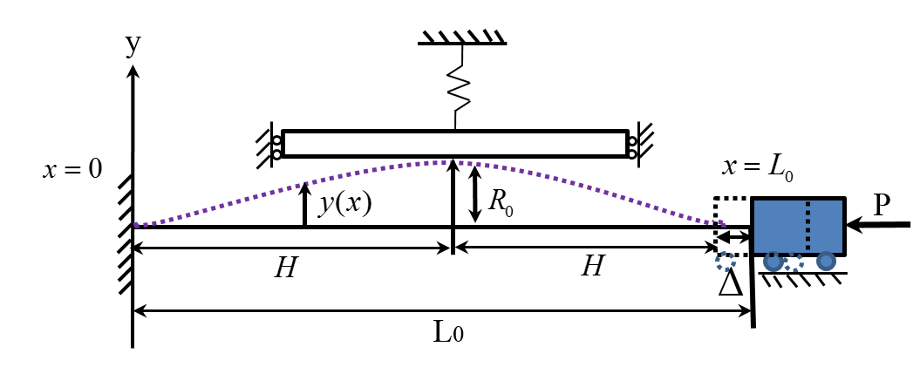

**Fig. 20:** A clamped fiber subjected to an axial compressive force  and constrained between flexible walls.

Treating the fiber as a thin line, , its vertical displacement at the contact point becomes:



In order to enable non-dimensional analysis, all lengths are normalized by  and forces by . Accordingly, the deflection of the fiber is governed by the (non-dimensional) equation:



where boundary conditions depend on contact conditions, as discussed in what follows. In addition, the horizontal displacement,, is found by



Because of symmetry, only the left half of the fiber is considered between  and .

**2.4.3.1 Pre-buckling of a clamped-clamped fiber analysis**

The solution of the buckling problem for a clamped-clamped segment with no contact has been well established and is presented here for completeness. Three stages of the fiber behavior are considered, namely: before contact, during the fiber’s buckling, and due to the fiber-cylinder contact.

At the first stage, the fiber experiences a horizontal displacement, but remains horizontal:



During the second stage, the force  reaches a critical buckling level, , so the buckling of the fiber instantaneously occurs, so the fiber “jumps” to the contact with a non-deformed cylinder at the point , where  was defined earlier (see Fig. 20). The horizontal displacement  becomes:



During the third stage a contact between the cylinder and the fiber occurs. A linear analysis of this process is presented in the next section.

**2.4.3.2 Point contact**

Once the fiber makes contact with the spring, the resistance of the spring to additional deflection needs to be taken into account. Thus, boundary conditions are:



Here  is the spring force , i.e.



Solving Eq. with boundary conditions (48), using Eq. lead to relation between .

From Eq. , the solution for  takes the form



By substituting Eq.  into Eq. , all unknown coefficients are defined:



The equation of the elastic line is expressed as:



Note that , the force in the spring, is unknown. It can be relation of the spring, namely  :



Therefore, spring force  in Eq.,

for a linear spring, when :



and for a non-linear spring, when :



Using definition of the displacement by Eq.  and substituting Eq.  and Eq. for linear spring and Eq. (54) for non-linear spring, the normalized horizontal displacement becomes:



Fig.  shows a good agreement between the experimental results and the numerical calculation for a small-deformation analysis.

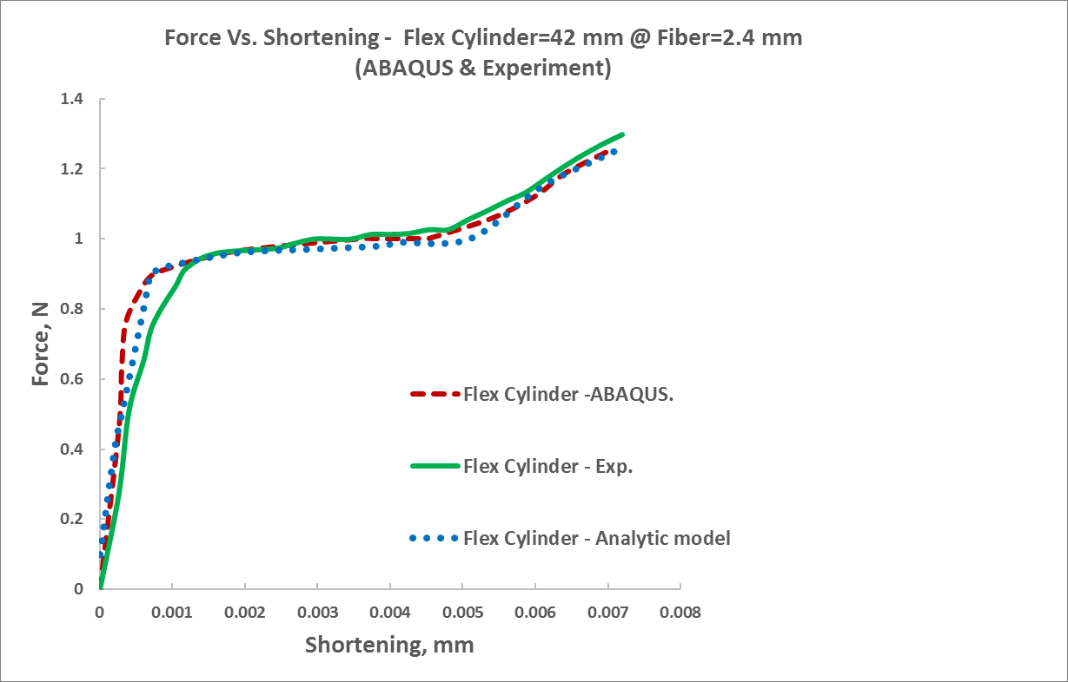





**Fig. 21:** The behavior predicted by small-deformation theory for the symmetric case. Measured vertical force versus end shortening for flexible cylinder: , and fiber:. The experimental results are compared to FE simulations results (red dashed curve) and analytical model (blue curve).

Note, that the fiber remains in the point contact configuration up to the moment when the internal bending moments at the fiber’s edges vanished. If the force  and the displacementare further increased, the onset of transition to line contact configuration occurs.