Solar urban districts: A holistic generative cross-climatic method for solar-driven environmental design of dense urban fabrics.

Part 3 - Detailed Description of the Research Program
This project offers a novel and robust approach for solar driven urban design, one which aligns with the history of solar architecture, addresses the gaps in previous solar envelope methods, and answers to the current needs by utilizing cutting edge computational methods for multi-objective environmental analysis and optimization.
- Scientific background
  - Solar design
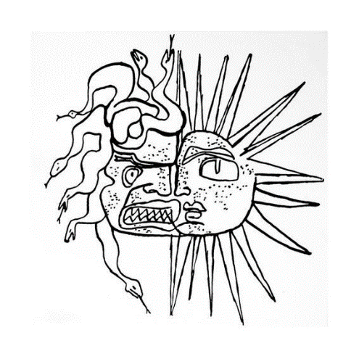Designing the built environment based on the solar position can be traced back from ancient history to the pre-air conditioning era. The sun is the main driving force for both thermal and visual comfort, and thus solar exposure determines the energy demand levels needed to deliver the required level of comfort according to a given setting. Until relatively recently, passive design was the main strategy available to effectively harness (expose to) or avoid (shade from) the sun’s energy to improve the environmental performance of buildings and cities. Arguably nowadays, although air conditioning and artificial lighting technologies have evolved immensely, passive strategies remain the most effective method to ensure both energy efficiency and thermal and visual comfort, while being cost effective (the cheapest energy is still the one saved). When solar energy production, which emerged as a key factor, is added to the equation, solar availability is even more important to consider and at the same time trickier to evaluate, as it is both part of the problem and the solution, especially in dense urban contexts [1] - i.e., the problematic summer excess heat or glare vs. the desirable winter heating, energy generation and daylight. The ‘Mask of Medusa’ by Le Corbusier (Fig. 1) reflects this duality well, and the double impact of solar radiation has become an important departure point for several studies which explore the tradeoffs between the pros and cons of solar performance in different temporal and spatial configurations and in different contexts.
In recent decades, with the rise of global urbanization rates to more than 55% [2] and the recognition of cities as the main energy consumers and carbon emitters [3], we are witnessing a shift of focus in environmental design research from the single building to the district and the city. Another important trend is the shift from the limited focus on the evaluation of energy efficiency to the balance between energy supply and demand, towards zero energy buildings -ZEBs, and recently even further towards regenerative design - by which buildings and districts are designed to enhance the environmental quality levels in and around them rather than to just minimize the use of resources [4].
Fig. 1: The contrasting impact of the
sun, Mask of Medusa, Le Corbusier
(1939)

  - Methods and tools for solar urban design
In the context of the tradeoff between high density and environmental performance, both trends, towards ZEBs and towards regenerative design, have played an important role in the state of the art on solar driven urban design. The studies of Knowles [5,6] are among the earliest on methods and tools to explore solar exposure at the urban scale. During the mid-70s Knowles introduced the Solar Envelope (SE) concept - a spatial boundary which accounts for the solar access of the built environment for a given time frame [5]. In other words, the SE method can be regarded as a generative concept by which the largest theoretical spatial boundaries are defined by the solar angles that ensure no over-shadowing of the surroundings for a specific time frame, e.g., the winter solstice in which the sun is at its lowest position. Knowles developed this concept further by adding the Shadow Fences which can maximize this volume by defining the vertical height of an imaginary plane above which solar exposure is desirable in neighboring buildings [6] (Fig. 2). Capeluto et al. [7,8] developed the computational tool SustArc which calculates the Solar Volume (Fig. 3) - a combination of both the Solar Rights Envelope - the maximal height which will not compromise solar rights of neighboring buildings, as well as the Solar Collection Envelope - the minimum height which will allow solar rights of the building under consideration. Stasinopoulos [9] explored the spatial impact of different criteria (plot size and proportion, orientation, ground slope etc.) on solar envelope designs using the Solar Volume Coefficient, i.e., the volume of a solar envelope per plot area. Among other findings he concluded that solar envelope methods generate lower densities than the urban regulations allow, which in turn can be compensated by locally based on other considerations, i.e., daylight, ventilation, and views, and generate so called ‘solar cityscapes.
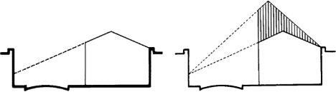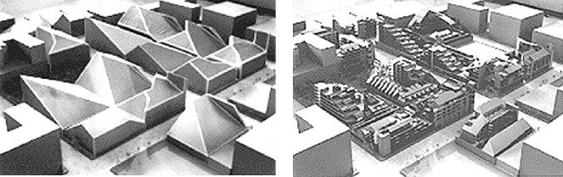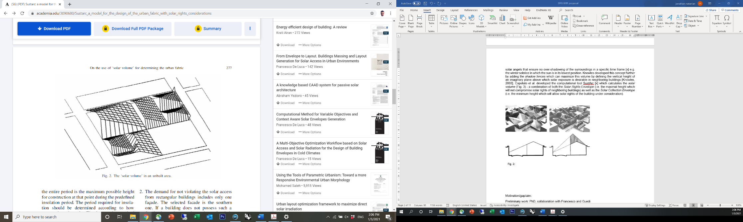
Fig. 3: The ‘Solar Volume’ representing solar exposure considerations for both existing and new buildings [7]
Fig. 2: The Solar Envelope concept applied on a typical housing project (top) and space and time constraints for solar envelopes (bottom) [6]

The Residential Solar Block (RSB) concept, introduced by Okeil [10], focuses on an urban block typology which offers a combination of both winter exposure and summer shading, in an attempt to offer a harmonized approach in which the advantages of the urban block are coupled with the energy performance advantages of the linear urban from (Fig. 4). Building on that concept, Vartholomaios later presented the RSB Envelope [11], in which, through a sequence of computational steps, the solar envelope and solar fan calculations are brought together to define solar envelopes for urban blocks in which the spatial inputs for the solar calculations are based on the outputs of energy simulations (Fig. 5). These methods can be regarded as ‘static’, i.e., the solar envelope is calculated for each building separately according to the spatial and sometimes temporal input data and are thus restricted in their ability to explore a larger number of design variables.

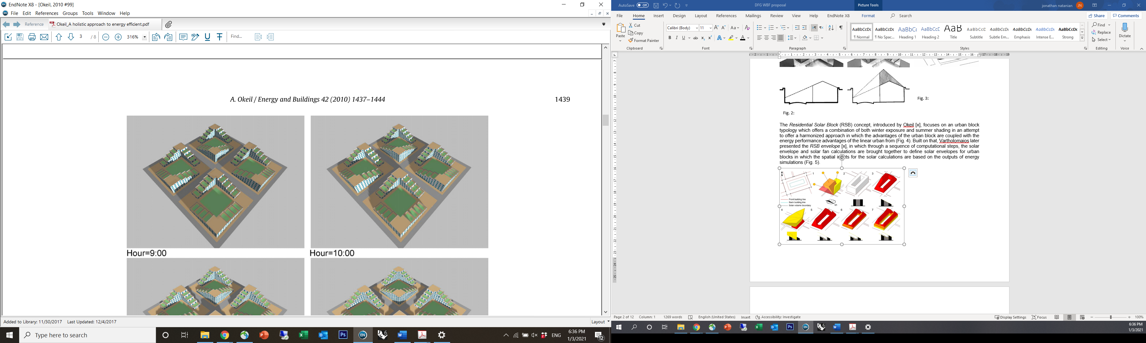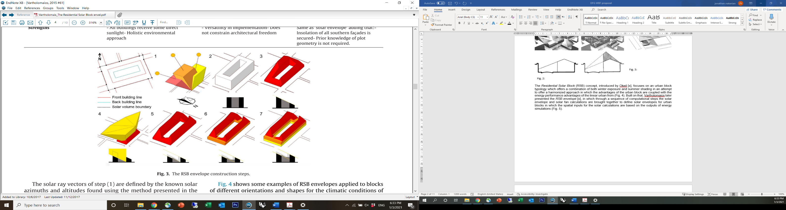
Fig. 5: The Residential Solar Block (RSB) envelope concept [11]
Fig. 4: Residential Solar Block (RSB) example optimized for latitude 48.00 [10]

  - Advanced methods and parametric workflows
Solar driven evaluation workflows have advanced due to recent advancements in digital workflows and parametric environmental assessment tools [12,13]. As an extension of the previous studies by Capeluto on the Solar Envelope, Capeluto and Plotnikov [14] presented the Parametric Solar Envelope concept, by which the shape of the solar envelope is simultaneously and seamlessly generated with every modification of weather data, geometry, or programmatic requirements. De Luca presented several studies conducted on solar envelopes using the Grasshopper parametric environment. In his studies, by capitalizing on the advanced capabilities of the parametric modeling environment, solar envelopes are generated using customable daylight requirements [15,16]. In a later study De Luca at el. presented the Reverse Solar Envelope Method [17,18], in which they used advanced subtractive methods combined with reverse raytracing to ‘curve’ out the built form in dense urban contexts to ensure daylight potential of the surrounding environment (Fig. 6). A recent development of this method includes the ability to generate a subtractive solar envelope with the support of geometric and radiometric properties stored in point cloud data [19]. These recent studies correlate well with recent trends in practice (Fig. 7) in which pixelated forms, driven among others, by climatic considerations, are becoming more and more frequently used in contrast to rigid or pure forms which reduces flexibility and/or diversity. The shift from the building to the urban scale is another notable trend in advanced solar design studies, where solar availability at the pedestrian level is considered together with the solar availability on the building façade [20], the interdependencies between urban typology and solar potential are explored [21,22], and urban blocks are generated based on solar potential and energy systems using optimization methods [23].
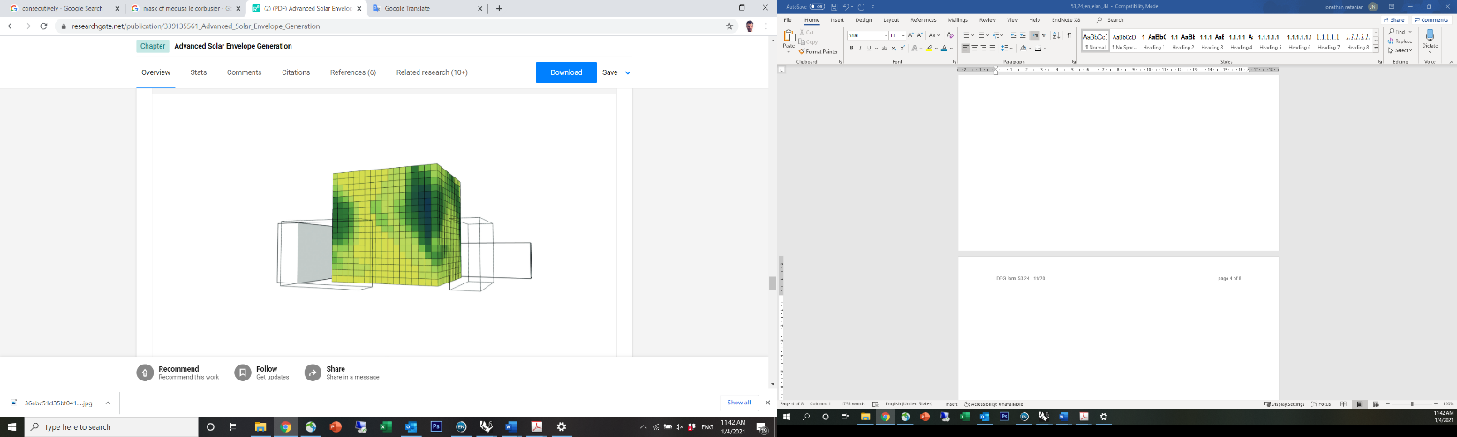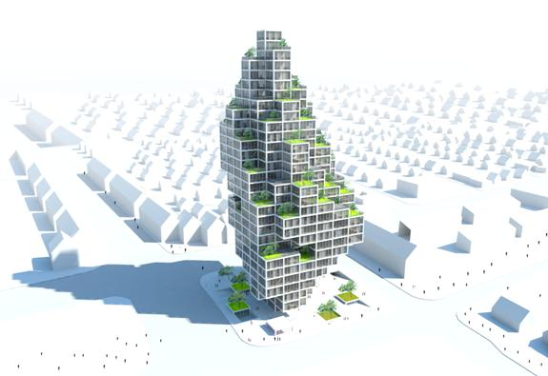
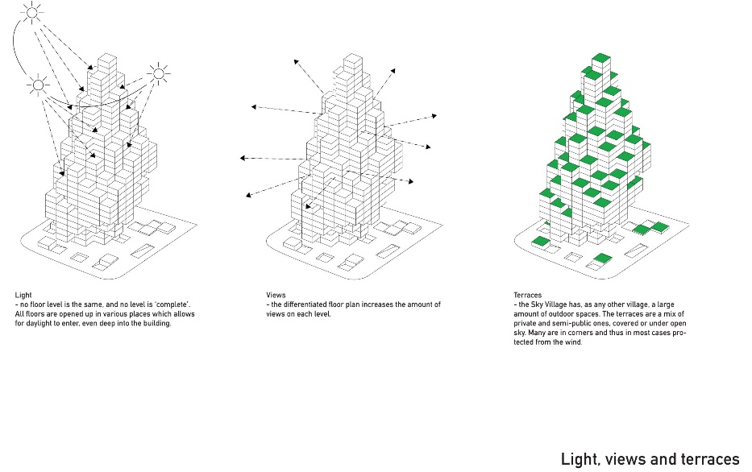

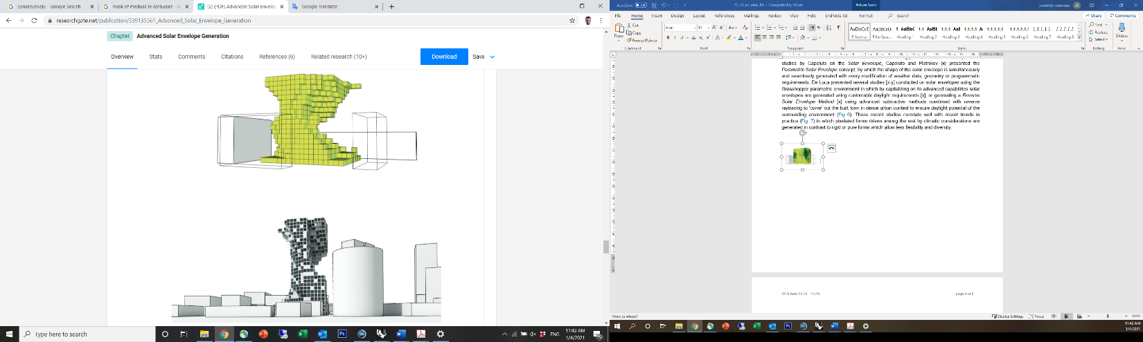

← Fig. 6: The Reverse Solar Envelope method [17]

↑ Fig. 7: MVRDV’s ‘Sky Village’ design proposal for Copenhagen

  - Preliminary studies by the PI on urban environmental performance
My recent studies were dedicated to exploring holistic urban scale environmental performance - beyond energy considerations - and asked whether we can be both dense and performative in hot climates by employing a methodology to balance urban form, energy supply and demand, and environmental quality.
To answer this question, we have established an automated Grasshopper-based workflow, which allows evaluating the environmental impact of a wide range of building and urban scale design parameters, including typology and density [24, 25]. Fig .8 shows the potential of this methodology was explored in the context of a case study in Tel Aviv [26], where I used my workflow to test the environmental performance tradeoffs of four different typological layouts designed by local architects. The results provided visual indications which helped the architects recalibrate their forms based on environmental performance considerations. More recent developments of this workflow capitalize on the adaptive nature of Grasshopper to include several other KPIs (e.g. contact with nature (biophilia) [27], climatic resilience and outdoor comfort [4]), as well as to couple different tools (e.g. for streaming microclimatic evaluation data as an input for energy evaluation [28] or to scale up outdoor comfort evaluation to annual temporal cycles [29].
The latest addition to my workflow was done in collaboration with Prof. Wortmann and focused on the integration of an Architectural Design Optimization (AOD) module, to highlight optimal design solutions based on environmental performance objectives. Our first findings were presented at the SimAUD 2020 conference, in which we introduced a benchmark for zero energy urban blocks’ multi-objective optimization in the context of Shanghai [30]. Our latest paper in Energy and Buildings [31] introduces simplified solar and geometrical-based metrics for energy performance which are used for multi-objective optimization (MOO) study of an urban district in Tel Aviv (Fig. 9). The results of running the optimization using these different metrics (Fig. 10), indicate that these metrics can serve as effective energy performance indicators for optimization analyses to inform early-stage morphological decision making. The dynamic nature of the computational evaluation approach I have developed allows it to expand and adapt to different scales and constraints. Thus, its integration into the SE approach which is currently very limited in its performance evaluation capacity has a high potential benefit.
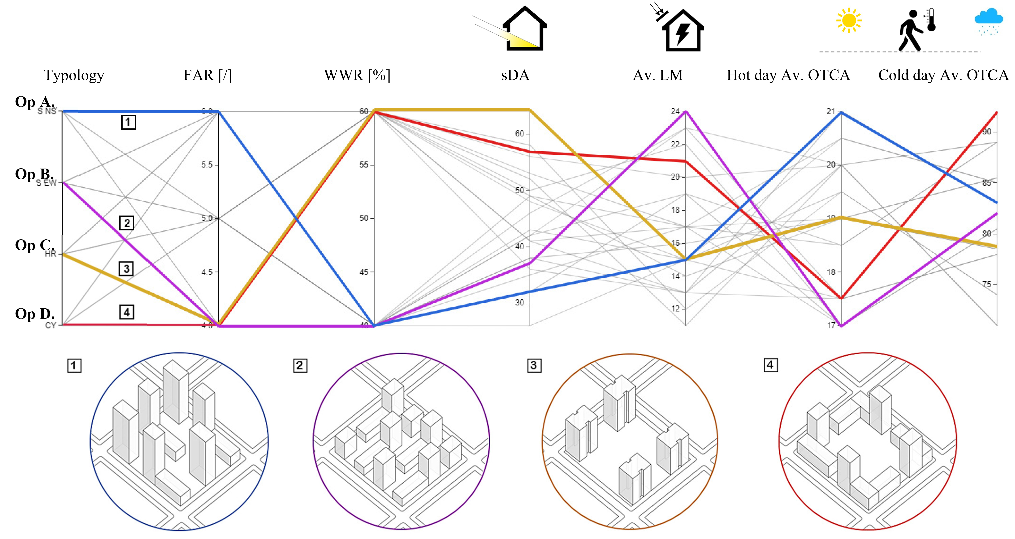

Fig. 8: Visual representation of energy, daylight, and outdoor comfort simulation results for 24 iterations, including highlight of four optimization scenarios and their corresponding input parameters.[26]

  - Scientific gaps
Despite these recent advancements powered by the integration of digital tools into SE workflows, the application of the SE concept still has several limitations: (1) the outputs of current SE methods include a theoretical spatial boundary, rather than an actual building mass which is more useful for designers; (2) the SE boundary gives a very rough estimation of the tradeoff between the desirable and undesirable impacts of solar radiation for a given boundary;

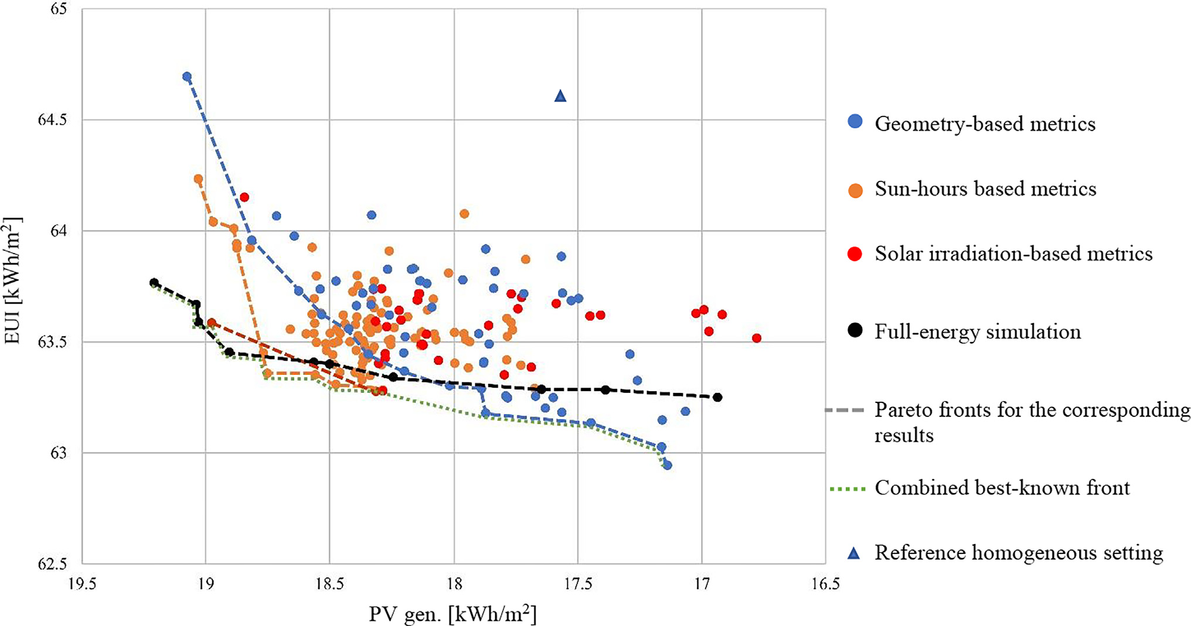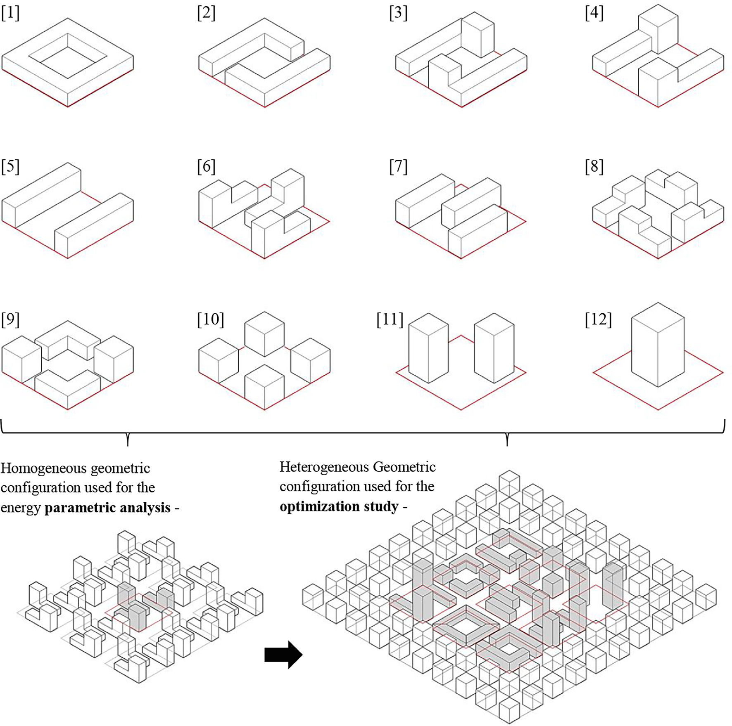
Geometry-based metrics

Sun-hours based metrics

Solar irradiation-based metrics

Full-energy simulation

Pareto fronts for the corresponding results

Combined best-known front

Reference homogeneous setting

← Fig. 9: 12 different typologies in block scale and district scale configurations used for the energy parametric analysis and the optimization studies [31].

↑ Fig. 10: Simulation results and Pareto front lines of the non-dominated solutions from MOO with prediction metrics (in color) and from a MOO run with full simulations
(black) [31].

Homogeneous configuration parametric analysis
Heterogeneous configuration optimization analysis

(3) it usually accounts for only the worst-case solar exposure and does not include other Key Performance Indicators (KPIs) such as energy, daylight and outdoor comfort, or the tradeoffs between those metrics; (4) it does not allow evaluating the mutual impacts of neighboring solar envelopes at a larger scale.
With rapid global urbanization rates, especially in hot regions, the Solar Envelope (SE) concept, in which a building form follows the boundaries defined by the solar rights of its surroundings remains relevant. However, further development of environmentally driven design tools and workflows for solar architecture, especially at the urban scale - is still in need [32]. Therefore, considering recent developments in environmental standards and advancements in analytical tools, specifically approaches for urban environmental performance evaluation, the stage is set for further the development of a new reliable and holistic solar-envelope approach.
- Research objectives
The overarching aim of this study is thus to offer a holistic approach for generative solar design based on the capabilities of parametric geometry generation and optimization tools.
This proposal offers an alternative parametric workflow which is based on an additive voxelization method by which multiple solar-driven massing alternatives are generated for a given design challenge – either a building addition or a new building mass, corresponding to a variety of environmental KPIs which can be defined by the user. In turn, the results from either the iterative parametric or an automated optimization process are seamlessly streamed and can be post-processed visually by the design/user. This project will explore new methods for the employment of solar envelope at the district scale by harnessing the potential of optimization methods based on simplified indicators to highlight best performing solar masses for a given boundary condition. Additionally, the work plan will go beyond the traditional focus on energy performance KPIs towards the tradeoff between several environmental KPIs in which energy performance and environmental quality interact.
  - Specific objectives
- Establish a digital workflow for holistic urban scale environmental performance evaluation.
- Identify and evaluate solar driven metrics to be used as environmental performance indicators for optimization.
- Evaluate the efficiency of optimization workflows and algorithms to screen best performing solutions out of a large range of design variants.
- Explore the robustness of the approach by accounting for diverse constraints and compare to traditional SE methods.
- Detailed description
  - Working hypothesis
New computational Solar Envelope (SE) generative approach – the Urban Solar Block - will achieve a higher performing, more holistic and robust outcome compared to traditional SE methods, as well as generate a diverse collection of design alternatives which will reinforce the interaction between environmental analysis and architectural design.
  - Research design and methods
Fig.11 describes the research design sequence which is divided to four tasks (corresponding to the objectives above) gathered in two modules – the environmental analysis and the optimization module. The next sub-sections describe the tasks in detail including the tools and methods applied in each one of them.
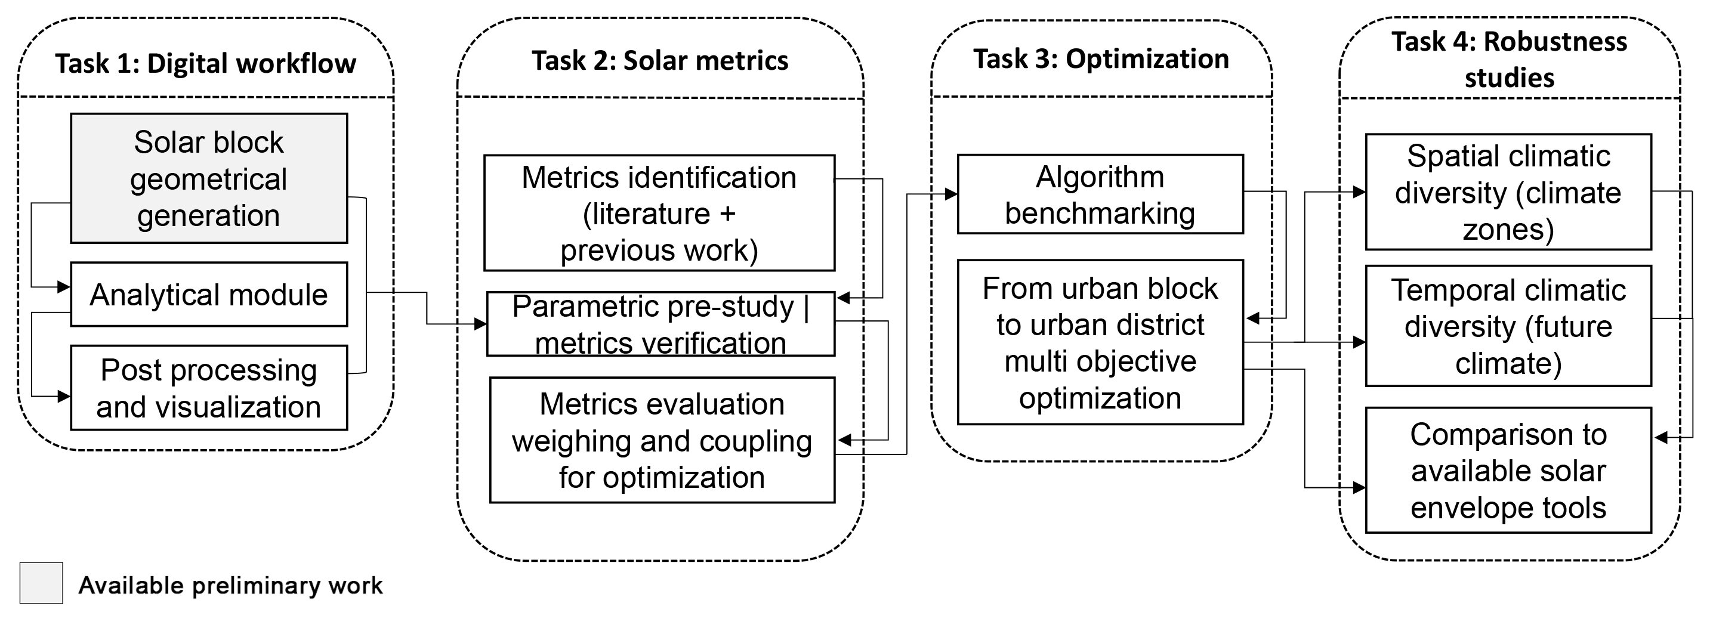

Fig. 11: The project’s research design sequence.

    - Task 1 - Establishing a digital workflow
This task will focus on establishing the computational foundation of the project including the geometrical solar block generator, the analytical module, and the visualization module. These three components interact seamlessly in Grasshopper [33] - a parametric interface for the 3D CAD (computer-aided design) program Rhino [34]. This segment of the work has already been constructed and tested by us (the PI and the project’s collaborators) [35] (see also preliminary results, sec 3.3).
The solar block generation is illustrated in Fig. 12. It is based on the following user-defined inputs: building’s contour, the height limit, and the module size. These inputs are automatically channeled in Grasshopper to a custom-made component in which the height of each corner of the building contour is used to generate a morphed box which serves as a subtraction boundary to generate the solar masses (pixelated according to the predefined module size, e.g., 3m). The boundaries of the design space are defined by the user’s inputs.
The analytical module is receiving the geometrical data for each iteration, sampling the relevant numerical and geometrical inputs and streams the data to the relevant environmental simulation engines. This part is conducted using several components under the Ladybug Tools plugin [36] in Grasshopper in which different environmental metrics (see task 2) will be calculated using the validated Radiance [37], EnergyPlus [38] modeling engines.
Post-processing and visualization is then conducted by streaming the simulation outputs through dedicated Grasshopper components such as Colibri [39] which ignite the iterative process and automatically export the results to Excel in a way which can be easily read and interacted with though the online DesignExplorer platform [40].
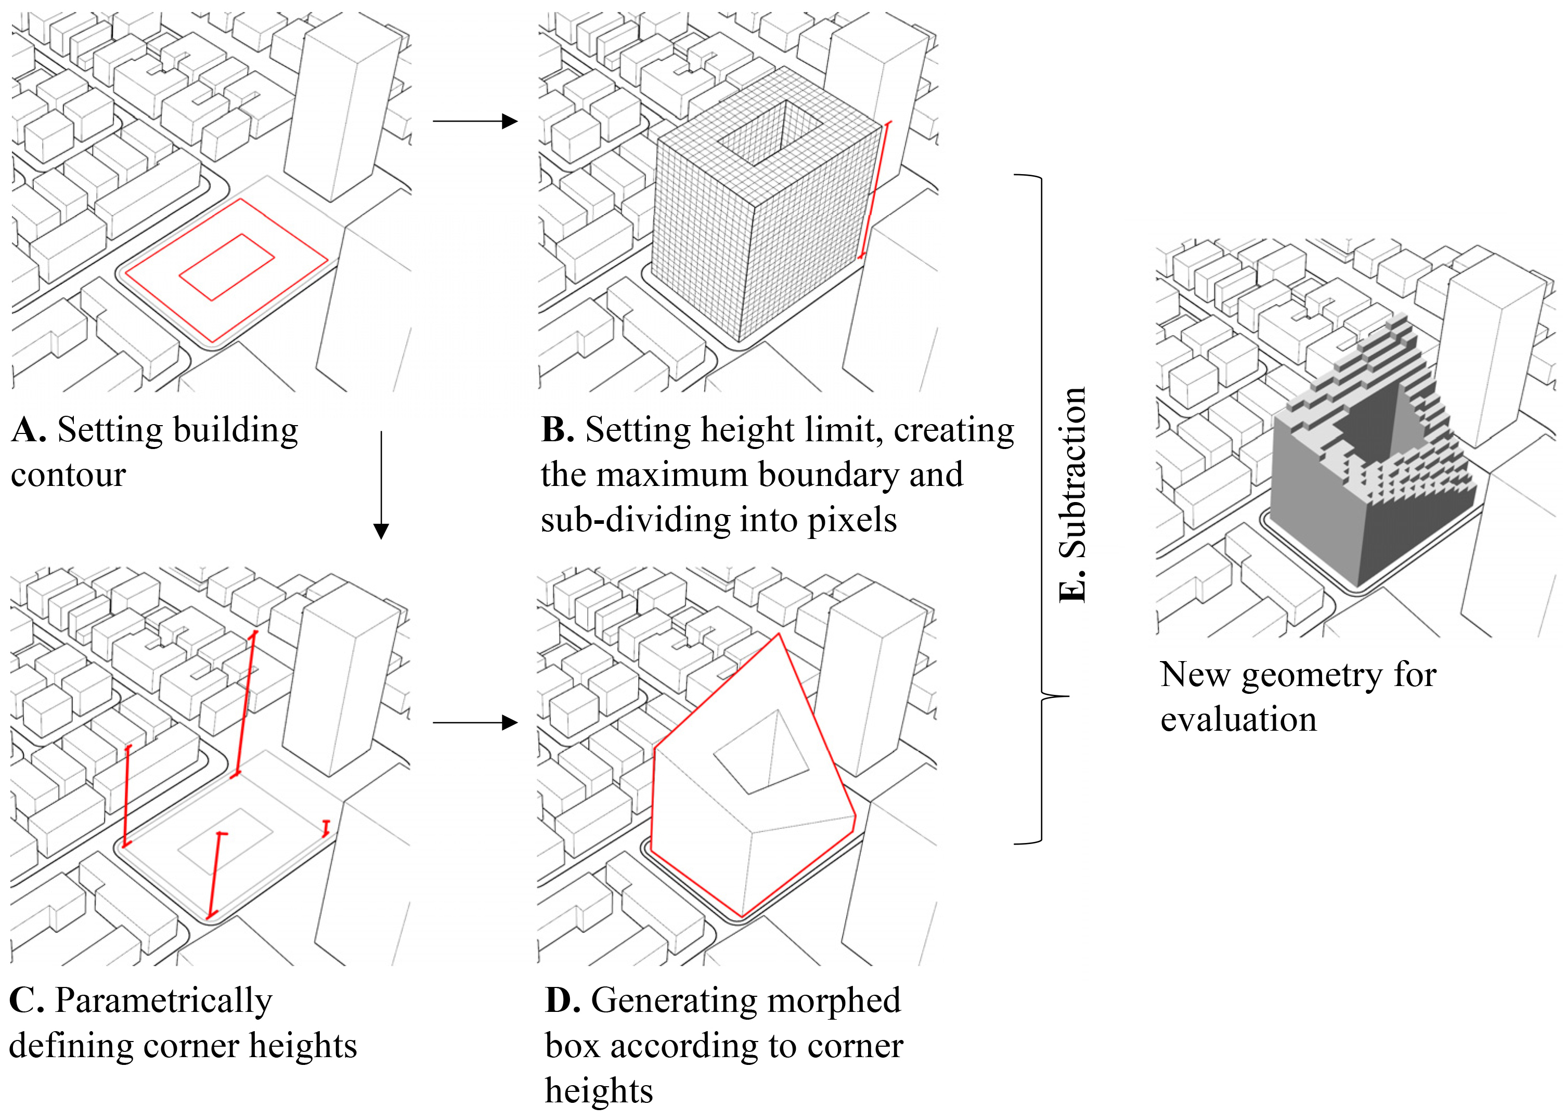

Fig. 12: The solar Block Generation sequence [after 36]

This computation workflow will be used for the next stages (tasks) of the project in which it will be applied on a district scale case study in Tel Aviv area, in which the built area is projected to double to meet the local demographic challenge. Tel Aviv is categorized by a Hot-summer Mediterranean climate [41], in which solar radiation plays a pivotal role in energy demand, energy generation potential as well as indoor and outdoor environmental quality. Hence, it serves as a suitable test bed for a harmonized approach for soar driven urban design approach.
    - Task 2 - Identifying and exploring solar driven metrics
This task will be dedicated to establishing suitable metrics for environmental performance evaluations. It will start with a wide literature review that will help identify the appropriate metrics which are used at similar scales and/or solar driven approaches. The preliminary research work which was focused on [31], and utilized [35] solar-driven metrics, will serve as a starting point for this task. These metrics (which are described in Table 1), recorded high correlation with energy performance, visual comfort, and thermal comfort, and can be roughly divided to exposure and shading indices [35], e.g., Outdoor Shading Index (OSI) which stands for the annual shading coefficient of outdoor surfaces, or the Context Exposure Index which stands for the exposure ration of the surrounding buildings.
Pre-study | The selection of performance metrics will not be automatic but will be based on a re-evaluating the metrics based on a sensitivity parametric study. This preliminary study will be conducted on a theoretical urban model and explore the efficiency of several solar based metrics to serve as effective indicators for different environmental criteria (as previously performed by us [31]).
Table 1: Solar based metrics used for performance evaluation in a preliminary study by the PI [35]
metric | definition | Calculation method | Analysis period | units
CEI | Context Exposure Index | The average solar exposure compliance percentage of the following surfaces according to the respective thresholds taken from Israeli standard SI 5281  Outdoor surfaces - 0.9 kWh/m² solar irradiation on at least 30% of surfaces  South facades - 1.26 kWh/m² solar irradiation  Roof surfaces - 4 hours of solar exposure on at least 50% of each roofs surface | outdoor surfaces \ south facades - 21st of December  08:00 – 16:00  roof surfaces - 21st of December  09:00 – 15:00 | [%]
NEI | New Building Exposure Index
SE | Sky Exposure | The average percentage of the sky visible from each of the test point across all the vertical surfaces - averaged between existing and new masses. | N/A | [%]
OSI | Outdoor Shading Index | The average of the annual irradiation ratio between exposed and obstructed configurations of each point across the outdoor surfaces (in and around the site), subtracted from 1 | Annual | [/]
FSI | East – West Facades Shading Index | East and West facades’ summer irradiation values (in MW/m²), subtracted from 1 - averaged between existing and new masses. | 1st of June – 31st of October | [1-MW/m²]
The analysis of the generic run using correlation studies will help evaluate the relations between metrics and highlight couples of contrasting metrics from the optimization analyses. A Principal Component Analysis (PCA) will then be conducted to help downsize the number of objectives by analyzing the overlaps between them and to generate weighted combinations between exposure and shading metrics. The additions this project will bring to our previous work in terms of upscaling to a full-scale district, the analyses of various climatic conditions as well as the experimentation with weighting methods is expected to extend the discussion on solar-driven metrics and their effective use in optimization workflows.
    - Task 3 – setting up an optimization workflow for solar driven urban design
When considering several design parameters and upscaling the performance evaluation from one building to a series of solar buildings or urban blocks - i.e., to a solar district - the very large number of possible iterations requires the integration of an optimization module into the evaluation workflow for an automated screening of the results based on selected objective(s). Since a holistic approach will be developed here, a multi objective optimization (MOO). i.e., one which involves at least two objectives, will be incorporated.
Based on the two previous tasks, this task, which will also function as a research module in this study, will be dedicated to the exploration of optimization methods for solar driven design. This task will start with setting up the optimization computational workflow in Grasshopper through the Opossum plugin for Grasshopper [42]. The Opossum components will be connected to the performance evaluation workflow which will be assembled throughout the previous tasks in Grasshopper, to allow a seamless data flow between the optimization and the generation, analysis, and visualization modules. The objectives selection for the MOO will be based on outputs of Task 2, and a series of sensitivity optimization studies will be conducted to test different algorithms and explore their performance in the context of our optimization problem. Fig. 13 illustrates one example sequence for processing the outcomes of the optimization process – following the optimization run, the best performing solar district designs configurations are automatically exported to excel. Then the non-dominated design configurations (on the pareto front graph) will be highlighted and transmitted to the designer for visual screening based on the input (variables) and outputs (objectives) data graphs.
To test the optimization, full energy performance (supply and demand), daylight and outdoor comfort simulations will be conducted, using validated engines. This part of the research will help compare the best-found solutions (the non-dominated) from the solar optimization study against a ‘standard’ redevelopment - using rigid flat building volumes which are increased in height with no solar consideration applied.

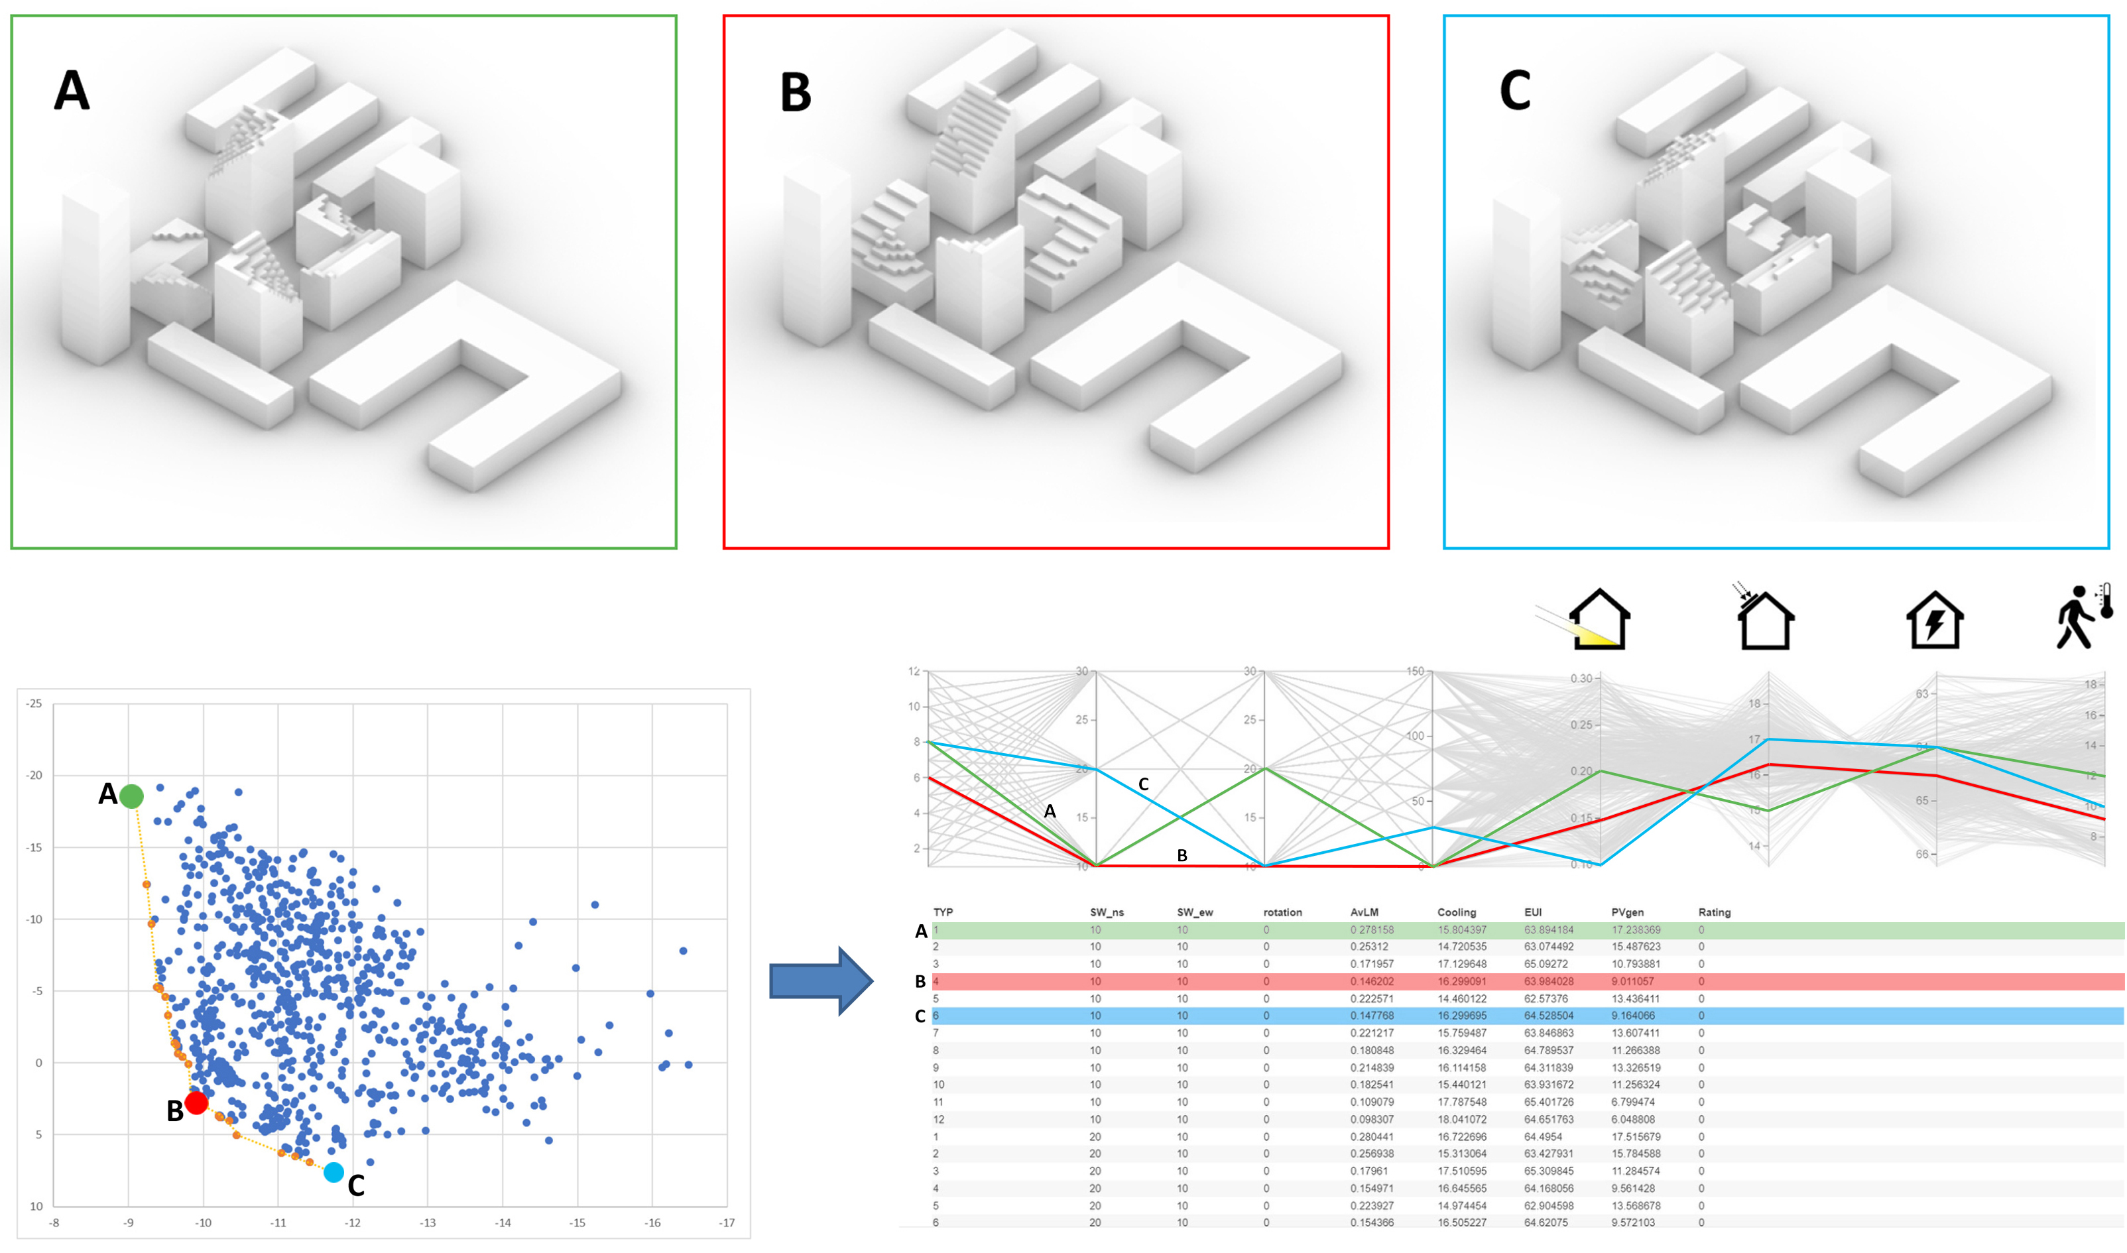

Fig. 13: Demonstration of an interface for visualizing the optimization results which will be used in this project. Non-dominated design alternatives from the optimization run will be highlighted and streamed for visual selection

    - Task 4 – Comparison to traditional SE methods and exploration of diverse urban and climatic conditions towards a robust approach
The last task will be dedicated to experiment with the workflow in different climatic conditions (regional climates and future climates) and scales. It is expected to finalize the project with observations on solar urban design, the integration of digital tools and optimization methods in solar driven design process and the robustness of solar urban design in different urban and climatic settings.
Climatic diversity | As the solar tradeoff will manifest itself differently in different climatic regions, an additional module will employ the two sets of exposure and shading metrics in the same morphological analytical configuration but in four different climatic contexts (as defined according to the Israel building code – SI 1045 [43]). This part will highlight insights regarding the robustness of the methodology and the metrics and/or their weights which require contextual adaptation. Additionally, an additional analytical climate module will be dedicated to future climate calculations using a 2050 climate file which will be approximated using Meteonorm weather generator software [44]. This will help add the important perspective of climatic adaptation of the solar urban block concept and raise the discussion of environmental performance and architectural form in a changing climate.
Comparison to traditional SE methods will be conducted for all analytical scenarios through running the same urban or climatic scenario usen in this project using the existing solar envelope tools (e.g., the Parametric Solar Envelope [14] or the Reverse Solar Envelope [17] methods). The comparison will help us establish a wide perspective of the challenges and opportunities of solar design and offer new directions for its future development.
  - Preliminary results
The solar block generation (SBG) methodology which will be used here was tested by us (Natanian, Wortmann, Francesco and Capeluto) in a preliminary study [35], which focuses on establishing the computational workflow to automatically generate the voxelated forms in Grasshopper and effectively analyze each iteration using a combination of different solar metrics. In this study, the methodology was applied on a redevelopment case study in Tel Aviv using a parametric study which included 6500 iterations. The best performing design configurations, which are illustrated in Fig. 14, demonstrate the wide potential of the SBG methodology – to seamlessly generate a large design space, evaluate each iteration using different analyses and evaluation metrics and plot the results for visual selection by the designer.
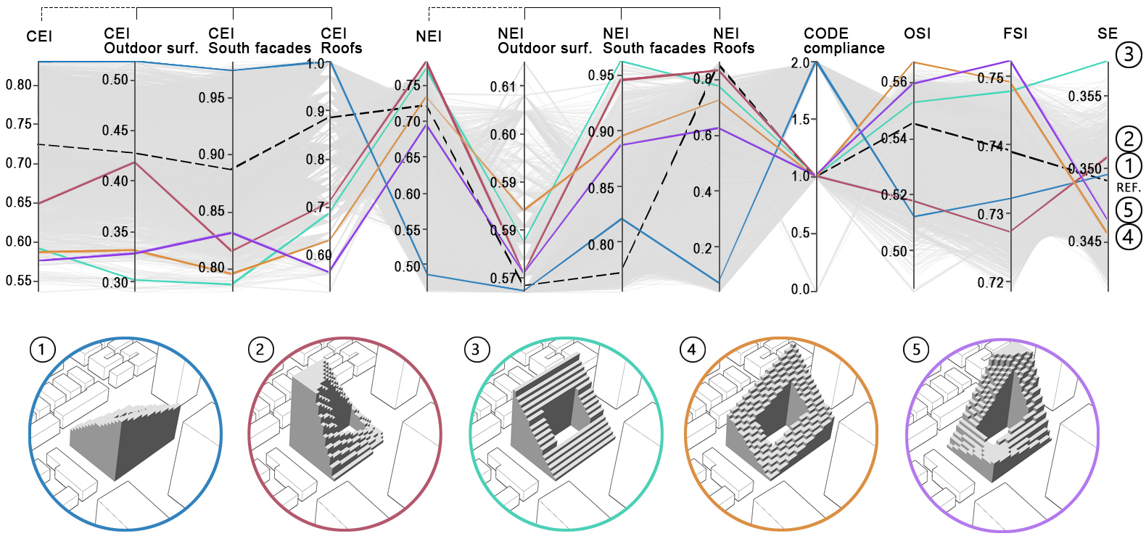

Fig. 14: Five block design alternatives which are highlighted from a 6500-iteration solar block parametric study [35].

Parallel research by Thomas Wortmann and myself [45], which was based on the same case study, was dedicated to exploring a multi-objective optimization (MOO) problem focusing on two objectives – maximizing the density (Floor Are Ratio) as well as the solar exposure of the surrounding buildings (the Context Exposure Index CEI). Here we benchmarked (i.e., performed an algoritmic performace evaluation) seven different MOO algorithms for the same site in Tel Aviv, but in this case, by comparing a courtyard typology to a high-rise solar building mass. The benckmark was performed using convergence, robustness and pareto-fronts comparisons (Fig. 15) for both the courtyard and the high-rise. This study concluded with making two evolutionary algorithms, namely HypE and SPEA2, and a model-based algorithm – RBFMOpt - as the most efficient and robust MOO algorithms for this type of study.
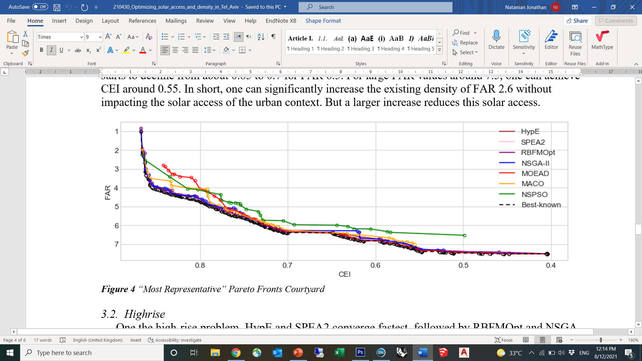

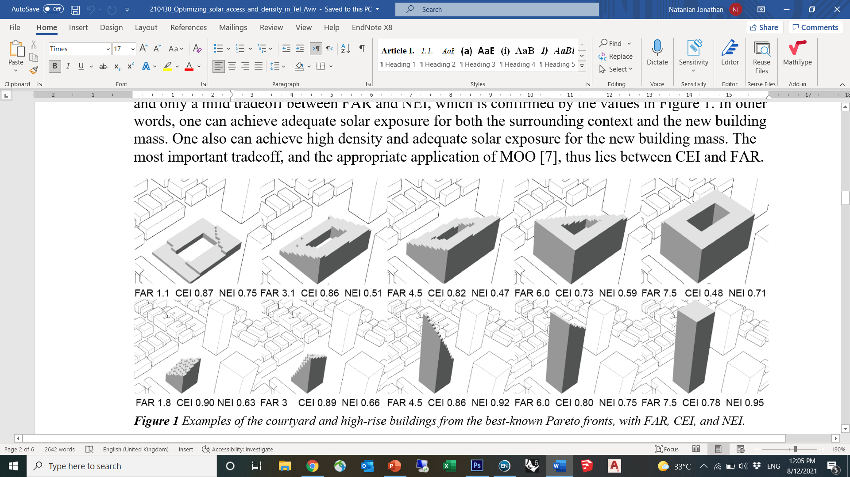

Fig. 15: Pareto front comparison between seven different MOO algorithms for a solar driven courtyard block (top) and seven courtyard design alternatives from the best-known Pareto-fronts (bottom) [45].

Insights and methods from these past studies will serve as the foundation for this research in terms of the urban analytical approach, the choice of environmental metrics, the use of tools to evaluate these metrics as well as the optimization methods which will help us achieve an effective screening of the results.
  - Expected results and pitfalls
    - Expected results
We expect that the employment of our solar urban blocks computational workflow will increase the integration of environmental performance indicators into architectural design, by establishing a generative approach in which performative insights are directly influencing the architectural form finding process. We anticipate that our approach will mark a new chapter in solar driven design - where through using parametric tools, powered by machine learning algorithms, new possibilities will open to effectively explore large design spaces, analyze several KPIs and effectively screen and transmit the best fit results to the designer. This adds new features to the existing solar envelope methodologies and offer a new horizon for the interaction between environmental engineering and architectural design which can potentially enrich both the design outcome in terms of architectural form, as well as the environmental performance of buildings and districts.
    - Expected pitfalls
As the geometrical workflow was already tested and performed well, it is less likely that it will pose any unexpected issues. There could be some unexpected issues in case we decide to add a new solar-based performance metric and not find a good correlation between that metric and the full simulation results, or discover that in our new context, the metrics we use are unsuitable – i.e., discover that one or some of the metrics is\are not indicative and thus not suitable to be used in optimization. In that case we can perform a parametric sensitivity analysis of multiple small variations of that metric to fine-tune it. In case the sensitivity analysis will still yield unsatisfying results, we will probably not use that metric in our evaluation.
Another issue that might surface is the running time, mostly during MOO runs. Luckily, we have extensive cloud space through both institutional (Technion) and commercial cloud services, as well as strong physical computation capabilities (at the Technion and TalTech). Additionally, we have experience in splitting the optimization runs for several segments which can serve as an additional solution to that problem in case the substantial computer power we have at our disposal will not be sufficient.
  - Available resources at the research team’s disposal
- Dr. Jonathan Natanian (PI) is an experienced architect and an environmental design researcher with a specific specialization in computational methods for environmentally driven urban design. The Environmental Performance and Design Lab (EPDL) led by him at the Technion’s faculty of Architecture and Town planning is dedicated to exploring the boundary between environmental engineering and architectural design in a cross-contextual, multi-scale and cross-disciplinary way. The lab’s equipment allows it to operate in three main clusters which together form a triangle of knowledge: data acquisition (cutting edge sensors, remote sensing devices), computational analysis (strong analytical and data physical servers and cloud computing capabilities) and a design interface (interactive screens combined with augmented reality (AR) and mixed reality (MR) devices).
- The research will be carried out at EPDL with the help of a PhD student (TBA) who will be dedicated to the project and supervised by the PI. He/she will specialize on environmental design using computational tools. An MSc or March student (with strong architectural design background) will complement the PhD student with data collection and design characterization of the experiments. A Post doc with a strong computational capability will join the third and fourth year of the project and will focus on the optimization module.
- Thomas Wortmann is an assistant Professor at the Institute for Computational Design and Construction (ICD) at the University of Stuttgart. He is an expert on computational design, building simulation, and optimization. He will support the use of Opossum, an award-winning, machine-learning based optimization tool that will be used in this project. Additionally, Thomas will support the optimization algorithms benchmarking tasks.
- Dr. Francesco De Luca is a renowned environmental design researcher from Tallin University of Technology (TalTec), specializing in advanced solar envelope methods and computational climatic design. Beyond his expertise in the field of computational methods for solar design, the project will benefit computational resources at his department at TalTech.
- Prof. Guedi Capeluto is a world-renowned expert in solar based design and solar tools for architectural and urban design. The Climate and Energy Lab in Architecture (CeLA) Guedi is leading at the Faculty of Architecture and Town Planning at the Technion will support the project with the invaluable knowledge Guedi has accumulated on the integration of solar design concepts and approached in architectural design and environmental policy.
  - Expected significance
This project introduces a pioneering perspective to the widely used ‘solar envelope’ method in the field of solar-driven architectural design. In the broader sense, it will help to unlock new possibilities for both designers and analysts to realize the environmental potential of their designs and generate building and district driven by a wide range of performance indicators. The scientific significance of the project is also routed in several other novelties this project offers to the wider field of urban environmental performance through its following features: its holistic analytical approach which brings together several environmental performance criteria; the generative methods it offers which allow to generate new solar-driven typologies through a bottom-up approach, and the optimization module, which will introduce new insights on selection criteria for multi objective environmental optimization. Thus, as this work aims to add scientific innovation to the field of solar-driven urban designs, it appeals both to the scientific community, urban designers, and policymakers, and establish a new link between them. In addition, through two test cases in the context of Tel Aviv, this work helps to overcome the knowledge gap on urban environmental performance in hot climates which are currently under-represented in contemporary research.

- Bibliography
[1] Compagnon, R. (2004). Solar and daylight availability in the urban fabric. Energy and buildings, 36(4), 321-328.
[2] United Nations, 2018 revision of world urbanization prospects.
[3] International Energy Agency, Energy Technology Perspectives 2016: Towards Sustainable Urban Energy Systems, OECD, 2016.
[4] Naboni, E., Natanian, J., Brizzi, G., Florio, P., Chokhachian, A., Galanos, T., & Rastogi, P. (2019). A digital workflow to quantify regenerative urban design in the context of a changing climate. Renewable and Sustainable Energy Reviews, 113, 109255.‏
[5] Knowles, R.L., 1981. Sun Rhythm Form. The MIT Press, Cambridge, Massachusetts.
[6] Knowles, R. L. (2003). The solar envelope: its meaning for energy and buildings. Energy and Buildings, 35(1), 15-25. https://doi.org/10.1016/S0378-7788(02)00076-2
[7] Capeluto, I. G., & Shaviv, E. (2001). On the use of ‘solar volume’ for determining the urban fabric. Solar Energy, 70(3), 275-280. https://doi.org/10.1016/S0038-092X(00)00088-8
[8] Capeluto, I. G., Yezioro, A., & Shaviv, E. (2003). Climatic aspects in urban design—a case study. Building and environment, 38(6), 827-835. https://doi.org/10.1016/S0360-1323(02)00063-X
[9] Stasinopoulos, T. N. (2018). A survey of solar envelope properties using solid modelling. Journal of Green Building, 13(1), 3-30.
[10] Okeil, A. (2010). A holistic approach to energy efficient building forms. Energy and Buildings, 42(9), 1437-1444. https://doi.org/10.1016/j.enbuild.2010.03.013
[11] Vartholomaios, A. (2015). The residential solar block envelope: A method for enabling the development of compact urban blocks with high passive solar potential. Energy and Buildings, 99(Supplement C), 303-312. https://doi.org/10.1016/j.enbuild.2015.04.046
[12] Jakica, N. (2018). State-of-the-art review of solar design tools and methods for assessing daylighting and solar potential for building-integrated photovoltaics. Renewable and Sustainable Energy Reviews, 81, 1296-1328.
[13] Horvat, M., & Dubois, M. C. (2012). Tools and methods for solar design–an overview of IEA SHC Task 41, Subtask B. Energy Procedia, 30, 1120-1130.
[14] Capeluto, I. G., & Plotnikov, B. (2017). A method for the generation of climate-based, context-dependent parametric solar envelopes. Architectural Science Review, 60(5), 395-407. https://doi.org/10.1080/00038628.2017.1331334
[15] De Luca, F., & Voll, H. (2017). Computational method for variable objectives and context aware solar envelopes generation. In Proceedings of the Symposium on Simulation for Architecture and Urban Design - SimAUD, Toronto, Canada.
[16] De Luca, F. (2017). From envelope to Layout. Buildings Massing and Layout Generation for Solar Access in Urban Environments. In Proceedings of the 35th eCAADe conference, Rome, Italy.
[17] De Luca, F., Dogan, T., & Sepúlveda, A. Reverse solar envelope method. A new building form-finding method that can take regulatory frameworks into account. Automation in Construction, 123, 103518. https://doi.org/10.1016/j.autcon.2020.103518
[18] De Luca, F. (2019). Advanced Solar Envelope Generation. In E. Naboni & L. Havinga (Ed.), Regenerative design in digital practice: a handbook for the built environment (pp. 123-128): EURAC Research
[19] Alkadri, M. F., De Luca, F., Turrin, M., & Sariyildiz, S. (2020). An integrated approach to subtractive solar envelopes based on attribute information from point cloud data. Renewable and Sustainable Energy Reviews, 123, 109742. https://doi.org/10.1016/j.rser.2020.109742
[20] Chatzipoulka, C., Compagnon, R., & Nikolopoulou, M. (2016). Urban geometry and solar availability on façades and ground of real urban forms: using London as a case study. Solar Energy, 138, 53-66.
[21] Lobaccaro, G., & Frontini, F. (2014). Solar energy in urban environment: how urban densification affects existing buildings. Energy Procedia, 48, 1559-1569.
[22] Lobaccaro, G., Lisowska, M. M., Saretta, E., Bonomo, P., & Frontini, F. (2019). A methodological analysis approach to assess solar energy potential at the neighborhood scale. Energies, 12(18), 3554.
[23] Waibel, C., Evins, R., & Carmeliet, J. (2019). Co-simulation and optimization of building geometry and multi-energy systems: Interdependencies in energy supply, energy demand and solar potentials. Applied Energy, 242, 1661-1682.
[24] Natanian, J., & Auer, T. (2018). Balancing urban density, energy performance and environmental quality in the Mediterranean: a typological evaluation based on photovoltaic potential. Energy Procedia,152, 1103-8.
[25] Natanian, J., Aleksandrowicz, O., & Auer, T. (2019). A parametric approach to optimizing urban form, energy balance and environmental quality: The case of Mediterranean districts. Applied Energy, 254, 113637.
[26] Natanian, J., & Auer, T. (2020). Beyond nearly zero energy urban design: A holistic microclimatic energy and environmental quality evaluation workflow. Sustainable Cities and Society, 56, 102094.
[27] Natanian, J. (2019). Communal and Biophilic Principles in Regenerative Projects. In E. Naboni & L. Havinga (Ed.), Regenerative design in digital practice: a handbook for the built environment (pp. 370-375): EURAC Research
[28] Natanian, J., Maiullari, D., Yezioro, A., & Auer, T. (2019). Synergetic urban microclimate and energy simulation parametric workflow. Journal of Physics: Conference Series, 1343, 012006.
[29] Natanian, J., Kastner, P., Dogan, T., & Auer, T. (2020). From energy performative to livable Mediterranean cities: An annual outdoor thermal comfort and energy balance cross-climatic typological study. Energy and Buildings, 224, 110283.
[30] Wortmann, T., & Natanian, J. (2020). Multi-Objective Optimization for Zero-Energy Urban Design in China: A Benchmark. In Proceedings of SimAUD 2020: Symposium on Simulation in Architecture and Urban Design, Vienna, Austria.
[31] Natanian, J., & Wortmann, T. (2021). Simplified evaluation metrics for generative energy-driven urban design: A morphological study of residential blocks in Tel Aviv. Energy and Buildings, 240, 110916.‏
[32] Kanters, J., Horvat, M., & Dubois, M. C. (2014). Tools and methods used by architects for solar design. Energy and Buildings, 68, 721-731.
[33] McNeel, R. (2010). Grasshopper generative modeling for Rhino, Computer software (2011b), http://www.grasshopper3d.com
[34] McNeel R. Rhinoceros 6. 2020. http://www.rhino3d.com/
[35] Natanian, J., De Luca F., Wortmann, T., & Capeluto G. (2021). The Solar Block Generator: an additive parametric method for solar driven urban block design. Journal of Physics: Conference Series, 2042 (In print).
[36] Ladybug Tools. http://www.ladybug.tools/
[37] Ward, G. J. (1994). The RADIANCE lighting simulation and rendering system. In Proceedings of the 21st annual conference on Computer graphics and interactive techniques (pp. 459-472).
[38] DOE. (2017). EnergyPlus. Retrieved from https://energyplus.net
[39] Core studio (2017). Colibri, in TT Toolbox for Grasshopper. Retrieved from Available from: http://core.Thorntontomasetti.com
[40] Tomasetti T. Core studio. Design Explorer; 2018. https://tt-acm.github.io/DesignExplorer
[41] Peel, M. C., Finlayson, B. L., & McMahon, T. A. (2007). Updated world map of the Köppen-Geiger climate classification.
[42] Wortmann, T. (2017). Opossum: OPtimizatiOn Solver with SUrrogate Models. https://aal.sutd.edu.sg/opossum/
[43] Standards Institute of Israel. SI 1045 - Thermal Insulation of Buildings.
[44] Meteonorm software (2021), version 8. https://meteonorm.com/en/meteonorm-version-8
[45] Wortmann, T. & Natanian, J. (2021). Optimizing solar access and density in Tel Aviv: Benchmarking multi-objective optimization algorithms. Journal of Physics: Conference Series, 2042 (In print).

