**SPINAL COMPRESSION FORCE DURING MANUAL MATERIAL HANDLING CALCULATED USING REAL AND PREDICTED HUMAN MOTION IN JACKTM SOFTWARE**

Zohar Potash, Yaar Harari, Raziel Riemer

Dep. of Industrial Engineering and Management, Ben-Gurion University of the Negev, Beer Sheva, Israel

.

Digital human modeling (DHM) software are the state of the art for ergonomic workplace design. The ergonomic analyses in DHM are based on a biomechanical model which is effected by the motion of the virtual manikin during the task (e.g. lifting technique). The aim of this study is to evaluate the difference in the calculation of spinal compression forces when using real human motion or the software motion prediction algorithms. To do so, in a laboratory experiment, 18 participants performed 2835 cycles of continuous sequential box-conveying tasks (i.e. removing a box from a shelf, carrying it for 2.7m, depositing it on a shelf). The participants’ motion was recorded using motion capture system. Then, the same box conveying tasks were simulated in JackTM using two different approaches: (1) using the motion capture data (i.e. using real human motion); (2) using the software’s task simulation builder (i.e. using motion prediction algorithms). Then compression forces acting on the L4/L5 vertebrae joint were calculated in JackTM using the software’s lower back analysis tool. The results show significance difference (p<0.05) in spinal compression forces between real motion and predicted motion for the removing and in carrying tasks (between 26-112%). No significant difference was found during the depositing task. Our results emphasis the importance of accurate motion prediction for calculation of biomechanical loads.

**INTRODUCTION**

Manual labor tasks are still common in various industries and modern production systems, and will remain essential in the near and intermediate future. Yet, despite decades of research aiming to reduce the number and severity of manual material handling (MMH) injuries, they continue to constitute a burden on industry, resulting in $15.08 billion in direct costs in 2013 within the US alone (Workplace and Index, 2016). The state of the art in workplace design is digital human modeling (DHM) software, which enable to create a virtual environment to simulate work processes.

One of the main issues when applying DHM is its inability to predict realistic human motion during the tasks that are performed as a sequence of manual material handling tasks (denoted multiple-task jobs). As a result, the software is mostly used for analysis of static postures and not for simulation of the entire work process. Further, most of the prediction models (biomechanical loads, times, motion and posture) and ergonomic risk-assessment tools were developed based on ‘single-task’ jobs, such as lifting or carrying a box (Hoozemans et al., 2008; Larivière et al., 2002; Lavender et al., 2003; Rose et al., 2013), while in practice many industrial jobs are ‘multiple-task’ jobs that include sequences of tasks (e.g. carrying the box and lowering it onto a pallet). Recent studies ((Harari et al., 2020, 2019) showed that there is difference in the kinematics between the single and the multiple-task. Moreover, the effect of the motion prediction in DHM on calculation of spinal has not been investigated. The goal of this study is to quantify the difference in spinal compression forces calculated using DHM between using real human motion or motion prediction algorithms. In this study we will use JackTM (Siemens PLM) as a representative to DHM software

**METHODS**

**Participants**

We performed a laboratory experiment including 18 subject participants (9 females, 9 males). The participants

mean age was of 26.8 years (range: 24-28 years), females height of 165.4 (SD 6.1) , males height of 178.8 cm (SD 5.04), and females weight of 63.4 kg (SD 12.2), males weight of 73 kg (SD 6.8). All participants were in good health – not suffering heart conditions, musculoskeletal disorders or any other diseases. The experiment protocol was approved by the university ethics committee.

**Experimental design**

The experimental layout included two stands distanced 2.7 meters apart, each consisting of three shelves at different heights (Figure 1).

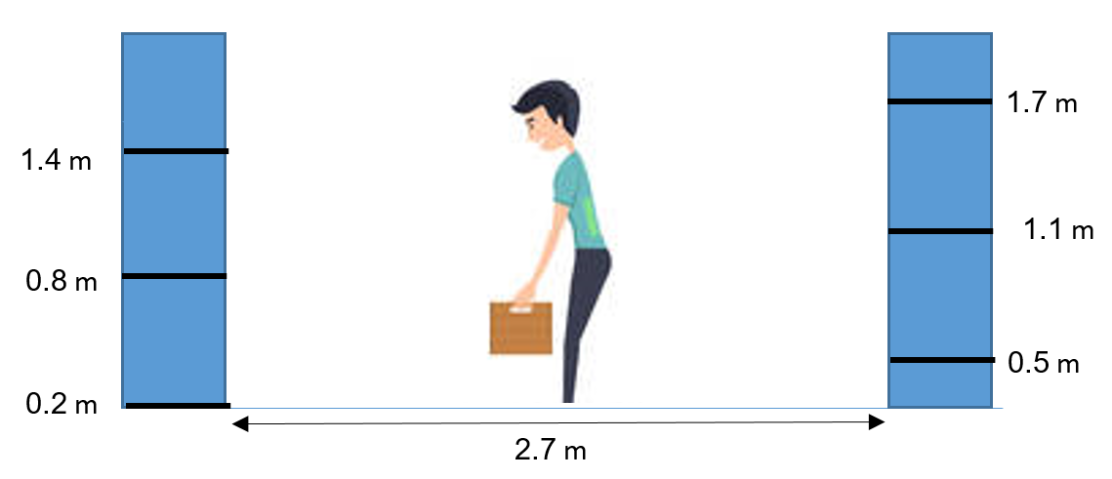

**Figure 1 – the experiment layout: two stations including three shelves, located 2.7 meters apart.**

The participants performed continuous sequential tasks, which included the following: 1) remove a box from a shelf; 2) turn 180 degrees and carry the box in front of the body for 2.7 meters; 3) deposit the box on a shelf. The box’s dimensions were 20 × 55 × 36 cm (height × width × depth) and it included handles on both sides at a height of 15 cm from the bottom of the box.

Each task had defined start and end time frames and was analyzed individually. The removing task began with the participant reaching for the shelf and ended when the box (now in the hands of the participant) reached a steady height in which it will be carried. The depositing task commenced when the participant started to place the box toward the shelf and ended when the hands returned to the sides of the body (after depositing the box on the shelf). The carrying task started at the end of the removing task and ended at the beginning of the depositing task. We developed a program for analysis of the motion capture signal and definition

of the conditions for the start and finish of each task, which is detailed in a previous publication (Harari et al., 2019). The participants handled boxes of different masses and removed (deposited) them from (to) shelves of different heights (Table 1) throughout the experiment. Participants were instructed to perform the task at a pace they assume they can maintain for an eight-hour shift without getting fatigued. The experiment was performed in a hierarchical order, one for each box mass. In each trial, the participants performed the box conveying tasks three times, demonstrating the 15 possible combinations of removing and depositing heights. In total 2835 box conveying tasks were recorded, each including a *removing*, *carrying* and *depositing* task.

**Table 1. The values of the box masses and initial/final heights investigated in this study.**

|  |  |
| --- | --- |
| **Box masses**  **[kg]** | **Initial/final heights [m]** |
| 2, 5, 8,  12* | 0.5, 0.8, 1.1,1.4, 1.7 |

*Only males

**Data collection and processing:**

To simulate an accurate human motion in JackTM the following was preformed: A full-body model was created using 62 reflective markers. Three markers where attached to the box position to determined it location and orientation in the space. The marker's location was recorded by motion capture systems’ 14 cameras (Oqus 300 and Oqus 500, QualisysTM, Göteborg, Sweden) at a sampling rate of 100 Hz and Butterworth zero lag low pass filter with cut off of 6Hz. Then a program developed in Visual3D™ software received the motion capture data and classified each of the tasks. In order for the JackTM software to run a simulation according to the motion capture data we performed a transformation to the markers models required by Jack as input. This was also performed using Visual3D™. Finally, we ran simulations in Jack in which the virtual manikin followed the motion as recorded use motion capture system, and calculated compression spinal forces during the simulation using the lower back analysis tool in JackTM.

Then, we used the software’s task simulation builder and simulated the exact same tasks as in the experiment. Once again, for each simulation we calculated the spinal compression forces. In all simulations the box mass represented by a vertical force (equal to half of the mass multiply by gravitational accelerations was applied to each of the hands). Last we compered the low back compression force obtain using the two methods

**Statistical analysis**

The independent variables were the model type (i.e. experiment or simulation), the mass of the handled box, the height of the removing shelf (for the removing task), and the height of the depositing shelf (for the depositing task). The dependent variable was the peak L4\L5 compression force. The difference between the experiment and simulation was investigated using a repeated analysis of variance (ANOVA) test and post hoc Tukey test. The statistical test were performed a separately to each task (removing, carrying, depositing). The statistical analyses were performed using the R-Studio environment (R Development Core Team, 2011). For all statistical tests, a significance level of P < 0.05 was set.

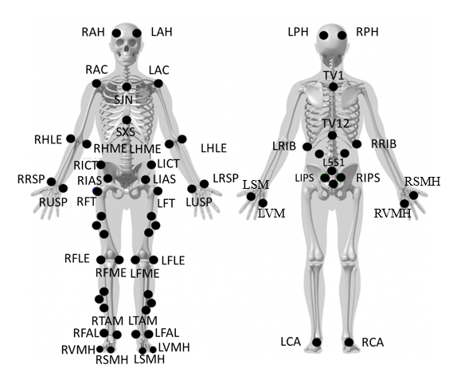

**Figure 2: The markers positions for creating the motion capture full-body model. The skeleton figure is taken from C3D website (www.c-motion.com/v3dwiki)**

**RESULTS**

We found a significant difference in spinal compression forces between using real motion and predicted motion for the removing, carrying (P-value ≤ 0.05) but not for depositing tasks (Table 2).

**Table 2: Results of the ANOVA tests for the removing, carrying and depositing tasks. For each dependent variable: DF- number of degrees of freedom, F- is the F value, and P is the significance level. The row type shows the significance of the difference between the two types (experiment and simulation). The remaining columns show whether the difference between the environment is effected by the following task parameters: box mass (BM), initial removing height (RH) and final depositing height (DH).**

|  |  |  |  |  |
| --- | --- | --- | --- | --- |
|  |  | **DF** | **F** | **P** |
| **Removing** | type | 1 | 1273.1 | **<0.05** |
| type* BM | 3 | 150.25 | **<0.05** |
| type* RH | 4 | 40.97 | **<0.05** |
| **Carrying** | type | 1 | 1702.6 | **<0.05** |
| type* BM | 3 | 11.39 | **<0.05** |
| type* RH | 4 | 929.64 | **<0.05** |
| type* DH | 4 | 33.23 | **<0.05** |
| **Depositing** | type | 1 | 0.36 | 0.55 |
| type* BM | 3 | 666.67 | **<0.05** |
| type* DH | 4 | 0.25 | 0.85 |

During the *removing* task, the peak spinal compression force using real motion were larger an average by 55.35% (SD=4.39%), compared to using predicted motion (Figure 3A). In the *carrying* task, the peak spinal compression force using the real motion were smaller by 28.85% (SD=62.1%) compared to using predicted motion (Figure 3B).

XXX here you should write about the interaction found significant in depositing XXX

**DISCUSSION**

The peak Compression force during removing was higher using the real motion ranging from 26 to 112% more than using the simulation motion. However, in carrying simulation motion resulted in higher load (27 to 31%) and in depositing there was no difference. The differences in the spinal compression forces between real and predicted motion could lead to differences in the risk of injury in DHM analyses. For the removing task, our result suggest that Jack underestimate the compression forces and thus might underestimate the risk of lower-back injury. On the other hand, during the carrying task the predicted motion resulted in overestimation in compression forces which might lead to unnecessary ergonomic interventions. It should be note that these difference were found for JackTM and in other DHM software’s with different motion predictions results may be different. Yet this study shows that when simulating a MMH task it is important to predict the motion as close as possible to a real worker motion.

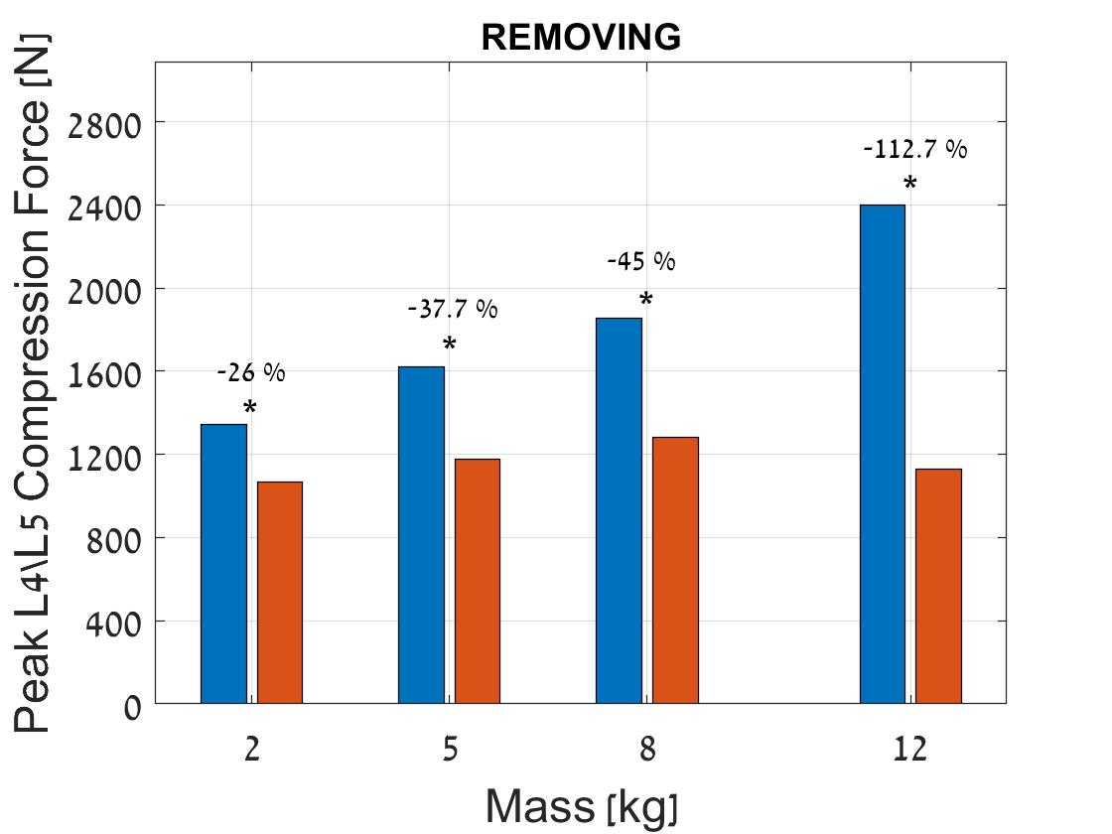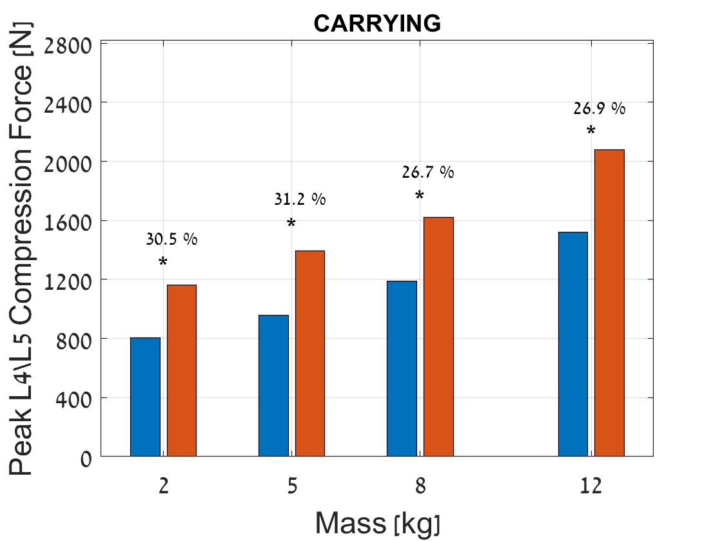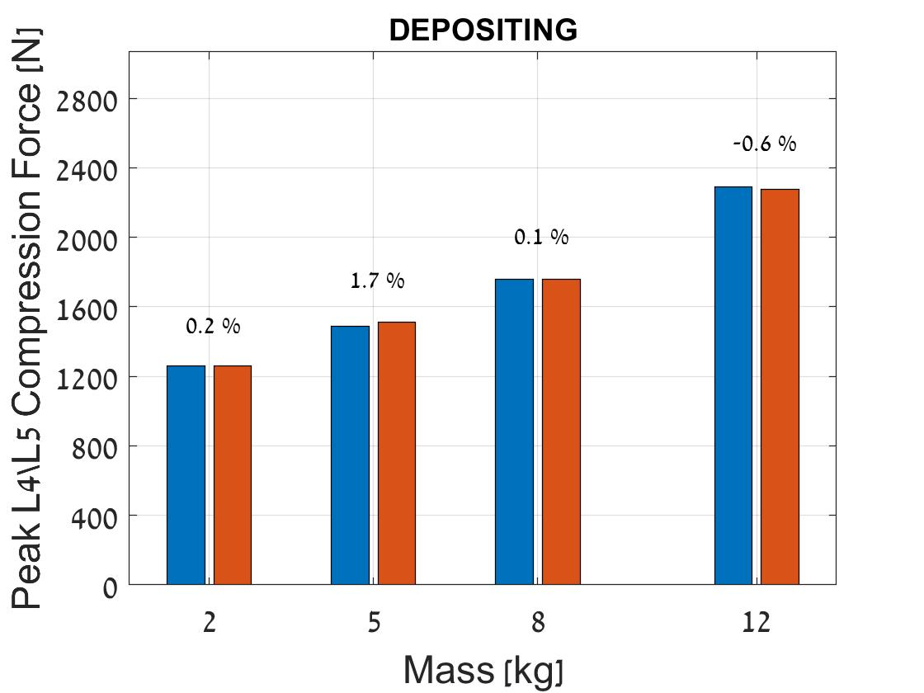

**C**

**B**

**A**

**Figure 3. Peak L4\L5 compression force for experiment and simulation for different box masses. A) during *removing* phase; B) during *carrying* phase; C) during *depositing* phase * indicates a significant difference between the model types (P < 0.05). Error bars = one standard error.**

Further, it might be possible to use the differences in compression forces found in this study when using Jack to simulate similar tasks to correct for the difference between the simulation and real workers.

**ACKNOWLEDGMENTS**

This work was supported by the following: The Israel Science Foundation under Grant No. 8//998; The Helmsley Charitable Trust through the Agricultural, Biological and Cognitive Robotics Initiative and by the Marcus Endowment Fund both at Ben-Gurion University of the Negev.

Mor Topaz and Yarden Avrahami for their assistance in the data collection and Shir Josef and Naama Sayag for their help with the simulation.

**REFERENCES**

Harari, Y., Bechar, A., Riemer, R., 2020. Workers’ biomechanical loads and kinematics during multiple-task manual material handling. Appl. Ergon. 83, 102985. https://doi.org/10.1016/j.apergo.2019.102985

Harari, Y., Riemer, R., Bechar, A., 2019. Differences in spinal moments, kinematics and pace during single-task and combined manual material handling jobs. Appl. Ergon. 81, 102871. https://doi.org/10.1016/j.apergo.2019.06.002

Hoozemans, M.J.M., Kingma, I., de Vries, W., van Dieën, J., 2008. Effect of lifting height and load mass on low back loading. Ergonomics 51, 1053–1063. https://doi.org/10.1080/00140130801958642

Larivière, C., Gagnon, D., Loisel, P., 2002. A biomechanical comparison of lifting techniques between subjects with and without chronic low back pain during freestyle lifting and lowering tasks. Clin. Biomech. 17, 89–98. https://doi.org/10.1016/S0268-0033(01)00106-1

Lavender, S.A., Andersson, G.B.J., Schipplein, O.D., Fuentes, H.J., 2003. The effects of initial lifting height, load magnitude, and lifting speed on the peak dynamic L5/S1 moments. Int. J. Ind. Ergon. 31, 51–59. https://doi.org/10.1016/S0169-8141(02)00174-9

Rose, J.D., Mendel, E., Marras, W.S., 2013. Carrying and spine loading. Ergonomics. https://doi.org/10.1080/00140139.2013.835870

Workplace, M., Index, S., 2016. 2016 Liberty Mutual Workplace Safety Index 2.