Table 1. Distribution of study variables by immigration (n = 218,187)
 |  | Immigrants (N=99,037) | Non-immigrants (N=119,150) | p-exact sig (2-sided) | Percentage missing
% Women |  | 52.3% | 46.9% | <0.001 | 0.00%
Average age at beginning of follow-up period (s.d) |  | 47.40 (4.34) | 47.30 (4.20) | <0.001 | 0.00%
% Married men |  | 83.8% | 77.0% | <0.001 | 0.04%
% Married women |  | 69.1% | 75.1% | <0.001 | 0.02%
Education level | High | 55.3% | 41.4% | <0.001 | 15.1%
 | Intermediate | 29.2% | 48.8%
 | Low | 15.5% | 9.7%
Socioeconomic status by residential area | High | 10.2% | 42.9% | <0.001 | 0.60%
 | Middle | 37.9% | 38.8%
 | Low | 51.9% | 18.3%
Income | High | 21.0% | 41.9% | <0.001 | 0.00%
 | Middle | 57.7% | 25.7%
 | Low | 21.4% | 32.4%

Table 2. Distribution of mortality rates by study variables. NAHR (Non Adjusted Hazard Ratio) and AHR (Adjusted Hazard Ratio).
 |  | % Mortality | Non Adjusted Hazard Ratio (NAHR) |  |  | Adjusted Hazard Ratio (AHR)
 |  |  | NAHR (99%CI) | p | AHR (99%CI) |  | P
Total |  | 9.4%
Immigration | Non-immigrants | 8.3% | 1.00 |  | **1.00
 | Immigrants | 10.7% | 1.321 (1.275-1.370) | <0.001 | **1.337 (1.290-1.386) |  | <0.001
Gender | Female | 7.6% | 1.00 |  | *1.00
 | Male | 11.2% | 1.531 (1.476-1.589) | <0.001 | *1.563 (1.506-1.621) |  | <0.001
Marital status | Married | 8.9% | 1.00 |  | **1.00
 | Unmarried | 11.2% | 1.309 (1.258-1.362) | <0.001 | **1.337 (1.285-1.392) |  | <0.001
Education level | High | 7.1% | 1.00 |  | **1.00
 | Intermediate | 10.0% | 1.392 (1.332-1.455) | <0.001 | **1.362 (1.303-1.424) |  | <0.001
 | Low | 17.6% | 2.559 (2.431-2.694) | <0.001 | **2.277 (2.162-2.397) |  | <0.001
Socioeconomic status by residential area | High | 7.7% | 1.00 |  | **1.00
 | Middle | 9.1% | 1.180 (1.125-1.238) | <0.001 | **1.159 (1.105-1.216) |  | <0.001
 | Low | 11.3% | 1.487 (1.419-1.559) | <0.001 | **1.453 (1.386-1.524) |  | <0.001
Income | High | 5.5% | 1.00 |  | **1.00
 | Middle | 10.1% | 1.912 (1.820-2.010) | <0.001 | **1.975 (1.878-2.077) |  | <0.001
 | Low | 13.3% | 2.883 (2.741-3.033) | <0.001 | **2.758 (2.618-2.904) |  | <0.001
* = Age adjusted Hazard Ratio
** = Age and Gender adjusted Hazard Ratio

Table 3. Results of Cox models for predicting mortality by social variables and their interactions within the entire study population (N=218,187)
Model 1 |  |  |  |  |  | Model 2 |  |  | Model 3
HR (99%CI) p |  |  |  |  |  | HR (99%CI) p |  |  | HR (99%CI) P
 | Immigration | Non-immigrants | 1.00 |  | 1.00 |  |  | 1.00
 |  | Immigrants | 1.297 (1.248-1.348) | <0.001 | 0.529 (0.469-0.597) |  | <0.001 | 0.660 (0.535-0.815) |  | <0.001
 | Gender | Female | 1.00 |  | 1.00 |  |  | 1.00
 |  | Male | 1.811 (1.745-1.880) | <0.001 | 1.575 (1.430-1.735) |  | <0.001 | 1.660 (1.492-1.847) |  | <0.001
 | Age |  | 1.087 (1.082-1.091) | <0.001 | 1.081 (1.076-1.085) |  | <0.001 | 1.08 (1.077-1.086) |  | <0.001
 | Income level | High | 1.00 |  | 1.00 |  |  | 1.00
 |  | Middle | 1.780 (1.689-1.876) | <0.001 | 1.573 (1.420-1.742) |  | <0.001 | 1.570 (1.400-1.761) |  | <0.001
 |  | Low | 2.651 (2.513-2.796) | <0.001 | 1.863 (1.683-2.061) |  | <0.001 | 2.039 (1.824-2.279) |  | <0.001
 | Marital status | Married | 1.00 |  | 1.00 |  |  | 1.00
 |  | Unmarried | 1.112 (1.067-1.159) | <0.001 | 1.165 (1.117-1.215) |  | <0.001 | 1.170 (1.122-1.220) |  | <0.001
 | Immigration X Gender |  |  |  | 1.362 (1.258-1.475) |  | <0.001 | 1.025 (0.806-1.304) |  | 0.792
 | Gender X Income | High income level |  |  | 1.00 |  |  | 1.00
 |  | Middle income level |  |  | 1.241 (1.104-1.396) |  | <0.001 | 1.271 (1.103-1.465) |  | <0.001
 |  | Low income level |  |  | 0.870 (0.775-0.977) |  | 0.002 | 0.751 (0.655-0.860) |  | <0.001
 | Immigration X Income | High income level |  |  | 1.00 |  |  | 1.00
 |  | Middle income level |  |  | 1.508 (1.338-1.699) |  | <0.001 | 1.297 (1.031-1.631) |  | 0.004
 |  | Low income level |  |  | 3.491 (3.094-3.940) |  | <0.001 | 2.548 (2.032-3.196) |  | <0.001
 |  | High income level |  |  |  |  |  | 1.00
 |  | Middle income level |  |  |  |  |  | 1.177 (0.900-1.539) |  | 0.118
Gender X Low income level
Immigration X 1.598 (1.222-2.089) <0.001
Income

Table 4. Analysis of mortality rates among immigrants compared to non-immigrants, adjusted for age and marital status, among women and men separately, focusing on the total study population and on each income level separately.
Non-immigrants , Immigrants
 |  |  | Men |  |  |  |  | Women
 | N |  | Kaplan Meier  survivor curve |  | AHR  (99% CI) | N |  | Kaplan Meier survivor curve |  | AHR  (99% CI)
Total population | 110,520 | Survival | 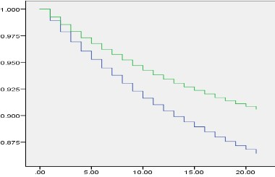  Years |  | 1.474  (1.407-1.545) p<0.001 | 107,667 | Survival | 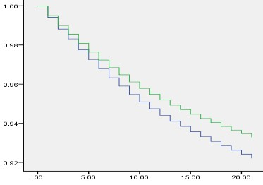  Years |  | 1.167  (1.102-1.236) p<0.001
Low income level | 27,563 | Survival | 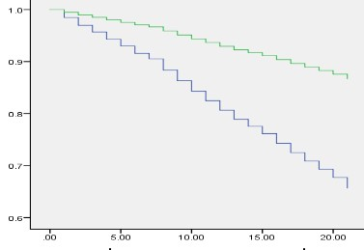  Years |  | 2.941  (2.704-3.199) p<0.001 | 32,220 | Survival | 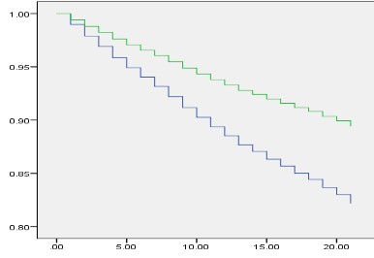  Years |  | 1.756  (1.614-1.909) p<0.001
Middle income  level | 37,094 | Survival | 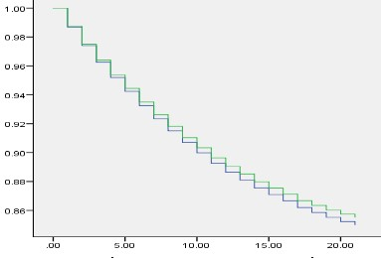 |  | 1.039  (0.963-1.121) p=0.200 | 50,959 | Survival | 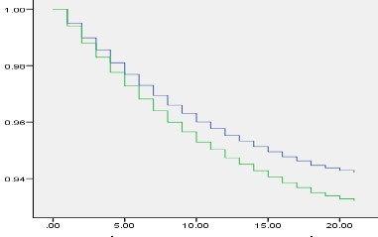 |  | 0.846  (0.772-0.927) p<0.001
 |  |  | Years |  |  |  | Years
High income level | 45,863 | Survival |  | 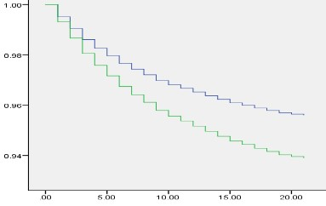  Years | 0.714  (0.635-0.804) p<0.001 | 24,852 | Survival |  | 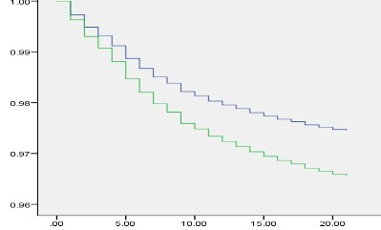  Years | 0.738  (0.596-0.913) p<0.001

