Figure 1. The theoretical structure of the proposed framework.

Horisontal
Solidarity

Job Insecurity
H3
H7
H2

Intentions to Leave the Organization
Incivility

H1

H5
H8
H4
H6
Horisontal
Solidarity
Horisontal
Solidarity

Table 1. Result summary for measurement models

Reflective Variables | Convergent Validity | Internal Constituency Reliability | Discriminant Validity
 | AVE | Cronbach's Alpha
 | > 0.50 | > 0.70 | HTMT  Confidence Interval Does Not Contain 1
Job Insecurity | 0.619 | 0.774 | Yes
Intentions to Leave the Organization | 0.708 | 0.885 | Yes
Horizontal Solidarity | 0.697 | 0.892 | Yes

Table 2. Significance analysis of the direct effects
 | Direct Effect | t Value | p Value
Incivility- Job Insecurity | 0.398 | 6.321 | .000
Incivility – Intentions to Leave the Organization | 0.320 | 3.371 | .001
Incivility- Solidarity | -0.288 | 3.178 | .001
Job Insecurity- Intentions to Leave the Organization | 0.278 | 3.286 | .001
Moderating Effect of Horizontal Solidarity on Incivility-> Job Insecurity | -0119 | 2.281 | 0.023
Moderating Effect of Horizontal Solidarity on Incivility-> Intentions to Leave the Organization | 0.140 | 2.361 | 0.018
Horizontal Solidarity – Job Insecurity | -0.139 | 2.326 | 0.020

Figure 2. simple slop analysis of the interaction effect.

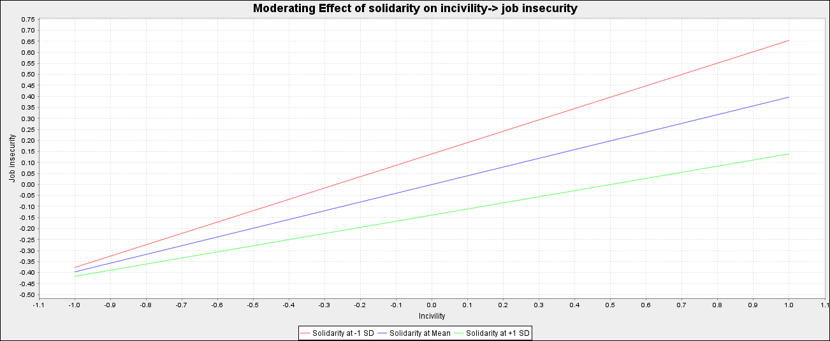

Figure 3. simple slop analysis of the interaction effect.

