Teacher self-efficacy in the COVID-19 pandemic: an exploration of EFL teachers pedagogical-technological knowledge and self-efficacy within distance learning frameworks

Tamar Meirovitz^{ab}*, Susie Russak^{c} and Ayala Zur^{d}

ªBeit Berl College of Education, Kfar Saba, Israel; ^{b}MOFET Institute, Israel; ^{c}Beit Berl College of Education, Kfar Saba, Israel; ^{d} Oranim College, Israel
*corresponding author tamar.meirovitz@beitberl.ac.il

Abstract
COVID-19 forced the educational world to revolutionize: classic face-to-face teaching methods were urgently transformed into accessible, reliable online distance education. This demanded revisiting existing technological-based educational processes and models and reinventing them. This study aimed to determine whether teachers of English as a Foreign Language are confident of their requisite knowledge for emergency remote teaching. A mixed methods approach was employed. One hundred and twenty-nine participants were recruited. Teachers reported a significant increase in the use of self-teaching, school colleague knowledge, school staff tutorials, and online school support. Teachers with higher levels of usage than levels of knowledge experienced greater technological difficulties and problems maintaining pupil engagement and motivation, and experienced the lowest teacher self-efficacy. Teachers with similar levels of knowledge and usage reported the highest levels of teacher self-efficacy. Findings highlight digital teacher self-efficacy as vital in adapting to online teaching during COVID-19 closure. Teacher education programs need to raise teacher awareness of new pedagogical-technological learning, provide opportunities to learn digital competence and encourage teachers to make personal adaptations to new digital technology within specific disciplinary contexts. Our findings have both theoretical and practical applications in pre-service and in-service teacher training.
Keywords: self-efficacy, online distance learning, teachers' professional knowledge, teachers' perceptions, TEFL, teachers' education, lifelong learning.
Introduction
Since the onset of COVID-19, educators everywhere have been coping with a changed reality. Online teaching is often the only platform whereby educators can remain connected with millions of students. Various synchronous and asynchronous lessons have been around for the past two decades; however, the exceptional circumstances associated with lockdown and school closure necessitated reinventing familiar technological advances in educational processes and models. Do teachers believe they have the knowledge and skills to deal with complex situations as they orchestrate distance learning?
In this unprecedented crisis a new term has emerged, Emergency Remote Teaching (ERT) (Hodges et al., 2020). Our study explores English as a Foreign Language (EFL) teachers’ belief in their own pedagogical technological knowledge and classroom application, and their self-efficacy (SE) during the school lockdown.
Exploring EFL teacher beliefs regarding their online instruction is especially valuable due to the global uniqueness of EFL (Faez & Karas, 2017). English is mandatory in most countries and the most prevalent language online. Moreover, the proliferation of online digital tools in English is invaluable in teacher education: a plethora of web resources and digital tools exist (Kitao & Kitao, 2000). In English instruction both the content and the language constitute the core of the lesson (Chiang, 2008). In distance learning, any online text can be relevant; it is increasingly difficult to separate the English language from the digital environment.
Literature Review
The past two decades have seen a shift from traditional teaching and learning modes of instruction to online learning practices (Martin, et al. 2019). This was intensified during the COVID-19 crisis when widespread school closure made it the only mode of learning (Pu, 2020).
Online teaching materials facilitate collaborative, interactive, project-based and authentic activities (Deacon et al., 2000). In the context of English online instruction, researchers have investigated how free Internet resources can aid English language learning (Kitao & Kitao, 2000; Meloni, 2000; Warschauer, 2000), and whether online learning EFL instruction has improved learners' language proficiency from internet resources (Marta, 2018; Meloni, 2000). A recent study (Krishnan et.al, 2020) conducted during COVID-19, examined distinguishing features between free online learning versus conventional learning, and broadly compared learning effectiveness. Findings indicated positive student attitudes toward free online resources, ascertaining that online materials and exercises contributed to their learning.

Teachers' Professional knowledge
It's broadly accepted that teacher knowledge significantly influences effective teaching and student learning, and the successful mastering of tasks. (Berliner, 2001, 2004, Darling-Hammond & Bransford, 2007; Grossman & McDonald, 2008; Gitomer & Zisk, 2015).
This study explores EFL teachers' metacognitive beliefs regarding their distance teaching during COVID -19, and examines if, how, and to what extent EFL educators acknowledge and deploy various aspects of knowledge.
Educational research often refers to teachers’ knowledge as the knowledge of metacognition (Sperling et al., 2002; Corebima, 2009; Jacobse & Harskamp, 2012; Sugiharto et al., 2018). Knowledge of cognition refers to cognition in general (Schraw, 1998), and the possibility of implementing strategies congruously (Garrison, 2003; Javid et al., 2013). Knowledge of cognition consists of three aspects of cognitive awareness: declarative knowledge, procedural knowledge, and conditional knowledge (Schraw, ibid.).
Gibson's (2008) theoretical framework of how the nature of knowledge influences technology integration, is predicted on the dichotomy between declarative (knowing about) and procedural (knowing how to do) knowledge. He concludes that the ultimate educational goal for technology and design must be to empower people to acquire, create and use knowledge necessary to deal with familiar and unfamiliar tasks.
Technological Pedagogical and Content Knowledge Model (TPACK) developed by Koehler & Mishra (2008) is relevant; TPACK is the most frequently cited model on teachers' professional knowledge in teacher EdTech research. The model extends Shulman’s idea of Pedagogical Content Knowledge (1986, 1987) which defined knowledge unique to teachers. The TPACK model illustrates the knowledge required by teachers for integrating technology into the classroom, while addressing the complex and situated nature of teacher knowledge. It identifies three types of knowledge educators need for successful EdTech integration: Content (CK), Pedagogy (PK), and Technology (TK) and emphasizes what lies at the intersections of these primary knowledge forms as explained by Koehler & Mishra: 'The interaction of these bodies of knowledge, both theoretically and in practice, produces the types of flexible knowledge needed to successfully integrate technology use into teaching' (2008, p.60).
We specifically examined the intersection of pedagogical and technological knowledge of EFL teachers. Pedagogical knowledge encompasses teacher knowledge of general pedagogical activities, including strategies for motivating students, presenting information, student assessment and classroom management. Technological knowledge is knowledge of how to use emerging technologies.

Teacher Self-Efficacy
Self-efficacy (SE) is an essential concept in Bandura's Social Cognitive Theory (1977, 1986). Teacher Self-Efficacy (TSE) is teachers' belief in their ability to influence student learning (Aston, 1984). It is 'the teacher's beliefs in her or his capability to organize and execute courses of action required to successfully accomplish a specific teaching task in a particular context' (Tscannen-Moran et al., 1998, p.3). This crucial construct in teachers’ belief systems has a direct impact on teaching practices, student outcomes and the ability of teachers to fulfil essential duties during the teaching process (Gan, Liu &Yang, 2020; Goddard, Hoy & Hoy, 2000; Klassen & Tze, 2014; Morris, Usher & Chen, 2016; Pajares, 2006; Tschannen-Moran & Hoy, 2001; Hoang, 2018; Zimmerman, 2000).
Bandura suggests four primary sources of information which influence SE: primary experience (success or failure in performing a task); vicarious experience (observation of others' performance), verbal persuasion (compliments and encouragement); and psychological states (emotional states when performing tasks). Primary experience is often the most influential in the formation of SE (Usher & Pajares, 2008) and is the most widely assessed source of TSE in educational research (Morris et al, 2016). Our study evaluates teachers' SE by asking them about their success or failure with specific digital tools or online teaching skills.
The role of teacher knowledge in the development of TSE is noted in educational research (Klassen et al. 2011). Studies show that teacher knowledge impacts TSE which in turn influences teachers' practice (Wyatt 2014). In the specific context of technology instruction, studies empirically validated a connection between TSE and intention to use technology (Anderson, et.al, 2011; Jeung, 2014; Banas & York, 2014; Valtonen et al. 2015). Research shows a significant correlation between teacher professional-technological content knowledge and TSE (Abbitt, 2011; Semiz & Ince, 2012; Depaepe and König 2018).
TSE is regarded as a specific domain or field rather than a general construct of self-confidence (Bandura, 1977). Tscannen-Moran et al. (1998) claim that TSE is 'the teacher's beliefs in her or his capability to organize and execute courses of action required to successfully accomplish a specific teaching task in a particular context' (p.3). This implies that teachers' context-specific judgements about their exact teaching behaviors should be investigated in domain-specific research (Klassen et.al., 2011). Research on TSE is more meaningful when explored as field-specific (Kaygisiz, Ulgun & Ulcar ,2020). Scholars (Bandura, 2006; Dellinger, Bobbett, Olivier, & Ellett, 2008; Tschannen-Moran & Woolfolk Hoy, 2001) claim that TSE research in a specific disciplinary field should include efficacy beliefs about specific pedagogical capabilities, and exclude content knowledge. Exploring TSE in the EFL domain and examining pedagogical and technological capabilities, (including teachers' beliefs on their digital teaching knowledge and capabilities), is part of their efficacy.
Research links teacher self-efficacy and technology in the classroom (Mishra & Kohler 2006, Niederhauser & Stoddart 2001; Joo et.al, 2018). Yet, TSE in online teaching remains relatively new. Most TSE measurement instruments in online education to date were based on scales internally validated for face-to-face teaching, such as general or content-specific pedagogy, and didn't consider technological knowledge (Newby et al.2011). Scholars recognize that a measure of SE in online pedagogy hasn't yet been empirically established (Corry & Stella, 2018). This study sheds light on TSE in online teaching in an unprecedented ERT context.
Research on TSE is unique in TEFL (Faez & Karas, 2017) yet has not been widely researched. The few existing studies examined teacher perceptions of efficacy regarding personal capabilities to teach English, and their self-reported English proficiency level and instructional strategies (Yilmaz, 2011; Underwood, 2012, Choi & Lee, 2016). Thus, Thompson and Woodward (2018) looked at EFL Japanese teachers' self-efficacy dimensions that included using English, communicative teaching strategies, teamwork capabilities, student achievement and regulatory practices. Other studies investigated SE beliefs for implementing self-regulated learning (Gan, Z., Liu, F & Yang, C.C.R, 2020; Vatoy K. 2020); TSE collective beliefs for job stress or job satisfaction (Goker, 2012); sources of SE of Vietnamese EFL teachers (Phan & Locke2015) and EFL TSE development in professional learning communities (Zonoubi et al., 2017). All studies focused on self-efficacy beliefs EFL in traditional instruction. Reviews on TSE research in EFL contexts concluded that this area is underrepresented in TSE research literature (Klassen & Tze, 2014; Konig, et al., 2016) and encouraged more research in the domain of TEFL.
This is especially evident for TSE in EFL online instruction. Our study focuses on teachers' beliefs on five questions:
1. What were their sources of knowledge of digital tools before and during the COVID 19 crisis?
2. Was there a difference between the level of their knowledge of digital tools and actual usage during the COVID 19 crisis?
3. How does the gap between knowledge and usage of DT relate to the challenges that EFL teachers experienced during COVID 19?
4. How does the gap between knowledge and usage of DT relate to measures of TSE during COVID 19?
5. What are EFL teachers' perception of distance ERT – challenges and opportunities?
Methodology
Our study employs a mixed method design for the research questions, in a complementary and expansive manner (Johnson et al., 2007). Quantitative data on EFL teacher knowledge, practice and TSE was obtained from closed-questions in the online questionnaire. Qualitative data was collected from the open -ended question which elaborated on the quantitative results, providing insights into teachers' perceptions of their distance teaching during COVID-19 including challenges and new opportunities. Sequential explanatory design ensured that qualitative data would provide a better understanding than quantitative data alone (Creswell, 2009; Creswell et al., 2003).

Participants
One hundred and twenty-nine participants were recruited from different countries where English is taught as a foreign language. The majority teach in Israel (79.8%), with additional participants from North America, Europe and Asia (19.4%). The mean age was 43.66 (SD 11.47). The mean number of years of reported teaching was 12.39 (SD 10.46). Grades taught were organized according to elementary (grades 1-6), Jr high school (grades 7-9), high school (grades 10-12), and other. Table 1 presents demographic information regarding participants.
Table 1. Participant Demographic Information (N=129).
 |  | N | Score in %
Gender | Female | 112 | 86.8%
Gender | Male | 17 | 13.2%
Country taught | Israel | 103 | 79.8%
Country taught | Other | 25 | 19.4%
Certification | Yes | 116 | 89.9%
Certification | No | 13 | 10.1%
 | BA | 33 | 25.6%
Academic Qualification | BEd | 27 | 20.9%
Academic Qualification | MA | 58 | 45.0%
Academic Qualification | PhD/EdD | 8 | 6.2%
Academic Qualification | Other | 2 | 1.6%
Grades Taught | Elementary (1-6) | 144
Grades Taught | Jr High (7-9) | 186
Grades Taught | High (10-12) | 216
The teachers reported teaching in grades 1-12; however, as the number of grades taught was not mutually exclusive, the total percentage for this item exceeded 100.

Tools
An online survey, using google forms, was comprised of 24 closed questions and one open question. (https://forms.gle/mQkGDE8iK8SRnfPAA). The closed questions examined:
Professional background: gender, age, country, native language, teaching certification, academic qualification, teaching grade level, teaching tenure.
Two Questions on distance EFL teaching prior to Corona utilized a 5- point Likert scale ranging from very high to not at all: a) knowledge of digital tools. b) Sources of digital tools.
Fourteen questions on distance EFL teaching during the Corona crisis, divided into clusters: sources of knowledge of digital tools, support from school, beliefs about personal levels of technological-pedagogical knowledge, perceptions regarding actual practice of digital tools, personal self-efficacy in distance teaching, opinions concerning the change in professional knowledge and practice, challenges in distance teaching and teachers' estimation of distance learning versus face-to-face. All questions were measured using a 5-point Likert scale, apart from the last item which used a 3-point Likert scale.
The questionnaire also included one open-ended question for teachers' reflections on distance EFL teaching during the Corona Crisis.

Procedure
Data was collected between March and May of 2020, right at the beginning of the COVID-19 lockdown in Israel. The questionnaire was posted on a site frequently visited by English teachers in Israel and on the English teachers' Facebook site. A snowball procedure collected data: a small pool of teachers was requested to complete the questionnaire and share it with friends and colleagues (from different countries where English is taught as a foreign language.) We clarified that data was for research purposes only; names and personal details would be deleted.

Data analysis
Since data was based on ranking, non-parametric tests were used. Measures of interest were described by using medians and means together with standard deviations (SD) and inter-quartile range (IQR). The Wilcoxon signed rank test evaluated differences between paired comparisons; the Kruskal-Wallis test examined differences among groups; the Mann-Whitney test provided post-hoc comparisons. The Spearman correlation tested association between measures of interest. Results were considered significant for p-value≤ 0.05. All analyses were carried out using SPSS version 25. Qualitative data of the open-ended question were analyzed using data-driven thematic analysis. Repeated patterns within the data obtained from teachers' responses to the questionnaire were identified, coded, and analyzed. Thematic analysis is reputedly more sensitive and more topic flexible (Braun & Clarke, 2006), Data-driven thematic analysis facilitated embracing the variety of answers without a priori assumptions.
Results
Question one examined sources of knowledge of digital tools before and during the COVID 19 crisis. The categories of 'self-taught' and 'school colleagues' received the highest scores before and during the COVID 19 crisis. Wilcoxon signed Ranks tests examined whether there were any changes in the sources of knowledge before and during COVID 19. Results indicated that during the pandemic there was a significant increase in the use of four sources of knowledge: self-taught, school colleagues, staff tutorials in school, and online school support. There was no significant increase in the reliance on teacher training courses and experiences along with in-service courses. Table 2 presents the differences between sources of knowledge before and during the COVID 19 crisis.
Table 2. Wilcoxon signed Ranks tests for differences between sources of knowledge before and during the COVID 19 crisis by means and median scores (N=129).
Source of knowledge |  | Mean score (SD) | Median (IQR) | Z score
Teacher training courses and experiences | Before | 2.93 (1.14) | 3 (2-4) | -0.91
Teacher training courses and experiences | During | 2.87 (1.25) | 3 (2-4) | -0.91
In-service courses | Before | 2.76 (1.12) | 2 (2-3) | -0.68
In-service courses | During | 2.72 (1.19) | 2 (2-3.5) | -0.68
Self-taught | Before | 4.16 (0.84) | 4 (4-4.5) | -3.64***
Self-taught | During | 4.35 (0.75) | 4 (4-5) | -3.64***
School colleagues | Before | 3.15 (1.12) | 2 (2-4) | -3.61***
School colleagues | During | 3.36 (1.15) | 3 (3-4) | -3.61***
Staff tutorials in school | Before | 2.71 (1.11) | 2 (2-3.5) | -2.71**
Staff tutorials in school | During | 2.92 (1.24) | 2 (2-4) | -2.71**
Online school technical support | Before | 2.52 (1.15) | 2 (2-3) | -3.74***
Online school technical support | During | 2.76 (1.22) | 2 (2-4) | -3.74***
Question two examined possible differences between levels of knowledge and usage of digital tools. The participants were requested to indicate a) how well they know each tool; b) the degree to which they use it. The mean scores indicate that four tools received a mean score of four or above for knowledge: emails, WhatsApp, video conferencing, and presentations; two tools received a mean score of four or above for usage: WhatsApp, video conferencing. To determine whether the differences between knowledge and usage scores were significant, an additional analysis was performed using Wilcoxon signed Ranks tests. Findings indicated significantly higher scores for knowledge than for usage on 11 out of the 12 tools. The only tool for which the gap between knowledge and usage was not significant was video conferencing, although even this showed a trend for higher level of knowledge than usage. Table 3 presents the differences between reported levels of knowledge and usage for each tool.

Table 3. Wilcoxon signed Ranks tests for differences between reported levels of knowledge and usage for each tool (N=129).

Tool |  | Mean score (SD) | Median (IQR) | Z score
WhatsApp | Know | 4.62 (0.81) | 5 (5-5) | -3.03***
WhatsApp | Use | 4.34 (1.30) | 4 (4-5) | -3.03***
Emails | Know | 4.74 (0.64) | 5 (5-5) | -5.85***
Emails | Use | 3.99 (1.37) | 3 (3-5) | -5.85***
Video conferencing | Know | 4.20 (0.87) | 4 (4-5) | -1.11
Video conferencing | Use | 4.08 (1.23) | 3 (3-5) | -1.11
Recordings | Know | 3.11 (1.19) | 3 (2-4) | -6.45***
Recordings | Use | 2.40 (1.37) | 1 (1-3) | -6.45***
Presentations | Know | 4.13 (0.93) | 4 (4-5) | -3.19***
Presentations | Use | 3.86 (1.22) | 3 (3-5) | -3.19***
Discussions | Know | 3.83 (1.08) | 3 (3-5) | -6.19***
Discussions | Use | 3.02 (1.46) | 3 (3-5) | -6.19***
E-posters | Know | 3.17 (1.19) | 2 (2-4) | -7.60***
E-posters | Use | 2.29 (1.32) | 1 (1-3) | -7.60***
Real world environment | Know | 2.37 (1.02) | 2 (2-3) | -7.69***
Real world environment | Use | 1.57 (0.91) | 1 (1-3) | -7.69***
E-books | Know | 3.38 (1.20) | 3 (3-4) | -7.90***
E-books | Use | 2.36 (1.27) | 1 (1-3) | -7.90***
Virtual Museums | Know | 2.80 (1.08) | 2 (2-4) | -8.37***
Virtual Museums | Use | 1.08 (0.95) | 1 (1-2) | -8.37***
Question three explored the relationship of the gaps between knowledge and usage scores for the digital tools in the study, and reported teacher challenges. To calculate the gap between knowledge and usage, the response for use was subtracted from the response for knowledge for each participant and tool. The gap between the two measures for each tool led to three categories: a) a positive category representing greater knowledge than use (K>U); b) a negative category ​​representing greater use than knowledge (K<U); c) zero category representing an equal measure of use and knowledge (K=U). Calculations of the three categories measured each tool and each participant individually by creating two profiles: one for tools and one for participants. For example, a participant who reported higher knowledge than use (K>U) across all 12 tools received a score of 12 for this category and a score of 0 for the category of K<U and K=U.
In question three participant profiles were examined in relation to the technical and pedagogical challenges that EFL teachers experienced using digital tools during the COVID 19 crisis (see question 21 in the survey for the full list). Negative correlations were found between the variable of high knowledge/low usage (K>U) and the following two challenges: enhancing existing knowledge of digital tools for teaching and learning (rs =-0.25, p=0.005), and choosing suitable materials for specific learning outcomes (rs=-0.19, p=0.03). These findings indicate that participants with higher knowledge than usage scores of digital tools report fewer difficulties in enhancing existing knowledge of digital tools and choosing suitable materials for specific learning outcomes. Moreover, the analysis indicated positive correlations between the high usage/low knowledge variable (K<U) and two of the challenges: overcoming technical problems (rs=0.21, p=0.02), and maintaining pupil engagement and motivation (rs=0.19, p=0.03). Participants with higher levels of usage and lower levels of knowledge with regards to digital tools report greater difficulties in overcoming technical problems and in maintaining pupil engagement and motivation.
Question four considered measures of self-efficacy: implementation of technology, teaching skills, and a general measure of TSE, and calculated the differences in self-efficacy scores in relation to each of the three profiles: K>U, K<U, K=U. Using the Kruskal-Wallis test the four digital tools with the highest mean scores for knowledge and usage were considered: WhatsApp, emails, video conferencing and presentations. In what follows, the findings for the four above mentioned tools in relation to the three measures of self-efficacy will be presented in figures 1-3. In each figure, the x-axis assigns one box for each category, in this case each profile (know<use; know=use; know>use). The y-axis presents the minimum, first quartile, median, third quartile, and maximum value in a set of numbers, along with outliers
Figures 1a-1d present the findings for these four digital tools in relation to the measure of self-efficacy in implementation of teaching skills. Post hoc comparisons, (see Appendix 1), indicated that for all four tools, the scores for the profile know = use were significantly higher than the scores for know< use. Moreover, the score for know=use was significantly higher than the score for know> use for the tools of WhatsApp and ppts. The score for know> use was significantly higher than the score for know< use for emails.

Figures 1a-1d. Mean Differences in implementation of teaching skills according to the three profiles representing the gap between knowledge and usage.
Figure 1a: WhatsApp | Figure 1b: Email
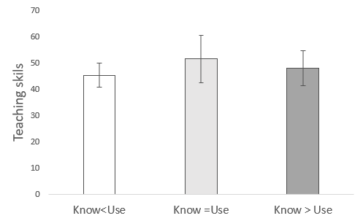 | 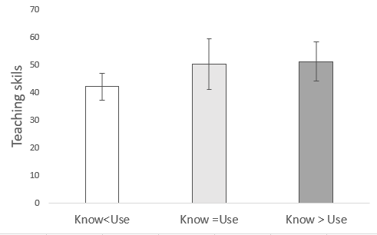
Figure 1c: Video conferencing | Figure 1d: Presentations
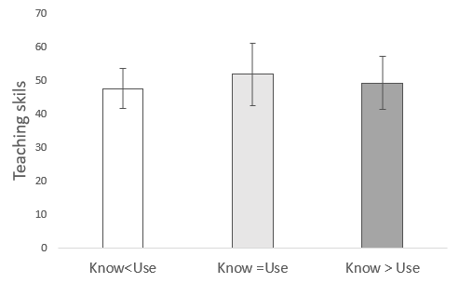 | 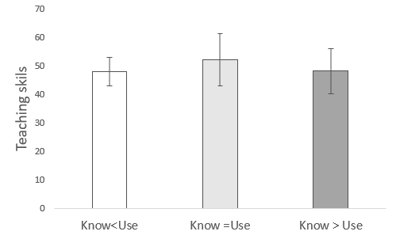
. Error bars represent ±SD.

Figures 2a-2d present the findings for the relationship between the three knowledge/usage profiles and the self-efficacy score for implementation of digital tools for the same four tools. The missing whiskers in some figures are due to similar values of the 25th and 75th percentiles and the 5th and 95th percentiles, respectively. Post hoc comparisons indicated that for whatsApp, emails and video conferencing, the scores for the profile know = use were significantly higher than the scores for know< use. Moreover, the score for know > use was significantly higher than the score for know < use for the tools of emails and video conferencing

Figures 2a-2d. Differences in implementation of digital tools according to the three profiles representing the gap between knowledge and usage.
Figure 2a: WhatsApp | Figure 2b: Email
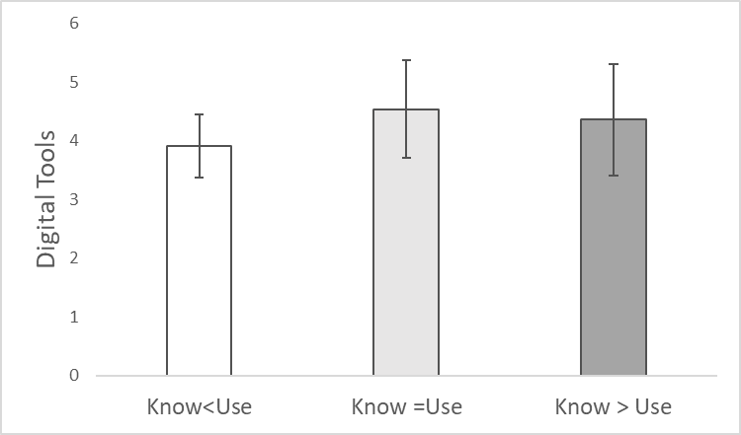 | 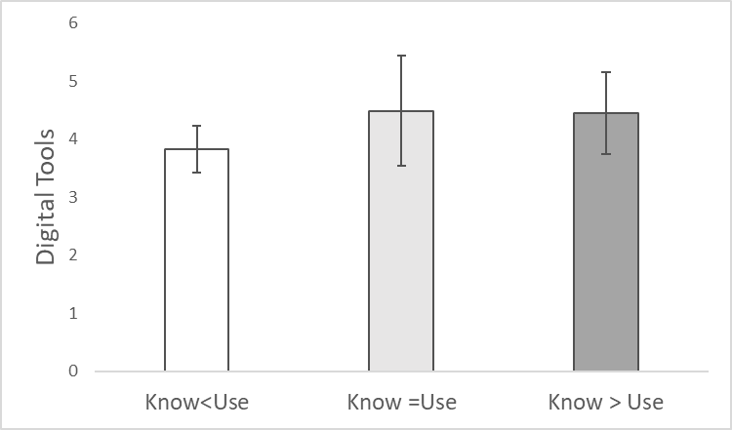
Figure 2c: Video conferencing | Figure 2d: Presentations
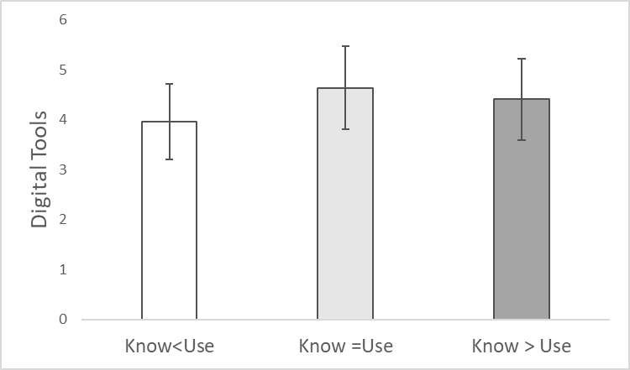 | 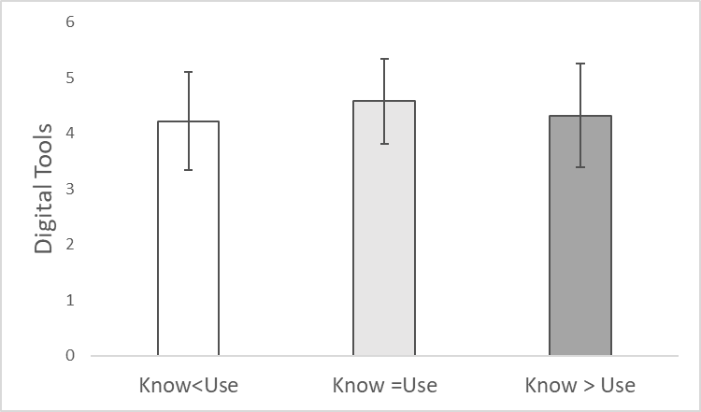
. Error bars represent ±SD.

The findings for the relationship between the three knowledge/usage profiles and the general self-efficacy score are presented in figures 3a-3d. The missing whiskers in some figures are due to similar values of the 25th and75th percentiles and the 5th and 95th percentiles, respectively. Post hoc comparisons indicated that for the tool of video conferencing, scores for know=use were significantly higher than scores for the two other profiles know<use and know> use. Moreover, the scores of know>use were significantly higher than those of know< use for emails.

Figures 3a-3d. Differences in implementation of digital tools according to the three profiles representing the gap between knowledge and usage.
Figure 3a: WhatsApp | Figure 3b: Email
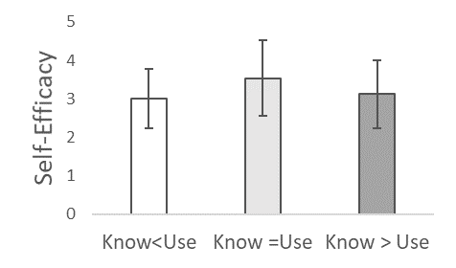 | 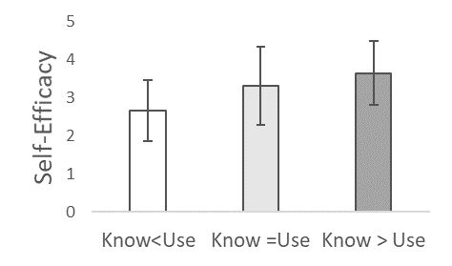
Figure 3c: Video conferencing | Figure 3d: Presentations
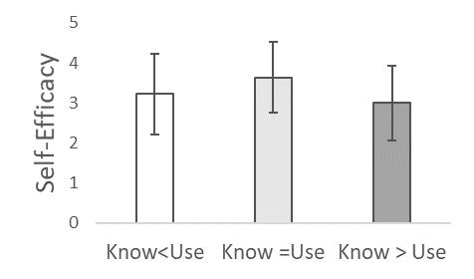 | 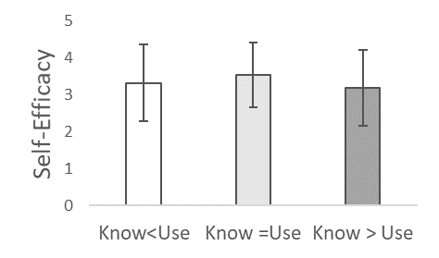
. Error bars represent ±SD.

One open-ended question furnished a deeper understanding of teachers' experience in distance learning during the Corona crisis: respondents were asked to reflect on distance learning during Corona. Answers were long and detailed, testifying willingness and need to reflect on the intense experiences. Qualitative coding of data driven themes was used to characterize the experience of EFL teachers in distance instruction. Data analysis was divided into three stages. At the first stage, respondents' answers were divided into meaning units and 220 meaning units were obtained. (A meaning unit is a sentence or two expressing one idea.) In the second stage, repeated patterns of meaning units were identified, and categorized. In the third stage, the categories were re-examined to better delineate their semantic field. The categories were divided into two main themes: challenges and advantages. The challenges category includes 154 meaning units and the advantages –66. Table 4 presents the challenges categories.

Table 4. Categories of challenges in distance EFL teaching reported by teachers during Corona crisis (N=154).
Category | Examples | Percentage of all answers
Lack of pedagogical-technological knowledge | I constantly ponder whether I am using the appropriate digital tool for a certain teaching strategy or language skill.  At the application stage, I feel I don't have an indication of what I'm doing is good.  Although I graduated college three years ago, I still feel challenged to integrate digital tools in a meaningful way in my teaching. | 25.3
Lack of professional guidance | What I miss is a template of an effective online lesson. Right now, in our online teaching, we are working through trial and error, without any pedagogical guidance.  None of the teachers in my school were prepared for this. Since the crisis started, we have received no actual advice how to deal with the situation, or any practical pedagogical advice concerning tools available online.  In my in-service professional courses, we were simply taught digital tools. We did not discuss when best to use them. | 18.9
Time consuming  lesson preparation | It’s challenging, exhausting and energy-draining  It takes a lot of time and effort to plan every online lesson. It has to be very accurate and efficient, very different from face-to-face teaching… takes time to get used to and it changes and develops constantly. | 14.46
Lack of face-to-face interaction with students. | What I miss most is the personal contact with my pupils.  I would much rather be in a classroom of 30-40 students. The personal interaction is missing: the ability to challenge them, help them, learn their individual strengths and weaknesses and adapt accordingly.  The opportunity to get to know them as people is missing, to see their reactions, to ease their doubts, their fears, to challenge them when necessary. All these are almost impossible in long distance. | 11.34
Table 4 indicates a stressful teaching experience derived from an overwhelming work load and new professional requirements without adequate support. In addition, teachers are deprived of a primary source of professional incentive – the interpersonal satisfying relationship with pupils. Table 8 presents the advantages categories.

Table 5. Categories of advantages in distance EFL teaching reported by teachers during Corona crisis (N=66).
Category | Examples | Percentage of all answers
Opportunity for professional development | I’m thankful for the opportunities during this time. to broaden my teaching tools and style  I feel I can take my teaching to a new level.  I've learnt new skills, and see the students in a different light. | 10.63
Facilitates meaningful, personalized and independent learning | It has created a more meaningful learning experience for the pupils since it allows more independent work and more personal feedback.  More independent work time (during which I'm available) has been built into the schedule. | 10.45
Satisfying experience | It is still incredibly fun and satisfying once you see how well the students cooperate and react to whatever new things you implement. | 8.92
Table 5 shows that the positive aspect of distance learning was the participants' experience of professional progress apparent in their students' significant learning outcomes.
Discussion
This study explores EFL teacher beliefs regarding their own pedagogical technological knowledge, its usage in classrooms and their feelings of self-efficacy (SE) in online ERT during the COVID-19 school lockdown. The first question explored teachers’ sources of knowledge regarding digital tools before and during the COVID 19 crisis. Our findings show that during the initial phase of the outbreak, teachers reported a significant increase in the use of four sources of knowledge: self-teaching, school colleagues, staff tutorials in school and online school support. We thereby infer that teachers had to expand their pedagogical technological knowledge; teachers who relied on themselves demonstrated an ability to make the necessary changes to teach in time of crisis (Hodges et al., 2020).

We did not find any significant increase in the reliance on pre-service teacher education and experiences, nor did teachers report that their in-service courses were useful. In pre-service education, the phrase "21st century skills" is common. Based on the findings of this study, however, when it became urgent to implement these skills, many teachers lacked sufficient professional technological preparation. This gap had previously been widely noted: 'Even though TPACK has been widely adopted in teacher education programs, its knowledge base is far less extensive and established as compared to PCK that forms the basis of methods courses.' (Koh, 2019 p.580). Clearly, in our age of rapid changes, teacher training at colleges cannot remain static and needs to be constantly updated for in-service training.

As the Covid crisis surprised the world it may be claimed that there was no time to prepare suitable in-service courses to accommodate the new reality, which explains teachers' dissatisfaction. Yet, this training should have been available earlier. Quantitative findings showed that teachers could not rely on previous in-service training. Teachers wished that they been better prepared in terms of technological digital skills and know-how. They noted that in-service courses lacked the requisite implementation of digital tools in teaching.

The importance of integrating meaningful teaching with technology is echoed in the literature. Koehler, Mishra, and Cain (2013) define TPACK as “an understanding that emerges from interactions amongst content, pedagogy, and technology knowledge […] knowledge underlying truly meaningful and deeply skilled teaching with technology” (p. 66). Educational research on initial teacher education programs supports the acquisition of teachers' professional knowledge and its relation to teacher education. Thomas, (2016) found that teachers' technological knowledge is critical for teachers' professional development. The significance of pedagogical and technological knowledge is widely acknowledged. Valtonen et.al. (2019) suggest that the strongest gains in teachers' development and confidence were for TPACK areas related to pedagogy, since these are arenas of endeavor, where pedagogical and technological knowledge interact. A primary source of teacher knowledge is teacher training courses. This sends a powerful message to program designers and instructors to include new digital tools in meaningful instruction. Most importantly, in our digital era, pre-service teacher training cannot offer long-term solutions. Teachers need to become independent and flexible learners, able to make meaningful interactions of pedagogy and technology independently, as well as solve problems.

The second research question examined whether there was a difference between the level of teacher knowledge of digital tools and their actual usage during the COVID 19 crisis. Findings indicated the only digital tool exhibiting no significant difference was video conferencing. Teachers reported significant knowledge gaps regarding all other tools. We surmised that in this unprecedented time of emergency and remote teaching, teachers mostly used video conferencing to substitute face-to-face lessons and enable a planned lesson in a digital format to move forward almost seamlessly. Similarly, other tools that were widely used, such as WhatsApp and emails, were designed to create communication and enable distance learning. Thus, the use of digital tools was not for pedagogical objectives; teachers did not fully implement all the advantages of distance learning.

The third question explored how the gap between knowledge and usage of DT relates to the challenges facing EFL teachers in the first period of the transition to distance learning. Findings indicate that teachers who reported knowing more about the tool than usage, or had similar levels of knowledge and usage, took control over their instruction. They could expand their digital knowledge and select appropriate materials. These teachers had the knowledge of cognition with its three aspects of cognitive awareness (Javid et.al., 2013; Schraw, 1998), and could implement knowledge congruously in their teaching. Those teachers whose knowledge was lower than usage encountered technological difficulties that impaired their teaching. This group lacked the professional metacognitive knowledge essential for successful teaching, illustrating the importance of reaching the application stage when acquiring knowledge is conditioned on understanding when, how, and where to use something, we already know (Yore & Treagust, 2006). This facilitates proficiency in the use of digital tools: independence, flexibility, and the ability to achieve goals by choosing appropriate teaching materials.

The fourth question explored the relationship of the gaps between teachers' knowledge and usage and their reported TSE. These gaps between knowledge and usage of DTs were also apparent in teachers' self-efficacy. Findings revealed that when teachers used DT more than they knew, all three SE scores: implementation of teaching skills, digital tools and general-self-efficacy - were low. Thus, not having the knowledge to implement tools affected their teaching and professional identity. Teachers with similar knowledge or knowing more of DT than usage, experienced high self-efficacy in their teaching and could adapt the tool within the pedagogical content.

In fact, during the first phase of the COVID -19 distance learning crisis, two distinct groups of teachers were formed: one experienced a dramatic decrease in their SE, and lost the flexibility and sense of control in their teaching, and a second flexible group saw COVID -19 as an opportunity to expand their teaching repertoire. This finding is backed up by the qualitative data.

Our findings pertaining to implementing DT tools in order to experience high SE in one's teaching are congruent with previous studies which emphasize success or failure in primary experience as a key source in TSE research (Usher & Pajares, 2008; Morris et al, 2016). Self-efficacy of DT per se plays a prominent role in digital learning processes and is a crucial construct in teachers’ belief systems that influences the failure and success of many aspects of education (Joo et.al, 2000; Klassen, Tze, Betts, & Gordon, 2011; Hoang, 2018). This is especially true in our ever-changing reality. Undoubtedly, self-efficacy of digital learning deserves further attention in research and practice.

The last question explored EFL teachers' perception of distance ERT, including challenges and opportunities. Findings showed that most of the EFL teachers' difficulties stemmed from a lack of pedagogical technological knowledge. These findings were supported by the quantitative findings. Teachers need to be shown how to integrate technology meaningfully in a specific pedagogical context to reach desired learning outcomes. Teaching digital tools separately does not achieve the desired outcomes. For effective teaching to take place, teachers must know in advance what their learning objectives are and find the most appropriate digital tool for the specific context. Interestingly, teachers who chose to describe the advantages in distance teaching during the Corona crisis indicated that it was an opportunity to sharpen and broaden their teaching tools. Although our study took place in an unprecedented situation - in ERT- when learners didn't have time to spend acquiring knowledge, there were teachers who seized the opportunity to expand their professional knowledge.

COVID-19 forced global education online. Our study, conducted in the heat of the moment, focuses on the significance of PTK as a crucial component of effective teaching and posits a strong link between teacher efficacy and PTK in online teaching. New digital learning depends on teachers' efficacy within their own technology. This includes teachers' beliefs about technology and their perceived and lived-in use of technology as an integral part of their teaching strategies. Teachers' beliefs regarding digital instruction should be forged in teacher education programs, both pre-service and in-service. Our findings strongly suggest a pressing need to raise teacher technology confidence; to broaden technological pedagogical cognitive skills, and enhance a culture of using technology meaningfully. As the present crisis showed failure to do so is at everybody's peril.

Our findings urge teacher education to enable teachers to take responsibility for becoming life-long independent digital learners (LLIDL). Digital instruction in teacher education programs should include more meaningful, relevant instruction, driven by teachers' initiative and interest. Teachers should be encouraged to make personal adaptations to new DT within their specific disciplinary contexts. Once teachers become familiar with adapting DT to an identified, desired pedagogical outcome, they will certainly be able to deploy new technology more effectively in the field. This is crucial if the promise of digital potential is to become classroom reality. Alarmingly, our findings show that right now this isn't the case. Although this research was conducted in EFL classrooms, we deem our findings applicable to various school subjects taught online during the first school lockdown.

The present study is heuristic and further study is necessary to install innovative approaches to enhance pedagogical-technological processes and methods within the constraints and opportunities of constantly changing technology, and to define the construct of SE in online education. While of course, Covid-19 has had debilitating consequences for many aspects of life. It's significance in teacher education is that in many countries in the world, understanding the policy decisions that flow from the increased role of digital technology in teaching will make hitherto unimaginable demands on the intellectual power and financial resource of educational policy makers. This present crisis has served as both wakeup and clarion call

Acknowledgments
With grateful thanks to Dr. Amihai Rigbi member of the research authority Beit Berl College and to the 129 English teachers contributing to this study.

References

Abbitt, J. T. (2011). An Investigation of the relationship between self-efficacy beliefs about technology integration and technological pedagogical content knowledge (TPACK) among preservice teachers. Journal of Digital Learning in Teacher Education, 27(4), 134–143. https://doi.org/10.1080/21532974.2011.10784670.
Anderson, S. E., Groulx, J. G., & Maninger, R. M. (2011). Relationships among preservice teachers’ technology-related abilities, beliefs, and intentions to use technology in their future classrooms. Journal of Educational Computing Research, 45(3), 321–338. https://doi.org/10.2190/EC.45.3.d.
Aston, P.T. (1984). Teacher efficacy: A motivational paradigm for effective teacher education. Journal of Teacher Education, 35(5), 28-32. https://doi.org/10.1177/002248718403500507.
Banas, J. R., & York, C. S. (2014). Authentic learning exercises as a means to influence preservice teachers’ technology integration self-efficacy and intentions to integrate technology. Australasian Journal of Educational Technology, 30(6), 728- 746. https://doi.org/10.14742/ajet.362.
Bandura, A. (1997). Self-efficacy: the exercise of control. New York: Freeman. Bandura, A. (2006). Guide for constructing self-efficacy scales. In F. Pajares & T. Urdan (Eds.), Self-efficacy beliefs of adolescents (Vol. 5, pp. 307–337). Greenwich: Information Age Publishing
Bandura, A. (1986). Social Foundations of thought and Action: A Social Cognitive Theory. Englewood Cliffs, New Jersey: Prentice-Hall.
Berliner, D. C. (2001). Learning about and learning from expert teachers. International Journal of Educational Research, 35(5), 463-482. https://doi.org/10.1016/S0883-0355(02)00004-6.
Berliner, D. C. (2004). Describing the behavior and documenting the accomplishments of expert teachers. Bulletin of Science, Technology & Society, 24, 200-212. https://doi.org/10.1177/0270467604265535.

Braun, V. & Clarke, V. (2006). Using thematic analysis in psychology. Qualitative Research in Psychology. 3(2), 77-101, DOI: 10.1191/1478088706qp063oa.
Chiang, M.-H. (2008). Effects of fieldwork experience on empowering prospective foreign language teachers. Teaching and Teacher Education, 24(5), 1270-1287. doi:10.1016/j.tate.2007.05.004.
Choi, E., & Lee, J. (2016). Investigating the relationship of target language proficiency and self-efficacy among nonnative EFL teachers. System, 58, 49-63. https://doi.org/10.1016/j.system.2016.02.010.
Creswell, J.W. (2009). Mapping the field of mixed methods research. Journal of Mixed Methods Research. 3 (2), 95-108. https://doi.org/10.1177/1558689808330883.

Creswell, J.W., Plano Clark, V.L., Gutmann, M.L & Hanson, W. E. (2003). Advanced mixed methods research designs. In A. Tashakkori & C. Teddlie (Eds), Handbook of Mixed Methods in Social and Behavioral Research. pp. 209-240. Thousand Oaks, CA:Sage.

Corebima, A. D. (2009). Metacognitive skill measurement integrated in achievement test. State University of Malang. http://recsam.edu.my/cosmed/cosmed09/AbstractsFullPapers2009/Abstract/Science Parallel PDF/Full Paper/01.pdf
Corry, M. & Stella, J. (2018). Teacher self-efficacy in online education: a review of the literature Research in Learning Technology, vol. 26, 1-11. https://doi.org/10.25304/rlt.v26.2047.
Darling-Hammond, L., & Bransford, J. (2007). Preparing teachers for a changing world: What teachers should learn and be able to do. San Francisco: Jossey-Bass.
Depaepe, F. & König, J. (2018). General pedagogical knowledge, self-efficacy and instructional practice: Disentangling their relationship in pre-service teacher education. Teaching and Teacher Education. 69, 177-190.
Deacon, A., Paxton, M. & Carr, T. (2000). Creating a project-based learning environment. Proceedings, Conference on Information Technology in Tertiary Education (CITTE), University of Port Elizabeth, South Africa, March. http://www.upe.ac.za/citte2000/ [viewed 5 Dec 2001, verified 26 Jan 2003 at http://www.upe.ac.za/citte2000/docs/adeacon.doc.

Dellinger, A.B., Bobbett, J.J., Olivier, D.F. & Ellett, C.D. (2008.) Measuring teachers’ self-efficacy beliefs: Development and use of the TEBS-Self. Teaching and Teacher Education. 24(3), 751-766. https://doi.org/10.1016/j.tate.2007.02.010

Doering, A., Koseoglu, S., Scharber,C., C., Henrikson, J., & Lanegran, D. (2014). Technology integration in K-12 geography education using TPACK as a conceptual model. Journal of Geography, 113(6), 223-237. http://doi.org/10.1080/00221341.2014.896393.
Faez, F. & Karas, M. (2017). Connecting language proficiency to (self-reported) Teaching Ability: a review and Analysis of research. RELC Journal. 48(1), 135-151. https://doi.org/10.1177/0033688217694755
Gan, Z., Liu, F., Yang, CCR. (2020). Student -teachers' self-efficacy for instructing self-regulated learning in the classroom. Journal of Education for Teaching. 46 (1), 120-123. https://doi.org/10.1080/02607476.2019.1708632.
Garrison, D. R. (2003). Cognitive presence for effective asynchronous online learning: The role of reflective inquiry, self-direction and metacognition. In J. Bourne, & J.C. Moore (Eds). Elements of quality online education: Practice and direction. The University of Calgary. 4, 47–58.
Gibson, K. (2008). Technology and technological knowledge: A challenge for school curricula. Teachers and Teaching: theory and practice, 14, 3–15. https://doi.org/10.1080/13540600701837582.
Gitomer, D. H., & Zisk, R. C. (2015). Knowing what teachers know. Review of Research in Education, 39, 1-53. https://doi.org/10.1080/21532974.2011.10784670.

Goddard, R. D., Hoy, W.K.& Hoy, A. W. (2000). Collective Teacher Efficacy: Its Meaning, Measure, and Impact on Student Achievement. 37(2), 479-507. American Research Journal. https://doi.org/10.3102/00028312037002479
Göker, S. D. (2012). Impact of EFL teachers’ collective efficacy and job stress on job satisfaction. Theory and Practice in Language Studies, 2(8), 1545–1551. https://doi.org/10.4304/tpls.2.8.1545-1551.
Grossman, P. L., & McDonald, M. (2008). Back to the future: Directions for research in teaching and teacher education. American Educational Research Journal, 45(1), 184-205. https://doi.org/10.3102/0002831207312906.
Hoang, T. (2018). Teacher Self-efficacy Research in English as Foreign Language Contexts: A Systematic Review. The Journal of Asia TEFL Vol. 15, No. 4, Winter 2018, 976-900. http://dx.doi.org/10.18823/asiatefl.2018.15.4.6.976.
Hodges, C. Moore, S. Lockee, B. Trust, T. and Bond, A. (2020), “The difference between emergency remote teaching and online learning”, EDUCAUSE.https://er.educause.edu/articles/2020/3/the-difference-between-emergency-remote-teaching-and-online-learning.
Jacobse, A. E., & Harskamp, E. G. (2012). Towards efficient measurement of metacognition in mathematical problem solving. Metacognition and Learning, 7(2), 133–149. https://doi-org.mgs.oranim.ac.il/10.1007/s11409-012-9088-x.
Javid, S., Alavi, H. R., & Pour, M. F. (2013). The relationship between religious commitment with meta-cognitive skills and philosophical mindedness of the graduate students of Kerman City Universities in the academic year 2011–2012. Journal of Religion and Health, 54(3), 943–953. https://doi.org/10.1007/s10943-013-9808-9.
Jeung, H. H. (2014). Understanding teachers’ continuance intentions towards distance training program: An Extension of technology acceptance model. Journal of Lifelong Learning Society, 10(2), 229–262. https://www.jstor.org/stable/26458506
Johnson, R. B., Onwuegbuzie, A. J., & Turner, L. A. (2007). Toward a definition of mixed methods research. Journal of Mixed Methods Research, 1(2), 112-133. https://doi.org/10.1177/1558689806298224.
Joo, Y. J., Park, S., & Lim, E. (2018). Factors Influencing Preservice Teachers’ Intention to Use Technology: TPACK, Teacher Self-efficacy, and Technology Acceptance Model. Journal of Educational Technology & Society, 21(3), 48–59. https://www.jstor.org/stable/26458506
Joo, Y., Bong, M., & Choi, H. (2000). Self-efficacy for self-regulated learning, academic self-efficacy, and Internet self-efficacy in Web-based instruction. Educational Technology Research and Development, 48(2), 5-17. https://doi.org/10.1007/BF02313398.
Kitao, K., & Kitao, K. (2000). Online resources and journals: ELT, linguistics, and communication. http://www.ling.lancs.ac.uk/staff/visitors/kenji/onlin.htm.
Kaygisiz, G.M., Ulgun, N. & Ulcar, F. M. (2020). The relationship between the level of self-efficacy beliefs of pre-service teachers and their levels of determining suitable taxonomy, strategy, and method-technique for science objectives. Science Education International, 31(1),117-126. https://doi.org/10.33828/sei.v31.i1.12.
Klassen, R. M., Tze, V. M., Betts, S. M., & Gordon, K. A. (2011). Teacher efficacy research 1998–2009: Signs of progress or unfulfilled promise? Educational Psychology Review, 23(1), 21-43. https://doi.org/10.1007/s10648-010-9141-8.
Klassen, R.M. & Tze, VMC. (2014). Teachers' self-efficacy, personality, and teaching effectiveness: a meta-analysis. Educational Research Review, 12, 59-76. https://doi.org/10.1016/j.edurev.2014.06.001.

Koehler, M. J., Mishra, P., & Cain, W. (2013). What is technological pedagogical content (TPACK)? Journal of Education, 193(3), 13-19. https://doi.org/10.1177/002205741319300303.

Koehler, M. J., & Mishra, P. (2008). Introducing TPACK. In J. A. Colbert, K. E. Boyd, K. A. Clark, S. Guan, J. B. Harris, M. A. Kelly & A. D. Thompson (Eds.), Handbook of Technological Pedagogical Content Knowledge for Educators (pp. 1–29). New York: Routledge.
Koh, J. H. L. (2019). TPACK design scaffolds for supporting teacher pedagogical change. Educational Technology Research and Development 67:577–595 https://doi.org/10.1007/s11423-018-9627-5 .
Krishnan, I. A., Ching H. S., Ramalingam, S.J., Maruthai, E., Kandasamy, P., De Mello, G., Munian, S., Ling, W.W. (2020). Challenges of Learning English in 21st Century: Online vs. Traditional During Covid-19. Malaysian Journal of Social Sciences and Humanities .5(9), 1-15. https://doi.org/10.47405/mjssh.v5i9.494.
König, J., Lammerding, S, Nold, G., Rohde, J., Strauss, S., & Tachtsoglou, S. (2016). Teachers’ Professional Knowledge for Teaching English as a Foreign Language: Assessing the Outcomes of Teacher Education. Journal of Teacher Education. 67(4) 320–337. https://doi.org/10.1177/0022487116644956.
Marta, L. M.C. (2018). Comparing online English language learning and face-to-face English language learning at el Bosque university in Colombia. https://doi.org/10.25772/CPER-NM95.
Martin, F; Budhrani, K; Kumar, S. & Ritzhaupt, A. (2019). Award-winning faculty online teaching practices: roles and competencies. Online Learning. 23 (1). 184-205. https://doi.org/10.1016/j.iheduc.2019.04.001.
Meloni, C. (2000). The Internet in the classroom: A valuable tool and resource for ESL/EFL Teachers. ESL Magazine. www.eslmag.com/Article.htm.
Mishra, P. & Koehler, M. J. (2006) ‘Technological pedagogical content knowledge: a new framework for teacher knowledge’, Teachers College Record, vol. 108, pp. 1017–1054. https://doi.org/10.1111/j.1467- 9620.2006.00684.x.
Morris, D. B., Usher, E. L., & Chen, J. A. (2016). Reconceptualizing the sources of teaching self-efficacy: A critical review of emerging literature. Educational Psychology Review, 29(4), 795-833. https://doi-org.mgs.oranim.ac.il/10.1007/s10648-016-9378-y.
Newby, T. J., et al., (2011) Educational Technology for Teaching and Learning, 4th ed., Allyn & Bacon/Pearson Education, Inc., Boston, MA.
Niederhauser, D. S. & Stoddart, T. (2001) ‘Teachers instructional perspectives and use of educational software’, Teaching and Teacher Education, vol. 17, pp. 15–31. https://doi.org/10.1016/S0742-051X(00)00036-6.
Pajares, F. (2006). Self-efficacy during childhood and adolescence: implications for teachers and parents. In F. Pajares & T. Urdan (Eds.), Self-efficacy beliefs of adolescents (pp. 117–137). Greenwich: Information Age Publishing.

Phan, N.T.T. & Locke, T. (2015). Sources of self-efficacy of Vietnamese EFL teachers: A qualitative study. Teaching and Teacher Education. 52, 73-82. https://doi.org/10.1016/j.tate.2015.09.006

Pu, H. (2020). Implementing online ELT in the time of crisis: ordeal or opportunity? English Language Teaching.74(3). https://doi-org.mgs.oranim.ac.il/10.1093/elt/ccaa030.
Schraw, G. (1998). Promoting general metacognitive awareness. Instructional Science, 26(1– 2), 113–125. https://doi.org/10.1023/A:1003044231033.
Semiz, K., &Ince, L. I. (2012). Pre-service physical education teachers’ technological pedagogical content knowledge, technology integration self-efficacy and instructional technology outcome expectations. Australasian Journal of Educational Technology, 28(7), 1248–1265. https://doi.org/10.14742/ajet.800.
Shulman, L. S. (1986). Those who understand: Knowledge growth in teaching. Educational Researcher, 15 (2), 4–14. https://doi.org/10.3102/0013189X015002004.
Shulman, L. S. (1987). “Knowledge and Teaching: Foundations of the New Reform”. Harvard Educational Review, 57, 1–22. https://doi.org/10.17763/haer.57.1.j463w79r56455411.
Sperling, R. A., Howard, B. C., Miller, L. A., & Murphy, C. (2002). Measures of children’s knowledge and regulation of cognition. Contemporary Educational Psychology, 27(1), 51–79. https://doi.org/10.1006/ceps.2001.1091.
Sugiharto, B; Corebima, A Susilo, H. & Ibrohim. (2018). A comparison of types of knowledge of cognition of pre-service biology teachers. Asia-Pacific Forum on Science Learning and Teaching, 19(1), 1 -16.
Thomas, S. (2016). Future Ready Learning: Reimagining the Role of Technology in Education. 2016 National Education Technology Plan. Office of Educational Technology, US Department of Education. http://www2.ed.gov/about/offices/list/os/technology/index.html
Tschannen-Moran, M & Woolfolk Hoy, A. (2001). Teacher efficacy: capturing an elusive construct. Teaching and Teacher Education, 17(1), 783-805. https://doi.org/10.1016/S0742-051X(01)00036-1.
Underwood, P. R. (2012). Teacher beliefs and intentions regarding the instruction of English grammar under national curriculum reforms: A theory of planned behaviour perspective. Teaching and Teacher Education, 28(6), 911–925. https://doi.org/10.1016/j.tate.2012.04.004.
Usher, E. L., & Pajares, F. (2008). Sources of self-efficacy in school: critical review of the literature and future directions. Review of Educational Research, 78, 751–796. https://doi.org/10.3102/0034654308321456.
Valtonen, T., Kukkonen, J., Kontkanen, S., Dillon, P., & Sointu, E. (2015). The impact of authentic learning experiences with ICT on pre-service teachers’ intentions to use ICT for teaching and learning. Computers & Education, 81, 49–58. https://doi.org/10.1016/j.compedu.2014.09.008.
Valtonen, T., Sointu, E., Kukkonen, J., Makital, J., Hoang, N., Paivi, H., Jarvela, S. Naykki, A., Pontinen, S., Kostianen, E., Tondeuir, J. ( 2019). Examining pre-service teachers' technological pedagogical content knowledge as evolving knowledge domains: a longitudinal research . Journal of Computer Assisted Research. .https://doi-org.mgs.oranim.ac.il/10.1111/jcal.12353.
Thompson, G. & Woodman, K, (2018): Exploring Japanese high school English teachers’ foreign language teacher efficacy beliefs, Asia-Pacific Journal of Teacher Education, https://doi.org/10.1080/1359866X.2018.1498062.
Warschauer, M. (2000). The changing global economy and the future of English teaching. TESOL Quarterly, 34(3), 511-535. https://doi-org.mgs.oranim.ac.il/10.2307/3587741.
Wyatt, M. (2014). Towards a re-conceptualization of teachers’ self-efficacy beliefs: tackling enduring problems with the quantitative research and moving on. International Journal of Research and Method in Education, 37(2), 166–189. https://doi.org/10.1080/1743727X.2012.705275.
Yilmaz, C. (2011). Teachers' perceptions of self-efficacy, English proficiency, and instructional strategies. Social Behavior and Personality. 39(10), 91-100. https://doi.org/10.2224/sbp.2011.39.1.91.
Yore, L. D., & Treagust, D. F. (2006). Current realities and future possibilities: Language and science literacy—empowering research and informing instruction. International Journal of Science Education, 28(2–3), 291–314. https://doi.org/10.1080/09500690500336973.
Zimmerman, B.J.2000. Self-efficacy: an essential motive to learn. Contemporary Educational Psychology. 25:82-91. https://doi.org/10.1006/ceps.1999.1016.
Zonoubi, R., Eslami Rasekh, A., & Tavakoli, M. (2017). EFL teacher self-efficacy development in professional learning communities. System, 66, 1–12. https://doi.org/10.1016/j.system.2017.03.003.

Appendix A

