TEXTILE INDUSTRY

**Spindle whorls**

Spindle whorls are tools used in the process of spinning and plying a yarn: they provide a rotating movement to the spindle and add a specific weight to keep fibres in tension. They are pierced in the middle to allow the insertion of the shaft and can vary in shape, material, dimension and weight. Shapes can be very different and can include discoid, cylindrical, spherical, plano-convex and conical items and can be influenced by technical requirements (*i.e.* a faster rotation requires a smaller diameter), material sources (bone plano-convex whorls are generally obtained by animal bones epiphyses) and even by fashion. Some of the most common materials in which they are produced are wood (rarely survived in archaeological contexts), bone, stone, pottery, metal and glass, which vary depending on chronology and geographic area under examination. Dimensions can vary between 8 mm of diameter to 8 cm and between 1 g (Liu 1978, 90) and 140-150 g of weight (Gleba 2008, 106). Dimensions and weights are the most important parameters, since they deeply affect the final result: a small and light spindle whorl will produce a thin thread, while a heavy and large whorl is required to spin a thick thread (Andersson Strand 2010, 13–14). This wide range of differences makes their identification very difficult, especially when they have to be distinguish from beads and, for the largest and heaviest examples, from loom weights. Another important parameter is hole diameter, since it has to be large enough to allow the insertion of a shaft.

Hazor area M has provided a very limited set of spindle whorls, only 18, which shows a great variation in shapes, less in materials and weights. Most of the objects belong to Iron Age II A and C, very few are dated to the Late Bronze Age. Several different shapes can be recognized. Half of the whorls are characterised by the plano-convex shape, while conical and biconical specimens are represented by a very limited amount of whorls. A single specimen of button, discoid and cylindrical whorls are known as well. Interestingly, plano-convex whorls are not all made of bone, but four specimens are made of stone and one of pottery. Stone is the dominant material, while bone and pottery whorls are generally less common. Weights can range between 3 and 60 g, but a quite large group of whorls are lighter than 10 g, another group has a medium weight between 10 and 30 g and only one specimen weighs 60 g (a biconical pottery whorl which could be a loom weight) (Cimadevilla 2012, 559). Even if the sample is too small to draw safe conclusions, it seems that yarn production in Hazor area M was oriented to a medium-high quality.

**Perforated sherds**

Perforated sherds are reworked pottery sherds with a single hole in the middle, which allows the insertion of a shaft for being used as spindle whorls. Many studies have been conducted on these simple tools, providing evidence that they can work as spindle whorls quite well (Shamir 1996, 150; Laurito, Lemorini, and Perilli 2014, 164; Rahmstorf et al. 2015, 271). Furthermore, they are cheap and easy to produce. However, not all sherds with a hole should be considered as whorls. In fact, hole should be large enough to fit a shaft, straight and possibly in central position. Holes and shapes can be very different, since some sherds are perfectly rounded and other roughly chipped to get a rounded shape. Holes can be perfectly cylindrical or hourglass, the last one being is more problematic and requiring padding to prevent the whorl from wobbling during spinning.

Although they are extremely common in the Levant and in Hazor as well (Cimadevilla 2012, 562), area M shows a very limited use of these artefacts. Only 8 specimens have been recognised, mostly dated to Iron Age IIC. Even if it is a very limited sample, they are characterised by all the typologies discussed before, ranging from well rounded to roughly chipped sherds. Holes are almost all hourglass, with just one example of cylindrical hole. Diameters span from 3 to 6.5 cm, and weight from 9.9 to 38.9 g, showing that they could have a quite large variability of usage.

**Loom weights**

A total of 48 loom weights were found in Area M at Hazor until 2014. They are almost all doughnut or spherical[1] in shape and made of poorly fired or unfired clay. Almost all come from Iron Age II levels.

An exception is represented by a cylindrical object, roughly cut, but with a well-shaped, cylindrical hole. Its dimensions and weight are compatible with a use as loom weight. Another interesting object is a broken weight which is very likely a flat rectangular weight. It is made of baked clay and part of a hole is preserved, and another one can be conjectured.

Dimensions and weights of clay loom weights are quite different. Many weights are incomplete or crumbled (unbaked clay loom weights are generally poorly preserved) and these data can only be inferred. Those which are complete or almost complete show broad differences, especially in weight. The largest loom weight has a diameter of 13.2 cm and a weight which should be near to one kg. Other loom weights do not exceed 300 g but most of the objects should have weights around 400/500 g. Height generally ranges between 3.5 and 6 cm and diameter between 4.5 and 8.8 cm, with most of the objects near 8 cm. Weight distribution shows that most of the objects have medium measures, which make them suitable for several warp settings. In fact, very light and very heavy loom weights allow only specific warp settings and final products, while medium weights can be used for a wider types of products (Andersson Strand 2012, 211).

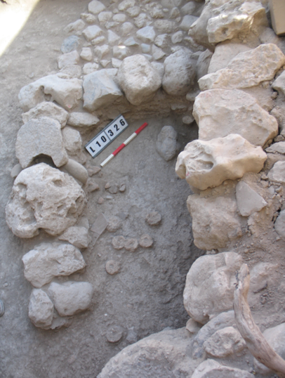Findspot

Most of the loom weights come from scattered loci of the area with no connection with other textile tools. However, a group comes from an industrial area at the northern edge of the tell. Here a basalt vessel workshop (Ebeling and Rosenberg 2015; Rosenberg and Ebeling 2018), was identified outside a pillared building. The building is dated to the 9th century BCE, but it was divided in smaller units in the 8th century, when the workshop was built. Three layers of beaten earth floors were identified in the workshop and fill contained ashes, organic materials, pottery sherds and pebbles. In the northeastern part of the room a square area delimited by two walls contained a dozen of clay loom weights scattered on the floor (L. 10-306 and 10-326, fig. 4). Their distribution allows to suppose that they were not in use on a loom at the moment of abandonment of the building. Several stone installations were also present in other parts of the room, together with two dozen of unfinished basalt vessels, some tools and spindle whorls. Unfortunately, at the moment of study the loom weights were almost completely crumbled and, in most cases, did not allow a reconstruction. The presence of textile tools in a workshop is not uncommon in Israel(Cassuto 2017, 193).

**Other tools: bone spatulae, spindles, needles**

Other objects could be linked to textile production, like bone shafts and spatulae. Bone shafts could be interpreted as tools used in spinning activities, as spindles or distaffs, or for other tasks, like kohl sticks or hair pins (Peyronel 2004, 55; Sauvage 2014, 205). The discussion of their function is mainly focused on Syrian implements, but southern Levant shows similar objects in Late Bronze and Iron Age contexts (Sauvage 2014, 198–200).

In Hazor, bone shafts from Area M are all datable to Iron Age II. They present a diameter between 0.7 and 1 cm, which makes them suitable as spindles/distaffs, but are unfortunately preserved only for few cm in length and do not allow a clear identification. Fragments do not show the typical decoration with lattice, herringbone and oblique patterns, but since the point of the shaft is the part more frequently preserved and decoration is generally placed at the “top” of the shaft it is not surprising.

Bone spatulae can be possibly connected to weaving: they could be used for packing weft and correcting small errors (Cecchini 1992, 16; Kemp and Vogelsang-Eastwood 2001, 358–73). In the Southern Levant, spatulae are known especially from Iron Age contexts and Hazor is not an exception (Bechar 2012). They are obtained by animal ribs, longitudinally cut in half and one of the extremities is cut to obtain a point. The other end is flat or rounded. Points are generally short and triangular in shape, but pen-nib examples are present as well. Implements from Hazor clearly show that they were generally not further refined and smoothness is acquired through use. In fact, many objects have cancellous bone exposed. It is visible at the rounded end and can be rough or partially smooth. Near the point, cancellous bone is smoother or completely obliterated, and this fact suggests a use of the tool only for its pointed part. Wear traces are compatible with rubbing on soft materials, like textiles and threads.

In conclusion, textile industry from Area M appears quite modest and does not seem to indicate the presence of large workshops for the production of fabrics. Tools are scattered through the area without indicating specific spaces for the production of textiles. Moreover, the only cluster identified is made by a small number of loom weights, which suggests that they either pertained to a very small loom or were simply stored there and weaving occurred elsewhere. Most of the objects here examined are dated to Iron Age II. A similar situation is known in other Southern Levantine sites, with the largest number of textile tools recovered in Iron Age II contexts (*e.g*. Megiddo (Lamon and Shipton 1939, 93–95; Sass 2000, 372), City of David (Shamir 1996, 135) or Tell el-Far’ah N (Chambon 1984, fig. 75). Typology of Hazor textile tools is consistent with other Levantine sites. In fact, shapes and materials of spindle whorls and loom weights are the same of many other Levantine sites, such as Megiddo(Lamon and Shipton 1939, 93–95), Tell es-Safi (Cassuto 2018), City of David (Shamir 1996), Tel Miqne (Shamir 2007), as is the presence of bone spatulae (e.g. Beth Shean (Yahalom-Mack and Mazar 2006, fig. 13.10), Megiddo (Lamon and Shipton 1939, 95–96) or Lachish (Sass 2004, fig. 28.12).

Fig. 1

|  |  |  |  |  |  |  |  |  |  |  |
| --- | --- | --- | --- | --- | --- | --- | --- | --- | --- | --- |
| No. | Object | Reg. No. | Chronology | Locus | Material | H. | D. | Hole | W. (g) | Notes |
| 1 | spindle whorl | 70416a | IA IIC | 6537 | ivory | 0.8 | 2.5 | 0.4 | 5.03 | dome (Cimadevilla 2012, fig. 12.2.11) |
| 2 | spindle whorl | 34618 | LBA destruction | 5571 | bone | 0.7 | 2.2 | 0.3 | 3.07 | dome |
| 3 | spindle whorl | 92956 | IA IIC | 13-522 | stone | 1.6 | 2.5 | 0.6 | 13.78 | dome |
| 4 | spindle whorl | 74688 | IA IIC | 09-345 | stone | 1.8 | 3.2 | 0.7 | 21.09 | dome |
| 5 | spindle whorl | 30891 |  | 5122 | stone | 1.4 | 2.7 | 0.4 | 11.69 | conical |
| 6 | spindle whorl | 34413 | LBA destruction | 5555 | stone | 0.9 | 2.1 | 0.25 | 5.55 | conical |
| 7 | spindle whorl | 37938 | LBA fill | 5797 | stone | 1 | 2.9 | 0.3 | 7.6 | dome |
| 8 | spindle whorl | 75485 | IA IIA-B | 10-320 | baked clay | 3.1 | 3.5 | 0.3 | 33.45 | biconical |
| 9 | spindle whorl | 76167 | IA IIA | 10-378 | bone | 0.9 | 2.4 | 0.3 | 4.48 | dome |
| 10 | prf. sherd | 38097 | IA IIC | 5784 | pottery | 0.9 | 3.4 | 0.25 | 13.8 |  |
| 11 | prf. sherd | 72359 | IA IIC | 07-332 | pottery | 0.9 | 5.3 | 0.5 | 32.65 |  |
| 12 | prf. sherd | 38800 | LBA fill | 5885 | pottery | 0.7 | 3.4x3.9 | 0.4 | 9.91 |  |

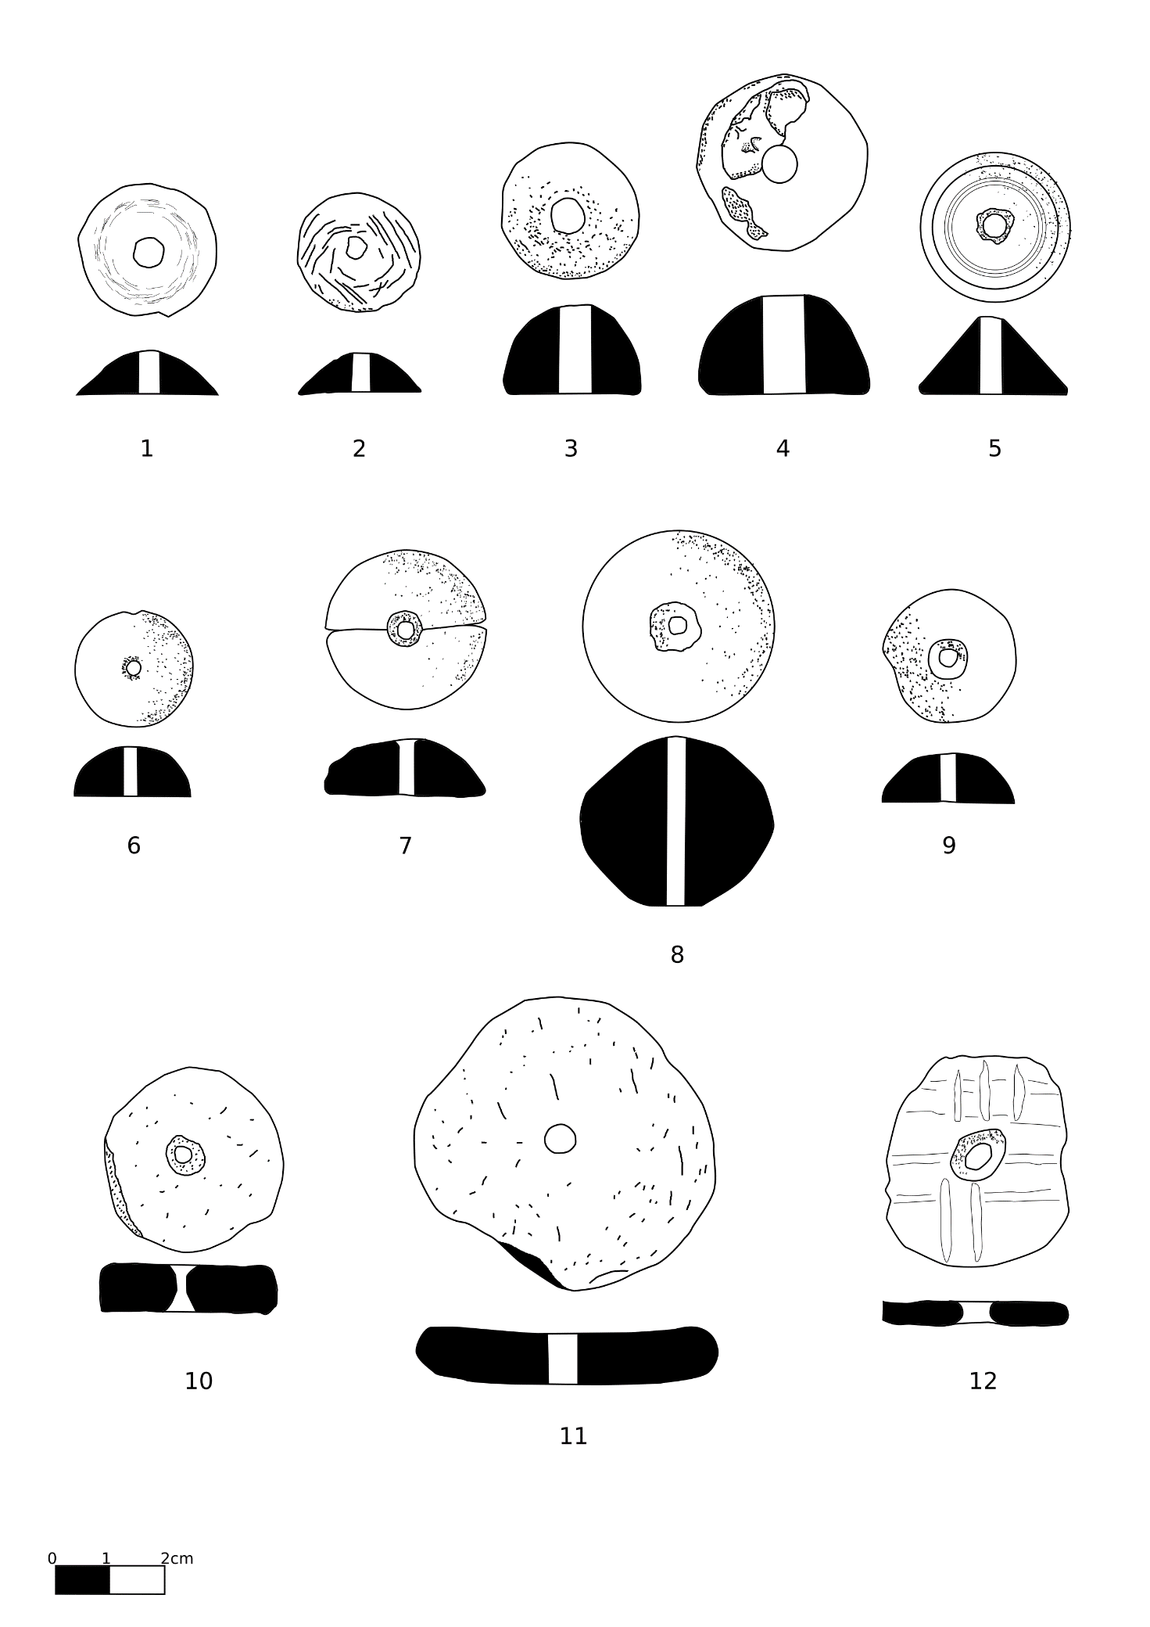

Figure 1 Spindle whorls and perforated sherds

|  |  |  |  |  |  |  |  |  |  |  |
| --- | --- | --- | --- | --- | --- | --- | --- | --- | --- | --- |
| Fig. 2 | |  |  |  |  |  |  |  |  |  |
| No. | Object | Reg. No. | Chronology | Locus | Material | H. | D. | Hole | W. (g) | Notes |
| 1 | loom weight | 34834 | baulk | 8M N 15-16 | baked clay | 4.1 | 6.4 | 1.7 | 140 | doughnut |
| 2 | loom weight | 30092 | IA IIC | 5016 | baked clay | 3.6 | 4.5 | 0.4 | 53+x | spherical |
| 3 | loom weight* | 37719 | Iron Age fill | 5772 | baked clay | 4.2 | 4.2x4.5 | 0.3 | 60.77 | biconical |
| 4 | loom weight | 37525 | Iron Age fill | 5777 | clay | 4.4 | 7.5 | 1.6 | 146+x | doughnut |
| 5 | loom weight | 70408 | LBA | 6533 | baked clay | 8.9 | 6.5 | 2.7 | 162+x | flat rectangular |
| 6 | loom weight | 72457 | IA IIC | 07-329 | baked clay | 5.1 | 5.9 | 0.6 | 148+x | spherical |
| 7 | loom weight | 72927 | IA IIC | 07-374 | baked clay | 5.9 | 8.3 | 1.3 | 233+x | spherical |
| 8 | loom weight | 73047 | IA IIC | 08-306 | baked clay | 5.3 | 7.9 | 1.5 | 232+x | spherical |
| 9 | loom weight | 76261 | IA IIC | 10-326 | clay | 3.5 | 7.5 | 1.8 | 141+x | doughnut |

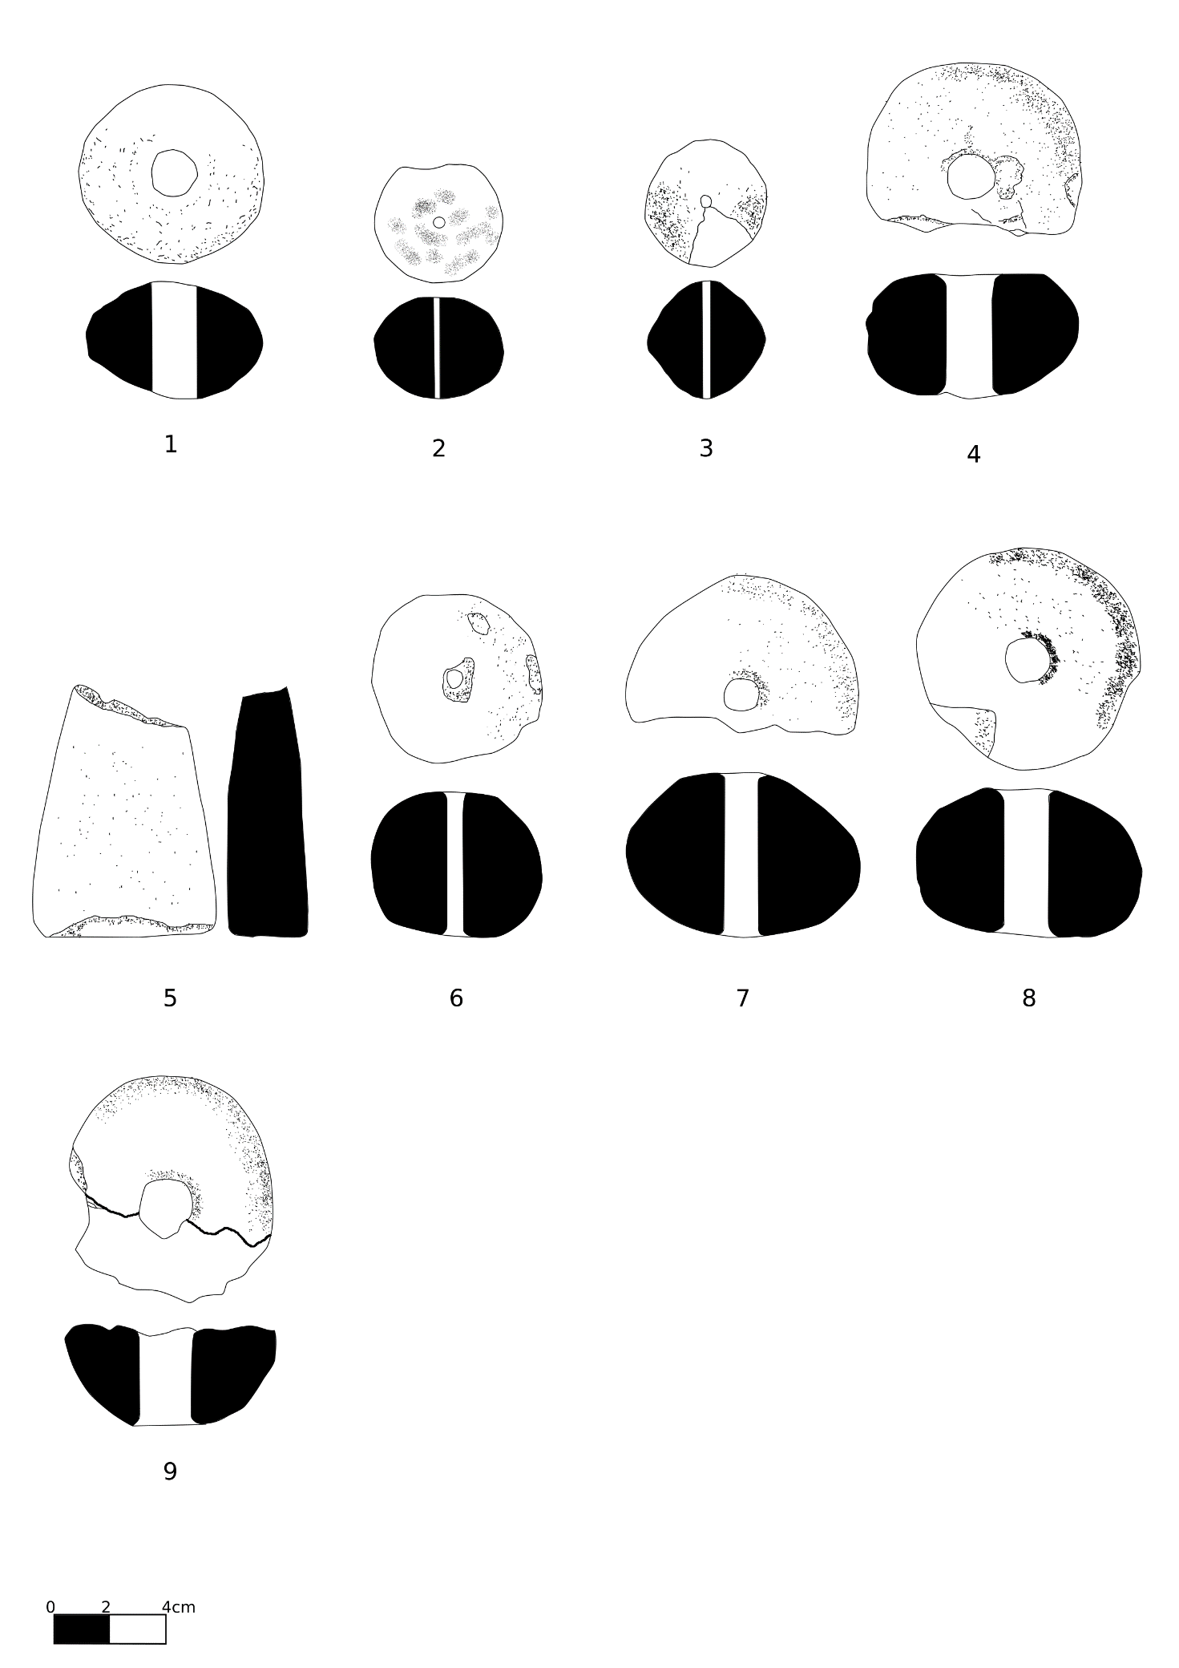

Figure 2 Loom weights

|  |  |  |  |  |  |  |  |  |  |  |  |
| --- | --- | --- | --- | --- | --- | --- | --- | --- | --- | --- | --- |
| Fig. 3 | | |  |  |  |  |  |  |  |  |  |
| No. | Object | Reg. No. | Chronology |  | Locus | Material | H. | D. | Th. | W. (g) | Notes |
| 1 | spatula | 78802 | IA IIC |  | 15-303 | bone | 4.7 | 1.8 | 0.2 |  |  |
| 2 | spatula | 74336 | IA IIC |  | 09-319 | bone | 4.1 | 1.9 | 0.1 |  |  |
| 3 | spatula | 38198 | LBA fill |  | 5801 | bone | 5.8 | 2.1 | 0.2 |  |  |
| 4 | spatula | 32407 | baulk |  | BM/L-10 | bone | 5.5 | 2.5 | 0.2 |  |  |
| 5 | spatula | 75009 | IA IIC |  | 09-350 | bone | 8 | 2.1 | 0.2 |  |  |
| 6 | spatula | 31802 |  |  | 5229 | bone | 11.9 | 2.6 | 0.2 |  |  |
| 7 | shaft | 93332 | IA IIC |  | 14-520 | bone | 4.6 | 0.7 |  |  |  |
| 8 | shaft | 73115 | 8th century fill |  | 08-316 | bone | 6.5 | 0.8 |  |  |  |
| 9 | shaft | 72378 | IA IIC |  | 07-329 | bone | 8.2 | 0.8 |  |  | floor above 10-326 |

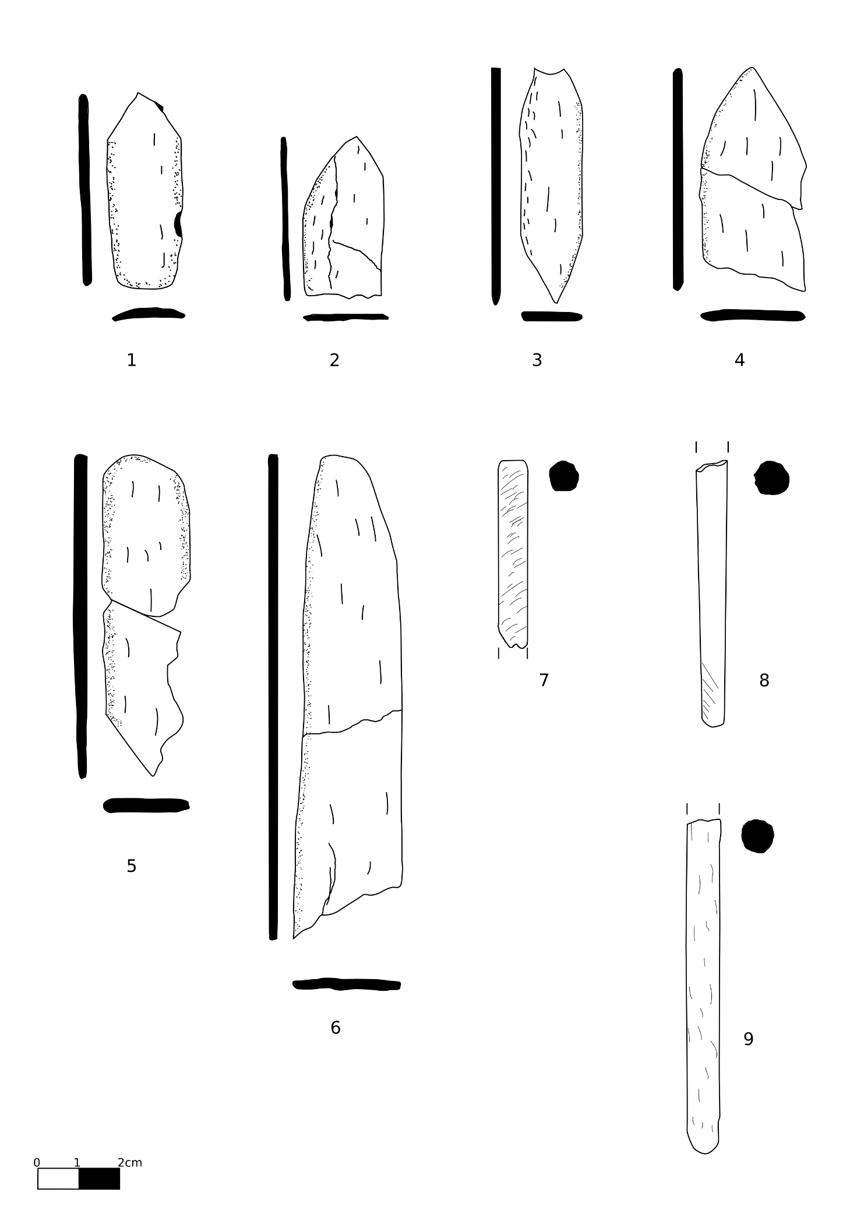

Figure 3 Bone shafts and spatulae

**Bibliography**

Andersson Strand, Eva. 2010. ‘The Basics of Textile Tools and Textile Technology’. In *Textile Terminologies in the Ancient Near East and Mediterranean from the Third to the First Millennia BC*, edited by Marie-Louise Nosch and Cécile Michel, 10–22. Oxford: Oxbow Books.

Andersson Strand, Eva. 2012. ‘From Spindle Whorls and Loom Weights to Fabrics in the Bronze Age Aegean and Eastern Mediterranean’. In *Kosmos: Jewellery, Adornement and Textiles in the Aegean Bronze Age”. Proceedings of the 13th International Aegean Conference (University of Copenhagen, Danish National Research Foundation’s Centre for Textile Research, 21-26 April 2010)*, edited by Marie-Louise Nosch and Robert Laffineur. Aegaeum 33. Liège: Peeters.

Bechar, S. 2012. ‘Worked Bone, Ivory and Horn Objects’. In *Hazor VI : The 1990-2009 Excavations: The Iron Age*, edited by Amnon Ben-Tor, Doron Ben-Ami, and Débora Sandhaus, 496–505. Jersualem: Israel Exploration Society.

Cecchini, Serena M. 1992. ‘Gli Avori e Gli Ossi. Appunti Sull’attività Tessile in Siria Del Nord Durante l’Età Del Ferro’. *Tell Afis e l’Età del Ferro* 2 (= Seminari di Orientalistica 2), 3–27. Pisa: Giardini.

Cimadevilla, Manuel. 2012. ‘Loom Weights and Spindle Whorls’. In *Hazor VI : The 1990-2009 Excavations: The Iron Age*, edited by Amnon Ben-Tor, Doron Ben-Ami, and Débora Sandhaus, 559–63. Jersualem: Israel Exploration Society.

Ebeling, Jennie, and Danny Rosenberg. 2015. ‘A Basalt Vessel Workshop and its Products at Iron Age Hazor, Israel’. *Journal of Field Archaeology* 40 (6): 665–74.

Gleba, Margarita. 2008. *Textile Production in Pre-Roman Italy*. Oxford: Oxbow Books.

Kemp, Barry J., and Gillian Vogelsang-Eastwood. 2001. *The Ancient Textile Industry at Amarna*. London: Egypt Exploration Society.

Laurito, Romina, Cristina Lemorini, and Assunta Perilli. 2014. ‘Making Textiles at Arslantepe, Turkey, in the 4th and 3rd Millennia BC. Archaeological Data and Experimental Archaeology’. In *Wool Economy in the Ancient Near East*, edited by Catherine Breniquet and Cécile Michel, 151–68. Oxford: Oxbow Books.

Liu, Robert K. 1978. ‘Spindle Whorls. Part I: Some Comments and Speculations’. *The Bead Journal* 3: 87–103.

Peyronel, Luca. 2004. *Gli strumenti di tessitura dall’età del Bronzo all’epoca Persiana*. Roma: Università degli studi di Roma La Sapienza.

Rahmstorf, Lorenz, Małgorzata Siennicka, Eva Andersson Strand, Marie-Louise Nosch, and Joanne Cutler. 2015. ‘Textile Tools from Tiryns’. In *Tools, Textiles and Contexts. Investigations of Textile Production in the Bronze Age Eastern Mediterranean*, edited by Eva Andersson Strand and Marie-Louise Nosch, 267–78. Oxford: Oxbow Books.

Rosenberg, Danny, and Jennie Ebeling. 2018. ‘Romancing the Stones: The Canaanite Artistic Tradition at Israelite Hazor’. *Biblical Archaeology Review* 44 (1): 46–51.

Sauvage, Caroline. 2014. ‘Spindles and Distaffs: Late Bronze and Early Iron Age Eastern Mediterranean Use of Solid and Tapered Ivory/Bone Shafts’. In *Prehistoric, Ancient Near Eastern & Aegean Textiles and Dresses*, edited by Marie-Louise Nosch, Cécile Michel, and Mary Harlow, 184–226. Oxford: Oxbow Books.

Shamir, Orit. 1996. ‘Loomweights and Whorls’. In *Excavations at the City of David 4. 1978-1985: Various Reports.*, edited by Yigal Shiloh, Donald T. Ariel, and Alon de Groot, 1985:135–70. Jerusalem: The Hebrew University.

1. It does not seem necessary to separate these two typologies since all the shapes in between the two are represented in the corpus. A separation would be, in many cases, completely arbitrary.