A NEW PERSPECTIVE ON THE TIES BETWEEN MORAL CONVICTION, IDEOLOGY, EMOTIONAL INTENSITY AND ACTION TENDENCIES

Thesis for the degree of Doctor of Philosophy

By Tziporit Glick

Submitted to the Senate of the Hebrew University of Jerusalem
March/2020

This work was carried out under the supervision of:
Prof. Eran Halperin and Prof. Maya Tamir.

Abstract
Emotions associated with moral convictions can carry profound implications for societies, by shaping people's action tendencies to moral events. Past research shows that attitudes held with strong moral convictions should have strong ties to emotions. However, in daily life, not every moral experience evokes intense emotional reactions. In this investigation, I argue that having an attitude with strong moral convictions is not sufficient to amplify emotions and subsequent action tendencies. Intense emotions arise in response to events that are relevant to individual’s personal concerns in a particular situation, and signal things that are of personal relevance. Accordingly, strong moral convictions will be tied to intense emotions only when a specific situation is of personal moral relevance. In the context of intergroup conflicts, political ideologies set the priority of moral values and hence dictate personal moral relevance (Hibbing, Smith & Alford 2013). The Moral Foundations Theory [MFT] (Haidt & Graham, 2007; Haidt & Joseph, 2004) identifies which moral issues are personally relevant to individuals as a function of their political ideology. Building on MFT, I hypothesized that strong moral conviction would lead to intense emotional experiences and subsequent action tendencies only when a specific event is morally relevant to a person, as reflected by political ideology and based on the person's endorsed moral foundations. The current research is conducted in the context of intergroup conflicts. To test my model I used validated moral scenarios, focusing on moral violations in the context of the Israeli-Palestinian conflict. These violations were based on different moral foundations, and thus differed in their moral relevance to political rightists versus leftists. I found that political ideology moderated the link between moral conviction and emotional experience, with moral conviction leading to intense emotions among rightists and leftists only when exposed to a violation of their prioritized foundation. Additionally, I demonstrated that the
effects of moral conviction on political action tendencies are mediated by emotion, but that this mediation is moderated by the match between political ideology and the moral foundation violated.
Keywords: Moral conviction, moral foundations, moral relevance, emotions, political action tendencies, intergroup conflict, political ideology

TABLE OF CONTENTS
Page
3 | Abstract |  | 1.
10 | Introduction........................................................................................................................... |  | 2.
11 | Intense Intergroup Emotions in the Context of Intergroup Conflicts......................... |  | 2.1
14 | The Relationship between Intergroup Emotions and Moral Convictions................... |  | 2.2
17 | Emotions, Moral Convictions, and Moral Relevance................................................. |  | 2.3
20 | Political Ideology, Moral Foundations, and Emotions in Intergroup Conflicts.......... |  | 2.4
23 | Current Research.................................................................................................................. |  | 3.
27 | Preliminary Study: Validation of Moral Foundation Scenarios........................................... |  | 4.
28 | Method......................................................................................................................... |  | 4.1
29 | Results........................................................................................................................... |  | 4.2
31 | Study 1.................................................................................................................................. |  | 5.
31 | Study 1A....................................................................................................................... |  | 5.1
32 | Method................................................................................................................. |  | 5.1.1
33 | Results.................................................................................................................. |  | 5.1.2
34 | Study 1B....................................................................................................................... |  | 5.2
34 | Method................................................................................................................. |  | 5.2.1
35 | Results.................................................................................................................. |  | 5.2.2
35 | Discussion........................................................................................................... |  | 5.2.3

Page
36 | Study 2.................................................................................................................................... |  | 6.
37 | Method.......................................................................................................................... |  | 6.1
38 | Results.......................................................................................................................... |  | 6.2
38 | Individualizing Moral Violation Scenario....................................................... |  | 6.2.1
42 | Binding Moral Violation Scenario.................................................................. |  | 6.2.2
45 | Discussion.................................................................................................................... |  | 6.3
46 | Study 3.................................................................................................................................... |  | 7.
47 | Method......................................................................................................................... |  | 7.1
48 | Results.......................................................................................................................... |  | 7.2
51 | Individualizing Moral Violation Scenario....................................................... |  | 7.2.1
55 | Binding Moral Violation Scenario.................................................................. |  | 7.2.2
61 | Discussion..................................................................................................................... |  | 7.3
62 | General Discussion................................................................................................................. |  | 8.
63 | Implications.................................................................................................................. |  | 8.1
66 | Limitations.................................................................................................................... |  | 8.2
67 | Conclusion.............................................................................................................................. |  | 9.
69 | References............................................................................................................................... |  | 10.

LIST OF FIGURES
Page
25 | A flowchart of the ties between moral conviction, moral foundation, and emotions.................. | 1.
26 | A flowchart of the ties between moral conviction, moral foundation, and emotions in the context of binding and individualizing moral violation............................................................... | 2.
30 | Perception of violation of binding foundation in all four scenarios............................................. | 3.
31 | Perception of violation of individualizing foundation in all four scenarios................................. | 4.
40 | Differences in the relationship between moral conviction and intergroup empathy for Palestinians among rightists and leftists....................................................................................... | 5.
41 | Differences in the relationship between moral conviction and conciliatory political action tendencies towards the Palestinians among rightists and leftists................................................. | 6.
43 | Differences in the relationship between moral conviction and intergroup anger towards Palestinians among rightists and leftists...................................................................................... | 7.
45 | Differences in the relationship between moral conviction and adversarial political reaction towards the Palestinians among rightists and leftists................................................................... | 8.
52 | Relationship between moral convictions and empathy following an individualizing violation for rightists and leftists................................................................................................................. | 9.
53 | Relationship between moral convictions and anger following an individualizing violation for rightists and leftists....................................................................................................................... | 10.
54 | Relationship between moral convictions and conciliatory political reactions following an individualizing violation for rightists and leftists......................................................................... | 11.
57 | Relationship between moral convictions and anger following a binding violation for rightists and leftists..................................................................................................................................... | 12.
58 | Relationship between moral convictions and empathy following a binding violation for rightists and leftists....................................................................................................................... | 13.
60 | Relationship between moral convictions and adversarial political reaction following a binding violation for rightists and leftists.................................................................................................. | 14.
LIST OF TABLES

30 | Means and standard deviations of moral violation of individualizing and binding moral foundation as a function of the article......................................................................................... | 1.
39 | Model statistics for the moderation model predicting intergroup empathy for the Palestinians.............................................................................................................................. | 2.
41 | Model statistics for the moderation model predicting conciliatory political action towards the Palestinians...................................................................................................... | 3.
43 | Model statistics for the moderated model predicting intergroup anger towards the Palestinians.................................................................................................................................. | 4.
44 | Model statistics for the moderated model predicting adversarial political action tendencies towards the Palestinians.............................................................................................................. | 5.
49 | Bivariate Relationships between Study 3 Variables – Binding Scenario Rightists.................... | 6.
49 | Bivariate Relationships between Study 3 Variables – Binding Scenario Leftists...................... | 7.
50 | Bivariate Relationships between Study 3 Variables – Individualizing Scenario Rightists......... | 8.
50 | Bivariate Relationships between Study 3 Variables – Individualizing Scenario Leftists........... | 9.
52 | Model statistics for the moderated model predicting intergroup empathy for the  Palestinians.............................................................................................................................. | 10.
53 | Model statistics for the moderated model predicting intergroup anger towards  Israelis....................................................................................................................................... | 11.
54 | Model statistics for the moderated model predicting conciliatory political action tendencies towards the Palestinians.............................................................................................................. | 12.
56 | Model statistics for the moderated model predicting intergroup anger towards the Palestinians.................................................................................................................................. | 13.
58 | Model statistics for the moderated model predicting intergroup empathy towards Israelis......................................................................................................................................... | 14.
59 | Model statistics for the moderated model predicting adversarial political action tendencies towards the Palestinians.............................................................................................................. | 15.

A New Perspective on the Ties between Moral Conviction, Ideology, Emotional intensity and Action Tendencies
The 2011 Social Protest (also known as the housing protest and the tent protest) involved a series of demonstrations held throughout Israel that addressed socio-economic issues such as housing costs, rising food prices, and governmental social budget cuts. These protests were morally charged (the protest's slogan was: "The people demand social justice") and attracted wide participation (a peak record of 400,000 demonstrators), A survey conducted by one of the most popular Israeli newspapers (Yediot Achronot, 2011) found that 88% of the Israeli public supported the protest proving that it was a broad and cross-sectoral (social and political) public moral issue. Nevertheless, the intensity of the emotional and behavioral responses of Israeli citizens regarding the protesting events was varied. Some felt outraged and acted accordingly, whereas others felt mere discomfort. Why?
Previous research shows that moral convictions, the extent to which people's evaluations of issues and events are imbued with morality (Skitka, Bauman & Sagris, 2005), amplify people's emotions, and, in turn, their behavioral tendencies (e.g., Skitka, 2010, 2014; see also Arsenio & Lover, 1995; Haidt, Skoe, Eisenberg & Cumberland, 2002; Skitka & Wisneski, 2011; Tangney, Stuewig & Mashek, 2007). However, in this research I argue that stronger moral convictions will not necessarily be linked to more intense emotional reactions. Intense emotions are elicited by the person’s subjective evaluation of a situation and signal things that are personally relevant to the individual (i.e., personally dear to people or linked to significant personal values) (Smith & Ellsworth, 1987; Lazarus, 1993). Moral convictions, in turn, are basic evaluations of "moral/immoral" and "right/wrong." They signal when a specific situation is morally related, but they do not signal personal relevance. That is why not every moral conviction will lead to intense emotion. Instead, I suggest that only when an event is both morally related and personally relevant will moral conviction lead to intense emotion.
However, within the socio-political context how can we know what events will be of moral relevance to a person? In the socio-political context, political ideology reflects the values that are most significant to people and thus determines the extent to which issues and events will be perceived as personally relevant. The Moral Foundations Theory (MFT; Haidt & Graham, 2007; Haidt & Joseph, 2004) lays out differences in which moral issues are personally relevant to different individuals as a function of their ideology. The mapping of people's moral relevance, in line with MFT and as reflected by political ideology, would suggest that moral convictions would translate into emotional reactions and subsequent action tendencies only when the event is of moral relevance to the person, as reflected by the person's endorsed moral foundations and reflected by political ideology.
Intense Intergroup Emotions in the Context of Intergroup Conflicts
Intergroup political conflicts are perceived as essential, irresolvable, and possessing enduring and destructive elements of mutual violence (Bar-Tal, 2007). Intense emotions such as anger and hate on the one hand, and compassion and empathy on the other, are an integral part of intergroup conflicts. It is customary to think that emotions involve a subjective reaction to a stimulus, and that they, rather than events per se, determine whether an emotion will be felt and which emotion it will be. Emotions arise in response to matters or situations people find personally significant and relevant (Roseman & Spindel, 1990). Thus, in the case of intergroup conflicts, intense emotions frequently surface around issues that people personally view as crucial and existential, and these emotions are potentially associated with attitudes and readiness to act.
Intergroup emotions are most prevalent in the context of intergroup conflict. They are experiences felt by individuals as a result of their belonging to or identifying with one social group, targeted at another social group (Smith et al., 2007; Smith & Mackie, 2008). Intense intergroup emotions typify intergroup conflicts and may be powerful engines contributing to their formation, preservation and escalation, as well as their resolution (Bar-Tal & Halperin, 2011, 2013; Halperin, Sharvit & Gross, 2011; Maoz, 2011; Staub, 2005).
Research has shown that both negative and positive intergroup emotions serve as important factors in influencing political attitudes and behavior in the context of intergroup conflicts. Negative intergroup emotions such as fear (Lerner, Gonzalez, Small & Fischoff, 2003; Maoz & McCauley, 2009), anger (Bar-Tal, 2007; Halperin, Russell, Dweck & Gross, 2011), and hatred (Halperin, 2008; Maoz, Bar-On & Yikya, 2007) were found to hinder progress towards conflict resolution and were associated with aggressive reactions and the escalation of political support for war (Lerner et al., 2003; Skitka, Bauman, Aramovich & Morgan, 2006). Similarly, positive emotions such as hope (Cohen-Chen, Halperin, Crisp & Gross, 2014), sympathy (Maoz & McCauley, 2005), and empathy (Stephan & Finlay, 1999) have been linked to reconciliatory behavior in conflicts.
The current study joins accumulated research (e.g., Halperin, 2016; Kamans, Zomeren, Gordijn & Postmes, 2014; Maoz & McCauley, 2008; Porat, Halperin & Tamir, 2016; Rosler, Cohen-Chen & Halperin, 2017) in examining the role of intergroup emotions in the context of intergroup conflicts, and focuses on understanding the differing intensities of intergroup emotions in the context of intergroup conflict. In this study I focus on two intergroup emotions, anger and empathy, that play a prominent role in intergroup conflict. Anger, in the context of political conflict, is usually targeted at the perpetrators of various actions in the conflict, whereas empathy is targeted at the targets of such actions. (Gray & Schein, 2012). Past research has established that both anger and empathy are relevant at all stages of conflict, have high motivational potential, and may have a powerful influence on people's political actions (e.g., Halperin, 2016; Halperin, Russel, Dweck & Gross, 2011; Kamans, Zomeren, Gordijn & Postmes, 2014; Maoz & McCauley, 2008; Porat, Halperin & Tamir, 2016).
Anger erupts when individuals feel that the improper actions of others have unjustly prevented them from attaining a goal; yet they feel capable of altering the situation (Frijda, 2004). Empirical evidence has shown that intergroup anger promotes intergroup aggression (Lerner et al., 2003; Skitka et al., 2006), which is positively linked to the attribution of blame to the outgroup (Halperin, 2011), and to an unwillingness to reconcile with adversaries (Lerner, et al., 2003). In contrast, empathy is generally regarded as an other-oriented cognitive and emotional response elicited by the need or distress of another person (Batson, 2008; Batson & Shaw, 1991). In the context of intergroup conflicts, research has shown that empathy toward the outgroup "breaks" emotional and cognitive barriers and predicates support for compromises (Maoz & McCauley, 2005, 2008), support for conciliatory actions (e.g., Pliskin, Bar-Tal, Sheppes & Halperin, 2014), and less support for aggressive policies (e.g., Rosler, Cohen-Chen & Halperin, 2017).
Although research has established that intense emotions are embedded in intergroup conflicts and are influential factors in the cycle of intergroup conflict, the nature of this connection requires further scrutiny. In particular, it remains unclear what leads people to experience such intense emotions in this context? Why do people differ in the intensity of their emotions in reaction to emotionally charged events? How do these differences in emotional intensity translate into political reactions? Recent research on emotions in the context of intergroup conflict has focused on the associations between emotions and morality. Intergroup political conflicts are morally charged; they often pose moral issues and dilemmas that require people to concentrate on their morality (Lammers & Stapel, 2009). Therefore, examining the interplay between morality and emotion can potentially shed light on the role of emotions in the cycle of intergroup conflict.
The Relationship between Intergroup Emotions and Moral Convictions
The belief that emotions and morality are deeply interrelated has long-standing roots in both theories and research (for reviews, see Chapman & Anderson, 2013; Damasio, 1994; Eisenberg, 2000; Greene, 2008; Haidt, 2001; Nichols, 2004; Pizarro & Strohminger, 2014; Tangney, Stuewig & Mashek, 2007). Emotions help us to distinguish the moral features of a given situation, they influence the link between moral features and moral standards, and they help us mobilize the resources needed for moral behavior (Ben Zeev, 1996). Thus, when we evaluate something as moral, our evaluation will often be accompanied by intense emotion. It has been found that emotions play a key role in how people form or strengthen morality, and provide the motivational force to do good and avoid wrongdoing (Kroll & Egan, 2004; Pagano & Huo, 2007).
Recently, researchers at the intersection of social and moral psychology focused on the associations between moral conviction and emotion, suggesting that moral conviction is associated with intensity of emotion (Skitka, Bauman & Mullen, 2004, Mullen & Skitka, 2006). Moral conviction reflects the extent to which a person believes that a particular attitude is connected to his or her fundamental sense of what is right or wrong, moral or immoral (Skitka et al., 2005; Skitka & Morgan, 2014). Although everyone has moral convictions, the extent to which a particular attitude reflects a sense of moral conviction differs from person to person, so that even issues thought to be quintessentially moral are actually only vested with moral conviction in the eye of the beholder (Skitka, 2014).
A vast body of research has shown that attitudes vested with moral conviction differ from non-morally convicted attitudes (Skitka, Bauman & Mullen, 2008). For example, moral convictions are often perceived to be objective, universal, independent of majority influence (Aramovich, Lytle & Skitka, 2012), and independent of authority (Skitka, Bauman & Lytle, 2009). One major contribution of moral conviction research highlights the unique associations between moral conviction and emotions. The Integrated Theory of Moral Conviction (Skitka, Bauman & Mullen, 2008) maintains that people who anchor moral conviction to their worldview and attitudes are more likely to experience intense negative and positive emotions in this regard (Skitka, Bauman & Sagris, 2005). People's core beliefs, values, and moral order give them a sense that their lives and experiences are stable and ordered (Pyszczynski, Solomon & Greenberg, 2003), and that threatening these existential needs might lead to intense negative emotions like outrage, anger, and contempt. Conversely, if the issue corresponds to their deep-seated moral convictions, they experience it as validation and reassurance of their moral expectations, leading to an intensification of positive emotions. Emotions concerning moral violations are especially strong, since moral violations represent attacks on one’s underlying worldviews and sense of moral order (e.g., Tetlock, Kirstel, Elson, Green & Lerner, 2000). One may feel outrage, contempt, and disgust when exposed to violations of one’s moral convictions (e.g., offensive graffiti on a house of prayer), but when exposed to a violation of strong, but non-moral, attitudes (e.g., offensive graffiti on an unauthorized wall in the street) such intense emotions will probably not arise.
Studies (Arsenio & Lover, 1995; Brandt, Wisneski & Skitka, 2015; Mullen & Skitka, 2006; Skitka & Wisneski, 2011; Skitka, Hanson & Wisneski, 2017) support the hypothesis that strong connections exist between moral conviction and emotions. For example, in a study that examined moral conviction regarding the Iraq War, Skitka & Wisneski (2011a) found that people whose moral opposition to the Iraq War was high rather than low experienced more negative emotions (i.e., anger and anxiety) with regard to America's military response. In contrast, supporters whose moral conviction was high experienced more positive emotions (i.e., pleasure and satisfaction) with regard to America's military response, compared to those low in moral conviction. These results emerged even when controlled for a variety of measures of attitude strength.
Researchers seem to agree that not only do attitudes vested with moral conviction predict intense emotions, but also that these emotions lead to subsequent action tendencies (Mullen & Skitka, 2006; Greenberg, Solomon & Pyszczynski, 1997; Tetlock, Kirstel, Elson, Green & Lerner, 2000). For example, the connection between the moral conviction of legalizing physician-assisted suicide and behavioral intent (i.e., willingness to engage in activism for or against physician-assisted suicide) was partially mediated – through negative emotions for opponents of physician-assisted suicide and positive emotions for supporters of physician-assisted suicide (Skitka & Wisneski, 2011). The mediation effect of emotions on the connection between moral conviction and behavior was replicated in the context of intergroup conflicts. Reifen-Tagar, Morgan, Halperin & Skitka (2014) found that political-ideological differences (e.g., leftists, rightists) in acceptance of polarized policy preferences (e.g., collateral damage to civilians, support for retribution, and support for compromise) were significant only when people's positions about the conflict were held with high moral conviction, and the presence or absence of emotion (guilt regarding harm) mediated the effects of moral conviction on policy preferences.
Though research has unequivocally demonstrated a strong interconnection between emotions and moral conviction, and has established that moral convictions amplify emotions and subsequent action tendencies, examining this interconnection in real-life events, such as in the context of political intergroup conflict, reveals a more nuanced picture. In a political context, we often see that though people hold moral convictions regarding political issues in general, when they encounter concrete events that are related to these general issues they respond with different emotional intensities. For example, most Israeli Jews hold strong moral convictions about the Israeli-Palestinian conflict. Despite that, intergroup conflict events such as the trial of Elor Azaria, or the visits of Israelis Knesset members to security prisoners, will evoke different intensities of emotional reactions; some feel intense fury and outrage towards the wrongdoers while others may feel mere dissatisfaction. Similarly, in these events, some Israelis feel deep sorrow and guilt for the victim while others will merely experience discomfort. If so, why do some people who perceive an issue as morally convicted react with emotional intensity, while others who see the issue as equally related to their moral conviction do not? In other words, what causes moral conviction to stimulate intense emotions in response to events of moral violation?
Emotions, Moral Conviction, and Moral Relevance
Appraisal theorists (e.g., Arnold, 1960; Frijda, 1986; Lazarus, 1991; Oatley & Roseman, 1979, 1984; Smith & Ellsworth, 1985), posit that emotions are elicited when a person evaluates an event or situation as important for his or her well-being and central concerns. Furthermore, they hold that the quality and intensity of the elicited emotion are not triggered by the 'objective' features of the situation itself, but by the person’s subjective evaluation of the situation, and that these personal appraisals are necessary to determine different emotional reactions towards a particular situation. This hypothesis is supported by empirical findings (e.g., Ellsworth & Smith, 1988; Folkman & Lazarus, 1985; Smith & Ellsworth, 1987; Smith & Lazarus, 1993).
A core assumption of appraisal theories of emotions is that when people experience an event they evaluate its significance according to a number of criteria such as its importance and consequences for one’s well-being (e.g., Roseman & Smith, 2001). Lazarus (1991) distinguished between primary appraisal - people's evaluation of whether the event is relevant or irrelevant for their well-being, and secondary appraisals - people's evaluation of whether they can cope with it. The primary appraisal confers personal relevance and is related to the intensity and valence of the emotion. (Folkman & Lazarus, 1985; Lazarus, 1991). The intensity of emotions, therefore, depends on what is personally relevant to the individual. Not everyone and not everything has emotional significance for us. We may have opinions about many issues and events, but not every important issue per se will elicit intense emotions.
In line with this argument, possessing a moral conviction regarding a moral event/issue may not be enough to induce intense emotions. Moral convictions are basic evaluations about whether a particular issue or event is "right" or "wrong," "moral," or "immoral", signaling whether the specific event is morally related or not, in the eye of the beholder. However, these moral evaluations are basic and generic and do not impinge on other aspects or characteristics of those issues (Graham et al., 2013). The 'dogmatic' nature of moral convictions is evident in research examining the frequency and targeting of moral conviction in everyday life. It has been found that people constantly moralize experiences and objects. People often even treat everyday objects (like refrigerators) as if they possess intrinsic moral qualities (Kreps & Bloom, 2008). In an ecological momentary assessment study, Hofmann, Wisneski, Brandt & Skitka (2014) examined how often people, in their daily life, are exposed to issues or events and identify them as moral or immoral. For three days, each participant was randomly signaled five times daily to indicate whether they had been exposed to a moral/immoral act within the past hour. Out of 13,240 reports, in 28.9% of responses participants reported experiencing a moral/immoral event. Given the frequency and targeting of moral convictions, we can assume that moral convictions do not necessarily involve any intricate effortful analysis, but rather a quick and unidimensional evaluation of the "moralness" of things. This dogmatic nature of evaluation could also explain the findings showing that moral convictions are often perceived as objective and independent of majority influence (Aramovich, Lytle & Skitka, 2012), and of authority (Skitka, Bauman & Lytle, 2009). Moral convictions are therefore theoretically not sufficient to elicit intense emotions, as not every right and wrong is personally relevant.
As presented, moral convictions are broad and unidimensional. However, specific events that may be related to moral convictions are often richer, multifaceted, and can involve more complex moral meanings. The moral meaning of an event, the particular content and nature of the violation, shapes the personal relevance of the event. This can be clarified by examining the examples in the context of the Israeli-Palestinian conflict: Individuals holding strong moral convictions about the Israeli-Palestine conflict who are exposed to specific events such as Elor Azaria's trial and Israelis' Knesset members' visits to security prisoners, might evaluate both events as moral concerns (meaning they are morally related, and they are either "wrong" or "right"). However, these judgments of "moralness" do not include evaluations of the nature of these moral events (meaning; what makes these events moral in the eyes of the beholder). What makes the specific event moral in the eyes of a specific person will determine its personal relevance. One might experience Elor Azaria's trial as important and relevant to one’s most profound values, whereas Israeli Knesset members' visits to security prisoners will not be of great personal relevance. Since only events of personal relevance will elicit intense emotions, we would expect that moral conviction regarding Elor Azaria's trial would elicit strong emotions, but moral conviction regarding the Israelis Knesset members' visits would not do so.
Therefore, I posit that in order for a moral event to elicit strong emotions the event will be both related to strong moral conviction and its prominent features will be personally relevant to an individual. Given that emotional experiences related to moral convictions must be directed to personal valences, in the context of intergroup conflicts, to understand how moral conviction shapes emotional reactions it may also be necessary to examine moral relevance as a potential explanation for these complex associations.
Political Ideology, Moral Foundations and Emotions in Intergroup Conflicts
Intergroup political conflict encompasses a broad range of moral situations that are translated into moral convictions. According to the Integrated Theory of Moral Conviction (Skitka, Bauman & Mullen, 2008), when people are exposed to political events related to their moral convictions they are expected to react with emotional intensity. However, as I have shown, these moral convictions are not necessarily linked to intense emotions. To understand and predict when moral convictions will be tied to intense emotions it is necessary to extract from within a particular event, those values that have the most significance and personal relevance for the individual. In the context of intergroup conflicts, political ideology is a useful tool for prioritizing personal moral concerns and attitudes.
Political ideology is defined as an "interrelated set of attitudes and values about the proper goals of society and how they should be achieved" (Tedin, 1987, p.65). Though there are numerous definitions of ideology (Gerring, 1997), the prevailing assumption is that political ideology is anchored in implicit evaluations that spring from deep psychological and dispositional mechanisms (Hibbing, Smith & Alford 2013). As such, political ideology shapes and reflects people's goals, expectations, and values, and determines the personal relevance of political-moral events. Moreover, in contrast to political worldviews and belief systems, political ideologies are concrete and specific (Keohane, 1976), content-laden, and context-dependent (Gerring, 1997), hence they are efficient tool for individuals to evaluate specific situations. Due to these characteristics, political ideology is perceived as a powerful and unique predictor of moral concerns (Graham, Haidt & Nosek, 2009).
In this sense, political ideology is distinct from moral conviction (in a political context). While moral conviction is a basic moral evaluation characterized by valence ("right"/"wrong", or "moral"/ "immoral"), political ideology is a more complex and differentiated evaluation and refers to the moral content of the event. Each ideology sets the hierarchy of values and attitude, which determines the personal relevance of the moral content in a particular event and its moral prominence. Therefore, differences in which moral issues and events are personally relevant to different individuals will be a function of their political ideological position. For instance, in the context of intergroup conflicts individuals might be exposed to moral events such as collateral damage and burning another nation's flag and perceive them both as moral related. However, these evaluations of "moralness" involve different moral content; collateral damage is concerned with harm and unfairness to innocent victims, whereas burning another nation's flag is concerned with degrading traditions, authorities, and symbols of nations. Conservative ideology versus liberal ideology might prioritize these events in a different moral order, thereby determining the different personal relevance of the event, and thus shaping the intensity of the emotional reaction.
There is a great deal of variation in the moral order posed by ideologies. One explanatory theory that lays out differences in which moral issues are personally relevant to different individuals as a function of their ideology is the Moral Foundations Theory [MFT] (Haidt, et al., 2004, 2007; Haidt, 2012). MFT proposes that morality is organized, prior to the experience, by psychological mechanisms termed "moral foundations". These moral foundations are thought to be innate and universal, and, at the same time, highly dependent on cultural institutions and practices (Graham, et al., 2011). Each foundation represents a set of intuitions that have evolved to resolve certain social dilemmas. The MFT delineates five psychological moral foundations: (a) care/harm, (b) fairness/unfairness, (c) loyalty/betrayal, (d) authority/subversion, and (e) sanctity/degradation. These foundations are distinct from one another and appear regularly in many contexts (Graham, et al., 2013).
MFT suggests that within different ideological positions, what will determine personal values are the moral foundations. Studies show that liberals and conservatives consider different moral foundations to be important and relevant (Haidt, Graham & Craig, 2009; Haidt, Graham & Joseph, 2009; Graham, Nosek, Haidt, Iyer, Koleva & Ditto, 2011; Nilsson & Erlandsson, 2015). Liberals endorse the care/harm and fairness/unfairness foundations (individualizing foundations) more strongly than the other foundations. Conservatives endorse all five foundations, but the hierarchy of the foundations is less clear, and compared to liberals, conservatives endorse the loyalty/betrayal, authority/subversion, and sanctity/degradation foundations (binding foundations) more strongly (Graham, et al., 2009).
The Moral Foundations Theory (Haidt & Graham, 2007; Haidt & Joseph, 2004) indicates a point of convergence linking the order of moral foundations and political ideology as "back-to-back" concepts, both seeking to define personal moral relevance. As described, political ideology is defined as an implicit evaluation that springs from deep psychological and dispositional mechanisms (Hibbing, Smith & Alford 2013), thus conceptualized as a psychological mechanism similar to how moral foundations are conceptualized,. Given that, and in line with theories on moral emotions (Haidt, 2003; Tangney, Stuewig & Mashek, 2007), and the Integrated Theory of Moral Conviction (Skitka, Bauman & Mullen, 2008), I propose that the intensity of emotional experiences associated with moral conviction will depend on the mapping of people's moral relevance, in line with MFT and reflected by political ideology,
Up to now, theories on emotions and convictions proposed that when people are exposed to events related to their convictions, they could be expected to experience intense emotions. However, this convention does not fully represent the everyday moral dynamic. I propose that intense emotional reactions and subsequent tendencies of political action may depend both on moral conviction (what is right or wrong) and political ideology (as reflecting the endorsed moral foundations - what matters to me). Overall, I argue that when exposed to moral violations, people with strong moral convictions will not always have intense emotional reactions and subsequent action tendencies. Rather, these reactions will be moderated by people's political beliefs that are connected to their fundamental moral beliefs.
Current Research
The mapping of people's moral relevance, in line with MFT and as reflected by political ideology, would suggest that moral convictions will translate into emotional reactions and subsequent action tendencies only when the event's most prominent features are morally relevant to a person's endorsed moral foundations, as reflected in his political ideology. Figure 1 presents the proposed conceptual model, which potentially could clarify why and when moral conviction will, and will not, stimulate intense emotions in response to events of moral violation.
The primary goal of my investigation is to test the hypothesized model in the context of intergroup conflicts. I hypothesize that considering that rightists (holding a conservative ideology) and leftists (holding a liberal ideology) differ with respect to the relevance of the moral foundations they endorse, when a specific moral event concerns moral considerations that uphold and bind the group (such as showing loyalty to the in-group by protecting its positive image), strong moral conviction will lead to intense emotional experiences among rightists but not among leftists. In contrast, I predict that among leftists but not rightists, when moral events concern harm avoidance and care for individuals (such as showing care for injured outgroup members), then strong moral conviction will lead to intense emotional experiences, and in turn to respectively relevant action tendencies. As suggested, moral relevance is reflected by the correlation between the moral foundation relevant to the specific event and political ideology. Figure 2 presents the proposed model in the context of binding and individualizing moral violations.

Life-Event/Issue
No
Yes
Is the foundation prominent in event (Individualizing/Binding) is of a prioritized concern to me?
Yes
Personal moral relevance
Corresponded action tendency
No moral relevance
Is it a moral event?
Do I hold moral conviction regarding it?
Intense emotion
Low emotion

Figure 1. A flowchart of the ties between moral conviction, moral foundation, and emotions

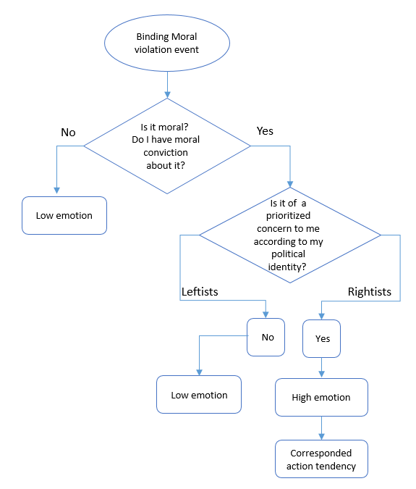
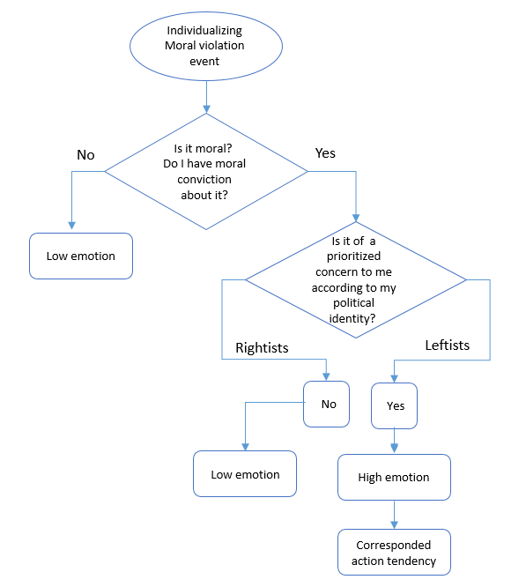

Figure 2. A flowchart of the ties between moral conviction, moral foundation, and emotions in the context of binding and individualizing moral violation.

The studies were conducted within the context of the Israeli-Palestinian conflict, which is regarded as an intense conflict because it is persistent, violent, and perceived, by most of those involved, as irresolvable (Bar-Tal, 2013). The Israeli-Palestinian conflict is highly salient to Israelis' lives, evoking vociferous divisions within Israeli society (including ideological divisions) in light of its relevance to individuals' primary, morally charged goals, values, and ideology (Bar-Tal, 2013). Therefore, in this context, moral events are more persistent, have robust emotional backing, and are expected to be experienced with higher intensity. Moreover, moral events in the context of the Israeli-Palestinian conflict are characterized by complexity and a multiplicity of moral considerations; hence, differences in the relevance of people's moral considerations are even more predictable.
I conducted three studies to test my proposed model. I first conducted a Preliminary Study to validate moral violation scenarios, in the context of the Israeli-Palestinian conflict, which were developed as a research stimulus. In Study 1A (N = 120) and Study 1B (N = 84) I examined the association between moral convictions and anger in a binding moral violation scenario among rightists and among leftists, and I examined the association between moral convictions and empathy in an individualizing moral violation scenario. In Study 2 (N = 463), I replicated Study 1 and tested the moderated-mediation model, using a representative sample of Jewish-Israeli society from the entire political spectrum. Additionally, I examined the downstream effect of the moderated ties between moral conviction and emotion on relevant political action tendencies. Study 3 (N = 296) examined the full hypothesized moderated-mediation model and its downstream effects on political reactions, using complementary moral emotions as mediators (for rightists, anger towards individualizing moral violators, for leftists empathy towards binding moral casualties), showing the moderated-mediation effects of moral conviction on direct political reaction, indirect political reaction, and action tendencies.
Preliminary Study: Validation of Moral Foundation Scenarios
Before testing the hypothesized model described above, I conducted a preliminary study to validate four moral-political conflict scenarios that were developed as research stimuli. I wanted to ascertain that most Israeli Jews, regardless of their political ideology, perceive the scenarios as moral related events violating either binding or individualizing moral foundations (Haidt, et al., 2007; Haidt, et al., 2004).
Method
Participants
I recruited 328 Jewish Israelis (M_{age} = 35.67 years, SD = 15.37, 61.1% females) to participate in an online study. Because I had four scenarios I wanted to validate among both leftists and rightists, I asked a sample of 40 leftists and 40 rightists to read each article, resulting in a sample of approximately 320. The sample size was determined based on a power analysis assuming 80% power to detect moderately sized differences between leftists and rightists (Cohen's d = .6).
Procedure
Participants were randomly assigned to read one of four ostensible news articles related to the Israeli-Palestinians conflict. Two articles described a violation of binding foundations, and the other two described violations of individualizing foundations (specifically harm-care foundation). The articles that featured a binding violation described: 1) a speech by Palestinian president Mahmoud Abbas at the UN General Assembly where he accused Israel of a 'war of genocide' in Gaza; 2) a warning against the rise of Palestinian illegal incursions into lands owned by Jews in the city of Jerusalem. The articles that featured an individualizing violation described: 1) IDF shelling as part of Operation "Protective Edge" that caused the death of four innocent Palestinian children 2) a Palestinian child living in Israel who suffers from cerebral palsy and is expelled with her family to the Gaza Strip by the Israeli authorities. After reading one of the articles, participants were asked to indicate the extent to which the article describes a moral violation with respect to each of the five foundations (from 1 = not at all to 6 = Very much): care, fairness, loyalty, authority, and purity. Then, they provided socio-demographic information, including their political ideology (from 1 = extremely right to 7 = extremely left).
Measures
Classifying Moral Foundation. Participants assessed the degree to which each of the five moral foundations was violated in the scenario. Participants responded on a 6-point scale (1 – not at all; 6 – to a large extent).
Political Ideology. Participants reported their ideology using a single item that assessed their subjective political position regarding foreign policy and security (e.g., military, international relations). Verbal anchors were extreme left (1) and extreme right (7), with a midpoint of center (4).
Demographic Questionnaire. Participants completed a brief demographic questionnaire. Items included gender, age, education, employment, religiosity, and political party affiliation.
Results
To examine whether each article described a violation of different moral foundations, I computed the individual foundation violation based on harm-care foundation and the binding foundation violation based on loyalty, authority, and purity foundations. Then I ran a one-way ANOVA for each foundation with the articles as a between-subjects variable. As expected, I found a significant main effect, F(3, 245) = 89.35, p < .001. Post-hoc analyses, testing the differences between the four articles indicated that the two binding scenarios were perceived as a greater violation of binding foundations (Abbas’ speech and Jerusalem lands) compared to the other two scenarios (four kids killed and sick child). Regarding the care foundation, there was a similar pattern such that the two individualizing scenarios (four kids killed and sick child) were perceived as having more violated the care foundation than the two binding scenarios (Abbas’ speech and Jerusalem lands) ( see Table 1, Figure 3 and Figure 4). These results were consistent when controlling for political ideology, and political ideology did not moderate these effects.

Table 1
Means and standard deviations of moral violation of individualizing and binding moral foundation as a function of the article.
 | “Binding” articles |  | “Individualizing (care)” articles
 | Abbas speech | Jerusalem lands | four kids killed | sick child
Individualizing | 4.22ª (1.22) | 4.04ª (1.47) | 5.14^{b} (1.21) | 4.70^{c} (1.39)
Binding | 4.08 ª (1.17) | 4.33ª (1.23) | 3.01^{d} (1.13) | 2.72^{d} (1.09)
Note. Different superscript letters signify means that are significantly different from one another (p < .05)

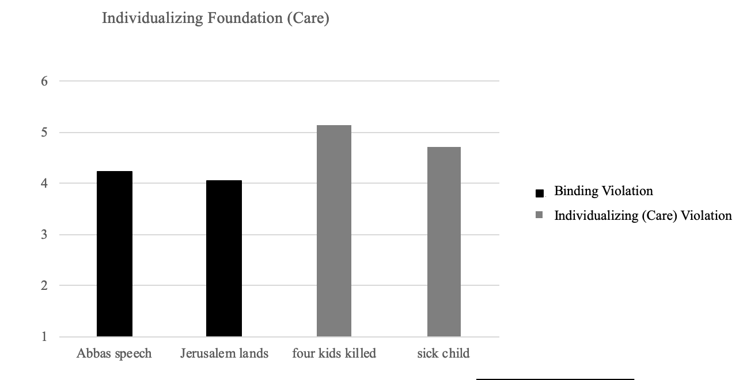
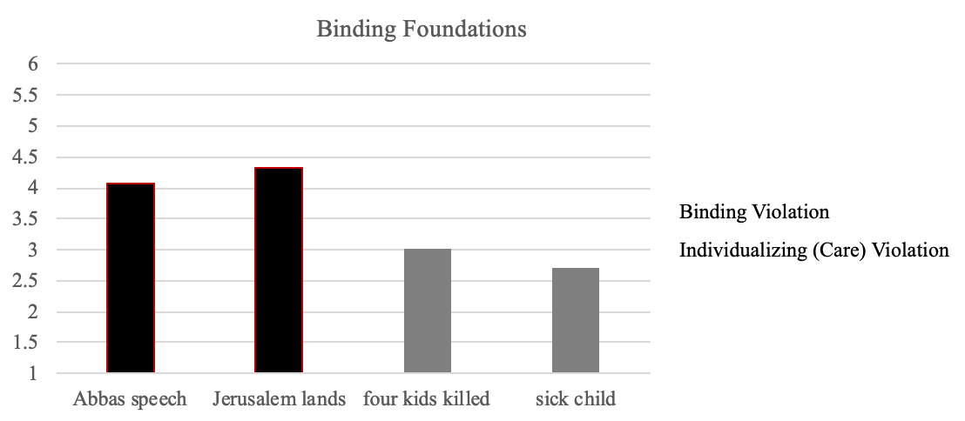
Figure 3. Perception of violation of binding foundation in all four scenarios.

Figure 4. Perception of violation of individualizing foundation in all four scenarios.

Study 1
Study 1 was conducted as an exploratory study aimed at examining the effect of moral convictions in conflict on emotional experience and to test whether this relationship would be moderated by moral foundation as reflected by political ideology. Since these were pilot studies, I used convenience samples that were not based on a power analysis. Specifically, I examined the association between moral convictions and anger in a binding moral violation scenario among rightists, and among leftists, and I examined the association between moral convictions and empathy in an individualizing moral violation scenario. I used separate samples for rightists and leftists to ensure that each sample focuses on the relevant moral foundation.
Study 1A
In this study, I tested whether, among rightists, the strength of moral conviction would be positively associated with high intergroup anger toward the perpetrators of a binding violation. Namely, that among rightists, who are high on moral conviction, being exposed to a violation of binding moral foundations would lead to intense intergroup anger towards the Palestinians, but that being exposed to a violation of an individualizing foundation would not lead to intense intergroup empathy for Palestinians.
Method
Participants
120 right-wing, Jewish Israelis voluntarily participated in an online study. Participants were recruited using snowball techniques. Fifteen participants were excluded from the data analysis because they failed to answer the reading comprehension questions correctly, leaving a sample of 105 (Mage = 40.52 years, SD = 12.46, 47.6% females). A post-hoc sensitivity analysis indicated that with this sample, I had 80% power to detect a correlation of r = .26.
Procedure
Participants were invited to take part in a study on attitudes and emotional responses in the context of the Israeli-Palestinian conflict. Participants indicated the extent to which their attitudes and emotions about the Israeli-Palestinian conflict are based on their moral convictions. They were then presented with two of the articles tested in the pilot study - Palestinian illegal incursions into Jewish lands (i.e., a binding article) and a sick Palestinian child being expelled by Israeli Authorities (i.e., an individualizing article). These scenarios represent two crucial issues at the heart of the Israeli-Palestinian conflict: land dispute and the citizenship law. The two scenarios were presented to participants one at a time, and the order of presentation was counterbalanced across participants. After reading each scenario, participants responded to two reading comprehension questions to ensure they had read and understood the text. Then they rated their emotional reactions and provided socio-demographic information, including political ideology.
Measures
Moral conviction. The degree to which participants viewed the Israeli–Palestinian conflict in general as a moral conviction issue was assessed with three items: "To what extent are your attitudes about the Israeli–Palestinian conflict a reflection of your core moral values and convictions?", "To what extent are your feelings about the Israeli–Palestinian conflict a reflection of your core moral beliefs and convictions?" and "To what extent are your feelings about the Israeli–Palestinian conflict deeply connected to your beliefs about 'right' and 'wrong'?" Participants responded on a 7-point scale (1 – not at all; 7 – very much). Participants' scores were averaged to create a single moral conviction scale (α = .82), with higher scores reflecting greater moral conviction about the Israeli–Palestinian conflict.
Emotional reaction. Participants rated the extent (1 – not at all; 7 – to a large extent) to which they experienced anger or empathy towards Palestinians in general.
Political Ideology. Participants reported their ideology using a single item that assessed their subjective political position regarding foreign policy and security (e.g., military, international relations). Verbal anchors were extreme left (1) and extreme right (7), with a midpoint of center (4).
Demographic Questionnaire. Participants completed a brief demographic questionnaire. Items included gender, age, education, employment, religiosity, and political party affiliation.
Results
As predicted, in the binding scenario, rightists' moral convictions were significantly related to intergroup anger, such that rightists with strong moral convictions experienced more anger towards Palestinians, r (105) = .246, p . = .01. In the individualizing scenario, no correlation was found between moral conviction and intergroup empathy, r (105) = .024, p=. 81. These correlations persisted when controlling for political ideology (meaning, controlling the extremity of the ideology), and when controlling for sociodemographic variables (i.e., age, sex, education, financial status).
Study 1B
In study 1B I tested whether, among leftists, the strength of moral conviction would be positively associated with high intergroup empathy toward the casualties of an individualizing violation. Namely, that among leftists strong moral conviction would lead to intense intergroup empathy for the Palestinians after being exposed to a violation of individualizing moral foundations, but that strong moral conviction would not lead to intense intergroup anger towards Palestinians, after being exposed to a violation of a binding foundation.
Method
Participants
84 left-wing, Jewish Israelis (Mage = 33.89 years, SD = 9.5, 42.9% females) voluntarily participated in an online study. The sample size was determined by the relative size of leftists in the Jewish Israeli population. Participants were recruited using snowball techniques. A post-hoc sensitivity analysis indicated that with this sample, I had 80% power to detect a correlation of r = .30.
Procedure
I used the same procedure as in study 1 except for using an adapted binding article that I thought might be of more relevance to topical events that occurred during the study and would be of interest to left-wingers. The binding article described a warning against the rise of calls in the Palestinian media denying Israel's right to exist.
Measures
Moral conviction. Same as in Study 1A (α =. 77).
Emotional reaction. Same as in Study 1A.
Political ideology. Same as in Study 1A.
Demographic questionnaire. Same as in Study 1A.
Results
As predicted, in the individualizing scenario, moral conviction was significantly related to intergroup empathy, such that leftists with strong moral conviction experienced more empathy for Palestinians, r = .31, p =.005. In the binding scenario, no correlation was found between moral conviction and intergroup anger towards Palestinians, r = -.18, p =.11. These correlations persisted when controlling for political ideology (meaning, controlling the extremity of the ideology) and sociodemographic measures (sex, age, education).
Discussion
Study 1 provided initial support for my first hypothesis, that in the binding scenario, rightists' strength of moral conviction was positively associated with intergroup anger towards the perpetrators, but when exposed to an individualizing foundation violation scenario the strength of moral conviction was not associated with intergroup empathy for the victims. Similarly, in the individualizing moral violation scenario, leftists' strength of moral conviction was positively associated with high intergroup empathy for victims, but when exposed to a binding violation scenario the strength of moral conviction was not associated with intergroup anger towards perpetrators.
Since studies 1A and 1B were exploratory studies, they were designed for separate samples, regarding specific individualizing and binding moral violation events, and thus did not allow for testing the interactive model indicating that in response to a violation of moral foundations, moral conviction will only predict emotions depending on the relevance of the moral foundation to the ideology. Furthermore, study 1 demonstrated associations between moral conviction and emotions, moderated by political ideology, but the second goal of examining the role of emotions in mediating political reactions was not tested.
Study 2
Study 2 was conducted to replicate and extend the findings obtained from Study 1, aiming to test the full model. In order to do so, I: (a) conducted the study using a representative sample of Jewish-Israeli society from the entire political spectrum, (b) used moral violation scenarios that were validated in the pilot study but were not used in the previous study, referring to crucial moral issues at the heart of the Israeli –Palestine conflict and that are of interest to all of Jewish-Israeli society, and (c) measured moral conviction and ideology, separately from the manipulation, over three different time-points, to make sure they are not affected by the manipulation.
Study 2 was also designed in accordance with the second goal of examining the downstream effect of the moderated tie between moral conviction and emotions on relevant political action tendencies. Specifically, I aimed to test my full model, testing whether in response to a specific violation, the ties between moral conviction and intensity of intergroup moral emotions would be moderated by moral foundations and their different moral relevance to political ideology, and that these emotions would mediate the effect of moral convictions on political action tendencies (e.g., political involvement and activism).
Method
Participants
463 Jewish Israelis (Mage = 38.99 years, SD = 12.45, 47.1% females) participated in an online study for monetary compensation. Sample size was based on a power analysis assuming a small effect size for the interaction between moral convictions and political ideology (change in r² = .02, when the interaction terms are added to the model) with 80% power. I used a nation-wide sample that represented the diverse Jewish-Israeli society in terms of its socio-demographic features and political ideology. Of the participants, 50.6% were rightists, 30.6% were centrists, and 18.7% were leftists. The sample represents the relative size of each political group in the Jewish Israeli population.
Procedure
The data was collected as part of a large-scale survey. Participants were contacted via email at three different time-points. In the first assessment, participants indicated their political ideology and provided socio-demographic information. In the second assessment, participants rated their moral conviction associated with their position on the Israeli-Palestinian conflict. Finally, in the third assessment, participants were randomly assigned to read one of two scenarios that were previously tested in the pilot study - a speech by Palestinian president Mahmoud Abbas that accuses Israel of a 'war of genocide' (i.e., a binding scenario), and IDF shelling that caused the death of 4 Palestinian children (i.e., an individualizing scenario). After reading the article, participants rated their emotional reactions to the article and their support of aggressive and conciliatory policies toward the Palestinians.
Measures
Moral conviction. Same as in Study 1 (α =. 80).
Demographic questionnaire. Same as in Study 1.
Political ideology. Same as in Study 1.
Emotional reaction. Same as in Study 1.
Support for aggressive policies. Participants rated their support for aggressive and conciliatory policies toward the Palestinians on a four-item scale (alpha .824.). The items were general and were used for both binding and individualizing scenarios. Example of a general aggressive policies item: the IDF should use violent means to disperse demonstrations of Palestinians because they are illegitimate. Participants responded on a 6-point scale (1 – not at all; 6 – to a large extent).
Support for conciliatory policies. Participants rated their support of conciliatory policies toward the Palestinians on a four-item scale (alpha .702). The items were general and were used for both binding and individualizing scenarios. Example of a general conciliatory policy item: Israel should promote joint economic and social projects of Israelis and Palestinians. Participants responded on a 6-point scale (1 – not at all; 6 – to a large extent).
Results
Individualizing moral violation scenario
I tested my hypothesis that after exposure to a violation of individualizing moral foundations, moral conviction would be associated with intense intergroup empathy for the Palestinians and subsequent conciliatory political action tendencies only among leftists. However, I expected that among rightists, moral conviction would not be associated with intense intergroup empathy for the Palestinians and subsequent conciliatory political action tendencies. First, I examined the effects on intergroup empathy for the Palestinians using Hayes Process model 1. There were significant direct effects of political ideology and moral conviction, and in addition, the interaction between moral conviction and political ideology was marginally significant. Analysis of the simple effects revealed that for leftists, moral conviction was positively related to intergroup empathy. Among rightists, there was no significant effect of moral conviction on intergroup empathy (see Table 2, and Figure 5.).

Table 2
Model statistics for the moderation model predicting intergroup empathy for the Palestinians
 | b | 95% CI | SE | t | p
Moral convictions | 0.04 | [0.09, 0.71] | 0.16 | 2.55 | 0.01
Political ideology | -0.68 | [-2.32, -1.04] | 0.32 | -5.19 | < .001
Moral convictions x political ideology | -0.71 | [-1.45, 0.26] | 0.37 | 1.9 | 0.05
Simple effect of moral convictions for leftists | 0.93 | [0.28, 1.58] | 0.33 | 2.82 | 0.005
Simple effect of moral convictions for rightists | 0.22 | [-0.13, 0.57] | 0.03 | 5.67 | 0.22

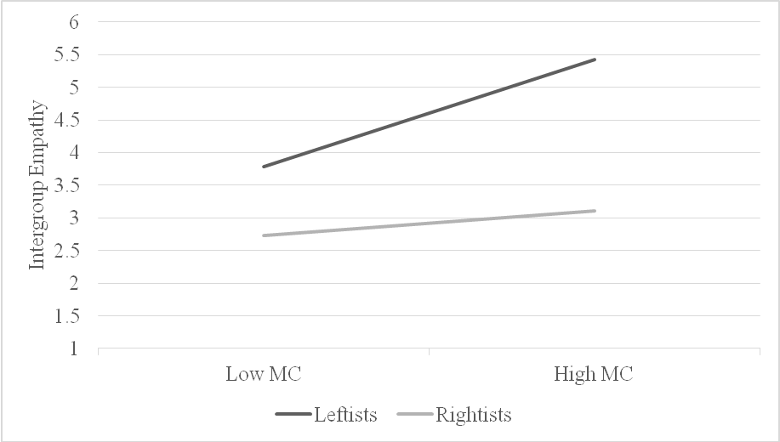

Figure 5. Differences in the relationship between moral conviction and intergroup empathy for Palestinians among rightists and leftists.

Then I examined the interaction on conciliatory political action tendencies. Similarly, there were significant direct effects of political ideology and moral conviction. The interaction between moral conviction and political ideology was also significant. Analysis of the simple effects revealed that for leftists, moral conviction was positively related to conciliatory political action tendencies towards the Palestinians. However, among rightists, there was no significant effect of moral convictions (see Table 3 and Figure 6).

Table 3
Model statistics for the moderation model predicting conciliatory political action tendencies towards the Palestinians
Variable | b | 95% CI | SE | t | p
Moral convictions | 0. 35 | [0.04, 0.71] | 0.16 | 2.25 | 0.03
Political ideology | -1.44 | [-2.32, -1.04] | 0.32 | -5.19 | < .001
Moral convictions x political ideology | -0.84 | [-1.59, -0.08] | 0.38 | -2.18 | 0.03
Simple effect of moral convictions for leftists | 1.00 | [0.31, 1.65] | 0.34 | 2.9 | < .001
Simple effect of moral convictions for rightists | 0.15 | [-0.22, 0.57] | 0.18 | 0.83 | 0.42

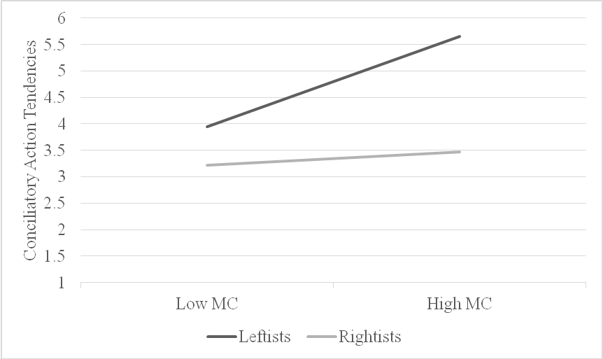

Figure 6. Differences in the relationship between moral conviction and conciliatory political action tendencies toward the Palestinians among rightists and leftists.

In the next step, I tested my full model in which, within the individualizing scenario, the effects of moral conviction on political action tendencies would be mediated by emotion (i.e., empathy towards Palestinians) but that this mediation would be moderated by political ideology and would only occur for leftists. Thus, I ran a moderated mediation analysis on conciliatory political reaction toward the Palestinians, considering moral conviction as the independent variable, political ideology as a moderator, and intergroup empathy for Palestinians as a mediator (PROCESS model 8). The analysis revealed that there was an indirect effect of moral conviction through intergroup empathy for Palestinians on conciliatory political reaction towards the Palestinians but only among leftists (a*b = 0.27, SE = 0.126, CI = [0.603, 0.537]), and not among rightists (a*b = 0.06, SE = 0.06, CI = [-.05, 0.19]).
Binding moral violation scenario
I then tested my hypothesis that exposure to violation of a binding moral foundations would lead to a similar process, but among rightists, using the same analysis strategy. Namely, moral conviction should be associated with intense intergroup anger toward the Palestinians, and subsequent adversarial political action tendencies toward the Palestinians among rightists. However, among leftists, moral conviction would not be associated with intense intergroup anger towards the Palestinians and subsequent adversarial political action. First, I examined intergroup anger towards the Palestinians, and found a significant direct effect of political ideology and a significant interaction between moral conviction and political ideology. Analysis of the simple effects revealed that for rightists, moral conviction was positively related to intergroup anger, whereas for leftists, there was no significant effect of moral conviction (see Table 4 and Figure 7).

Table 4
Model statistics for the moderated model predicting intergroup anger towards the Palestinians.
Variable | b | 95% CI | SE | t | p
Moral convictions | 0.2 | [-0.11, 0.51] | 0.16 | 1.26 | 0.21
Political ideology | 0.28 | [0.61, 1.96] | 34 | 3.77 | < .001
Moral convictions x political ideology | -0.91 | [0.13, 1.70] | 0.4 | 2.3 | 0.02
Simple effect of moral convictions for rightists | 0.4 | [-0.22, 0.570] | 0.17 | 2.31 | 0.02
Simple effect of moral convictions for leftists | -0.51 | [-1.28, 0.19] | 0.36 | -1.43 | 0.16

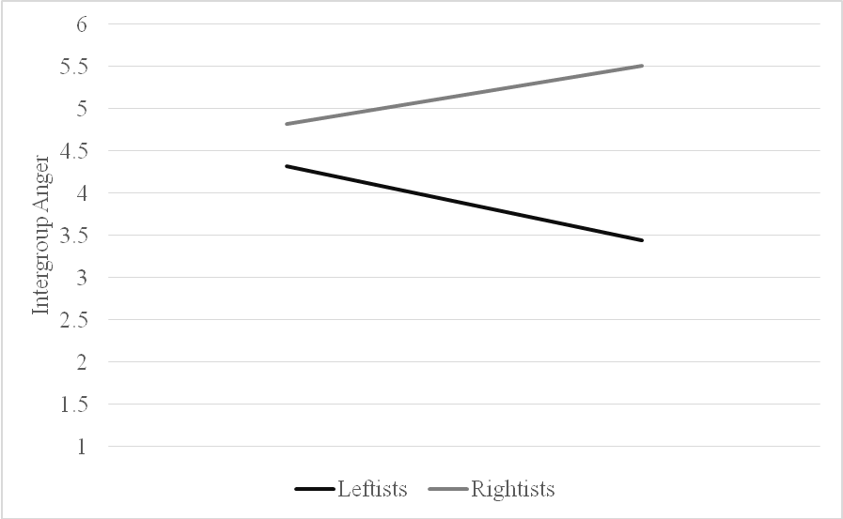

Figure 7. Differences in the relationship between moral conviction and intergroup anger toward Palestinians among rightists and leftists.

Next, I examined adversarial political action tendencies toward the Palestinians. There was a significant direct effect of political ideology, but no significant direct effect of moral convictions. The interaction between moral convictions and political ideology was marginally significant. Analysis of the simple effects revealed that for rightists, moral conviction was positively related to adversarial political reaction toward the Palestinians. Among leftists, there was no significant effect of moral conviction (see Table 5 and Figure 8).

Table 5
Model statistics for the moderated model predicting adversarial political action tendencies towards the Palestinians
Variable | b | 95% CI | SE | t | p
Moral convictions | 5. 14 | [-.04, 0.35] | 0.08 | 1.6 | 0.11
Political ideology | 0.28 | [4.97, 5.31] | 34 | 60.59 | < .001
Moral convictions x political ideology | 0.43 | [-0.69, 0.93] | 0.25 | 1.7 | 0.09
Simple effect of moral convictions for rightists | 0.25 | [0.04, 0.47] | 0.11 | 2.31 | 0.02
Simple effect of moral convictions for leftists | -0.18 | [-0.62, 0.27] | 0.23 | -0.77 | 0.44

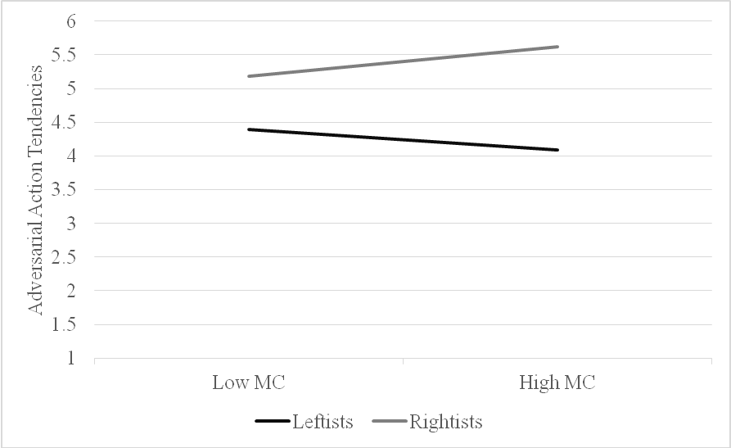

Figure 8. Differences in the relationship between moral conviction and adversarial political reaction toward the Palestinians among rightists and leftists.

In the next step, I aimed to test the full model that following a binding violation the effects of moral conviction on political action tendencies would be mediated by emotion, in this case, anger towards Palestinians, but that this mediation would be moderated by political ideology and would only occur for rightists. Thus, I ran a moderated mediation analysis on adversarial political action tendencies toward the Palestinians, considering moral conviction as the independent variable, political ideology as a moderator, and intergroup anger towards Palestinians as a mediator (PROCESS model 8). The analysis revealed that there was an indirect effect of moral conviction through intergroup anger towards Palestinians on adversarial political reaction toward Palestinians but only among rightists (a*b = 0.06, SE = 0.03, CI = [0.005, 0.1387]), and not among leftists (a*b = -0.07, SE = 0.06, CI = [-.22, 0.029]).
Discussion
The findings of Study 2 both replicate the findings of Study 1 and provide initial support for the model arguing that moral conviction is positively associated with moral emotions only when the moral events are perceived as relevant to the participants' moral foundations, and that these ties would shape the downstream effects on relevant political action tendencies. This was found using a representative sample of Jewish-Israeli society from the entire political spectrum, and using scenarios that refer to additional moral issues that lie at the heart of the Israeli–Palestinian conflict.
Although Study 1 and Study 2 supported my hypothesis, these studies have several limitations. First, the studies examined only one emotion (e.g., anger towards binding violators and empathy for individualizing victims) for each moral scenario/political group, but the inverse emotions were not tested (e.g., anger towards individualizing violators, and empathy for binding victims). This creates unnecessary potential confound and might indicate a possible alternative effect of the mediation of political ideology on the ties between moral conviction and emotions. Second, the role of emotions in mediating political action tendencies was tested by using only one political policy scale, meaning, in the individualizing scenario, only support for conciliatory policies was tested, and in the binding scenario, only support for aggressive policies was tested. Moreover, the scale's items were general. They did not refer specifically to the issues presented in each scenario. Study 3 was designed to address these issues.
Study 3
Study 3 was conducted to examine the full model, using complementary moral emotions that were not tested in the previous studies as mediators. In the current study, all participants (i.e., leftists and rightists) reported their anger and empathy for victims, as well as anger and empathy towards perpetrators, both in the individualizing and in the binding scenarios. Additionally, I expanded the examination of the effects of moral conviction on political action tendencies using three different measures for political action tendencies; direct political reaction, indirect political reaction, and political collective action tendencies.
Method
Participants
296 Jewish Israelis (Mage = 39.68 years, SD = 12.92, 52.4% females) participated in an online study for monetary compensation. The sample size was based on a power analysis to detect a relatively small interaction (Cohen's f = .03) at 80% power. I used a nation-wide sample that represented the diverse Jewish-Israeli society in terms of its socio-demographic features. Of the participants, 59.1% were rightists, and 40.9 % were leftists.
Procedure
Participants were invited to take part in a study on attitudes and emotional responses in the context of the Israeli-Palestinian conflict. Participants were presented with two scenarios: a. Palestinian illegal incursions to Jewish lands (i.e., a binding article) and b. a sick Palestinian child being expelled by Israeli Authorities (i.e., an individualizing article). The two scenarios were presented to participants one at a time, and the order of presentation was counterbalanced across participants. After reading each scenario, participants responded to two reading comprehension questions to ensure they had read and understood the text. Then they rated their emotional reactions, their political action tendencies, and indicated the extent to which they experience the Israeli-Palestinian conflict as a moral conviction issue. Finally, participants provided socio-demographic information, including political ideology.
Measures
Emotional reactions. Participants rated the extent (1 – not at all; 6 – to a large extent) to which they experienced anger and empathy towards Palestinians and towards Israelis in reference to each of the scenarios they read.
Direct and indirect political action tendencies. Participants rated their support for adversarial and conciliatory policies toward the Palestinians on four items, two of which were specific to the scenario (example of a specific item; President Abbas must be asked to retract his remarks as a condition for the transfer of funds), and another two, which were general for all scenarios (example of a general item: Israel must deal with this issue firmly). Participants responded on a 6-point scale (1 – not at all; 6 – to a large extent).
Political collective action tendencies. Participants rated their willingness to be involved in political action (on-line protest) in favor of Israelis and in favor of Palestinians. For each item, participants responded on a 6-point scale (1 – not at all; 6 – to a large extent).
Moral conviction. Same as in Study 2 (α =. 80).
Political ideology. Same as in Study 1.
Demographic questionnaire. Same as in Study 1.
Results
Tables 6-9 presents means, standard deviations (SDs) and simple correlations
between our key variables. As predicted, for both rightists and leftists emotional intensity was associated with moral conviction following scenario of violation of their prioritized foundation. Also as predicted, following scenario of violation of their prioritized foundation both rightists' and leftists' emotional intensity and moral conviction were associated with respectively relevant action tendencies. When exposed to scenario of violation different from their prioritized foundation, leftists' emotional intensity was not associated with moral conviction. As for rightists, emotional intensity was not associated with moral conviction and respectively relevant action tendencies regarding the Palatines, but emotion to Israelis was associated with moral conviction.

Table 6
Bivariate Relationships between Study 3 Variables – Binding Scenario Rightists (N=168)
 | M (SD) | 1 | 2 | 3 | 4
1. Political Ideology | 2.14 (0.57) | -
2. Moral conviction | 4.98 (0.97) | -.08 | -
3. Anger to Palestine | 5.14 (1.43) | .01 | .19* | -
4. Empathy to Israelis | 4.87 (1.56) | -.05 | .16* | .39** | -
5. Adversary political action tendencies to Palestinians | 4.84 (0.94) | -.19* | .39** | .19* | .18*
*p < .05, **p < .01

Table 7
Bivariate Relationships between Study 3 Variables – Binding Scenario Leftists (N=128)
 | M (SD) | 1 | 2 | 3 | 4
1. Political Ideology | 5.80 (0.51) | -
2. Moral conviction | 5.11 (0.93) | .18 | -
3. Anger to Palestine | 2.93 (1.45) | -.50** | -.15 | -
4. Empathy to Israelis | 2.69 (1.30) | -.47* | -.11 | .51** | -
5. Adversary political action tendencies to Palestinians | 2.86 (1.20) | -.62** | -.26* | .59** | .37**
*p < .05, **p < .01

Table 8
Bivariate Relationships between Study 3 Variables – Individualizing Scenario Rightists (N=168)
 | M (SD) | 1 | 2 | 3 | 4
1. Political Ideology | 2.14 (0.57) | -
2. Moral conviction | 4.98 (0.97) | -.08 | -
3. Empathy to Palestinians | 2.02 (1.31) | .17 | -.04 | -
4. Anger to Israelis | 1.63 (1.18) | .09 | -.16* | .26** | -
5. conciliatory political reaction to Palestinians | 1.99 (0.95) | .21** | -.09 | .62** | .27**
*p < .05, **p < .01

Table 9
Bivariate Relationships between Study 3 Variables – Individualizing Scenario Leftists (N=128)
 | M (SD) | 1 | 2 | 3 | 4
1. Political Ideology | 5.80 (0.51) | -
2. Moral conviction | 5.11 (0.93) | 0.17 | -
3. Empathy to Palestinians | 4.36 (1.47) | .40** | .38** | -
4 Anger to Israelis | 3.77 (1.68) | .34* | .21* | .63** | -
5. conciliatory political reaction to Palestinians | 4.02 (1.24) | .49** | .33** | .68** | .60**
*p < .05, **p < .01

Results for the individualizing moral violation scenario
I tested my hypothesis that after exposure to a violation of individualizing moral foundations, moral conviction would be associated with intense intergroup empathy for the Palestinians, and with intense intergroup anger towards the Israelis, and subsequent conciliatory political action tendencies, only among leftists. However, I expected that among rightists moral conviction would not be associated with intense intergroup empathy for the Palestinians, nor to intense intergroup anger towards the Israelis, and subsequent conciliatory political action tendencies. First, I examined the effects on intergroup empathy for the Palestinians using Hayes Process model 1. There was no significant direct effect of political ideology on intergroup empathy for Palestinians, and there was a significant direct effect for moral conviction. The interaction of moral conviction and political ideology on intergroup empathy for Palestinians was significant. Analysis of the simple effects revealed that for leftists, moral conviction was positively related to intergroup empathy. Among rightists, there was no significant effect of moral conviction on intergroup empathy (see Table 6 and Figure 9). I repeated these procedures to test the hypothesis that in the individualizing scenario, moral convictions would be positively related to in-group anger towards Israelis only for leftists. As expected, and shown in table 6, the interaction between moral conviction and political ideology on in-group anger towards Israelis was significant. Analysis of the simple effects revealed that only for leftists, moral conviction was positively related to in-group anger towards Israelis. (See Table 7 and Figure 10).
Then I examined the interaction on conciliatory political action tendencies. Similarly, there were marginally significant direct effects of political ideology and moral conviction. The interaction between moral conviction and political ideology was also significant. Analysis of the simple effects revealed that only for leftists, moral conviction was positively related to conciliatory political action tendencies toward the Palestinians. However, among rightists, there was no significant effect of moral convictions (see Table 8, Figure 11).

Table 10
Model statistics for the moderated model predicting intergroup empathy for the Palestinians
Variable | b | 95% CI | SE | t | p
Moral convictions | 1.33 | [0.77, 1 .87] | 0.28 | 4.74 | < .001
Political ideology | 1.24 | [-0.45, 2.93] | 0.86 | 1.44 | 0.15
Moral convictions x political ideology | -0.69 | [-1.02, -0.36] | 0.17 | -4.12 | < .001
Simple effect of moral convictions for leftists | 0.63 | [0.34, 0.89] | 0.13 | 4.99 | < .001
Simple effect of moral convictions for rightists | -0.06 | [-0.27, 0.15] | 0.11 | -0.55 | 0.58
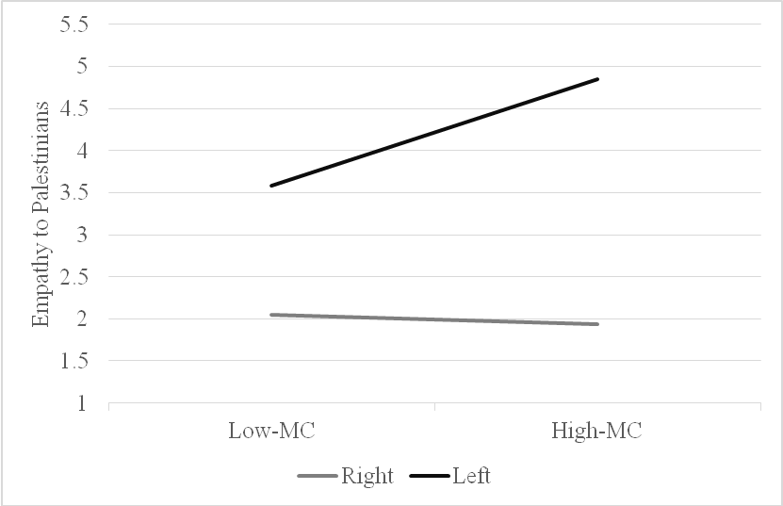

Figure 9. Relationship between moral convictions and empathy following an individualizing violation for rightists and leftists.

Table 11
Model statistics for the moderated model predicting intergroup anger towards Israelis
Variable | b | 95% CI | SE | t | p
Moral convictions | 0.95 | [0.38, 1.51] | 0.28 | 3.33 | < .001
Political ideology | 0.71 | [-1.01, 2.44] | 0.88 | 0.81 | 0.42
Moral convictions x political ideology | -0.56 | [-0.90, -0.22] | 0.17 | -3.29 | < .001
Simple effect of moral convictions for leftists | 0.38 | [0.13, 0.64] | 0.13 | 2.92 | 0.004
Simple effect of moral convictions for rightists | -0.18 | [-0.39, .04] | 0.11 | -1.63 | 0.1

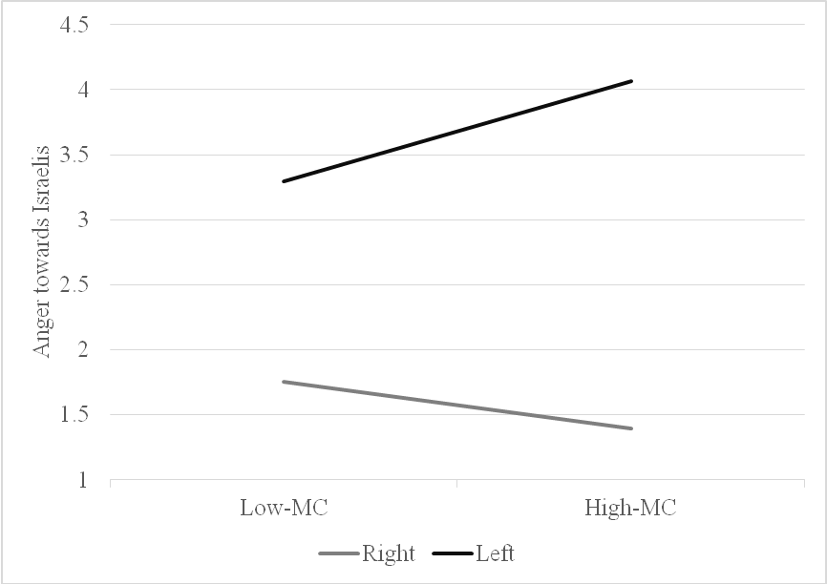

Figure 10. Relationship between moral convictions and anger following an individualizing violation for rightists and leftists.

Table 12
Model statistics for the moderated model predicting conciliatory political action tendencies towards the Palestinian
Variable | b | 95% CI | SE | t | p
Moral convictions | 0.98 | [0.54, 1.40] | 0.22 | 4.46 | < .001
Political ideology | 0.68 | [-0.65, 2.00] | 0.13 | -1.03 | 0.32
Moral convictions x political ideology | -0.71 | [0.24, 0.64] | 0.37 | 1.9 | 0.06
Simple effect of moral convictions for leftists | 0.44 | [0.28, 1.58] | 0 | 4.39 | < .001
Simple effect of moral convictions for rightists | -0.09 | [-0.25, 0.76] | 0.08 | -1.06 | 0.29

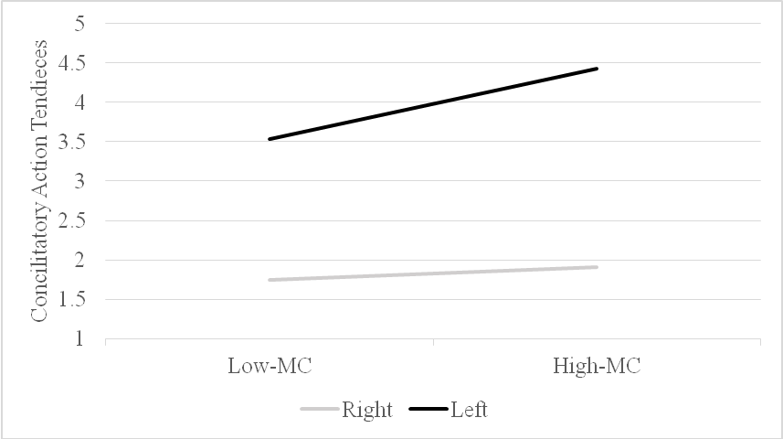

Figure 11. Relationship between moral convictions and conciliatory political reactions following an individualizing violation for rightists and leftists.

In the next step, I aimed to test the full model in which, within the individualizing scenario, the effects of moral conviction on political action tendencies would be mediated by emotion (i.e., empathy for Palestinians) but that this mediation would be moderated by political ideology and would only occur for leftists. Thus, I ran a moderated mediation analysis on conciliatory political reaction toward the Palestinians, considering moral conviction as the independent variable, political ideology as a moderator, and intergroup empathy for Palestinians as a mediator (PROCESS model 8). The analysis revealed that there was an indirect effect of moral conviction through intergroup empathy for Palestinians on conciliatory political reaction toward the Palestinians but only among leftists (a*b = -0.03, SE = 0.05, CI = [-0.13, 0.06]).
Additionally, I tested my full moderated mediation model for the complementary moral emotion, in this case, in-group anger towards Israelis. Using the same procedure, I found that, as expected, there was an indirect effect of moral conviction through in-group anger towards Israelis on conciliatory political action tendencies towards the Palestinians among leftists (a*b = 0. 13, SE = 0.07, CI = [0.02, 0.30]). Contrary to my predictions, I found an effect among rightists, but in the opposite direction (a*b = -0.06, SE = 0.03, CI = [-.13, -0.00]).
Results for the binding moral violation scenario
I then tested the hypothesis that exposure to violation of binding moral foundations would lead to a similar process but among rightists, using the same analysis strategy. Namely, moral conviction should be associated with intense intergroup anger towards the Palestinians and with more intense intergroup empathy for the Israelis, and subsequent adversarial political action tendencies toward the Palestinians among rightists. However, among leftists, moral conviction would not be associated with intense intergroup anger towards the Palestinians, nor to intense intergroup empathy for the Israelis, and subsequent adversarial political action. First, I examined intergroup anger towards the Palestinians, and found that there was no significant direct effect of political ideology on anger towards Palestinians, and significant direct effect for moral conviction. The interaction between moral conviction and political ideology on intergroup anger towards Palestinians was significant. Analysis of the simple effects revealed that for rightists, moral conviction was positively related to intergroup anger towards Palestinians, whereas for leftists, there was no significant effect of moral convictions (see Table 9, and Figure 12).

Table 13
Model statistics for the moderated model predicting intergroup anger towards the Palestinians
Variable | b | 95% CI | SE | t | p
Moral convictions | 0.76 | [-0.24, -1.28] | 0.26 | 2.88 | < .001
Political ideology | 0.26 | [-1.55, -2.08] | 0.92 | -0.29 | 0.77
Moral convictions x political ideology | -0.5 | [-0.84, -0.14] | 0.18 | -2.74 | < .001
Simple effect of moral convictions for leftists | -0.22 | [-0.50, 0.05] | 0.14 | -1.6 | 0.11
Simple effect of moral convictions for rightists | 0.27 | [0.05, 0.50] | 0.11 | 2.4 | 0.02

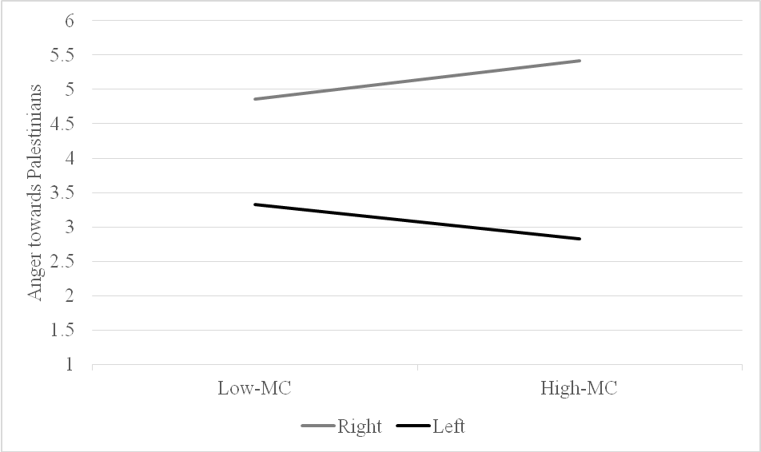

Figure 12. Relationship between moral convictions and anger following a binding violation for rightists and leftists.

In addition, I found that taking into account the interaction, there was a significant direct effect of political ideology on in-group empathy for Israelis, and for moral conviction, there was a marginal significant direct effect. As expected, the interaction between moral conviction and political in-group empathy for the Israeli stance was significant. Analysis of the simple effects revealed that for rightists, moral conviction was positively related to in-group empathy for Israelis, but among leftists, there was no significant relationship between moral conviction and in-group empathy for Israelis (see Table 10, and Figure 13).

Table 14
Model statistics for the moderated model predicting intergroup empathy towards Israelis
Variable | b | 95% CI | SE | t | p
Moral convictions | -0.58 | [-0.19, .03] | 0.31 | -1.87 | 0.07
Political ideology | -0.07 | [-1.96, 1.81] | 0.96 | -0.07 | 0.94
Moral convictions x political ideology | 0.42 | [.05, 0.78] | 0.19 | 2.22 | 0.03
Simple effect of moral convictions for leftists | -0.17 | [-0.45, 0.48] | 0.14 | -1.17 | 0.25
Simple effect of moral convictions for rightists | 0.25 | [0.02, 0.48] | 0.12 | 2.01 | 0.04

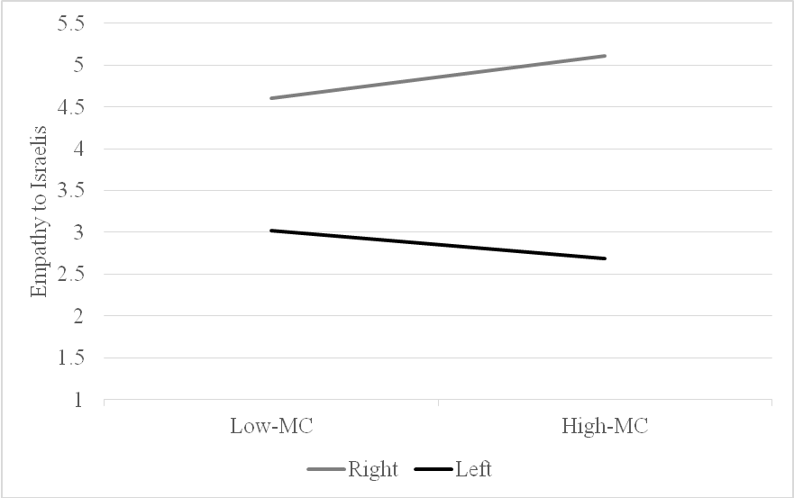

Figure 13. Relationship between moral convictions and empathy following a binding violation for rightists and leftists.

As expected, I also found that taking into account the interaction, there was a significant direct effect of political ideology on adversarial political action tendencies towards the Palestinians, and significant direct effect moral conviction. The interaction between moral conviction and political ideology on adversarial political action tendencies towards the Palestinians was significant. Analysis of the simple effects revealed that for rightists, moral conviction was positively related to adversarial political action tendencies towards the Palestinians. Among leftists, there was also a significant relationship between moral conviction and adversarial political action tendencies towards the Palestinians, but in the opposite direction (see Table 11 and Figure 14).

Table 15
Model statistics for the moderated model predicting adversarial political action tendencies towards the Palestinians
Variable | b | 95% CI | SE | t | p
Moral convictions | -1.06 | [-1.47, -0.64] | 0.21 | -5.05 | < .001
Political ideology | -1.61 | [-2.88, -0.34] | 0.64 | -2.51 | 0.01
Moral convictions x political ideology | 0.71 | 0.47, 0.96] | 0.12 | 5.7 | < .001
Simple effect of moral convictions for leftists | -0.34 | [0.21, 0.53] | 0.01 | -3.53 | < .001
Simple effect of moral convictions for rightists | 0.37 | [0.21, 0.53] | 0.08 | 4.66 | < .001

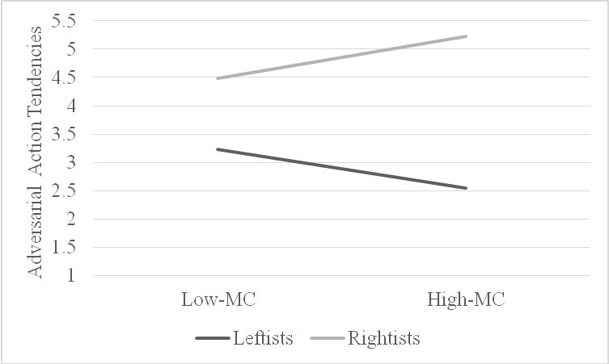

Figure 14. Relationship between moral convictions and adversarial political reaction following a binding violation for rightists and leftists.

In the next step, I tested the full model that following a binding violation the effects of moral conviction on political action tendencies would be mediated by emotion, in this case, anger towards Palestinians, but that this mediation would be moderated by political ideology and would only occur for rightists. Thus, I ran a moderated mediation analysis on adversarial political action tendencies towards the Palestinians, considering moral conviction as the independent variable, political ideology as a moderator, and intergroup anger towards Palestinians as a mediator (PROCESS model 8). The analysis revealed that there was an indirect effect of moral conviction through intergroup anger towards Palestinians on adversarial political action tendencies towards the Palestinians, but only among rightists (a*b = 0.07, SE = 0.04, CI = [0.01, 0.15]), and not among leftists (a*b = -0.06, SE = 0.04, CI = [-0.15, 0.001]).
Additionally, I tested my full model that the effects of moral conviction on political action tendencies would be mediated by emotion, in this case, the complementary moral emotion, in-group empathy for Israelis, but that this mediation would be moderated by political ideology and would only occur for rightists. Thus, I ran a moderated mediation analysis on adversarial political action tendencies towards the Palestinians, considering moral conviction as the independent variable, political ideology as a moderator, and in-group empathy for Israelis as a mediator (model 8). The analysis on adversarial political action tendencies towards the Palestinians revealed that there was no indirect effect of moral conviction through in-group empathy for Israelis on adversarial political action tendencies towards the Palestinians among rightists (a*b = 0. 04, SE = 0.02, CI = [-.00, .08]). As expected there was no indirect effect for leftists (a*b = 0.03, SE = 0.02, CI = [-0.08, 0.01]).
Discussion
The results of Study 3 draw a more nuanced picture than that provided by the first two studies. Study 3 fully examined my model for ties between moral conviction and emotions. Across the analyses, I found the predicted effects except for one specific case: After exposure to a binding violation, I found no indirect effect among rightists of moral conviction through in-group empathy for Israelis on adversarial political action tendencies toward the Palestinians. This makes sense since anger towards the moral violator is a central moral emotion in the context of conflict and expected to be more predictive of adversarial action than empathy for the moral violation victim (e.g., Breugelmans & De Cremer, 2007, Cheung-Blunden & Blunden, 2008; Huddy et al., 2007; Reifen Tagar, Frederico & Halperin, 2011). These findings suggest that using the moral emotions tested in the previous studies together with the inverse emotions, led to a similar pattern of results, thus helping to eliminate the possible confound of the different emotions measured in the binding versus individualizing scenarios in the previous studies.

General Discussion
Do attitudes held with strong moral conviction always have strong ties to intense emotional reactions and subsequent action tendencies? Up to now, morality models have posited that moral conviction elicits intense emotions, which shape behavioral reactions. The model presented suggests that this assumption will not always hold true and that people's moral convictions will not always be tied to intense emotions. Differences in people's emotional reactions to moral events may lead to mutual accusations of a lack of concern for morality and constitute a cause of tension and conflict between people and groups in society. In this sense, my research provides an explanation for the variety of intensity in emotional reactions to moral events, by drawing from theories of moral emotions (Haidt, 2003; Tangney, Stuewig & Mashek, 2007), ITMC (Skitka, Bauman & Mullen, 2008) and MFT (Haidt et al., 2007, 2004). Using these theories together, I developed a model showing that people's political beliefs, which are connected to their fundamental moral foundations, will moderate the ties between moral conviction and emotions.
I tested the validity of the model in the context of ideological intergroup conflicts, and specifically with regard to the Israeli-Palestinian conflict. I examined the ties between moral conviction and emotional reaction among rightists and leftists, referring to typical moral events in the context of the Israeli-Palestinian conflict. My finding in studies 1-3 demonstrates that people's different prioritization of moral foundations, as reflected by political ideology, shapes ties between moral conviction and emotions in reaction to either individualizing or binding moral violations. Such that, both rightists and leftists with strong moral convictions react with emotional intensity to a moral event only when that event is relevant to the moral foundations that each political group most values. These findings shed light on the mechanism that can explain why and how people differ in their emotional reactions to moral events. Although the investigation was conducted in the context of political intergroup conflict, based on our theoretical model, I assume that my findings can be generalized beyond a particular context and across samples. Building on these findings, in the future, it would be important to test the generalizability of the model to other social contexts.
Implications
The present study has both theoretical and methodological implications for moral psychology and political psychology research. Prior work on moralization often used the concepts of moral convictions, moral foundation and political ideology (as well as moral mandates, moral beliefs, and moral intuitions) as intertwined concepts, and had not adequately distinguished between them (Mulen & Skitka, 2006; Wright, Cullum & Schwab, 2010; Skitka, 2015; Haidt, 2007). These moral processes were addressed as holding similar psychological traits such as; (a) personal and intuitive evaluations (e.g., Haidt, 2001; Skitka et al., 2005) (b) influenced by context (e.g., Haidt, 2007; Skitka, 2014) (c) tightly connected to emotions (Skitka, Bauman & Sargis, 2005) (d) motivational force leading to correspondent behavioral reactions (Graham, Haidt & Nosek 2009, Skitka & Wisneski, 2011). The model presented suggests that moral conviction, moral foundations, and political ideology are different segments of the moral judgment system, signaling related, but distinct, paths contributing to moral judgments. One way to differentiate between these paths is to categorize them in terms of 'valence' versus 'content'. The moral conviction path is directed at the valence of things, aimed to answer 'is the event or issue moral? 'Is it 'right or wrong?' (in the eyes of the beholder)? It is a broad and general evaluation, comparable to a binary judgment that can be solved with a quick 'yes/no' assessment. On the other hand, the moral foundation’s path deals with the content of things and indicates their importance for people. The moral foundation aims to capture the moral meaning of an event and to answer 'by what means is the event moral/immoral?' This path is rooted in a specific- diversified context, often rich in details and values (especially in social and political contexts), and can be guided by the five moral foundations (Graham et al., 2013). . The presented model recognizes the different role of each path and assumes that both paths are essential to elicit intense emotions in reaction to moral events. This line of argument also leaves open several questions concerning the nature of the relationship between moral conviction and moral foundations, and future research is required to establish it.
Next, my model offers a new frame regarding the concepts of moral foundations and political ideology. The dominant view in moral psychology and in political psychology is that moral foundations and political ideology are indissoluble. The Moral Foundations Theory (MFT) has well established the correlation between moral foundations and ideology (e.g., Haidt, 2012; Nilsson & Erlandsson, 2015), and extensive application research of MFT has shown that moral foundations reliably predict political attitudes and action tendencies (e.g., Clifford, 2017; Franks & Scherr, 2015; Graham, Haidt & Nosek, 2009; Haidt, 2012; Inbar, Pizarro & Bloom, 2009, 2012; Schein & Gray, 2015). Moreover, some models suggest a causal explanation positing that moral foundations govern political ideology, while counter theoretical models suggest the opposite causal path, that is, that moral foundations are driven by political beliefs (Hatemi, Crabtree & Smith, 2019), and are made in order to justify preexisting social and political beliefs. This investigation follows the predominant norm, assuming the intertwined ties between moral foundations and ideology. However, rather than examining the dichotomous chicken-or-egg question (do moral foundations underlay political ideology, or does political ideology shape moral foundations?), I refer to moral foundations in a political context and to political ideology as a tightly closed concept that eventually determines one's prioritized moral concerns regarding a specific moral event. Both concepts might provide the same 'content' judgments (foundations' affiliation and foundations' order) that underpin moral judgments.
From the perspective of intergroup relations, my findings are of interest to accumulated research examining the moral judgments of liberals and conservatives. In many of these studies, two major approaches are addressed; one claims for inherent intergroup differences between rightists and leftists (Altemeyer, 1988; Jost, Glaser, Kruglansky & Sullway, 2003; Kugler, Jost & Noorbaloochi, 2014; Matar, 2006). The other approach suggests that differences in the emotional and behavioral reactions of liberals and conservatives to moral events arise from the different moral values each group endorses (e.g., Caprara, Schwartz, Capanna, Vecchione & Barbaranelli, 2006; Graham, Haidt & Nosek, 2009; Janoff-Bulman, 2009). My investigation strengthens the MFT approach and the context-dependent approach (Kessler, Proch, Hechler & Nagler, 2015). According to the findings, although liberals and conservatives rely on different sets of moral foundations and may differ in the content of the issues they believe to be morally relevant (Graham, Haidt & Nosek, 2009; Hofmann, Wisneski, Brandt & Skitka, 2014), the processes underlying moral judgment in the context of political conflicts appear to be similar. Both conservatives and liberals, when exposed to related moral events, use their hierarchy of moral values to single out the most relevant moral events to be emotionally addressed. These findings join other studies (e.g., Skitka & Washburn, 2016, 2018) that indicate that liberals and conservatives are more psychologically similar, in terms of psychological processes, than past research had typically assumed. Understanding the similarities, as well as the differences, across the ideological spectrum, should reduce mutual alienation and hostility and may improve the understanding of different emotional and behavioral reactions to moral-political events.
Limitations
The present research has several noteworthy limitations: First, my proposed model points to one potential mechanism, namely the prioritization of moral foundations as reflected in one's political ideology, that shapes the ties between moral conviction and emotion. This explanation cannot rule out an alternative explanation for the demonstrated findings that may rely on the political group conflict hypothesis (Frimer, Gaucher & Schaefer, 2014). The political group conflict hypothesis assumes that ideological differences in moral foundations are not necessarily due to differences in moral values per se but are driven by in-group-versus-outgroup categorizations. In this sense, in-group-versus-outgroup categorizations of competing political groups might be the cause of the observed differences in the studies. The scenarios used in this investigation had systematic differences between the foundation violated and the conditions (in terms of the perpetrators and the victims of the violations), meaning; the binding violation is always a violation committed by Palestinians against Israelis, whereas the individualizing foundations are always a violation by Israelis against Palestinians. This limitation is linked to a general identified complication to tease apart the unique effect of the moral foundations and minimize the potential confound of the target groups. The built-in content of the moral foundations might often confound with people's stereotypes and reactions toward specific target groups, as shown in other studies as well (Voelkel & Brandt, 2018).
Moreover, this methodological limitation rests on a more in-depth theoretical issue; what is the nature of the relationship between people's moral identity and their social identity? Are our moral foundations 'stronger' or 'weaker', than our group identification? Though this investigation favors the position claiming that moral foundations should be above and beyond the identity of the target of the moral violation, the influence of the target's group identity should not be ignored. Strengthening this claim requires more research examining the relationship between moral foundations and different target groups, and the effect of these relationships on moral convictions and moral emotions.
The second limitation of the moderated-mediation model is that although I suggested that moral conviction, moderated by the moral foundations, would elicit intense emotions, I cannot infer any causal influence of moral conviction on the emotions I examined; anger and empathy. Since no causal evidence is provided, I cannot rule that a third factor could explain why someone has both high moral convictions and intense emotional reactions, and the particular nature of these relationships remains unclear. As mentioned above, many previous studies referred to intertwine ties between moral convictions, emotions, and behavior but given the difficulties of manipulating moral convictions, they measured rather than manipulated moral convictions and relied on correlational methods (e.g., Skitka et al., 2005; Skitka, Bauman & Mullen, 2008; Voelkel1 & Brandt, 2019; Zomeren, Postmes & Spears, 2011). Future studies should try to manipulate the causal effect of moral conviction on emotions and test its potential causal effect on anger and empathy and its subsequent behavioral effects.
Third, I measured both emotional reactions and political action tendencies using self-reports. Although such measures have established validity, (e.g., Batson et al., 1997; Jost, 2006), given that the issues presented in the scenarios are politically charged, participants may have responded according to how they would like to appear, as is stereotypically expected of their political group (Farwell & Weiner, 2000). Thus, it might be that these stereotypes influenced my results. Future studies could utilize measures of emotional experiences that do not rely on self-report and assess actual aggressive or conciliatory actions within the political context.

Conclusion
Research on ties between morality and emotions has been shaped by the idea that moral conviction elicits intense emotions and subsequent behavioral reactions (Skitka, 2010). On the other hand, my work proposes that moral conviction will not always be tied to intense emotions, and that moral relevancy will moderate the ties between moral convictions and emotions. I demonstrated that, in the context of intractable conflicts, rightists and leftists' differing prioritization of moral foundations, as reflected by their political ideology, shapes the ties between moral convictions and emotional reactions to moral events. These results emphasize the key role of moral relevancy in translating moral conviction into intense emotion and may articulate, in part, an explanation for when and why people differ in their emotional reactions to a moral event.

References
Bar-Tal, D. (2007). Socio-psychological foundations of intractable conflicts. American Behavioral Scientist, 50(11), 1430-1453.
Bar-Tal, D. (2013). Intractable conflicts: Socio-psychological foundations and dynamics. Cambridge, UK: Cambridge University Press.
Batson, C. D. (2008). Empathy-induced altruistic motivation. Paper presented at Inaugural Herzliya Symposium on Prosocial Motives, Emotions, and Behavior, Israel.
Batson, D., Polycarpou, M. P., Harmon-Jones, E., Imhoff, H. J., Mitchener, E. C., Bednar, L. et al. (1997). Empathy and Attitudes: Can Feeling for a Member of a Stigmatized Group Improve Feelings Toward the Group? Journal of Personality and Social Psychology, 72, (1), 105-118.

Ben-Nun Bloom, P. (2013). The Public’s Compass: Moral Conviction and Political Attitudes.

American Politics Research, 41, (6), 937-964.
Bloom, P. (2016). Against Empathy: the case for rational compassion. New York, NY: Harper Collins.
Brandt, M. J., Wisneski, D. C., & Skitka, L. J. (2015). Moralization and the 2012 presidential election campaign. Journal of Social and Political Psychology, 3, 211-237.
Cohen-Chen, S., Halperin, E., Crisp, R. J., & Gross, J. J. (2014). Hope in the Middle East: Malleability beliefs, hope, and the willingness to compromise for peace. Social Psychology and Personality Science, 5, 67-75.
Coleman, P. T., Vallacher, R. R., Nowak, A., & Lan Bui-Wrzosinska, L. (2007). Intractable conflict as an attractor: A dynamical systems approach to conflict escalation and intractability. American Behavioral Scientist, 50, 1454-1475.
Crawford, J. T., & Pilanski, J. M. (2013). Political intolerance, right and left. Political Psychology, 10, 1467-1492.
Fischer, A. H., & Roseman, J. (2007). Beat them or ban them: The characteristics and social functions of anger and contempt. Journal of Personality and Social Psychology, 93(1), 103-115.
Ellsworth, P. C., & Smith, C. A. (1988) From Appraisal to Emotion: Differences among
Unpleasant Feelings. Motivation & Emotion, 12, (3), 271-302.
Frijda, N. H. (2004). Emotions and action. In A. S. R. Manstead, N. Frijda, & A. Fischer (Eds.), Feelings and emotions: The Amsterdam symposium (pp. 158-173). Cambridge, UK: Cambridge University Press.
Gerring, J. (1997). Ideology: A Definitional Analysis. Political Research Quarterly, 50, 947-994.
Graham, J., Haidt, J., & Nosek, B. (2009). Liberals and conservatives use different sets of moral foundations. Journal of Personality and Social Psychology, 96, 1029-1046.
Haidt, J. (2001). The emotional dog and its rational tail: A social intuitionist approach to moral judgment. Psychological Review, 108, 814-834.
Haidt, J., & Graham, J. (2007). When morality opposes justice: Conservatives have moral intuitions that liberals may not recognize. Social Justice Research, 20, 98-116.
Haidt, J., Graham, J., & Joseph, C. (2009). Above and below left-right: Ideological narratives and moral foundations. Psychological Inquiry, 20, 110-119.
Haidt, J., & Joseph, C. (2004). Intuitive Ethics: How Innately Prepared Intuitions Generate Culturally Variable Virtues. Daedalus, 55-66.
Halperin, E. (2008). Group-based hatred in intractable conflict in Israel. Journal of Conflict Resolution, 52, 713-736.
Halperin, E. (2011). Emotional barriers to peace: Emotions and public opinion of Jewish Israelis about the peace process in the Middle East. Peace and Conflict: Journal of Peace Psychology, 17, 22-45. ​
Halperin, E. (2016). Emotions in conflict: Inhibitors and facilitators of peace making. Oxford, England: Routledge.
Halperin, E., Porat, R., Tamir, M., & Gross, J.J. (2013). Can emotion regulation change politcial attitudes in intractable conflicts? From the labratory to the field. Psychological Science, 24, 106-111.
Halperin, E., Russell, A. G., Dweck, C. S., & Gross, J. J. (2011). Anger, hatred, and the quest for peace: Anger can be constructive in the absence of hatred. Journal of Conflict Resolution, 55(2), 274-291.
Hatemi, P. K., Crabtree, C., & Smith, K. B. (2019). Ideology Justifies Morality: Political Beliefs
Predict Moral Foundations. American Journal of Political Science, 63(4), 788–806. https://doi.org/10.1111/ajps.12448
Hofmann, W., Wisneski, D. C., Brandt, M. J., & Skitka, L. J. (2014). Morality in everyday life. Science, 345, 1340 – 1343.
Iyer, R., Graham, J., Koleva, S., Ditto, P., & Haidt, J. (in press). Beyond Identity Politics: Moral Psychology and the 2008 Democratic Primary. Analyses of Social Issues and Public Policy.
Jost, J. T. (2006). The end of the end of ideology. American Psychologist, 61(7), 651-670.
Kamans, E., Zomeren, M., Gordijn, E. H., & Postmes, T. (2014). Communicating the right emotion makes violence seem less wrong: Power-congruent emotions lead outsiders to legitimize violence of powerless and powerful groups in intractable conflict. Group Processes & Intergroup Relations, 17(3) 286–305.
Lazarus, R.S., & Alfert, E. (1964) Short-circuiting of threat by experimentally altering cognitive appraisal. Journal of Abnormal and Social Psychology. 69:195–205.
doi: 10.1037/h0044635.
Lerner, J. S., Gonzalez, R. M., Small, D. A., & Fischhoff, B. (2003). Effects of fear and anger on perceived tasks of terrorism: A national field experiment. Psychological Science, 14, 144-150.
Maoz, I. (2011). Does contact work in protracted asymmetrical conflict? Appraising 20 years of reconciliation-aimed encounters between Israeli Jews and Palestinians. Journal of Peace Research, 48(1), 115-125.
Maoz, I., Bar-On, D., & Yikya, S. (2007). “They understand only force”: A critical examination of the erruption of verbal violence in a Jewish-Palestinian dialogue. Peace and Conflict Studies. (2)14, 27-48.
Maoz, I., & McCauley, C. (2005). Psychological correlates of support for compromise: A polling study of Jewish-Israeli attitudes toward solutions to the Israeli-Palestinian conflict. Political Psychology, 26, 791-808.
Maoz, I., & McCauley, C. (2008). Threat, dehumanization and support for retaliatory-aggressive policies in asymmetric conflict. Journal of Conflict Resolution, 52, 93 – 116.
Maoz, I., & McCauley, C. (2009). Threat perceptions and feelings as predictors of Jewish-Israeli support for compromise with Palestinians. Journal of Peace Research, 46, 525−539.
Pliskin, R., Bar-Tal, D., Sheppes, G., & Halperin, E. (2014). Are leftists more emotion-driven than rightists? The interactive influence of ideology and emotions on support for policies. Personality and Social Psychology Bulletin, 40, 1681-1697.
Porat, R., Halperin, E., Tamir, M. (2016). What we want is what we get: Group-based emotional preferences and conflict resolution. Journal of Personality and Social Psychology, 110(2), 167-190.
Reifen-Tagar, M., Halperin, E., & Frederico, C. (2011). The positive effect of negative emotions in protracted conflict: The case of anger. Journal of Experimental Social Psychology, 47, 157-163.
Reifen-Tagar, M., Morgan, G. S., Skitka, L., & Halperin, E. (2014). Moral conviction in the context of protracted intergroup conflict: When ideology matters in the Israeli-Palestinian conflict. European Journal of Social Psychology, 44(2), 117-125.
Roseman, I.J, & Spindel, M., (1990). Appraisals of Emotion-Eliciting Events: Testing a Theory of Discrete Emotions. Journal of Personality and Social Psychology, 5, 899-915.
Rosler, N., Cohen-Chen, S., & Halperin, E. (2017). The distinctive effects of empathy and hope in intractable conflicts. Journal of Conflict Resolution, 6(1), 114-139.
Salomon, G. (2004). A narrative-based view of peace education. Journal of Social Issues, 60(2), 273-288.
Shiffman, S., Stone, A. A., & Hufford, M. R. (2008). Ecological momentary assessment. Annu. Rev. Clin. Psychol. 4, 1–32.
Shweder, R. (2002). The nature of morality: The category of bad acts. Medical Ethics Journal, 9 (1) 6-7.
Skitka, L. J. (2010). The psychology of moral conviction. Social and Personality Psychology Compass, 4, 267-281.
Skitka, L. J. (2014). The psychological foundations of moral conviction. In J. Wright & H. Sarkissian (Eds.), Advances in Moral Psychology (pp. 148 - 166), New York: Bloomsbury Academic Press.
Skitka, L. J., & Bauman, C. W. (2008). Moral conviction and political engagement. Political Psychology, 29, 29-54.
Skitka, L. J., Bauman, C. W., Aramovich, N. P., & Morgan, G. C. (2005). Moral conviction: Another contributor to attitude strength or something more? Journal of Personality and Social Psychology, 88(6), 895-917.
Skitka, L. J., Bauman, C. W., Aramovich, N. P., & Morgan, G. C. (2006). Confrontational and preventative policy responses to terrorism: Anger wants a fight and fear wants "them" to go away. Basic and Applied Social Psychology, 28, 375–384.
Skitka, L. J., Bauman, C. W., & Mullen, E. (2008). Morality and justice: An expanded theoretical perspective and review. In K. A. Hedgvedt & J. Clay-Warner (Eds.), Advances in group processes, 25, 1–27.
Skitka, L. J., Hanson, B. E., & Wisneski, D.C. (2017). Utopian hopes or dystopian fears? Understanding the motivational underpinnings of morally motivated political engagement. Personality and Social Psychological Bulletin, 43,177-190.
Skitka, L. J., & Morgan, S. (2014). The social and political implications of moral conviction. Advances in Political Psychology, 35(1).
Skitka, L. J., & Wisneski, D. C. (2011). Moral conviction and emotion. Emotion Review, 3, 328-330.

Skitka, L. J., Wisneski, D. C., & Brandt, M. J. (2017). Attitude moralization: Probably not intuitive or rooted in perceptions of harm. Current Directions in Psychological Science, 27, 9-13. doi.org/10.1177/0963721417727861
Smith, E. R. (1993). Social identity and social emotions: Toward new conceptualization of prejudice. In D. M. Mackie, & D. L. Hamilton (Eds.), Affect, cognition and stereotyping: Interactive processes in group perception (pp. 297-315). San Diego, CA: Academic Press.
Smith, E. R., & Mackie, D. M. (2008). Intergroup emotions. In M. Lewis, J. M. Haviland-Jones, & L. F. Barrett, (Eds.), Handbook of emotions (3rd ed., pp. 428-439). New York, NY: Guilford.
Stephan, W. G., & Finlay, K. (1999). The role of empathy in improving intergroup relations. Journal of Social Issues, 55, 729-743.
Ugazio, G., Lamm, C., & Singer, T. (2011). The Role of Emotions for Moral
Judgments Depends on the Type of Emotion and Moral Scenario. Emotion. Advance online publication. doi: 10.1037/a0024611
Van Bavel, J. J., Packer, D. J., Haas, I. J., Cunningham, W. A. (2012). The importance of moral construal: Moral versus non-moral construal elicits faster, more extreme, universal evaluations of the same actions. PLOS ONE, 7(11), e48693.
Van Zomeron, M., Postmes, T., Spears, R., & Bettache, K. (2011). Can moral convictions motivate the advantaged to challenge social inequality?: Extending the social identity model of collective action. Group Processes and Intergroup Relations, 14, 735-753.
Wisneski, D. C. & Skitka, L. J. (2017). Moralization through moral shock: Exploring emotional antecedents to moral conviction. Personality and Social Psychological Bulletin, 43, 139-150.
Wrigh, C., & Nicholas, C. (2008). The Cognitive and Affective Dimensions of Moral Conviction: Implications for Attitudinal and Behavioral Measures of Interpersonal Tolerance. Personality and Social Psychological Bulletin, 34, 1461-1476.
Zaki, J. (2014). Empathy: A motivated account. Psychological Bulletin, 140(6), 1608-1647.

On March 24, 2016, a Palestinian assailant who stabbed an Israeli soldier was shot, wounded and "neutralized". He was then shot again in the head by Elor Azaria, an Israeli Defense Forces (IDF) soldier, as he lay wounded on the ground.
Israeli Knesset members, mostly from the BLD Party, visit terrorists in prison, such as Hassan Salameh, one of the planners of the attack on Bus Line 18 in Jerusalem, in which 46 people were murdered.
The individualizing foundation should theoretically be based on care and fairness foundations, but since it is difficult to encompass both foundations in one scenario, and the harm foundation is most relevant to the intergroup context, the scenarios focused only on care issues, and therefore I focused only on the care foundation.
Moral conviction measures ask about the conflict in general rather than about reactions to the particular scenario participants read.
Study 2 was a part of a large-scale survey conducted in Germany, the United States and Israel, using two other conditions: a neutral text condition and an external text condition. The results of the study were published in other publications. For the current study, I used only the relevant data.

