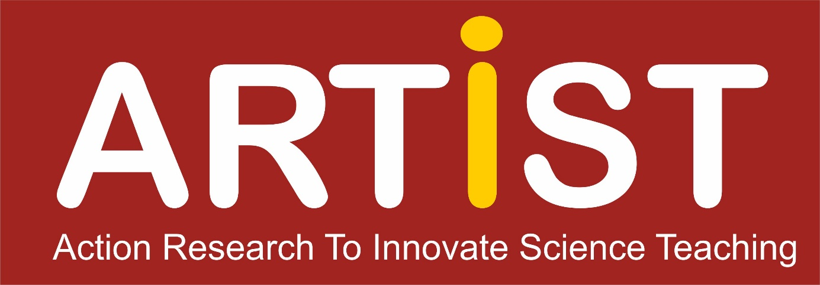

**The ARTIST Guidebook**

Version 1.5 (October 2018)

A Guidebook to Prepare and Conduct Workshops on Action Research in Science Teacher Education

Prepared by the ARTIST – Action Research to Innovate Science Teaching Project (Editors Franz Rauch, Marika Kapanadze, Nadja Frerichs and Ingo Eilks with contributions from the whole ARTIST consortium)



This guide is part of the ARTIST – Action Research to Innovate Science Teaching project. The project was co-funded by the European Union under the program ERASMUS+ - Capacity Building in Higher Education (CBHE) from 2016-2019 under grant agreement number 573533-EPP-1-2016-1-DE-EPPKA2-CBHE-JP.

We gratefully acknowledge the funding by the European Union.

This guide is published under a Creative Commons Attribution-NonCommercial-ShareAlike (BY-NC-SA) license .

**The ARTIST Guidebook**

**Table of contents**

1. About this guide 1

2. The ARTIST project 3

3. Action research to innovate science teaching 9

[4. Activities and materials to be used in science teacher education action research  
workshops 21](#_Toc517082495)

4.1 Action research - how to start

4.2 Action research - action and reflection

4.3 Networking activities

4.4 How to start dissemination

5. Selected figures to be used in science education action research workshops 45

6. Exemplary action research sketches from ARTIST and beyond 57

7. Resources to prepare and to be used in action research workshops 77

7.1 Recommended books on action research

7.2 Recommended articles and chapters on action research in science education

7.3 Supporting policy resources from the Internet

7.4 Methodological resources from the Internet

7.5. The Collaborative Action Research Network (CARN)

8. ARTIST Centers and contact points in different countries 81

### About this guide

The *Action Research to Innovate Science Teaching* *Project* (ARTIST) aims at promoting teacher education practices. Its objective is to provide practicing and prospective science teachers with knowledge and skills to operate action research for the innovation of science education and the merit of their students. ARTIST identified and developed resources to implement action research in science teacher education courses. This guidebook contains materials and information used and disseminated in workshops during the ARTIST project focusing the implementation of ARTIST courses in the partner institutions. It also provides insights into the course of the ARTIST project.

The materials in the ARTIST Guidebook are suggested to help teacher educators and continuing professional development providers with tools to be used in their teacher education courses. The guidebook provides workshop ideas, workshop materials, and figures that can form the base for science teacher education practices with a focus on action research. It provides exemplary cases that might inspire teachers in their potential action research interests. The collection is free to be used in non-commercial provisions of science teacher professional development (pre- and in-service) on all levels.

Within the ARTIST consortium books, articles, chapters, and Internet resources were identified that are suitable to build a broad information base for the implementation of action research and classroom-based innovation in science teacher education. A corresponding list of recommended resources is given within this book.

For the support in use, ARTIST centers were founded in Germany, Austria, Ireland, Turkey, Georgia, Israel and the Philippines. The teams in the ARTIST centers are available to support science teachers and teacher educators on their way to implement action research in science teacher education. The final chapter of this guide introduces the ARTIST centers and provides contact details.

By the ARTIST Guidebook, the ARTIST homepage, and the founding of the *Action Research and Innovation in Science Education* journal (ARISE), the ARTIST project hopes to support teacher education in science education in general and in the different science disciplines in particular and on all levels of education, from primary science to teaching in higher education.

The consortium wishes all science educators, teachers and students good luck and fruitful experiences in applying action research for the promotion of modern, innovative and effective science learning.

*Ingo Eilks, Marika Kapanadze and the ARTIST consortium*

### The ARTIST project

*Ingo Eilks, Nadja Frerichs and Marika Kapanadze*

This chapter describes the ARTIST project in which this guide was developed. ARTIST is an ERASMUS+ Capacity Building in Higher Education (CBHE) action and aims at introducing science education researchers as well as teachers to the philosophy of action research. Action research targets the research-based transformation of science education practices.

**The idea of ARTIST**

The focus of the *Action Research to Innovate Science Teaching Project* (ARTIST) is to innovate science education through classroom‐based and teacher‐driven action research. Action research aims the cyclical transformation of authentic practices through the action research cycle of innovation, research, reflection, and further improvement of the innovation approach. Beyond the interest of concrete change and innovation, action research aims for the generation of knowledge and best practice strategies, serving as patterns for innovations in the field of interest, but also in contributing to the continuous professional development of the acting practitioners. ARTIST considers action research to be one of the most promising strategies for innovating science education and creating evidence‐based classroom practices in domain‐specific educational studies.

**Transforming science education by action research**

Action research in science education seeks to improve science classroom practices by cycles of planning and operating action, observation/research, reflection, and revision (Laudonia, Mamlok-Naaman, Abels & Eilks, 2017). Action research has been identified as one of the most promising strategies for research-oriented science teacher education and continuing professional development as well as for classroom innovation. Action research’ potential was suggested both by educational policy (e.g., European Commission, 2013; 2015) and domain-specific science education research (Eilks, 2014; Mamlok-Naaman & Eilks, 2012). Strategies of action research provide an alternative route (or even a different paradigm) of educational research and evidence-based practice improvement in science education including a different view on the research to practice relationship (Bodner, MacIsaac & White, 1999; Mamlok-Naaman, Eilks, Bodner & Hofstein, 2018).

There is a large variety of action research strategies and foci of research provided in the science education literature (Laudonia et al., 2017). The approach suggested in the ARTIST project is an accompanied, participatory, but also teacher‐centred interpretation of action research. Innovations are suggested to be thought out, implemented, researched, and reflected by the practitioners under the direction of science educators from higher education institutions (HEIs) leading towards further steps of development and innovation.

ARTIST is a curriculum reform project in higher education. The curricular focus behind ARTIST is introducing science education researchers and prospective or practicing science teachers towards the philosophy and methods of action research, in order to form a basis for research‐based transformation in science education. ARTIST provides the framework for the development of appropriate training materials, courses and activities. ARTIST will be the platform for the exchange and sustainable implementation of action research into science education within the participating HEIs.

In order to give action research activities within ARTIST a joint and valuable focus, ARTIST aims to raise motivation and achievement in science education and to enhance interest and improve the opportunities of the young generation in careers and further education in science and engineering fields. To connect the idea of action research for innovating science education with the aim of improving the career opportunities of the young generation in science and engineering, a unique feature of ARTIST is the development of networks of universities with schools and industry/SMEs. Each HEI within ARTIST builds up a regional network around it, consisting of the HEI, secondary schools and representatives of industry/SMEs.

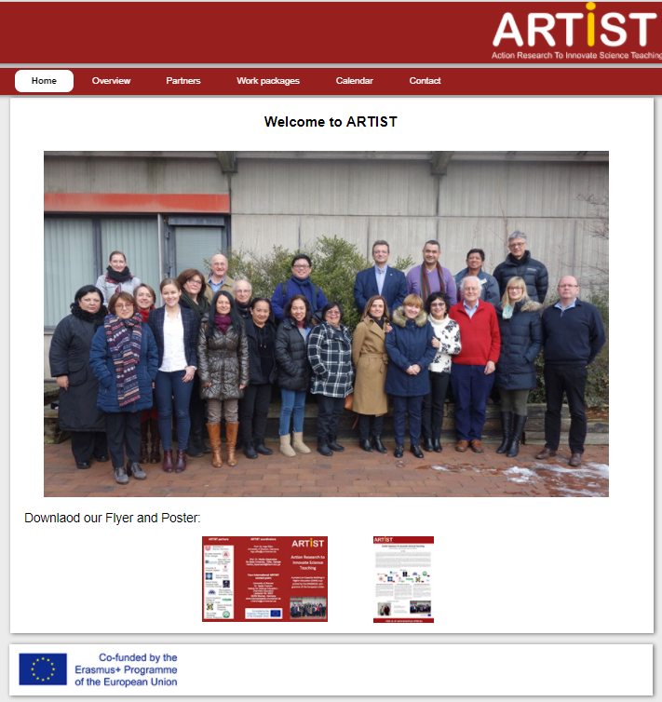

*Figure 1. The ARTIST website*

**The ARTIST partners**

The ARTIST project is an ERASMUS+ Capacity Building in Higher Education (CBHE) action (www.erasmus-artist.eu). The action is cross-regional encompassing partners from Europe and Asia. The consortium of ARTIST was formed based on the successful project *Student Active Learning in Science (SALiS)* funded by the European Union under the TEMPUS framework from 2010-2012 (Kapanadze & Eilks, 2014).

Partners in ARTIST are:

* University of Bremen, Bremen, Germany
* Ilia State University, Tbilisi, Georgia
* University of Limerick, Limerick, Ireland
* Alpe-Adria- University, Klagenfurt, Austria
* Gazi University, Ankara, Turkey
* Batumi Shota Rustaveli State University, Batumi, Georgia
* Acadenic Arab College of Education, Haifa, Israel
* Oranim College of Education, Oranim, Israel
* De la Salle University, Manila, Philippines
* Ateneo de Manila University, Manila, Philippines

The project is funded by the European Commission for the years from 2016-2019.

**ARTIST courses, centres, and networks**

Course structures and teaching materials about how to do action research in educational settings with a special focus on science education are developed, Guidance is given how to establish and maintain partnership networks of HEIs and schools. The course structures and teaching materials will be developed based on a needs analysis, good practice reports, collaboration between the partner institutions, and adapting the ARTIST principles to the local needs of the partner institutions.

Training materials, teaching guides, slide shows and handouts are prepared for the ARTIST workshops and course. An action research guide specifically focusing science education is developed which will help secondary and tertiary science teachers to learn about action research. Materials cover basics of conducting action research for informing practice and introduction of innovations in teaching science. ARTIST courses are provided and implemented. As action research is suggested as one of the most promising strategies in science teacher professional development (Mamlok-Naaman et al., 2018) student teachers and participants in continuous professional development participate in all ARTIST beneficiary institutions.

Networks of the partner universities, schools and enterprises are maintained around each of the ARTIST HEIs to ensure sufficient background and impact of the project. Institutions develop existing infrastructure by procuring and installing specific equipment and materials needed to promote teacher education for career orientation related to the industries in the partnership network. Equipment includes special media or items for demonstrating, studying and investigating, e.g., biochemical, genetic or technological processes. Equipment is purchased and installed in all ARTIST universities in the so-called partner countries, namely Georgia, Israel, and the Philippines. ARTIST centres are established as supporters and facilitators for schools and teachers doing action research in science education.

The means of the communication from the ARTIST project are diversified in order to achieve the maximum outreach. ARTIST educational workshops are held in 2018 in the Philippines, Georgia and Israel. All workshops include a day for the interested public, namely teachers, teacher educators, and educational policy stakeholders. A final conference will be held in summer 2019 in Batumi, Georgia.

**ARISE – The journal of action research and innovation in science education**

To promote long-term sustainability and for the stimulation of the interest into action research, a new international electronic peer reviewed journal is established. The journal is called *Action Research and Innovation in Science Education* (ARISE). It will provide a unique place for teachers and researchers to publish action research and small-scale innovation studies in all fields of science education. In order to feed the first volume of the ARISE journal action research and innovation case studies are to be conducted by all partners focusing on aspects of inquiry‐based science education, teaching and learning of science, and career orientation in science education.

ARISE is a peer-reviewed international journal. ARISE publishes academic and practitioner research in the field of science education. Papers shall be about action research, practitioner research, or classroom-based research and innovation studies. Papers may comprise theoretical discussions, research studies, or reports on evidence based curriculum innovation. Contributions may focus all the science teaching domains, from early childhood science through the secondary and university level to informal science and environmental education. Manuscripts on science teacher education in connection to action research, classroom-based research and innovation or research-based learning in teacher education are welcome as well as papers on the methodology of action research for classroom innovation in science education.

The ARISE journal, launched by the ARTIST project, will become a central instance for visibility and impact of the ARTIST project. After the ARTIST project, the ARISE journal will be maintained by the *International Society for Educational Research (iSER)*. All partners designated from the consortium agreed to serve as editors and editorial board members beyond the funding period to make ARISE a success on the long run. The editorial board also incorporates further experts from the field of science education across all regions of the world.

**Outlook**

Action research is a unique way of transforming educational practices based on evidence and in the same time of contributing to teachers continuing professional growth. Action research is suggested by educational policy (European Commission, 2013; 2015) but is still under-represented in the literature of science education (Laudonia et al., 2017). The ARTIST project intends to strengthen action research in science education for the sake of better science teaching and more effective science learning. The ARTIST project intends to lead to sustainable transformations in teacher education in the participating HEIs and countries. First implementations show already change in teacher education practices, will be further improved and will be continued in the ARTIST centres and networks established with the help of the project.

**References**

Bodner, G. M., MacIsaac, D., & White, S. R. (1999). Action research: overcoming the sports mentality approach to assessment/evaluation. *University Chemistry Education*, *3*(1), 31–36.

Eilks, I., (2014). Action Research in science education: From a general justification to a specific model in practice. In T. Stern, F. Rauch, A. Schuster, & A. Townsend (Eds.), *Action research, innovation and change* (pp. 156-176). London: Routledge.

European Commission (2013). *Supporting teacher educators for better learning outcomes*. Brussels: European Commission. Retrieved from the World Wide Web, April 14, 2018, at ec.europa.eu/dgs/education.../support-teacher-educators_en.pdf.

European Commission (2015). *Shaping career-long perspectives on teaching. A guide on policies to improve initial teacher education*. Brussels: European Commission. Retrieved from the World Wide Web, April 14, 2018, at ec.europa.eu/dgs/education_culture/repository/education/library/reports/initial-teacher-education_en.pdf.

Kapanadze, M., & Eilks, I. (2014). Supporting reform in science education in middle and Eastern Europe - Reflections and perspectives from the project TEMPUS-SALiS. *Eurasia Journal of Mathematics, Science and Technological Education*, *10*, 47-58.

Laudonia, I., Mamlok-Naaman, R., Abels, S., & Eilks, I. (2017). Action research in science education - An analytical review of the literature. *Educational Action Researc*h advance article.

Mamlok-Naaman, R., & Eilks, I. (2012). Action research to promote chemistry teachers’ professional development – cases and experiences from Israel and Germany. *International Journal of Mathematics and Science Education*, *10*, 581-610.

Mamlok-Naaman, R., Eilks, I., Bodner, G., & Hofstein, A. (2018). *The professional development of chemistry teachers.* Cambridge: RSC.

### Action research to innovate science teaching

*Ingo Eilks, Franz Rauch, Nadja Frerichs and Marika Kapanadze*

This chapter describes the main principles, goals, ethical aspects as well as limitations of action research in the context of the ARTIST project. In particular, the differences between traditional formal research and action research are outlined. A model of the action research cycle is described.

**The potential of action research to innovate science teaching**

Science, engineering and technology are in the heart of every modern society and related education is suggested to be needed for its development (Bradley, 2003). Both, the growth of prosperity as well as coping with local, regional and global challenges, e.g. clean water supply or climate change, and sustainable development of our future are indispensable connected to science and technology (Matlin, Mehta, Hopf & Krief, 2015.) and related education for sustainable development (Burmeister, Rauch & Eilks, 2012). Society needs its citizens to be educated and scientifically literate, to make informed decisions about corresponding developments within society (Hofstein, Eilks & Bybee, 2011). One solution, to improve how we cope with these challenges, is investing in more relevant science education from the primary to the tertiary sectors (Stuckey, Hofstein, Mamlok-Naaman & Eilks, 2013).

The keys for developing science education are both evidence‐based curriculum development and investment in teacher education (pre‐ and in‐service). Teachers are the key for any effective practice in education (Hattie, 2008) and their views and experiences play an important role in any development or implementation of reform in general (van Driel, Beijaard & Verloop, 2001) or concerning relevant science education in particular (Hugerat, Mamlok-Naaman, Eilks & Hofstein, 2015). This is the point where action research comes into play. Action research has great potential to contribute to positive developments in science education teaching practices and corresponding teacher education (Mamlok-Naaman, Eilks, Bodner & Hofstein, 2018). Action research provides potential to directly change classroom practices and in the same time to enrich science teachers’ professional knowledge base (Eilks, 2014) leading to teachers’ professional growth (Mamlok-Naaman & Eilks, 2012).

Action research seeks to establish a culture of research‐based innovations in science education based in participatory and pragmatic research paradigms (Creswell, 2003) and with connections to critical theory (Kemmis, 2007). Action research is a set of strategies for cyclically researching and innovating authentic practices (in this case in science education) by the practitioners (in our case science teachers) (Altrichter, Feldman, Posch & Somekh, 2008). A large variety of action research strategies and initiatives exist already in science education (Laudonia, Mamlok-Naaman, Abels & Eilks, 2017). Implementation of action research needs, however, continuing support by developing and providing courses, course materials, guides and support for further science teachers to become active and reflective innovators of their classroom practices by action research.

Generally, all action research aims at enabling teachers to reduce deficits in their teaching and develop more motivating and effective educational practices (Eilks & Ralle, 2002). This work is guided by evidence gained in small-scale research activities operated by the teachers in their authentic teaching and learning environments (Altrichter et al., 2008). Cooperative and collaborative practices of action research also intend to network practitioner among each other and to other stakeholders relevant to science education (Mamlok-Naaman & Eilks, 2012). Collaboration is suggested to both provide support for the individual teacher and to allow the newly recognised solution strategies to be of help to wider regional, national and international audiences (Eilks & Ralle, 2002).

Science education works in an international landscape covering a wide area of different cultural and socio‐ economic conditions. This means that action research has to materialize differently under various cultural, educational and societal conditions. The various experiences in the application of action research are suggested to better come up with differences between different educational practices than traditional research often can do. In doing so, action research allows also for learning from each other by respecting and reflecting different foci, activities and methodological decisions in different socio-cultural environments. Action research can provide cultural insights relevant to science education and make science teacher education an intercultural experience. In the case of the ARTIST project networking takes place between researchers and practitioners from Western Europe with Turkey, Georgia, the Philippines and Israel. The intercultural aspect is particularly relevant within Israel, with the involvement of both Jewish and Arab sectors, as they are two very different cultural environments within the one nation. Further networks might help also supporting national classrooms that face increasing diversity by growing migration in many countries of the world.

Among the major deficits described in many reports in science education, especially in the physical sciences, are poor student motivation, a misplaced perception of relevance of science teaching (Stuckey et al., 2013), and a shortage of young people embarking in careers in science and engineering (Osborne & Dillon, 2008). Action research can help to reduce these problems. Innovations by action research can address student motivation, their perception of relevance of science learning, career orientation, and science careers preparation. By directly applying innovations based on evidence action research has direct potential to reduce deficits reported from practice, like lacks in focusing the relevance of science education (Stuckey et al., 2013).

To make most potential of action research, networks of higher education institutions for science education research and teacher education with teachers and schools are suggested, as well as networks with businesses (industry or SMEs). Within these networks action research and innovation case studies will have potential to give the students an authentic perception of science, utilizing its application in industry and SMEs and also in everyday life processes and products provided by the corresponding companies. This connection with industry and SMEs is suggested to help reducing the gap in students’ perception of relevance of science education (Hofstein & Kesner, 2006), by parallel science education allowing to referring to the three dimensions of relevant science education, namely individual, societal and vocational relevance (Hofstein & Kesner, 2015).

The implementation of action research case studies into science education can help to make science teachers become more reflective practitioners (Leitch & Day, 2000). The teachers can gain skills for ongoing innovation of their teaching based on evidence and reflection by action research. Action research case studies towards integrating science education with society and the economy sector can contribute to raising the level of scientific literacy in the young generation for a self‐determined life and to enable the ability to democratically participate in society, today and in the future, following the EU policy of promoting science education for responsible citizenship (EU Commission, 2015b).

**Action research in science education and needed implementation**

Action Research aims for the cyclical innovation of authentic practices through the action research cycle of planning, action, evaluation, and reflection, leading to further improvement of the innovation approach (Altrichter et al., 2008). Beyond the interest of concrete change and innovation, action research – in all its different interpretations - aims for the generation of knowledge and best practice strategies, serving as a pattern for innovations in the field of interest, but also in contributing to the continuous professional development of the acting practitioners (Laudonia et al., 2017). Action research is suggested to be one of the most promising strategies for innovating science education and creating evidence‐based classroom practices in domain‐specific educational studies (Marks & Eilks, 2010).

More generally spoken Action Research has not only has to meet the requirements of any other social research methodology, but also those of practical usefulness for the people concerned including high ethical standards and compliance with values like democratic participation, sharing of knowledge and emancipation from ignorance and dependency. Based upon the work Heron and Reason (2008) and others four principles of action research could provide guidelines for action researchers (Stern et al.):

(1) Good Action Research pursues worthwhile practical purposes

* by trying to find solutions for authentic problems and empowering the people concerned to acquire relevant knowledge and to share it with others;
* by leading to actions that are embedded in a humanistic value system.

(2) Good Action Research is collaborative / participatory

* by involving the people concerned into the research process;
* by agreeing upon ethical rules for the collaboration.

(3) Good Action Research is responsive and developmental

* by engaging in a continuous series of research-and-development cycles;
* by taking the different perspectives of various stakeholders into consideration in search of satisfactory problem solutions.

(4) Good Action Research connects theory and praxis

* by balancing action and reflection; (reflection can inspire or evaluate actions or uncover the motives behind them; action can prove or disprove theoretical assumptions);
* by generating theoretical knowledge, delivering problem solutions and promoting practical improvements.

A core question in this work is: Should action research meet the same standards for validity and rigour as traditional scientific research? Or is it a distinctive way of approach to inquiry and which should therefore be judged by its own standards? This chapters is written in the belief that an answer to this question is crucial for the recognition of action research in the academic arena.

As a first step, we offer the following quality features (Altrichter, Posch, Somekh & Feldmann 2008; Altrichter 1990):

*Action research is a mode of reflective professional action*

Action research, in this sense,

* builds on everyday competencies by which practitioners observe, interpret, make sense of and develop their practice,
* attempts to give assistance to develop, differentiate, and systematise these professional competencies, and
* aims to establish and develop a professional discussion between people working in and concerned with education in order to improve and validate educational practice and the knowledge underlying it.

*Professional practice is “research in the practice context and it resembles a “reflective conversation” with the situation*

Classrooms are not places to apply laboratory findings, rather they are laboratories them-selves. There is no structural difference between reflective professional activities and research activities. Thus, we may argue vice versa: Action research is a mode of reflective professional action. Action Research starts from and is explicitly based on everyday reflection and tries to give stimulation and practical assistance for its elaboration.

*Action Research is characterised by confronting data from different perspectives*

Practically, action researchers tackle this problem by the following strategies:

* Collect also other views than your own. Interviewing the students obviously makes the 'practical theory' more comprehensive and improves the chance that some reasonable action strategy might be derived from it. The views of all relevant parties directly concerned by the situation under research must be represented in the practical theory.
* Action researchers confront different perspectives on the same situation and use 'discrepancies" as a starting point or for the analysis. E.g., the discrepancy between the students' and the teacher's perception.
* Action research's emphasis on the confrontation of different perspectives is ex-pressed in the procedure of triangulation. In a triangulation data from different sources are confronted, e.g. the teacher's view of a situation, the students' views (as collected e.g. through interviews) and a third person's perception (e.g. a classroom observation by an observer who has been invited by the teacher).

*Action research incorporates reflection and development of educational values*

Action research holds that a teaching strategy is an attempt to realise an educational idea in a concrete interactional form. As educational ideas always incorporate educational values, it does not make sense to separate instrumental questions from intentional ones.

*Action research is characterised by holistic inclusive reflection*

Reflective practitioners do not evaluate their practical experiments by asking: "Did we achieve the ends we set ourselves?" Rather they ask: "Do we like what we got?" The reflection also involves the context and conditions of the practice researched.

*Action research implies research and development of teacher´s self-concept and competencies*

Practically, action research's usual practice aims to counter feelings of being deskilled by peer collaboration and consultation by 'critical friends'. Action research projects or courses try to establish a supportive climate through group support and facilitation.

*Action research is characterised by inserting findings into a critical professional*

Action research encourages practitioners to formulate their experiences and practical knowledge in order to share them (e.g. with fellow professionals, parents, administrators and an interested public) and publish teacher studies.

Anyhow, all action research seeks to improve classroom practice by cycles of planning and operating innovative action, research-based observations, reflection, and revising the operated teaching strategy (Figure 1) (Laudonia et al., 2017). One of the most promising approaches for wider dissemination of action research and its findings is an accompanied, participatory/collaborative and in the same time teacher‐centred interpretation of action research. Following corresponding strategies, innovations are thought out, implemented, researched, and reflected by the practitioners (or groups of practitioners) under the direction and guidance of science education researchers from academic science education leading towards the next step of innovation (Mamlok-Naaman & Eilks, 2012). A corresponding curricular focus in teacher education is needed for introducing science education researchers and prospective and practicing secondary towards the philosophy and methods of action research which are substantially different from traditional, positivistic/post-positivistic education research (Table 1). Teacher education curricula are needed in order to form a basis for research‐based innovation in science education via the teachers and their students. This book tries to provide a framework for the development of appropriate training courses and activities.

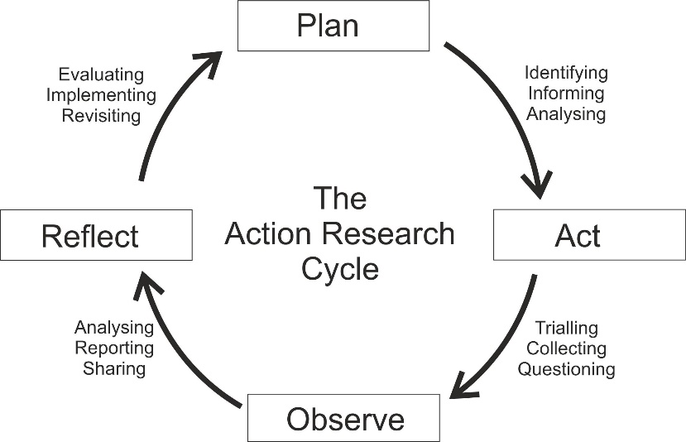

*Figure 1. A typical model for the action research cycle*

Table 1. Differences between traditional formal research and action research (Innotech, w.y.)

|  |  |  |
| --- | --- | --- |
| **Topic** | **Traditional research** | **Action research** |
| Training needed by researcher | Extensive | On own or with consultation |
| Goals of research | Knowledge that is generalizable | Knowledge to apply to the local situation |
| Method of identifying the problem to be studied | Review of previous research | Problems of goals currently faced |
| Procedure of literature review | Extensive using primary sources | More cursory, using secondary sources |
| Sampling approach | Random or representative sampling | Students or clients with whom they work |
| Research design | Rigorous control, long time frame | Looser procedures, change during study; quick time frame; control through triangulation |
| Measurement procedures | Evaluate and pretest measures | Convenient measures or standardized tests |
| Data analysis | Statistical tests, qualitative techniques | Focus on practical, not statistical significance, present raw data |
| Application of results | Emphasis on theoretical significance | Emphasis on practical significance |

Participation of student teachers in classroom‐based research studies conducted by in‐service teachers are suggested to become part of pre‐service science teacher education (at undergraduate or graduate level). This is suggested as one way toward developing research‐oriented learning in teacher education. Participation of in‐service teachers in action research shall be made part of their continuous professional development (Mamlok-Naaman, Rauch, Markic & Fernandez, 2013). Implementation needs to be done to form a continuously growing community of practitioner researchers in science education. Higher education institutions and state institutes of education might serve as coordinators and facilitators for ongoing classroom‐based action research within their local and national environments.

Additionally, cooperation of teachers and schools with universities, industry and businesses will further help developing and implementing relevant content and student‐active methods for teaching science, considering the competencies mapped out together with industry and business representatives. Action research can be used for evidence‐based and sustained development and implementation of the curricular activities and related pedagogies, towards fulfilling the needs identified in society, industry and businesses.

Foci of corresponding studies might encompass:

* Developing and implementing context‐based and societally‐driven science curricula, by including industry, society and businesses related contexts and socio‐scientific issues in science education,
* Supporting science learning by connecting formal and informal learning, i.e. by school‐industry‐ partnerships,
* Promoting inquiry‐based science learning and innovative practical work in science, as essential elements for future academic and any other professional careers in science and technology related fields,
* Implementing student‐centred teaching methods in science for the development of soft skills important for raising further education and employment opportunities, or
* Creating and researching alternative methods of assessment of learning processes considered relevant for future employment.

Continuing professional development based on a self‐learning experience of science teachers, while reflecting on their own practices on the basis of small‐scale classroom‐based research and innovation studies will help to improve science teaching practices and contribute to the innovation of science teaching at large, by the dissemination of quality studies from science classrooms.

**Action research, science education and the problem of dissemination**

Action research has limitations in disseminating its effects and findings (Mamlok-Naaman & Eilks, 2012). Action research activities and findings are often not well documented and reported, especially when it comes to traditional academic channels of knowledge dissemination (Laudonia et al., 2017). Teachers are often not trained for academic writing, nor is this in their focus. Collaborative networks with higher education institutions might help to overcome this gap (Eilks, 2014). Nevertheless, new channels for knowledge dissemination of action research are needed.

Teacher action research might be better reported in smaller documentations than in traditional educational research papers. An international platform is, however, missing, aside a few English language national science teacher journals. A new platform and format needs to be established to allow teachers learning from each others action research experience. The journal *Action Research and Innovations in Science Education* (ARISE) is on its way to provide a corresponding platform. The future, however, needs to proof whether such a different format will lead to more documented knowledge from action research for an international audience and the sake of science education.

**Educational action research and aspects of ethics**

Educational action research is educational research and thus has to respect certain ethical standards. These standards encompass, among others, to be always clear and transparent to students, respect teachers’ and students’ rights and interests, and to avoid harm to any individual present in the educational field of interest. Consent is needed of all persons involved, and in case of children consent of their parents. Data has to be handled with sufficient care. Results have to be documented throughout, but anonymized and confidential.

There are, however differences between action research and traditional positivistic/post-positivistic research (Creswell. 2003). Different than traditional formal and mostly positivistic/post-positivistic research, participatory/critical research traditions do not want to omit but intend to change authentic practice by purpose (Treagust, Won & Duit, 2014). Critical research, and action research has eminent components thereof (Kemmis, 2007), intends to change societal practice to improve the situation and chances of the persons involved. This means action research cannot do research just for the sake and interest of the researcher. It has to respect the interests of all persons involved, generally the students and teachers. This has, e.g., consequences for the available research designs. Control group studies are very prominent in positivistic/post-positivistic research. A critical researcher would not teach a control group with a traditional approach just for research’s sake if the alternative setting promises better effects based on theoretical and experiential assumptions.

Action research is participatory and critical research (Kemmis, 2007). It aims at empowerment and emancipation (Mamlok-Naaman & Eilks, 2012). It will never aim to show that a certain practice is misleading or less successful. Action research seeks to identify improved practices and to understand the mechanisms of practice improvement. Like a good teacher will always try to do the best he knows to support his students learning, any action researcher will try to identify, implement and understand the best possible practice he can imagine. If any changes are not successful, an action research teacher will adapt his teaching strategy to an improved or altered strategy until the originally identified problem is eased.

**Science education action research and the future**

Politically, action research is a highly demanded area, suggested e.g. by the European Commission (2013; 2015a) or UNESCO (2015). It became a political suggestion for the improvement of science education in many countries all over the world. Support for action research is, however, still limited. Resources for schools are limited anyhow in many countries of the world; higher education institutions as cores and coordinators for action research in schools report difficulties to get funds for this specific kind of research when compared to traditional, formal and positivistic/post-positivistic research.

The ARTIST project documents that funds can become available. The European Union started to fund action research, in our case in science education. The dissemination from ARTIST will be a crucial instance for future project applications. The justification of its doing is well developed, practice started to change. It is now time to keep the track and to continue in applying for investment for more action research as one of the most promising ways to transform and innovate science education, to provide teachers with better tools to professionalize and professionally grow, and enrich the academic research practices in science education.

**References**

Altrichter, H. (1990) Quality features in an action research strategy. USI-Series Nr. 12, BMUK, Vienna.

Altrichter, H., Feldman, A., Posch, P., & Somekh, B. (2008). *Teachers investigate their work: An introduction to action research across the professions* (2nd revised edition). London: Routledge.

Bradley, J. D. (2005). Chemistry education for development. *Chemical Education International*, 7, Retrieved from the World Wide Web, July 01, 2011, at <http://old.iupac.org/publications/cei/vol6/index.html>.

Burmeister, M., Rauch, F., & Eilks, I. (2012). Education for Sustainable Development (ESD) and secondary chemistry education. *Chemistry Education Research and Practice,* 13 (2), 59-68.

Creswell. J. W. (2003). *Research design*. Thousand Oaks: Sage

Eilks, I., (2014). Action Research in science education: From a general justification to a specific model in practice. In T. Stern, F. Rauch, A. Schuster, & A. Townsend (Eds.), *Action research, innovation and change* (pp. 156-176). London: Routledge.

European Commission (2013). *Supporting teacher educators for better learning outcomes*. Brussels: European Commission. Retrieved from the World Wide Web, April 14, 2018, at ec.europa.eu/dgs/education.../support-teacher-educators_en.pdf.

European Commission (2015a). *Shaping career-long perspectives on teaching. A guide on policies to improve initial teacher education*. Brussels: European Commission. Retrieved from the World Wide Web, April 14, 2018, at ec.europa.eu/dgs/education_culture/repository/education/library/reports/initial-teacher-education_en.pdf.

European Commission (2015b). Science education for responsible citizenship. Brussels: EU Commission. Retrieved from the World Wide Web, April 14, 2018, at [ec.europa.eu/research/swafs/pdf/pub_science_education/KI-NA-26-893-EN-N.pdf](http://ec.europa.eu/research/swafs/pdf/pub_science_education/KI-NA-26-893-EN-N.pdf).

Heron, J., & Reason, P. (2008). Extending epistemology within a co-operative inquiry. In P. Reason & H. Bradbury (Eds.), *Handbook of action research: Participative inquiry and practice*. London: Sage.

Hofstein, A., Eilks, I., & Bybee, R. (2011). Societal issues and their importance for contemporary science education: a pedagogical justification and the state of the art in Israel, Germany and the USA. *International Journal of Science and Mathematics Education, 9* (6), 1459-1483.

Hofstein, A., & Kesner, M. (2006). Industrial chemistry and school chemistry: Making chemistry studies more relevant. *International Journal of Science Education*, *28*, 1017-1039.

Hofstein, A., & Kesner, M. (2006). Learning from and about industry for relevant chemistry education. In I. Eilks & A. Hofstein (Eds.), *Relevant chemistry education* (pp. 285-300). Rotterdam: Sense.

Hugerat, M., Mamlok-Naaman, R., Eilks, I., Hofstein, A. (2015). Professional development of chemistry teachers to teach relevant oriented chemistry. In I. Eilks, A. Hofstein (Eds.), *Relevant chemistry education - From theory to practice* (pp. 369-386). Rotterdam: Sense.

Innotec (w.y.). Classroom action research. Retrieved from the World Wide Web, April 04, 2018, www.seameo-innotech.org/iknow/wp-content/uploads/2014/03/COMPETE-21.-Classroom-action-research.pdf.

Kemmis, S. (2007). Critical theory and participatory action research. In P. Reason & H. Bradbury (Eds.), *The Sage handbook of action research* (2 ed., pp. 121-138). London: SAGE.

Laudonia, I., Mamlok-Naaman, R., Abels, S., & Eilks, I. (2017). Action research in science education - An analytical review of the literature. *Educational Action Researc*h advance article.

Leitch, R., & Day, C. (2000). Action research and reflective practice: towards a holistic view. *Educational Action Research*, *8*, 179-193.

Mamlok-Naaman, R., & Eilks, I. (2012). Action research to promote chemistry teachers’ professional development – cases and experiences from Israel and Germany. *International Journal of Mathematics and Science Education*, 10, 581-610.

Mamlok-Naaman, R., Eilks, I., Bodner, G., & Hofstein, A. (2018). *The professional development of chemistry teachers.* Cambridge: RSC.

Mamlok-Naaman, R., Franz R., Markic, S., & Fernandez, C. (2013). How to keep myself being a professional chemistry teacher? In: I. Eilks, & A. Hofstein (Eds.). *Teaching chemistry – a studybook* (pp. 269-298). Rotterdam: Sense.

Marks, R., & Eilks, I. (2010). Research-based development of a lesson plan on shower gels and musk fragrances following a socio-critical and problem-oriented approach to chemistry teaching. *Chemistry Education Research and Practice, 11* (2), 129-141.

Matlin, S. A., Mehta, G., Hopf, H., & Krief, A. (2015). The role of chemistry in inventing a sustainable future. *Nature Chemistry*, *7,* 941-943.

Stern, T., Townsend, A., Rauch, F., Schuster, A., (2014) (Eds.). *Action research, innovation and change: International and interdisciplinary perspectives*. London: Routledge.

Stuckey, M., Hofstein, A., Mamlok-Naaman, R., & Eilks, I. (2013). The meaning of ‚relevance‘ in science education and its implications for the science curriculum. *Studies in Science Education, 49*, 1-34.

Treagust, D. F., Won, M., & Duit, R. (2014). [Paradigms in science education research](http://pure.ipn.uni-kiel.de/portal/en/publications/paradigms-in-science-education-research(ae2fbd83-f1b2-42b8-9963-0dad4cb3460b).html). In N. G. Lederman, & S. K. Abell (Eds.), *Handbook of research on science education* (Vol. II, pp. 3-17). New York: Routledge.

UNESCO (2015). Action research to improve youth and adult literacy. Empowering learners in a multilingual world (Eds. H. Alidou and C. Glanz). United Nations: UNESCO. Retrieved from the World Wide Web, April 14, 2018, at unesdoc.unesco.org/images/0023/002322/232243e.pdf.

van Driel, J. H., Beijaard, D., & Verloop, N. (2001). Professional development and reform in science education: the role of teachers' practical knowledge. *Journal of Research in Science Teaching*, *38*, 137-158.

### Activities and materials to be used in science teacher education action research workshops

*Ingo Eilks and Franz Rauch with contributions from Doris Arztmann, Rachel Mamlok-Naaman and Stefan Zehetmeier*

|  |  |  |
| --- | --- | --- |
| **4.1** | Action research - how to start |  |
|  | * Identifying action research questions | 22 |
|  | * Developing action research activities in a group | 23 |
|  | * What will be the benefit? | 24 |
|  | * Documenting a concept or an action research study | 25 |
|  | * Reflections on ethics in educational action research | 26 |
| **4.2** | Action research - action and reflection |  |
|  | * Formal research vs. action research | 27 |
|  | * Data sources for my action research | 28 |
|  | * Developing a questionnaire | 29 |
|  | * Reflecting questions for a questionnaire | 20 |
|  | * Train yourself for interviews | 31 |
|  | * Some hints for interviewers | 32 |
|  | * Participatory classroom observation | 33 |
|  | * Analytical discourse | 34 |
|  | * SWOT-Analysis | 35 |
|  | * Sociometry | 36 |
|  | * Investigating practices and practice architectures | 37 |
|  | * An exemplary timetable of an action research | 38 |
| **4.3** | Networking activities |  |
|  | * Who can help me? | 39 |
|  | * My action research network | 40 |
|  | * Networking: Step by step | 41 |
| **4.4** | Dissemination |  |
|  | * Who might be interested in my action research? | 42 |
|  | * Ways to disseminate my action research | 43 |
|  | * Reflecting media for my publication | 44 |

**Identifying action research questions**

Action research questions emerge from own experiences and needs. Action research questions are of different kind than traditional research questions. Think about the following questions and identify any need from your practice that can be challenged this way:

* I would like to improve by ______________________________ ___________________________________________________
* I am perplexed by ____________________________________ ___________________________________________________
* I am really curious about _______________________________ ___________________________________________________
* Something I really think would make a difference is _________ ___________________________________________________
* Something I really would like to change is _________________ ___________________________________________________
* What happens to student learning in my classroom when I ___ ___________________________________________________
* How can I implement _________________________________ ___________________________________________________
* How can I improve ___________________________________ ___________________________________________________

From Pine, G. (2009). *Teacher action research*. Thousand Oaks: Sage.

**Developing action research activities in a group**

1. Form groups of four participants.
2. Develop and write down individually one research questions, and indicate the population to which it is addressed (10 minutes):

__________________________________________________________________________

__________________________________________________________________________

1. Each participant should present his/her research question to his group (5 minutes).
2. The group members should discuss and choose one research question out of the four (15 minutes):

__________________________________________________________________________

__________________________________________________________________________

1. The group members should discuss the way in which they would like to conduct their research in class, namely, what kind of research tools will they use (15 minutes):

__________________________________________________________________________

__________________________________________________________________________

__________________________________________________________________________

__________________________________________________________________________

1. Each group member should write a reflection on the activity (5 minutes):

__________________________________________________________________________

__________________________________________________________________________

__________________________________________________________________________

__________________________________________________________________________

__________________________________________________________________________

__________________________________________________________________________

1. Each group member should share the reflection with his/her group colleagues.

**What will be the benefit?**

If my action research will be successful, the benefit will be …

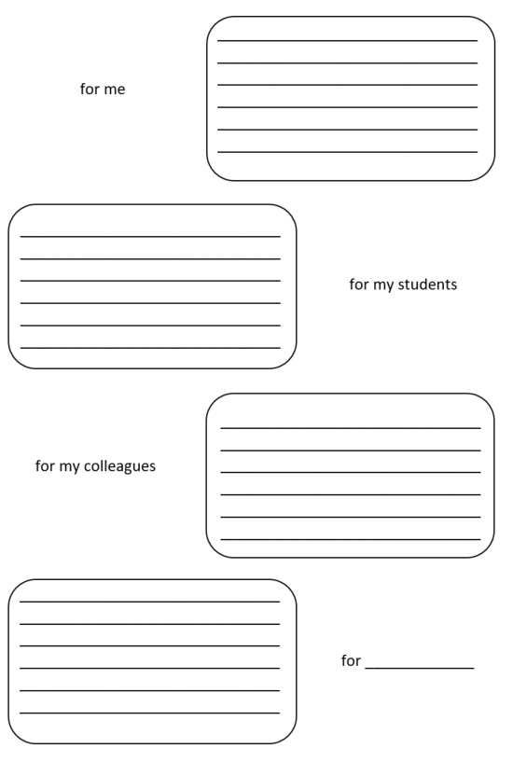

**Documenting a concept of an action research study**

1. What is your developmental interest? What would you like to make better? What are your goals?

__________________________________________________________________________

__________________________________________________________________________

1. What is the research question? Formulate a research questions. (The research question has to serve the developmental interest.)

__________________________________________________________________________

__________________________________________________________________________

1. What do you already know about the research question? How do you know it? What evidence to you have? What hypotheses do you have?

__________________________________________________________________________

__________________________________________________________________________

1. What further information do you need to answer your research question?

__________________________________________________________________________

__________________________________________________________________________

1. How could you get information? What research methods are best to get valid information?

__________________________________________________________________________

__________________________________________________________________________

1. How could you plan your action research process? What resources do you have (Know-ledge, time, money ….? Make a plan. What you want to do, how would you do it and when.

__________________________________________________________________________

__________________________________________________________________________

**Reflections on ethics in educational action research**

|  |  |  |
| --- | --- | --- |
| **Preparation phase:** | **Done** | **Improve** |
| Develop awareness of ethical issues by reading documents about ethics of action research and any relevant legal restrictions. |  |  |
| Reflect the aims of your research: What do you hope to achieve? What should be the gains for you, the students, and the school? What implications may arise from your action research? |  |  |
| Communicate the aims of your research to relevant groups of participants and potential audiences (headmaster, colleagues, parents, students). |  |  |
| Prepare short written research outlines for the various audiences (headmaster, colleagues, parents, students). State the aims of the research, the possible outcomes, and potential implications. |  |  |
| Be open, talk about the plans for your research with colleagues. Check whether they are interested to join you in your research. |  |  |
| Gain formal permission from the headmaster and any other relevant authorities. |  |  |

**Implementation phase:**

|  |  |  |
| --- | --- | --- |
| Become aware of your professional obligations as a teacher to your students. |  |  |
| Become sensitized of gender / ethnic / socio-economic issues. |  |  |
| Communicate the aims of the action research with the students. |  |  |
| Offer confidentiality as far as possible, offer the right to withdraw from data collection as far as possible. |  |  |
| Become aware of the possible implications of one to one interviewing situations with students and regulations to make use of electronic recording equipment (audio and video). |  |  |
| Plan mechanisms to reflect continuously on your research as it grows and consider all potential consequences of whatever action you decide to take. |  |  |
| Become sensitized to reconsider intended changes as the research develops. |  |  |

**Evaluation phase:**

|  |  |  |
| --- | --- | --- |
| Become reflective on your own perspective on subjectivity. Prepare reflections of your perspective with colleagues or supervisors. |  |  |
| Use communicative validation with the students to validate data interpretation. |  |  |
| Plan to maintain a dialogue with all participants. Become sensitized to handle any conflict carefully between their perspectives and your perspective. |  |  |
| Become sensitized to accept changes as result of findings and feedback. |  |  |

**Formal research vs. action research**

|  |  |  |
| --- | --- | --- |
| **Topic** | **Formal research** | **Action research** |
| Who is doing the research? |  |  |
| What interest does the research have? |  |  |
| From which base the research question is set up? |  |  |
| What is the role of literature in the research? |  |  |
| How is the research sample selected? |  |  |
| What characterizes the research design (linear vs. cyclical)? |  |  |
| What type/depth of data collection procedures are dominant? |  |  |
| What type of data analysis procedures are dominant? |  |  |
| What makes the quality of the research? |  |  |
| Which research paradigm is behind research? |  |  |

**Data sources for my action research**

Reflect sources of data for your research with respect to their feasibility both to the research interest and the research process (++ very high, + high, o medium, - low, -- not at all)

|  |  |  |  |  |
| --- | --- | --- | --- | --- |
|  | Potentially  useful | Demand in collection | Demand in analysis | Comment / N.A. |
| Standardized questionnaire |  |  |  |  |
| Open questionnaire |  |  |  |  |
| Written narrative |  |  |  |  |
| Semi-structured, structured interview |  |  |  |  |
| Open, narrative interview |  |  |  |  |
| Observation |  |  |  |  |
| Audio, video recording |  |  |  |  |
| Performance test |  |  |  |  |
| Analysis of student artefacts |  |  |  |  |
| Mind-mapping, concept mapping |  |  |  |  |
| Other: __________________________ |  |  |  |  |

**Developing a questionnaire**

Reflect the following questions individually or in a small group before formulating a questionnaire:

* What do you want to get information about?
* Why would you like to get these information? What would you like to do with the information?
* Why would you like to get these information with a questionnaire?
* What are your experiences and knowledge with the creation and analysis of questionnaires?

Formulate questions by taking the aspects below into account. Design the draft of a questionnaire.

***Types of questions***

Basically, we distinguish *open questions* (cannot be answered by yes or no) and *closed questions*(the answer are formulated already and the respondent mark with a cross). In both cases, you should take into account the following aspect when constructing the questions:

* Is the question really necessary? In how far could you use the answer for solving your problem or answering your research question?
* One question must contain only one topic. Otherwise, you cannot interpret the answers clearly.
* Do the respondents know enough about the question? Are they able to give substantial answers?
* Questions on subjective information (opinions, attitudes) might be complemented by questions on concrete actions and facts.
* Personal and controversial questions might not be answered honestly (socially desirable answers or wrong answers to protect the respondent).
* The questions in a questionnaire should not be one-sided (only negative or only positive aspects).
* Is the question formulated in a clear language? Are the respondents able to understand it?
* Is the formulation suggestive? Does the question put answers into the mouth of respondents?
* Fosters the formulation of the question emotional resistance among respondents?
* Is it better to ask the question directly or indirectly? An example for a directly asked question: „What did you like in group work? An example for an indirectly asked question: „Stefan and Franz talk about the groupwork. Franz says, that he did not participate in group work because the others did the work anyhow. What is your opinion?“

**Reflecting questions for a questionnaire**

Is it better to ask an open or closed question? Questions could also combine both forms?.

Example:

„Please chose one or more answers:

O I liked to work alone

O I liked to work with another student

O I liked to work in a group

Please note why you choose this/these answer(s)?

____________________________________________________________________________________________________________________________________________________________________________________________

In case of a closed question: how many answers should be possible? Only two (yes or no) or more (three to six …)

Examples:

Please tick the answer:

The teacher was interested in my work?

O Correct

O Wrong

Or with three possibilities:

O Always

O Sometimes

O Never

Is it clear for the respondents what is expected from them, what they have to do?

What is the best sequence of questions in the questionnaire? Usually it is better to ask about facts at the beginning and about meanings, attitudes, and emotions later.

**Train yourself for interviews**

Train yourself by three interviews. Form groups of three people. Each one in the group of three takes over one of the following three roles:

1. **Interviewer:** asks questions
2. **Interviewee:** answers questions
3. **Observer:** listens and give feedback about the interview as critical friend, serves as a time keeper

**First round** (approx. 40 minutes):

1. Choose the theme of the interview
2. Choose roles
3. The interviewer notes down some questions he/she wants to ask (ca. 5 minutes)
4. Interview: approx. 10 minutes
5. Feedback from observer
6. Discussion in the group: what did we learn?

The interview could be recorded or you make notes.

*Change roles for the second and third round.*

#### Task of the roles

***Interviewer***

*Listen:*

* Do not interrupt interviewee.
* Accept pauses (These are necessary to order thoughts).
* Attention (neutral but showing that you are interested to understand).

*Questions:*

* Do not formulate questions suggestive.
* Inquire in order to understand what the interviewee means.

***Interviewee***

Answer as honest as possible

***Observer***

Listen carefully and make notes about the process of the interview. Give feedback about your observations after the interview. Be careful with criticism. Tell mainly what you have observed. Pay attention of the time. **Some hints for interviewers**

**Listening instead of talking. *Most important is that you have a neutral attitude but showing the interviewee that you are interested in what he/she is telling you.***

You should not take more than 10 % of the conversation.

**Note down some guiding questions before the interview**

These questions helps you not to lose focus. You should, however, be open to new perspectives within the theme of the interview. The interview should get the character of a conversation.

**Be neutral in your reactions.**

Do not judge what interviewee says.

**Ask clear questions. Avoid suggestive questions.**

Do not put words in the mouth of the interviewee.

**Accept pauses**

The interview might be interrupted when you do not accept silence.

**Do not urge the interviewee to answer questions.**

The interviewee decides what he/she wants to say.

**Be careful asking for feelings too directly and at the beginning of the interview already.**

The flow of the interview might be interrupted.

**Do not give up questioning**

Do not accept a change of roles during one interview.

**If necessary for better comprehension in the later analysis,**

* Repeat statements of the interviewee in order to understand fully.
* Ask for examples and more concrete information.
* Ask for reasons and purposes.
* Ask for clarifications of contradictions.

**Time and space**

Schedule enough time for the interview (approx. 20 minutes depending on the topic). Find a place where you will not be interrupted by others, e.g. choose a room which you can reserve for the interview.

**After the interview**

Check if the interview is tape-recorded. Start with the transcript and analysis of the interview as soon as possible.

**Participatory classroom observation**

**Purpose:** Direct observation offers authentic information and builds upon everyday experience. Mutual learning of observer and observed can take place.

**Steps of participatory observation**

* A teacher invites a person (other teacher or researcher) to observe a class. A teacher should not be forced to be observed in an Action Research process.
* Both persons meet before the observation and negotiate time and focus of the observation and the feedback meeting afterwards.
* In general, one can distinguish between *open observation* and *focused observation* (e.g. focused on a student, a group of students, or the teacher; focused on a certain phase or activity of the lesson).
* Students should be informed that an observer is in the class and why the observation takes place.
* The observation should last no longer than an hour as it needs intensive concentration. Use an observation sheet:

|  |  |
| --- | --- |
| Location:  Time:  Observed person:  Observer: | |
| **Observations**  (What do I see and hear?) | **Interpretations/reflections**  (What are my thoughts, interpretations, and suggestions?) |

* If there is time, interpretations/reflections can be added during the observation. Shortly after the observation the observer reads the write-up and adds reflections etc.
* A feedback meeting with the observed person helps for mutual learning. *Keep in mind: The observer is not the evaluator of the observed.*
* Steps of feedback:

1. The observer informs the observed person about what he/she saw and heard (the left column of the observation sheet)
2. The observed person reacts and mentions reflections and interpretations.
3. The observer offers his/her interpretations und reflections (right column of the observation sheet)
4. Further steps and consequences are discussed.

**Analytical Discourse**

**Steps**

1. Basic information on the issue by the person who wants to analyze a situation (10 – 15 minutes)
2. Participants ask questions to gain a comprehensive and consistent impression of the situation (approx. 20 minutes).

**Rules:**

**Only questions,**

**No critical comments,**

**No suggestions**

**Mainly three types of questions are suitable:**\* *concretion of remarks* (i.e. to give an example or provide more details)  
* *underlying theories* (i.e. to give reasons for any action described)  
* *expansion of the system* (i.e. to give more information about people or events who may be related to the problem but have not so far been mentioned)

3. All participants may give comments, share reflections etc. (no question rule anymore) (approx. 5 to 10 minutes)

**Facilitation**

Someone in the group (or an outsider) should moderate the analytical discourse. He or she is also allowed to ask questions.

**SWOT-Analysis**

The SWOT-Analysis is a simple method to gain information/assessment/estimation from individuals and groups who are involved in an initiative, project, organization etc.

The SWOT-Analysis has for elements

* Strengths
* Weaknesses
* Opportunities
* Threats/risks

Those who participate at a SWOT-Analysis have to be involved in the projct or know enough about it.

**Steps:**

* Choose a project, initiative ….
* Write answers in the four boxes

|  |  |
| --- | --- |
| **Strengths** | **Weaknesses** |
| **Opportunities** | **Threats/Risks** |

* Compare and discuss answers in a group (in case of more than one participant)
* Based on the data/analysis draw consequences for the project

**Sociometry**

**Purpose of the method:**

Identify differences and similarities in a group by means of self-positioning and group-reflection. The method is used for data collection.

Time required 30 to 60 minutes, depending on group size and number of questions  
  
**What is sociometry?**

Sociometry is a method in empirical social research founded by Jakob Moreno in the 1930s. It is useful for the open analysis of relationships between members of a group in a so-called sociomatrix. Based on a question, group members position themselves in the room along their own answers. The visible individual positions that ensue makes similarities as well as differences within the group directly visible and tangible. It provides information about the composition of group-members and enables a reflection of one's own position.  
  
**How does it work?**

Sociometry starts with informing the participants that the researcher/facilitator will ask several questions. The researchers/facitlitators stress that participants should answer these as they feel today (answers may look differently tomorrow).

Then the facilitator asks their first question. This may be something like: "What is the age distribution in this group? Please form a line according to your age, the oldest person stands on the left side of the room, the youngest at the end of the row to the right." The task of the group members now is to communicate with each other and form a row according to their age. Further questions can be adapted according to research context. Some questions may be answered with a yes / no line-up. For some questions, we recommend clouds of interest/affiliation (E.g. what are my preferred teaching formats in science education?)

After each question posed by the facilitator, time should be taken for its resolution and possible discussion in the group. The group members are invited to tell why they are standing where they stand. Some questions might tough social taboos of the specific goup (according to context these might be income, religious affiliations etc.) Here it is advisable to discuss the meaning of the question in the group. After some questions from the facilitator, I recommend giving the group members the space to formulate their own questions to the group and have them set up. At the end of sociometry should be a general reflection of the method and its outcomes with all participants.

**What is sociometry good for? What can the method do?**

The method reveals instantaneous differences and similarities in a group based on self-positioning and provides an opportunity to reflect on it together.

**Investigating practices and practice architectures**

|  |  |
| --- | --- |
| **Elements of practices** | **Practice architectures** |
| *Project* | *Practice landscape* |
| What do participants (including myself) say they are doing, or intend to do, or have done? | How do different participants (and other involved or affected) interact with different people or objects? |
| *Sayings (Communication)* | *Cultural-discursive arrangements* |
| What do different participants say in the practice as they do it (what language is used, especially specialized language)? | Where does this language or specialist discourse come from? |
| What ideas are most important to different participants? |  |
| *Doings (activities)* | *Material-economic arrangements* |
| What are participants doing? | What physical spaces are being occupied? |
| Are there sequences or connections between activities? | Are particular kinds of set-ups or objects involved? |
| Are ends or outcomes being achieved? | What material and financial resources are involved? |
| *Relatings* | *Social-political arrangements* |
| How do participants (and others involved or affected) relate to one another? | What social and administrative systems of roles, responsibilities, functions, obligations, and reporting relationships enable and constrain relationships in the project? |
| Are there systems of positions, roles or functions? Are relationships of power involved? | Do people collaborate of compete? Is there resistance, conflict or contestation? |
| Who is included and excluded from what? |  |
| Are there relationships of solidarity and belonging (shared purposes)? |  |
| *Dispositions (habitus)* | *Practice traditions* |
| *Understandings:* How do participants understand what is happening? | What do our observations tell us about practice traditions in the sense of “the way we do things around here”? |
| *Skills:* What skills and capacities are participants using? | Is there evidence of professional practice traditions – like following an inquiry approach in science teaching – and do these enable or constrain what participants hope to achieve? |
| *Values:* What are participants’ values, commitments and norms relevant to the practice? |  |

Based on Kemmis, S., Mc Taggart, R. & Nixon, R. (2014). *The action research planner*. Singap ore: Springer, p. 81f.

**An exemplary timetable of an action research**

|  |  |  |  |  |
| --- | --- | --- | --- | --- |
| Cycle | Week/Activity | Monitoring | Duration | Comments |
| 1 | 1 Clarifying general idea  2  3 Recon-naissance  4 | Class 4T: keep diary for all lessons. Tape-record in one lesson per week, and collect examples of written work and assignment cards for these lessons | One lesson per week (with exception of keeping diary) | Team meeting |
| 5 General plan  6 | Diary (4T) |  | Write an analytic memo and begin to formulate plan |
| 7 Half term break |  |  | Write first draft of general plan |
| 8 General plan | Diary (4 T) |  | Discuss general plan at team meeting |
| 9 Develop action  10 Steps 1 |  |  | Write time table for monitoring in weeks 11-14 |
| 11  12 Implement  action steps 1  13  14 | Diary (4T)  (+ techniques selected at weeks 9-10) | Two lessons   per week  One lesson per  week | Study evidence collected  Write analytic memo to share at team meeting |
| 15  16  17 | Write case study (3.000 words maximum + case record for team meeting in week 1 next term |  |  |
| 2 | 18 …. |  |  |  |

Based on Elliot, J., (1991). *Action research for educational change*. Milton Keynes: Open University Press, p. 85ff.

**Who can help me?**

1. Are there individuals or organizations in my district or community who are already working to research and innovate science teaching in my domain? If so, what are they doing? Is it working? What can I do to help them?

_________________________________________________________________________

_________________________________________________________________________

_________________________________________________________________________

1. Are there teachers in my school who are passionate about seeing an increase in the quality of science education? If so, what steps have they taken to make this reality?

_________________________________________________________________________

_________________________________________________________________________

_________________________________________________________________________

1. Is the principal of my school supportive of science education? What do I expect him to do to support my initiative?

_________________________________________________________________________

_________________________________________________________________________

_________________________________________________________________________

1. Are there any external partners (industry, small and medium size enterprises, public sector, non-formal education providers) that support science education?

_________________________________________________________________________

_________________________________________________________________________

_________________________________________________________________________

1. Are there any school-based groups that do fundraising work for education in my school or district? Are there parents with relevant science and technology related professions that also want to increase science education in my school/district?

_________________________________________________________________________

_________________________________________________________________________

_________________________________________________________________________

Make a list of any such individuals, organizations or businesses on the backside of this sheet!

**My action research network**

Reflect who should be involved and who can help in your action research. Consider students, colleagues, advisors (e.g. from the academia or institutes of education), or external partners (e.g. from non-formal learning providers, societal groups, or business). Describe the purpose and potential contribution to the action research.

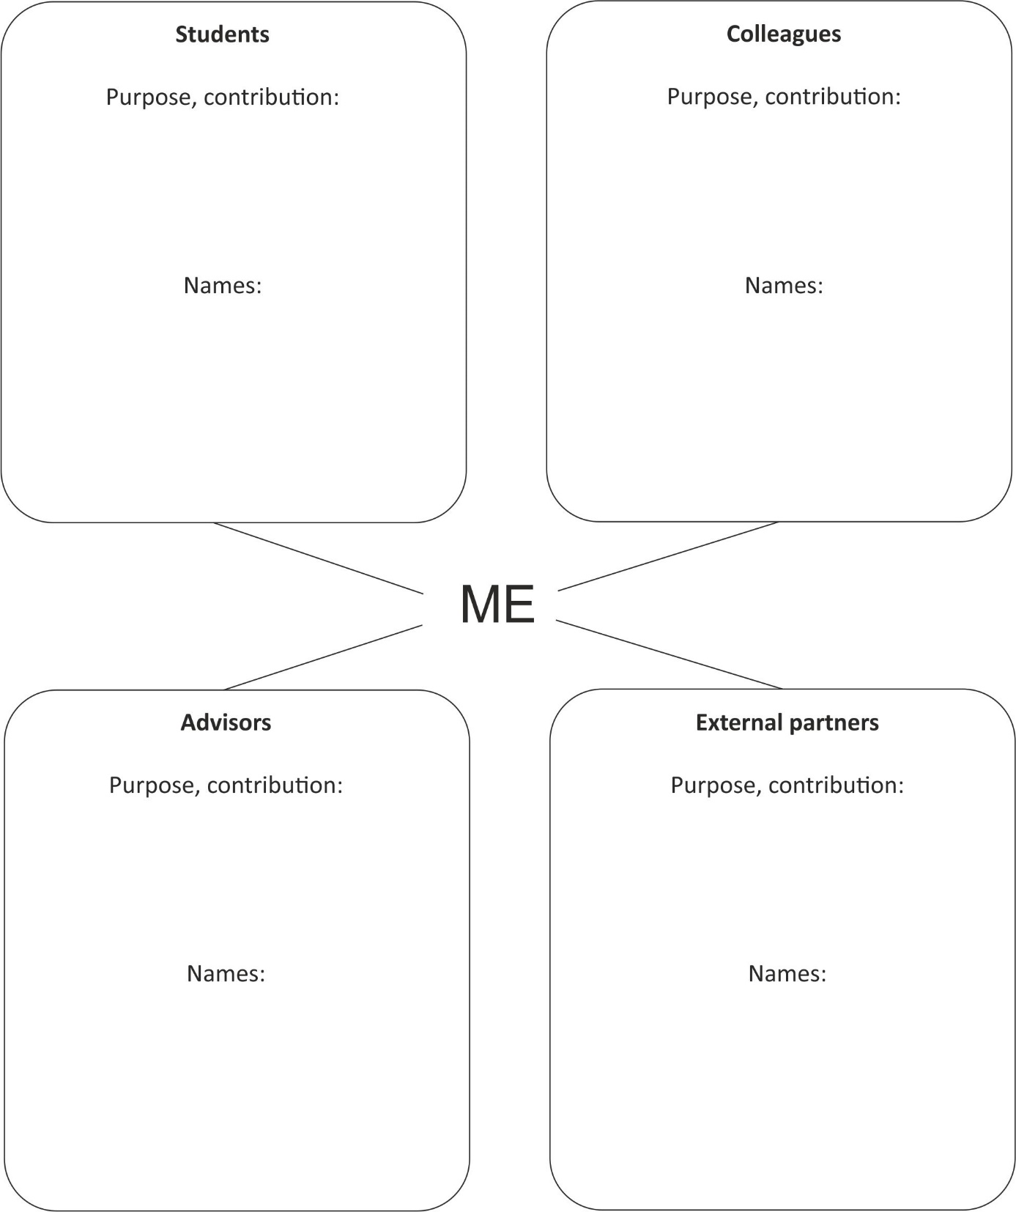

**Networking: Step by step**

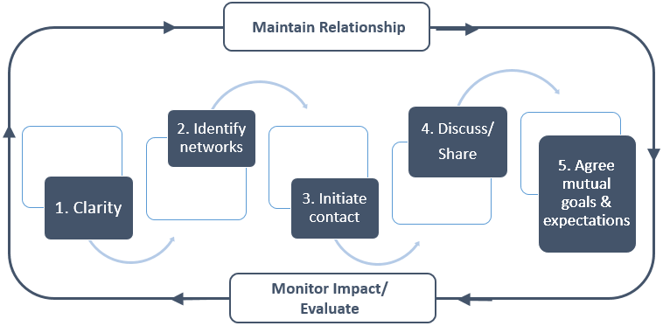

**Step 1: Clarity**

* Able to articulate benefits to company (inspire future workforce, boost staff morale and improve staff communication skills, corporate social responsibility…)
* Clear about what are we asking for? Time, expertise, access to staff…
* Have identified potential concerns (lack of time…)

**Step 2: Identify Networks**

* What are the main STEM related industries?
* What partnerships are already in place or not?
* What information is available on STEM related careers?
* What proportion of pupils move into STEM related careers?

**Step 3: Initiate Contact**

* Find out who is the person to contact
* Do I know someone who could make introduction
* Cold call

**Step 4: Discuss/Share**

* Describe/Explain ARTIST
* Listen to challenges or concerns
* Flexible approach

**Step 5: Agree mutual goals and expectations**

* When will the partnership start
* When will it end? Duration?
* How much time commitment is expected weekly/monthly?

**Maintaining and strengthening partnerships**

* Acknowledge effort / joint successes
* Schedule follow-up meetings. Check-in with partners
* Keep alert for changes (e.g. company expansion/down-sizing/restructuring) that may affect plans
* Remind networks of mutual goals to stay on track

**Monitor/Evaluate Impact**

* Decide intended outcome/impact of ARTIST network
* What are the key performance indicators?
* What tools will we use to measure?

**Who might be interested in my action and research?**

The results of my research might be interesting …

|  |  |
| --- | --- |
| for ___________________ | Interest:  Because: |
| for ___________________ | Interest:  Because: |
| for ___________________ | Interest:  Because: |
| for ___________________ | Interest:  Because: |
| for ___________________ | Interest:  Because: |
| for ___________________ | Interest:  Because: |

**Ways to disseminate my action research**

|  |  |  |  |
| --- | --- | --- | --- |
|  | Appropriate | Interested | Done |
| Meetings with colleagues from my school |  |  |  |
| Handouts/materials for colleagues from my school |  |  |  |
| Local or regional teacher networks |  |  |  |
| Regional or national teacher conference |  |  |  |
| School website |  |  |  |
| National science teacher journal |  |  |  |
| Online collection of teaching strategies and materials |  |  |  |
| Printed collection of teaching strategies and materials |  |  |  |
| International science teacher or research journal |  |  |  |

**Reflecting media for my publication**

|  |  |
| --- | --- |
| **Publication types in science education**   * + Articles in international journals   + Articles in national teacher journals   + Chapter in books (national or international)   + Monograph   + Teaching materials collections   + Self-prints   + Internet | |
| **What do I have to offer?**   * Empirical research findings * Report on the development of an innovation * Report on teacher learning processes/professional development * Description of an innovation or changed teaching strategy * Teaching materials/media | **Do I want to influence practice or raise my own reputation?**   * Research journal vs. practice publication * Availability (access, spread, acknowledgment, …) * Reputation * Formal quality criteria (peer-review, international publisher, etc.) * Time to publication |
|  |  |

### Selected figures to be used in science education action research workshops

*Ingo Eilks and Franz Rauch*

**Overview**

|  |  |  |
| --- | --- | --- |
|  | * A model to reflect potential fields for action research to innovate science education | 44 |
|  | * Classroom research, teacher research, and action research in science education | 45 |
|  | * A model of the action research cycle | 46 |
|  | * A comparison of traditional research with action research | 47 |
|  | * An overview on research paradigms in educational research | 48 |
|  | * Modes of action research illustrated by quotes | 49 |
|  | * A model of participatory action research in science education | 50 |
|  | * A potential model for upscaling action research based innovations | 51 |
|  | * Potential views of evaluation in action research based innovations | 52 |
|  | * Potential roles of teacher researchers and external researchers in action research | 53 |

*A model to reflect potential fields for action research to innovate science education*

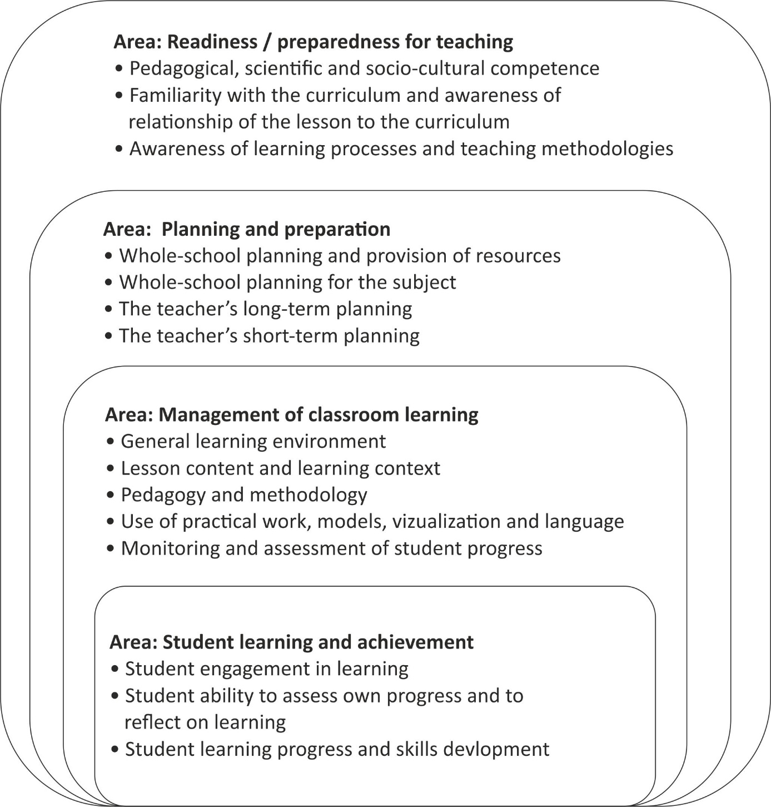

Adopted from European Network of Policy-Makers for the Evaluation of Educational Systems (w.y.). Evaluation of Foreign Languages at Upper Secondary Level (EFLUSL) - EFLUSL quality indicators.

*Classroom research, teacher research, and action research in science education*

|  |  |  |  |
| --- | --- | --- | --- |
|  | Classroom research | Teacher research | Action research |
| Takes place in authentic science teaching practice where students and teachers come together for learning science | X | X | X |
| Is operated either by a teacher or under strong involvement of the corresponding science teacher |  | X | X |
| Intends changes and applies a clear and cyclical strategy of change, data collection, evaluation and reflection |  |  | X |

*A model of the action research cycle*

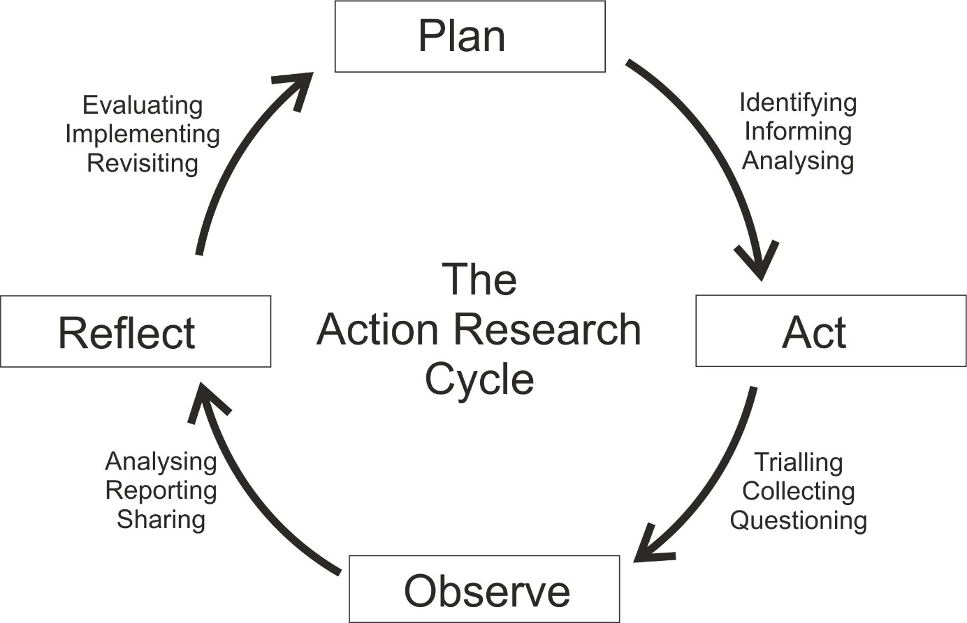

*A comparison of formal (traditional) research with action research*

|  |  |  |
| --- | --- | --- |
| ***Topic*** | ***Formal research*** | ***Action research*** |
| Training needed by researcher | Extensive | On own or with consultation |
| Goals of research | Knowledge that is generalizable | Knowledge to apply to the local situation |
| Method of identifying the problem to be studied | Review of previous research | Problems of goals currently faced |
| Procedure of literature review | Extensive using primary sources | More cursory, using secondary sources |
| Sampling approach | Random or representative sampling | Students or clients with whom they work |
| Research design | Rigorous control, long time frame | Looser procedures, change during study; quick time frame; control through triangulation |
| Measurement procedures | Evaluate and pretest measures | Convenient measures or standardized tests |
| Data analysis | Statistical tests, qualitative techniques | Focus on practical, not statistical significance, present raw data |
| Application of results | Emphasis on theoretical significance | Emphasis on practical significance |

From Classroom action research. www.seameo-innotech.org/iknow/wp-content/uploads/2014/03/COMPETE-21.-Classroom-action-research.pdf.

*Research paradigms in educational research and their characteristics*

|  |  |
| --- | --- |
| ***(post-)Positivism***   * *Deterministic* * *Reductionistic* * *Empirical observation and measurement*   *Aim: Theory verification* | ***Constructivism***   * *Understanding by interpretation* * *Multiple meanings* * *Social and historical (re)-construction*   *Aim: Theory generation* |
| ***Pragmatism***   * *Consequences of action* * *Problem-centred* * *Pluralistic* * *Real-world oriented*   *Aim: Change* | ***Criticality (Advocacy/Participatory)***   * *Political* * *Empowerment* * *Issue-oriented* * *Collaborative*   *Aim: Emancipation* |

Inspired by J. W. Creswell (2003). *Research design*. Thousand Oaks: Sage.

*Modes of action research inspired by Grundy and illustrated by quotes from Masters*

|  |  |  |  |  |
| --- | --- | --- | --- | --- |
| **Technical action research** |  | **Practical (or collaborative/ participatory/interactive) action research** |  | **Emancipatory (or teacher-centered) action research** |
| *“The underlying goal of the researcher in this approach is to test a particular intervention based on a pre-specified theoretical framework, the nature of the collaboration between the researcher and the practitioner is technical and facilitatory. The researcher identifies the problem and a specific intervention, then the practitioner is involved and they agree to facilitate with the implementation of the intervention.”* |  | *“In this type of action research project the researcher and practitioner come together to identify potential problems, their causes and potential interventions. The problem is defined after dialogue with the researcher and the practitioner and a mutual understanding is reached.”* |  | *“Emancipatory action research promotes emancipatory praxis in the participating practitioner, that is, it promotes a critical consciousness which exhibits itself in a political as well as practical action to change. […] This mode of emancipatory action research does not begin with the theory and ends with practice, but is informed by theory and often it is confrontation with the theory that provides the initiative to undertake the practice. […] The dynamic relationship between theory and practice in emancipatory action research entails the expansion of both theory and practice during the project.”* |

* Grundy, S. (1982). Three modes of action research. *Curriculum Perspectives*, 2(3), 23–34.
* Masters, J. (1995). The history of action research. In I. Hughes (Ed.), Action research electronic reader. Sidney: The University of Sidney. Retrieved from www.docstoc.com/docs/2187576/THEHISTORY-OF-ACTION-RESEARCH.

From Mamlok-Naaman, R., & Eilks, I. (2012). Action research to promote chemistry teachers’ professional development – Cases and experiences from Israel and Germany. International Journal of Mathematics and Science Education, 10 (3), 581-610.

*Modes of action research and its reflection in terms of interest and power*

*"Technical action research serves the interests of exercising greater control over human behaviour to produce the desired outcomes;*

*practical action research serves the interests of practical wisdom in discerning the right course of action in particular circumstances;*

*critical [emancipatory] action research serves the interests of emancipating people from oppression."*

Elliott, J. (2005). Becoming critical: the failure to connect. Educational Action Research, 13, 359-374.

*“The differences in the relationship between the participants and the source and scope of the guiding ‘idea’ can be traced to the question of power.*

*In technical action research it is the ‘idea’ which is the source of power for action and since the ‘idea’ often resides with the facilitator, it is the facilitator who controls power in the project.*

*In practical action research the power is shared between groups of equal participants, but the emphasis is upon individual power of action.*

*Power in emancipatory action research resides wholly within the group, not with the facilitator and not with individuals within the group.*

*It is often the change in power relationships within a group that causes a shift from one mode to another.”*

Grundy, S. (1982). Three modes of action research. *Curriculum Perspectives*, 2(3), 23–34.

*A model of participatory action research in science education*

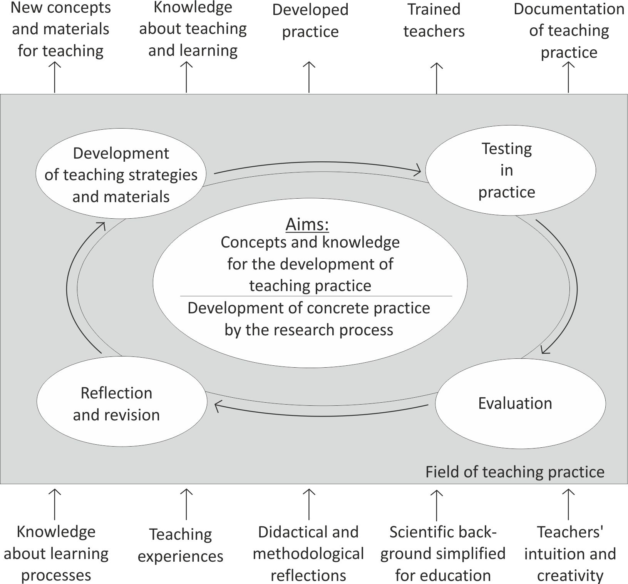

From Eilks, I., & Ralle, B. (2002). Participatory Action Research in chemical education. In B. Ralle & I. Eilks (Eds.). *Research in Chemical Education - What does this mean?* (pp. 87-98). Aachen: Shaker.

*A potential model for upscaling action research based innovations*

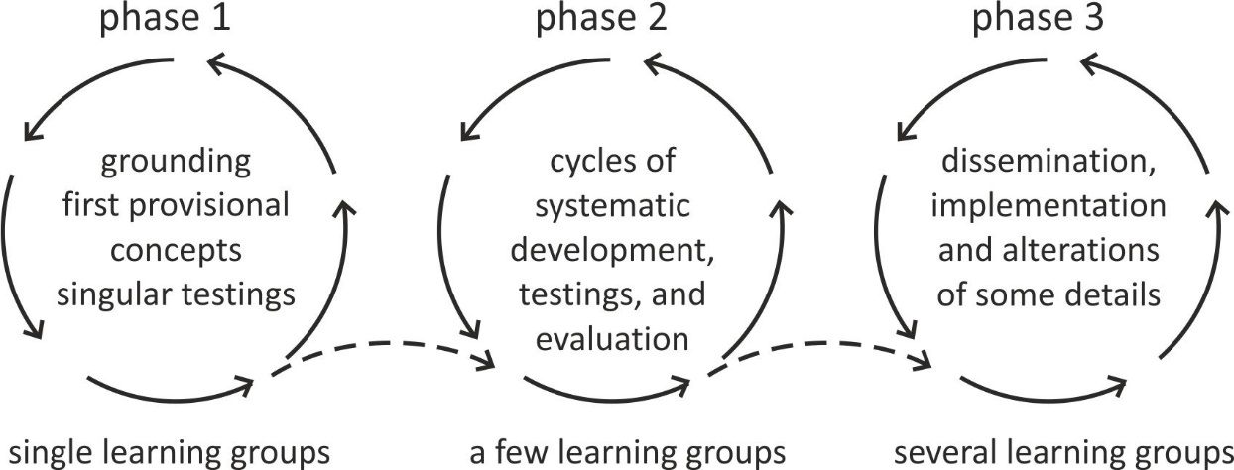

From Eilks, I., & Ralle, B. (2002). Participatory Action Research in chemical education. In B. Ralle & I. Eilks (Eds.). *Research in Chemical Education - What does this mean?* (pp. 87-98). Aachen: Shaker.

*Potential views of evaluation in classroom-based action research for innovations in the curriculum and pedagogy*

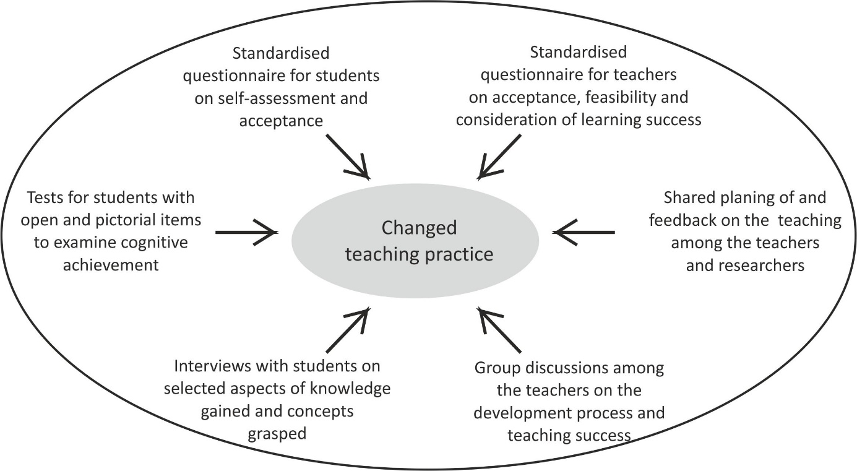

From Eilks, I., & Ralle, B. (2002). Participatory Action Research in chemical education. In B. Ralle & I. Eilks (Eds.), *Research in Chemical Education - What does this mean?* (pp. 87-98). Aachen: Shaker.

*Potential roles of teacher researchers and external researchers in action research*

|  |  |
| --- | --- |
| **Teacher researcher** | **External researcher** |
| * Initiation of action research motivated by experience * Analysis of the literature in comparison to classroom experience * Structuring new strategies and concepts * Application of new strategies and concepts * Data collection * Evaluation of data * Joint reflection and negotiating of further change | * Initiation of action research motivated by prior research * Co-ordination and support of the teacher research * Providing relevant literature and information access * Providing access to already existing strategies and concepts * Support in keeping ethical measures and standards of research data handling * Methodological training and support in evaluation of data * Joint reflection and negotiating of further change * Support in dissemination and publication of the action research findings |

Inspired by Eilks, I., & Ralle, B. (2002). Participatory Action Research in chemical education. In B. Ralle & I. Eilks (Eds.), *Research in Chemical Education - What does this mean?* (pp. 87-98). Aachen: Shaker.

### Exemplary action research sketches from ARTIST and beyond

*Compilation by Ingo Eilks*

**Overview**

|  |  |  |
| --- | --- | --- |
|  | * Spaces for self-directed learning and decision making by students in a project on forests (Austria) | * 58 |
|  | * A self-study of the use of interactive historical vignettes enhanced with concept cartoons in teaching of nature of science (Turkey) | * 59 |
|  | * Applying a POE teaching strategy sequence in teaching floating and sinking with regard to students’ alternative conceptions (Israel) | * 60 |
|  | * Implementing phosphate recovery in formal and non-formal chemistry learning (Germany) | * 61 |
|  | * Improving student`s understanding and perception of cell, structure and function using laboratory activities, computer video and paste models (Israel) | * 62 |
|  | * Inquiry based learning in physics (Georgia) | * 63 |
|  | * Interactive lecture demonstration and inquiry-based instruction in addressing students’ misconceptions in electric circuits (Philippines) | * 64 |
|  | * The influence of teaching methods on the understanding of ninth grade students of basic concepts in chemistry (Israel) | * 65 |
|  | * Incorporating industry links in to a career orientation program for secondary school pupils (Ireland) | * 66 |
|  | * Increasing students’ motivation in studying the module of “Reproductive Systems” applying the problem-based learning towards life sciences (Georgia) | * 67 |
|  | * Gamified science instruction in a reformatory classroom setting (Philippines) | * 68 |
|  | * The constructivist approach as a process for changing the misconceptions about the elements, compounds and mixtures at the microscopic and macroscopic level among eighth graders (Israel) | * 69 |
|  | * Implementing open learning environments in a mathematics classroom (Austria) | * 70 |
|  | * Finding the right degree of student-centeredness in pedagogy when teaching chemical bonding in a Swiss vocational school (Switzerland/Germany) | * 71 |
|  | * Innovating pre-service science teacher education in the field of ICT usage (Germany) | * 72 |
|  | * A metacognitive approach to the professional development of in-service science teachers (Israel) | * 73 |
|  | * Professional development for teacher educators on education for sustainable development (ESD) (Austria) | * 74 |
|  | * Action research as an impetus for building a course of collaborative learning, and promoting of a learning/investigating teachers' community (Israel) | * 75 |

**Spaces for self-directed learning and decision-making by students in a project on forests**

|  |  |
| --- | --- |
| **Done by**  Franz Rauch, Klagenfurt, Austria | **Field of practice**  Lower secondary biology education, grade 9 |
| **Research interest**  General aim:  How can students be better prepared to live in a complex and contradictory world? How can students be prepared to take initiative and shape their local environment?  Specific questions for the research in class: How react students to a given space for more self-directed learning and decision-making? | **Action**   * Project on forests for two month * Excursion in a school nearby with a ranger organized by the teacher * Students work in three thematic groups chosen by the students: (1) plants in the forest; (2) Dying of forests (air pollution); (3) Rainforest in South America * Students inquire the topics in groups: searching and analyzing materials; interviews with experts * Students write reports, present them and reflect results and processes |
|  |  |
|  | |
| **Data used**   * Research diary by the teacher * Observation of students by the teacher * Interviews of students after the project by the teacher * Observation of students by another teacher (critical friend) * Analysis of students’ reports | **Gained knowledge**  The teacher successfully offered the students space for decision-making and self-directed learning. The students took this opportunity and were able to make decisions even better than the teacher expected it.  Offering space for decision does not mean to leave students alone. The students struggled sometimes to deal with the complexity of the topic and the materials.  In future project the teacher will include more reflection phases with the students during the project. |
| **References**  Rauch, F. (2000). Schools – A place for ecological learning. *Environmental Education Research*, 6 (3), 245-258. | |

**A self-study of the use of interactive historical vignettes enhanced with concept cartoons in teaching of nature of science**

|  |  |
| --- | --- |
| **Done by**  Manolya Yücel Dağ & Mehmet Fatih Taşar, Ankara, Turkey | **Field of practice**  Middle school 5th grade students |
| **Research interest**  I designed this research study involving classroom implementations of interactive historical vignettes (IHV) enhanced with concept cartoons to develop 5th grade students’ understandings of nature of science. | **Action**  I conducted a research to reveal how in my classroom I implemented culturally relevant IHVs through adaptation of self-study method. |
| **View into the data or action**   |  |  | | --- | --- | |  | **Action** | | Before classroom  implementations | Writing life stories | | Preparing journals and implementing the questionnaires  (pre-test) | | Classroom implementation process | IHV 1: Bin Bilimli Ahmet Çelebi  IHV 2: Kuşçu Ali’nin Ay Sevdası  IHV 3: Ömer Hayyam Gökyüzünü İzliyor  IHV 4: Koca İnsan Kocasinan  IHV 5: Ak Dede Akşemseddin | | After classroom implementations | Implementing the questionnaires (post-test) | | Analyzing my collected data through the narrative analysis technique | | |
| **Data used**  The findings revealed the importance of the presence of teacher as a researcher in classroom implementations of IHVs while teaching nature of science. I observed that I was reflecting my experiences, values, and beliefs in my classroom practices and they effected my communication with my students. Through this self-study, I found an opportunity to get to know myself better as a teacher and was urged to change some of my characteristics as a result of experienced self discovery process. This self-study, shedding light on my personal life, can be seen as a step towards other teachers’ self-discovery.   * IHV documents * Video recordings * Questionnaires * Journals * E-mail together with life stories * Peer reviews * Photographs | **Gained knowledge** |
| **References**  Yücel Dağ, M. (2015).*A self-study of the use of interactive historical vignettes enhanced with concept cartoons in teaching of the nature of science* (Doctoral thesis). Gazi University, Ankara Turkey. | |

**Applying a POE teaching strategy sequence in teaching floating and sinking with regard to students’ alternative conceptions**

|  |  |  |
| --- | --- | --- |
| **Done by**  Jumana Hasan and Aya Sabah, Rene village, Israel, and Fadeel Joubran, Haifa, Israel | **Field of practice**  Physics teaching in middle school | |
| **Research interest**  Recovering alternative conceptions of 8th grade students in "Floating and Sinking". Understanding the influence of applying POE strategy in teaching Sinking and Floating" on student alternative conceptions. | **Action**  An active learning sequences based on POE strategy was developed and implemented in teaching "Floating and sinking" in 8th grade. | |
| **View into the data or action** | | |
| Applying ten questions test aimed in discovering alternative conceptions in "Sinking and Floating" - Pre | | C:\Users\aaa\Downloads\IMG-20180619-WA0007.jpgC:\Users\fadeelj\Downloads\IMG-20180619-WA0005.jpg  Teaching "Sinking and Floating" with POE strategy. (5-7 cycles with stage no. 4) |
| Name:-----------  Subject:----------  Predict before POE demonstration:------------  Explain before POE demonstration:------------  Observe ……  Explain after POE demonstration:------------  Filling POE worksheet (5-7 cycles with stage no. 3) | | Applying ten questions test aimed in discovering alternative conceptions in "Sinking and Floating" - Post |
| **Data used**   * Feedback questionnaires * Feedback POE sheets * Interviews | **Gained knowledge**  Reducing alternative conceptions. Students have a better understanding regarding natural phenomena. The POE strategy contributes to make the learning-teaching more active. | |
|  | | |

**Implementing phosphate recovery in formal and non-formal chemistry learning**

|  |  |
| --- | --- |
| **Done by**  Christian Zowada, Antje Siol & Ingo Eilks, Bremen, Germany | **Field of practice**  Secondary and vocational formal and non-formal chemistry learning from grade 10 |
| **Research interest**  Implementing phosphate recovery as an example of applied environmental technology into secondary and vocational education and to understand how non-formal learning in this case can be supported by digital media learning | **Action**  A non-formal learning environment was developed and implemented dealing with modern technologies for phosphate recycling. The implementation was framed by a digital learning environment based in PREZI technology. |
| **View into the data or action** | |
| **Data used**   * Classroom observation * Feedback questionnaires | **Gained knowledge**  A non-formal learning environment was developed based in PREZI technology can be highly supportive to prepare a class visit to a non-formal learning place. It helps to frame experimental learning with necessary content and contextualization. technologies for phosphate recycling. The implementation was framed by a digital learning environment |
| **References**  Gulacar, O., Zowada, C., & Eilks, I. (2018). Bridging chemistry learning back to life and society. In I. Eilks, S. Markic & B. Ralle (Eds.), *Building bridges across disciplines for transformative education and sustainability* (pp. 49-60). Aachen: Shaker. | |

**Improving student`s understanding and perception of cell structure and function using laboratory activities, computer video and paste models**

|  |  |  |
| --- | --- | --- |
| **Done by**  Riam Abu Mokh, Haifa-Israel | | **Field of practice**  Secondary school science, grade 8 |
| **Research interest**  Encourage teachers to make a difference, which aims to improve the student's perception of the cell structure which based on:   * Check out the current situation * Applying different teaching modes * Check out the situation after applying the new method for *teaching*   **View into the data or action**  New teaching method rather than Frontal learning  Innovation and various means to reflect the scientific facts based onlab activities, paste models and video simulations  Pre-Test based on frontal teaching | | **Action**    Developing alternative teaching modes which is based on laboratory activities, computer videos, paste models and competitions between students based on different activities like developing bezels and game cards.  tdytdtrdvjx |
| **Data used**   * Questionnaire includes several questions regarding different concepts about the cell. It was distributed twice, in the first time after teaching by conventional frontal method, and at the second time after applying the alternative method. * Observation * s | **Gained knowledge**  The need for changing the teaching mode from frontal teaching to more "reactive" teaching which activates the students and give them the opportunity to plan, discover and draw conclusions more palpably. | |
|  | | |

**Inquiry based learning in physics**

|  |  |
| --- | --- |
| **Done by**  Marika Garsevanishvili, Sofio Kharchilava, Tamta Makhatadze & Marika Kapanadze, Tbilisi, Georgia | **Field of practice**  Secondary school students |
| **Research interest**  Implementing IBL in physics and identify the changes of students motivation. Understanding the influence of hands on experiments on students attitudes' changes to study Physics. | **Action**  Set of different hands on experiments were developed. Lessons modules based on inquiry approach were planned and implemented at secondary level. |
| **View into the data or action** | |
| **Data used**   * Focus group discussions * Classroom observation * Motivation questionnaire | **Gained knowledge**  Students enjoyed lesson with hands on experiments. They stressed their interest to inquiry. Areas of needed change in teaching approach identified. Lessons modules should be planned using inquiry approach and hands on experiments. |
|  | |

**Interactive lecture demonstration and inquiry-based instruction in addressing students’ misconceptions in electric circuits**

|  |  |
| --- | --- |
| **Done by**  Mark Anthony Casimiro, Cornelia C. Sotto and Ivan B. Culaba, Manila, Philippines | **Field of practice**  Secondary school |
| **Research interest**  Which is more effective in addressing the misconceptions in electric circuits of junior high school students: the interactive lecture demonstrations (ILD) or the inquiry-based instruction (IBI) ? | **Action**  Two classes composed of randomly selected grade 9 students were taught electric circuit. In one class the IBI was used while in the other class the ILD was used. |
| **View into the data or action**  Designing of different learning activities  Determining misconceptions in electric circuits from previous studies  Executing the different approaches (ILD and IBI)  Administering the pre-test  Conducting interviews (before, during and after the intervention)  Administering the post-test  Analyzing and comparing the results of the post test of the two groups as well as the responses in the interviews  Suggestions and recommendations for  for further studies  **Data used**  Pre-test and post test results, mean percentage gain, interview of students and teachers, focus group discussions…  **Gained knowledge**   * + Both the ILD and IBI resulted to a positive conceptual change in the students’ understanding of electric circuits although IBI group has higher average post test score   + In ILD, classroom and time management is easier to handle and does not require multiple set-ups but students have no hands-on experience. It is more adoptable to small classrooms with many students.   + In IBI students have hands-on experience and enhanced collaborative work but difficult to manage time and supervision in large classes in small classrooms.   + In theory, IBI and ILD are both effective methods of teaching but in practice the local classroom environment and availability of equipment have to be taken into consideration.- | |

**The influence of teaching methods on the understanding of ninth grade students of basic concepts in chemistry**

|  |  |
| --- | --- |
| **Done by**  Hekmat Abo Saleh and Naim Najami, Haifa, Israel | **Field of practice**  Secondary science education, basic concepts in chemistry for 9th grade |
| **Research interest**  Improving the teaching process on basic concepts in chemistry  **View into the action**    *Students practicing the methods from the research* | **Action**  Checking existing situation - interviews for students  Definition of difficulties - by analyzing the interviews  Learning through games, collaborative learning, laboratory experimentation  A class post-test after completing the subject, re-interviews  Conclusions - After analyzing the interviews |
| **Data used**   * Interviews with students * Feedback questionnaires | **Gained knowledge**  New insights regarding teaching to improve and promote the classroom instruction  Reflective study has its own value and is indeed beneficial to the teachers` work |
|  | |
|  | |

**Incorporating industry links in to a career orientation program for secondary school pupils**

|  |  |
| --- | --- |
| **Done by**  Aimee Stapleton, Martin McHugh, Laurie Ryan, Peter Childs & Sarah Hayes, Limerick, Ireland | **Field of practice**  Career orientation for secondary school students, aged 15-16 years |
| **Research interest**  Promoting and raising the awareness of careers and third-level courses in science among students. Running a dedicated weeklong programme with as many links to industry as possible.  . | **Action**  Development of a career-orientation week that involves (i) a site tour to industry, (ii) career talks and (iii) an industry-led workshop. Adjusting each element consecutively during two action research cycles. |
| **View into the data or action** | |
| **Data used**   * Feedback questionnaires * Draw a Scientist Test: Before and after the program, students were asked to draw and label a picture of a scientist at work | **Gained knowledge**  Networking with industry is very similar to networking with academic/education professionals. Although industry not familiar with the term “action research”, they are very familiar with the concept of cyclical improvements in their own practice. |

**Increasing students’ motivation in studying the module of “Reproductive Systems” applying the problem-based learning towards life sciences**

|  |  |
| --- | --- |
| **Done by**  Rusudan Khukhunaishvili, Marina Koridze & Zhana Chitanava, Batumi, Georgia | **Field of practice**  Secondary school biology students |
| **Research interest**  PBL methods in the learning some modules of Biology. Increasing the students’ motivation towards the study of Life Sciences. Science comer-cialization opportunities to promote the learning process and to increase the students' awareness in establishing the culture of gaining knowledge, as well as promoting healthy lifestyles. | **Action**  Formulation of the problem; finding the ways of resolving the problem; lab works; practice skills that students will need in future. |
| **Views into data or action**  Cycle 1 Reflection Cycle 2 Reflection Cycle 3  The lesson process on the reproductive system; Discussion on the topic: Infertility - the result, the problem or the verdict.  Discuss the problem statement and list its significant parts. Selection of target groups of students considering the focused observation and gender equality.  The photo session "we are the future parents"; Visit to the artificial insemination clinic; Role-playing games; Interview with specialists; Observation: counting and sorting genital cells, sperm injection and cryoconservation.  Lesson module; Practical activity - microscopic observation on ready-made drugs. Short presentations and discussion.  Evaluation Evaluation Evaluation  60% of the class is less involved in the process, avoiding their opinion on the issue; Less understanding of infertility mechanisms and problems.  High interest in finding new information, ethical issues of artificial insemination. Developing communication skills  90% of students were actively involved in the process; feel that do not know enough to solve the problem but that is the challenge; | |
| **Data used**  Focus group discussions  Motivation questionnaire  Classroom observation  Feedback questionnaires | **Gained knowledge**  Develop critical thinking and problem solving, collaboration skills, information retrieval and evaluation skills. Students acquired new knowledge and were interested in other challenges in life sciences. |
|  | |

**Gamified science instruction in a reformatory classroom setting**

|  |  |  |
| --- | --- | --- |
| **Done by**  Analyn Tolentino & Lydia Roleda, Manila, Philippines | **Field of practice**  Secondary science education | |
| **Research interest**  Exploring the effects of gamifying Science instruction in terms of student achievement and student’ motivation; examining the students’ and teachers’ lived experiences on gamified science instruction | **Action**  The elements of gamification such as points, badges, leaderboards, storyline, rules and levels, were incorporated into science instruction. | |
| **View into the data or action**  Paired Sample Test Between Pre and Post-Gamification Responses to Science Motivation Questionnaire (SMQII) | | Gamified science instruction  Non-gamified Instruction |
| **Data used**  Responses to Motivation questionnaire Assessment scores Interview responses Journal entries | **Gained knowledge**  Gamifying instruction is an effective approach in increasing student achievement and motivation in science. Students had both positive and negative experiences on the gamified science instruction but the former outweigh the latter. Preparing for and implementing a gamified science instruction can be a demanding task for a teacher but its positive effect on student’s attitude towards learning science are remarkable. | |
| **References**  Tolentino, A. N., & Roleda, L. S. (2017). Learning physics the gamified way. Paper presented at the DLSU Research Congress 2017. xsite.dlsu.edu.ph/conferences/dlsu-research-congress-proceedings/2017/LLI/LLI-I-019.pdf. | | |

**The constructivist approach as a process for changing the misconceptions about the elements, compounds and mixtures at the microscopic and macroscopic level among eighth graders**

|  |  |
| --- | --- |
| **Done by**  Ahmad Basheer, Sakhnin, Israel, Ayshi Sindiani and Mahmood Sindiani, Nazareth**,** Israel | **Field of practice**  Chemistry teaching in Junior “A” High School |
| **Research interest**  Revealing alternative conceptions of 8th grade students in “elements, compounds and mixtures at the microscopic and macroscopic level“; understanding the influence of applying the constructivist approach strategy in teaching “elements, compounds and mixtures “on student alternative conceptions | **Action**  An active learning sequences based on constructivist approach (developing and implementing a self-directed learning scenario) was developed and implemented in teaching “elements, compounds and mixtures" in 8th grade |
| **Views into data or action** | |
| **Data used**   * Pre and Post-tests * Interviews * Classroom observation | **Gained knowledge**  - Reducing alternative conceptions.  - Students have a better understanding regarding the microscopic and macroscopic level.  - Constructivist approach contribute to the learning-teaching be more active |

**Implementing open learning environments in a mathematics classroom**

|  |  |
| --- | --- |
| **Done by**  Eve (pseudonym), Austria; provided by Stefan Zehetmeier, Klagenfurt, Austria | **Field of practice**  Lower secondary mathematics education |
| **Research interest**  Eve had the goal to promote open learning settings by implementing new teaching approaches in her mathematics classes. She aimed at enhancing pupils’ self-directed and inquiry-based learning opportunities.  Eve’s research question: “Are my pupils able to acquire mathematical knowledge by using self-directed learning settings?” | **Action**  Eve introduced open learning environments and using working plans in her classes.  Thus, pupils could choose their individual working pace, task sequences and social forms. Moreover, pupils bore responsibility and control concerning their learning efforts. |
|  | |
| **Data used**  Eve developed observation sheets to gather data regarding classroom activities. She kept a research diary in which to save personal experiences and thoughts. Further, she prepared various tasks and conducted interviews with individual pupils to assess their mathematical learning progress. At the end of each semester, pupils were asked to complete a questionnaire concerning their learning and skill development, as well as their evaluation of the open learning settings. | **Gained knowledge**  Eve’s observations portrayed a picture of pupils with “eagerness, motivation, calmness, curiosity, and autonomy; however also scepticism, uncertainty, and questions” (Eve’s reflective paper, p. 20). Pupils gained positive achievements in the assessment tasks, which was “really surprising” for Eve: “All without exception were able to develop knowledge and skills in this self-directed and open learning environment” (Eve’ reflective paper, p. 21). |
| **References**  Zehetmeier, S. (2015). Sustaining and scaling up the impact of professional development programmes. *ZDM - The International Journal on Mathematics Education*, 47(1), 117–128. | |

**Finding the right degree of student-centeredness in pedagogy when teaching chemical bonding in a Swiss vocational school**

|  |  |
| --- | --- |
| **Done by**  Ivano Laudonia, Chur, Switzerland, & Ingo Eilks, Bremen, Germany | **Field of practice**  Vocational school chemistry education |
| **Research interest**  Finding the right balance between teacher-centered and student-centered pedagogies when teaching chemical bonding in Swiss vocational education. | **Action**  Developing and implementing a self-directed learning scenario on chemical bonding. Consecutive adjusting the learning scenario and its related media in different action research cycles. |
| **View into the data or action** | |
| **Data used**   * Feedback questionnaires * Motivation questionnaire | **Gained knowledge**  Students in vocational education have a different view on student-centered pedagogies than reported from students in general education. Students ask for more guidance and teacher input before acknowledging and valuing student centered leaning scenarios. |
| **References**  Laudonia, I., & Eilks, I. (2018). Teacher-centred action research in a remote participatory environment - A reflection on a case of chemistry curriculum innovation in a Swiss vocational school. In J. Calder & J. Foletta (Eds.), *Participatory Action Research (PAR): Principles, approaches and applications* (pp. 215-231). Hauppage: Nova. | |

**Innovating pre-service science teacher education in the field of ICT usage**

|  |  |
| --- | --- |
| **Done by**  Moritz Krause & Ingo Eilks, Bremen Germany | **Field of practice**  Chemistry pre-service teacher education |
| **Research interest**  Understanding the ICT-related needs of chemistry student teachers for innovations of a teacher education seminar. Understanding the influence of the changes in the course on student teachers’ ICT-related attitudes and self-efficacy. | **Action**  Continuing innovation of a chemistry teacher education course in ICT in science education by implementing new hard- and software and newly developed media and teaching strategies. |
| **View into the data or action**  Mean values of the pre- and post-test (smaller values indicate more positive attitudes and more positive self-efficacy beliefs correspondingly):   |  |  |  | | --- | --- | --- | | **Dimension** | | **Mean** | | Attitudes to use ICT in teaching in general | pre-test | 2,6259 | | post-test | 2,2519 | | Self-efficacy beliefs about the use of the ICT in general | pre-test | 2,1769 | | post-test | 2,0000 | | Attitudes to use ICT in chemistry teaching | pre-test | 2,1926 | | post-test | 1,9852 | | Self-efficacy beliefs about the use of the ICT in chemistry lessons | pre-test | 2,6600 | | post-test | 1,9960 | | |
| **Data used**   * Focus group discussions * Feedback questionnaires * Attitudes and self-efficacy questionnaires | **Gained knowledge**  Certain areas of change in course content were identified. Constant innovation leads to more satisfaction among the participants. The course contributes to developments of ICT-related attitudes and self-efficacy. |
| **References**  Krause, M., & Eilks, I. (2018). Using action research to innovate teacher education concerning the use of modern ICT in chemistry classes. *Action Research and Innovation in Science Education*, in print. | |

**A metacognitive approach to the professional development of in-service science teachers**

|  |  |
| --- | --- |
| **Done by**  Osnat Eldar & Shirley Miedijensky, Tivon, Israel | **Field of practice**  Professional development of in-service high schools science and mathematics teachers |
| **Research interest**  Characterizing the design principles of two courses, exposing expressions of metacognition among the teachers and examining the changes they designed and applied in their teaching units and teaching processes, and studying the interactions among the participants (researchers, teachers, children) in order to understand the teachers’ metacognitive knowledge and skills. | **Action**  Designing and implementing science education courses based on a metacognitive approach. The teachers designed, made changes to their design, and experienced an iterative process of improving their activities.  Those teachers were exposed to a variety of c Those teachers were exposed to a variety of content such as theories, models and examples of teaching resources including lab experiments and simulations. The teachers designed, made changes to their design, and experienced an iterative process of improving their activities. ntent such as theories, models and examples of teaching resources including lab experiments and simulations. The teachers designed, made changes to their design, and experienced an iterative process of improving their activities. |
| **View into the data or action** | |
| **Data used**   * Course design and activities * Interviews with the teachers * The teachers’ teaching activities * Teachers’ reflections * Researchers’ reflections | **Gained knowledge**  Encouraging teachers to develop and design activities and test them within a supportive environment can promote their metacognitive knowledge. |
| **References**  Eldar, O., & Miedijensky, S. (2016). Design and implementing a metacognitive approach to the professional development of in-service science teachers – an Israeli case study. ICERI Proceedings, pp. 3313-3320.  Eldar, O., & Miedijensky, S. (2015). Designing a metacognitive approach to the professional development of experienced science teachers. In A. Peña-Ayala (Ed.), *Metacognition: fundaments, applications, and trends. A profile of the current state-of-the-art*. Intelligent Systems Reference Library, 76, 299-319. | |

**Professional development for teacher educators on education for sustainable development (ESD)**

|  |  |
| --- | --- |
| **Done by**  Franz Rauch, Klagenfurt, Austria, &  Regina Steiner, Linz, Austria | **Field of practice**  In-service science teacher education |
| **Research interest**  How might inquiry based learning in ESD be developed and sustained within teacher education at universities? How can action research inform ESD? | **Action**  The University course *Innovation in Teacher Education – Education for Sustainable Development* (BINE) is a professional development course in higher education in Austria. BINE course three one-week seminars and regional mentoring meetings. Participants write case-based research studies in order to get a certificate. Equal emphasis is put on theoretical-methodical foundation and learning from one’s own practical experiences/projects. |
| **Data used**  The course is evaluated by a formative and summative self-evaluation with internal (questionnaires, feedback by participants) and external (questionnaires interviews with participants at the beginning and the end of the course) components. | **Gained knowledge**  The BINE course offers an adequate instructional and learning strategy for the participants to construct the meaning of the complex issues of sustainable development and ESD by researching, reflecting and exchanging in the learning group focused on concrete examples. The action research process provides a basis for learning in order to further developing the participants’ concepts of ESD as well.  as research and implementation competencies.earning in order to further develop  the participants’ concepts of ESD as well  as research and implementation competencies. |
| **References**  Rauch, F., & Steiner, R. (2015). BINE: Professional development ESD course for higher education teachers, Austria. In D. Kapitulcinova et al. (Eds.), *Leading practice publication: professional development of university educators on education for sustainable development in European countries* (pp. 114-119). Prague: Charles University. | |

**Action research as an impetus for building a course of collaborative learning, and promoting of a learning/investigating teachers' community**

|  |  |
| --- | --- |
| **Done by**  Rachel Cohen, Oranim, Israel | **Field of practice**  Science teaching in-service teacher education |
| **Research interest**  How can I improve my course instruction? How can I promote student action research and implementation of change processes in their schools on the subject of collaboration? | **Action**  Developing and implementing a collaboration course on science teaching. Consecutive adjusting the learning scenario in different action research cycles. |
| **View into the data or action**  The first circle: Exploring students' perceptions and teaching / action methods (before beginning the course)  The second circle: Building knowledge for teaching-learning and a cooperative professional community  The third circle: Action research - the "glue" that connects the components, motivating change, and developing professional community studying / investigating | |
| **Data used**   * The researcher observed the learning processes * Using collaborative maps (using the aquarium method) * A two-stage quiz (personal and collaborative discussion) * Content analysis of student action studies | **Gained knowledge**  Certain areas of needed changes in course content were identified. Constant innovation leads to more satisfaction among the teachers participants. The course contributes to developments of collaboration learning related attitudes and promoting self-teachers action-research. |
|  | |

### Resources to prepare and to be used in action research workshops

#### 7.1 Recommended books on action research

Altrichter, H., Feldman, A., Posch, P., & Somekh, B. (2008). *Teachers investigate their work: An introduction to action research across the professions* (2nd revised edition). London: Routledge.

Anderson, G. L., Herr, K. G., & Nihlen, A. S. (2007). *Studying your own school: An educator’s guide to practitioner action research*. Thousand Oaks: Corwin.

Burnaford, G., Fischer, J. & Hobson, D. (Eds.). (2001)*. Teachers doing research: The power of action through inquiry*. Mahwah: Lawrence Erlbaum.

Carr, W., & Kemmis, S. (1986). *Becoming critical: education, knowledge and action research*. London: Falmer.

Goodnough, K. (2011). *Taking action in science classrooms through collaborative action research*. Rotterdam: Sense.

Hollenbach, N., & Tillmann, K.-J. (Eds.). (2009). *Teacher research and school development*. Opladen: Barbara Budrich.

Kemmis, S., McTaggart, R., & Nixon, R. (2014). *The action research planner*. Dordrecht: Springer.

Mills, G. E. (2014). *Action research: A guide for the teacher researcher* (5th ed.). Boston: Pearson.

Noffke, S. E., & Somekh, B. (Eds.). (2009). *Educational action research*. Los Angeles: SAGE.

[Rauch, F.,](https://www.sensepublishers.com/catalogs/authors/auth-franz-rauch/) [Schuster, A.,](https://www.sensepublishers.com/catalogs/authors/auth-angela-schuster/) [Stern, T.,](https://www.sensepublishers.com/catalogs/authors/auth-thomas-stern/) [Pribila, M.](https://www.sensepublishers.com/catalogs/authors/auth-maria-pribila/), & [Townsend, A. (Eds.). (2014).](https://www.sensepublishers.com/catalogs/authors/auth-andrew-townsend/) *Promoting change through action research*. Rotterdam: Sense.

Stern, T., Rauch, F., Schuster, A., & Townsend, A. (Eds.). (2014). *Action research, innovation and change* (pp. 156-176). London: Routledge

#### 7.2 Recommended articles and chapters on action research in (science) education

Bodner, G. M., MacIsaac, D., & White, S. R. (1999). Action research: overcoming the sports mentality approach to assessment/evaluation. *University Chemistry Education*, *3*(1), 31–36.

Capobianco, B., Horowitz, R., Canuel-Browne, D., Trimarchi, R. (2004). Action research for teachers. www.nsta.org/publications/news/story.aspx?id=49119.

[Capobianco](https://www.tandfonline.com/author/Capobianco%2C+Brenda+M), B., & [Feldman](https://www.tandfonline.com/author/Feldman%2C+Allan), A. (2010). Repositioning teacher action research in science teacher education. *Journal of Science Teacher Education, 8,* 909-915.

Dass, P., Hofstein, A., Mamlok, R., Dawkins, K., & Pennick, J. (2008). Action research as professional development of science teachers. In I. V. Erickson (Ed.), *Science education in the 21st century* (pp. 205–240). Hauppauge: Nova.

Dickson, G., & Green, K. L. (2001). The external researcher in participatory action research. *Educational Action Research*, *9*, 243–260.

Eilks, I. (2014). Action Research in science education: From a general justification to a specific model in practice. In T. Stern, F. Rauch, A. Schuster, & A. Townsend (Eds.), *Action research, innovation and change* (pp. 156-176). London: Routledge.

Eilks, I., & Ralle, B. (2002). Participatory action research in chemical education. In B. Ralle & I. Eilks (Eds.), *Research in Chemical Education - What does this mean?* (pp. 87-98). Aachen: Shaker.

Feldman, A. (1994). Erzberger’s dilemma: validity in action research and science teachers’ need to know. *Science Education*, *78*, 83-101.

Feldman, A. (1999). The role of conversation in collaborative action research. *Educational Action Research,* *7*(1), 125–144.

Feldman, A. (2000). Action research in science education. *ERIC Digest*, www.ericdigests.org/2003-1/action.htm.

Feldman, A., & Minstrel, J. (2000). Action research as a research methodology for study of teaching and learning science. In A. E. Kelly & R. A. Lesh (Eds.), *Handbook of research design in mathematics and science education* (pp. 429-455). Mahwah: Lawrence Erlbaum.

Goodnough, K. (2004). Dealing with messiness and uncertainty in practitioner research,; the nature of participatory action research. *Canadian Journal of Education*, *31*, 431.458.

Hunter, W. J. (2007). Action research as a framework for science education research. In G. M. Bodner & M. K. Orgill (Eds.), *Theoretical frameworks for research in chemistry/science education* (pp. 152-171). New York: Prentice Hall.

Kemmis, S. (1993). Action research and social movement: a challenge for policy research. *Education Policy Analysis Archives*, 1, retrieved from epaa.asu.edu/epaa/abs1.html.

Kusch, J., Rebolledo, G., & Ryan, C. (2005). [Practice in planning and planning in practice: re‐assessing and clarifying action research in a multi‐national context](https://www.tandfonline.com/doi/full/10.1080/0022027042000319152).[*Journal of Curriculum Studies*](https://www.tandfonline.com/toc/tcus20/current)*, 37,* 465-481.

Laudonia, I., & Eilks, I. (2018). Teacher-centred action research in a remote participatory environment – a reflection on a case of chemistry curriculum innovation in a Swiss vocational school. In J. Calder & J. Foletta (Eds.), *(Participatory) action research: principles, approaches and applications* (pp. 215-231). Hauppauge: Nova.

Laudonia, I., Mamlok-Naaman, R., Abels, S., & Eilks, I. (2018). Action research in science education - An analytical review of the literature. *Educational Action Research*, 26, 480-495*.*

Mamlok-Naaman, R., & Eilks, I. (2012). Action research to promote chemistry teachers’ professional development – cases and experiences from Israel and Germany. *International Journal of Mathematics and Science Education,* *10* (3), 581-610.

[Megowan-Romanowicz, C.](http://adsabs.harvard.edu/cgi-bin/author_form?author=Megowan-Romanowicz,+C&fullauthor=Megowan-Romanowicz,%20Colleen&charset=UTF-8&db_key=PHY) (2010). Inside out: Action research from the teacher-researcher perspective. *Journal of Science Teacher Education*, *21*, 993-1011.

Price, J. N. (2001). [Action research, pedagogy and change: The transformative potential of action research in pre-service teacher education](https://www.tandfonline.com/doi/abs/10.1080/00220270118039). [*Journal of Curriculum Studies*](https://www.tandfonline.com/toc/tcus20/current), 33, 43-74.

Radford, M. (2007). Action research and the challenge of complexity. *Cambridge Journal of Education*, *37*, 263–278.

Roth, K. J. (2007). Science teachers as researchers. In S. K. Abell & N. G. Lederman (Eds.), *Handbook of research on science education* (pp. 1203-1260). Mahwah: Lawrence Erlbaum.

Taber, K. S. (2013). Action Research and the academy: seeking to legitimise a ‘different’ form of research. *Teacher Development*, *17*, 288-300.

Vaughan, M., & Burnaford, G. (2016). Action research in graduate teacher education: a review of the literature 2000–2015. *Educational Action Research, 24*, 280-299.

Warrican. S. J. (2006). Action research: a viable option for effecting change. *Journal of Curriculum Studies, 38*, .1-14

Wood, P., & Butt, G. (2014), [Exploring the use of complexity theory and action research as frameworks for curriculum change](https://www.tandfonline.com/doi/full/10.1080/00220272.2014.921840). [*Journal of Curriculum Studies*](https://www.tandfonline.com/toc/tcus20/current)*, 45,* 676-696.

Zehetmeier, S., Andreitz, I., Erlacher, W., & Rauch, F. (2015). Researching the impact of teacher professional development programmes based on action research, constructivism, and systems theory. *Educational Action Research*, *23*, 162-177.

#### 7.3 Supporting policy resources from the Internet

Action research to improve youth and adult literacy. Empowering learners in a multilingual world. Hassana Alidou and Christine Glanz (eds). United Nations: UNESCO 2015. unesdoc.unesco.org/images/0023/002322/232243e.pdf.

Supporting teacher educators for better learning outcomes. Brussels: European Commission 2013. ec.europa.eu/dgs/education.../support-teacher-educators_en.pdf.

Shaping career-long perspectives on teaching. A guide on policies to improve initial teacher education. Brussels: European Commission 2015. ec.europa.eu/dgs/education_culture/repository/education/library/reports/initial-teacher-education_en.pdf.

#### 7.4 Methodological resources from the Internet

A toolkit for participatory action research. www.dss.gov.au/sites/default/files/documents/06_2012/research_in_action.pdf.

[Action research: a guide for associate lecturers - The Open University](http://www.open.ac.uk/cobe/docs/AR-Guide-final.pdf). www.open.ac.uk/cobe/docs/AR-Guide-final.pdf.

Action research guide for Alberta teachers. www.teachers.ab.ca/sitecollectiondocuments/ata/publications/professional-development/actionresearch.pdf.

Action research project tutorial

valenciacollege.edu/faculty/development/tla/actionResearch/ARP_softchalk/.

Classroom action research.

www.seameo-innotech.org/iknow/wp-content/uploads/2014/03/COMPETE-21.-Classroom-action-research.pdf.

Educational research terms. people.ds.cam.ac.uk/kst24/EdResMethod/Index.html

[Research in action: A guide to best practice in participatory action research. www.dss.gov.au/sites/default/files/documents/06_2012/research_in_action.pd](https://www.dss.gov.au/sites/default/files/documents/06_2012/research_in_action.pdf)f.

#### 7.5 The Collaborative Action Research Network (CARN)

The Collaborative Action Research Network (CARN) www.carn.org.UK/?from0carnnew/

The journal Education Action Research www.tandfonline.com/loi/reac20

### ARTIST Centers and contact points in different countries

[**Universität Bremen, Bremen (Germany)**](http://www.chemiedidaktik.uni-bremen.de/idcstart_eng.php)

The chemistry education group from the University of Bremen developed a broad, nationally and internationally highly recognized expertise in research and curriculum development in science and sustainability education. The special emphasis in curriculum development was and is student‐active science learning through societal‐oriented science curricula, hands‐on lab activities and cooperative learning. Most of the developments in recent years were based on applying teacher‐centered and collaborative action research. A specific model of Participatory Action Research was developed and popularized by the group and is now applied in different fields and countries. The group shares its theoretical contributions, expertise and experiences within ARTIST and acts as a facilitator and accompanier of the professional development, research and innovation process within ARTIST.

|  |  |
| --- | --- |
| **Our team**  Prof. Dr. Ingo Eilks , Dr. Nadja Belova | **Contact**  University of Bremen  Dr. Nadja Frerichs  Institute for Science Education (IDN)  Leobener Str. NW 2  28359 Bremen, Germany  [n.frerichs@uni-bremen.de](mailto:n.frerichs@uni-bremen.de) |

[**Ilia State University, Tbilisi (Georgia)**](http://iliauni.edu.ge/en/)

We develop, pilot and implement the ARTIST curriculum and establish networks with schools and industries in Georgia. We also helped to install and digital equipment with partners to improve teacher training facilities for in and pre‐service teacher trainings. Staff members of ISU disseminate the information about the project, support teachers, provide resources, and ensure the long-term sustainability of ARTIST.

|  |  |
| --- | --- |
| **Our team**  Prof. Dr. Marika Kapanadze, Dr. Manana Varazashvili, Dr. Ekaterine Mikautadze, Ekaterine Slovinsky | **Contact**  Ilia State University  Prof. Dr. Marika Kapanadze  3/5 Kakutsa Cholokashvili str,  0162, Tbilisi, Georgia  [marika_kapanadze@iliauni.edu.ge](mailto:marika_kapanadze@iliauni.edu.ge) |

[**Alpen-Adria-Universität, Klagenfurt (Austria)**](http://ius.aau.at/en/)

The Institute of Instructional and School Development (IUS) offers participants of university courses a framework for developing their competencies by collaborating in working on professional problems. Teachers are seen as reflective practitioners and are supported in investigating their professional practice using the methods of action research. We run currently 12 professional development university courses for teachers (one course is for science teachers). The institute conducts among others (i.e. in the fields of Education for Sustainable Development, School Leadership, Career Counselling for Teachers) the national large‐scale project IMST (Innovations in Mathematics, Science and Technology Teaching). The project involves about 7000 teachers across all Austria who participate in projects, attend conferences or cooperate in regional and thematic networks. The expertise gained in the professional development courses and the IMST project especially is shared in ARTIST.

|  |  |
| --- | --- |
| **The AAU ARTIST-Team**  Prof. Dr. Franz Rauch, Dr. Diana Radmann | **Contact**  Alpen-Adria-Universität Klagenfurt  Prof. Dr. Franz Rauch  IUS, Sterneckstrasse  9020 Klagenfurt. Austria  [Franz.Rauch@aau.at](mailto:Franz.Rauch@aau.at) |

**University of Limerick, Limerick (Ireland)**

We have a long history of pre‐service science teacher education, and strong links with schools and teachers across Ireland. We have considerable expertise of networking with education and businesses and experience over many years in partnership activities with industries. An ARTIST key initiative is setting up local networks between industry, SME, HEI’s and teachers. We have already a partnership with 22 industries across Ireland, and through its strong links with industry and Science Foundation Ireland, Enterprise Ireland and the Industrial Development Authority (Ireland’s key funders and stakeholders with industry) is well positioned to deliver local and national industrial networks. The networks will contribute to the dissemination of ARTIST into the relevant sectors: schools and industry/SMEs. Our links to schools, HEI and industry partners are well placed for this role. To promote action research in schools and contribute to the training of teachers in schools and HEI’s are primary goals, which we are well placed to deliver, given its major role in preservice teacher education.

|  |  |
| --- | --- |
| **The UL Artist-Team**  Dr. Sarah Hayes, Dr. Peter Childs, Dr. Aimee Stapleton | **Contact**  University of Limerick, Limerick, Ireland  Dr. Sarah M. Hayes  MS2-021, SSPC, Bernal Institute  Castletroy, Limerick, Ireland  [Sarah.Hayes@ul.ie](mailto:Sarah.Hayes@ul.ie) |

**Gazi Universitesi, Ankara (Turkey)**

We are the oldest and biggest teacher training institution in Turkey and thus have a tradition in teacher education in Turkey with strong links with teachers and schools. We work in ARTIST to locally conduct action research, to promote them and provide wide access to action research by teachers and teacher candidates. We set up networks between industry, SME, HEI’s and teachers in Turkey. Over the years, we have already established partnerships with Ministry of National Education (MNE) and have continuing contracts and projects for in-service teacher education. This plays a key role for dissemination of ARTIST. Our involvement and positions in international organizations will help fast popularization of ARTIST and the ARISE journal in the global scale. Maintaining and managing the journal in the following years will also be a main task that we will undertake.

|  |  |
| --- | --- |
| **Our team**  Prof. Dr. Mehmet Fatih Taşar, Prof. Dr. Yuksel Altun, Duygu Yılmaz, Jale Ercan | **Contact**  Gazi Üniversitesi Muhasebe ve Kesin Hesap  Prof. Dr. Mehmet Fatih Tasar  Rektörlük Binasi  06500 Teknikokullar, Ankara, Turkey  [mftasar@gmail.com](mailto:mftasar@gmail.com) |

**Batumi Shota Rustaveli State University, Batumi (Georgia)**

Batumi Shota Rustaveli State University aims to facilitate development of competence-based learning. To this end, the university will engage in the planned cooperation with local factories, e.g. Kakhaberi LLC – a dairy products manufacturer and will further ensure organizing and conducting relevant workshops, discussions and demonstrative scientific experiments for the students. Site visits, monitoring of production cycle and similar close engagement with the production process of the manufacturer will definitely encourage and elevate motivation of science learning in general. Hands‐on experience of the relevant practitioners will be transformed into practical teaching resulting in reflection of the forgoing process in the science learning curricula of various schools and universities which, in turn, would also trigger their development by Action Research.

|  |  |
| --- | --- |
| **Our team**  Prof. Dr. Marina Koridze, Prof. Dr. Rusudan Khukhunaishvili, Tea Koiava | **Contact**  Batumi Shota Rustaveli State University, Batumi, Georgia  Prof. Dr. Rusudan Khukhunaishvili  35, Ninoshvili str,  6010, Batumi, Georgia  [rrusudan.khukhunaishvili@bsu.edu.ge](mailto:rrusudan.khukhunaishvili@bsu.edu.ge) |

**Oranim Academic College of Education, (Israel)**

The college provides the highest level of academic and professional training, and addresses a range of educational, pedagogical and social dilemmas and topics. Master Degree programs are for individuals who seek professional and intellectual advancement with an emphasis on practical implementation, and come from the fields of education and teaching. We work to develop graduates who are knowledgeable, intellectually curious, mature and socially responsible, and have the highest personal ideals and values. The M.Ed. program in Science Education provides expert academic and pedagogical training for in‐service high school teachers. It trains them to be expert leading teachers, skilled in curriculum development and able to head science programs in schools. In this framework, teachers are encouraged to perform action research in order to evaluate their own teaching. We share our experiences and techniques will in contact with teachers, corresponding courses and activities.

|  |  |
| --- | --- |
| **Our team**  Prof. Dr. Ricardo Trumper, Dr. Rachel Cohen, Dr. Amos Cohn, Dr. Osnat Eldar, Dr. Iris Wagner Gershgoren, Dr. Shirley Miedijensky | **Contact**  Oranim Academic College of Education  Prof. Dr. Ricardo Trumper  3600600 Doar Tivon  Kiriat Tivon, Israel  rtrumper@research.haifa.il |

**The Academic Arab College for Education, Haifa (Israel)**

Most science teachers in primary, middle and high schools in the Arab sector in Israel teach science with limited experiments, demonstrations and simulation for their students. The main reason for this is that they have a problem with research and prefer traditional frontal methods of teaching. This reduces the motivation for students to learn science and the result is fewer students chose to learn sciences in universities and higher education institutions, especially in the Arab sector. As a partner in the ARTIST project, we help many of our in‐service "and pre‐service" teachers to practice action research in their classrooms to improve science education and make it more relevant for the students by focusing on career orientation and the application of science in businesses and industry. In our college, we have a distinguished young team from all science fields with a high motivation, who work to succeed in the implementation of this attractive, unique and challenging project. Our team is involved in action research studies in collaboration with partners from the Weizmann Institute of Science.

|  |  |
| --- | --- |
| **Our team**  Prof. Dr. Muhamad Hugerat, Dr. Ahmad Basheer, Dr. Naji Kortam, Dr. Riam Abu-Mukh, Dr. Naim Najami, Dr. Fadeel Joubran, Salem Saker | **Contact**  Acadamic Arab College of Education  Dr. Ahmad Basheer  22 HeHashmal Street  Haifa 33145, Israel  Ahmad0330@gmail.com |

[**Ateneo de Manila University (Philippines**](http://www.ateneo.edu/ls/sose/physics)**)**

The Philippines has recently adopted a new Basic Education curriculum wherein two more years were added to what used to be a ten‐year Basic Education. During the last two years, called the senior high school, the students have the option to take a technical‐vocational track wherein they can find employment upon graduation or an academic track wherein they can proceed to university education. The courses offered in the academic track are what used to be first two years of fundamental college‐level courses. The shift to the new curriculum is laden with challenges especially in the senior high school science courses. In the ARTIST we: Review science education programs, with inputs from the ARTIST partners in order for these programs to be better cognizant to the challenges of the new Basic Education System. We incorporate action research in the curriculum and utilize it for curriculum innovation. We develop courses which will empower the graduate students to perform research‐ based innovations in teaching in their respective classes.

|  |  |
| --- | --- |
| **Our Team**  Ivan Culaba, Dr. Joel Tiu Maquiling, Dr. Maria Obiminda Cambaliza, Johanna Mae Indias | Ateneo de Manila University  Ivan B. Culaba  Katipunan Ave., Loyola Heights  Quezon City 1108, Philippines  iculaba@ateneo.edu |

**De la Salle University, Manila (Philippines)**

As a university in South-east Asia, we act as a hub for implementation of the project in this region. Our science education programs in the masters and doctoral levels serve as the platform for the evaluation of efficacy and applicability of the developed modules for science teachers. Through the participation of our graduate students (science teachers) richer and more diverse data are obtained that lead to further enhancement of the teacher education modules. Through the university's extensive connections with the different higher education institutes across the country, a vast network of teacher researchers as well as education administrators nationwide was set up.

|  |  |
| --- | --- |
| **Our team**  Dr. Lydia Roleda, Prof. Dr. Maricar Prudente, Dr. Minie Rose Lapinid, Prof. Dr. Socorro Aguja | **Contact**  De La Salle University, Manila, Philippines  Dr. Lydia Roleda  2401 Taft Avenue  Manila, 1004 Philippines  Lydia.roleda@dlsu.edu.ph |

**www.erasmus-artist.eu**