**The impact of the Corona Crisis on Quality Management in Organizations**

Sharon Anker1,2

1Department of Management, Ben-Gurion University of the Negev, Beer-Sheva 8410501, Israel

2Shimon Peres Negev Nuclear Research Center, Beer-Sheva 8419001, Israel

*Corresponding author. Email: [sharon_anker@hotmail.co.il](mailto:sharon_anker@hotmail.co.il)

Sharon Anker has an MSc in Environmental Engineering from Ben-Gurion University of the Negev. He is currently Manager of Quality/Organizational Excellence at the Shimon Peres Negev Nuclear Research Center. He holds certifications from the Israel Society for Quality (ISQ) and the American Association of Quality (ASQ)

# **ABSTRACT**

This paper focuses on the particular impact of the COVID-19 pandemic on the field of quality management within organizations. There have been several cases of product quality failures in Israel and abroad over the last few years. This problem has become even more acute during the COVID-19 pandemic, which has changed the patterns of daily life, especially in the work environment. The pandemic has had a strong impact on quality professionals, who must find creative ways to ensure that they are meeting quality standards and adjusting their products to meet their customers’ needs. The issue is first addressed through a conceptual framework, followed by a presentation of an empirical study in quantitative method.

This is a two-phase study: first a survey among local professionals; and then an international survey. Based on open-ended questions among quality professionals, over 81% of respondents claimed that the role of a quality engineer is dependent on organizational culture. Responses to open-ended questions about the meaning of organizational culture cited the elements of support from management, a supportive quality management framework, and the quality engineer added value to the organization. Over 70% of respondents believed that the status of quality professionals has remained unchanged since the COVID-19 pandemic, raising issues such as presence in the workplace, status, authority, job description, and the importance the organization attributes to quality. Some of the respondent quality professionals reported having received additional responsibilities related to the coronavirus, including implementing COVID-19 prevention guidelines. Additionally, over 70% of respondents claimed that their status in the organization had not changed within the last five years.

A Match Quality assessment of the statements was performed to analyze the results of the opinion survey. It was found that most quality professionals who worked at their places of employment (and not from home) during the pandemic lockdowns felt that their status of their roles had not changed with regard to their organizational and professional status, job description, and the importance of quality in the organization. In contrast, those who worked off-site during the pandemic lockdowns reported that the status of their role had changed and was in decline.

The research hypothesis was also tested among quality professionals abroad. Due to a low response rate, it was not possible to perform a full analysis of the opinion survey. However, it is possible to identify similar trends among these quality professionals as well.

**KEYWORDS** : quality; quality engineer; organization culture.

# **INTRODUCTION**

In recent years, there have been a number of non-quality events in Israel and around the world. These events affected daily product consumption and damaged the companies' image and profits. The most familiar and deadly event occurred in 2013 – Remedy changed the herbal formula without the VP's orderly quality control. These events have intensified the difficulty of quality practitioners performing their duties, in light of the fact that their status varies from one organization to another, which depends on the organizational culture. This difficulty also stood out in the Corona event which changed the lifestyle we are used to and forced us to adapt to the new situation – working in social remoteness. This effect was also felt in the activity of the quality practitioner, he is required to find creative ways to ensure compliance with quality standards and adaptation of products to the customer, for example: the tests carried out so far on the site, are currently carried out from "far away" – he is required to find creative ways to ensure compliance with quality standards and adaptation of products to the customer.

By the time this work was published, the impact of the Covid-19 crisis on quality management in Israeli organizations had not yet been carried out (the results will be detailed below). In order to examine whether there is a variance in quality practice between existing in Israel and abroad, I passed a similar questionnaire to those engaged in quality abroad.

# **Aim**

This work examines the The impact of the Corona Crisis on Quality Management in Organizations

in the context of two key concepts: quality engineer and Organizations culture. The research hypothesis was formulated based on literature review, in the context of key terms: organizational culture and quality engineer. The theoretical basis of the discussion regarding status will be examined based on recognition and professional experience. The hypotheses we examined in this study:

1. First hypothesis: there is a dependency of quality engineer status in corporate culture;
2. Second hypothesis: there is a dependency of quality engineer status on unexpected events;
3. Third hypothesis: There has been a decline in quality in organizations in recent years.

The research hypothesis was examined in a quantitative part and is based on a questionnaire sent in 2020 to quality dealers through the various media: the Israeli Quality Association website, an email to quality people and the sharing of the collaborative media questionnaire (Facebook, LinkedIn WhatsApp).

# **Quality Engineers**

In Israel, the stringent requirements of quality standards and the tightening of customer requirements have prompted organizations to appoint quality engineers, even when not required to do so. In general, quality systems that are applied in organizations usually operate according to a matrix system. A variety of measures are applied, some of them managerial, others technical or engineering-oriented. Typically, an organizational quality manager and/or a quality engineer are responsible for implementing the requirements of the quality system and ensuring excellence in the organizational units, where, in most cases, theoretical knowledge and qualifications are required. In this context, the quality engineering profession in Israel has grown almost without intervention by the establishment and without the influence of academic experts.

The knowledge of the quality engineer can be acquired in two tracks: (a) non-academic track, quality study through quality colleges; (B) Academic-scientific track, academic degree for quality. In light of the fact that there are no criteria for employment in the position, quality employment is now considered a profession that requires "soft skills" - there are no restrictions regarding the people who are appointed to it, in terms of: education, training and professionalism. This is also reflected in the fact that we can often find differences in their status depending on the organizational culture.

One of the key factors in not institutionalizing the role of a quality engineer is what skills are required of him, is the vague, and sometimes ambiguous, nature of his job. It was found that in order to measure the impact of his success on the profitability of the company, he must recognize and apply different communication styles at work across the organization, when the degree of success depends on motivating people to implement required changes, he is required to "take" authority as a leader and supporter.

The prominent practitioners in the field, Director of the Quality and Accreditation Division to the Standards Institution of Israel, addressed the issue of the professionalization of quality engineering. They noted three main characteristics of a quality engineer: (a) relevant knowledge in the form of a professional background relevant to the organization; (b) the ability to work on a team, including the ability to establish good communication with all interested parties in the organization; and (c) extensive knowledge of the quality profession. They also said that there should be formal certification conferring a recognized diploma (i.e. Certified Quality Engineer or CQE) (Gitai 2001).

Along with these characteristics, there are other important characteristics: analytical skills - the ability to quickly identify problems and their causes; Critical thinking - the ability to offer solutions to problems and ways to improve, including the ability to offer a fresh and creative perspective on a procedure or problem; attention to details; Communication skills - ability to convey complex ideas to all stakeholders; Skill in teamwork and more. You can learn more about the correlation between professionalism and success, from the words of Dr. Avigdor Sonnenschein (2016), “It is true that a quality engineer will be a professional in the fields of quality, he will have the skills to convince all stakeholders to implement quality processes. He must focus on the areas of professional excellence "(Sonnenschein, 2016). Despite the above, it is difficult to examine a correlation between his professionalism and the degree of success in the job and declare that a professional and authoritative quality engineer could reduce and / or prevent the events mentioned in the work (Ericsson, 2007). , That the degree of success of a quality engineer in a job relies heavily on the support of the management and the organizational culture .Until now, a correlation between his professionalism and his success has not been examined (he will examine in the following article). Due to the fact that there are no uniform criteria for the job, it can be found that many quality engineers did not necessarily choose this track as a career development track, and therefore, sometimes there are very professional people in this role and sometimes there are people with lack of professional knowledge in quality (Ekroni and Milo, 2012).

# **Quality Engineer Authority**

According to the research editor, the responsibility for the quality of the product lies with everyone who participated in its preparation, but a quality engineer is required to know the world of quality, standards and laws. In order for the organization to meet them optimally, it is an informal "responsibility" for the quality of the product. If it is wrong, the cost of repair is higher than when a mistake is made at an earlier stage of production.

There are three main types of organizations that quality engineers work for. The first type includes organizations working according to government regulations (for example, pharmaceutical companies). In such organizations, the quality manager is involved in almost all processes, enjoys correspondingly high levels of authority (conferred by laws and standards that are clearly defined), and is unlikely to be opposed. The second type includes organizations involved in the food industry and pharmaceutical industries. Here, too, the quality manager is involved in many processes and has a strong standing, albeit with less authority than in pharmaceutical companies. Organizations of the third type, namely industrial organizations and service providers, constitute approximately 75 per cent of organizations. In such organizations, the quality manager is often considered a burden and may be ignored or side-lined for business reasons.

Today, the role of the quality manager is one of the most challenging in any organization. Unlike other positions, it is multidisciplinary and requires an understanding of all aspects of the organization’s activities (including, but not limited to, marketing, production, maintenance, and R&D). Therefore, being a good quality manager is no simple matter. The quality engineer is a vital contributor to a company’s commercial success, who, nevertheless, must work to avoid being positioned as an ‘enemy’ or as a control department; rather, the quality engineer should be an important and trustworthy partner in the company’s development and business achievements. In fact, a professional quality engineer can increase a company’s profitability.

In the opinion of the study editor, in order to enable a quality engineer to act effectively, it is recommended that his status not depend on the organizational culture. Improving the status of the quality engineer may attract professional employees, thus reducing the number of cases in which "vacant" employees are appointed to the position (some are dissatisfied and some perceive the position as an opportunity to improve their status).

Without authority, it will be difficult for the quality engineer to perform his job optimally, so in most organizations this role is perceived as “producing papers, and delaying work” for stakeholders, even though everyone believes and thinks quality of processes and products is paramount (Ekroni, 2016).

# **organizations** **Culture**

organizations Culture It is a key concept in the study of the social sciences. Organizational culture is a cognitive system that incorporates beliefs, attitudes, values, norms of behavior, assumptions, and shared expectations that shape the way people act and interact in the organization (Parker, 2000. Parker. , Schein) offering analysis at three levels: (a) Basic level - apparently and customary in the field (form of behavior of employees towards the environment and towards colleagues): (b) Values ​​- the values ​​that characterize the organization, (for any other values ​​organization); (c) Basic assumptions - on which the organization is based (transparency, teamwork, environmental protection, safety, etc.) The organizational culture is the glue that connects the employees to themselves, to the organization itself and to its external environment.

Four dominant types of organizational cultures are recognized: (1) sales; (2) "Clan"; (3) Hierarchy; (4) "Adhocracy".

In Israel, in most organizations, there is a "hierarchical" culture. There is a set of values ​​as part of the strategy, mission and vision dictated by senior management, which influences the goals of the organization and guides its members in decision making. An organization whose managers will lead and instill this perception by setting a personal example, will create an organizational norm in which quality is in the public domain.

Organizational culture is the most important factor that makes it possible to distinguish: between an organization that strives for excellence, gives real value to its customers and therefore will also succeed over time; And an organization that does the bare minimum, does not provide real value to customers and therefore will not usually survive long. Organizations that have been able to promote quality and innovation have managed to maximize their profits.

The degree of success of a quality engineer in a job depends largely on the organizational culture, which is based on values, beliefs, worldview, and behavioral norms, in which there is a focus on the issue of behavior.

the authority should be given by a regulator, and others (Moshe Ekroni and Liat Milo) that the professional organization should help management of the employing organization to encourage the building of a supportive organizational culture.

# **EMPIRICAL RESEARCH**

# **Methods**

The present study examined the impact of the corona crisis on quality. The study focused only on the Israeli context (an attempt was made to examine this effect among practitioners abroad as well). The study examined the profession of quality and the connection to the organizational culture.

The questionnaire was constructed on the basis of the findings of the interviews and the literature, and its focus was the quality organizational culture.

Accordingly, it was divided into three parts: items examining the perception of the job, its structure, and its limits from the point of view of those involved in quality; items examining the perceptions and expectations of the quality practitioner regarding their roles within a professional field of knowledge; and items collecting background data.

The questionnaire was built using Google Forms and was passed on to participants as a link via: the Israeli Quality Association website, an email to quality people who were at the quality conferences, Facebook, LinkedIn WhatsApp. Completing each questionnaire took an average of 10 minutes. The data analysis is done using SPSS software and is based on Chi-squared splitting.

A pilot was conducted in which 30 experienced people with experience in the field of quality participated. We used language familiar to quality people to minimize errors that may result from the format, tool, or order of questions. The pilot examined the wording of the questions and their clarity.

Nevertheless, the use of the questionnaire gave the study uniformity, as the participants were asked the same questions in the same order, and the closed nature of the items made it possible to draw meaningful comparisons between their responses. The data analysis was performed using SPSS statistical software.

# **Study participants**

137 quality personnel answered the questionnaire. Segmentation of respondents by rank and position: 58 women (42%) and 79 men (58%); It was found that the survey was answered by quality personnel from a variety of positions: VP of Quality / Global Quality Manager, Quality Engineer, Quality Manager, Quality Manager and Excellence. It was found that 124 of the respondents (90%) are engaged in full-time quality and 14 of the respondents Part-time quality (example: Quality and Safety Officer).

**General findings**: From the analysis of the attitude survey, it can be learned that over 76% of the quality practitioners were present at work during the closure. In the correlation examination, it was found that there is no difference between the sexes between the quality dealers (53%) and the quality dealers (47%) who were present at the closure work.

# **Findings**

### ***The status of a quality engineer depends on the corporate culture.***

We will examine using the following questions (Appendix A):

1. Does the role of the quality engineer depend on the corporate culture? Yes No
   1. If you marked yes, but is it reflected in your organization?
2. Has the importance of quality in your organization changed in your organization following the Corona event? All / not
   1. If you marked yes, how is it reflected in your organization?

An analysis of the attitude survey shows that over 81% think that their role depends on the erogenous culture, a result that does not depend on the position and the organization (as shown in Graph 1). From the verbal responses of the participants, it can be learned that the management that backs and assimilates a supportive erogenous culture, influences the status of the quality engineer and promotes quality in the organization as a strategy.

A strong correlation was obtained between those who think their status is not declining and those who think the role depends on the organizational culture; It was also found that 82% of the respondents think that the importance of quality did not change in the Corona incident.

Examining the verbal responses of the participants who answered that the role of the quality engineer depends on the organizational culture, the following groups were found: quality promotion requires the backing of quality support management (repeated 8 times); An organizational culture is needed that supports and influences the quality system and promotes it (repeats 8 times); The quality role is required to have added value (repeated 5 times); The positioning of the quality engineer in the organizational structure is required (repeated 4 times); Awareness and importance to quality is required that will enhance quality (repeated 4 times).

n their combined role, the quality engineer is required to ensure that the quality of the products is not compromised, inter alia, by remote tests. A strong correlation was obtained between those who think that the status of quality practitioners has not changed following the Corona event and those who think that their role and status depends on the corporate culture. This result is in line with what is written in an article published in 2019 by S. Anchor.

Examining the verbal responses of the participants who answered that the importance of quality in the organization had changed following the corona event, the following groups were found: there is an increase in the importance of safety and a corona supervisor (repeated 4 times); There is an increase in the importance of quality (repeated 3 times); Increased awareness of process risk management / safety (repeated 3 times); There is an increase in quality control in the process (repeated times).

This was reinforced by the responses of a survey conducted to quality practitioners abroad (as shown in Graph 2).

**In conclusion**, the results of the data comparison test and the statistical analysis clearly show that the field of quality both in Israel and abroad depends on the corporate culture.

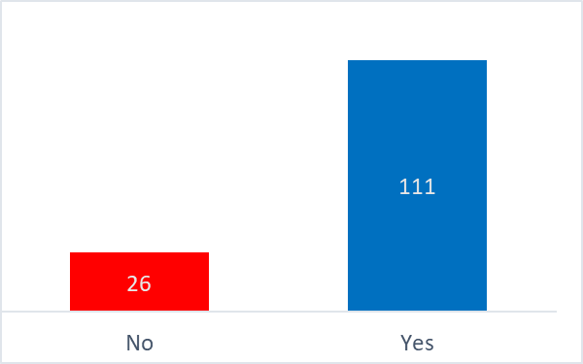

Graph number 1: Does the role of the person engaged in quality depend on the organizational culture in Israeli

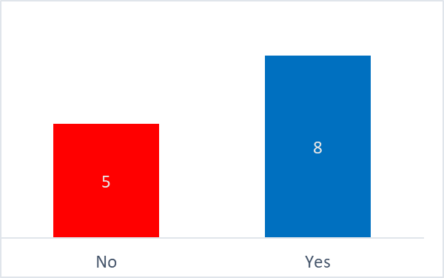

Graph No. 1: Does the role of the quality practitioner depend on the corporate culture abroad

### ***there is a dependence on the status of a quality engineer in unexpected events***

We will examine using the following questions (Appendix A):

1. Were you present at work during the closure's? (Yes/No)

2. Has your job status changed as a result of the Corona crisis?

1 . Unchanged 2. Improved 3. Worsened / Decreased 4. Other

3. Has your authority changed following the Corona incident? (Yes/No)

4. Has the description of your occupation changed during the Corona period? (Yes/No

* 1. If yes, how did the description of your occupation change during the Corona event?

1. Has the importance of quality in your organization changed in your organization following the Corona event? (Yes/No)
   1. If yes, how is it expressed?

An analysis of the survey of attitudes found that over 76% of the practitioners who were present at work think that their status has not changed, while those who did not come to work (Khalat or fired) think that the culture of quality causes a decrease in quality and damage to their status.

It was found that about 78% of the respondents think that the status of their job has not changed (as shown in graph 3), about 85% of the participants think that their authority has not changed, and about 84% of the participants think that their job description has not changed in the corona event. Examining the verbal answers of the participants who answered that the description of his occupation changed during the corona period, the following groups were found: for the most part the quality personnel was added activity after the corona supervisor (repeated 14 times); It was found that some of them were fired from work (repeated 3 times); It was found that part of the description of the occupation has not changed (times).

Examining the verbal responses of the participants who answered that the importance of quality has changed in the organization following the corona event, the following groups were found: there is an increase in the importance of safety appointed by the corona supervisor (repeated 4 times); There is an increase in the importance of quality (repeated 3 times); Increased awareness of process risk management / safety (repeated 3 times); There is an increase in quality control in the process (repeated times).

A strong correlation was found between those who thought their authority and occupation description did not change at the Corona event, and those who were present at work.

This was reinforced by the responses from the survey conducted to quality dealers abroad. An analysis of the position survey found that over 82% of dealers present at work think their status has not changed following the corona (as shown in Graph 4), and 81% of respondents think their job status has not changed. Over 73% of the participants think that their authority has not changed and over 91% of the participants think that the description of their occupation has not changed in the Corona event.

**In conclusion**, the results of the data comparison test and the statistical analysis clearly show that the quality area did not change in the corona event, these were added to it additional roles responsible for the corona event.

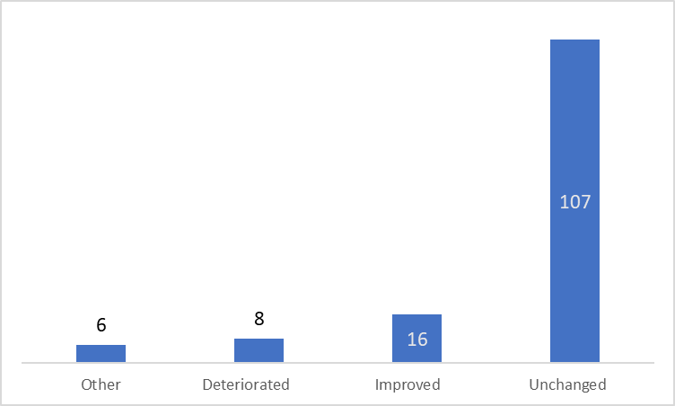

Graph number 3: Has the status of your job changed as a result of the corona crisis in Israeli

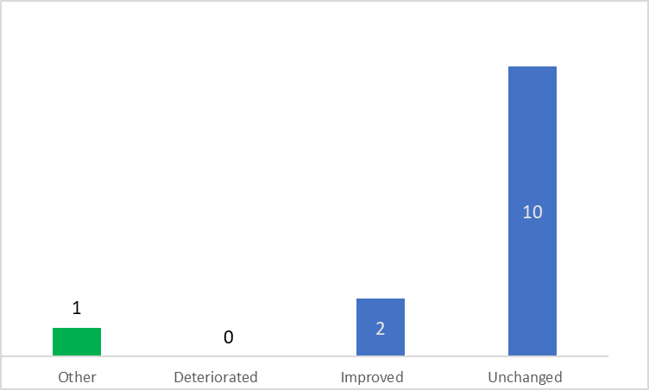

Graph number 4: Has your job status changed as a result of the Corona crisis abroad

### ***there has been a decline in quality in recent years***

We will examine using the following questions

1. Do you think the status of quality dealers is declining? Yes No
   1. If you said yes, I would be happy to think what the reasons are for this?
2. Has the status of quality dealers in your organization been declining in the last 5 years? Yes No
   1. If yes, how is it expressed?

An analysis of the position survey found that about 72% of the respondents think that the importance of quality is not declining (as shown in Graph 5). Also, over 81% of the participants think that their status in the organization in which they work has not changed, which means that there is an organizational culture for quality. The other respondents think that there is a decrease in the importance of quality (unclear customer requirements, unprofessional quality person, lack of powers and more). Examining the verbal responses of the participants who answered when there was a decline in status dealing with quality, the following groups were found: there is a lack of management backing in light of the corona issue (repeated 6 times); There is a decrease in the quality of the products, compliance with the schedule (repeated 4 times); there is a decrease in the importance of quality, focus on survival (repeated 3 times); the status of the quality dealer is not enshrined in law (repeated times).

Examining the verbal responses of participants who answered when there has been a decline in status dealing with quality in the last 5 years, the following groups were found: Examining the verbal responses found the following categories: there is a decline in management commitment (repeated 15 times); Lack of expertise, professionalism and authority (repeated 5 times); There is a decrease in the quality of the products, compliance with the schedule (repeated 4 times); there is a requirement to reduce each (circular 3); No change (repeated times).

A strong correlation was found for participants who think that their status is not declining for those who are important whose status status has not changed. This was reinforced by the responses from the survey conducted to quality practitioners abroad. An analysis of the survey of positions shows that about 55% of respondents think that the importance of quality has not decreased. ).

In conclusion, the results of the data comparison examination and the statistical analysis clearly show that the status of quality practitioners is not declining both within and outside the organization.

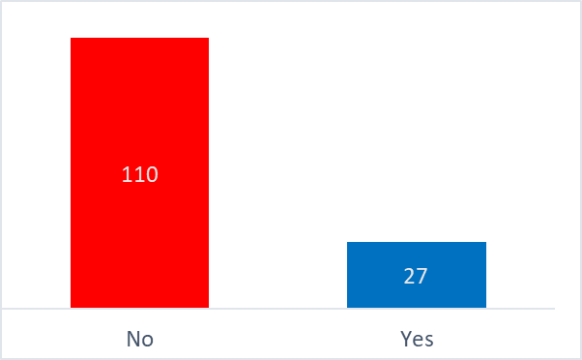

Graph number 5: the status of those involved in quality in your organization declining in the last 5 years in Israel

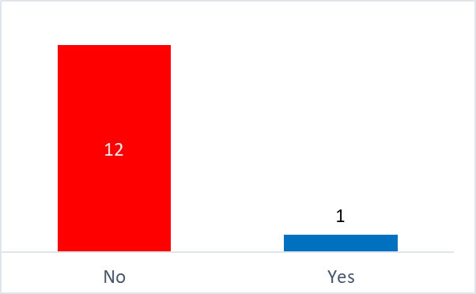

Graph number 6: the status of quality dealers in your organization declining in the last 5 years abroad

# **Discussion and conclusions**

his study examines the impact of the Covid-19 on the quality field based on the experience of quality practitioners as professionals in the context of two key terms: erogenous culture and quality engineer. The findings show that the role of the quality engineer depends on the organizational culture, regardless of the role and the organization - the promotion of quality requires the backing of management that supports quality and an organizational culture that supports and influences the quality system. Quality people who were present at work think that their status has not changed, compared to those who were not present at work think that the importance of quality has changed. It was found that most quality personnel agree that the status of their job / authority / and description of their occupation has not changed at the Corona event, some of them have added activities related to the Corona in order to prevent damage to product quality.

It can be learned from the survey that the status of practitioners did not change during the corona both inside and outside the organization, when

Those who think that their status is declining say that it is due to a decrease in management commitment, found that there are unprofessional quality personnel, the organization focuses on survival, there is a demand for reduction in CA and the status of the quality dealer is not anchored in regulation.

Similar results of the situation of quality practitioners in Israel were obtained from quality practitioners abroad. It was found that their position does not depend on the organizational culture regardless of role and organization. Also, that the status of their position / authority / description of their occupation did not change at the Corona event

Here are some suggestions made by the participants in order to improve their status: training for senior managers in the organization in quality; Raising the professionalism and skill of quality personnel; Expanding the field of quality to organizational excellence, operational excellence, engineering factor, risk management, user regulation / safety.

# **Research Limitations**

The ability to include the findings of the study on the entire population of quality practitioners in Israel and abroad, given that we were unable to reach all those dealing with quality. Also, the time of the study lasted for months.

# **REFERENCES**

Abbott, A. (1988). *The System of Professions: An Essay on the Division of Expert Labor*. Chicago, IL: University of Chicago Press.

Halevi. A. (2017*). Assimilation of knowledge and quality methods in industry*, the 35th annual conference of the Israeli Tel Aviv Quality Association, November 2017

In principle, and in full (2012). With the face forward. Quality: Journal of Quality and Excellence of the Israeli Quality Association, 51, 26–29.

In principle, and in full, (2012). Challenges and ways to empower the quality manager. Journal of Quality and Excellence of the Israeli Quality Association, 50, 12–14.

Anchor, S. (2019) Expertise and authority in the work of a quality engineer. Thesis submission work.

Questionnaire for research work in Hebrew - the role of the dealer in the quality of Google Forms

[Questionnaire about the position of quality engineers - Google Forms](https://docs.google.com/forms/u/1/d/1w1CsWusm3yygHIlSPTLK5cT6vrypQTWaT64g13PZNQY/edit?usp=drive_web) - Google Forms

Ekroni, M. (2012). ‘Facing Forward to Quality’, *Quality and Excellence Journal of the Israeli Society for Quality*, 51: 26–9 [Hebrew].

Ekroni, M (2012). ‘Challenges and Ways to Empower the Quality Manager’, *Quality and Excellence Journal of the Israeli Association for Quality*, 50: 12–14 [Hebrew].

Etzioni, Amitai. 1969. *The semi-professions and their organisation*: Teachers, nurses, social workers. New York: Free Press

Giddens, A. (1984). *The Constitution of Society: Outline of the Theory of Structuration*. Cambridge: Polity Press.

Ronen, Z. (2013). ‘Does Your Company Need Quality Management?’ *Business Excellence*, May 5 <https://business-excellence.co.il/blog/126-do-you-need-a-quality-manager> accessed 7 September 2019.

State of Israel v. Bar-Ilan et al. (2000). <[shalhevetold.co.il/pub//psak%20din/psak_makabiya.doc](https://www.google.co.il/url?sa=t&rct=j&q=&esrc=s&source=web&cd=1&ved=2ahUKEwi3tfqf0vfdAhXRMewKHcuYBI0QFjAAegQIAhAC&url=http%3A%2F%2Fshalhevetold.co.il%2Fpub%2F%2Fpsak%2520din%2Fpsak_makabiya.doc&usg=AOvVaw0KpnL6wMbHbnK2eBEv3gY1)> accessed 7 September 2019.

Weber, M. (1968). *Economy and Society*. Berkeley, CA: University of California Press.

Zonnenschein, A. (2016). ‘We Must Uproot the Culture of the Loose Slapdash in the Food Industry’, *The Marker* <https://www.themarker.com/opinion/1.3103885> accessed 7 September 2019.