**The Young State of Israel in a Drawing by Nachum Gutman**

This activity is based on an illustration from the children's newspaper *Davar Le'Yeladim* that was published three months after the establishment of the State of Israel. It was drawn by the famous Israeli artist Nachum Gutman. The situation in Israel was difficult at the time, since the young state was still fighting the War of Independence. Nevertheless, Gutman depicts a vision of peace and tranquility.   
In this lesson we discuss how the artist viewed life in Israel and whether the illustration presents reality or hope for the future.

**Lesson Plan**

**Getting Ready**

|  |  |
| --- | --- |
| Short description of lesson | Teachers introduce the front cover of the children's newspaper *Davar* *Le'Yeladim* that was published three months after the establishment of the State of Israel. On the cover is an illustration by the famous Israeli artist Nachum Gutman presenting his vision for peace.  The class then discusses the illustration and Gutman's vision and places this in the context of the difficult situation in Israel at the time.  Finally, the students create artwork depicting Israel and their vision for its future. |
| Age group | Primary school |
| Curriculum | * **Israel Studies** – Independence Day, the establishment of the State of Israel * **History** – the history of the twentieth century * **Art** – illustration and cartoons * **Media** – children's newspapers |
| Goals | * To learn about the establishment of the State of Israel and the War of Independence. * To expose students to the work of the artist Nachum Gutman. * To discuss visions and dreams of peace. |
| Primary sources from the NLI collections | * [**Young State of Israel,** Nachum Gutman, 1948](http://web.nli.org.il/sites/NLI/Hebrew/digitallibrary/pages/viewer.aspx?presentorid=NLI_EDU&docid=NNL03_EDU700275971) |
| Background information | * [State of Israel (1948-present](https://en.wikipedia.org/wiki/History_of_Israel#State_of_Israel_.281948.E2.80.93present.29)), *Wikipedia* * [Israel, 1948-1967 - Building a new nation](https://www.myjewishlearning.com/article/israel-1948-1967/), *My Jewish Learning* * [Works of Nachum Gutman](https://www.google.co.il/search?q=Nachum+Gutman&rlz=1C1GGRV_enIL751IL751&source=lnms&tbm=isch&sa=X&ved=0ahUKEwj-1q313LvXAhXIEewKHYSZAPoQ_AUICigB&biw=1229&bih=619), Google |
| Material, equipment, and preparations | * Printouts of the worksheet and the Nachum Gutman illustration * Projector * Individual computers for the students (optional) * Art materials |
| Files | * Worksheet * Printed copies of the primary sources. |

**Lesson Plan**

|  |  |
| --- | --- |
| Opening | * Class discussion about the State of Israel.  Refer briefly to the following points:   + The Zionist movement   + The British Mandate   + The Holocaust   + The British decision to leave Israel   + The declaration of the State of Israel   + The War of Independence |
| Class Discussion | * Discuss the atmosphere in Israel and the Jewish world with the establishment of the new Jewish State. * Discussion points:   + **How did people feel after the declaration of the State of Israel?** Joy, relief, excitement, worry, apprehension   + **Why were they excited?** This was the first time in two thousand years that the Jewish people had an independent state where they could be free and safe.   + **Why were they worried?** It was clear that the Jewish State would have to fight for its survival. |
| Pair activity | Divide the students into pairs to explore the primary source.  Each pair has two tasks:   1. Complete a puzzle of the primary source. If students have access to computer, they can complete the puzzle online – <https://www.jigsawplanet.com/?rc=play&pid=0eaf4bedb056>   (This puzzle was created with 16 pieces. If this is too easy or too hard, you can change the puzzle by clicking on the "Play As" button on the top of the screen.)  If not, you can create a puzzle yourself in the traditional way.   1. Complete the worksheet that deals with the primary source. |
| Class discussion | After the pair activity, the students share their work.  Use their answers to hold a discussion on the following topics:   * **What is depicted in the illustration?** A utopian and serene depiction of Israel: a three-generation family, working the fertile land, traditional grandparents, peace and tranquility. * **What was the real situation in Israel at the time?** War of Independence, much of Israel still underdeveloped, many lone Holocaust survivors or refugees from Arab countries, economic difficulties, arid land. * **Why did the artist show Israel in this way?** Gutman is possibly presenting a vision or dream of a peaceful and prosperous future. * **What is the connection between the verse from Isaiah and the illustration?** The verse also envisages a hopeful and positive future for the Land of Israel. This quotation creates a connection between the Jewish sources, the vision of a national Zionist revival, and the establishment of the State of Israel. * **What elements of Gutman's picture were actually realised?** Israel today is a prosperous and fertile country. Families of three generations and more are very common; the tragedy of the Holocaust and the expulsion from the Arab countries, while not forgotten, is a thing of the past. However, agriculture is not a central feature of modern Israel. Likewise, the buildings and infrastructure in Israel today are far more modern and developed than Gutman imagined in 1948. |
| Individual activity | * Explain that Nachum Gutman drew the State of Israel as he saw it in his dreams and not as it actually was at the time. * Ask each student to create two images: the real Israel (including houses, streets, schools, family and friends) and their vision for Israel. They can use online creation apps or draw two images on paper. |
| Wrapping up | * Students show their work and explain the vision and the reality. * Conduct a class discussion on the differences between the two and ways to bridge these differences. |

**Young State of Israel, *Davar Le’Yeladim*, 1948**

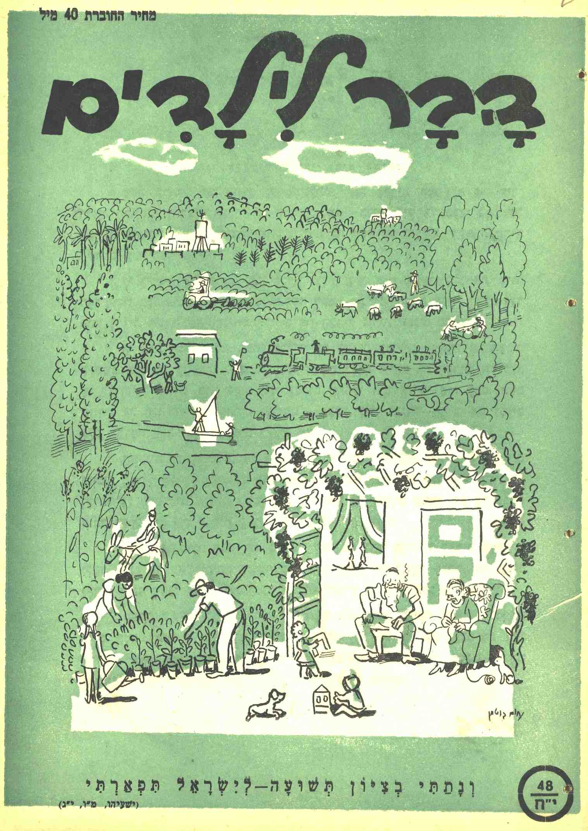

**Name ___________________**

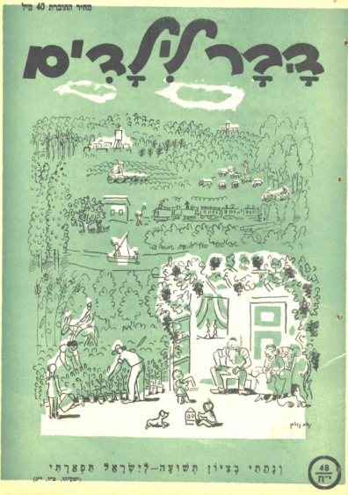

**Worksheet – The Young State of Israel**

This is the front cover of a children's newspaper printed in Israel three months after the establishment of the State of Israel.

Examine the illustration and answer the following questions.

1. Describe the picture.  
   Write a list of at least six items, three places, and three people you can see in the picture.   
   ____________________________________________________________________________________________________________________________________________________________________________________________________________________________________
2. What is the atmosphere depicted in the picture? How does it make you feel about life in Israel in 1948?  
   ________________________________________________________________________

________________________________________________________________________

1. What do you know about the situation in Israel in the months following the Declaration of Independence? Was the situation difficult? Why or why not?  
   ________________________________________________________________________

________________________________________________________________________

________________________________________________________________________

1. Does the atmosphere depicted in the picture reflect the reality of the times?  
   ________________________________________________________________________
2. Why do you think that the artist chose to show the situation in Israel in this way?  
   ________________________________________________________________________
3. At the bottom of the picture is a verse from the Bible: “And I will place salvation in Zion; for Israel My glory” (Isaiah 46:13).   
   What does the verse mean?  
   ________________________________________________________________________________________________________________________________________________

Why do you think that the artist added this verse to the picture?  
________________________________________________________________________

BONUS QUESTIONThis illustration was drawn by the famous Israeli artist Nachum Gutman. Gutman created many images of life in Israel in the twentieth century.  
Search the internet for images by Nachum Gutman, and choose one that you particularly like. Why did you choose this picture? What is shown in the picture? What historical period does it describe?