##### Abstract

[Abstract I](#_Toc529005566)

[List of symbols III](#_Toc529005567)

[List of figures III](#_Toc529005568)

[List of tables VII](#_Toc529005569)

[1. Introduction 1](#_Toc529005570)

[1.1 Motivation of this work 1](#_Toc529005571)

[1.2 How do fish detect objects in water without using vision ? 2](#_Toc529005572)

[1.3 Sensory organs of the LL 3](#_Toc529005573)

[1.4 Blind fish can detect non-moving obstacles 5](#_Toc529005574)

[1.5 Hydrodynamic imaging. 6](#_Toc529005575)

[1.6 Hydrodynamic stimuli 7](#_Toc529005576)

[1.7 Distance of detection 7](#_Toc529005577)

[1.8 Discrimination of shapes 9](#_Toc529005578)

[1.9 Role of neuromasts in object detection 10](#_Toc529005579)

[1.10 The shape of underwater robots 10](#_Toc529005580)

[1.11 Detection and identifying a body using bioinspired sensors. 11](#_Toc529005581)

[2. Theoretical works on hydrodynamic imaging 11](#_Toc529005582)

[2.1 Slender bodies approaching a wall 11](#_Toc529005583)

[2.1.1 Sphere approaching to a wall or another sphere 15](#_Toc529005584)

[2.2 Detection of a body in the presence of current 15](#_Toc529005585)

[3. Objectives of this work 17](#_Toc529005586)

[4. A mathematical model of detecting of a sphere by a sphere 18](#_Toc529005587)

[4.1 Problem formulation 18](#_Toc529005588)

[4.2 Testing cases 23](#_Toc529005589)

[5. Numerical results 25](#_Toc529005590)

[5.1 The coefficients of the added mass and the repulsive force 25](#_Toc529005591)

[5.2 Sphere approaching to a wall 28](#_Toc529005592)

[5.3 Two spheres 31](#_Toc529005593)

[6. Experimental investigation 34](#_Toc529005594)

[6.1 Experimental layout 35](#_Toc529005595)

[6.2 Construction of the sphere 36](#_Toc529005596)

[6.3 Pressure sensor 38](#_Toc529005597)

[6.4 Experimental results 39](#_Toc529005598)

[6.4.1 Pressure difference 39](#_Toc529005599)

[6.4.2 Detection distance 43](#_Toc529005600)

[7. Fish moving in a tube with current 44](#_Toc529005601)

[7.1 Experimental apparatus 44](#_Toc529005602)

[7.2 Experimental protocol and fish filming 45](#_Toc529005603)

[7.3 Image processing of fish trajectories. 47](#_Toc529005604)

[7.4 Results 50](#_Toc529005605)

[7.4.1 No obstacle in the pipe 50](#_Toc529005606)

[7.4.2 Trajectories in the pipe with obstacle. 51](#_Toc529005607)

[8. References 54](#_Toc529005608)

[Appendises. 58](#_Toc529005609)

[8.1 Appendix A – Pump data sheet 58](#_Toc529005610)

##### List of symbols

*a* - radius of sphere *A*

*b* - radius of sphere *B*

*c* - distance between the spheres

 - location of sphere *A*

 - location of sphere *B*

 - added mass coefficient

-radius of a sphere

*h* - distance between the sphere and a virtual wall (or wall)

- detection distance

*L -* fish characteristic length

 - Reynolds number

*t -* time

 - velocity field vector

 - velocity of sphere *A*

 - velocity of sphere *B*

 - velocity potential of sphere *A*

 - velocity potential of sphere *B*

 - boundary layer thickness

 - total velocity potential

##### List of figures

[Figure 1. Prey and predator revealing each other in darkness. 2](#_Toc529005509)

[Figure 2. A Mexican Tetra (*Astyanax mexicanus* ) gliding parallel to a wall in a corner of an aquarium (photo by G. Zilman, Laboratory of Marine Hydrodynamic, Dept. Mechanical Engineering, Tel Aviv University). The distance between the head of the fish and the front wall is approximately 25 mm in A, 14 mm in B, 8 mm in C, and 4 mm in D. 3](#_Toc529005510)

[Figure 3. The LL periphery according to Bleckman and Zelick (2009). The drawing shows the pores of the LL canals (circles) and the spatial distribution of superficial neuromast (dots). In most of fish species, one canal runs above the eye (supraorbital), one below the eye (infraorbital) and one on the lower jaw (mandibular) (see also Montgomery, Coombs and Baker, 2001). In some fishes the trunk canal does not run the full length of the body (Bleckman and Zelick, 2009). Most fish have relatively few superficial neuromasts, concentrated near the head and near the trunk of the LL system. 3](#_Toc529005511)

[Figure 4. Sketch of a superficial neuromast (not to scale). A typical superficial neuromast may be up to high andwide, and may contain tens of hair cells (Triantafyllou, Weymouth and Miao, 2016). 4](#_Toc529005512)

[Figure 5. Superficial neuromast in a boundary layer of thickness . A. The velocity in the boundary layer of thickness  is zero on the skin of the body and reaches some value  on the conditional margin of the boundary layer and bending of a neuromast in the boundary layer due to the moment acting on it. B. Hydrodynamic force *D* acting on the cross-section of a neuromast. 4](#_Toc529005513)

[Figure 6. A sketch of a canal neuromast (not to scale). A CN is located between two adjacent pores in an under skin canal. It is larger than the SN, and is of hundreds of microns in diameter, and contains hundreds to thousands of hair cells (van Natten, 2006). 5](#_Toc529005514)

[Figure 7. Schematic diagram of the LL of a Mexican Tetra, illustrated on an image of a gliding Mexican Tetra in an aquarium of the laboratory of the Marine Hydrodynamics. The location of the pores and superficial neuromast is rather approximate and inspired by drawing of Windsor et al. (2010a) and Schemmel (1967). 6](#_Toc529005515)

[Figure 8. Collision of a Mexican Tetra with a corner wall (photos by G. Zilman, Laboratory of Marine Hydrodynamic, Dept. Mechanical Engineering, Tel Aviv University). In frame C the fish propels itself too close to the wall and in frame D collides with it. In frames E –H it does not move forward. Noticeable, that it frame G the fish moves slightly backwards in order to provide more space for maneuvering (in the consequents frames D-H the fish does not move forward) 8](#_Toc529005516)

[Figure 9. Mexican Tetra approaching a corner. wall (photos by G. Zilman, Laboratory of Marine Hydrodynamic, Dept. Mechanical Engineering, Tel Aviv University). The consequent positions of the fish are shown from the upper left photograph A to the lower right photograph in the clockwise direction H. 8](#_Toc529005517)

[Figure 10. A. Ship avoiding maneuver with a radius of turn of order of 2 of its length for typical ships and submarines. B. Fish avoiding maneuver with radius of turn of order of half fish length. 10](#_Toc529005518)

[Figure 11. Omni-Directional Intelligent Navigator (ODIN), which is owned and maintained by the Autonomous Systems Laboratory, College of Engineering, University of Hawaii 11](#_Toc529005519)

[Figure 12. Three images of fish A with respect to plane walls forming a corner. Image B provides the zero normal velocity on the vertical read line of the corner A. Image C provides the zero normal velocity on the horizontal blue line of the corner A. Image D provides the zero normal condition on the red line of the corner C and on the horizontal blue line of the corner B. Image C violates the boundary condition on the red line of the corners A-B and image D violates the boundary conditions of the corners A-C. Therefore, for small distances from the wall the method of images is associated with an error. Nevertheless, for streamlined bodies which weakly disturb the fluid, the method of images gives reasonable accuracy and a transparent explanation of the physics of a body moving near the corner. As it follows from the flow in corner A is disturbed by motion four fish. If fish A is equipped with velocity and pressure sensors it may perceive the variations of the velocity and pressure fields induced by three fish B, C and D. 12](#_Toc529005520)

[Figure 13. Pressure coefficient and canal pores density along the body of a schematic fish (view from above). Solid line – pressure coefficient; dashed line – canal pores density (arbitrary units). The distribution density of the canal pores neuromasts correlates well with the location of maximum differential hydrodynamic pressure on the fish’s body ( Ristroph, Liao and Zhang, 2015; Dubois, Cavagna and Fox, 1974). 13](#_Toc529005521)

[Figure 14. The normalized velocity  and the pressure coefficient  calculated for a two-dimensional and three-dimensional body according to Milne-Thomson (1968). Solid line – Joukovskii two-dimensional profile; dashed line– airship form. Each of the two bodies can be characterized by its slenderness, that is by the ratio between the length of the body and its maximal width (or diameter). As long as these parameters for the bodies are close, the behavior of the pressure coefficients for them is qualitatively similar. For most slender fish the rate of change of pressure is largest in their front part, with a decrease towards the tail. 13](#_Toc529005522)

[Figure 15. Pressure distribution about a stream-lined body of revolution representing the so-called airship form (redrawn and modified from Schlichting, 1979). 14](#_Toc529005523)

[Figure 16. Pressure distribution on a circumference of a sphere as a function of the polar angle calculated in the clockwise direction (in the forward stagnation the polar angle). A. Dash-dotted line– subcritical (experiment); solid line–supercritical  (experiment); dashed line–potential flow theory (redrawn and modified from Schlichting, 1979) B. Subcritical (numerical solution of the Navier-Stokes equations, redrawn and modified from Bazilevs et al., 2014). 14](#_Toc529005524)

[Figure 17 . The wake of a cylinder in a stream for different Reynolds numbers (adopted from Vogel, 1994). 16](#_Toc529005525)

[Figure 18. The coordinate system. The centers of both spheres are located on the ** axis of the fixed in space coordinate system . Another coordinate system  is attached to the body *A* and moves with it as a whole;  are unit vectors normal to the surfaces of the corresponding spheres *A* and *B.* The distance between the centers of the spheres is denoted as *c* and the minimal distance between the surfaces of the spheres is denoted as *h.* 18](#_Toc529005526)

[Figure 19. A. Two equal spheres moving in the opposite directions with equal speeds and high Reynolds numbers. Due to symmetry, on the dashed line the normal to it velocities which are induced by the spheres, cancel each other. In a case this line can be imagined as a rigid wall on which the zero normal velocity is satisfied in the left and right half-spaces. B. A sphere moving away from the wall with velocity *U.* C. A finite radius sphere approaching to a large one (); the later can be considered as a rigid wall. 18](#_Toc529005527)

[Figure 20. Illustration of the method of images. Dipole *A* with intensity  is located in the point *A* at a distance *C* from the center of the sphere *B* of diameter *b*. 20](#_Toc529005528)

[Figure 21. Successive images introduced in order to satisfy the boundary conditions on moving sphere *A* and sphere *B* if its velocity . 21](#_Toc529005529)

[Figure 22. The element of the surface is  and the projection of the external normal to the sphere on the *ox* axis is . In such a case can be written as 24](#_Toc529005530)

[Figure 23. Added mass coefficient and velocity at the fore edge of the sphere, at a small distance from the wall () with changing number of images *N*. Solid line - ; dashed line -  . 26](#_Toc529005531)

[Figure 24. Added mass coeeficient as a function of the normalized distance to the wall. Solid line – present calculation; dashed line () Kharlamov (2007), method of images with accelerated convegence of series; dash-dotted line () Yang (2006), dotted line () Milne-Thomson (1968). 27](#_Toc529005532)

[Figure 25. Coefficient of the force acting on a sphere approaching a wall perpendicularly. Solid line – Lagrange’s equation; open circles – pressure integration. 27](#_Toc529005533)

[Figure 26. Normalized velocity on the meridian circumference of a sphere approaching a wall as a function of the distance *h* and the coordinate *x*: . For  the velocity on the meridional circumference coincide with that for . 28](#_Toc529005534)

[Figure 27. A B: Streamlines in the plane  of a sphere approaching a wall from the left. CD. Pressure coefficient on the same sphere. 29](#_Toc529005535)

[Figure 28. Pressure coefficient along the meridian circumference for different distances from a wall. 30](#_Toc529005536)

[Figure 29. Pressure coefficient in the stagnation point for small . Broken line – calculated pressure coefficient; square line – approximated pressure coefficient . It is seen that for small distances to the wall  the pressure coefficient behaves as . 30](#_Toc529005537)

[Figure 30. A sphere of radius *a* approaching another non-moving sphere of much larger radius A–B. Streamlines. C–D. Pressure coefficient. More detailed analysis show that the results presented in Figure 27 and Figure 30 are almost identical. 32](#_Toc529005538)

[Figure 31. Streamlines and the pressure coefficient around a sphere approaching another still sphere . A. and C. ; B. and D. . 33](#_Toc529005539)

[Figure 32. Streamlines and the pressure coefficient around a sphere approaching to another still sphere . A. and C. ; B. and D. . 34](#_Toc529005540)

[Figure 33. Streamlines and the pressure coefficient around a sphere approaching to another still sphere . A. and C. ; B. and D. . 34](#_Toc529005541)

[Figure 34. The experimental system. 35](#_Toc529005542)

[Figure 35. A sphere approaching to a brittle wall. A. View from above. B. Side view. 1. Moving carriage; 2. Connecting tube; 3. Sphere; 4. Rigid wall; 5. Breakable wall. The center of the sphere was 0.35 m below the water free surface. 36](#_Toc529005543)

[Figure 36. Parts of the sphere. 1. Pressure holes (see Figure 37). 2. Front part of the sphere. 3. Sealed box containing the pressure transducers. 4. O-Ring preventing leaks between the two main parts of the sphere. 5. Inner connector. 6. Rear part of the sphere. 7. Connecting tube, connecting of the entire sphere to the moving carriage. 36](#_Toc529005544)

[Figure 37. Location of the holes in the sphere. An end of a thin 2 mm silicone pipes was inserted in each hole. The other end of the pipe lead to pressure transducers, placed in the sealed box (see also Figure 36, item 3). The signals from the pressure sensors were recorded and processed by a computerized system of data acquisition as it is illustrated in Figure 38. 37](#_Toc529005545)

[Figure 38. Schematic diagram of measured data processing. 37](#_Toc529005546)

[Figure 39. The Freescale MP3V5004G pressure sensor. A. An image of the sensor. B. A schematic discription of the pressure sensor; a silicone diaphragm deforms according to the pressure difference. 38](#_Toc529005547)

[Once  and are found, the differential pressure for each sensor can be estimated using . An example of calibration of six sensors is presented in Figure 40. 39](#_Toc529005548)

[Figure 41. Sensor calibration. 39](#_Toc529005549)

[Figure 42. Pressure coefficient difference as a function of the time while the sphere approaches to the wall (*U*= 0.5 m/s). The read circle indicates the contact of the sphere with the wall. A. Row signal. B. The same in logarithmic scale with error bars. 40](#_Toc529005550)

[Figure 43. Comparison of the experimental and theoretical pressure difference coefficients. The time  when the pressure difference attains the maximum. Solid line – theory; open circles – experimental results. A. *U*=0.5 m/s. B. *U*=0.6 m/s. C. *U*=0.5 m/s. D. *U*=0.6 m/s. 42](#_Toc529005551)

[Figure 44. Experimental pressure difference coefficient measured until the time of contact (*U*= 0.5 m/s). The open circle indicates the location and time when  43](#_Toc529005552)

[Figure 45. Schematic experimental setup. A. Top view. B. Side view. 44](#_Toc529005553)

[Figure 46. A blind Mexican cave fish avoiding an obstacle in a tube. The fish is  long swimming in a  diameter pipe. Photos displayed in 0.2 sec difference. 1. Fish approaches the obstacle. 2. Fish starts the avoiding maneuver. 3-4. End of the avoiding maneuver. 5. Fish moves towards the wall of the tube. 6. Fish perceives the tube and starts the avoiding maneuver. 7-8. End of the avoiding maneuver. 45](#_Toc529005554)

[Figure 47. Flow visulazation past a cilindrical obstcale placed in a tube. , . 46](#_Toc529005555)

[Figure 48. Fish avoiding the obstacle while swimming against the stream in a tube with fluorescein. . Photos displayed in 0.2 sec difference .1. Fish gliding towards the obstacle. 46](#_Toc529005556)

[Figure 49. Fish colliding with the obstacle while swimming against the stream in a tube with fluorescein. . Photos displayed in 0.2 sec difference. 1-2 fish gliding towards the obstacle. 3. Tail beat close to the obstacle. 4 fish collides with the obstacle. 5-6. Fish swims backwards7-9. Fish preforms an avoiding maneuver. 47](#_Toc529005557)

[Figure 50. Fish avoiding an obstacle. 47](#_Toc529005558)

[Figure 51. Coordinate system of an image with a fish. The origin of the coordinate system *Oxy* is chosen in the upper corner of the image. The red star denotes the fish nose. This image say me nothing because it does not contain any necessary information. The most important is the plastic ruler but it is not here. Why do you need the broken line? 48](#_Toc529005559)

[Figure 52. Image processing steps. A. Original image. B. The result of comparison between the image and the background image, using Matlab function "imabsdiff”. C. Converting the resultant image B to a black-white image, Matlab function “im2bw”. D. Building the contour (red dashed line), locating the nose of the fish (astrix), the endpoint of the body (circle) and the centroid (cross), Matlab functions “bwboundaries.m” and “regionprops.m”. The Matlab code is shown in appendix. Where is it? 49](#_Toc529005560)

[Figure 53. Trajectory of the nose of a fish swimming in the tube. A. Top view. B. Side view 50](#_Toc529005561)

[Figure 54. The trajectory of the nose of the fish in a tube without an obstacle. 50](#_Toc529005562)

[Figure 55. Fish approaching obstacle in the pipe with obstacle without current (). 51](#_Toc529005563)

[Figure 56. Trajectories of fish in the pipe with an obstacle . A. fish approaches obstacle in the direction of water flow. B. fish approaches obstacle against the direction of water flow 51](#_Toc529005564)

[Figure 57. Trajectory of fish in a tube with an obstacle and a current of . A. Swimming in the direction of the current; B. Swimming against the current. 52](#_Toc529005565)

##### List of tables

[Table 1. Minimum number of images  required for calculating the pressure coefficient and the velocity on a sphere with  as a function of the distance to the wall  are presented in the second and third columns. 26](#_Toc529005611)

[Table 2. Spheres parameters and the corresponding figure numbers 31](#_Toc529005612)

[Table ‎6.1 Average detection time and distance at 3 velocities 43](#_Toc529005613)

[Table 4. The probability of the fish entering an imaginary cylinder around the obstacle. 53](#_Toc529005614)

[Table 5. Chance of collision with an obstacle depending on the direction of motion. 53](#_Toc529005615)

# 

# Introduction

## Motivation of this work

Inspecting marine infrastructures such as dams, ports, marine gas/oil platforms and piping systems became an important task of marine operations in the XXI century. Underwater system systems require frequent inspection and replacement subsea components. Given that divers my work only at limited depth and limited time and taking into account the potential risk of underwater labor, remotely operated underwater vehicles (ROVs) and autonomous underwater vehicles (AUVs) are considered as a potentially important instrument for sea exploration (Griffiths, 2002. ). Offshore oil and gas installations are presently serviced mainly by remotely operated vehicles (ROVs), receiving power through a cable which connects a ROV with the operating center. The long tether is not simple to operate especially for large depths. That motivated using of autonomous underwater vehicles (AUVs). Nowadays AUVs are frequently named as robots and the entire field of related to AUVs manufacturing and exploiting as robotics. In fact AUVs are nothing more than unmanned automated submarines guided my more sophisticated autopilots than earlier. AUVs are currently used for scientific survey tasks, oceanographic sampling, underwater archeology, under-ice survey, mine detection and landing site survey. Today, approximately 200 AUVs are operational. Although many of them are still experimental, the progress in design and use of AUV is rapid. In order to navigate without collision in a complex sea environment, near other moving and nonmoving objects, an AUV has to be able to detect them, to estimate the distance to them, and to avoid collision with them and to reconstruct their form. To create an image of an inspected objects a ROV/AUV are typically equipped with sonars and/or photo cameras. Although a considerable progress was achieved in developing underwater cameras and the related software for processing of digital images (Kocak et al., 2008) vision in murky or deep water with low illumination is still much less effective than that in air. So far, sonars serve as a primary tool for underwater navigation (Paull et al., 2014).

However, in sonars of AUV also have limitations. Due to the wide beam frequently used in sonars their directional resolution may be insufficient for certain purposes of decocting and recognizing objects. For instance, because of specular reflection of the acoustic wave send to a smooth plane surface at oblique angles of incidence, the reflected signal does not returns to the transmitter. That makes an object consisting on plane surfaces invisible for an AUV. In a domains of complex geometry, the multiple reflection can produce images of non-existing objects.

In this context marine engineers are interested in a technology of detecting underwater objects by AUVs beside of using optical or acoustic means. Do such alternative methods already exist? Nature gives a seemingly positive answer to this question.

## How do fish detect objects in water without using vision ?

As it is difficult to imagine that eyes, although useless, could be in any way injurious to animals living in the darkness, I attribute their loss wholly to disuse.

Darwin (1859)

Typically, most aquatic animals use vision for orientation in space, hunting, foraging and avoiding predators.

|  |
| --- |
|  |

Figure 1. Prey and predator revealing each other in darkness.

However, in addition to vision, cartilaginous/bony fishes and aquatic amphibians developed a mean, which allows them to perceive motion of other animals even in full darkness. It is called the *mechanosensory lateral line*, or commonly the *LL* (LL). Living fishes constitute about 25,000 species comprising about 50% of all vertebrates, and they all have a LL. This fact suggests that it is the most ancient and important sensory organ of fish (e.g. Dijkgraaf, 1963; Bleckmann, 2006; Coombs and Mongomery, 2014). Although the LL has been known and has been described more than three and a half centuries ago (see e.g. Parker, 1904) it still attracts the close attention not only of biologists, but also physicist and engineers (for further general information refer e.g. to the recent book Bleckmann, Mogdans and Coombs, 2014). Today, it can be said that the terminology of physics, engineering and shipbuilding has been enriched with a new expression "*artificial LL",* which refers to continuous attempts to create man-made sensors mimicking the LL system.

The structure of the fishes’ lateral line was described in such a huge body of considerable works that not all of them could be acknowledged here. Therefore, the reader is sent only to a few of them, which we consider as the most relevant for our study (e.g. Dijkgraaf, 1963; Montgomery, Coombs and Baker, 2001; van Netten, 2006; Bleckmann, 2006; McHenry, Strother, and van Netten, 2008; Coombs and Mongomery, 2014). According to a generally accepted paradigm in the biology of aquatic animals, the LL allows them to detect the water velocity field and pressure gradients in a thin boundary layer of viscous fluid adjusted to their skin.

From the mechanic and hydrodynamic point of view, a fish is a time varying deformable body. To describe in full detail its motion and, correspondingly, the functioning of the LL is extremely difficult, if possible. Therefore, in order to understand the hydrodynamic functioning of the LL, simplifications of fish motion seem inevitable. The so-called fish gliding motion is one of such useful simplifications, which is frequently used in fish hydrodynamics. During the so-called gliding regime a fish moves approximately along a straight line whereas its body preserves approximately the same shape. An example of such a motion is illustrated in Figure 2.

|  |  |
| --- | --- |
| A | B |
| C | D |

Figure 2. A Mexican Tetra (*Astyanax mexicanus* ) gliding parallel to a wall in a corner of an aquarium (photo by G. Zilman, Laboratory of Marine Hydrodynamic, Dept. Mechanical Engineering, Tel Aviv University). The distance between the head of the fish and the front wall is approximately 25 mm in A, 14 mm in B, 8 mm in C, and 4 mm in D.

The gliding motion concept allows one to introduce dimensionless hydrodynamic quantities, which are generally accepted in the hydrodynamics of rigid bodies.

## Sensory organs of the LL

The sensory organs of the LL are called neuromasts and consist of two types. Neuromasts which are located on a fish's skin are called *surface neuromasts* (SN); neuromasts which are located beneath the skin, in small diameter canals, are called *canal neuromasts* (CN). A sketch of distribution of superficial and canal neuromasts is shown in Figure 3.

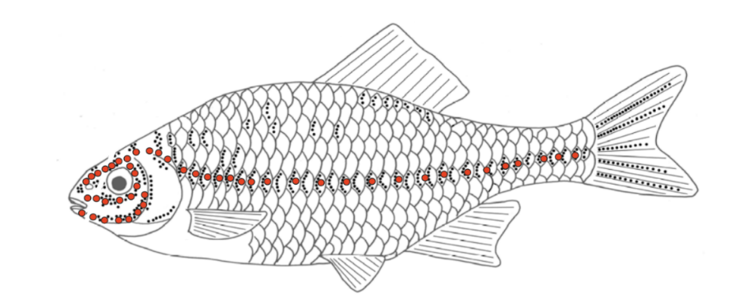

Figure 3. The LL periphery according to Bleckman and Zelick (2009). The drawing shows the pores of the LL canals (circles) and the spatial distribution of superficial neuromast (dots). In most of fish species, one canal runs above the eye (supraorbital), one below the eye (infraorbital) and one on the lower jaw (mandibular) (see also Montgomery, Coombs and Baker, 2001). In some fishes the trunk canal does not run the full length of the body (Bleckman and Zelick, 2009). Most fish have relatively few superficial neuromasts, concentrated near the head and near the trunk of the LL system.

Both types of neuromasts consist of a *cupula* and sense hairs inside it. LL neuromasts are innervated by afferent nerve fibers. When the hairs deform, the nerves obtain a signal, which is transferred to the fish’s nerve system (Montgomery 2000; Montgomery, Coombs and Baker, 2001; van Netten, 2006; McHenry Strother and van Netten, 2008). Figure 4 illustrates how a superficial neuromast works. Different local drag forces in different cross-sections along a cupula create a bending moment acting on it. The bending leads to the deformation of the cupula and deformation of the bundle of sensing hairs. Because the drag and the fluid velocity in the boundary layer of a fish's skin are directly related, the surface neuromasts are viewed as the sensors of the fluid velocity near the fish.

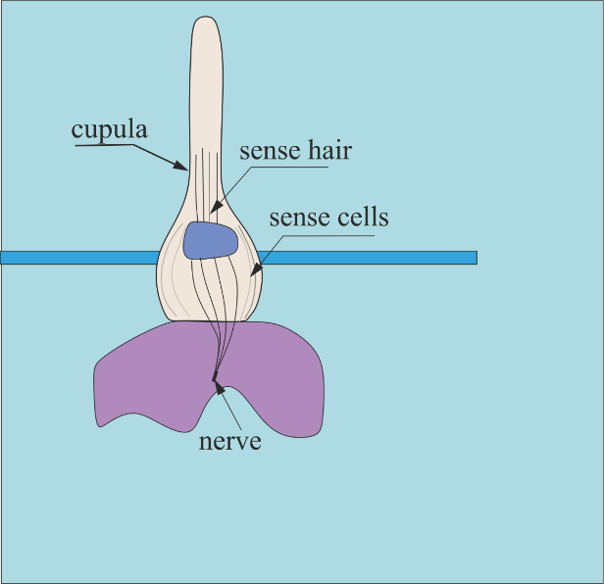

Figure 4. Sketch of a superficial neuromast (not to scale). A typical superficial neuromast may be up to high andwide, and may contain tens of hair cells (Triantafyllou, Weymouth and Miao, 2016).

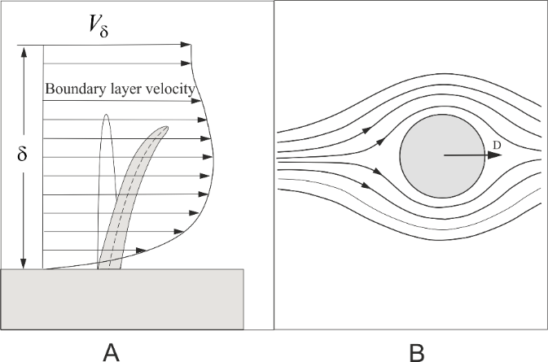

Figure 5. Superficial neuromast in a boundary layer of thickness . A. The velocity in the boundary layer of thickness  is zero on the skin of the body and reaches some value  on the conditional margin of the boundary layer and bending of a neuromast in the boundary layer due to the moment acting on it.  
B. Hydrodynamic force *D* acting on the cross-section of a neuromast.

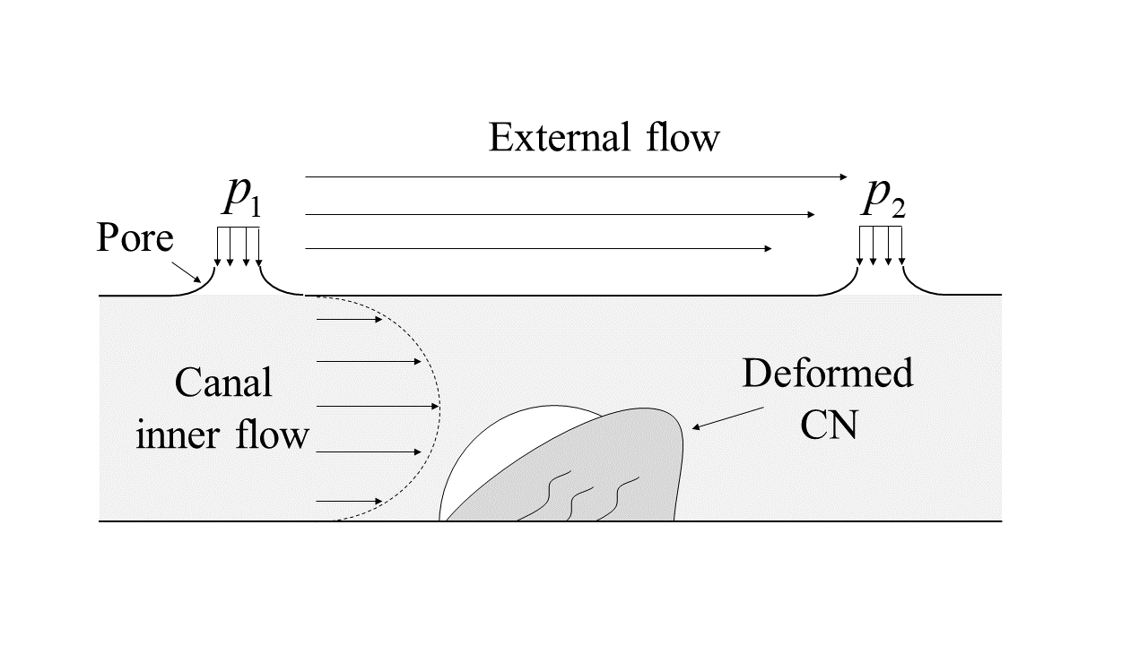

Figure 6. A sketch of a canal neuromast (not to scale). A CN is located between two adjacent pores in an under skin canal. It is larger than the SN, and is of hundreds of microns in diameter, and contains hundreds to thousands of hair cells (van Natten, 2006).

The pressure gradient in the canal, as illustrated in Figure 6, induces slow motion of a fluid inside it. The normal and shear stresses on the surface of a cupula related to this flow lead to a deformation and bending of the sensing hairs inside it (Bleckmann 2006, Montgomery 2000; Montgomery, Coombs & Baker, 2001 McHenry 2008; van Netten, 2005, 2006; McHenry, Strother and van Netten, 2008). Therefore canal neuromasts are considered as sensors of pressure gradient.

## Blind fish can detect non-moving obstacles

Using their LL fish can detect moving objects, which create water motion. In his seminal review of his own and previous works of others biologists Dijkgraaf (1963) reported that in 1908, Hofer (Hofer, 1908) already observed a pike with dimmed vision, which swam in a tub at a certain distance from the wall without touching it. Moreover, a ruler of 4 cm width held in the animal’s way was perceived at about 0.5-1 cm distance. These avoiding reactions disappeared after cauterization of the canal organs of the LL on the head of the fish. Thus, Hofer (1908) concluded that the fish observed could "feel at a distance" with its LLs. Referring to his own work carried out in 1934, Dijkgraaf (1963) describes distant perception of the walls of an aquarium by blinded fish *Corvina* (25cm in length). When a *Corvina* fish approached the aquarium wall perpendicularly, this obstacle was detected at a distance of about 1-2 cm. Experiments with sighted but surgically blinded fishes are harmful for the animal and technically difficult. Needless to say it is much more convenient to perform experiments with a non-surgically operated and 100% healthy fish than with a surgically or chemically treated one. Ideally one would want to carry out experiments with fish which were born blind.

The Blind Mexican Tetra (*Astyanax mexicanus*) or Mexican Tetra gives such a unique opportunity. Mexican Tetra fish live in caves at full darkness and do not need eyes to survive. Over 530 papers and reports have been published on the Mexican Tetra since 1936 (Keene, Yoshizawa and McGaugh, 2015). Discussing all of them even in the context of the present study is unnecessary and not intended. In this review are considered only the most recent works relating directly to the present study.

It is generally accepted that Mexican Tetra do not emit any sound or electrical signal, and that their LL system solely enables them to sense moving and non-moving objects (e.g. Dijkgraaf, 1963; Campenhausen, Riess and Weissert, 1981; Teyke, 1985). As in all cartilaginous and bony fish, the LL of Mexican Tetra consists of superficial and canal neuromasts (Figure 7).

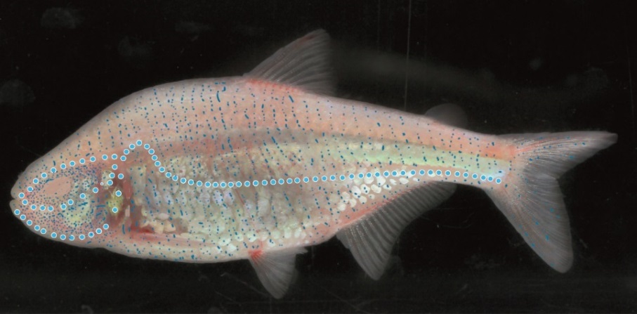

Figure 7. Schematic diagram of the LL of a Mexican Tetra, illustrated on an image of a gliding Mexican Tetra in an aquarium of the laboratory of the Marine Hydrodynamics. The location of the pores and superficial neuromast is rather approximate and inspired by drawing of Windsor et al. (2010a) and Schemmel (1967).

The length of this Mexican Tetra illustrated Figure 7 is ~6 cm, the maximum width ~0.9 cm and the ratio of its height to length ~ 0.25. The speed of Mexican Tetra fish in laboratory conditions varies from 2 cm/s to 10 cm/s. The original photo of Mexican Tetra was manipulated to add the canal pores (blue circles with white outlines) and superficial neuromasts (small blue dots). It is assumed that a canal neuromast is located approximately midway between each pair of pores.

Comparing the LLs of a sighted fish (Figure 3) and of Mexican Tetra (Figure 7) it can be concluded that their principal features are the same. The canal neuromasts distribution on the blind Mexican Tetra is similar to most fish (Montgomery, Coombs and Baker, 2001). However, the SN neuromast of Mexican Tetra are somewhat larger, their density in the head area of the fish is higher and assumingly more sensitive than those of surface fish (Yoshizawa et al., 2014).

## Hydrodynamic imaging.

The name given by Dijkgraaf (1963) to the ability of blinded fish to detect non-moving obstacles was termed "distant touch". Apparently this figurative expression is deeper and more informative than a rather formal term "hydrodynamic imaging", which is accepted today in the scientific literature to describe the same phenomenon. In fact, obstacle avoiding is associated not only with a "distant touch" (which actually implies "no touch"), but with a real touch of obstacles by a fish's head and fins, when a fish explores them for the first time. In this respect Dijkgraaf (1963) makes an important remark:

"Of course, ... care must be taken to avoid animals’ learning by trial and error where the obstacles are and memorizing their spatial relationship... They may become so well acquainted with this relationship that they collide with solid surfaces after a re-arrangement of the aquarium because they depend on memory rather than on mechanical sensory cues... "

Teyke (1988) confirmed Dijkgraaf's observation and concluded that the Mexican Tetra creates a cognitive internal map and keeps the memory of that map lasting about two days. Windsor, Tan and Montgomery (2008) reported that the fins of the Mexican Tetraoften contact the wall as the fish swims near it, which lead them to a conclusion that numerous tactile contacts of a Mexican Tetra with obstacles may be used to create and memorize a map of its surroundings. In agreement with Windsor (2008), Patton et al. (2010) demonstrated that depending on the shape of an aquarium, blind Mexican cave fish were able to follow its walls even after inactivating of the LL system. However, later Windsor, Paris and de Perera (2011) argued that constructing a map only by touching the obstacles may have place only when the LL of a fish is disabled; when it is functioning, the LL based hydrodynamic imaging dominated the wall detecting process.

In this work, the expression "hydrodynamic imaging" is used. It implies that the image of the surrounding is formed in the blind fish’s brains only by means of the LL without tactile stimuli.

## Hydrodynamic stimuli

As a fish moves through water it creates hydrodynamic disturbances. Considering a gliding fish, it can be assumed that in a coordinate system attached to the fish, the velocity field and the pressure gradient are stationary. When a fish glides in unbounded fluid with constant velocity *U*, it is a good approximation to represent the water velocity **V** and water pressure *p* in a fish's boundary layer as being proportional to *U* and , correspondingly:

 ,

 ,

where the normalized velocity  and the pressure coefficient  depend mainly only on the parameters defining the fish body shape and on the Reynolds number

 , 

where *L* is the characteristic length of the fish and  is the water kinematic viscosity. When a fish moves in a confined area in presence of other bodies, the normalized velocity and the pressure coefficient depend not only on the fish's body shape but also on the time varying geometric parameters, which define the disposition of the fish with respect to other bodies. For instance, in Figure 2  depend on the distance between the head of the fish and its side from the two walls of the corner.

## Distance of detection

A fish approaching to a wall hits it approximately 15% of events. An example of a collision event is shown in Figure 8.

|  |  |  |  |
| --- | --- | --- | --- |
| E:\Data\Data\Presentations\Saloniki\3_CollsionTop_2\CollsionTop2\CollsionTop2_126.png | E:\Data\Data\Presentations\Saloniki\3_CollsionTop_2\CollsionTop2\CollsionTop2_147.png | E:\Data\Data\Presentations\Saloniki\3_CollsionTop_2\CollsionTop2\CollsionTop2_129.png | E:\Data\Data\Presentations\Saloniki\3_CollsionTop_2\CollsionTop2\CollsionTop2_157.png |
| A | B | C | D |
| E:\Data\Data\Presentations\Saloniki\3_CollsionTop_2\CollsionTop2\CollsionTop2_159.png | E:\Data\Data\Presentations\Saloniki\3_CollsionTop_2\CollsionTop2\CollsionTop2_170.png | E:\Data\Data\Presentations\Saloniki\3_CollsionTop_2\CollsionTop2\CollsionTop2_153.png | E:\Data\Data\Presentations\Saloniki\3_CollsionTop_2\CollsionTop2\CollsionTop2_172.png |
| E | F | G | H |

Figure 8. Collision of a Mexican Tetra with a corner wall (photos by G. Zilman, Laboratory of Marine Hydrodynamic, Dept. Mechanical Engineering, Tel Aviv University). In frame C the fish propels itself too close to the wall and in frame D collides with it. In frames E –H it does not move forward. Noticeable, that it frame G the fish moves slightly backwards in order to provide more space for maneuvering (in the consequents frames D-H the fish does not move forward)

According to numerous experiments Teyke (1985) revealed that the collision event strongly depends on the distance from an obstacle at which a fish beats its tail for the last time approaching a wall. Tayke (1985) found that when this distance is less than approximately half of the fish’s body length, the collision was almost unavoidable. In Figure 9 consequent positions of Mexican Tetra approaching to a corner are shown.

|  |  |  |  |
| --- | --- | --- | --- |
|  |  |  |  |
| A | B | C | D |
|  | E:\Data\Presentations\Saloniki\2_RegularTop\OpeningFins\CollsionTop2_139_croped.png |  |  |
| E | F | G | H |

Figure 9. Mexican Tetra approaching a corner wall (photos by G. Zilman, Laboratory of Marine Hydrodynamic, Dept. Mechanical Engineering, Tel Aviv University). The consequent positions of the fish are shown from the upper left photograph A to the lower right photograph in the clockwise direction H.

From the photos solely it is difficult to say at which distance from the corner the fish detects it. An indirect indication of the corner detection may be the moment when the fish starts to open the fins in order to prepare the turning maneuver. In Figure 9 it takes place between the positions E and F. If this assumptions is true then the fish detected the corner when the distance between its head and the wall perpendicular to the direction of the fish's motion is about 2.7 cm, that it approximately half of its body which is consistent with observations of Teyke (1985), Hassan (1986) and Windsor (2008). If one postulates that fish are trying to avoid collisions, then it follows that they have to stop to propel themselves deliberately at a certain safe distance. According to Montgomery, fishes are capable to detect the motion of another fish at a distance approximately equal to its’ body length. The mathematical model of the distant touch, observations of Teyke (1983) and similar observations illustrated in Figure 9 are consistent with Montgomery’s observations. In such a case a question arises. If Mexican Tetra can detect obstacles at distances of order of their length why do they perform an avoiding maneuver at much smaller distances of order of 2-4 mm?

Surprisingly, these distances do not depend on fish velocity (Teyke 1985, 1988, 1989; Windsor, Tan and Mongomery, 2008; Windsor, 2014 and others) and according to independent observations. Seemingly, this experimental evidence is in a strong contradiction with the hypothesis that the stimuli of the LL of fish are the water velocity and pressure gradient on their bodies. The velocity in the thin boundary layer of a fish's body is proportional to the speed of the fish, and the pressure gradient to the velocity square. Thus, a question arises: why do fish perform the avoiding maneuver at the same distance from a wall independently on their speed?

The only explanation, which is given so far in the scientific literature is formulated in the purely biological language by invoking the concept of just noticeable difference (JND) of Weber's fractions (Windsor at al. 2010). It is based on the discovery of German anatomist and physiologist E. H. Weber who studied the ability of humans to discriminate between weights in each hand. He found that a person is unable to discriminate between two weights if the relative difference between them is less than 5%. For instance a person cannot discriminate between 41 g and 40 g weight (the relative difference in weights is 2.5%), but can usually discriminate between 21 and 20 g, or 63 and 60 g (the relative difference 5%). From these observations in 1834 Weber formulated a law that establishes that for the just noticeable difference a given intensity of stimulation is proportional to the original stimulus. Remarkably similar results were discovered for sound, light, smell, and taste stimuli. In general it was discovered that if *S* is the magnitude of a stimulus and (JND) is just noticeable difference for discrimination, then the ratio of the JND and the initial stimulus is constant

 ,

where k is a certain constant different for different physical processes of sensing. The noticeable differences in sensation occur only when the increases (or changes) in stimuli are a constant percentage of the stimulus itself. If Mexican Tetra detect objects using hydrodynamic stimuli, thenand *S* are proportional to the same power of a fish's speed and their ratio does not depend on it. However, although Weber's law can be applied for stimuli such as sound, light, smell, and taste stimuli, still there is no direct proof that it can be applied to the stimuli of the LL of fish. The problem of maximum detecting range is strongly related to the ability of fish to memorize maps whose scales are much larger than the minimal distance of the avoiding maneuver, 0.1 body length approximately (Windsor et al., 2008, Windsor, 2014) .

Recently Holzman, Finkel and Zilman (2014) noticed that Mexican Tetra fish swimming in an unfamiliar environment open and close their mouth at a higher frequency than in open water, particularly when a fish was heading to an obstacle. Based on these observations, Holzman, Finkel and Zilman (2014) hypothesized that the Mexican Tetra uses mouth suction to create a hydrodynamic signal varying with the distance to an obstacle and weakly dependent on a fish's velocity.

## Discrimination of shapes

Hassan (1986), Von Campenhausen, Riess and Weissert (1981) and Weissert and von Campenhausen (1981) in a series of experiments, demonstrated that Mexican Tetra can discriminate the shape of a horizontal or vertical rectangular door and different grids of vertical bars. De Perera (2004) checked the ability of the blind cave fish to encode size and shape by placing 4 landmarks (Lego bricks) in a water tank and checking the fish’s behavior after altering the landmarks’ configuration. After changing the arrangement of landmarks the fish started to swim faster, exploring the area as an unknown area. The increase in the speed of Mexican cave fish was explained by Teyke (1988) as an attempt increase the hydrodynamic stimuli. Using this argumentation solely, de Perera claimed that Mexican Tetra fish can detect a change in distance between objects. This explanation is in contradiction with the experimental evidence that the distance of detecting of objects does not depend on of the fish’s swimming velocity.

## Role of neuromasts in object detection

There is an overlap of the functions SN and CN (Montgomery, Coombs and Baker, 2001). In order to determine the role of SN and CN in the fish’s object detection, researchers disabled the neuromasts, physically and/or chemically, and then observed the fish’s behavior. Fish with disabled SN can detect objects as fish with acting SN. Fish with disabled CN lose their ability to do that, completely or partially. Today it is agreed that CN are mostly related to the investigating of the surroundings and SN detect oscillating stimulations in the water (Abdel-Latif, Hassan and von Campenhausen, 1990; Hassan, Abdel-Latif and Biebricher, 1992; Montgomery, Coombs and Baker, 2001, Windsoor, Tan and Montgomery, 2008).

## The shape of underwater robots

It is not sufficient to detect an obstacle by a moving body. It is necessary to avoid it. If the distance of detection is small, performing an avoiding maneuver may be a problem. Most ships and fishes are slender, which is dictated by the need to reduce the energy demanded to maintain their speed. As a body is more slender, it is more stable at a straight course and it is more difficult to turn it. For most slender bodies the radius of turn is of order of their double length (Figure 10A), whereas the radius of turn of a fish is approximately half of the fish length (Figure 10 B).

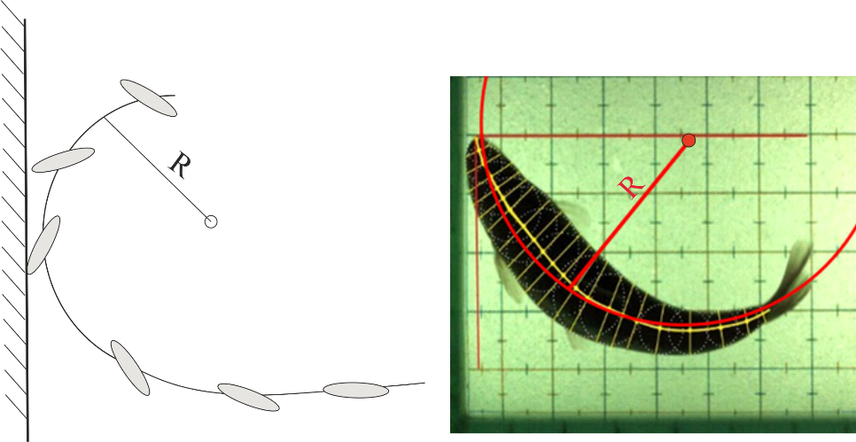

A B

Figure 10. A. Ship avoiding maneuver with a radius of turn of order of 2 of its length for typical ships and submarines. B. Fish avoiding maneuver with radius of turn of order of half fish length.

Today it is technically difficult and expensive to build a submarine that is able to change its shape as a living fish. Therefore, the engineering community started to design spherical underwater vehicles with high turning capabilities. One of the possible solutions of this problem is to use a spherical underwater vehicle instead of a typical slender body because the turning radius of a spherical marine vehicle can be made by orders of magnitude smaller than that of a slender body of the same displacement (see e.g. Choi and Yuh, Yue, Guo and Du, 2012,1993; Chyba et al. , 2008; Lin et al. 2009; Guo et al. 2011; Rust and Asada, 2011; Mazumadar et al., 2013; Yue, Guo and Shi, 2013; Li, Guo and Yue, 2015, patent <http://www.google.com.pg/patents/US4455962).(need> to read and add them to the bibliography).

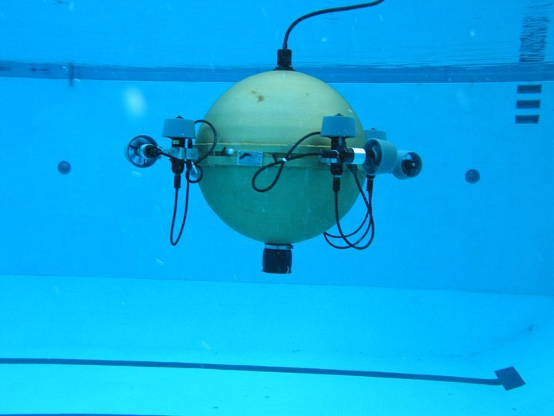

Figure 11. Omni-Directional Intelligent Navigator (ODIN), which is owned and maintained by the Autonomous Systems Laboratory, College of Engineering, University of Hawaii.

https://math.hawaii.edu/stomp/STOMP/gallery/O8.html

In this context the classical solutions of a sphere, approaching to an obstacle gained a new interest.

## Detection and identifying a body using bioinspired sensors.

Bioinspired and biomimetic sensors were described in a very large body of the literature. They include thermal, piezo resistive, capacitive, magnetic, piezoelectric, MEMS and commercials pressure sensors-transducers. The detail reviews of all investigations in this field is beyond the scope of the present work. Recent reviews by Tao and Yu (2012), Bleckmann, Mogdans, Coombs (eds). (2014) and Triantafyllou, Weymouth and Miao (2016) contain considerable relevant information on this subject.

# Theoretical works on hydrodynamic imaging

## Slender bodies approaching a wall

When a fish approaches obstacles, the later will alter the velocity and pressure fields on the fish skin and create a temporal signal. It is generally accepted that Mexican Tetra is capable to detect that signal using its LL and translate it into the distance from the obstacle. One of the simplest methods allowing to understand the physics of hydrodynamic imaging is based on the premises of potential flow and method of images, which is illustrated in Figure 12.

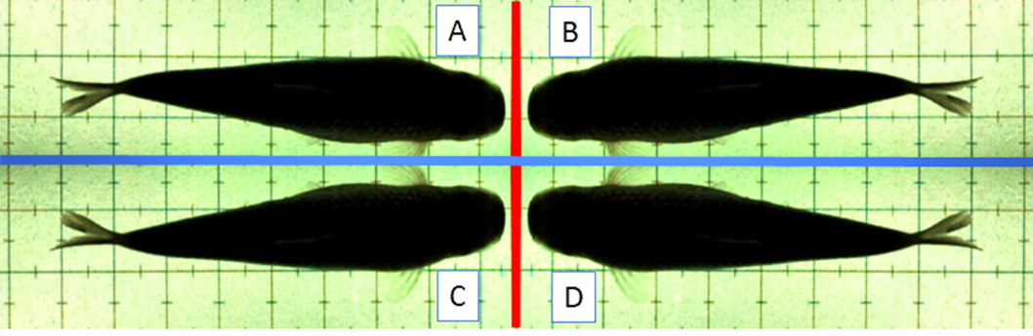

Figure 12. Three images of fish A with respect to plane walls forming a corner. Image B provides the zero normal velocity on the vertical read line of the corner A. Image C provides the zero normal velocity on the horizontal blue line of the corner A. Image D provides the zero normal condition on the red line of the corner C and on the horizontal blue line of the corner B. Image C violates the boundary condition on the red line of the corners A-B and image D violates the boundary conditions of the corners A-C. Therefore, for small distances from the wall the method of images is associated with an error. Nevertheless, for streamlined bodies which weakly disturb the fluid, the method of images gives reasonable accuracy and a transparent explanation of the physics of a body moving near the corner. As it follows from the flow in corner A is disturbed by motion four fish. If fish A is equipped with velocity and pressure sensors it may perceive the variations of the velocity and pressure fields induced by three fish B, C and D.

The method of images is valid for large distances of a fish to the walls of the corner. Handelsman and Keller (1967) considered a slender body of revolution approaching perpendicularly or parallel to a wall and gave an asymptotic solution of the problem as an expansion of the velocity potential in Taylor series with respect to a small parameter which was the inverse slenderness of the body. Based on Handelsman and Keller (1967), Hassan (1992) attempted to calculate the pressure on a slender body of revolution approaching a wall. According to Hassan (1992) there is a pressure rise in the stagnation point of the body up to a distance of about 0.05 body lengths from the wall, but a decrease in pressure for closer distances. This result is unclear and was not explained in Hassan’s (1992) work.

Windsor et al. (2010) calculated the pressure and velocity on a fish's body using Navier-Stokes equations and measured the velocity field using particle imaging velocimetry technique. Windsor et al. (2010) demonstrated that the pressure gradient in the stagnation point of the body of revolution approaching a wall drastically increases as the distance to the wall decreases. As approaching the wall from a distance of 0.3 to 0.02 body lengths of the fish, the pressure coefficient  at the stagnation point increased from 1.0 to over 4.0 but pressure downstream the stagnation point remained approximately the same as in open water. In contrast to the results of Hassan no pressure drop was revealed. Windsor et al. (2010) found that for relatively small Reynolds numbers of the problem and small distances to a wall the viscosity may influence the pressure quantity close to the stagnation although the general behavior of the pressure coefficient remains the same. This result can be explained by the small thickness of the boundary layer in the front part of the body where the most drastic changes of the pressure coefficient take place. It is important to note that in the front part of the fish’s body, the density of the Mexican Tetra pressure and velocity sensors, the canal and surface neuromasts, is maximum.

|  |
| --- |
|  |

Figure 13. Pressure coefficient and canal pores density along the body of a schematic fish (view from above). Solid line – pressure coefficient; dashed line – canal pores density (arbitrary units). The distribution density of the canal pores neuromasts correlates well with the location of maximum differential hydrodynamic pressure on the fish’s body (Ristroph, Liao and Zhang, 2015; Dubois, Cavagna and Fox, 1974).

The behavior of the pressure coefficient of slender bodies is rather robust and is qualitatively similar for different body shapes, which is illustrated in Figure 14.

|  |
| --- |
|  |

Figure 14. The normalized velocity  and the pressure coefficient  calculated for a two-dimensional and three-dimensional body according to Milne-Thomson (1968). Solid line – Joukovskii two-dimensional profile; dashed line– airship form. Each of the two bodies can be characterized by its slenderness. That is by the ratio between the length of the body and its maximal width (or diameter). As long as these parameters for the bodies are close, the behavior of the pressure coefficients for them is qualitatively similar. For most slender fish the rate of change of pressure is largest in their front part, with a decrease towards the tail.

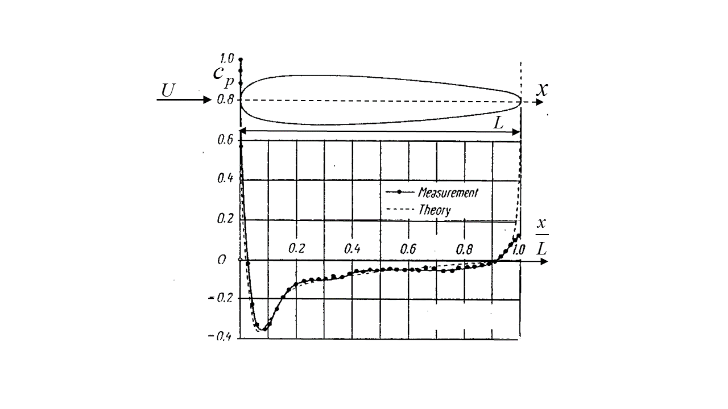

Figure 15. Pressure distribution about a stream-lined body of revolution representing the so-called airship form (redrawn and modified from Schlichting, 1979).

Concerning the influence of viscosity on the pressure around a streamlined body, it can be said that its role on the pressure on the body is essential only in its rear part. In the front part of the body the pressure can be represented qualitatively and quantitatively using the premises of the inviscid irrational flow (see Figure 15–Figure 16. Moreover, the same is true even for a sphere, as it is illustrated in Figure 16.

|  |  |
| --- | --- |
|  | H:\Data\Students\Tomer\Tomer's thesis\Tomer's thesis\images\KimExperiment.png |
| A | B |

Figure 16. Pressure distribution on a circumference of a sphere as a function of the polar angle calculated in the clockwise direction (in the forward stagnation the polar angle). A. Dash-dotted line – subcritical (experiment); solid line–supercritical  (experiment); dashed line–potential flow theory (redrawn and modified from Schlichting, 1979) B. Subcritical (numerical solution of the Navier-Stokes equations, redrawn and modified from Bazilevs et al., 2014).

As it follows from Figure 16, for angles up to  approximately, for both subcritical and supercritical Reynolds numbers, the pressure on the meridional circumference is in a full agreement with that obtained theoretically for a sphere in potential flow

### Sphere approaching to a wall or another sphere

A sphere moving in inviscid fluid close to a plane wall is a classical problem of hydrodynamics (e.g. Lamb, 1916; Milne-Thompson, 1968). It is based on the Stoke's method of images. Using the method of images, Hicks (1879) found a general expressions for the added mass of the fluid for a sphere approaching another sphere. Basset (1888) offered an approximation of the kinetic energy of two spheres moving along the line of centers also using the method of images. Endo (1938) calculated the velocity potential of two moving spheres using bipolar coordinates and calculated the pressure and the forces acting on two fixed spheres in uniform flow. Weihs and Small (1975) considered the problem of two moving spheres using a bi-spherical coordinate system. Using spherical harmonics Miloh (1977) expressed the potential of a sphere approaching a wall as a series of Legendre polynomials whose coefficients can be found as a solution of a system of linear algebraic equations with an infinite number of unknowns. Using similar technique Bentwich and Miloh (1978) solved the same problem using the stream function instead of the velocity potential, calculated the kinetic energy and the force acting on the sphere approaching a wall and gave examples of the force acting of a sphere approaching a wall. Recently Kharlamov, Chara and Vlasak (2008) using Lamb's (1916) solution calculated the added mass of a sphere moving parallel and perpendicular to a wall using infinite series of images in a sphere.

*Surprisingly, among all referred works non-of them deals directly with an exact solution of the problem representing the main interest for the problem of hydrodynamics imaging, that is a precise calculation of the pressure on a sphere approaching to a wall.*

## Detection of a body in the presence of current

So far, all the observations of a fish avoiding obstacles were carried out in still water. In that case the only water flow is generated by the fish itself and the entire velocity field depends only on the fish motion. If a body-obstacle is placed in the ambient current, to detect a body the fish must process the stimuli of the lateral line, which incorporate those pertaining to the self-induced velocity field and to the ambient velocity field. Depending of the Reynolds number of the obstacle and the ambient turbulent intensity the character and the intensity of body-generated hydrodynamics disturbances may be rather different as it is illustrated in Figure 17.

|  |
| --- |
| C:\Users\Gregory\Desktop\Tomer\images\Vogel - wake.PNG |

Figure 17 . The wake of a cylinder in a stream for different Reynolds numbers (adopted from Vogel, 1994).

The hydrodynamic field created by the body can be considered as a feature of the obstacle that either help a Mexican Tetra to reveal it, or a noise that masks it undetectable. To our best knowledge these alternatives experiment were not checked experimentally.

# Objectives of this work

1. To exploit the exact solution of Lamb (1916) to calculate the velocity and pressure variations on a sphere approaching another sphere or a plane wall, a work which was not been done before.

2. To verify the obtained theoretical solution experimentally, which was also done for the first time.

3. Establish the conditions of detectability of a wall by a sphere using commercial pressure sensors.

4. To observe and record for the first time the process of fish avoiding an obstacle in the presence of current.

# A mathematical model of detecting of a sphere by a sphere

## Problem formulation

We consider rigid spheres A and B of radii . The spheres move with velocities  and  along a line connecting their centers (Figure 18).

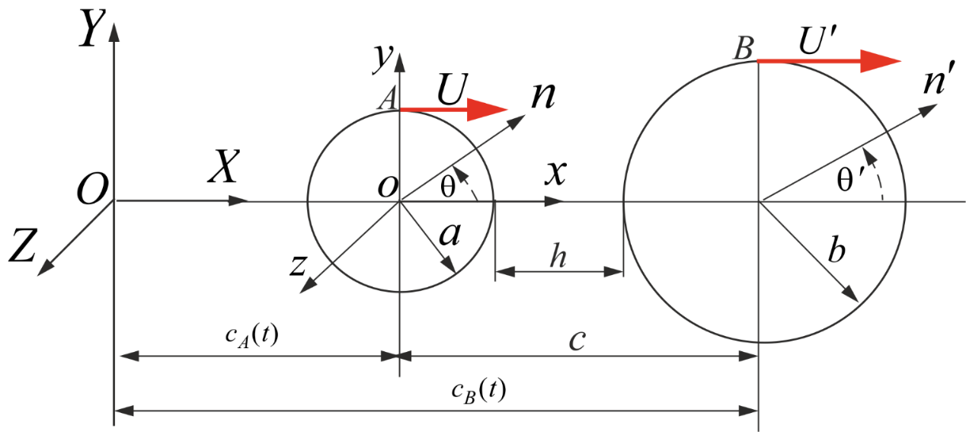

Figure 18. The coordinate system. The centers of both spheres are located on the ** axis of the fixed in space coordinate system . Another coordinate system  is attached to the body *A* and moves with it as a whole;  are unit vectors normal to the surfaces of the corresponding spheres *A* and *B.* The distance between the centers of the spheres is denoted as *c* and the minimal distance between the surfaces of the spheres is denoted as *h.*

Two limiting cases are of particular interest for the present study.

1. Two equal spheres *A* and *B* move in opposite directions with equal speeds *U* and  correspondingly (Figure 19 A).

2. Sphere *A* moves towards a still sphere *B* whose radius is much larger than that of sphere *A* (Figure 19 B).

In both limiting cases it is possible to consider motion of a single sphere approaching a wall or moving away from it.

|  |  |
| --- | --- |
|  |  |
| A B | C |

Figure 19. A. Two equal spheres moving in the opposite directions with equal speeds and high Reynolds numbers. Due to symmetry, on the dashed line the normal to it velocities which are induced by the spheres, cancel each other. In a case this line can be imagined as a rigid wall on which the zero normal velocity is satisfied in the left and right half-spaces. B. A sphere moving away from the wall with velocity *U.* C. A finite radius sphere approaching to a large one (); the later can be considered as a rigid wall.

The locations of both sphere change in time  as follows:

 ,

,

where is the distance between the centers of the spheres.

The two coordinate systems *OXYZ* and *oxyz* relate as

 .

Further, the following relation will frequently be used:



Given that  are time dependent the following relations also hold:

 

From here on, the time derivative of a quantity will be denoted by an overdot.

The fluid motion is irrotational and the fluid velocity is determined by its potential as



Due to the linearity of the problem, the total velocity potential  can be represented as sum of two unit potentials,  pertaining to motion of sphere *A* and  pertaining to motion of sphere *B*:

. 

Each of the potentials satisfies the Laplace equation

,

and therefore the potential  satisfies the Laplace equation. Each of the unit potentials satisfie the boundary condition of zero normal velocity on the surface of the corresponding sphere. For convenience, this boundary value problem is formulated initially in the moving coordinate system.



where

 .

For , the spatial and time derivatives of the unit potentials tend to zero. Once the potential  is known in the moving coordinate system, it can be expressed in the fixed in space coordinate system . Pressure in the fluid can be calculated in the fixed in space coordinate system using Bernoulli's integral:

,

where  is the static pressure far from the spheres. Without loss of generality can be assumed. In unbounded fluid, the velocity potential of a sphere of radius *a,* which moves along the *OX* axis with velocity *U*,can be represented as a velocity potential of a doublet of strength



moving with the same velocity in the direction of thesame axis. In view of equation in the moving coordinate system, the potential of the doublet can be expressed as (Milne-Thomson, 1968):

 ,

where



If another dipole with density



and coordinate  moving with velocity  along *OX* axis is also introduced in the flow then its potential is



The boundary conditions of zero normal velocity on the spheres is satisfied only if the distance c between them is infinite. To satisfy for finite *c* additional measures should be taken.

In this work we use the method of images because it gives an exact solution of the problem although its form is "unwieldy" (Milne-Thomson (1968) paragraph 16.30). However, what was "unwieldy" for numerical calculations in 1950, when Milne-Thomson wrote the first edition of his book, became the most practical and convenient form of computing a variable using a recurrent formula



which in any computer language can be expressed as a loop

*for n=1, N*

*q(n+1)=function q(n)*

*end*

According to Hicks (1879) Stokes initially studied the motion of two spheres in 1843. Stokes studied the motion of two spheres in inviscid irrotational fluid by using an image of a doublet in a sphere as it is illustrated in Figure 20 (Lamb 1945) and briefly explained below.

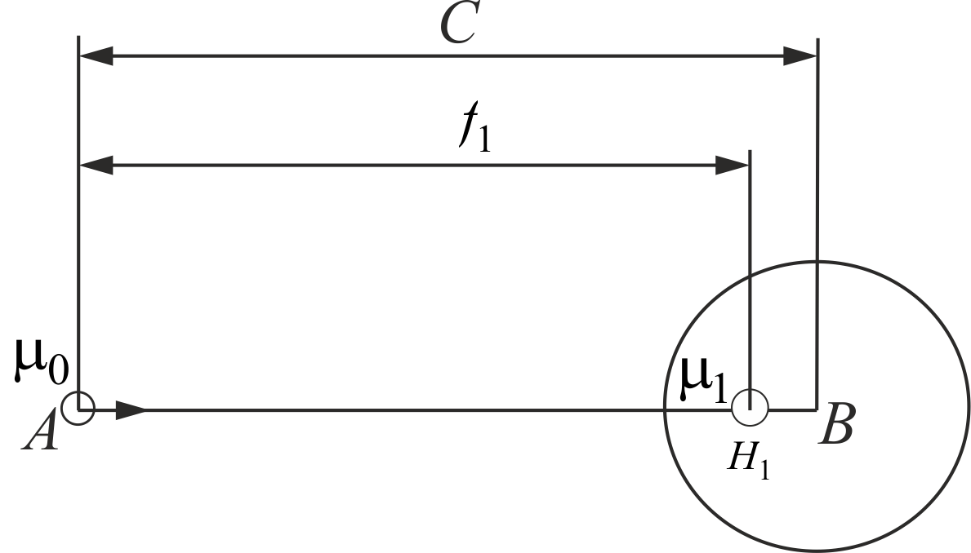

Figure 20. Illustration of the method of images. Dipole *A* with intensity  is located in the point *A* at a distance *C* from the center of the sphere *B* of diameter *b*.

If both sphere *B* and the dipole do not move, the zero normal velocity condition on the sphere’s surface is satisfied under the following conditions: another dipole with intensity is placed inside it at point  such that  and the distance between the  and *A* is  However, the dipole  violate the boundary condition on sphere *A.* To neutralize its influence, an image of  in the interior of sphere *A* can be introduced. This image, namely  also violates the boundary condition on *B*, which can be compensated by introducing a diploe , an image of , and so on (Figure 21). A similar problem can be formulated when sphere *B* moves with velocity  and sphere *A* is in rest. Introducing in the center of sphere *B* a dipole with intensity , a system of images  can be introduced which are located at distances  from the center of sphere *A*.

For odd dipole numbers the density of images and their distances  from the center of *A* are expressed as follows (Lamb 1945):





For even dipole numbers  the corresponding quantities are





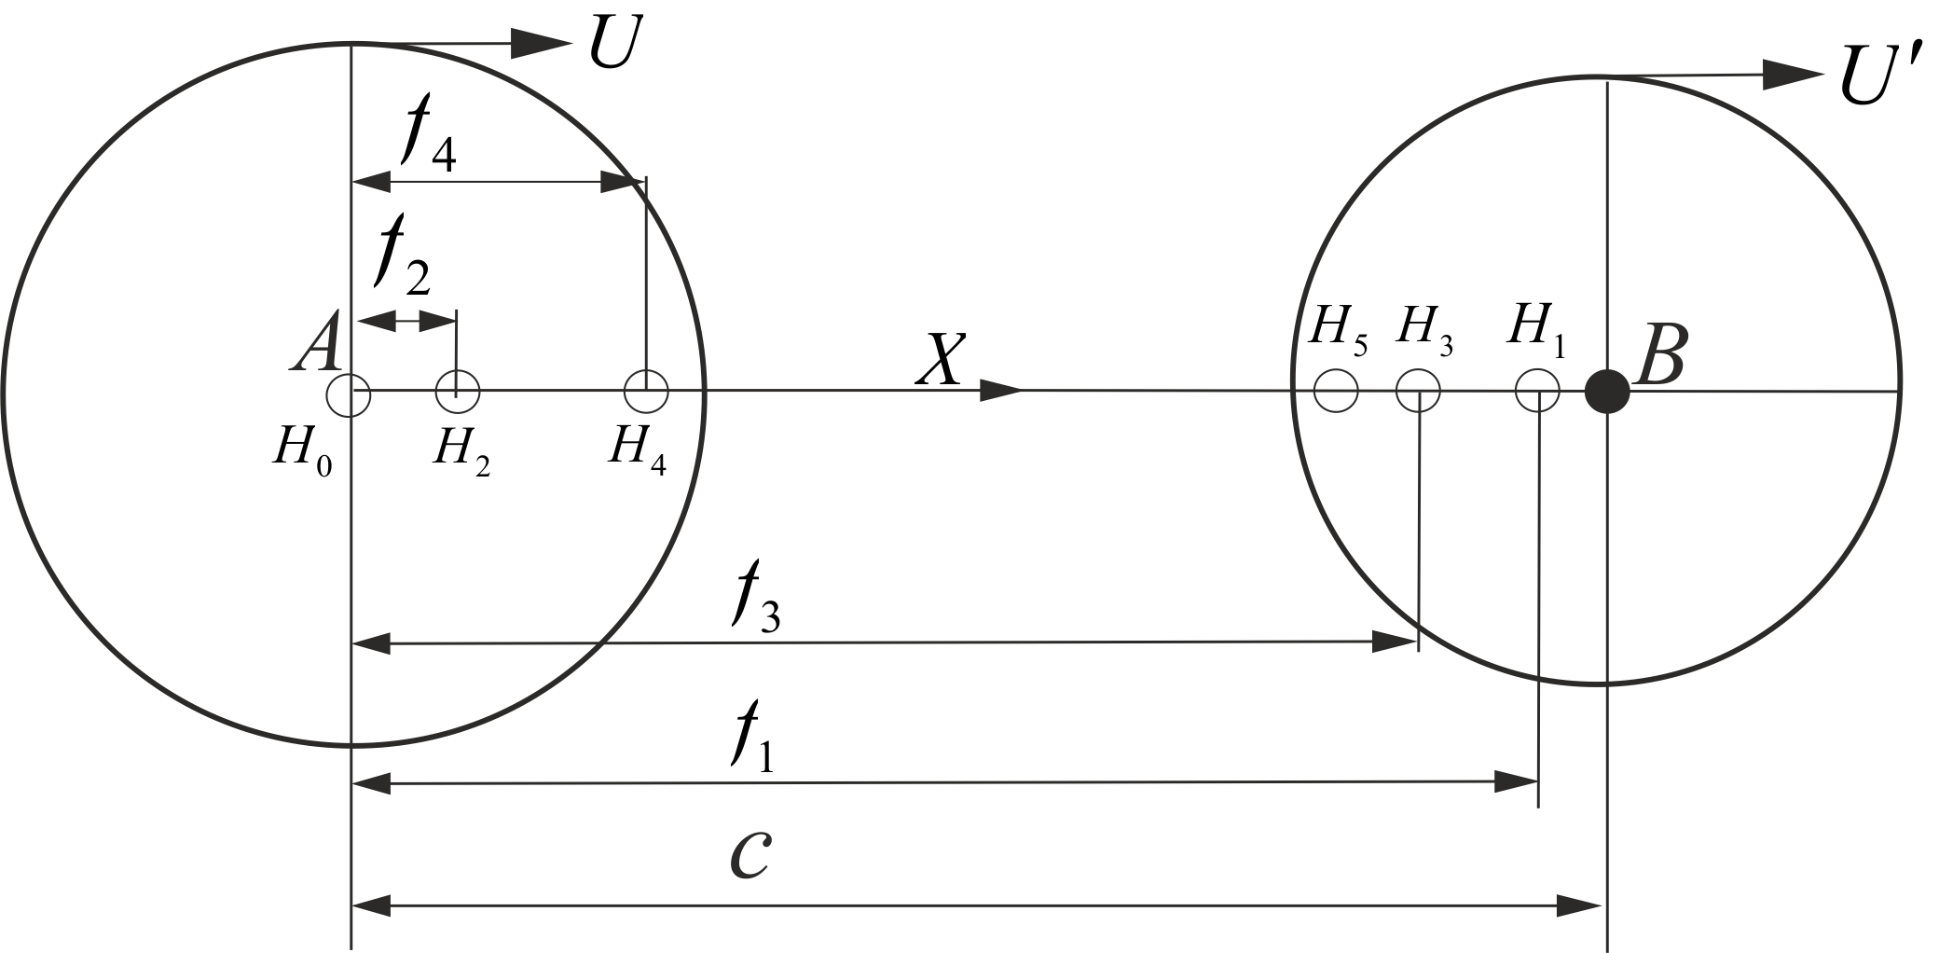

Figure 21. Successive images introduced in order to satisfy the boundary conditions on moving sphere *A* and sphere *B* if its velocity .

Finally, the fluid velocity potential of the series of dipoles can be written as follows:



where for   and  are defined by , and for  as

 

Here



are the distances of the doublets from the origin of the fixed in space coordinate system with



and  do not depend on time, that is 

The pressure on a moving sphere has to be referred to the moving coordinate system whereas the Bernoulli equations refer to the fixed in space coordinate system. In view of -The spatial and derivative involved in the Bernoulli equation can be written as









Further, for brevity the partial derivatives with respect to time will be also denoted by overddot as

. To illustrate the general scheme of calculating - consider unit potentials

 ,

where

 .

and the subscript *n* and superscript in prime are tacitly omitted. With these notations the gradient of the velocity potential referred to the moving coordinate system can be written using-. To calculate the time derivatives of the potentials  it is necessary to take into account that time dependent are not only the distances of the images to the wall but also and their intensities:



In view of and taking into account that  we also have



The time derivatives of distances, and dipoles  can be obtained from - for odd and even *n* asfollows:

For odd 





For even 





Equations - and - can be used for calculating and then the velocity potential .

Once  and  are defined by -, and their time derivatives  and  by -, then -, - and hence are defined also.

## Testing cases

All previous studies considered the force *F* acting on a sphere approaching a wall with a right oblique angle. This problem is adopted here as a benchmark in order to compare this force obtained by other researchers with our results. For this purpose, consider first two equal spheres of the same radii *a* moving in the opposite direction () along the line connection their centers. The plane bisecting *AB* will be the plane of symmetry and may be taken as a fixed boundary on either side Lamb (1945). The kinetic energy of the fluid  in the, say, left side is half of the total fluid energy *T* on the both sides of the plane. The later can be calculated as Lamb (1945):

 ,

where

 ,

,



The kinetic energy is associated with the added mass  of a single sphere as



Once *T* and hence  are known, the force acting on a sphere approaching a wall with a right angle can be calculated by using the Lagrange equations of the second kind (Lamb, 1945). By introducing the generalized coordinates  and  the hydrodynamic force acting on a sphere approaching a wall can be written follows:



Substituting into gives

,

where the added mass depends on the distance  of the center of the sphere to the wall. For the added mass coefficient



two limiting values are exact Hicks, W. (1879):



The hydrodynamic forces acting on a sphere as a function of  can be calculated wither by using or by direct integration of the pressure over the surface of the sphere



In Figure 22 the calculation of in the spherical coordinate system is illustrated.

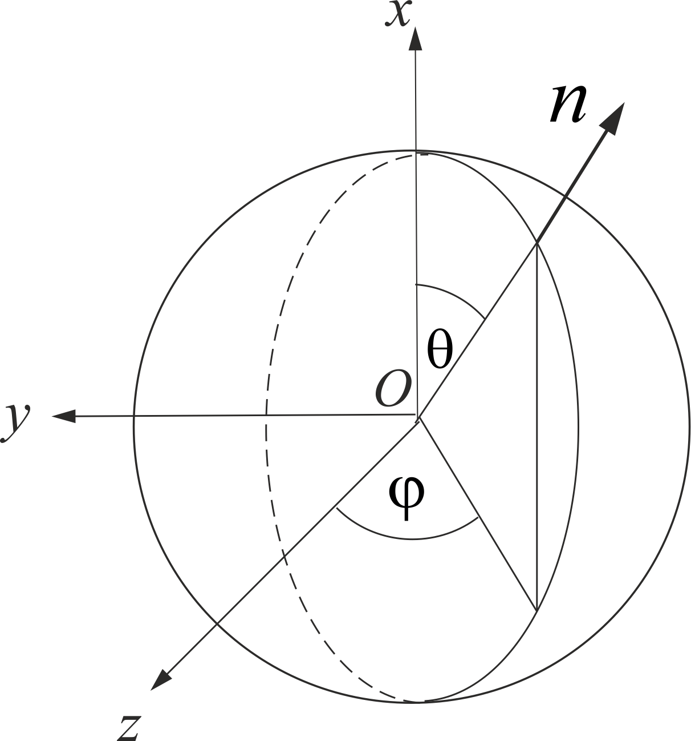

Figure 22. The element of the surface is  and the projection of the external normal to the sphere on the *ox* axis is . In such a case can be written as



Because the flow is axisymmetric with respect to the Ox axis and does not depend on , from it follows that 



The hydrodynamic added mass coefficients and the hydrodynamic coefficients



,

are used here for validating of the present algorithm.

# Numerical results

In this section several numerical examples are given.

1. The added mass coefficient  for a sphere approaching a wall as a function of the distance to the wall.

2. The coefficient of the hydrodynamic force  acting on a sphere approaching a wall as a function of the distance to the wall.

The pressure coefficient on a sphere approaching a wall

.

3. The fluid velocity components in the plane *Z*=0:

4. The instantaneous streamlines in the plane *Z*=0:

5. The pressure coefficient on a sphere approaching another sphere along the line connection their centers

All computations presented here were performed using MATLAB and Visual Fortran compilers with double precision. In order to determine the number of images *N* required to provide the relative accuracy of calculations, all quantities of interest were computed with consequently increasing *N* until the relative error  was attained. As expected, the number of required images increases with the normalized distance  decreasing. The integral characteristics such as the added mass coefficient or the force acting on a sphere, required less images than the fluid velocity or the pressure coefficient. The maximum number of images was necessary to calculate the fluid velocity and the pressure in closest vicinity of the stagnation point.

## The coefficients of the added mass and the repulsive force

To calculate the added mass coefficient for =0 it is sufficient to take into account about 100 images, which gives . The exact value of the same coefficient calculated by Hicks (1879) is  (the relative error is less than ). It should be noted, that calculating the velocity *V* in the stagnation point is subject to an error due to the numerical rounding of the computer calculations. However, even for such small distances as  the condition for the fluid velocity in the stagnation point  is satisfied with an accuracy up to 14 digits with accounted 800 images.

With these limitations it was found that the number of images  was sufficient for all the consequent computations. It should be noted, that we did not experience any practical difficulties in computing all the quantities of interest using standard personal computers. Typically calculating the velocity and the pressure along the meridional circumference of a sphere on a standard PC took a couple of seconds. Therefore any attempt to accelerate the commutations by accelerating the series convergence were not attempted. In Figure 23 and Table 1 are presented examples of the convergence algorithm for calculating the quantities of interest.

|  |
| --- |
| C:\Users\Tomer\Dropbox\TEZA\lyx\Images\Converted\Convergnce.png  Made from: C:\Users\Tomer\Dropbox\TEZA\Plots for teza\Convergence test\menyN.m  fig file: C:\Users\Tomer\Dropbox\TEZA\lyx\Images\figs\Convergnce.fig |

Figure 23. Added mass coefficient and velocity at the fore edge of the sphere, at a small distance from the wall () with changing number of images *N*. Solid line - ; dashed line -  .

Table 1. Minimum number of images  required for calculating the pressure coefficient and the velocity on a sphere with  as a function of the distance to the wall  are presented in the second and third columns.

|  |  |  |
| --- | --- | --- |
|  |  |  |
| 2 | 1 | 1 |
| 1.5 | 2.0 | 2.0 |
| 0.5 | 4 | 3 |
|  | 9 | 8 |
|  | 29 | 26 |
|  | 94 | 83 |
|  | 299 | 265 |
|  | 914 | 832 |

The values of the added mass coefficient calculated using the present algorithm are in a good agreement with those reported by other authors (Figure 24).

|  |
| --- |
| C:\Users\Tomer\Dropbox\TEZA\lyx\Images\Converted\added_mass_comparison.png  fig: C:\Users\Tomer\Dropbox\TEZA\lyx\Images\figs\added_mass_comparison.fig  Made from: C:\Users\Tomer\Dropbox\TEZA\Plots for teza\Force\Force.m |

Figure 24. Added mass coeeficient as a function of the normalized distance to the wall. Solid line – present calculation; dashed line () Kharlamov (2007), method of images with accelerated convegence of series; dash-dotted line () Yang (2006), dotted line () Milne-Thomson (1968).

As it can be seen in Figure 24, the agreement between the present calculations and those reported by other authors is very good except the lowest order approximation by Milne-Thomson (1968) which is not valid for .

In Figure 25 the results of calculating the repelling force coefficient  are presented.

|  |
| --- |
| C:\Users\Tomer\Dropbox\TEZA\lyx\Images\Converted\Froce_log.png  fig: C:\Users\Tomer\Dropbox\TEZA\lyx\Images\figs\Froce_log.fig  made from: (long run!)  C:\Users\Tomer\Dropbox\TEZA\Plots for teza\Force\Force.m |

|  |
| --- |
|  |

Figure 25. Coefficient of the force acting on a sphere approaching a wall perpendicularly. Solid line – Lagrange’s equation; open circles – pressure integration.

It is seen in Figure 25 that the agreement between the present calculation and those reported by other authors are also in very good agreement. For instance, the discrepancies cannot be noticed in the scale of the figures and the lines thicknesses.

## Sphere approaching to a wall

The calculated velocities on the circumference of a sphere approaching a wall are illustrated in Figure 26.

|  |
| --- |
| C:\Users\Tomer\Dropbox\TEZA\lyx\Images\Converted\VOnSphere5distances - corrected.png  fig: C:\Users\Tomer\Dropbox\TEZA\lyx\Images\figs\VOnSphere5distances - corrected.fig   Made from: C:\Users\Tomer\Dropbox\TEZA\Plots for teza\theo 5 time steps.m |

Figure 26. Normalized velocity on the meridian circumference of a sphere approaching a wall as a function of the distance *h* and the coordinate *x*: . For  the velocity on the meridional circumference coincide with that for .

Figure 26 demonstrates an interesting feature: in the stagnation (critical) points the velocity of the fluid is equal to the velocity of the sphere as it should be. However, in the closet vicinity to the forward critical point the velocity rises and at a certain coordinate  the velocity reaches an extremum. At a small distances of  the velocity change reaches .

To calculate the streamlines around a sphere approaching a wall, a standard Matlab tool (*streamslice.m* ) was invoked. Examples of the streamlines are presented in Figure 27.

|  |  |
| --- | --- |
| C:\Users\Tomer\Dropbox\TEZA\lyx\Images\Converted\Streamlines_h1_N1000.png  MADE FROM C:\Users\Tomer\Dropbox\TEZA\Plots for teza\Theo - streamlines\Streamlines_plot_better_res.m |  |
| A. | B. |
| C:\Users\Tomer\Dropbox\TEZA\lyx\Images\Converted\"C:\Users\Tomer\Dropbox\TEZA\lyx\Images\Converted\Cp_h_no_lines1_N1000.png"  made from: C:\Users\Tomer\Dropbox\TEZA\Plots for teza\Theo - streamlines\Streamlines_plot_better_res.m | C:\Users\Tomer\Dropbox\TEZA\lyx\Images\Converted\Cp_h_no_lines2_N1000.png  Made from: C:\Users\Tomer\Dropbox\TEZA\Plots for teza\Theo - streamlines\Streamlines_plot_better_res.m |
| C. | D. |

Figure 27. A B: Streamlines in the plane  of a sphere approaching a wall from the left. CD. Pressure coefficient on the same sphere.

As it can be seen in this figure the streamlines become denser as the distance to the wall decreases which in agreement with the velocity variation along the circumference shown in Figure 26. The denser streamlines indicate the pressure rise, becoming particularly drastic in the closest vicinity of the stagnation point. The pressure coefficient  is plotted in Figure 28.

C:\Users\Tomer\Dropbox\TEZA\lyx\Images\Converted\CpOnSphere5distancesCorrected.png

fig:
C:\Users\Tomer\Dropbox\TEZA\lyx\Images\figs\CpOnSphere5distancesCorrected.fig

made from:
C:\Users\Tomer\Dropbox\TEZA\Plots for teza\theo 5 time steps\Main.m

Figure 28. Pressure coefficient along the meridian circumference for different distances from a wall.

In Figure 29 the pressure coefficient is plotted in log-log scale

C:\Users\Tomer\Dropbox\TEZA\lyx\Images\Converted\Theo_till_contact_log.png

Fig
C:\Users\Tomer\Dropbox\TEZA\lyx\Images\figs\Theo_till_contact_log.fig

made from:
C:\Users\Tomer\Dropbox\TEZA\Plots for teza\log and normal change of pressure\plot_log_theo.m

Figure 29. Pressure coefficient in the stagnation point for small . Broken line – calculated pressure coefficient; square line – approximated pressure coefficient . It is seen that for small distances to the wall  the pressure coefficient behaves as .

Although for  the pressure in the stagnation point tends to infinity, nevertheless, the integral of the pressure over its surface is finite, which can be explained in the following way. When  the integration over the entire surface of the sphere can be replaced by the integration over its surface with the excluded singular point plus an integral over a semi sphere of infinitesimal radius *h* and corresponding surface . Given that the value of the pressure on the small semi sphere is proportional to *,* the value of integral over the semi sphere is proportional to . Thus, the contribution of the singular pressure to the total integral of the pressure over the sphere is negligible.

## Two spheres

Two spheres with ratios *b/a* presented in Table 2. The corresponding streamlines and pressure coefficients in the plane *Z*=0 are presented in Figure 30 - Figure 33.

Table 2. Spheres parameters and the corresponding figure numbers

|  |  |  |  |  |
| --- | --- | --- | --- | --- |
| Figure number | 32 | 33 | 34 | 35 |
| *b/a* | 1000 | 1.0 | 0.5 | 0.1 |

The case of a sphere approaching a much larger sphere provides a verification of the algorithms and the code because in this case the larger sphere can be considered as a rigid wall.

|  |  |
| --- | --- |
| C:\Users\Tomer\Dropbox\TEZA\lyx\Images\Converted\Streamlines_h1_N1000_b1000_Corrected.png  made from: C:\Users\Tomer\Dropbox\TEZA\Plots for teza\Theo - streamlines\Streamlines_plot_better_res_Non_Symmetric.m | C:\Users\Tomer\Dropbox\TEZA\lyx\Images\Converted\Streamlines_h2_N1000_b1000_corrected.png  made from: C:\Users\Tomer\Dropbox\TEZA\Plots for teza\Theo - streamlines\Streamlines_plot_better_res_Non_Symmetric.m |
| A. () | B. () |
| C:\Users\Tomer\Dropbox\TEZA\lyx\Images\Converted\Cp_h_no_lines1_N1000_b1000.png  made from: C:\Users\Tomer\Dropbox\TEZA\Plots for teza\Theo - streamlines\Streamlines_plot_better_res_Non_Symmetric.m | C:\Users\Tomer\Dropbox\TEZA\lyx\Images\Converted\Cp_h_no_lines2_N1000_b1000.png  made from: C:\Users\Tomer\Dropbox\TEZA\Plots for teza\Theo - streamlines\Streamlines_plot_better_res_Non_Symmetric.m |
| C. () | D. () |

Figure 30. A sphere of radius *a* approaching another non-moving sphere of much larger radius A–B. Streamlines. C–D. Pressure coefficient. More detailed analysis show that the results presented in Figure 27 and Figure 30 are almost identical.

|  |  |
| --- | --- |
| C:\Users\Tomer\Dropbox\TEZA\lyx\Images\Converted\Streamlines_h1_N1000_b1_corrected.png | C:\Users\Tomer\Dropbox\TEZA\lyx\Images\Converted\Streamlines_h2_N1000_b1_corrected.png |
| A | B |
| C:\Users\Tomer\Dropbox\TEZA\lyx\Images\Converted\Cp_h_no_lines1_N1000_b1.png | C:\Users\Tomer\Dropbox\TEZA\lyx\Images\Converted\Cp_h_no_lines2_N1000_b1.png |
| C | D |

Figure 31. Streamlines and the pressure coefficient around a sphere approaching another still sphere . A. and C. ; B. and D. .

|  |  |
| --- | --- |
| C:\Users\Tomer\Dropbox\TEZA\lyx\Images\Converted\Streamlines_h1_N1000_b05_corrected.png | C:\Users\Tomer\Dropbox\TEZA\lyx\Images\Converted\Streamlines_h2_N1000_b05_corrected.png |
| A | B |
|  |  |
| C | D |

Figure 32. Streamlines and the pressure coefficient around a sphere approaching to another still sphere . A. and C. ; B. and D. .

|  |  |
| --- | --- |
|  | C:\Users\Tomer\Dropbox\TEZA\lyx\Images\Converted\Streamlines_h2_N1000_b01_corrected.png |
| C:\Users\Tomer\Dropbox\TEZA\lyx\Images\Converted\Cp_h_no_lines1_N1000_b01.png |  |

Figure 33. Streamlines and the pressure coefficient around a sphere approaching to another still sphere . A. and C. ; B. and D. .

The presented in Figure 30-Figure 33 results clearly indicate that a rigid wall or another sphere can be revealed by a moving spherical detector although the distance of detection depends on the ratio *b/a* and the velocity of detector.

# Experimental investigation

The goals of the experiment described in this section was:

1. To verify the discussed above mathematical model for calculating the pressure on a sphere approaching a wall.

2. To verify the feasibility of detection of a wall by a moving sphere using commercial transducers.

## Experimental layout

The experiment was carried out in the water tank of the "Water Waves Research Laboratory" of the School of Mechanical Engineering at Tel Aviv University. The length of the water lank is 21.0 m, its width is 1.0 m and depth is 0.6 m. The walls of the tank are made from transparent glass (Figure 34).

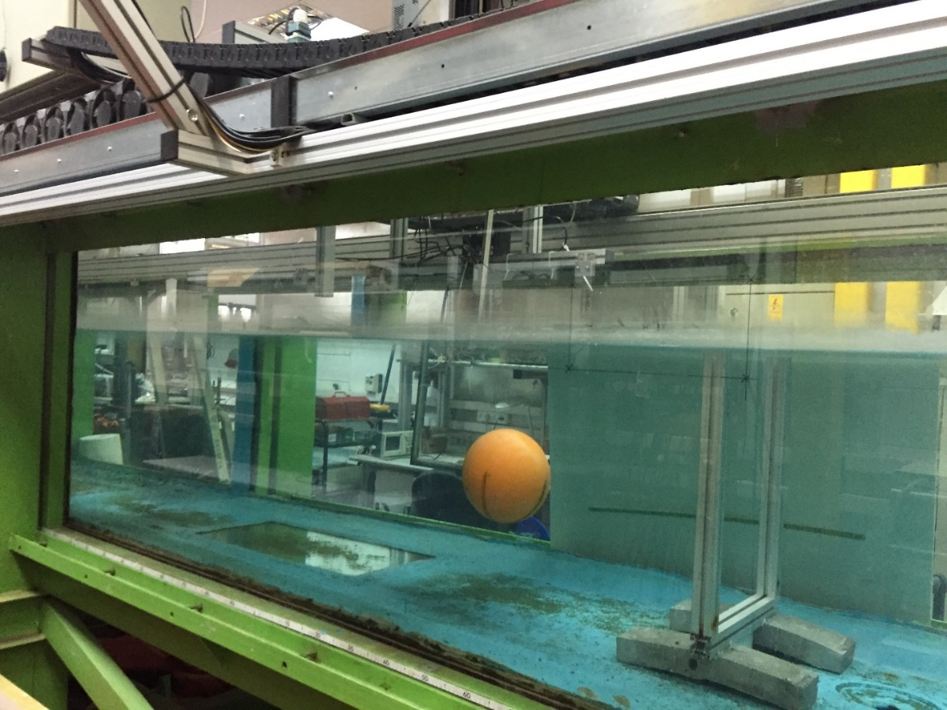

Figure 34. The experimental system.

A carriage whose velocity may vary from 0.5 cm/s to 1 m/s moves along the tank. The velocity of the carriage and its position along the tank are recorded with an error of less than 1%. The object of experiments was a rigid sphere of diameter  rigidly attached to the carriage and moving towards a fixed in space wall (Figure 35). A rigid but brittle plastic plane was inserted into a metallic frame of width ~2*d* mounted on the bottom of the tank (see next Figure 35).

|  |  |
| --- | --- |
|  |  |
| A | B |

Figure 35. A sphere approaching to a brittle wall. A. View from above. B. Side view. 1. Moving carriage; 2. Connecting tube; 3. Sphere; 4. Rigid wall; 5. Breakable wall. The center of the sphere was 0.35 m below the water free surface.

The wall was covered by an aluminum foil. Two small thin separate metal sheets separated by a 0.5o distance were attached to the fore edge of the sphere. Both of the sheets were connected to a 5V power source. Once the sphere touched the aluminum foil the circuit was shortened, and an electric signal indicating the contact was recorded.

## Construction of the sphere

The sphere was manufactured using a three dimensional printer printed at “Dfus 3D” company (Herzelia). The sphere was made from Polylactic acid with a condense exterior to prevent leaking. After printed, the sphere was covered with layers of varnish to further seal its surface. The sphere was designed as two connecting parts in order to allow insertion of the pressure sensors into it (Figure 36)

|  |
| --- |
| C:\Users\Tomer\Dropbox\TEZA\lyx\Images\Converted\Xploaded_no_table.png |

Figure 36. Parts of the sphere. 1. Pressure holes (see Figure 37). 2. Front part of the sphere. 3. Sealed box containing the pressure transducers. 4. O-Ring preventing leaks between the two main parts of the sphere. 5. Inner connector. 6. Rear part of the sphere. 7. Connecting tube, connecting of the entire sphere to the moving carriage.

The sphere was printed with eleven holes on the meridian circumference of the sphere. The first of them is located at the polar angle , and the rest as it is shown in Figure 37.

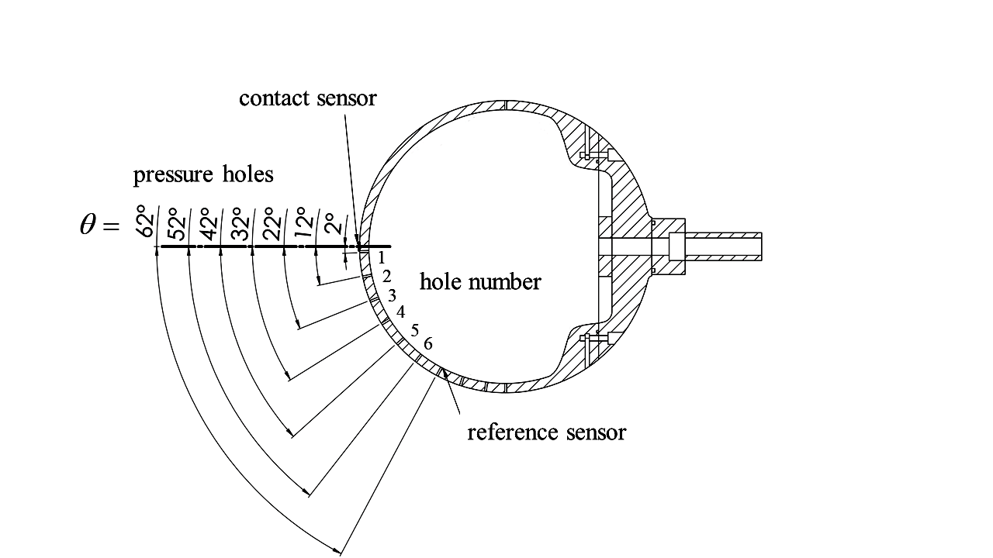

Figure 37. Location of the holes in the sphere. An end of a thin 2 mm silicone pipes was inserted in each hole. The other end of the pipe lead to pressure transducers, placed in the sealed box (see also Figure 36, item 3). The signals from the pressure sensors were recorded and processed by a computerized system of data acquisition as it is illustrated in Figure 38.

The pressure transducers were electrically connected to a computer through the connecting pipe.

|  |
| --- |
| experimental system schematic |

Figure 38. Schematic diagram of measured data processing.

The aim of the experiment is to find if it is possible to detect the wall by the used pressure sensors. The following criteria of detection are adopted here. Assume that for each pair of six sensor it is possible to measure the pressure difference  between two points corresponding to two polar angles . In order to verify the measurements regardless of the specific conditions of the experiment, the pressure difference is normalized with the dynamic pressure, and can be expressed as

 ,

where . The relative pressure difference



is defined here as a criterion of detecting the wall. If may exceed a certain threshold then equation



gives the maximal distance of detection.

The feasibility of detection and the distance of detection depend on the accuracy of measurements,

which is determined by the sensitivity of the used sensor an the noise of measurements. In this context

may have one robust solution, many or none.

Most of the experiments presented here were carried out for Re  . As it follows from Figure 16 such Reynolds number the flow may considered as potential till the angle , where . Correspondingly, the pressure difference



was used here to calibrate the pressure sensors in water.

## Pressure sensor­

In the present experiment, a Freescale MP3V5004G pressure sensor was used. The range of measurements is 0–4 kPa. According to factory specifications, the maximum error of the sensor is Pa. However, in practice, according to our calibration, the error of measurements was 2 times smaller and did not exceed  Pa. The approximate dimensions of the sensor are  mm, which allows to place several of them into the interior of the sphere (Figure 39). Two 1.5V batteries connected in parallel powered the sensors.

|  |  |
| --- | --- |
| PressureSensor |  |
| A | B |

Figure 39. The Freescale MP3V5004G pressure sensor. A. An image of the sensor. B. A schematic discription of the pressure sensor; a silicone diaphragm deforms according to the pressure difference.

A stress strain gauge connected to the diaphragm converts this deformation into an electrical signal, which converts to pressure readings. The pressure sensors were supplied by the factory calibration curve representing the pressure in Pa as a function of electric voltage, that is



where  and  are constant coefficients. Eq. being normalized with the dynamic pressure can be rewritten as



where  and  are the normalized coefficients of proportionality.

Each new experiments started from the calibration of sensors dried in air at least for twelve hours. First, the initial voltage measured  was subtracted from the voltage reading for each -th sensor. After that in a series of  experiments the proportionality coefficient  was calculated for each -th sensor as

.

Once  and are found, the differential pressure for each sensor can be estimated using . An example of calibration of six sensors is presented in Figure 40.

|  |
| --- |
| C:\Users\Tomer\Dropbox\TEZA\lyx\Images\Converted\calibration_plot.png  fig: C:\Users\Tomer\Dropbox\TEZA\lyx\Images\figs\calibration_plot.fig  made from: C:\Users\Tomer\Dropbox\TEZA\Plots for teza\Calibration plot\Plot_calibration_plot.m |
|  |

Figure 41. Sensor calibration.

Using this and other measurements it was found that the maximum error of measurements of  do not exceed ~0.1. As it follows from theoretical calculation presented in the previous sections, for  the theoretical value of the pressure coefficient is of order of 1.0 and grows as  . Therefore, it can be assumed that for distances  the sensitivity and accuracy of the pressure sensors is sufficient for comparison of the theoretical and experimental results.

## Experimental results

### Pressure difference

A raw time dependent signal when the sphere approaches to the wall is illustrated in Figure 42, where a sharp rise of the pressure on time can be observed, which in full agreement with the theoretical prediction.

|  |
| --- |
|  |
| C:\Users\Tomer\Dropbox\TEZA\lyx\Images\Converted\pressure_change_in_time_with_contact.png  fig: C:\Users\Tomer\Dropbox\TEZA\lyx\Images\figs\pressure_change_in_time_with_contact.fig  made from: C:\Users\Tomer\Dropbox\TEZA\Plots for teza\Whole exp and zoom\make_plots_10_5_16.m |
|  |

Figure 42. Pressure coefficient difference as a function of the time while the sphere approaches to the wall (*U*= 0.5 m/s). The read circle indicates the contact of the sphere with the wall. A. Row signal. B. The same in logarithmic scale with error bars.

In the experimental Figure 42 the differential pressure coefficient attains it maximum somewhat after the contact of the sphere with the wall. This peculiarity may be caused by the rather fast variation of the pressure in time at small distances from the wall. The air compressibility and water, which is inevitably presented in the pipes connecting pressure holes of the sphere, may lead to the time lag in response of the measuring system to the pressure variation. In the experiments presented here it was difficult to estimate a constant time lag. In order not to increase the degree of uncertainty, it was assumed that the measurements are yet reliable till the maximum of .

An example of comparison of theoretical and experimental data is shown in Figure 43. In Figure 43 A-B, where the pressure difference is presented, the agreement between the theoretical and experimental data can be considered as satisfactory qualitatively and quantitatively. In Figure 43 C-D where the pressure difference  is presented, the agreement is satisfactory qualitatively.

C:\Users\Tomer\Dropbox\TEZA\lyx\Images\Converted\few_exp_500_time_and_location.png

fig:
C:\Users\Tomer\Dropbox\TEZA\lyx\Images\figs\few_exp_500_time_and_location.fig

made from:
C:\Users\Tomer\Dropbox\TEZA\Plots for teza\Whole exp and zoom - AVG\make_plots_10_5_16_avg.m


A

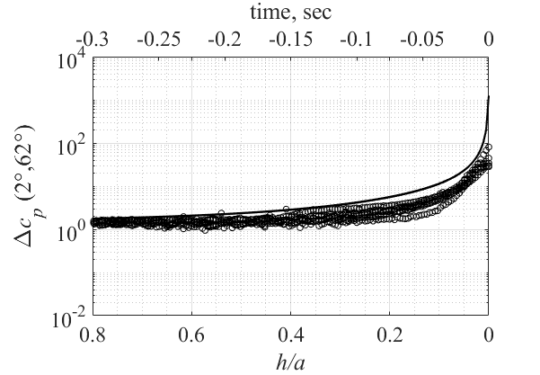

B

C:\Users\Tomer\Dropbox\TEZA\lyx\Images\Converted\few_exp_500_time_and_location_hole2.png

fig:
C:\Users\Tomer\Dropbox\TEZA\lyx\Images\figs\few_exp_500_time_and_location_hole2.fig

made from:
C:\Users\Tomer\Dropbox\TEZA\Plots for teza\Whole exp and zoom - AVG hole2\make_plots_10_5_16_avg_hole2.m

C

C:\Users\Tomer\Dropbox\TEZA\lyx\Images\Converted\few_exp_600_time_and_location_hole2.png



made from:
C:\Users\Tomer\Dropbox\TEZA\Plots for teza\Whole exp and zoom - AVG - 600 hole2\make_plots_10_5_16_avg_600_hole2.m



D

Figure 43. Comparison of the experimental and theoretical pressure difference coefficients. The time  when the pressure difference attains the maximum. Solid line – theory; open circles – experimental results. A. *U*=0.5 m/s. B. *U*=0.6 m/s. C. *U*=0.5 m/s. D. *U*=0.6 m/s.

These figure show a good agreement between the theoretical calculation and the measured results. The agreement is best at  and at larger angles show less agreement. The relative error is larger at higher angles since the  values are smaller.

### Detection distance

According to the results of theoretical and experimental investigations the maximum pressure difference is attained when the pressure sensor is located in the point . Thus, the pressure difference between this point and the reference point  is used here as the most representative estimate of the detection distance  given by the equation



where  is the noticeable dimensionless difference. Because both parts of are proportional to , the detection distance which can be found from this equation, does not depend on *U.*

An example of the estimation the detection distance based on experimental results for 

|  |
| --- |
| C:\Users\Tomer\Dropbox\TEZA\lyx\Images\Converted\till_contact_detection_combined_time_and_distance.png  fig: C:\Users\Tomer\Dropbox\TEZA\lyx\Images\figs\till_contact_detection_combined_time_and_distance.fig  made from: - (made corrections in the fig file) C:\Users\Tomer\Dropbox\TEZA\Plots for teza\Whole exp and zoom\make_plots_10_5_16.m |

Figure 44. Experimental pressure difference coefficient measured until the time of contact (*U*= 0.5 m/s). The open circle indicates the location and time when 

The same processing of the pressure data was made for all the experiments which were held. For each measurement, the distance from the wall and the corresponding time were calculated. The time presented below is the time remaining before the sphere hit the wall.

Table ‎6.1 Average detection time and distance at 3 velocities

|  |  |  |
| --- | --- | --- |
| velocity *U*, m/s | time before hitting the wall, sec | normalized distance from the wall at detection, *h/a* |
| *U*=0.5 | 0.15 | 0.34 |
| *U*=0.6 | 0.11 | 0.30 |

# Fish moving in a tube with current

## Experimental apparatus

The experimental system consists of a closed transparent tube connected to a water pump, allowing to create a water current in the tube (Figure 45).

|  |  |  |  |
| --- | --- | --- | --- |
| |  |  | | --- | --- | | C:\Users\Tomer\Dropbox\TEZA\lyx\Images\Converted\fishpics_exp_system.png  made from the powerpoint presentation | C:\Users\Tomer\Dropbox\TEZA\lyx\Images\Converted\fishpics_exp_system_side.png   made from the presentation | | |
| A | B |

Figure 45. Schematic experimental setup. A. Top view. B. Side view.

1. Four transparent straight Perspex tubes with an inner diameter  were connected by four  semitransparent bends. The bends were specially designed and 3D printed from semitransparent ABS.

2. An open section was created in a part of the tube to insert a fish through it.

3. The entire tube was submerged into a  transparent tank filled by water to overcome the optic distortion created by the round tube.

4. A centrifugal pump is connected to the tube to create a water flow (see parameters in Appendix ? )

5. Holders of the tube.

6-7. The pump takes the water from the water tank (6) and returns it back to the tank after passing through the tube (7).

8. A flowmeter is located between the pump and the tube.

9. An ABS printed cylindrical obstacle with a circular cross-section mm and height equal to the pipe’s inner diameter 54mm was placed into the tube.

10. A  section of the tube was filmed by two hi-speed (100 fps) synchronized digital video cameras  pixel CMOS, Optronics GmBh, Germany (see 11-12) equipped with 60mm/f2.8 and 20 24mm/f1.8 lenses (Nikkor, Japan).

11. Camera located above.

12. Camera located at the side of the water tank.

The mean velocity of the flow  in the tube is calculated as the ratio of the flow rate *Q* measured by the flowmeter to the area of the inner cross-section of the tube. The corresponding Reynolds number is calculated as , where  is the water kinematic viscosity.

## Experimental protocol and fish filming

Thirty two Mexican Tetra cave fish were obtained from a local pet trade. The fish were kept in two separate aquariums, 16 fish in each aquarium. Water temperature in the aquariums was kept at. The fish were fed daily commercial “Tetra flakes”. Water quality tests were checked weekly. The experiments with fish described below complied with IACUC approved guidelines for the use and care of animals in research at Tel Aviv University, Israel. The flow in the tube was visualized by injecting fluorescein sodium (product of Sigma Aldrich) which is non-toxic to fish. An example of flow visualization is shown in Figure 47.

The experiments were carried in the tube with and without obstacle, in still and running water (mean flow velocity ,  and , ) with five different fish in each particular experiment. To avoid testing of the same fish twice, for each particular experiment a fish was taken from an aquarium, say 1, and after the experiment it was returned to aquarium 2.

Examples of filming of fish in a tube are given in Figure 46–Figure 48.

|  |  |  |
| --- | --- | --- |
| C:\Users\Gregory\Desktop\Tomer\images\Fish in pipe\03-03-14-03-10.332_478.png  1 | 2 | 3 |
| 4 | 5 | 6 |
| 7 | 8 | 9 |

Figure 46. A blind Mexican cave fish avoiding an obstacle in a tube.   
 The fish is  long swimming in a  diameter pipe. Photos displayed in 0.2 sec difference. 1. Fish approaches the obstacle. 2. Fish starts the avoiding maneuver. 3-4. End of the avoiding maneuver. 5. Fish moves towards the wall of the tube. 6. Fish perceives the tube and starts the avoiding maneuver. 7-8. End of the avoiding maneuver.

|  |
| --- |
|  |

Figure 47. Flow visulazation past a cilindrical obstcale placed in a tube. , .

|  |  |  |
| --- | --- | --- |
| C:\Users\Tomer\Dropbox\TEZA\Fish pics\vortex visualization\For teza\No hit\Edited - No circle | C:\Users\Tomer\Dropbox\TEZA\Fish pics\vortex visualization\For teza\No hit\Edited - No circle | C:\Users\Tomer\Dropbox\TEZA\Fish pics\vortex visualization\For teza\No hit\Edited - No circle |
| C:\Users\Tomer\Dropbox\TEZA\Fish pics\vortex visualization\For teza\No hit\Edited - No circle | C:\Users\Tomer\Dropbox\TEZA\Fish pics\vortex visualization\For teza\No hit\Edited - No circle | C:\Users\Tomer\Dropbox\TEZA\Fish pics\vortex visualization\For teza\No hit\Edited - No circle |
| C:\Users\Tomer\Dropbox\TEZA\Fish pics\vortex visualization\For teza\No hit\Edited - No circle | C:\Users\Tomer\Dropbox\TEZA\Fish pics\vortex visualization\For teza\No hit\Edited - No circle | C:\Users\Tomer\Dropbox\TEZA\Fish pics\vortex visualization\For teza\No hit\Edited - No circle |

Figure 48. Fish avoiding the obstacle while swimming against the stream in a tube with fluorescein. . Photos displayed in 0.2 sec difference .1. Fish gliding towards the obstacle.

|  |  |  |
| --- | --- | --- |
|  |  |  |
|  |  |  |
|  |  |  |

Figure 49. Fish colliding with the obstacle while swimming against the stream in a tube with fluorescein. . Photos displayed in 0.2 sec difference. 1-2 fish gliding towards the obstacle. 3. Tail beat close to the obstacle. 4 fish collides with the obstacle. 5-6. Fish swims backwards7-9. Fish preforms an avoiding maneuver.

## Image processing of fish trajectories.

The aims of imaging a fish's motion in a pipe are to determine the coordinates of the fish's nose, the rear end of its body, the fish's contours in the two mutually perpendicular planes and the centroid of the area bounded by the contour. Fish trajectory is defined as the trajectory of its nose as it is illustrated in Figure 50.

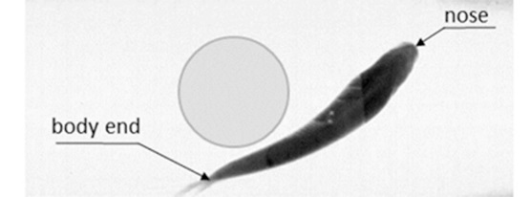

Figure 50. Fish avoiding an obstacle.

The trajectory of the nose is determined if its coordinates are determined in a chosen coordinate system illustrated in Figure 51.

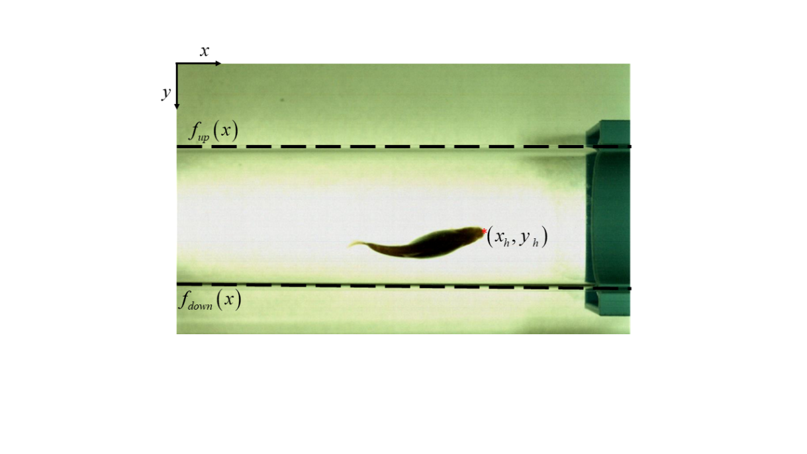

Figure 51. Coordinate system of an image with a fish. The origin of the coordinate system *Oxy* is chosen in the upper corner of the image. The red star denotes the fish nose.

A Matlab code was created for this purpose, processing the fish’s motion in the pipe. The image processing procedure starts from generating an image of the filmed area without a fish and without an obstacle. On the next steps of processing, this image serves as a background of other images of the fish in a tube with and without the obstacle. In order to determine the actual dimensions in the images, an image with a plastic ruler was processed and scaled according to the ruler units.

The main steps of the algorithm of image processing of a fish's motion in a tube are described in Figure 52.

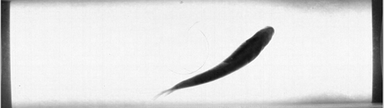

A

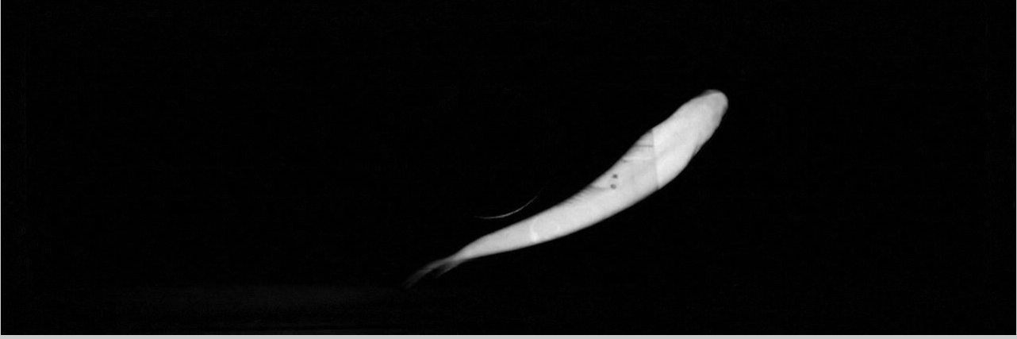

B

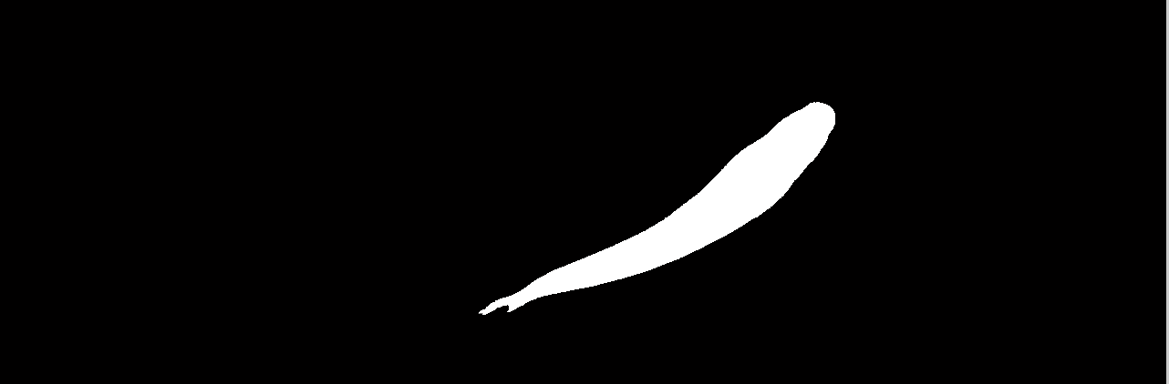

C

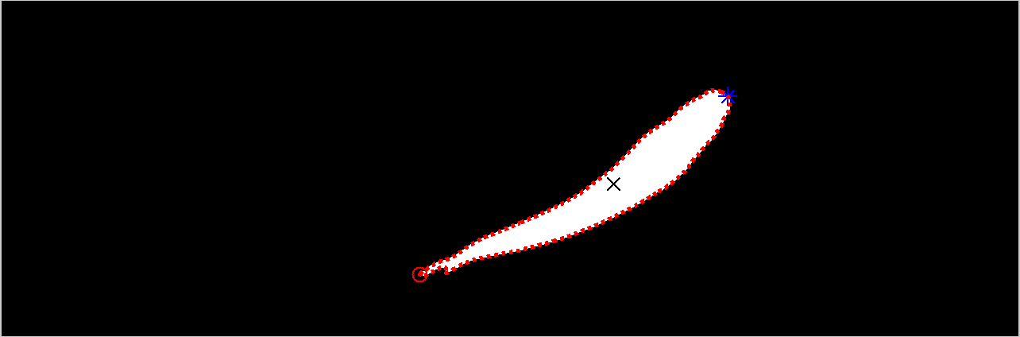

D

Figure 52. Image processing steps. A. Original image. B. The result of comparison between the image and the background image, using Matlab function "imabsdiff”. C. Converting the resultant image B to a black-white image, Matlab function “im2bw”. D. Building the contour (red dashed line), locating the nose of the fish (astrix), the endpoint of the body (circle) and the centroid (cross), Matlab functions “bwboundaries.m” and “regionprops.m”. The Matlab code is shown in appendix.

The obtained by image processing fish trajectories are shown in Figure 53

|  |  |  |
| --- | --- | --- |
|  | |  |
| A | B | |

Figure 53. Trajectory of the nose of a fish swimming in the tube. A. Top view. B. Side view

## Results

### No obstacle in the pipe

The results of the fish’s head movement in the tube without the obstacle are shown in Figure 54.

Top view Side view

|  |  |
| --- | --- |
|  |  |
|  |  |
|  |  |
|  |  |
|  |  |
|  |  |

Figure 54. The trajectory of the nose of the fish in a tube without an obstacle.

In a tube without obstacle the only visible difference is in the density of trajectories of fish in the side view: In a tube without current, fish prefer to move closer to the bottom of the tube. We did not attempted to analyze this phenomenon and concentrated rather on the drastic difference in the trajectories patterns in the pipe without obstacle and with it.

### Trajectories in the pipe with obstacle.

|  |
| --- |
|  |

Figure 55. Fish approaching obstacle in the pipe with obstacle without current ().

|  |
| --- |
| A |
| C:\Users\Tomer\Dropbox\TEZA\lyx\Images\Converted\Fish_pics_top_obs_400_against.png  made in powerpoint  B |

Figure 56. Trajectories of fish in the pipe with an obstacle . A. fish approaches obstacle in the direction of water flow. B. fish approaches obstacle against the direction of water flow

|  |
| --- |
| A |
| B |

Figure 57. Trajectory of fish in a tube with an obstacle and a current of . A. Swimming in the direction of the current; B. Swimming against the current.

Comparing Figure 55 and Figure 57, we can make two conclusions.

1. When a fish approaches to the obstacle without current the distance it starts the avoiding maneuver is smaller compared to that when it moves in the direction of the current.

2. When a fish approaches to the obstacle againt current the distance it starts the avoiding maneuver is smaller compared to that when it moves in a pipe without current in the direction of the current.

Fish start their avoiding maneuver… we suggest to find the location by plotting imaginary cylinder around the obstacle.

|  |
| --- |
| C:\Users\Gregory\Desktop\Tomer\images\One_fish_with_circles.png |

Figure 58. 3 imaginary cylinders around the obstacle. Dashed line (---) . Solid line (–) . Dotted line (…) . In this image, the fish entered the cylinders 1 and 0.5 cm from the obstacle, but didn’t collide with it.

It is hard to say if there was actual contact between the fish and the obstacle using image processing. Furthermore, it is difficult to define when the fish starts an avoiding maneuver before hitting the obstacle We suggest to find these locations by plotting imaginary cylinders around the obstacle. Three cylinders, of radii were plotted around the obstacle. We defined a collision if the fish entered the  cylinder. The probability of the fish entering these imaginary cylinders is shown in Table 4.

Table . The probability of the fish entering an imaginary cylinder around the obstacle.

|  |  |  |  |
| --- | --- | --- | --- |
|  | Probability, % | | |
| Distance from sphere, cm | No current | With current | Against current |
| 1 | 78 | 45 | 80 |
| 0.5 | 58 | 15 | 64 |

When swimming with the current the fish stays further away from the obstacle then when swimming against the current. This can also be seen in subfigure A in Figure 56 and Figure 57 where there is an area that the fish rarely enters when approaching the obstacle.

These observations are correlated with the highest number of collisions of fish with an obstacle when it swims against the current in the wake of the cylinder.

Table 5. Chance of collision with an obstacle depending on the direction of motion.

|  |  |  |  |
| --- | --- | --- | --- |
| Current | Number of trajectories | Number of collisions | Probability, % |
| No current | 55 | 8 | 15 |
| With current 20-35 mm /s | 44 | 1 | 2 |
| Against current 20-35 mm /s | 47 | 12 | 25 |

The probability of the fish colliding with the obstacle is bigger when it approaches from downstream. We assume the vortices created in the wake of the cylinder create hydrodynamic noise. This noise comprises the fish’s ability to detect the obstacle.

# References

Abdel-Latif, H, ES Hassan, and C von Campenhausen. 1990. "Sensory performance of blind Mexican cave fish after destruction of the canal neuromasts." *Naturwissenschaften* (Springer) 77 (5): 237-239.

Basset, Alfred Barnard. 1888. *A treatise on hydrodynamics: with numerous examples.* Vol. 2. Deighton, Bell and Company.

Bazilevs, Y, J Yan, M de Stadler, and S Sarkar. 2014. "Computation of the flow over a sphere at Re= 3700: A comparison of uniform and turbulent inflow conditions." *Journal of Applied Mechanics* (American Society of Mechanical Engineers) 81 (12): 121003.

Bentwich, M, and T Miloh. 1978. "On the exact solution for the two-sphere problem in axisymmetrical potential flow." *Journal of Applied Mechanics* (American Society of Mechanical Engineers) 45 (3): 463-468.

Bleckmann, Horst. 2006. "The lateral line system of fish." *Fish Physiology* (Elsevier) 25: 411-453.

Bleckmann, Horst, and Randy Zelick. 2009. "Lateral line system of fish." *Integrative zoology* (Wiley Online Library) 4 (1): 13-25.

Bleckmann, Horst, Joachim Mogdans, and Sheryl L Coombs. 2014. *Flow sensing in air and water.* Springer.

Chen, J., J. Engel, N. Chen, S. Pandya, S. Coombs, and C. Liu. 2006. "Artificial Lateral Line And Hydrodynamic Object Tracking." *19th IEEE International Conference on Micro Electro Mechanical Systems.* 694-697.

Colvert, Brendan, and Eva Kanso. 2016. "Fishlike rheotaxis." *Journal of Fluid Mechanics* (Cambridge Univ Press) 793: 656-666.

Coombs, Sheryl and Janssen, John and Webb, Jacqueline F. 1988. "Diversity of Lateral Line Systems: Evolutionary and Functional Considerations." In *Sensory Biology of Aquatic Animals*, edited by Jelle and Fay, Richard R. and Popper, Arthur N. and Tavolga, William N. Atema, 553-593. New York, NY: Springer New York. https://doi.org/10.1007/978-1-4612-3714-3\_22.

Coombs, Sheryl and Montgomery, John C. 1999. "The Enigmatic Lateral Line System." In *Comparative Hearing: Fish and Amphibians*, edited by Richard R. and Popper, Arthur N. Fay, 319-362. New York, NY: Springer New York. http://dx.doi.org/10.1007/978-1-4612-0533-3\_8.

Coombs, Sheryl and Montgomery, John. 2014. "The Role of Flow and the Lateral Line in the Multisensory Guidance of Orienting Behaviors." In *Flow Sensing in Air and Water: Behavioral, Neural and Engineering Principles of Operation*, edited by Horst and Mogdans, Joachim and Coombs, Sheryl L. Bleckmann, 65-101. Berlin, Heidelberg: Springer Berlin Heidelberg. https://doi.org/10.1007/978-3-642-41446-6\_3.

de Perera, Theresa Burt. 2004. "Spatial parameters encoded in the spatial map of the blind Mexican cave fish, Astyanax fasciatus ." *Animal Behaviour* 68 (2): 291-295. http://www.sciencedirect.com/science/article/pii/S0003347204001538.

Denton, E. J. and Gray, J. A. B. 1989. "Some Observations on the Forces Acting on Neuromasts in Fish Lateral Line Canals." In *The Mechanosensory Lateral Line: Neurobiology and Evolution*, edited by Sheryl and G{\"o}rner, Peter and M{\"u}nz, Heinrich Coombs, 229-246. New York, NY: Springer New York. http://dx.doi.org/10.1007/978-1-4612-3560-6\_11.

Denton, E. J., and John Gray. 1983. "Mechanical Factors in the Excitation of Clupeid Lateral Lines." *Proceedings of the Royal Society of London B: Biological Sciences* (The Royal Society) 218 (1210): 1-26. http://rspb.royalsocietypublishing.org/content/218/1210/1.

Dijkgraaf, Sven. 1963. "The functioning and significance of the lateral-line organs." *Biological Reviews* (Wiley Online Library) 38 (1): 51-105.

Dubois, ARTHUR B, GIOVANNI A Cavagna, and Richard S Fox. 1974. "Pressure distribution on the body surface of swimming fish." *J. Exp. Biol* (Citeseer) 60: 581-591.

ENDO;, Dyuro;. 1938. "The Forces on Two Spheres Placed in Uniform Flow." *Proceedings of the Physico-Mathematical Society of Japan. 3rd Series* 20 ( ): 667-703.

Feitl, Karla E., Victoria Ngo, and Matthew J. McHenry. 2010. "Are fish less responsive to a flow stimulus when swimming?" *Journal of Experimental Biology* (The Company of Biologists Ltd) 213 (18): 3131-3137. http://jeb.biologists.org/content/213/18/3131.

Fernandez, Vicente I, Audrey Maertens, Frank M Yaul, Jason Dahl, Jeffrey H Lang, and Michael S Triantafyllou. 2011. "Lateral-line-inspired sensor arrays for navigation and object identification." *Marine Technology Society Journal* (Marine Technology Society) 45 (4): 130-146.

Griffiths, Gwyn. 2002. *Technology and applications of autonomous underwater vehicles.* Vol. 2. CRC Press.

Handelsman, Richard A, and Joseph B Keller. 1967. "Axially symmetric potential flow around a slender body." *Journal of Fluid Mechanics* (Cambridge Univ Press) 28 (01): 131-147.

Hassan, El Sayed. 1986. "On the discrimination of spatial intervals by the blind cave fish (Anoptichthys jordani)." *Journal of Comparative Physiology A* 159 (5): 701-710. http://dx.doi.org/10.1007/BF00612042.

Hassan, El. S. and Abdel-Latif, H. and Biebricher, R. 1992. "Studies on the effects of Ca2++ and Co++ on the swimming behavior of the blind Mexican cave fish." *Journal of Comparative Physiology A* 171 (3): 413-419. http://dx.doi.org/10.1007/BF00223971.

Hassan, El-S. 1985. "Mathematical analysis of the stimulus for the lateral line organ." *Biological cybernetics* (Springer) 52 (1): 23-36.

Hassan, El-S. 1992. "Mathematical description of the stimuli to the lateral line system of fish derived from a three-dimensional flow field analysis." *Biological Cybernetics* (Springer) 66 (5): 443-452.

Hicks, WM. 1879. "On the motion of two cylinders in a fluid." *Quarterly Journal of Pure and Applied Mathematics* 16: 113-140.

Hofer, Bruno. 1908. "Studien {\"u}ber die Hautsinnesorgane der Fische I." *Die Funktion der Seitenorgane bei den Fischen. Ber Kgl Bayer Biol Versuchsstation M{\"u}nchen* 1: 115-168.

Holzman, Roi, Shimrit Perkol-Finkel, and Gregory Zilman. 2014. "Mexican blind cavefish use mouth suction to detect obstacles." *Journal of Experimental Biology* (The Company of Biologists Ltd). http://jeb.biologists.org/content/early/2014/03/25/jeb.098384.

Hubbs, Carl Leavitt, and William Thornton Innes. 1936. "The first known blind fish of the family Characidae: a new genus from Mexico." (University of Michigan Museum of Zoology).

Jaffe, Jules S, Kad D Moore, John McLean, and Michael P Strand. 2001. "Underwater optical imaging: status and prospects." *Oceanography* 14 (3): 66-76.

Keene, Alex, Masato Yoshizawa, and Suzanne Elaine McGaugh. 2015. *Biology and evolution of the Mexican cavefish.* Academic Press.

Kharlamov, AlexanderAndreevich, Zdenak Chara, and Pavel Vlasak. 2008. "Hydraulic formulae for the added masses of an impermeable sphere moving near a plane wall." *Journal of Engineering Mathematics* (Springer Netherlands) 62 (2): 161-172. http://dx.doi.org/10.1007/s10665-007-9186-y.

Kocak, Donna M, Fraser R Dalgleish, Frank M Caimi, and Yoav Y Schechner. 2008. "A focus on recent developments and trends in underwater imaging." *Marine Technology Society Journal* (Marine Technology Society) 42 (1): 52-67.

Lamb, H. 1916. *Hydrodynamics.* University Press. https://books.google.co.in/books?id=OztMAAAAMAAJ.

Lamb, Horace. 1945. "Hydrodynamics, 1932." *Cambridge UP* 236-241.

Maertens, Audrey P, and Michael S Triantafyllou. 2014. "The boundary layer instability of a gliding fish helps rather than prevents object identification." *Journal of Fluid Mechanics* (Cambridge University Press) 757: 179-207.

McHenry, Matthew J, James A Strother, and Sietse M Van Netten. 2008. "Mechanical filtering by the boundary layer and fluid--structure interaction in the superficial neuromast of the fish lateral line system." *Journal of Comparative Physiology A* (Springer) 194 (9): 795-810.

Milne-Thomson, Louis Melville. 1968. *Theoretical hydrodynamics.* Courier Corporation.

Miloh, T. 1977. "Hydrodynamics of deformable contiguous spherical shapes in an incompressible inviscid fluid." *Journal of Engineering Mathematics* 11 (4): 349-372. http://dx.doi.org/10.1007/BF01537094.

Montgomery, John C. and Coombs, Sheryl and Baker, Cindy F. 2001. "The mechanosensory lateral line system of the hypogean form of Astyanax fasciatus ." In *The biology of hypogean fishes*, edited by Aldemaro Romero, 87-96. Dordrecht: Springer Netherlands. http://dx.doi.org/10.1007/978-94-015-9795-1\_5.

Narkis, Y. 1982. "The pressure on a sphere approaching a wall." *Israel Journal of Technology* 20: 277.

Parker, George Howard. 1904. *The function of the lateral-line organs in fishes.* US Government Printing Office.

Patton, Paul, Shane Windsor, and Sheryl Coombs. 2010. "Active wall following by Mexican blind cavefish (Astyanax mexicanus)." *Journal of Comparative Physiology A* (Springer) 196 (11): 853-867.

Paull, L., S. Saeedi, M. Seto, and H. Li. 2014. "AUV Navigation and Localization: A Review." *IEEE Journal of Oceanic Engineering* 39 (1): 131-149.

Ristroph, Leif, James C. Liao, and Jun Zhang. 2015. "Lateral Line Layout Correlates with the Differential Hydrodynamic Pressure on Swimming Fish." *Phys. Rev. Lett.* (American Physical Society) 114: 018102. http://link.aps.org/doi/10.1103/PhysRevLett.114.018102.

Schemmel, Christian. 1967. "Vergleichende Untersuchungen an den Hautsinnesorganen ober- und unterirdisch lebender Astyanax-Formen." *Zeitschrift f{\"u}r Morphologie der Tiere* 61 (2): 255-316. https://doi.org/10.1007/BF00400988.

Schlichting, H. 1979. *Boundary-layer theory.* McGraw-Hill. https://books.google.co.il/books?id=fYdTAAAAMAAJ.

Tao, Junliang, and Xiong Bill Yu. 2012. "Hair flow sensors: from bio-inspiration to bio-mimicking—a review." *Smart Materials and Structures* (IOP Publishing) 21 (11): 113001.

Teyke, T. 1985. "Collision with and avoidance of obstacles by blind cave fishAnoptichthys jordani (Characidae)." *Journal of Comparative Physiology A* (Springer) 157 (6): 837-843.

Teyke, T. 1988. "Flow field, swimming velocity and boundary layer: parameters which affect the stimulus for the lateral line organ in blind fish." *Journal of Comparative Physiology A* 163 (1): 53-61. http://dx.doi.org/10.1007/BF00611996.

Teyke, T. 1989. "Learning and remembering the environment in the blind cave fishAnoptichthys jordani." *Journal of Comparative Physiology A* 164 (5): 655-662. http://dx.doi.org/10.1007/BF00614508.

Triantafyllou, Michael S., Gabriel D. Weymouth, and Jianmin Miao. 2016. "Biomimetic Survival Hydrodynamics and Flow Sensing." *Annual Review of Fluid Mechanics* 48 (1): 1-24. http://dx.doi.org/10.1146/annurev-fluid-122414-034329 .

van Netten, Sietse M. 2006. "Hydrodynamic detection by cupulae in a lateral line canal: functional relations between physics and physiology." *Biological Cybernetics* 94 (1): 67-85. http://dx.doi.org/10.1007/s00422-005-0032-x.

Vogel, Steven. 1994. *Life in moving fluids: the physical biology of flow.* Princeton University Press.

Voinov, OV. 1969. "On the motion of two spheres in a perfect fluid: PMM vol. 33, No 4, 1969, pp. 659--667." *Journal of Applied Mathematics and Mechanics* (Elsevier) 33 (4): 638-646.

Von Campenhausen, C, I Riess, and R Weissert. 1981. "Detection of stationary objects by the blind cave fishAnoptichthys jordani (Characidae)." *Journal of comparative physiology* (Springer) 143 (3): 369-374.

Weihs, D, and RD Small. 1975. "An exact solution of the motion of two adjacent spheres in axisymmetric potential flow." *Israel Journal of Technology* 13: 1-6.

Weissert, R, and C Von Campenhausen. 1981. "Discrimination between stationary objects by the blind cave fishAnoptichthys jordani (Characidae)." *Journal of comparative physiology* (Springer) 143 (3): 375-381.

Winder, A. A. 1975. "II. Sonar System Technology." *IEEE Transactions on Sonics and Ultrasonics* 22 (5): 291-332.

Windsor, Shane and Paris, James and de Perera, Theresa Burt. 2011. "No role for direct touch using the pectoral fins, as an information gathering strategy in a blind fish." *Journal of Comparative Physiology A* 197 (4): 321-327. http://dx.doi.org/10.1007/s00359-010-0615-4.

Windsor, Shane P. 2014. "Hydrodynamic imaging by blind Mexican cavefish." In *Flow sensing in air and water*, 103-125. Springer.

Windsor, Shane P, Delfinn Tan, and John C Montgomery. 2008. "Swimming kinematics and hydrodynamic imaging in the blind Mexican cave fish (Astyanax fasciatus)." *Journal of Experimental Biology* (The Company of Biologists Ltd) 211 (18): 2950-2959.

Windsor, Shane P, Stuart E Norris, Stuart M Cameron, Gordon D Mallinson, and John C Montgomery. 2010. "The flow fields involved in hydrodynamic imaging by blind Mexican cave fish (Astyanax fasciatus). Part I: open water and heading towards a wall." *Journal of Experimental Biology* (The Company of Biologists Ltd) 213 (22): 3819-3831.

Yang, Fu-Ling. 2006. "Interaction law for a collision between two solid particles in a viscous liquid." Ph.D. dissertation, California Institute of Technology.

Yang, Yingchen, Jack Chen, Jonathan Engel, Saunvit Pandya, Nannan Chen, Craig Tucker, Sheryl Coombs, Douglas L. Jones, and Chang Liu. 2006. "Distant touch hydrodynamic imaging with an artificial lateral line." *Proceedings of the National Academy of Sciences* 103 (50): 18891-18895. http://www.pnas.org/content/103/50/18891.abstract.

Yang, Yingchen, Nam Nguyen, Nannan Chen, Michael Lockwood, Craig Tucker, Huan Hu, Horst Bleckmann, Chang Liu, and Douglas L Jones. 2010. "Artificial lateral line with biomimetic neuromasts to emulate fish sensing." *Bioinspiration \& Biomimetics* 5 (1): 016001. http://stacks.iop.org/1748-3190/5/i=1/a=016001.

Yoshizawa, Masato, William R Jeffery, Sietse M van Netten, and Matthew J McHenry. 2014. "The sensitivity of lateral line receptors and their role in the behavior of Mexican blind cavefish (Astyanax mexicanus)." *Journal of Experimental Biology* (The Company of Biologists Ltd) 217 (6): 886-895.

# Appendises.

## Appendix A – Pump data sheet



  
  
  
  