**Presented to …**

January 2020

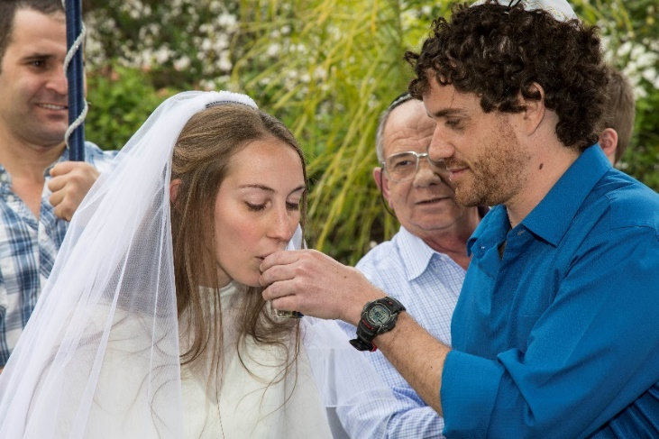

**EXECUTIVE SUMMARY**

In recent years, Tzohar has witnessed a growing trend wherein traditional Jewish marriage is called into question and more and more people are choosing not to marry in a Jewish ceremony.

This is especially true in Tel Aviv. Given the unique nature of Tel Aviv as a “global” city with a very high concentration of non-observant Jews whose connection with their Jewish heritage is often tenuous, many Tel Aviv couples choose alternatives to Jewish marriage.

Having a noticeable, physical presence in Tel Aviv where our target audience is located, has already proven its effectiveness. More Tel Aviv couples are already choosing to marry via Tzohar. An integral part of our efforts to facilitate Jewish weddings in Tel Aviv, is our initiative to establish a permanent Tzohar Marriage Registration and Counseling Center in Tel Aviv.

Tzohar invites you to partner with us in order to combat Israel’s Jewish marriage crisis in Tel Aviv in a permanent, welcoming and accessible location. For a generous gift of $600,000, Tzohar will name the registration section of the Center as per the donor’s wishes. We expect over 10,000 people to frequent Tzohar’s Marriage Registration and Counseling Center each year.

The Tzohar Marriage Registration and Counseling Center in Tel Aviv will cement our presence in this community and highlight to this generation that there is a different way to experience Jewish tradition – the ‘Tzohar Way’!

**about Tzohar’s jewish Marriage Program**

## The Need

Jewish couples in Israel can only marry and obtain their Marriage License via the Rabbinate.

Tragically, over one third of Israel’s secular couples resent the notoriously coercive and bureaucratic process that this involves, and they are therefore opting for civil alternatives in Cyprus or Prague, or they choose not to marry at all.

Since 1996, Tzohar has been working to preserve Jewish marriage in Israel and combat a wave of mass assimilation. Our goal is to enable all Jews in Israel to have a meaningful, halachic Jewish wedding.

Tzohar has succeeded in creating Israel’s only private registry that serves as a legal and halachic interface to the Rabbinate, customized for secular couples. The Tzohar experience is renown as inclusive and welcoming, which is not only dramatically reducing the alienation of secular Jews but is building cohesion across Israel's secular/religious divide which is threatening the very fiber of Jewish society in Israel.

## Project Overview:

Tzohar's Jewish Marriage Project is comprised of three key components, which encompass the entire Jewish marriage process:

**STEP 1: Marriage registration**

For many secular couples, the process of marriage registration at the local Rabbinate office is their first encounter with the "religious establishment.” **This registration experience is cumbersome and difficult and often alienating and frustrating to those using the service.**

**Couples who register their marriage with Tzohar do not need to visit a bureaucratic government office.** The Tzohar experience of registering for marriage encompasses all the halachic considerations in a welcoming, pleasant, clear, concise and positive manner.

**STEP 2:**  **Bridal counseling**

For secular brides, one of the most formidable barriers to choosing a halachic wedding in Israel is the legal requirement to visit the *mikveh* (ritual bath) and to undertake a minimal amount of instruction in the laws of Jewish family life.

**Whereas the bridal counseling service provided by the Rabbinate has a very poor reputation, Tzohar offers an accepting and understanding experience which is highly acclaimed.**

Both bride and the groom are invited to meet with one of Tzohar's specially trained, female bridal counselors, who facilitate discussion and consideration of Jewish perspectives on relationships and intimacy.

Tzohar is utilizing this opportunity to create a positive experience that permanently strengthens the couple's sense of Jewish identity from the outset of their married life.

**STEP 3: Meaningful halachic wedding ceremonies**

Tzohar's goal of providing a meaningful Jewish wedding ceremony for all Jewish couples starts at the very beginning of the process, when Tzohar staff matchethe couple with a Tzohar volunteer rabbi who is best suited for them and their backgrounds.

The rabbi meets the couple at least once in his home before the wedding ceremony in order to get to know them, to acquaint them with the process, and to discuss any special requests or concerns that they may have. (In contrast, those couples who register at the local Rabbinate are assigned a rabbi to conduct the ceremony, who usually meets the couple for the first time at the ceremony itself.)

**Tzohar invests significantly in training its volunteer rabbis and ensures that each couple celebrates a meaningful Jewish wedding ceremony. In addition, Tzohar rabbis do not take payment and encourage the couples to stay in touch after the wedding if they so wish.** (In contrast, rabbis from local Rabbinates often require “tips” of hundreds or thousands of shekels in order to perform the ceremony.)

**Tzohar Marriage Center Tel-Aviv**

## Responding to Changing Trends

Given the unique nature of Tel Aviv as a “global” city with a very high concentration of non-observant Jews whose connection with their Jewish heritage is often tenuous, many Tel Aviv couples are choosing alternatives to Jewish marriage.

**This trend threatens the very fibre of Israel as our Jewish State, and it is imperative that we act now and provide critical access to Tzohar’s marriage services in the heart of Israel’s most populous and largely secular city.**

The importance of Tzohar’s Jewish Marriage Program cannot be overstated. We must act now and establish a welcoming presence in Tel Aviv in order to reverse this trend, and to shed light on the relevance and beauty of our Jewish traditions and practices.

To this end, Tzohar intends to establish a permanent Tzohar Marriage Center in Tel Aviv.

## Tzohar Presence in Tel Aviv

## In 2017 Tzohar launched a pilot project in Tel Aviv when we opened a small branch of our marriage department. In 2018 we extended our Tel Aviv marriage services and offered bridal counseling to couples in an additional location. The next step in our growth was in January 2019 when we moved into our new offices which consist of four rooms, two to process marriage registration and two for counseling. Today, approximately 60% of couples registering to marry via Tzohar, do so via our Tel Aviv branch.

**Our Accomplishments**

Tzohar first began operating in Tel Aviv towards the end of 2017. As per the diagrams below, this new office quickly became the most popular branch for Jewish marriage registration via Tzohar.

In 2018 Tzohar’s Tel Aviv branch serviced 1,437 couples, 40% of all those who utilized Tzohar’s marriage registration service. In 2019, the branch served 1,614 – over 50% of those who utilized our registration service and an **increase of 12% from the previous year.**

## The Need to Establish a Permanent Center in Tel Aviv

The success of Tzohar’s current Tel Aviv office highlights the importance of a Tzohar presence in Tel Aviv. However, it has become clear that the current offices do not fully answer the demand for our services.

Tzohar is seeking a permanent home for its Tel Aviv marriage activities for the following reasons:

1. Financial Consideration: The extremely high and prohibitive monthly costs of renting a central location in Tel Aviv. A permanent location would allow Tzohar to use its limited financial resources for additional aspects of the Jewish Marriage Project.
2. Ritual Bath (Mikvah) for Tzohar brides. Tzohar's Jewish Marriage program offers couples a professional, friendly and meaningful experience throughout the marriage process. However, in many cases, all this is overshadowed and undermined by a difficult experience at the Mikvah. Tzohar plans to operate a Mikvah and to train Mikvah attendants at the exceptionally high standards to which Tzohar trains all our volunteers. This will ensure that the entire process runs smoothly, is meaningful and is delivered with respect and sensitivity.
3. Expanding Current Activities. Bridal counseling sessions are held in the current offices. However, the premises are not large enough to accommodate all the scheduled sessions, and as a result we are forced to find alternative locations to hold the sessions. This predicament will only become worse as the demand for our services grows.
4. Offering Additional Activities. Often, couples who turn to Tzohar to marry need to use the services of Tzohar’s Shorashim Roots Investigation Unit to prove their Jewish status. In addition, each Tzohar volunteer rabbi meets with the couple before the actual ceremony. Currently, the existing offices are not large enough to accommodate these activities.

**Tzohar strives to be able to offer ALL of its marriage services from permanent premises in Tel Aviv, making Tzohar’s marriage services easily accessible to all Tel Aviv couples.**

## Tzohar’s New Home in Tel-Aviv

Tzohar is currently working to acquire two locations in Tel Aviv - one for marriage registration and counseling and the other for the Mikvah.

The decision to separate these two elements was born from the understanding that many of the couples who turn to Tzohar to marry harbor a deep mistrust of the religious establishment. This is particularly the case when considering the rabbinic requirement of visiting the Mikvah in order to marry. As the couple meet Tzohar professionals and are welcomed by our specially trained staff and volunteers, this mistrust slowly dissipates. As a result of this arrangement, couples are not confronted by the very symbol of their mistrust on their first meeting with Tzohar.

## Tzohar Marriage Registration and Counseling Center

Tzohar is currently in the process of purchasing permanent premises in Tel Aviv to house our registration and bridal counseling services. This property is located at 56 Yigal Alon Street in Tel Aviv (Toyota Building) on the 17th floor (See Appendix A).

The location of this Center is crucial to the success of this initiative. Tzohar’s Marriage Registration and Counseling Center must be easily accessible. This particular location lies in the heart of the Tel Aviv business district, is accessible both by car and public transport, and is within walking distance of the Tel Aviv Hashalom train station.

The Center is approximately 210 M² in size. Currently, one third of this space is rented out. Tzohar intends to occupy 135 M² and to continue to rent out the remaining space. This arrangement will provide us with a monthly income that will off-set a portion of the maintenance costs of the Center.

**The Tzohar Mikvah**

In addition, Tzohar intends to open a Mikvah within the Beit Knesset Shalom complex located at 67 Yehoshua Bin Nun Street (See Appendix B), the ‘Old North’ of Tel Aviv. Tzohar is currently finalizing the agreement to use the space.

**Provisional Budget**

**Tzohar’s Marriage Registration and Counseling Center**

**67 Yigal Alon Street**

|  |  |  |
| --- | --- | --- |
| **ITEM** | **NIS** | **USD $1=3.5 NIS** |
| **Purchase of the premises at 56 Yigal Alon Street** | 3,874,500 | 1,107,000 |
| **Professional Consultants** - including Lawyers, Architects, engineers and building consultants | 40,000 | 11,429 |
| **Subcontractors** - Demolition and construction | 120,000 | 34,286 |
| **Furniture -** carpentry, office furniture | 50,000 | 14,286 |
| **Permits and licenses** | 0 | 0 |
| **Unforeseen expenses 15%** | 518,925 | 148,264 |
| **Project Management & Supervision 10%** | 345,950 | 98,843 |
| **TOTAL** | **5,105,625** | **1,458,750** |

**Provisional Budget Tzohar Mikvah**

**67 Yehoshua Ben Nun Street**

|  |  |  |
| --- | --- | --- |
| **ITEM** | **NIS** | **USD $1=3.5 NIS** |
| **Professional Consultants** - including Lawyers, Architects, engineers and building consultants | 300,000 | 85,714 |
| **Subcontractors** - Demolition and construction | 3,323,970 | 949,706 |
| **Furniture -** carpentry | 80,000 | 22,857 |
| **Permits and licenses** | 50,000 | 14,286 |
| **Unforeseen expenses 15%** | 563,096 | 160,884 |
| **Project Management & Supervision 10%** | 375,397 | 107,256 |
| **TOTAL** | **4,692,463** | **1,340,704** |

**Sponsorship Opportunities for the Tel Aviv Marriage Center**

Tzohar will name the Center or section of the Center, as per the donor’s wishes.

|  |  |  |
| --- | --- | --- |
| **ITEM** | **NIS** | **USD $1=3.5 NIS** |
| **Naming rights for the Tel Aviv Complex - Marriage Registration & Counseling Center** | **8,750,000** | **2,500,000** |
| **Naming rights for the - Marriage Registration & Counseling Center** | **4,200,000** | **1,200,000** |
| **Naming rights for the *mikvah* complex** | **4,550,000** | **1,300,000** |
| **Naming rights for the *Registration section of the Marriage Registration & Counseling Center*** | **2,100,000** | **600,000** |

**Donor Request & Recognition**

Tzohar kindly requests that XXXX partner with Tzohar in the amount of $600,000, to sponsor the registration section of the Center. Tzohar will name the section as per the donor’s wishes. With your generous support we can combat civil marriage in Tel Aviv and help guarantee the Jewish future of the State of Israel.

**Appendix A: Mock Up of the Offices**

(These are artistic renditions, for illustration purposes only)

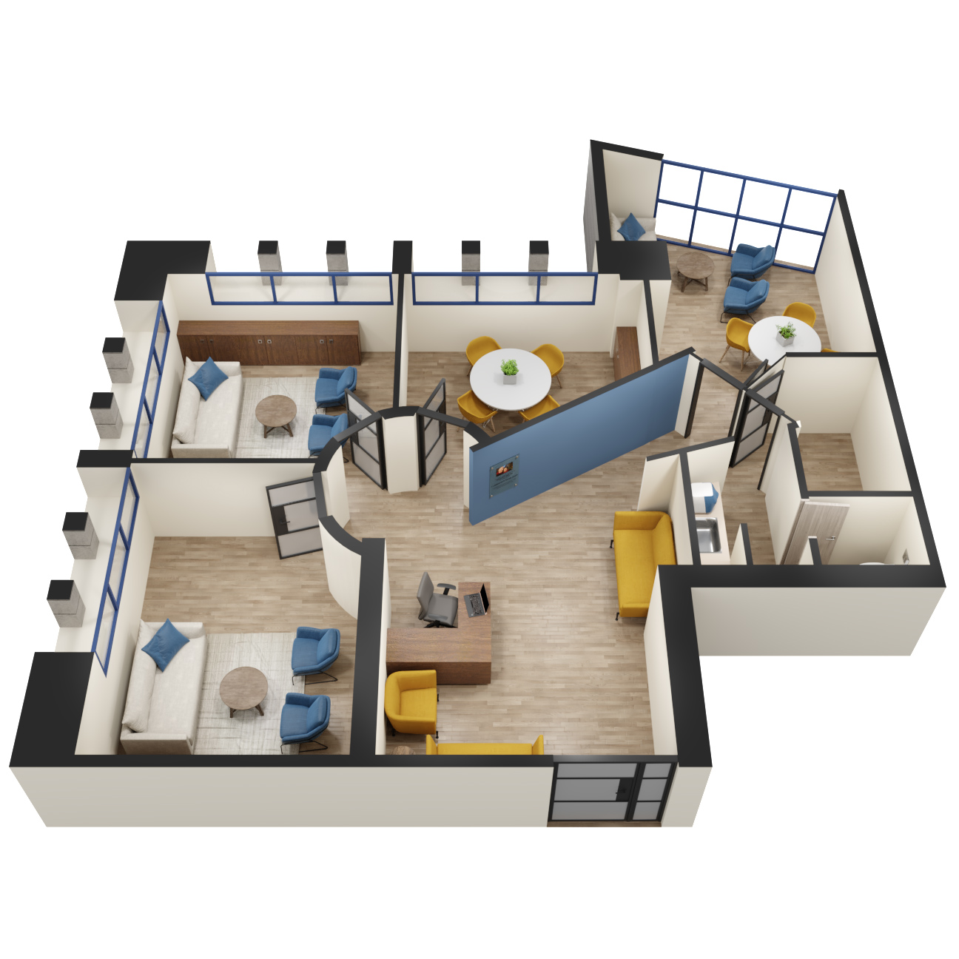

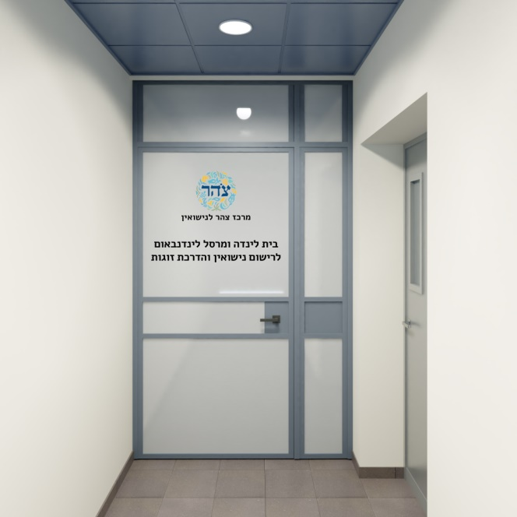

**For illustration only - dedication will be as per the donor’s wishes**

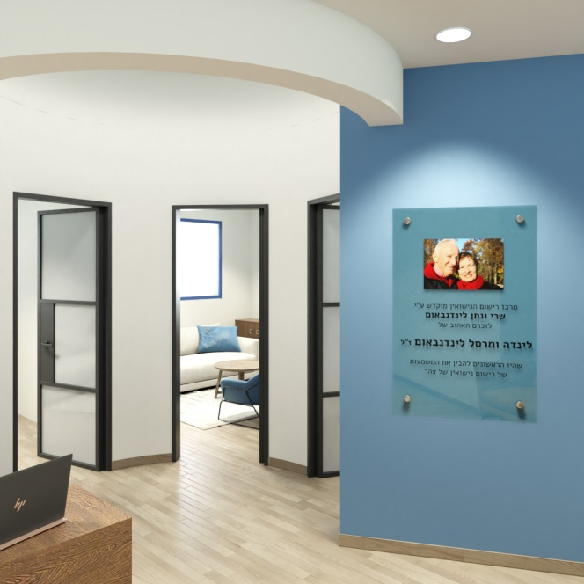

**For illustration only - dedication will be as per the donor’s wishes**

**Appendix B: Mock Up of the Mikveh**

(These are artistic renditions, for illustration purposes only)

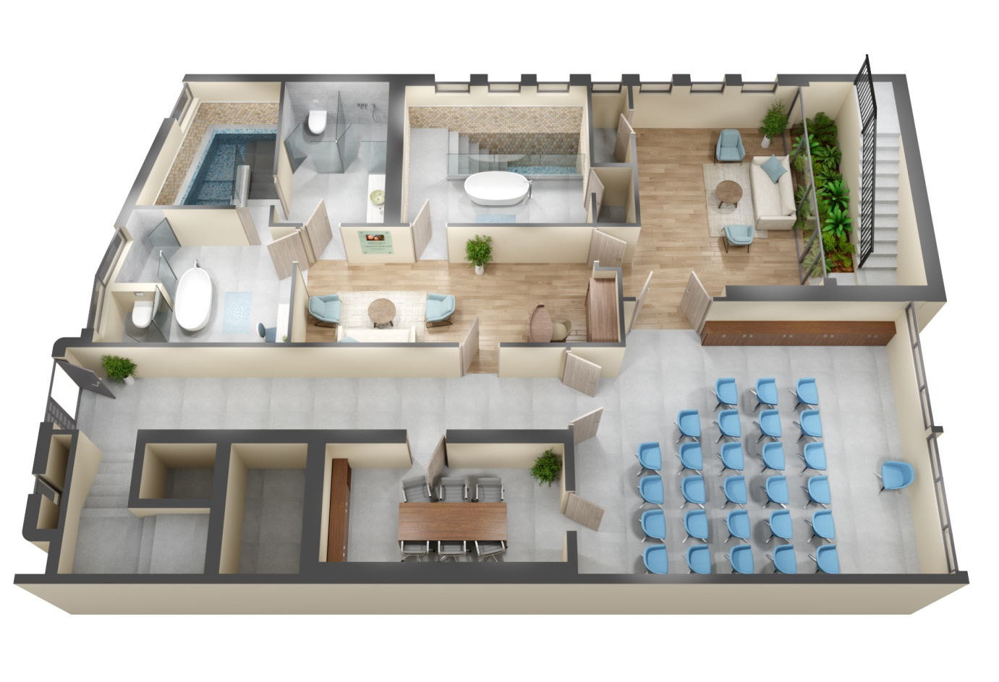

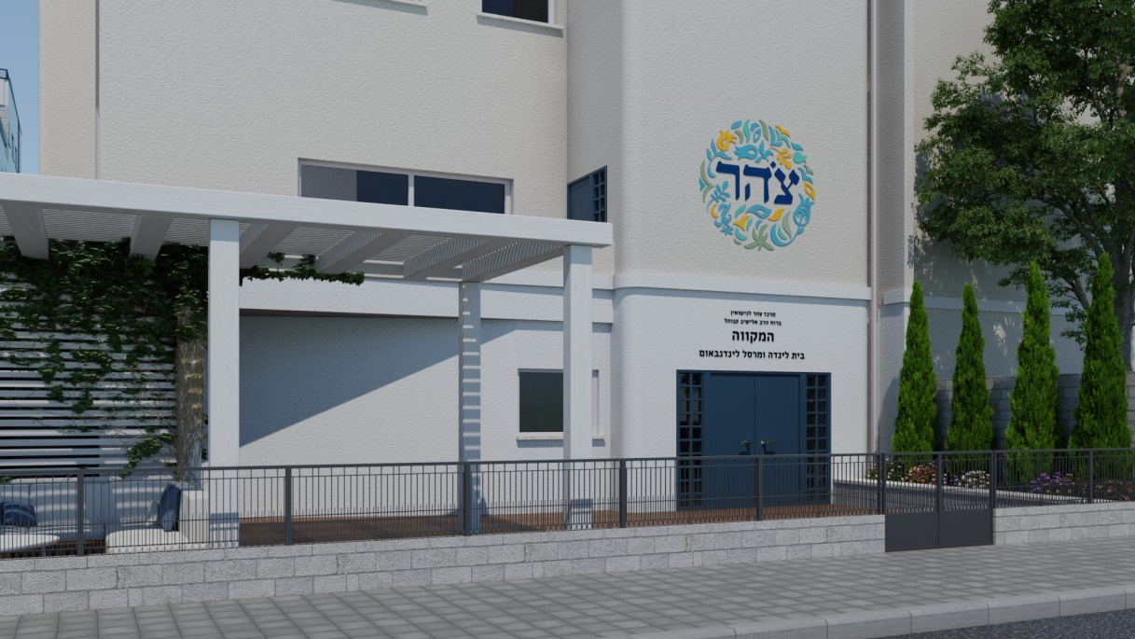

**For illustration only - dedication will be as per the donor’s wishes**

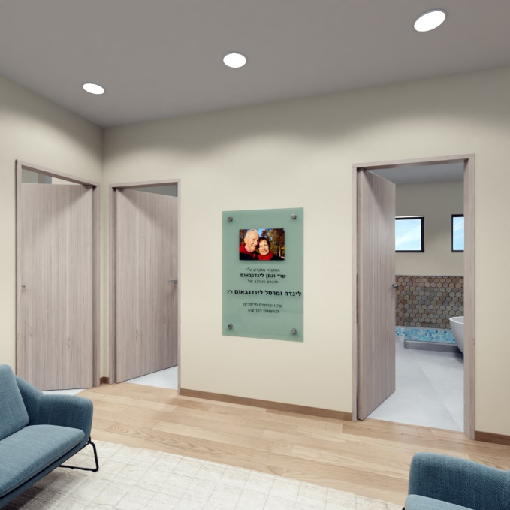

**For illustration only - dedication will be as per the donor’s wishes**