**How do I reset my password?**

**The pre-requisites for being able to reset your password are that**

* **You know your KONE username (=KONE email/UPN in format firstname.lastname@kone.com)**
* **You have Microsoft Authenticator -app installed on your device and it has been registered to your KONE account.   
  OR**
* **You have mobile phone number recorded in Workday.**

1. Go to <https://passwordreset.kone.com>
2. Provide your KONE Username (= KONE email/UPN) and prove you are not a robot by entering the characters you see on the screen, and then **click “Next”.**

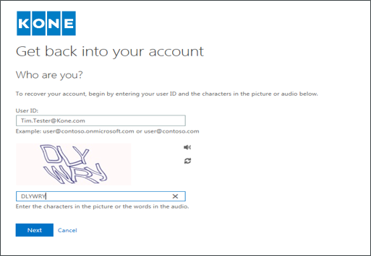

If you cannot identify the characters, click this icon to generate new characters.

1. Select whether you want to prove your identity using your mobile number or the Authenticator app which is installed on your device.

* If you select **“Text my mobile phone”** you will receive a verification code to your mobile number.
* If you select **“Call my mobile phone”** you will receive a verification code via mobile phone call.
* 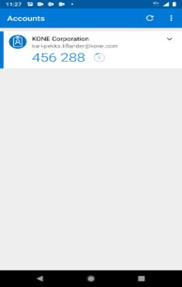If you select **“Enter a code from my authenticator app”** you will get a verification code to the “Microsoft Authenticator” application on your mobile device.

1. Provide the verification code to the text box.

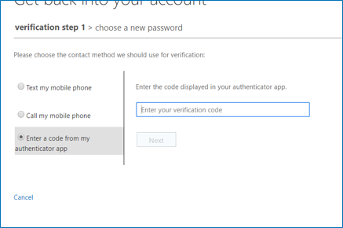

1. Enter a new password and **click “Finish”.**

