**Discover the Secret in the Picture!**

**1**

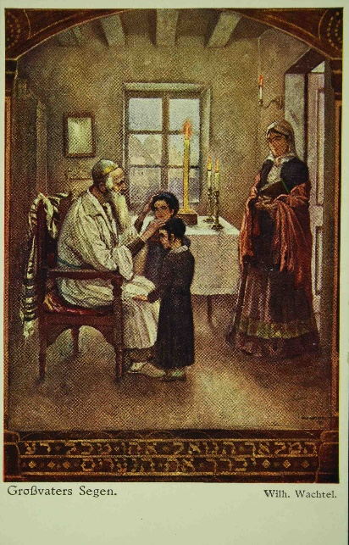This is a [colourful picture of a family](https://web.nli.org.il/sites/NLI/English/digitallibrary/pages/viewer.aspx?docid=EDU_XML_ENGSP476&presentorid=EDU_XML_ENG&searchurl=https%3A%2F%2Fweb.nli.org.il%2Fsites%2Fnlis%2Fen%2Feducation%2Fpages%2Fresults.aspx%23%3Fquery%3Dlsr16%2Cexact%2CPrimary+Source%26query%3Dany%2Ccontains%2Cgrandfather%26institution%3DNNL%26vid%3DEDU_XML_ENG%26loc%3Dlocal%2Cscope%3A(EDU_XML_ENG)%26sortField%3Dlso04%26indx%3D1%26bulkSize%3D8) from the collections of the National Library of Israel. The picture was painted in 1914.

**2**

**First Glance**

**<add image of picture>**

The first stage to understanding this image and learning its's secrets is to observe the details.

Write a list of all the details you see in the picture? _________________________________________  
_________________________________________________________________________________________________________________________________________________________________________________________________________________________________________________________

**3. Closer Observation**

Now, let's look a little closer…

What is happening in the picture? _______________________________________________________  
___________________________________________________________________________________What is the old man doing? What is the women doing? And the children? _______________________  
___________________________________________________________________________________

What is the old man wearing? _______________________________________________________

What is on the table? _________________________________________________________________

What can you see on the man's chair? _______________________________________________

What time of day is it? ________________________________________________

**4. Making Sense of it all…**

**<add image of picture>**

First, let's try and figure out when this scene is taking place?

What do you think? _________________________

Why do you assume this?   
Write hints that you found in the picture that helped you come to this conclusion______________________________________________________________________  
___________________________________________________________________________________

4.

**The Eve of Yom Kippur**

Some of you might have assumed that this scene took place on the Eve of Shabbat. This is a logical guess.   
But if we look closer we can see that the picture is actually depicting an Ashkenazi family before the beginning of Yom Kippur.

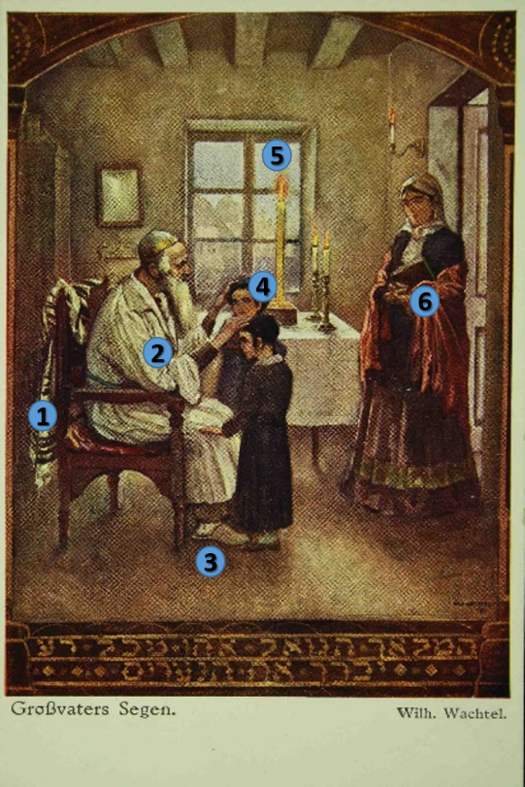Write the number of the detail in the picture that matches the Ashkenazi customs of the eve of Yom Kippur.

* On the eve of Yom Kippur it is customary for all members of the family to go to the special "Kol Nidrei" service. ______
* Many people wear white clothes to symbolize purity. Men often wear a special garment called "kittel". ______
* Many people observe the prohibition of wearing leather shoes on Yom Kippur and wear slippers or shoes of different materials. ________
* In addition to the candles that are lit before Yom Kippur (like on Shabbat), an additional candle is lit and is intended to last through the whole day. _____
* Some communities traditionally have a special blessing for the sons and daughters on the eve of Yom Kippur. ______
* As opposed to all evening prayers in the year, it is customary to wear a tallit also on the evening of Yom Kippur. _____

This picture depicts customs of certain Ashkenazi communities.  
What special customs does your family have for the evening or day before Yom Kippur?

_________________________________________________________________________________________________________________________________________________________________________________________________________________________________________________________

**5. Who are the people in the picture?**

We have figured out that this is a scene of the eve of Yom Kippur.   
But who are the people in the image?



A hint at the bottom of the page can help you solve this mystery.

What language is this written in? ______________

What does it mean (Tip – use google translate. Instead of this letter – **ß** – you can use the letters **ss**

<answer> This picture is indeed depicting a grandfather blessing his grandchildren on the eve of Yom Kippur with wishes for the new Jewish year.

**6. What is this blessing?**

As we mentioned above, it is customary to bless the children on the eve of Yom Kippur and according to other traditions each Shabbat night.

What is the origin of the blessing?

A hint to this also appears below the picture.

These are the words that were included in the picture:

"המלאך הגואל אותי מכל רע יברך את הנערים"   
"the angel who has redeemed me from all evil, bless the boys"

These words are a quote from a biblical story.

Search for these words in Genesis chapter 48 and answer the questions:

* Who is blessing?
  + Joseph
  + Jacob **<correct answer>**
  + Moses
* Whom is he blessing?
  + Joseph
  + Joseph's sons **<correct answer>**
  + Joseph's grandsons

This blessing was given by Jacob before his death. As is written in Genesis chapter 48, Jacob blesses his sons including Joseph and his two sons Menashe and Ephraim.

|  |  |
| --- | --- |
| And Joseph said to his father, “They are my sons, whom God has given me here.” “Bring them up to me,” he said, “that I may bless them.”… The Angel who has redeemed me from all harm— Bless the lads. In them may my name be recalled, And the names of my fathers Abraham and Isaac, And may they be teeming multitudes upon the earth.” | וַיֹּ֤אמֶר יוֹסֵף֙ אֶל־אָבִ֔יו בָּנַ֣י הֵ֔ם אֲשֶׁר־נָֽתַן־לִ֥י אֱלֹהִ֖ים בָּזֶ֑ה וַיֹּאמַ֕ר קָֽחֶם־נָ֥א אֵלַ֖י וַאֲבָרֲכֵֽם...  הַמַּלְאָךְ֩ הַגֹּאֵ֨ל אֹתִ֜י מִכָּל־רָ֗ע יְבָרֵךְ֮ אֶת־הַנְּעָרִים֒ וְיִקָּרֵ֤א בָהֶם֙ שְׁמִ֔י וְשֵׁ֥ם אֲבֹתַ֖י אַבְרָהָ֣ם וְיִצְחָ֑ק וְיִדְגּ֥וּ לָרֹ֖ב בְּקֶ֥רֶב הָאָֽרֶץ׃ |

This biblical story is the inspiration for the traditional *birkat habanim –* the blessing of the sons and daughters.

According to the tradition, the parents (or grandparents) place their hands on the child and bless blessings taken from the priestly blessings:

|  |  |
| --- | --- |
| For boys: May you be like Ephraim and Menashe. | יְשִׂימְךָ אֱלֹהיִם כְּאֶפְרַיְם וְכִמְנַשֶּׁה |
| For girls: May you be like Sarah, Rebecca, Rachel, and Leah. | יְשִׂימֵךְ אֱלֹהיִם כְּשָׂרָה רִבְקָה רָחֵל וְלֵאָה |
| And then – for both boys and girls:  May God bless you and protect you. May God show you favor and be gracious to you. May God show you kindness and grant you peace. | יְבָרֶכְךָ ה' וְיִשְׁמְרֶךָ יָאֵר ה' פָּנָיו  אֵלֶיךָ וִיחֻנֶּךָּ ִישָּׂא ה' פָּנָיו אֵלֶיךָ וְיָשֵׂם לְךָ שָׁלום |

**7. The Artist**

We have learned about the scene in the picture and about the tradition that it is depicting.

What about the artist?

What is his name? ____________________________  
  
  
The artist who painted this painting is Wilhelm Wachtel.

**Who was Wilhelm Wachtel?**

Wachtel was born in Lvov, Poland in 1875. He studied art in Krakow and later in Munich. Most of his art was of Jewish and Zionist themes.

Click [here](https://www.google.com/search?rlz=1C1GCEB_enIL903IL903&sxsrf=ALeKk01HQXhm2IkphP_5KQWinEwd5DFO5w:1597561531081&source=univ&tbm=isch&q=wilhelm+wachtel+artist&sa=X&ved=2ahUKEwjqiMS8lJ_rAhXDyaQKHRm_DD4Q7Al6BAgPEDU&biw=1280&bih=578) to see other paintings by Wachtel.

* Choose one image.
* Why did you pick this image?
* Describe the image _________________________________________________________  
  ________________________________________________________________________________________________________________________________________________________
* Give the image a title _________________________________________________________
* Is the picture you chose similar to the one of the grandfather blessing the children? Explain why or why not. ______________________________________________________________  
  ____________________________________________________________________________

**8. Connecting the picture to your life!**

* Do your parents usually bless you on Yom Kippur or on Shabbat?   
  Do your parents have another special time when they give you their good wishes?   
  When is this?   
  What do they say?   
  How do you feel when they bless you in this way?  
  ____________________________________________________________________________________________________________________________________________________________________________________________________________________________________
* This picture shows a family on the eve of Yom Kippur.  
  Do you observe Yom Kippur?  
  What do you do on this day?  
  Does your family have special traditions for the eve of Yom Kippur? If so what are they?  
  ____________________________________________________________________________________________________________________________________________________________________________________________________________________________________

**9. Being Creative**

* Imagine an artist came to your home on Yom Kippur.

Help the artist decide which moment to paint.

Explain why you chose this moment.    
Draw your own picture of this moment.

* Write a story or create a meme based on this picture by Wilhelm Wachtel.   
  What are the people saying to each other?  
  What happened before?  
  What happened after?