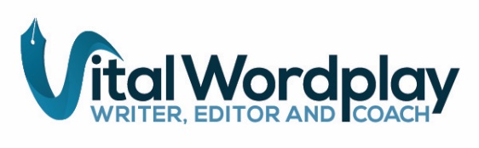

**Barbra Rodriguez**

[barbra@vitalwordplay.com](mailto:barbra@vitalwordplay.com)

Editor with 21 years of experience. Skilled at developing succinct, vibrant copy that is on message and helps a client’s voice shine. Editing of [books](https://www.vitalwordplay.com/editing-info), magazines and other long-form content is informed by 24 years of writing professionally about health, diversity, engineering, sustainability and other areas (see [LinkedIn](https://www.linkedin.com/in/vitalwordplay/) clips).

# Skills & Experience

Editing

* Copyediting, proofreading, fact checking
* Medical and scientific editing
* Magazine issues (20-plus), blogs
* Online educational webinars
* Citation formatting
* Style guide and book map creation

Writing

* + Book ghostwriting
  + Magazine and Web features
  + Conference correspondent
* Press releases (over 200 developed)
* Social media
* Providing photo suggestions, taglines

# Work History

**Freelancer** 2016-present

Editing clients include: MIT and Catapult presses, W.W. Norton; self-published authors; Jackson School of Geosciences, UT Austin, and Deep Foundations Institute (engineering magazine editing)

**Science Writer/Editor** 2008-2016

UT Austin Lady Bird Johnson Wildflower Center (8 years), Cockrell School of Engineering (3 years), Natural Sciences College (2 years, Communications Director)

**Sr. Comm. Coordinator** 2000-2002

Alvin J. Siteman Cancer Center,

Washington University School of Medicine in St. Louis; Part-time freelance writer

**Medical Science Writer** 1997-2000 Washington Univ. School of Medicine in St. Louis

# Education

UC, San Diego Copyediting Certificate Program, 2019 (aced all classes); UC, Santa Cruz Science Communication program, 1996 certificate; master’s in molecular cell biology and biochemistry, Washington University in St. Louis, 1994; bachelor’s in biology and in secondary science education, University of Missouri, Columbia, 1987

# Activities

Writer’s League of Texas (WLOT) Agents & Editors Conference (2018-2020); Diversity Travel Fellowship, World Conference of Science Journalists, and Journalist Travel Grant, Ecological Soc. of America Conference, 2017; non-fiction book competition judge, National Association of Science Writers, 2016, and for WLOT competitions, 2014, 2015; Austin Creative Non-Fiction meetup group director, 2011-2013