DECISION
!11
(Power of Attorney)
The President of the European Investment Bank,
HAVING REGARD TO Article 11 (6) of the Statute of the European Investment Bank ("the Bank");
CONSIDERING the need to avoid any discontinuity in the functioning of the Bank, particularly in case of emergency;
CONSIDERING the desirability, for this purpose, of authorising the Directors of the Bank's Legal Directorate to represent the Bank, or to appoint agents and lawyers to represent the Bank, and to adopt any necessary measures to defend the interests of the Bank, in judicial and extrajudicial matters;
DECIDES :
Article 1
The Directors of the Legal Directorate of the Bank (Director General and Department Directors) are authorised to represent the Bank or to appoint agents or external lawyers to represent the Bank, in judicial or extrajudicial matters, particularly before any Union or national administrative, legai or judicial authority, within or outside the European Union.
Article 2
- The Directors of the Legal Directorate are specifically authorised to adopt ali necessary measures
and take ali necessary action in order to represent the interests of the Bank before any Union or national administrative, legai or judicial authority, within or outside the European Union.
- The Directors of the Legal Directorate, as well as the agents or external lawyers whom they have
appointed, are authorised:
- to sign, execute and submit any legai, judicial or extrajudicial act or any document related
to such act and/or to connected procedures in any kind of proceedings before any Union or national administrative, legai or judicial authority, within or outside the European Union;
- to appear, as representatives of the Bank, in any kind of proceedings before Union or
national administrative, legai or judicial authorities, within or outside the European Union.
Article 3
- The Directors of the Legal Directorate to whom powers have been delegated by the present
decision appear on the List of Authorised Signatures of the Bank.
- For the exercise of the powers defined in the present decision, the Directors of the Legal
Directorate may act individually.
Agents and external lawyers appointed by virtue of the present decision shall act in accordance with the terms and conditions of the mandate given to them.

- The Directors of the Legal Directorate of the Bank are authorised to sub-delegate the powers set forth in the present decision, for a limited period of time or with a limited scope, to members of the Bank with the ability to legally bind it, in accordance with the provisions of the List of Authorised Signatures of the Bank.
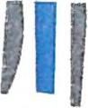
- The powers defined in the present decision are delegated unti) written revocation.
- The present decision applies without prejudice to any other Power of Attorney or Delegation of Power to the Directors of the Legal Directorate or other services or members of the Bank.
Luxembourg,"/Ò 2018
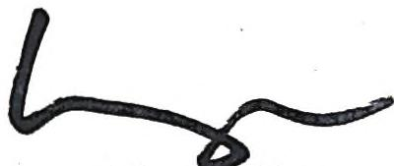
Werner Hoyer President
The undersigned Paul BETTINGEN, civil law notary residing in Niederanven (Grand-Duchy of Luxembourg)
hereby certifies the authenticity of the signature of
Mr. Werner HOYER apposed hereabove.
Senningerberg, 4th day 2⁴ • tober 2018hiG_{A},
<_{(,}⁴> i i!,

.<:Z2
ct1 CL.
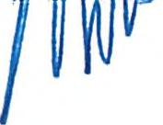
``‘)EF3pM

