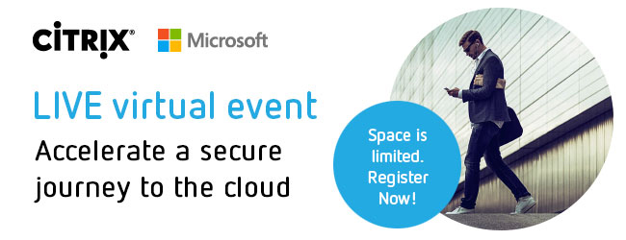

LIVE virtual event

Accelerate a secure journey to the cloud

Space is limited. Register Now!

Citrix and Microsoft continue to innovate through a partnership that is stronger than ever and grounded in simplifying the journey to the cloud for their customers.

**Session highlights:**

* Learn ways to stay secure regardless of where you are in your digital transformation journey.
* Hear best practices from customers who are successfully moving workloads - including mobile and desktop workspaces - to the cloud.
* Be the first to hear about what's next for Citrix and Microsoft