**Atmospheric indices allow anticipating the incidence of jellyfish coastal swarms**

Coastal incidence of jellyfish in the Alboran Sea

J.J. Bellido 1,2*, J. C. Báez 3,4, L. Souviron-Priego1,2, F. Ferri-Yañez 5, C. Salas 2, J. A. López 1 & R. Real 2

1Aula del Mar de Málaga. Calle Pacífico 80, E-29004, Málaga.

2Departamento de Biología Animal, Cátedra de Ciencias del Litoral de la Costa del Sol, Facultad de Ciencias, 29071, Campus de Teatinos, Universidad de Málaga, Málaga

3Instituto Español de Oceanografía (IEO), Centro Oceanográfico de Málaga, Puerto Pesquero s/n, 29640 Fuengirola, Málaga.

4Investigador asociado de la Facultad de Ciencias de la Salud, Universidad Autónoma de Chile, Chile

5Helmholtz Centre for Environmental Research – UFZ. Halle (Saale), Germany.

* Corresponding author: [jjbellido@auladelmar.info](mailto:jjbellido@auladelmar.info) (+34) 637401042

**Abstract**

Jellyfish swarms affect littoral ecosystems, are unpleasant for bathers and jeopardize coastal socio-economic sectors. Anticipating the incidence of jellyfish swarms could be useful for implementing preventive management measures. Macroclimatic indices are good candidates for this type of anticipation since they are macro-ecologically related to oceanographic characteristics that affect marine species after a certain time lag. An increase of jellyfish swarms has been recently reported in the Mediterranean Sea. From 2005 to 2018, jellyfish swarms in the littoral of the province of Malaga (Spain, northwest coast of the Alboran Sea), mainly formed by the mauve stinger (*Pelagia noctiluca*), were frequent during summer. We recorded data on jellyfish swarm incidence in the province of Malaga from 2005 to 2018 using the reports in local newspapers, searches in Google Search Engine, and a citizen science application for mobile phones as information sources. With this information, we classified the period in years of low, medium and high incidence of jellyfish swarms. Then, we tested if the known effects of the Arctic Oscillation (AO) and North Atlantic Oscillation (NAO) in winter on the sea surface temperature (SST) during the year, which in turn affects the proliferation of jellyfish, could explain the inter-annual variation in this incidence. Our hypothesis significantly explained the variation in the medium versus low incidence of jellyfish swarms, with medium incidence in the summers of higher SST. This suggests that medium incidence of jellyfish swarms was caused by the proliferation of jellyfish. This also suggests that years of medium incidence of jellyfish in the beach during summer could be anticipated by computing the average AO and NAO values of the previous winter. Years of high incidence of swarms could not be explained by this process. We speculate that they may be caused by a change in the distribution of the swarms rather than by proliferation. Jellyfish may be pushed from the pelagic western anticyclonic gyre of the Alboran Sea to the northern coast by eddies that are formed when, as recent literature has shown, this gyre is weakened by westerly winds and the Atlantic jet. Citizen science has contributed useful data to build macroecological models that may result in better management plans based on scientific data.

**Keywords**

Alboran Sea; Arctic Oscillation; climatic fluctuations; Mediterranean Sea; North Atlantic Oscillation; *Pelagia noctiluca;* Sea Surface Temperature.

**Abbreviations**

AICc: Akaike Information Criterion

AJ: Atlantic water jet

AO: Atlantic Oscillation

AUC: Area Under the receiving operating characteristic Curve

ECS: Environmental Citizen Science

LON: Local Observer Network

NAO: North Atlantic Oscillation

NOAA: National Oceanic and Atmospheric Administration

PV: potential vorticity

SST: Sea Surface Temperature

WAG: Western Alboran Gyre

**Introduction**

Jellyfish experience strong inter-annual variation in density within their natural life cycles, which results in inter-annual fluctuations in the jellyfish swarm occurrence pattern (Mills, 2001; Boero, 2013). For the purposes of this study, the term 'jellyfish' is used in reference to medusae of the phylum Cnidaria (Scyphozoa, Cubozoa) and swarm refers to a large number of specimens in an area, regardless of whether the increase in number was caused by proliferation, aggregation, or distribution change (Hamner & Dawson, 2009). A natural oscillatory pattern in jellyfish swarms has been estimated to occur with a periodicity of 20 years, based on data collected all around the world (Condon *et al.,* 2013). These cyclical patterns of occurrence have been associated with climatic fluctuations (Boero *et al.*, 2008). More specifically, studies in the western Mediterranean basin estimated a periodicity of 12 years for swarms of mauve stinger (*Pelagia noctiluca* Forskal, 1775), related to climatic fluctuations and patterns in annual precipitation, temperature and atmospheric pressure (Goy *et al.,* 1988). In smaller seas, such as the Alboran Sea, this periodicity in mauve stinger swarms may be shorter, as it is the case in the Adriatic Sea, with several significant swarm periodicities of 10 years, 2,5 years, 8-14 months and 8 months, since 1970 (Kogovsek *et al*., 2010).

The North Atlantic Oscillation (NAO) captures the difference of pressure between the Azores anticyclone and the low-pressure region near Iceland and is considered the largest source of seasonal and annual variability of atmospheric conditions in the North Atlantic basin (Hurrell, 1995, Hurrell *et al.,* 2001). The Arctic Oscillation (AO) is defined by a southern dipole in the atmospheric pressure at sea level between Polar Regions and middle latitudes and could be interpreted as the signature of modulations in the force of the polar vortex in height (Thompson & Wallace, 1998). The effect of these climatic indices has a greater impact in winter on the North Atlantic climate (Hurrell, 2001; Thompson & Wallace, 1998). More specifically, Báez *et al.* (2013) found that the combination of low NAO and high AO values during winter increases the Sea Surface Temperature (SST) of the Alboran Sea during the year. High SST is known to have an effect on the population cycle of *Pelagia noctiluca*, favoring the development of ovules and, thus, their proliferation (Avian *et al*., 1991). Consequently, winter values of NAO and AO could be good candidates to anticipate the incidence of jellyfish swarms the following summer.

Testing the effects of these macroclimatic indices on jellyfish requires to increase the sources of reliable data about jellyfish swarm occurrence at the beaches where they may cause problems. Environmental Citizen Science projects (ECS) are a way to engage the citizens in science and research. For this reason, EU institutions recommend the implementation of ECS initiatives (Science Communication Unit, 2013). At present, the ECS has entered a new phase thanks to the new mass media that have been facilitated by the use of internet and smartphones. These media favor the setting of networks of committed citizens that may be useful to record the presence of species around the world in an easy and economical way (Conrad & Hilchey, 2011; Palmer *et al.,* 2017). In this context, the Provincial Deputation of Malaga, in collaboration with Aula del Mar of Malaga, has developed the *Infomedusa App*, a smartphone application in use since 2013, which may be used by citizens to monitor the presence and abundance of jellyfish swarms along the coast of the province of Malaga (north coast of the Alboran Sea).

The aim of this study is to assess whether inter-annual variation in atmospheric indices in winter may be indicative of the incidence of *Pelagia noctiluca* swarms the following summer on the coasts of Malaga. We used diverse sources of data to establish the level of incidence of the swarms, including those provided by the citizen science *Infomedusa App*. We specifically aimed to test if the known effects of the AO and NAO in winter on the SST during the year are related to the proliferation of jellyfish, and could explain the inter-annual variation in the incidence of jellyfish swarms in the coasts of Malaga. This information will be helpful for forecasting and managing these swarms in order to minimize their impact on the coastal human activities and littoral ecosystems.

**Materials and Methods**

*Study area*

Our study area was the coast of the province of Malaga (Spain), located in the north-west of the Alboran Sea, (Fig. 1). The Alboran Sea comprises the westernmost part of the Mediterranean Sea and is directly connected with the Atlantic Ocean through the Strait of Gibraltar. It is bordered by the Iberian Peninsula to the north, Africa to the south, the Strait of Gibraltar to the west, and the Almeria-Oran oceanographic to the east. It is about 180 km wide in the N-S direction and about 350 km long in the W-E direction (Fig. 1). One of the most characteristic hydrological features of the Alboran Sea is the presence of two highly variable superficial anticyclonic gyres at its western and eastern halves (the so-called Alboran Gyres) as a result of the incoming of the Atlantic water jet through the Strait of Gibraltar (Sánchez-Garrido *et al.,* 2013; Oguz *et al.*, 2014).

*Local data collection*

Aula del Mar (<https://www.auladelmar.info/>) is a non-governmental organization based in Malaga whose main aim is the study and conservation of the marine environment, particularly within the limits of the Alboran Sea. It has been recording reports of diverse origins of jellyfish incidence on the coast of Malaga province since 2005. Since 2015, these reports included those of the ECS app *Infomedusa App* (see below). As an additional source of information, the impact of searches in the Google Search Engine relative to the searching term “medusas” in Spain was measured using the online tool Google Trends (Fig. 2). The third source of information was the number of news related to jellyfish presence on the coast of the province of Malaga in the local newspaper *Diario Sur*, using the newspaper library available online since 2006 (Fig. 2). Using data from these sources, the years between 2005 and 2018 were classified as years with low, medium or high incidence of jellyfish in the beach, according to the relative abundance of reports, news, and searches from Google.

Monitoring jellyfish through citizen science

Since the year 2013, daily information from May to September about sighting and stranding of jellyfish on the coast of the province of Malaga was provided by citizens via the *Infomedusa App* (<http://www.infomedusa.es/>). During the years 2013 and 2014 this information was collected only by a Local Observer Network (LON) composed of volunteers and professionals who worked on the coast, such as civil protection agents, lifeguards, and municipal technicians.

Since 2015, *Infomedusa app* users have been able to interact using a public chat for each beach, allowing users to send photos and comments focused primarily on the presence of jellyfish and the state of the beach. Thus, the app became a free ECS platform for smartphones that collects information about the presence of jellyfish. The app covers all the beaches along the coastal municipalities of the province of Malaga (Fig. 1). These reports were analyzed and classified in five categories: i) irrelevant report (not useful information about jellyfish provided); ii) absence of jellyfish in the beach (explicitly stated in the report); iii) low abundance of jellyfish in the beach (report referred to less than 10 individuals per day and beach); iv) medium abundance of jellyfish in the beach (when there were between ten and dozens of individuals per day and beach) and v) high abundance of jellyfish in the beach (explicitly stating in the report the presence of more than one hundred individuals per day and beach). When no LON user reported a possible swarm of jellyfish, the information was validated by the accumulation of similar reports or other sources of validation, such as local authority reports or press news. Between 2015 and 2018, about 77,000 comments were issued by the users of the *Infomedusa App*.

*Statistical analysis*

We created three temporal binary variables, with the states occurrence = 1 and absence = 0, related to the incidence of jellyfish swarms in the summer of each year between 2005 and 2018, namely: 1) HM: occurrence of years with medium or high incidence of jellyfish combined (state = 1) versus years of low incidence of jellyfish at the beach (state = 0), 2) H: occurrence of years with high incidence of jellyfish (state = 1) *versus* years of low and medium incidence combined (state = 0), and 3) M: occurrence of years with medium incidence of jellyfish (state = 1) versus years of low incidence of jellyfish swarms at the beach (state = 0).

We hypothesized that high SST values, caused by low NAO and high AO values during the previous winter, favor the proliferation of jellyfish due to reproduction. Thus, we were expecting that summers with an increased incidence of jellyfish swarms at the beach would be preceded by winters with a combination of low NAO values and high AO values. We tested if the probability of finding summers with incidences of coastal swarms of jellyfish was significantly related to the NAO and the AO winter values from January to March (NAOw and AOw) using logistic regression, one the most commonly used method to investigate the relationship between binary data and environmental variables (Sillero *et al.,* 2010). In this way, we tested the relationship between the three temporal binary variables and the average NAO and AO values of the previous winter. NAOw and AOw values for the whole studied period 2005–2018 were taken from the monthly values available at the National Oceanic and Atmospheric Administration (NOAA) website (<http://www.noaa.gov>).

We built probability (P) models for the occurrence of summers with an increased incidence of jellyfish swarms according to the NAOw alone (model 1), to the AOw alone (model 2), to the NAOw and AOw together (model 3), and also building a probability model based on the logit function obtained by Báez *et al.* (2013), which determined the probability of observing mean annual SST values higher than average in the function of the NAOw and AOw values (model 4). Given that high SST values are associated to low NAOw and high AOw values (Báez *et al.*, 2013), to corroborate our hypothesis the coefficient multiplying the NAOw alone in model 1 should be negative, the coefficient multiplying the AOw alone in model 2 should be positive, the coefficients multiplying the NAOw and AOW in model 3 should be negative and positive, respectively, and the coefficient multiplying the logit function obtained by Báez *et al.* (2013) in model 4 should be positive.

We also checked if the function obtained by Báez *et al.* (2013) was still predictive of SST values in the Alboran Sea by updating the model with SST values from 2005 to 2018 (Muñoz *et al.*, 2013) and assessing the discrimination capacity of the updated model using the "Area Under the receiving operating characteristic Curve" (AUC) (Lobo *et al.*, 2008). SST values from 2005 to 2010 were available in Báez *et al.* (2013), and those from 2011 to 2018 were extracted from the product “erdMH1sstdmday” at NOAA CoastWatch ([https://coastwatch.pfeg.noaa.gov](https://coastwatch.pfeg.noaa.gov/)) data web service using the R package “rerddapXtracto”.

The four models for each target binary variable were ranked according to the corrected Akaike Information Criterion (AICc) (Akaike, 1973; Burnham & Anderson, 2004). The statistical significance of the models was assessed using the Omnibus test (Legendre & Legendre, 1998; Hosmer & Lemeshow, 2000; Peng *et al.,* 2002).

We then applied the favorability function (Real *et al*., 2006; Real *et al*., 2017) to assess the degree to which the climatic conditions during winter favor the occurrence of jellyfish blooms the following summer. Favorability (F) was calculated from P using the following equation (Real *et al*., 2006):

F = [P/(1-P)]/[(n1/n0) + (P/[1-P])],

where n1 and n0 are the number of years with occurrence and absence of jellyfish bloom, respectively. Thus, we obtained four favorability models corresponding to the four probability models.

We evaluated the discrimination capacity of the models with the AUC (Lobo *et al.*, 2008). The classification capacity of the models, using the favorability value F = 0,5 as classification threshold (Acevedo & Real, 2012), was assessed by measuring their sensitivity, specificity, correct classification rate (CCR), and Cohen’s Kappa (Fielding & Bell, 1997).

**Results**

Between 2005 and 2018, *Pelagia noctiluca* was the most frequent species on the coast of Malaga in summer and the only species that appeared in high concentrations. Other species were scarce close to the coast and were not detected forming swarms.

According to the data collected by the *Infomedusa App*, data analyzed from Google Trends, and the online newspaper library of the *Diario Sur*, years with medium or high incidence of jellyfish swarms in the littoral of Malaga were frequent between 2005 and 2018, as these events occurred in 9 out of the 14 years analyzed (Fig. 2). Four of these years were considered years with high incidence of jellyfish. Thus, for HM we had a total of 14 values, with 9 occurrences, for H we had 14 values with 4 occurrences, and for M we had 10 values with 5 occurrences (Fig. 2).

The updated model obtained by Báez *et al.* (2013) was still predictive of SST values in the Alboran Sea from 2005 to 2018, as the updated model significantly discriminated SST values above average from those below average (AUC = 0.844, p < 0,05). According to Hosmer and Lemeshow (2000, p.162), this AUC value represents an excellent discrimination capacity.

The logic functions of the probability models for the occurrence of summers with incidences of jellyfish swarms can be seen in Table 1.

Discrimination, classification and AICc values of the models can be seen in Table 2, while a graphic representation of the most significant favorability models can be seen in Fig. 3.

Coefficients of models 2, 3 and 4 for HM were in agreement with our hypothesis, but only model 2 was significant and its classification power was moderate according to all evaluation measures (Table 2). However, when separating the high and medium jellyfish density events in separate models for H and M, the four models for H were not significant, while models 2, 3 and 4 for M were significant (Table 1) and with higher discrimination and classification power (Table 2). Therefore, our hypothesis was only corroborated for M. Model 4 for M was the most significant and the best according to AICc values. For H the relationship with SST was negative, which suggests that high-density events were not caused by the proliferation of jellyfish, but by another factor that our models cannot explain.

**Discussion**

*The role of citizen science in jellyfish bloom monitoring*

The ability to form swarms is a natural feature of jellyfish, which tend to appear abruptly during spring and summer (Hamner & Dawson, 2009). In recent years, jellyfish swarms have attracted considerable scientific interest due to the perceived increase of their impacts on human activities and marine ecosystems (Graham *et al*., 2014). Our results confirm that the first years of the XXI century have been a period with a relevant presence and abundance of jellyfish, particularly *Pelagia noctiluca*, along the nearly 200 kilometers of the coast of Malaga. Due to the lack of long temporal data series in the Alboran Sea for the abundance of jellyfish, it is not clear if this represents a large-scale change in the patterns of the coastal swarms of this species (Condon *et al*., 2012). However, blooms of *Pelagia noctiluca* have indeed been reported more frequently in the Mediterranean since 1999 (La Spada *et al*., 2002; Daly Yahia *et al*., 2010; Kogovšek *et al*., 2010, Licandro *et al*., 2010).

For that reason, it is of great importance to increase the sources of reliable data available for scientific analyses of jellyfish swarms. In this case, the press, Internet, Aula del Mar legacy databases and citizen science have provided profuse and useful data that have allowed us to analyze the jellyfish incidence between 2005 and 2018. Data provided by citizen science (i.e. *Infomedusa*) have been more abundant since 2015 when the app chat was implemented (see material and methods section). Lee e*t al*. (2006) stated that citizen science complements and enhances scientific studies, and also may complement governments in actions for which they have not enough resources. However, Silvertown (2009) recommended checking the quality of citizen science data before the analyses. In our case, data obtained from the app users have been standardized and contrasted with other data sources, mainly local authorities. In this way, citizen science provided reliable and contrastable data such as, for example, the identification of the jellyfish species responsible for the late swarms as *Pelagia noctiluca* with the use of photography.

*Macroecological context of jellyfish swarms in the coast of Malaga*

Attempts at modelling the presence of jellyfish swarms on the coast have usually faced difficulties, such as the scarcity of available data, limited sources of information and constraints in the model used (Tomlinson *et al.,* 2018). For example, Berline *et al.* (2012) compared six Mediterranean zooplankton time series from 1957 to 2006 and found no significant correlations between climate indices and local temperature or zooplankton abundance. They did not find any correlation between zooplankton abundance of different coastal stations, suggesting that local drivers (climatic, anthropogenic) would be dominant for these stations. Berline *et al.* (2012) also concluded that the link between local and larger-scale climate should be investigated further to understand zooplankton fluctuations.

Another element to be accounted for is the jellyfish behavior, which can actively swim counter-current, facilitating swarm formation (Malej, 1989; Fossette *et al.,* 2015), and can submerge, avoiding the effect of superficial currents and winds (Zavodnik, 1987), which makes the prediction of the swarm formation elusive. However, in general, jellyfish swarms must be the outcome of changes in proliferation, aggregation or distribution patterns in the populations involved, and the success in modelling these changes is dependent on the identification of the relevant biogeographical and macroecological context.

In our case, the macroecological context within which to model the temporal pattern of the swarms is the Alboran Sea. The Almeria-Oran front, which constitutes the eastern limit of the Alboran Sea (Tintore *et al.,* 1988), behaves typically as a fertilization site in an otherwise oligotrophic environment (Fiala *et al.,* 1994). Smaller zooplankton, which does not undertake vertical migration, remain concentrated near the surface in the fast-flowing frontal jet (Fielding *et al.,* 2001) acting as a source of food for, and therefore favoring the presence of, gelatinous organisms such as jellyfish. On the other hand, the Almeria-Oran front makes a strong barrier for the large jellyfish swarms formed in the Western Mediterranean and for other planktonic organisms (Pérez-Portela *et al.,* 2019), which indicates that the causes of jellyfish swarms in the coast of Malaga should be found within the Alboran Sea.

*Sea surface temperature and jellyfish proliferation*

Our models comparing years with medium density *versus* years of low density of jellyfish, encompassed in the binary variable M, point to a coincidence between the increased proliferation of jellyfish and the increase in sea surface temperature in the Alboran Sea. This fact has also been found in the Moroccan North-West Mediterranean coastline (Aouititen *et al.*, 2019). The NAO in the negative phase in combination with the AO in a positive phase during winter increases the accumulation of snow in mountain peaks, which increases the runoff of fresh water to the sea in spring and summer due to the melting of that snow (Báez *et al.,* 2013). This runoff of freshwater reduces the sea surface salinity and density in the Alboran Sea, changing the depth of water mixture, and reducing the input of colder water by the coastal upwelling (Báez *et al.,* 2013) which, in turn, increases the Sea Surface Temperature. Our updated model suggests that this relationship was still acting during the study period. The effect of SST on the *P. noctiluca* reproduction success is well known (Canepa, 2014). A study in the Adriatic Sea suggested that *P. noctiluca* has a life cycle of one year (Piccinetti-Manfrin *et al.,* 1986). This species reproduces on the high seas without any polyp phase (Delap & Delap, 1906). Reproduction seems to be carried out at any time (Piccinetti-Manfrin *et al.,* 1986) with peaks in spring and autumn (Rottini Sandrini & Avian, 1991). Avian *et al*. (1991) suggested that high water temperature favors the development of the ovules of *P. noctiluca*, induced by metabolic changes. This is not surprising, as changes in water temperature play a key role in gonadal development and growth of many marine organisms (Ansell, 1972, Carrasco *et al*., 2006). This is why SST is one of the main driving environmental variables influencing planktonic cnidarian community composition, abundance and spatial distribution patterns at a mesoscale area in the Mediterranean (Guerrero *et al.,* 2018).

In addition to this, the coastal upwelling areas are zones of advection of jellyfish (Hamner *et al.,* 1994). Our results suggest that the higher input of freshwater with a large amount of nutrients from rivers to the sea were coincident with years of medium density of jellyfish. The latter could be due to the formation of coastal fronts with a proliferation of microzooplankton, which jellyfish blooms are generally associated with (Graham *et al.,* 2001). Taking all of the above into account, the increased reproduction of *P. noctiluca* after winters with high AO and low NAO values would coincide with the proliferation of microzooplankton in coastal upwellings, which favors the presence of jellyfish swarms at these coastal fronts (Shenker, 1984).

This pattern may be difficult to generalize to the whole planet, as cold waters have been linked to jellyfish swarms in colder areas of the world. (Purcell, 2005). To take a global perspective, it is possible that the species from cold areas would produce large swarms during colder periods while the swarms of temperate species would be favored by warm periods (Purcell, 2005).

*Effect of the Western Alboran Gyre*

However, our hypothesis was not corroborated in the model comparing years of high density of jellyfish *versus* those of medium and low density combined, as encompassed in the binary variable H. When high and medium density events were merged in the binary variable HM, the results were mixed and confusing, with only AO values responding according to our hypothesis. This suggests that with the variable HM we were mixing events due to two different processes, which blurred the results. This also suggests that high-density blooms are not the result of proliferation, but rather of changes in aggregation or distribution patterns of the species.

When gelatinous plankton drifts into surface waters, it is subjected to the forces of winds and currents in a similar way as other passive particles in suspension in the open seas (MacAli *et al.,* 2018). Alboran Gyres (Fig. 1) could then be the main drivers of this passive movement, acting as vectors for the aggregation of gelatinous plankton in the periphery (where there are fronts with abundant zooplankton) (Mutlu, 2001, Leon *et al*.*,* 2015). According to Sánchez-Garrido *et al*. (2013), the surface circulation of the Western Alboran Sea collapses through the interaction of the Atlantic water jet (AJ) - Western Alboran Gyre (WAG) system and a growing cyclonic eddy that arises close to the Spanish coast. This eddy develops as the WAG partially blocks the positive potential vorticity (PV) flux coming from the Strait of Gibraltar. Flows driven by atmospheric pressure have the potential of destabilizing the circulation by raising dramatically the PV flux within a time scale of some days. This results in a force that can convey the jellyfish to the continental shelf where they can be driven to the shore by local vectors (Goy *et al.,* 1988; Pourjomeh *et al.,* 2017; MacAli *et al.,* 2018).

Therefore, the geographical location and relative intensity of the WAG (Fig. 1) seem to be dependent on the frequency and intensity of Atlantic fronts that can reduce and even eliminate the WAG, weakening the thermo-saline barrier of the coast (Sánchez-Garrido *et al.,* 2013). This elimination favors the formation of eddies that move to the continental shelf carrying jellyfish previously accumulated in the gyre and giving place to the occurrence of high incidence of jellyfish swarms, which are driven first toward western beaches and, afterwards, to the eastern ones following the direction of the current. In years of low coastal incidence of jellyfish swarms, the direction and strength of the current in the north part of the well-established WAG may retain jellyfish mainly within this gyre and could protect the beaches from the arrival of jellyfish swarms, giving place to the occurrence of low incidence of jellyfish swarms. When the WAG is stabilized and SST is higher, proliferation produces small swarms of *P. noctiluca* composed by old and large specimens about 10-30 cm long and elliptical in shape (Malej, 1989) which, after their last spawning and before they die, are carried out by the winds and wash up on the beaches (Hamner & Hauri, 1981; Malej, 1989). The relationship between these oceanographic processes and the high density of jellyfish in the coasts is only a speculation and must be tested when longer temporal series of jellyfish blooms and swarms become available.

**Acknowledgments**

We thank Diputación Provincial de Málaga and Aula del Mar for providing data from *Infomedusa App* for this research. We are grateful to all the members of Civil Protection, Beach Lifeguard Services, Municipal Technicians, Local Police, Civil Guard, Coastal Cleaning Boat Services, volunteers, etc., who have collaborated altruistically and professionally in the Local Observers Network.

**References**

Acevedo, P., Real, R., 2012. Favourability: concept, distinctive characteristics and potential usefulness. *Naturwissenschaften*, 99 (7), 515-522.

Akaike, H., 1973. Information Theory and an Extension of the Maximum Likelihood Principle. p. 199–213. In: *Proceedings of the second international symposium on information theory. Akademiai Kiado*, Petrov, B.N., Csaki, F. (Eds)*.* Budapest, Hungary*.*

Ansell, A., 1972. Distribution, growth and seasonal changes in biochemical composition for the bivalve *Donax vittatus* (da Costa) from Kames Bay, Millport. *Journal of Experimental Marine Biology and Ecology*, 10 (2), 137-150.

Aouititen, M., Bekkali, R., Nachit, D., Luan, X., Mrhraoui, M., 2019. Predicting Jellyfish Strandings in the Moroccan North-West Mediterranean Coastline. *European Scientific Journal,* 15 (2), 72-84.

Avian, M., Rottini Sandrini, L., Stravisi, F., 1991. The effect of seawater temperature on the swimming activity of *Pelagia noctiluca* (Forsskål). *Italian Journal of Zoology*, 58 (2), 135-143.

Báez, J.C., Gimeno, L., Gómez-Gesteira, M., Ferri-Yáñez, F., Real, R., 2013. Combined Effects of the North Atlantic Oscillation and the Arctic Oscillation on Sea Surface Temperature in the Alboran Sea. *PLoS ONE*, 8 (4), e62201.

Berline, L., Siokou-Frangou, I., Marasović, I., Vidjak, O., Fernández de Puelles, M.L. *et al.,* 2012. Intercomparison of six Mediterranean zooplankton time series. *Progress in Oceanography*, 97–100, 76-91.

Boero, F., Bouillon, J., Gravili, C., Miglietta, M.P., Parsons, T. *et al*., 2008. Gelatinous plankton: Irregularities rule the world (sometimes). *Marine Ecology Progress Series*, 356, 299-310.

Boero, F., 2013. Review of Jellyfish Blooms in the Mediterranean and Black Sea. Studies and Reviews. *General Fisheries Commission for the Mediterranean*, 93.

Burnham, K.P., Anderson, D.R., 2004. Multimodel Inference: Understanding AIC and BIC in Model Selection. *Sociological Methods & Research*, 33 (2), 261-304.

Canepa, A.J., 2014. *Jellyfish of the Spanish Mediterranean coast: effects of environmental factors on their spatio-temporal dynamics and economic impacts*. PhD Thesis. University of Barcelona, Spain, 252 pp.

Carrasco, C., Navarro, J., Leiva, G., 2006. Biochemical composition and tissue weight of *Chorus giganteus* (Gastropoda: Muricidae) exposed to different diets and temperatures during reproductive conditioning. *Interciencia,* 31 (5), 376-381.

Condon, R.H., Graham, W.M., Duarte, C.M., Pitt, K.A., Lucas, C.H. *et al*., 2012. Questioning the rise of gelatinous zooplankton in the world's oceans. *BioScience*, 62 (2), 160-169.

Condon, R.H., Duarte, C.M., Pitt, K.A., Robinson, K.L., Lucas, C.H. *et al*., 2013. Recurrent jellyfish blooms are a consequence of global oscillations. *Proceedings of the National Academy of Sciences*, 110 (3), 1000-1005.

Conrad, C.C., Hilchey, K.G., 2011. A review of citizen science and community-based environmental monitoring: issues and opportunities. *Environmental Monitoring and Assessment*, 176 (1-4), 273-291.

Daly Yahia, M.N., Batistic, W., Lucic, D., Fernández de Puelles, M.L., Licandro, P. *et al*., 2010. Are outbreaks of *Pelagia noctiluca* (Forskäl, 1771) more frequent in the Mediterranean basin? In: Gislason, A., Gorsky, G. (Eds.), Proceedings of the Joint ICES/CIESM Workshop to Compare Zooplankton Ecology and Methodologies between the Mediterranean and the North Atlantic (WKZEM): ICES Cooperative Research Report, 300, pp. 8-14. Copenhagen.

Delap, M., Delap, C., 1906. Notes on the plankton of Valencia Harbour, 1902–1905. *Fisheries, Ireland, Scientific Investigations 1905*, 7, 3-21.

Fiala, M., Sournia, A., Claustre, H., Marty, J.C., Prieur, L. *et al.,* 1994. Gradients of phytoplankton abundance, composition and photosynthetic pigments across the Almeria-Oran front (SW Mediterranean Sea). *Journal of Marine Systems*, 5 (3-5), 223-233.

Fielding, A., Bell, J., 1997. A review of methods for the assessment of prediction errors in conservation presence/absence models. *Environmental Conservation*, 24 (1): 38-49.

Fielding, S., Crisp, N., Allen, J., Hartman, M., Rabe, B. *et al.,* 2001. Mesoscale subduction at the Almeria–Oran front: Part 2. Biophysical interactions. *Journal of Marine Systems*, 30 (3-4), 287-304.

Fossette, S., Gleiss, A.C., Chalumeau, J., Bastian, T., Armstrong, C.D. *et al.,* 2015. Current-Oriented Swimming by Jellyfish and Its Role in Bloom Maintenance. *Current Biology*, 25 (3), 342-347.

Goy, J., Morand, P., Etienne, M., 1988. Long-term fluctuations of *Pelagia noctiluca* (Cnidaria, Scyphomedusa) in the western Mediterranean Sea. Prediction by climatic variables. *Deep Sea Research*, 36 (2), 269-279.

Graham, W.M.,

Graham, W.M., Gelcich, S., Robinson, K.L., Duarte, C. M., Brotz, L. *et al*., 2014. Linking human wellbeing and jellyfish: ecosystem services, impacts and social responses. *Frontiers in Ecology and the Environment*, 12 (9), 515-523.

Guerrero, E., Gili, J.M., Grinyó, J., Raya, V., Sabatés, A., 2018. Long-term changes in the planktonic cnidarian community in a mesoscale area of the NW Mediterranean. *PLOS ONE*, 13 (5), e0196431.

Hamner, W.M.,

Hamner, W.M., Hamner, P.P., Strand, S.W., 1994. Sun-compass migration by *Aurelia aurita* (Scyphozoa): population retention and reproduction in Saanich Inlet, British Columbia. *Marine Biology*, 119 (3), 347-356.

Hamner, W.M.,

Hosmer, D.W., Lemeshow, S., 2000. *Applied Logistic Regression. Wiley Series in Probability and Statistics.* Wiley, New York, 375 pp.

Hurrell, J.W., 1995. Decadal Trends in the North Atlantic Oscillation: Regional Temperatures and Precipitation. *Science*, 269 (5224), 676-679.

Hurrell, J.W., Kushnir, Y., Visbeck, M.H., 2001. CLIMATE: The North Atlantic Oscillation. *Science*, 291 (5504), 603-605.

Kogovšek, T., Bogunovic, B, Malej, A., 2010. Recurrence of bloom-forming scyphomedusae: wavelet analysis of a 200-year time series. *Hydrobiologia,* 645, 81-96.

La Spada, G., Marino, A., Sorrenti, G., 2002. *Pelagia noctiluca* “Blooming” in the Strait of Messina: preliminary studies on the applicability of two methods for isolating nematocytes. *Marine Ecology*, 23 (1), 220-227.

Lee, T., Quinn, M., Duke D., 2006. Citizen, Science, Highways, and Wildlife: Using a Web-based GIS to Engage Citizens in Collecting Wildlife Information. *Ecology and Society*, 11 (1), 11.

León, P., Blanco, J., Flexas, M., Gomis, D., Reul, A., *et al.,* 2015. Surface mesoscale pico–nanoplankton patterns at the main fronts of the Alboran Sea. *Journal of Marine Systems*, 143, 7-23.

Licandro, P., Conway, D.V.P., Daly Yahia, M.N., Fernandez de Puelles, M.L., Gasparini, S. *et al*., 2010. A blooming jellyfish in the northeast Atlantic and Mediterranean. *Biology letters*, 6 (5), 688-691.

Lobo, J., Jiménez-Valverde, A., Real, R. 2008. AUC: a misleading measure of the performance of predictive distribution models. *Global Ecology and Biogeography*, 17 (2), 145-151.

MacAli, A., Semenov, A., Venuti, V., Crupi, V., D’Amico, F. *et al.,* 2018. Episodic records of jellyfish ingestion of plastic items reveal a novel pathway for trophic transference of marine litter. *Scientific Reports*, 8 (1), 6105.

Malej, A., 1989. Behaviour and trophic ecology of the jellyfish *Pelagia noctiluca* (Forsskål, 1775). *Journal of Experimental Marine Biology and Ecology*, 126 (3), 259-270.

Mills, C.E., 2001. Jellyfish blooms: are populations increasing globally in response to changing ocean conditions? *Hydrobiologia*, 451 (1-3), 55-68.

Muñoz, A.R., Márquez, A.L. Real, R. 2013. Updating known distribution models for forecasting climate change impact on endangered species. *PLoS ONE*, 8(6): e65462.

Mutlu, E., 2001. Distribution and abundance of moon jellyfish (*Aurelia aurita*) and its zooplankton food in the Black Sea. *Marine Biology*, 138 (2), 329-339.

Oguz, T., Macias, D., Garcia-Lafuente, J., Pascual, A., Tintore, J., 2014. Fueling plankton production by a meandering frontal jet: a case study for the Alboran Sea (Western Mediterranean). *PLoS ONE*, 9 (11), e111482.

Palmer, J.R.B., Oltra, A., Collantes, F., Delgado, J.A., Lucientes, J. *et al.,* 2017. Citizen science provides a reliable and scalable tool to track disease-carrying mosquitoes. *Nature Communications*, 8 (1), 916.

Peng, C.Y.J., Lee, K.L., Ingersoll, G.M., 2002. An Introduction to Logistic Regression Analysis and Reporting. *The Journal of Educational Research*, 96 (1), 3-14.

Pérez-Portela, R., Wangensteen, O.S., Garcia-Cisneros, A. *et al.* 2019. Spatio-temporal patterns of genetic variation in *Arbacia lixula*, a thermophilous sea urchin in expansion in the Mediterranean. *Heredity* 122**,**244-259.

Piccineti-Manfrin, C., Piccinetti, C., Fiorentini, C., 1986. Distribuzione di *Pelagia noctiluca* in Adriatico negli anni 1983 e 1984. *Nova Thalassia*, 8, 99-102.

Pourjomeh, F., Shokri, M.R., Rezai, H., Rajabi-Maham, H., Maghsoudlou, E., 2017. The relationship among environmental variables, jellyfish and non-gelatinous zooplankton: A case study in the north of the Gulf of Oman. *Marine Ecology*, 38 (6), e12476.

Purcell, J.E., 2005. Climate effects on formation of jellyfish and ctenophore blooms: a review. *Journal of the Marine Biological Association of the United Kingdom*, 85 (3), 461-476.

Real, R., Barbosa, A. M., Vargas, J. M., 2006. Obtaining environmental favourability functions from logistic regression. *Environmental and Ecological Statistics*, 13 (2), 237-245.

Rottini Sandrini, L., Avian, M., 1991. Reproduction of *Pelagia noctiluca* in the central and northern Adriatic Sea. *Hydrobiologia*, 216–217, 197-202.

Sánchez-Garrido, J.C., García Lafuente, J., Álvarez Fanjul, E., Sotillo, M.G., de los Santos, F.J., 2013. What does cause the collapse of the Western Alboran Gyre? results of an operational ocean model. *Progress in Oceanography*, 116, 142-153.

Science Communication Unit, University of the West of England, Bristol 2013. *Science for Environment Policy In- depth Report: Environmental Citizen Science*. Report produced for the European Commission DG Environment, December 2013. <http://ec.europa.eu/science-environment-policy> (Accessed XXX)

Shenker, J.M., 1984. Scyphomedusae in surface waters near the Oregon coast, May–August 1981. *Estuarine, Coastal and Shelf Science*, 19 (6), 619-632.

Sillero, N., Martínez-Freiría, F., Real, R., Barbosa, A.M., 2010. Los modelos de nicho ecológico en la herpetología ibérica: pasado, presente y futuro. *Boletín de la Asociación Herpetológica Española*, 21, 2-24.

Silvertown, J., 2009. A new dawn for citizen science. *Trends in Ecology and Evolution*, 24 (9), 467-471.

Thompson, D.W.J., Wallace, J.M., 1998. The Arctic oscillation signature in the wintertime geopotential height and temperature fields. *Geophysical Research Letters*, 25 (9), 1297-1300.

Tintore, J., La Violette, P.E., Blade, I., Cruzado, A., 1988. A Study of an Intense Density Front in the Eastern Alboran Sea: The Almeria–Oran Front. *Journal of Physical Oceanography*, 18 (10), 1384-1397.

Tomlinson, B., Maynou, F., Sabatés, A., Fuentes, V., Canepa, A. *et al.,* 2018. Systems approach modelling of the interactive effects of fisheries, jellyfish and tourism in the Catalan coast. *Estuarine, Coastal and Shelf Science*, 201, 198-207.

Zavodnik, D., 1987. Spatial aggregations of the swarming jellyfish *Pelagia noctiluca* (Scyphozoa). *Marine Biology*, 94 (2), 265-269.

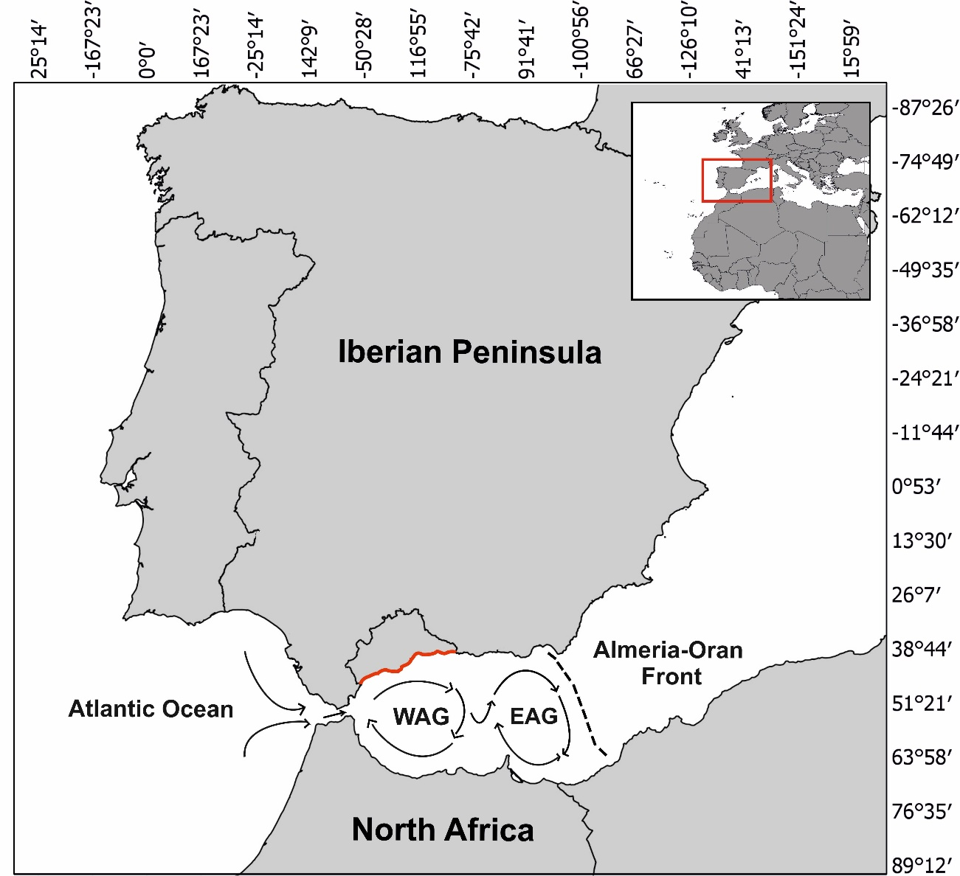

**Fig. 1.** Area of study. The province of Malaga is represented, being the red line the location of the coast of Malaga in the Alboran sea. Geographical situation and the surface circulation of the Alboran Sea are represented. Arrows represent stream lines, and Western (WAG), and Eastern (EAG) Alboran gyres are shown.

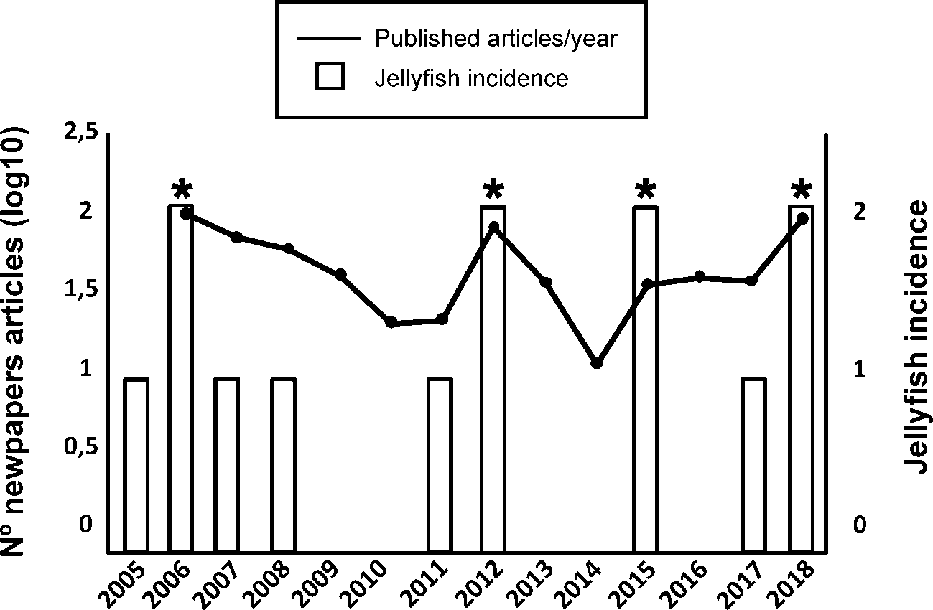

**Fig. 2**. Incidence of jellyfish swarms detected in the coast of the province of Malaga from 2005 to 2018. Columns represent jellyfish incidence according to reports of diverse origin received in Aula del Mar, categorized as follow: 0 = low (when a few individuals were reported), 1 = medium (when jellyfish in small groups were reported) and 2 = high (when large swarms of jellyfish were reported). Asterisks represent the years with the most notable peaks in the results of searches for the term “medusas” (Spanish term for "jellyfish") in Google Trend between 2005 and 2018 for Spain. Line represents the Log10 of the number of news published every year in Malaga by the local press (Diario Sur) related to high density of jellyfish at beaches (available since 2006).



**Fig. 3:** Graphic representation of the best significant models according to AICc for the binary variables HM (A), and M (B). No significant model was obtained for the binary variable H. Crosses (X) represent the years with occurrence (upper part of the graphics) or absence of occurrence (lower part of the graphics) of jellyfish swarms. Dots represent the favourability values (between 0 and 1), i.e., the degree to which jellyfish swarm incidence in a given year in summer is favoured according to the different AOw (A) and predicted SST (B) values. HM, H and M as in table 1.

**Table 1.** Logit functions of the four probability models tested for each of the three target variables HM, H and M**.** HM: occurrence of years with medium or high incidence of jellyfish combined (state = 1) versus years of low incidence of jellyfish in the beach (state = 0). H: occurrence of years with high incidence of jellyfish (state = 1) versus years of low and medium incidence combined (state = 0). M: occurrence of years with medium incidence of jellyfish (state = 1) versus years of low incidence of jellyfish swarms in the beach (state = 0). Coefficients are shown for the intercept and the explanatory variables NAOw, AOw, and YSST. Omnibus test and significance values are shown. Significant values are shown in bold.

|  |  |  |  |  |  |  |
| --- | --- | --- | --- | --- | --- | --- |
| **Model** | **Intercept** | **NAOw** | **AOw** | **YSST** | **Omnibus test** | ***P*** |
| HM1 | 0.242 | 1.234 |  |  | 2.008 | 0.156 |
| HM2 | 0.908 |  | 1.575 |  | 4.803 | **0.028** |
| HM3 | 1.699 | -1.581 | 2.528 |  | 5.486 | 0.064 |
| HM4 | 1.030 |  |  | 0.176 | 0.962 | 0.327 |
| H1 | -1.788 | 1.771 |  |  | 2.488 | 0.115 |
| H2 | -0.903 |  | 0.431 |  | 0.436 | 0.509 |
| H3 | -2.379 | 3.052 | -1.278 |  | 3.452 | 0.178 |
| H4 | -1.881 |  |  | -0.331 | 2.699 | 0.100 |
| M1 | -0.173 | 0.929 |  |  | 0.795 | 0.373 |
| M2 | 0.133 |  | 2.004 |  | 4,605 | **0.032** |
| M3 | -1.784 | -5.154 | 4.461 |  | 7.188 | **0.027** |
| M4 | 0.814 |  |  | 0.907 | 5.721 | **0.017** |

**Table 2.** Measure of the model evaluation indices: Area under the curve (AUC), Cohen’s Kappa, sensitivity, specificity, correct classification rate (CCR) and corrected Akaike information criterion (AICc) of the models performed. HM, H and M as in table 1. *: AUC value statistically significant (p < 0,05).

|  |  |  |  |  |  |  |
| --- | --- | --- | --- | --- | --- | --- |
| **Model** | **AUC** | **Kappa** | **Sensibility** | **Specificity** | **CCR** | **AICc** |
| HM1 | 0.622 | 0.255 | 0.667 | 0.600 | 0.643 | 18.098 |
| HM2 | 0.822 | 0.255 | 0.667 | 0.600 | 0.643 | 15.303 |
| HM3 | 0.844* | 0.255 | 0.667 | 0.600 | 0.643 | 16.478 |
| HM4 | 0.667 | 0.255 | 0.667 | 0.600 | 0.643 | 19.144 |
| H1 | 0.725 | 0.286 | 0.750 | 0.600 | 0.643 | 16.120 |
| H2 | 0.575 | - 0.077 | 0.500 | 0.400 | 0.429 | 18.173 |
| H3 | 0.725 | 0.512 | 0.750 | 0.800 | 0.786 | 17.013 |
| H4 | 0.775 | 0.512 | 0.750 | 0.800 | 0.786 | 15.909 |
| M1 | 0.520 | 0 | 0.600 | 0.400 | 0.500 | 14.925 |
| M2 | 0.880* | 0.400 | 0.800 | 0.600 | 0.700 | 11.115 |
| M3 | 0.960* | 0.600 | 0.800 | 0.800 | 0.800 | 10.339 |
| M4 | 0.880* | 0.400 | 0.800 | 0.600 | 0.700 | 9.999 |