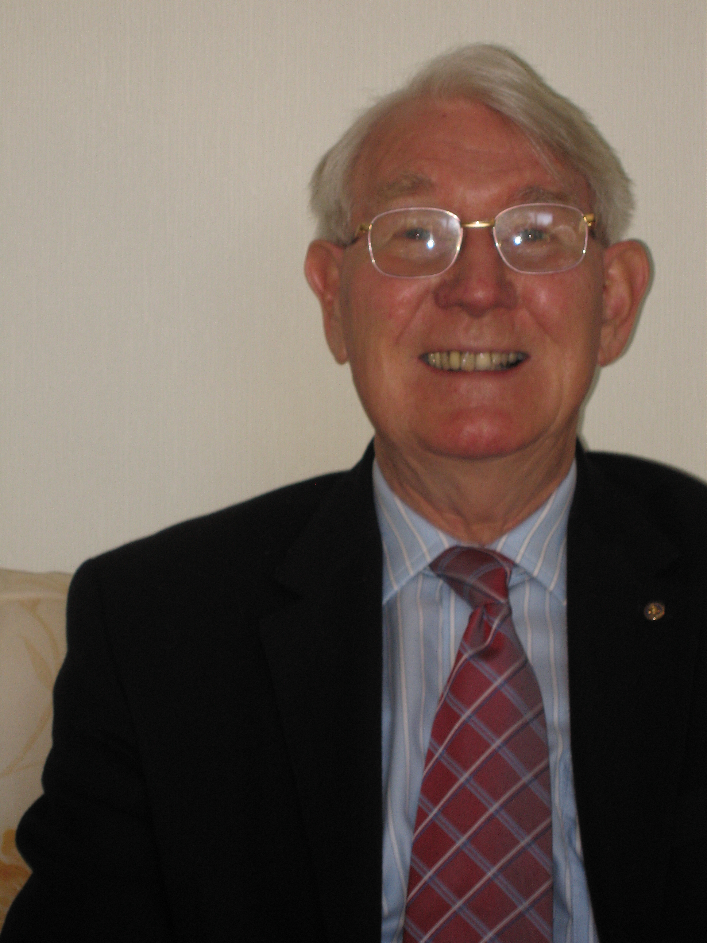 | John Gardam BSc(Eng), FIMechE, FITI,  Freelance Translator and Consultant  14 Lodge Close, Etwall, Derbyshire, DE65 6NA  Telephone No. 01283 733266  Mobile No. 07729 779663  E-Mail: johndgardam@gmail.com  Linkedin.com/in/john-gardam 666189124  Curriculum vitae
Married: Wife’s name Annette
One daughter, now a Dentist
Training

Studied Mechanical Engineering at Imperial College, London University. Awarded BSc(Eng) 2nd Class Honours. In long vacations worked abroad for Volvo in Sweden, Volkswagen in Germany and Saurer in Switzerland.
After retirement, studied French and German on the Honours Degree course at Derby and Nottingham Universities, but did not do sufficient modules to obtain a degree, and at Montpellier and Berlin Universities on short summer school courses.

Career

Worked for British Rail as a Mechanical Engineer for more than 30 years in a variety of jobs to do with the design and maintenance of locomotives and rolling stock, including 4 years seconded to ORE in Holland. This was the International Railway Research Organisation and it was here that I used German and French. I was Technical Secretary to 5 International Committees.

Freelance translation

Left British Rail in 1992 to become a freelance technical translator of German to English and French to English, specialising in 3 subjects:

Railways
Mechanical and Electrical Engineering
Instruction Manuals

My wife proof reads every word I translate which improves the quality. I am a Founder Member of ITI and since December 2015, FITI. Member of ITI LRG (London Regional Group), as well as French & German Networks, NWTN and ITI-YTI.

Recent translation customers include The European Commission, (Contracts Nos. Rail 10-012fr and de and Rail 16) Eurostar, UIC, Plasser & Theurer as well as other companies and agencies. I trade as Railway Translation Service.

I have Microsoft Windows 10, Microsoft Office 2016 SDL Trados 2019, MemoQ, 9.3 IntelliWebSearch and a PDF converter. I work with a computer that has 3 big screens.

Other information

I read the Business Section of the Daily Telegraph every day and several articles in the Economist every week so I understand the terms used in the worlds of banking and finance. I am familiar with engineering terms and units, specifications and standards as I have translated these for many years.

