CERTIFICATION OF AUTHENTICITY

"I, Hadas Salomon, a qualified translator possessing sound knowledge of both the English and Hebrew languages, hereby certify that the translation of the document listed below is as true and close to the original document as possible and has been translated to the best of my ability and knowledge, from the English language into Hebrew."

apbd 009-103 009 US dc letter 29 MAY 2015

Signed

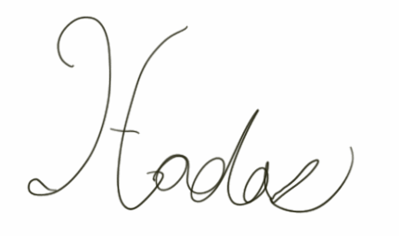

May 31, 2015

