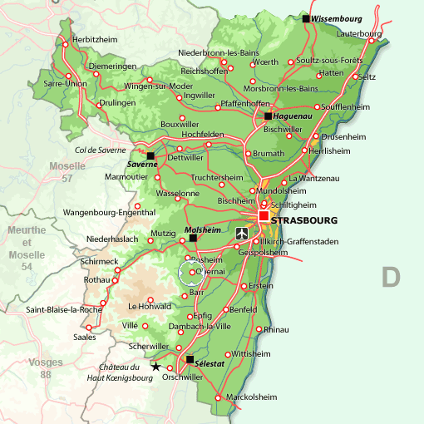

**A Brief History of Obernai**

Obernaim, originally referred to and known as “Ehenheim”, was also known as “Oberehnheim”. It was granted town rights in 1240 and granted such autonomy during this time period in the 13th century by the royal Hohenstaufen family. With this new status as an independent town, Obernai had the right to build its own fortifications and have its own commercial markets and fairs. In the mid-14th century, and by 1354, Obernai, along with nine other imperial towns of Alsace aligned themselves together to create the Décapole. Under this organization, Obernai was free of imperial [Holy Roman] rule and of rule by the nobility. This unique military alliance, which was originally recognized by Emperor Charles IV in 1354, was dissolved by King Louis XIV in 1679.

Obernai, during the Renaissance, underwent a golden age in which the Alsatian town grew in prosperity from commercial trade: crafts and wine production. During this period of time, famous architectural buildings were erected in Obernai that are still prevalent today: Hôtel de Ville, the Halle aux Blés, the Beffroi – the Kapellturm town and the Puits à Six Seaux well. The Thirty Years’ War (1618 to 1648), however, left Obernai and most of Alsace in ruins due to the religious wars. The war was finally concluded with the Peace of Westphalia in 1648.

In 1679, King Louis XIV annexed Obernai and the other nine towns, known as the Décapole, into the French empire. With this acquisition, Obernai lost its autonomous rights that it had held for approximately 440 years. Under King Louis XIV, Obernai became a royal town. Although it lost its independence, Obernai, during the 18th century, underwent a new age of prosperity: 35 different trades were established and over 306 master craftsmen developed business within Obernai. After the French Revolution, Obernai underwent significant changes regarding its landscape. Roads and railroads were developed, thus uniting Obernai to the other towns within Alsace and that of France.

**Sites to See within Obernai:**

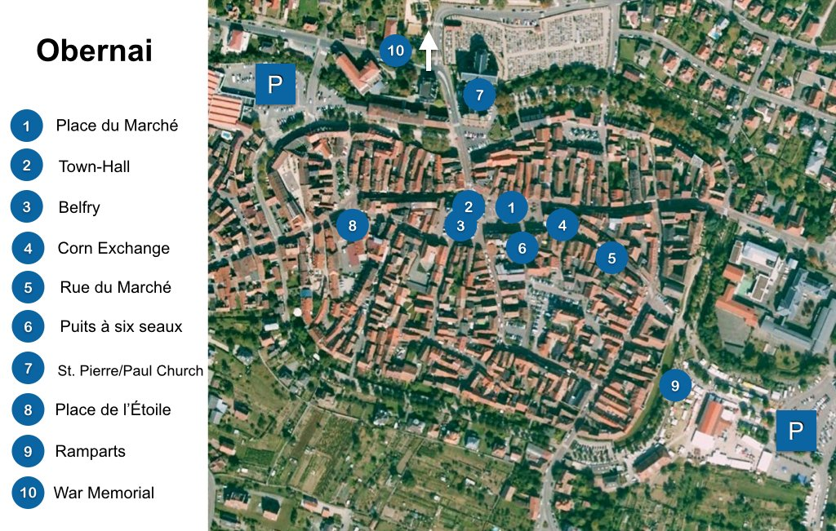

Obernai Map and Key:

1. Place du Marché
2. Town Hall
3. Belfry
4. Corn Exchange
5. Rue du Marché
6. Puits à six seaux
7. St. Pierre and St. Paul Church
8. Place de l’Étoile
9. Fortification walls
10. War Memorial
11. P refers to parking lots

**Place du Marché**

Obernai is a unique Alsatian town that combines medieval and Renaissance architecture. At the very heart and center of Obernai is the Place du Marché. This Alsatian town center features half-timbered built houses, town-hall, the belfry, and the corn exchange house or hall.

**The Town Hall**

The Town Hall is near the Chapel Tower within Obernai. The location of the Town Hall was originally the foundation for the former Court of the Burghers. The Town Hall is one of the oldest sites within Obernai, which dates back to 1370. The Town Hall expanded in size during the 19th century, featuring neo-Renaissance, neo-classical architecture. The façade features vivid colors and a fine sculpted balcony that dates back to 1604.

**The Belfry**

The Chapel Tower (known as the Kapelturm) dates back to the 13th century in 1285. This was the bell tower of the Virgin’s Chapel. This Gothic style bell tower is one of Alsace’s tallest bell towers. Since 1596, the belfry has been flanked by four other watchtowers. Although the chapel was destroyed by a fire in 1873, the tower became an enduring historical and cultural monument to Obernai. It acts as a bell tower, a watch tower, and as the town’s belfry.

**The Corn Exchange Market**

This market dates back to 1554 during the Renaissance. While Renaissance in architecture, this market building contains Gothic elements. This corn exchange market was at one point a public butchery.

**The Rue du Marché**

This street is the most famous street within Obernai that links the town center to the synagogue and the famous fortifications are aligned on both sides of this famous road. In front of these fortifications are the beautiful half-timbered houses, restaurants and cafes, including the Vintage and the Café des Amis.

**Puits à six seaux**

Known as the “Six Bucket Well”, the Puits à six seaux was built in 1579 by a group of craftsmen from Strasbourg. Crafted in Renaissance style, the Puits à six seaux is one of the finest wells in all of Alsace. The copper roof contains a weather vane that depicts different scenes from the Old Testament. It is supported by three Corinthian columns.

**St. Pierre and St. Paul Church**

This massive church was constructed between 1865 and 1970. Built using pink sandstone of the Vosges Mountain range, this church replaces its two predecessors: the Gothic cathedral of the 15th century and the Romanesque church of the 12th century. The church’s façade features stained-windows that date back to the 15th century. The St. Pierre and St. Paul Church is topped with two identical soaring steeples and spires.

**The Walled Fortifications**

During the medieval period, the walls of Obernai were 1,400 meters long and had approximately 20 towers and four gates to protect the town itself. Since the medieval period, the central portion of the walled fortifications has been transformed into an area that enables the visitor and the resident of Obernai to take a nice walk to see the surrounding natural beauty of Obernai. The best site to see the entire walled fortifications is located along the “Parking des Remparts”.

**How to Get to Obernai:**

1. **By car**: Obernai is located along the Alsace Wine Route that connects Marlenheim to Thann. It is easily reachable by car from Strasbourg (30 km), Colmar (47), Freiburg-im-Breisgau (80 km), Mulhouse (90 km), Basel (116 km) and Nancy (125 km). Paris is approximately 460 km away.
2. **By train**: Obernai train station is along the Strasbourg-Obernai-Barr-Sélestat line. By taking the Strasbourg train line, one can easily travel to Mulhouse, Frankfurt, Lyon, Basel, and Paris.
3. **By air**: Obernai is close to the international airport of Strasbourg-Entzheim (25 km). This international airport is used by national and European airlines.