Development of a Multi-Objective Optimal Design Approach for Combined Water Systems
Abstract: Recently, due to extreme climate change, the number of flood events occurring across the globe has been rising; however, water shortages are becoming increasingly common. Furthermore, the ability of water distribution systems (WDSs) to supply consumers is being overwhelmed because of urbanization, population concentration, and increases in water consumption. For this reason, to solve water shortage problems, water reuse technologies are being developed and improved that use simple chemical treatment processes to reuse water for purposes such as flushing toilets, washing, and gardening. However, most water reuse systems, such as those that reuse rainwater or water used in individual buildings, are designed and operated as independent systems. Therefore, this study develops an optimal design for combined water systems that use modeling and designing WDSs, urban drainage systems, and water reuse systems simultaneously to solve the problem of water shortages and reduce flooding damage. To consider the design of combined water systems, the existing WDS demand is divided into water for drinking and other uses. To derive optimal design solutions for the three combined water systems, single- and multi-objective optimization techniques are applied while considering various design criteria (i.e., construction cost, system resilience, and flooding volume). The developed combined water system design techniques could be used to create designs that solve the problem of long-term water shortages and aid in the development of sustainable water systems.
Keywords: multi-objective optimal design; combined water system; water distribution system; drainage systems; water reuse systems; harmony search

1. Introduction
A combined water system is an operations and modeling system that combines a water distribution system (WDS), an urban drainage system (UDS), and a water reuse system (WRS). A WDS aims to supply a sufficient quantity of water from water sources to consumers at an adequate water pressure and with high water quality so that water is supplied in abnormal circumstances in the same way as it would be under normal circumstances. Stormwater drainage systems prevent inundation damage caused by flooding and improve public health.
Although there has been an increase in precipitation in Korea due to climate change, it is expected that the amount of usable water will continue to be insufficient [1,2]. In addition, water shortages due to increased water consumption per capita and urban development are predicted. Accordingly, it is necessary to establish a stormwater drainage system, ensure the efficient operation of water supply systems, and implement WRSs. Previous studies have focused on using rainwater to minimize the impact of drought and water shortage. The hydrological operation method and capacity of storage tanks in a building were determined by analyzing the capacity, usage rate, and reliability of the rainwater storage tank, after which the effectiveness and applicability were assessed [3–6]. In addition, Sample and Liu [7] created an optimal design by introducing a hydraulic-hydrological optimization formula that used the trade-off between the capacity of a rainwater storage tank for rainwater collection and the use time. Furthermore, the feasibility of water reuse in large-scale areas was evaluated from a hydraulic point of view, where a positive evaluation was made in areas with water shortages [8].
Moreover, in a study using gray water to solve water shortages, a collaborative hydraulic analysis was performed with EPANET, a WDS hydraulic analysis solver. Sally and Mohammad [9] presented a simulation methodology for small-scale WRSs. The efficiency and feasibility analysis results obtained for WRSs emphasized the need for WRSs in the future in terms of sustainability [10,11]. Momeni et al. [12] demonstrated the economic effect of water demand reduction and water supply when using WRSs by various approaches. In addition, some studies have improved the hydraulic stability of WDSs by predicting the demand and supply of WDSs to prepare for water shortages [13,14]. Although these studies improved the hydraulic stability of WDSs through rainwater reuse or water reuse, UDSs were shown to lack preparation for future uncertainties such as water shortage prevention, urban population concentration, and water shortages. In this way, combined hydraulic simulation is necessary to solve the problems of WDSs and UDSs simultaneously.
Therefore, this study proposed an optimal design technique for combining WDSs, UDSs, and WRSs to overcome water shortages and reduce excessive flooding damage due to extreme climate change. The design approach combined EPANET and EPASWMM, which are the hydraulic solvers used for WDS and UDS analysis. In addition, since hydraulic analysis for WRSs has not been developed, EPANET was configured to supply water to consumers using water from rainwater storage tanks as a limited reservoir to simulate a WRS. The various design criteria used included the total construction cost, the system resilience, and the flooding volume. Moreover, the applied constraints included the standard of nodal pressure and rainfall intensity. According to those objective functions and constraints, the combined water system was designed through single- and multi-objective harmony searches. If the design is followed by dividing supply water according to usage characteristics, the resilience of WDSs will be improved due to the diversification of water sources, as will economic aspects such as the production cost of WDS water.

2. Optimal Design of Combined Water Systems

2.1. Concept and Modeling of the Combined Water System
To design a combined water system, this study considered the WRS and WDS separately according to their use of water. Figure 1 shows the process used for differentiating water intended for WDSs compared to that used for water destined for reused water systems. Water that is treated at a water purification plant can be used in WRSs and water distribution networks. However, reused water, such as rainwater or wastewater that has gone through a sewage treatment facility, cannot be used as drinking water in a WDS despite chemical treatment. Therefore, modeling was performed so that the water for the existing WDS and water for the reused water system would not be mixed.
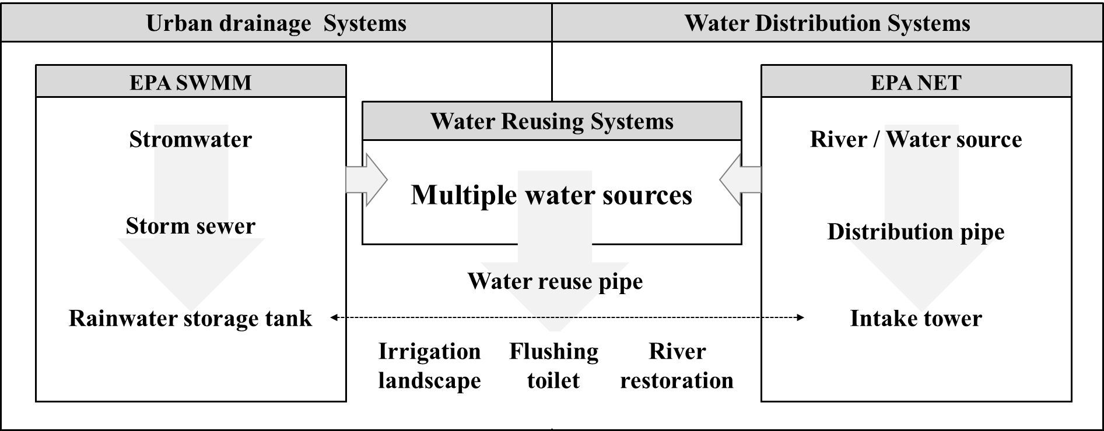
Figure 1. A flowchart of combined water systems and urban drainage systems.
Furthermore, in this study, a plan was developed to restrict reused water systems to rainwater only and use this as toilet water, landscaping water, and firefighting water to reduce the water used by existing WDSs. Therefore, EPASWMM, which is an urban runoff analysis program provided for free by developers at the EPA, was used to calculate the capacity of rainwater storage tanks that can be used in the reused water system. The capacity of the rainwater storage tanks was set to that of multiple water sources in the WDS analysis program EPANET. The analysis was then conducted by differentiating between nodes in the WDS and nodes in the reused water system, as shown in Figure 2.
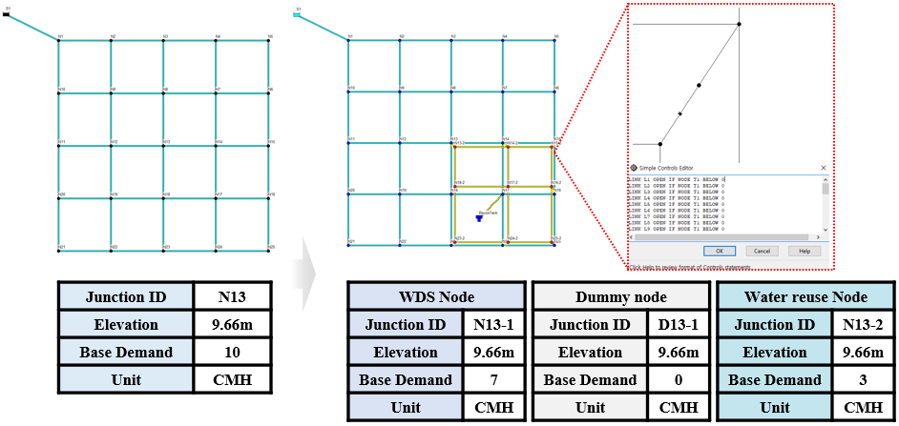
Figure 2. Schematic view of water reuse systems modeling using EAPNET 2.2.
According to the data published by the Korea National Sewer Information System (https://www.hasudoinfo.or.kr/), the water reuse rate is approximately 30%. Therefore, in this study, 70% of the existing WDS demand was set as the WDS drinking water demand, and the remaining 30% was set as the WRS demand; this water was mainly intended for uses such as flushing toilets, cooling industrial units, and watering gardens.
Furthermore, the EPANET control tool was used because it lets the user install nodes that have the same properties as conventional nodes but no demand (dummy nodes) and flow control valves (check valves). The capacity of the rainwater storage tanks was set as the amount of stormwater that cannot be accommodated by the stormwater drainage system. The pipes that combined the WDS and the reused water system were set to the same length, assuming the nodes were the same as the existing nodes.

2.2. Design Optimization
In this study, to obtain the optimal design for a combined water system featuring a WDS, UDS, and WRS, the harmony search (HS) algorithm, a well known metaheuristic optimization algorithm, was used [17]. Since WDSs and WRSs are based on pressure water supply, EPANET was used, and the UDS used EPASWMM. For the design of the combined water system, these two hydraulic solvers were linked with HS through MATLAB, and two design approaches based on single-objective and multi-objective optimization were proposed according to the decision variables and objective functions.

2.2.1. Combined Water System Single-Objective Optimization
In this study, a single-objective optimal design was created using a combined water system. For the constraints, the stormwater drainage system constraints, WDS constraints, and WRS constraints were all considered in the design when it was created. The objective function was set as minimizing the sum of the stormwater drainage system design cost, the WDS design cost, and the WRS design cost. Figure 3 shows a flow chart of the optimal single-objective design process for the combined water system.
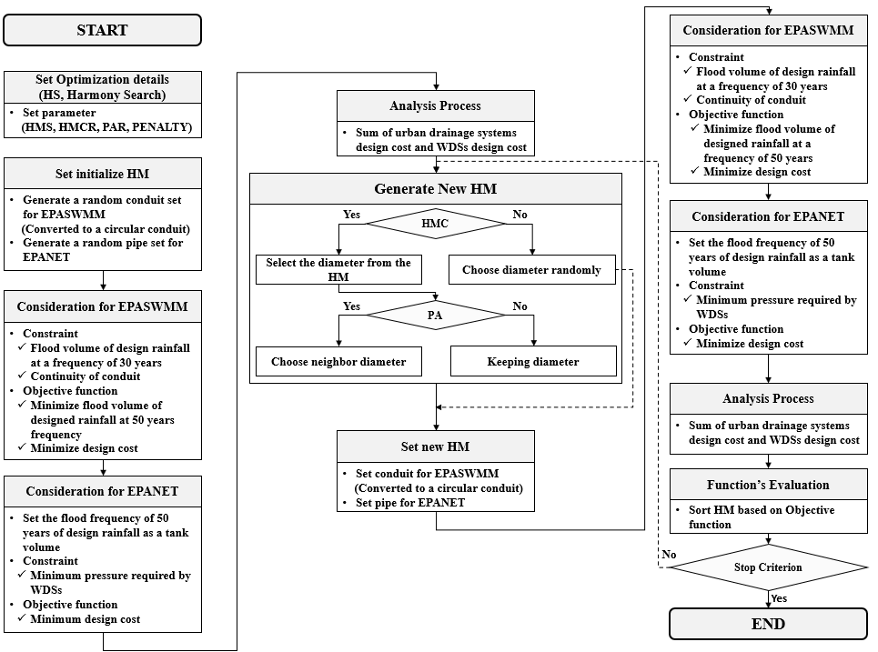
Figure 3. Optimal design of the combined water system based on the single-objective harmony search.

2.2.2. Combined Water System Multi-Objective Optimization
Figure 4 is a flowchart of the optimal multi-objective design process used for the WDS and the WRS, which was implemented after the optimal multi-objective design process for the stormwater drainage system.
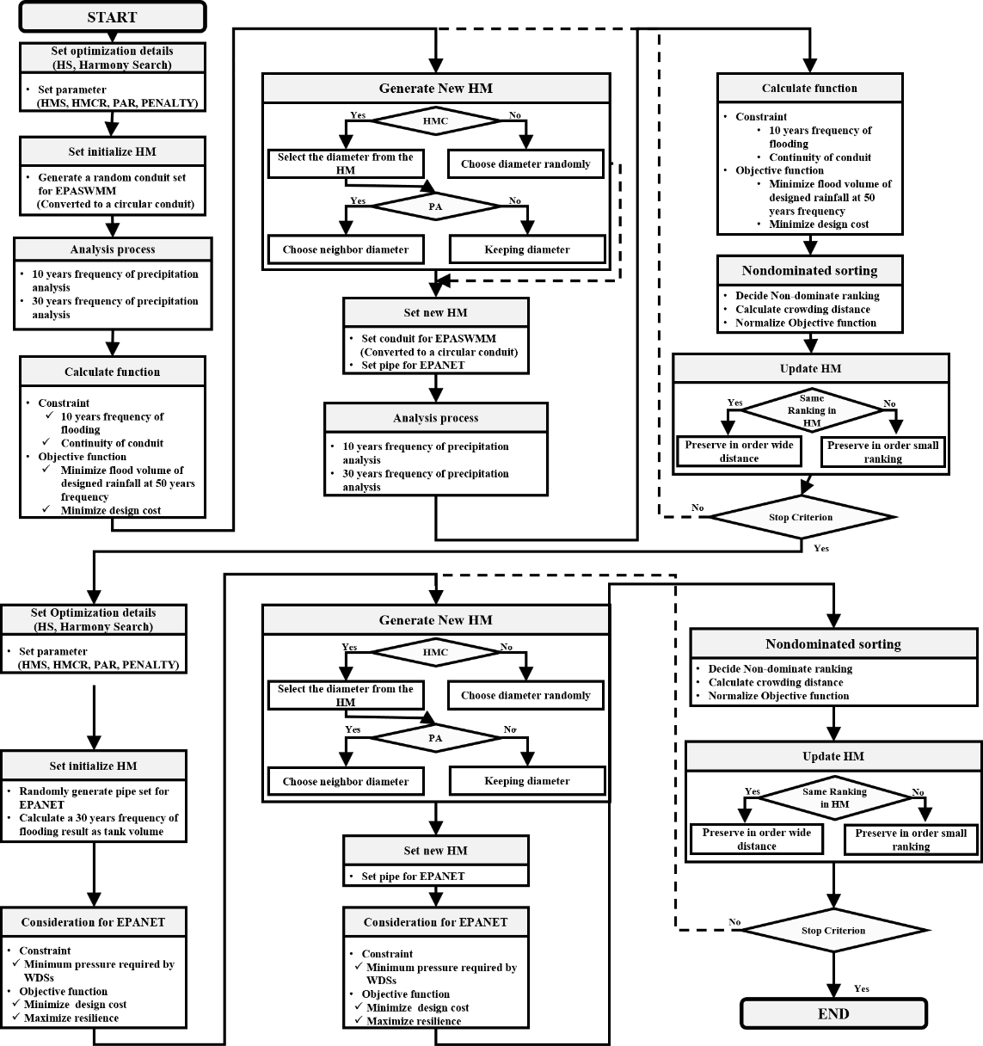
Figure 4. Optimal design of combined water system based on the multi-objective harmony search.
The optimal multi-objective design process for the WRS was performed in situ based on the results of the Pareto optimal solution of the stormwater drainage system. Thirty-year frequency design precipitation intensity was the focus of the stormwater drainage system’s design. Fifty-year frequency design precipitation intensity and minimization of design cost were set as the objective functions.
The reason why the 50-year frequency design precipitation intensity was applied in this study was that if the 50-year frequency design precipitation intensity is exceeded, flooding occurs at all nodes as it already exceeds the capacity of the system. Although an optimal design was determined to minimize this, there was almost no difference between the optimal solutions, so this study used a 50-year frequency design precipitation intensity as the exceeded rainfall intensity.
Figure 5 shows the results obtained from the design process illustrated in Figure 4. The multi-objective optimal design for the combined water system was created in two stages. First, the multi-objective optimal UDS design was created. Second, the multi-objective WDS design was created based on the Pareto optimal solutions for the UDS.
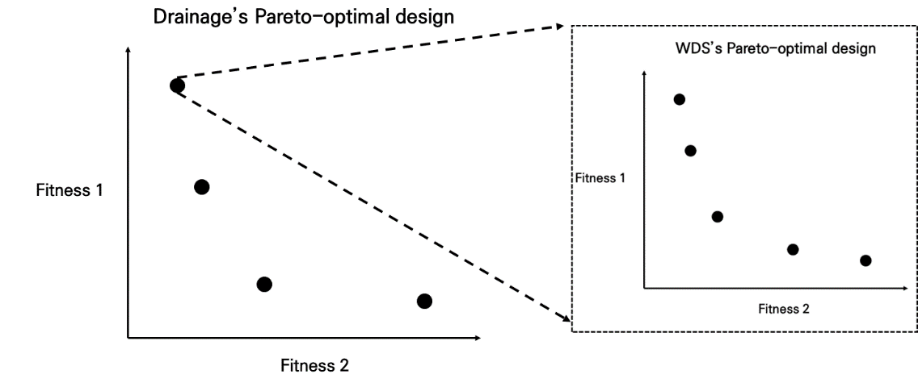
Figure 5. Schematic diagram of multi-objective optimization for the optimal design of a combined water system.

2.3. Objective Function and Constraints
The existing UDS was designed with a 10-year frequency. The design cost, which is the objective function, was calculated under the assumption that the design cost increases as the pipe diameter increases [18].
Minimizing the design cost assumed a linear increase in the design cost as the diameter increased. In addition, the design cost can be expressed as Equation (1) by multiplying the cost according to the diameter of the pipe by the length.
$Minimum design cost=\sum_{p=1}^{P}{Cost\left(D_{p}\right)L_{p}}$ | (1)
Here, P represents the total number of pipes, Cost(D_{p}) indicates the design cost according to the diameter of the pipe, and L_{p} is the length of the pipe. Therefore, the design cost is the sum of the design cost according to the diameter per unit length of the pipe multiplied by the length of the pipe.
For the objective function of the stormwater drainage system, an analysis was performed by increasing the design precipitation intensity to improve the resilience of the existing design for the drainage system. The minimization of flood volume at increased design precipitation intensities was considered, as shown in Equation (2). The greater the design cost minimization, the greater the pipe overloading and flood vulnerability. Therefore, the objective function was configured using the trade-off between design costs, in which there was a high vulnerability to flooding and overflow at the increased design precipitation intensity.
$Minimize Flooding=\sum_{n=1}^{N}{Flooding_{n}}$ | (2)
Here, N represents all the nodes in the stormwater drainage network, and n represents a particular node. Flooding is the sum of the flooding volume at all times at a particular node.

3. Application and Results
The WDS and stormwater drainage systems that were used in this study to create the optimal design for the combined water systems were the systems in G-city, Republic of Korea. The number of subareas, nodes, and pipes in the stormwater drainage system was 32, and the existing stormwater drainage network was designed for a 10-year frequency design precipitation intensity. A total of 118 consumers and 130 pipes were in the water distribution network. Figure 6 shows the sewer pipe piping diagram and the water distribution network diagram of the target region.
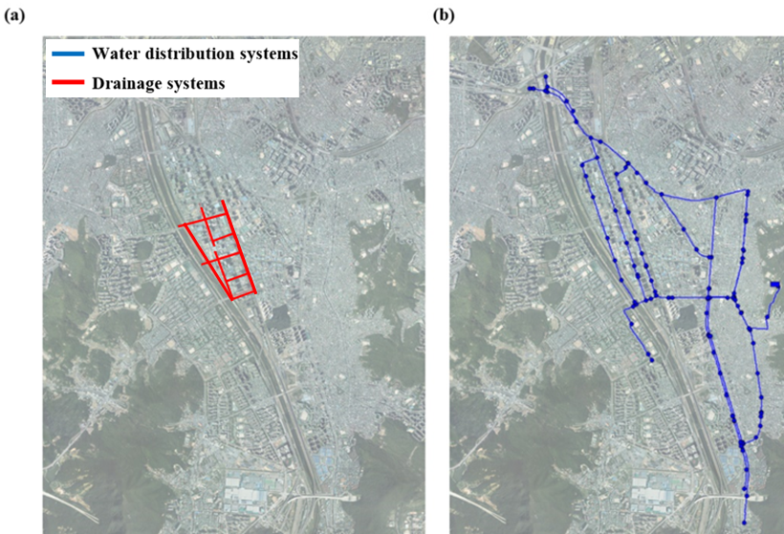
Figure 6. The layout of G-city: (a) the layout of the urban drainage system and (b) the layout of the water distribution system.
Based on this, the stormwater drainage and water distribution networks were used to derive the water reuse network, and modeling was conducted by dividing the demand of the WDS nodes into a 7:3 ratio based on the water reuse rate in Korea. As shown in Figure 7, the stormwater drainage system network diagram, the WDS, and the WRS were derived simultaneously. The WRS area was partitioned based on the stormwater drainage system network. The area indicated by the dotted line is the water reuse area; the node quantity in the combined water system was 192, and the number of pipes was 227.
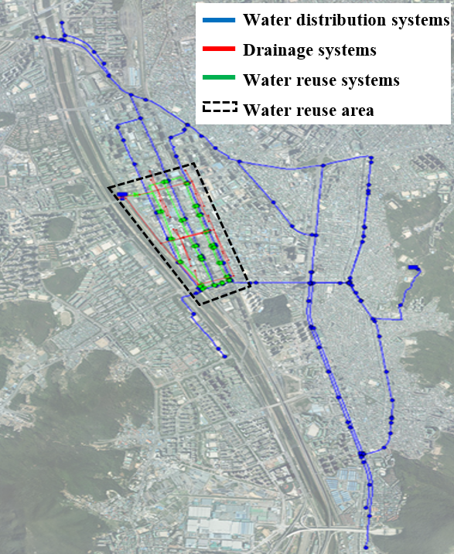
Figure 7. Layout of water reclamation and reuse systems.

3.1. Comparison with Existing Systems
To judge the suitability of the optimal designs for the stormwater drainage system and the WDS, the optimal designs were first compared with the existing designs. The Pareto-optimal solutions for the existing design and the optimal design of the stormwater drainage network were derived, as shown in Figures 8 and 9 and Tables 1 and 2.
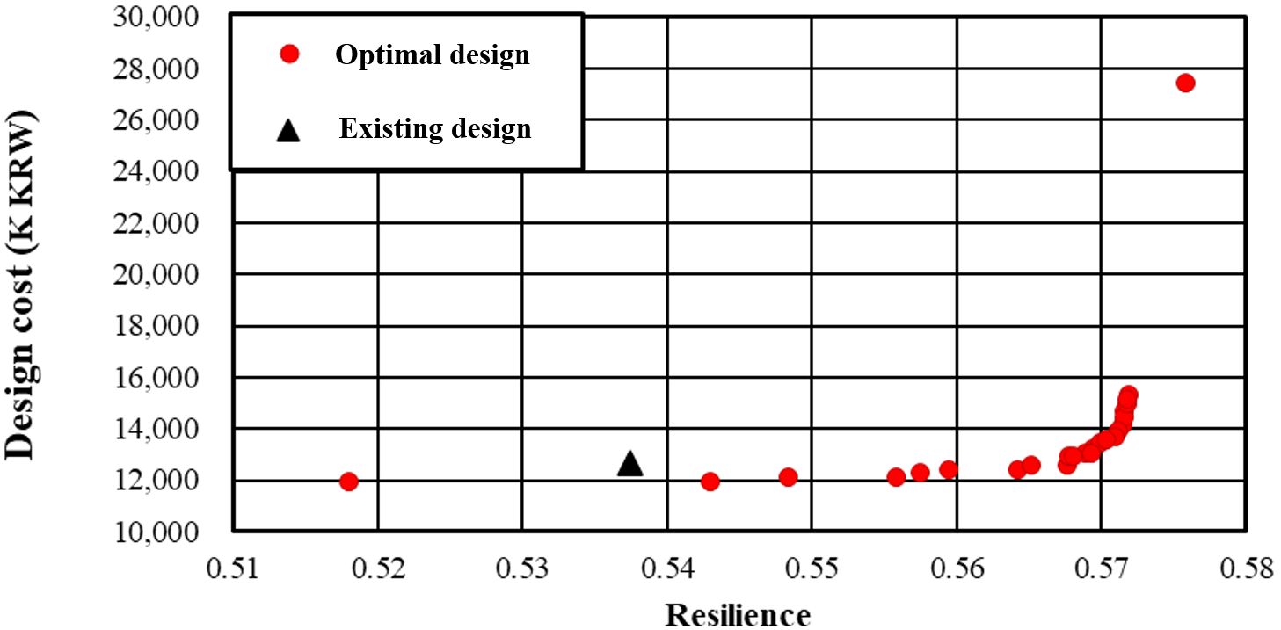
Figure 8. Pareto optimal solutions for the optimal design of water distribution systems.

Table 1. Comparison results between the optimal design and existing design for the WDS.
Solution | Cost (K KRW) | Resilience
Existing design | 12,667,965.6 | 0.537
Optimal design | 11,922,710.0 | 0.543
Difference | 745,255.6 | 0.006
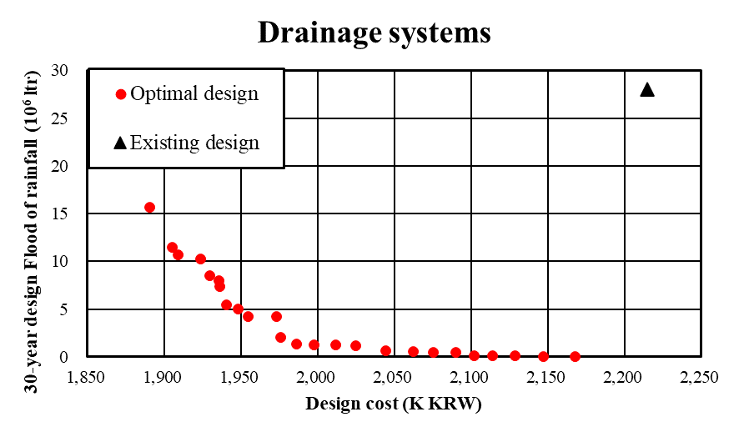
Figure 9. Pareto optimal solutions for the optimal design of urban drainage systems.
Table 2. Comparison results between the optimal design and existing design for UDSs.
Solutions | Cost (K KRW) | Volume of Flood Water (10⁶ L)
Existing design | 2,514,715 | 28.056
Optimal design | 2,167,664 | 0
Difference | 347,051 | 28.056
The comparison between the optimal and existing designs was performed based on the closest designs. The difference in resilience shown in Figure 8 and Table 1, which show a comparison of the WDS, was 0.006, which means that the difference between the existing and optimal designs was not drastic. However, the design with 1.2% (0.006) better resilience led to better result values in terms of construction cost.
The existing stormwater drainage network was designed based in the 10-year frequency design precipitation intensity, and the optimization was performed using 30-year frequency flood volume minimization as the objective function. The difference between the existing and optimal designs was drastic. In particular, this study found that there was a 28.056 × 10⁶ L difference in flood volume at a 30-year frequency design precipitation intensity.

4. Conclusions
This study used a multi-objective optimal design approach to develop a combined water system comprising a WDS, UDS, and WRS. To consider the design of the combined water systems, the existing WDS demand was divided into drinking water and water intended for other uses (e.g., flushing toilets, cooling industrial units, and gardening), where water for other uses was supplied by the WRS, and the resources of the WRS were assumed based on the capacity of the rainwater storage tank in comparison to the level of precipitation, and the objective functions were applied to the minimum construction cost of these systems, the maximum system resilience of the WDS and WRS, and the minimum flooding volume that would exceed the designed rainfall intensity of the UDS for the three combined water systems (i.e., WDS, UDS, and WRS). For the constraints, the minimum nodal pressures for the WDS and WRS and zero flooding in the designed rainfall intensity of the UDS were the factors considered, while the diameters of pipes and conduits were used as the decision variables. In brief, the steps of this study were as follows:
- The existing designs are vulnerable to flooding and inundation despite all efforts made so far. This was confirmed in this study, where the existing and optimal designs for the stormwater drainage system and WDS were compared and analyzed.
- In this study, an optimal single-objective design was created for the combined water system. The flood volumes produced as a result of the urban inundation analysis program were used as input data in the WDS analysis program to derive an optimal design that is superior in terms of both hydraulic stability and design cost.
- An optimal design was derived for the combined water systems based on the multi-objective optimal design of the stormwater drainage system. The increase in the plan resiliency factor was slight compared with the increase in cost. However, the results were superior to those of the existing design and the optimal design for the WDS in terms of resiliency and pressure.
In future studies, the multi-objective optimization of WDSs, UDSs, and WRSs should be performed by examining the trade-offs between the water treatment costs and design costs, system resilience, and CO₂ emissions in combined water systems. Furthermore, future studies that consider not only hydraulic stability but also water quality safety should assist managers and designers in their decision-making by providing various Pareto optimal solutions.

