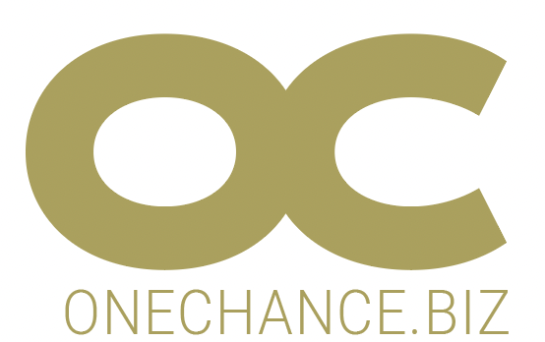

**APPLICATION FOR FUNDING**

**AU BON COIN**

**Paris 18th Arrondissement**

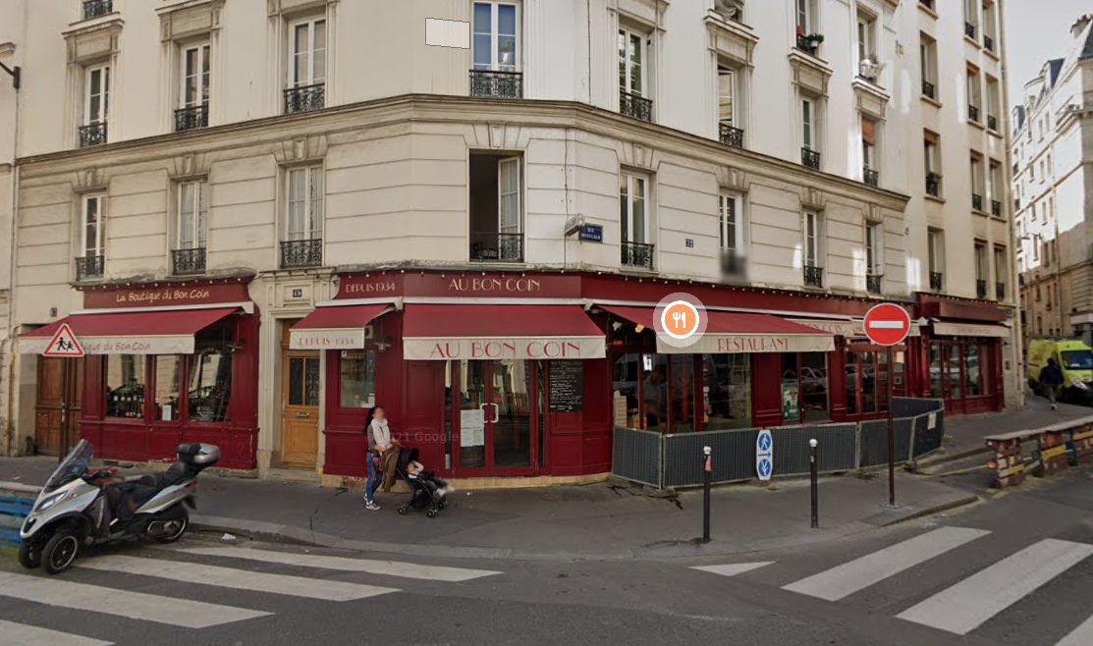

**APPLICATION FOR FUNDING**

**I: THE REQUEST / Summary**

Financing the acquisition of :

* 150,000€ of shareholders' current accounts in the holding company JB L HOLDING.

Diagram

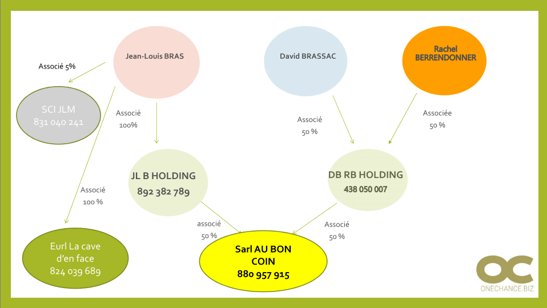

**II PROJECT LEADERS**

***Mr Jean-Louis BRAS***

53 years old, single with no children. From Aveyron region.

Pays a paltry rent (310€ / quarter) to live at the same address as the AU BON COIN brasserie that his family has operated since 1934 (third generation). Since 1934, tenants of the same family of owners who refuse to sell.

Mr BRAS manages the "physical" part, the venue, the wines, the orders,

The two partners serve lunch and dinner, a task they both share, but Mr BRAS is more of a morning person, from 7am,

His partner ***David BRASSAC*** (through the holding company DB RB), 49 years old, is not affected by the loan application. From Aveyron region.

David BRASSAC is an experienced professional. From 1986 to 2011, he was the managing partner of "le Vieux Colombier" Café COSTES in Paris.

Mr BRASSAC is a neighbour and childhood friend of Mr BRAS, all from the same village as the COSTES (for the record, COSTES Cafés have been the benchmark for trendy cafés in Paris since 1985, along with Philippe STARCK).

Mr BRASSAC manages the bar, the social events, the accounts, the security... as someone who prefers evenings & night-times, he is in charge of closing-up at around 1am.

***Rachel BERRENDONNER***, his partner of 30 years, has no operational role apart from organising the accounting and access to bank accounts.

***SARL AU BON COIN:***

Activity: Parisian brasserie café in a very good location in the 18th Arrondissement.

* Bar + Traditional Aveyronnaise restaurant **>** **250 seats per day**
* Wine cellar

*ANNUAL ACCOUNTS 2020:*

Not significant (in the context of Covid-19).

JL BRAS owner since 2006, previously manager on behalf of his mother.

TURNOVER 944K€ (for an average of 1200K€ the previous 3 years) and net profit after Corporate Tax 179K€ (normal potential > 250K€/year). The location and the quality offered 'protect' the business, but the two partners are particularly good at adapting.

The Covid crisis was well managed, with the establishment receiving only €35K in aid and €47K in exemptions.

No anomalies in the Annual Accounts / the 23K€ of other fees = costs of transforming from business in own name into a company, legal costs etc.

Solid financial structure, own funds 1479K€ and *no financial debt*, no short term investments.

Permanent cash surplus > 200K€.

Obligation to return dividends to the two holding companies:

* No constraints for DB-RB
* JL B Holding loan repayment = 77K € / year (end of 12/2027)

*Outlook for 2021 and onwards* :

Please see the attached *conservative* forecast (based on a 20% reduction in the number of observations in 2021), which we believe is clearly underestimated, given the fundamentals and, above all, the motivation and skills of the two partners.

The year 2021 lost its first 5 months, due to Covid lockdown: despite this, the business has been able to increase its cash-flow slightly thanks to takeaway sales, some aid, partial unemployment of the teams, and this, while paying the managers.

After 2021: 1350 / 1400K€ of turnover, quite consistent due to the dynamics instilled by the new partner (more likely 1700K€).

Net result after IS 200K€ on average, let's emphasize the CAUTIOUS aspect of this forecast : the business is very well placed, 250 seats minimum and a qualitative offer at competitive price + development of the wine cellar and the impact of the new partner. A result between 300 and 400K€/year seems more realistic, notwithstanding the unaccounted part of the business.

Simple Shareholder Company ***SAS JL B HOLDING***: ***Holding company*** of Mr JL BRAS

*ANNUAL ACCOUNTS 2020:*

No Annual Accounts: creation at the end of 2020 to acquire the 50% of shares held in AU BON COIN by JL BRAS, and have them financed € 500K by Caisse d'Epargne. Value 650K € => 150K € in current accounts of partners. Accounting document attached.

Directors' personal dividends (FP) 650K € / debt 500K €

*Outlook 2021* : RAS apart from the application submitted.

**OBJECTIVES of the partners:**

To develop and enhance the value of this 2€ to 3€ million business in order to secure the professional and personal future, in particular through dividend payments.

**STRATEGY**

Optimise the existing brasserie bar and wine cellar.

The arrival of David BASSAC and the end of Jean-Louis BRAS's troubles suggest that the best is yet to come.

**METHODS USED**

See the "development forecast" annexed to the file.

* **Financial resources** : 650K€ contribution from DB-RB during the capital increase. Reorganisation of the finances of JL BRAS and AU BON COIN.
* **Human resources** : 11 employees
* **Technical resources**: two premises at the same address (two different leases to secure the operation in case of necessary relocation), fully equipped.

**FINANCIAL REQUIREMENTS**

*Reason for the application:*

Jean-Louis BRAS wishes to turn the page on past misadventures and settle his personal debts accumulated since 2018, in order to move forward serenely. 150K€ requested, of which 40K€ will be maintained in the structure, only to be used if the dividends for the next two financial years are higher than the attached forecast.

**ON THE PROFESSIONAL LEVEL: history:** extract from the 2019 Annual Accounts:

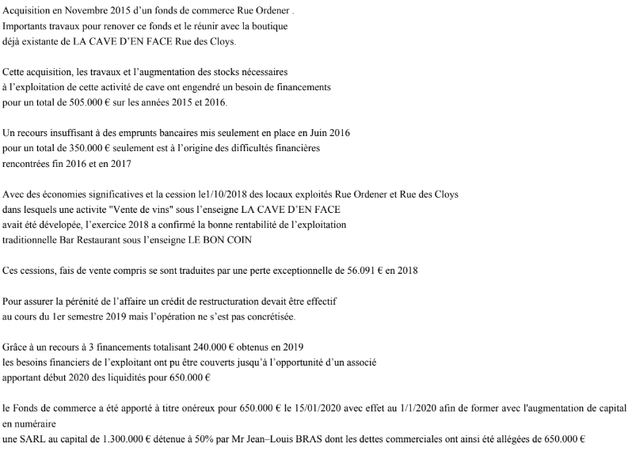

Over the course of this history, the following complications arose :

* The premises opposite, initially rented for 40m², to extend the business, were finally taken for 140m² (floor included + annex), at the instigation of Mr Julien COHEN (TV programme "Affaire Conclue") and building works have been undertaken. In 2016, the latter signed an 'I Owe You' with Mr BRAS for 120,000€ (2016, so legal deadline 2021 unless mistaken), which he has little chance of recovering.
* Cafés RICHARD, Mr BRAS' supplier, subtly got rid of a troublesome employee by having him hired by Mr BRAS, which is a really unproductive and costly liability. Mrs RICHARD later apologised for this but did not pay any compensation.

The business cash-flow has therefore been remedied as follows:

* creation at the beginning of 2020 of AU BON COIN Ltd (SARL) with contributions towards the business capital (Fonds de Commerce) valued at 1300K€ - debts 650K€ = 650K€
* 650K€ reserved capital increase: arrival of Mr BRASSAC (DB-RB) and injection of 650K€, completely clearing the debts of the structure.

The business is now on the right track, co-managed with efficiency and without naivety, .

Debts are purged and the cash flow is healthy.

**ON A PERSONAL LEVEL:**

* In an awkward position in 2017, Mr BRAS confided in some malicious people from among his clientele, who turned out to be racketeers. Under threat, the extortion amounted to more than 400,000€: he emptied his personal bank accounts all at the same time.
* On the verge of collapse, until he turned to his suppliers at Rungis (who know the ONE CHANCE partners), who helped him get rid of these malicious people, before introducing him to us.
* Putting the 86,000€ tax due to the French Treasury (Tresor Public) on standby (notice 2020 / income 2019) ...

In total between 700 and 800K€ disappeared in this mishap (business + personal).

In order to completely smooth out his personal situation, Mr BRAS requested a loan of €150,000 over 7 years from his holding company, representing the balance of the value of the shares purchased from AU BON COIN.

The client is highly motivated to turn the page on this disastrous episode and make a fresh start.

We want to provide them a solution because the fundamentals are very good, the company is very profitable, and the partners are hard-working, honest and professional.

*We are also targeting contact with their network, a strategic challenge.*

***PLEASE NOTE / Eurl LA CAVE D'EN FACE*** : sale of wines by internet. Nothing to Report, Development of personal equity

***About JB L HOLDING***

**Applied for a medium to long-term loan**

**7 year medium to long-term loan** 150,000€ + 15,000€ One Chance fee + various bank guarantee fees = **max** **180,000€** if possible with 12 month grace period i.e. 12 + 84.

Pledge of shares not possible or second only

Jointly-liable Indivisible Personal Guarantee (Caution Personnelle et Solidaire Indivisible) percentage to be determined (only professional assets, personal share is symbolic)

Death or Disability Insurance (Assurance Deces Invalidité) 100% Jean-Louis BRAS

Commitment to not sell any shares of the Simple Shareholder Company (Société par Actions Simplifiée) without the bank's prior consent.

Letter of Credit ?

ONE CHANCE application fees and handling fees: 15,000€ excluding VAT

*Repayment capacity*

50% of the dividends of Sarl AU BON COIN > 100K€/year.

77K€ / year Caisse d'Epargne Bank loan + 30K€ / year loan applied for = 107K€ / year.

The forecast is underestimated, and the "undeclared" is not taken into account.

The documents communicated, drawn up on the basis of AU BON COIN's activity being voluntarily discounted by 20%, indicate that dividends will not be paid out in 2022. To secure the financier, Mr BRAS undertakes to place 40,000€ in short-term financial products with us, which will be released if the dividend income is significantly higher than the profits forecasted.

**Short term**

Not applicable. Subsidiary with a large cash surplus: “cash machine”.

***Commercial bank counterparties***

To be determined if this is of interest to the financier.

He has just entrusted his Visa/Mastercard transactions to the Caisse d'Epargne, which has granted him the loan of 500K€ on his Holding Company.

Has no ties to the CIC Bank, which has failed to support him.

CONCLUSION:

AU BON COIN's finances are healthy, and it does not need any funding for years.

It is a question of helping Mr BRAS, a reliable professional, to clear his personal debts (taxes and third parties) through his holding company.

The risk is put into perspective by the arrival of a known and recognised partner, and the capacity of the business to generate higher than forecast cash-flow.

**ONECHANCE CONSULTANTS' OPINION**

**RESULT OF THE STUDY: Positive Endorsement**