Aylin Yengin
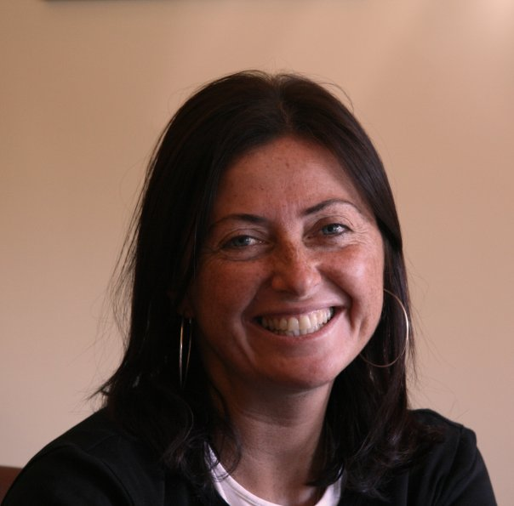

Place of Birth: İstanbul
Date of Birth: 10.09.1969
Marital status: Single
Nationality: Turkish
Translation background:
After graduating from English Teaching Department in 1992, worrying that both my English and French would degrade with time, I started translating short articles and documents for various companies. I had taken elective translation courses in college and in order to put theory into practice, I decided to contact a publishing house in 1997. As I did not have any experience with long texts, they tried me out with a few pages and after they approval, they asked me to translate my ‘first book’ that was published in 1999 (The Cobra Event, a 1998 thriller novel by Richard Preston). Since then I have translated around 50 books from French and English to Turkish including ‘Water for Elephants’, ‘Life of Pi’, ‘Le Petit Prince’, and ‘Hector et La Recherche du Bonheur’ which were all adapted into movies. Currently, I continue my translations as much as my busy workload permits. Beside books and other documents, I also translate press bulletins for leading companies, historical documents and various texts in a very wide range of topics.
My native tongue is Turkish, but I have grown in a French-speaking environment, studied French and English and I can translate almost anything from and to these three languages.
Educational background:
1987 – 1992 Boğaziçi University
Faculty of Language and Literature
English Teaching Department
1980 – 1987 Notre Dame de Sion High School for Girls
1976 – 1980 Şişli Terakki Lisesi
Business experience:
2011 - IFC Istanbul, Program Assistant and ACS Supervisor
2009 – 2011 Deloitte, Personal Assistant to CEO
2006 – 2009 Koç Holding A.Ş. Assistant to President Automotive Group
Koç Holding A.Ş. Personal Assistant to CEO
1998 – 2006 CEGEDIM Bilişim ve Danışmanlık, CRM Database Manager
- Revising and renewing the company’s database for the use of major pharmaceutical firms
- Administrating, matching and merging data acquired from new business clients
- Recruiting, “training” and managing Database Department consisting of eleven database operators
- Ensuring customer satisfaction involving CRM, sales and problem management
- Supporting and coordinating direct mail activities
- Service Monitoring and reporting on activities, costs, performance
- Directly reporting to the General Manager
1992 – 1998 KLM Royal Dutch Airlines, Capacity Controller
- Responsible of the Sales Department
- Dealing mainly with statistics including flight capacity, yield management and loading
- Continuously in contact with travel agencies, in charge of group ticketing
1987 – 1991 EL AL Israel Airlines, Reservations and Ticketing Responsible
- Employed in town office,
- Customer and travel agencies related ticket sales.
- Individual and group ticketing
- In charge of accounting and bookkeeping
Special Training:
- Database and SQL training in France / Project Management training in France
- CRM training in France
- Advanced computer trainings
- Multiple international trainings including reservations, ticketing, statistics and yield control, during airline business

Foreign Languages:
- English : Excellent both written and spoken
- French : Excellent both written and spoken
- Turkish : Native language
Computer Skills:
Microsoft Word, Excel, PowerPoint, Access, SQL
Hobbies:
- Music
- Movies
- Traveling
- Translation and editing both from English and French
- Free-lance writer for art events in a weekly newspaper (AGOS and ŞALOM)

Please click on the following links to access the books I have translated
http://www.kitapyurdu.com/yazar/aylin-yengin/1564.html

Please click on the following links to access my newspaper articles (all written in Turkish)
http://www.agos.com.tr/tr/yazar/245/aylin-yengin
http://www.salom.com.tr/authordetails.asp?id=60

