Issues to Consider:

1) Feminist Theory

2) Business Theory

3) Information Management

Difference between education and advocacy:

1) Questions vs. Answers

2) Approach to policy vs. invitation to critique policy

Between Advocacy and Education in the Field of Israel

A. Education Model - Needs to be worked on

B. Public Diplomacy

1. Old PD

a. Definition

b. Goals

c. Practicum

d. Players

2. New PD

a. Definition

b. Goals

c. Practicum

d. Players

3. Comparative Look

4. Questions

C. Nation Branding

1. What is Nation Branding

a. Definition

b. Goals

c. Practicum

d. Players

2. Difference between PD and NB

3. Questions

D. Advocacy

1. What is Advocacy?

a. Definition

b. Goals

c. Practicum

d. Players

2. Between Advocacy and Education

E. Conclusion

“The initiation into worthwhile pursuits while respecting the autonomy of the learner”- Richard Peters

Israel Sheffler

“An activity aimed at the achievement of learning, and practiced in such a manner as to respect the students intellectual integrity and capacity for independent judgement.”

***Philosophies in Jewish Education***

How do we view individuals? Are they all part of the greater human race (the commonality of man), or are they all unique individuals?

**1. Liberal Arts School of Thought**: (1940s, Robert Hutchins & Mortom Adler) – the commonality of man.

·         Believes that people must be part  of the Great Conversation: taking place between generations.

·         Democracy: ultimately, all our votes are equal: this is problematic because people who do not understand what is needed are making the decisions. **So they created a canon of literature that everyone in the civilized world needs to know. From Greek philosophy to modern thought.**

·         Learning in this curriculum continued to adulthood (“the tragedy of education is that it’s wasted on children” – believed that real learning only takes place in adulthood between 2 people). The art of education is to get kids to want to get educated when they leave the school system

·         **The teacher**: In this model the teacher needs to be a subject matter expert. Teacher needs to be a great communicator.

·         The outcome: people are going to be part of the great conversation.

·         **Curriculum**: the canon.

·         **Challenge**: getting students through the door. This is an elitist system: how many people can understand Aristotle?

·         The art of teaching is not teaching them what they want to know, but what they ought to know.

à Jewish education: **liberal arts Jewish education perspective** = help students understand the canon so they can be part of the Jewish Conversation (between generations). The stakeholders in the world are the people who know, we are a knowledge-driven culture.  This is cultural empowerment, has little to do with religion. People have to make decisions, they need strength of knowledge.

·         Example: “Rashi says” and not “rashi said” = there is an intergenerational conversation going on in Jewish study!

·         You buy into the system by being part of it- this allows for Jewish continuity. Judaism is a knowledge-driven culture.

·         Aim of education: get people part of the culture in terms of their ability to be part of the conversation.

·         This is how we measure success: we are successful if the student can take part of the conversation.

·         ***Attack on this approach***: it ignores the uniqueness of every individual. The “one size fits all” approach is articulating the position that everybody can learn everything.

* educational success is defined as what happens to the students.

**2. The Humanist Approach to Education:**

·         Speak to individuals from where they are sitting, without this you do not have a chance at education.

·         As an educational value, it is critical that we educate to the uniqueness of the individual and not to the commonality. The conversation is uniquely personal, and we need to cater to that to ensure that everyone reaches their own potential. Bring individuals to excellence in their domain

·         Maslow language: let every student reach self actualization/realization. Everyone should live a fulfilled life.

·         **The teacher**: a people person, they need empathy- the ability to read people. Leave your personal baggage at home: see only the student, it’s not about the teacher. Student is the focus of teacher’s endeavor.

·         **Curriculum**: identity, relevance and significance to the student. The content must be relevant!

·         **Attack of Adler on this**: you are turning education into nursery school. Feel good, you can do no wrong. But are you attaining anything valuable?

**à Humanist Jewish education:**individual is empowered to be Jewish. The liberal arts graduate is empowered because they’re part of the great conversation, not because they feel good. The humanist graduate **feels** empowered! Relevance is everything- you only study the relevant stuff- you choose what is meaningful.

**Humanist**:

·         Pro: Speaks to the individual and empowers them

·         Con: You may feel empowered but you’re an ignoramous.

**Liberal Arts:**

·         Pro: Intellectually you’re empowered,

·         Con: Crtitique: you may be empowered but emotionally, where are you?

·         Success is measured by whether or not the student is self actualized.

**3.** **Behaviorist**: based on Bilcomb – father of sociology

·         Perspective on education: the goal is to create a functioning society.

·         We need a high degree of socialization: individual must internalize the values of the society and identify them. Incorporate them into their world view. Then they have a sense of continuity.

·         **Teacher**: someone who embodies the values of the society. Lead by example. The ideal *madrich*. It’s not what you say but what you do. People who know how to influence people (charismatic, community building, parenting)

·         **Successful outcome**: active members of society, people who have bought into/internalized the value system.

*Socialization can only take place in a supportive environment (material taught in school that conflicts with what’s being taught at home)

**Jewish educational realm:** success as defined as buying into the system. Students who express their Judaism through practice. Measure what they did before they walking in versus walked out.

·         ***Challenge***: you need a highly intensive approach- it must be a very high impact education. This is a high-impact educational experience.

·         the ABC of socialization is the buy-in. this is why Jewish camping/informal education is a far more successful in socialization than formal education.

·         You can’t have it when the teacher is the disciplinarian in the classroom! Choosing the teacher, setting, and curriculum is critical!

·          People will want to identify and be personally involved in this. But we can’t have everything, what do you choose? What are your priorities? Which philosophy do you approach?

·         ***Variables***:

* + Use the target audience- who is the target audience? How old? Background?
  + Budget
  + Time allocation (weekly, annual?)
  + Environment: Setting- formal or informal setting?

·         This variables are critical in forming realistic goals?

·         Adult education: the most challenging is #3- it’s hard to get an adult to change their behavior/practice? They have already made life decisions. The easiest

Where does education towards the affinity for a place fit it?

Does IE or IA leave real room for humanism?

Where does Engagement fit into these categories?

In what contexts are these issues addressed?

**Public Diplomacy**

**Definition**

*Academic Field: Part of international relations and communication*

**Academic Definition:** "Influence of public attitudes on the formation and execution of foreign policies" (Edmund Gullion, 1965) retired American diplomat turned dean of the Fletcher School of Diplomacy at Tufts University near Boston)[1]

"An international actor's attempt to manage the international environment through engagement with a foreign public."(Cull)[2]

**Popular Definition:** Murrow Center Brochure: "... [PD] encompasses dimensions of international relations beyond traditional diplomacy; the cultivation by governments of public opinion in other countries; the interaction of private groups and interests in one country with another; the reporting of foreign affairs and its impact on policy; communication between those whose job is communication, as diplomats and foreign correspondents and the process of intercultural communications". [3]

**Old School**: 'Direct communication with foreign peoples, with the aim of affecting their thinking and ultimately, that of their governments'. (Malone, 1985)[4]

**Goals**: 'influence the general public of the target nation'[5], get the citizens to change their own governments foreign or domestic policy.

**Practicum**: Content includes 'activities, directed abroad in the fields of information, education and culture, whose objective is to influence a foreign government, by influencing its citizens. [6]

On the one hand they are educational activities but the goal is similar to propaganda.

**Players:**

Diplomats, government officials.

**Historical Background of Old School PD: Cold War**

Period 1: American and Western values spread throughout Eastern Europe (and also in secret in the USSR)

Period 2: Fall of the Berlin Wall- Public diplomacy efforts decrease

Period 3: September 11

**New Public Diplomacy**[7]**:**

**Goals:**

*Cull***:** Same as prior but different tactics

*Szondi*: Political and economic interest promotion to create receptive environment and positive reputation of the country abroad

*** Old diplomacy focused on creating behavioral changes while new PD focuses on changes in attitude.[8]

[*Which model should we use (cull or szondi)? They make similar points but cull sees the goal as remaining stagnant while Szondi believes that it has changed. Are there any other critical distinctions?]*

**Practicum:** The mechanisms used by these actors to communicate with world publics have moved into new, real-time and global technologies (especially the Internet). These new technologies have blurred the formerly rigid lines between the domestic and international news spheres. In place of old concepts of propaganda Public Diplomacy makes increasing use of concepts on one hand explicitly derived from marketing—especially place and nation branding—and on the other hand concepts growing from network communication theory

Active Listening should override dictating messages and policy (bottom up instead of top down)

New terminology of PD as the language of prestige and international image has given way to talk of ‘soft power’ and ‘branding

Cull- Elements of Public Diplomacy: 1) Listening (the foundation for all effective public diplomacy); 2) Advocacy; 3) Cultural Diplomacy; 4) Exchange; 5) International Broadcasting. The report also identifies 6) Psychological Warfare

**Players:** The international actors are increasingly non-traditional and NGOs are especially prominent

Departure from the actor-to-people Cold War-era communication and the arrival of a new emphasis on people-to-people contact for mutual enlightenment, with the international actor playing the role of facilitator. In this model the old emphasis on top down messaging is eclipsed and the prime task of the new public diplomacy is characterized as ‘relationship building.’ The relationships need not be between the actor and a foreign audience but could usefully be between two audiences, foreign to each other, whose communication the actor wishes to facilitate.

**What influence might this have?**

NGO may have overlapping interests with the government, they are promoting their own agenda at the end which may or may not fall in line with that of the government.

Hard to coordinate efforts on a grand scale? How does an organizations need to survive affect its PD message?'

**Comparative Chart:**

**Cull[9]**

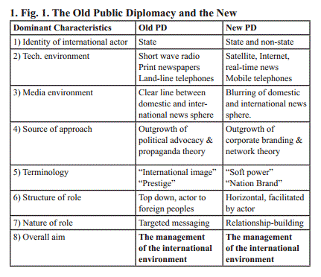

**Szondi[10]**

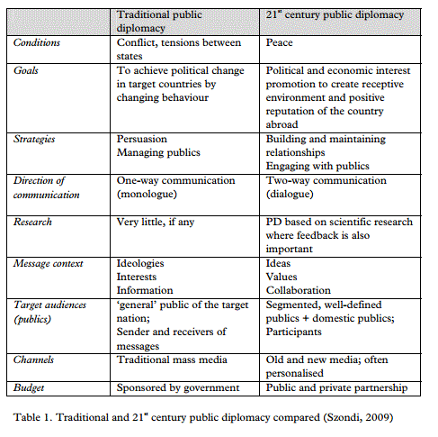

**Key issues to address in discussing New PD**

* Domestic v. Foreign? Who is the target audience?
* What is the degree of tension between the two sides (can be used as low level conflict resolution between countries)?
* What is the direction of communication: one way or dialogue
* How powerful are the actors to implement decisions
* What is the timeframe for these activities? Are they designed for short term or long-term success?

**Public diplomacy to a domestic public:[11]**

1. Domestic input from citizens for foreign policy formulation (engaging approach)

2. Explaining foreign policy goals and diplomacy to domestic public (explaining approach)[Public Affairs Office in the US]

**Questions in relation to IE**

How much is Israeli PD aimed towards foreign govt. vs. foreign populations? Is it ever aimed at the domestic public? What about Jews as messengers of the Jewish State around the world? Does Israel face challenges that make New PD a particularly difficult challenge? Can it even work if it doesn't have the precondition of a relationship between two countries (see Szondi conflict vs. peace)? Can this be circumvented in any way through a third party and still be considered PD? How strong of a role do NGO's and non profits play in New PD in Israel?

What role does Israel Hasbarah play? How is it similar or different from New/ Old PD?

Is modern day Israel advocacy an attempt to help the Israeli government do their job and spread the messages espoused by the government or are they independent bodies with their own approach to Israel? What room is made for organizations with dissenting opinions? How did social media change the role of advocacy organizations and increase their power?

**Nation Branding**

*Academic Field: Marketing*

**Definition**- "Nation branding concerns applying branding and marketing communications techniques to promote a nation's image." (Fan, 2006)[12]

"Use of the tools of branding to alter or **change the behavior, attitudes, identity** or image of a nation in a positive way." (Gudjonsson, 285) [13]

**Goal**- image promotion in order to change both attitude and behavior (much like consumerism I think). Impacts both the political but especially economic realms.

**Practicum**: According to Anholt country branding occurs when public speaks to public. A substantial portion of the county needs to get behind the strategy, otherwise it does not take off.[14]

Requires collaboration between government and others to reach desired outcomes

Less sophisticated means of presenting the ideas , meant for mass appeal.

**Players**: May be initiated by government, but thinking is completed by marketing professionals more than government officials. Concepts and ideas need to be backed by the masses.

The target audience can be defined as 'blue ocean' because they do not even know this 'product' is available to them.

**History:** World fairs (Lithuanian attempt to become independent entity 1919). Pursued actively in the last 10-15 years.

**Differences Between PD and NB**

Target audience- Nation branding is much more public than PD (which is generally intended for smaller influence groups). NB can be aimed at specific segments who are interested while PD needs to be completed with decision makers, regardless of policy.

PD tries to find similarities between countries while NB tries to differentiate them.

NB need to be recognized as belonging to the country of origin, while PD can sometimes be more effective if the public do not know the players involved.

**Chart Form**

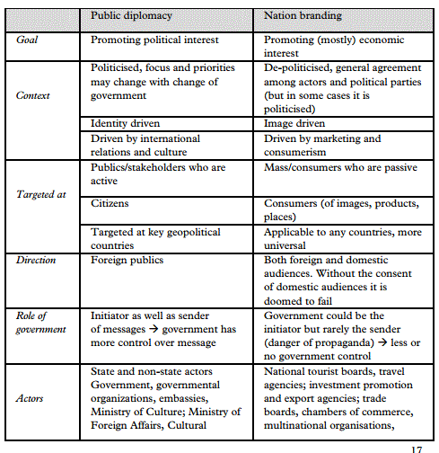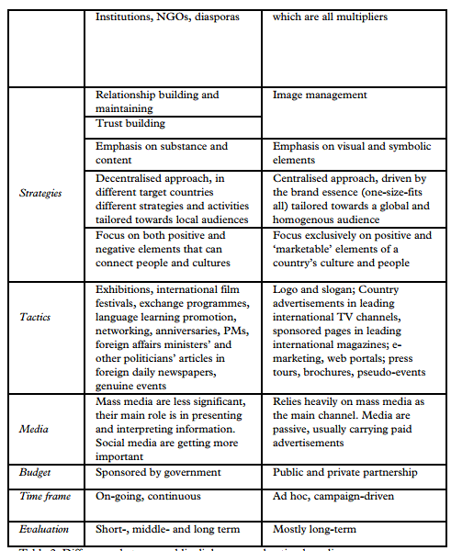

Questions:

When "Israel advocacy and education" organizations state that they want to "improve the image of Israel in the world" what activity are they engaging in? When Israel is presented as humanitarian, leader in high-tech, scientifically advanced isn't this NB? How much is NB used for tourism vs. other endeavors? What are Israel's unique challenges when it comes to NB?

**Advocacy**

*Academic Field: Social Work?*

**Definition**: The word 'Advocate' comes from a Latin word meaning 'to be called to stand beside'.

**Advocacy Common Usage:** Advocacy is speaking acting, writing with minimal conflict of interest on behalf of the sincerely perceived interests of a disadvantaged person or group to promote, protect and defend their welfare and justice by being on their side and no-one else’s being primarily concerned with their fundamental needs remaining loyal and accountable to them in a way which is emphatic and vigorous and which is, or is likely to be, costly to the advocate or advocacy group.[15]

Whereas public diplomacy focuses on the greater relations between two different countries, advocacy is seen as a way to promote specific causes and promote them in the eyes of the public and those who can come to their aid.

History: Ancient examples of advocacy may be found in Herodotus where envoys from Xerxes of Persia appeal to the people of Argos for their neutrality in the Empire’s invasion of Greece in 480 BC. The Persian argument was based on kinship in that in legend Argives and Persians shared a common ancestry through the hero Perseus. Argos remained neutral, though presumably not for this reason.

**Goals:** Being active for a specific cause.[16]

**Practicum:**

There are (at least) three different ways in which advocacy work can be completed[17]:

1. Advocacy **for** those affected by a situation

2. Advocacy **with** those affected by a situation

3. Advocacy **by** those affected by a situation, i.e. self-advocacy

Advocates can act by speaking out, writing or leading rallies. When advocating **for** someone the goal is to act on their behalf to improve their situation and assist them in their place. To advocate **with** someone is to become a partner together with those in need who are acting for themselves but need further assistance, power and clout. Advocacy **by** those affected by means advocating for one's self to improve what they see as an injustice or challenge.

**Players:**

NPO's

Individuals who influence their circles

Between Advocacy and PD

Advocacy can be seen as part of public diplomacy and one method for promoting the image of one country in that of another. In the context of public diplomacy advocacy is seen as "an actor's attempt to manage the international environment by undertaking an international communication activity to promote a particular policy, idea or that actor's general interests in the minds of a foreign public." In this definition, advocacy can be seen as an out product of public diplomacy.

*Avi: The distinction in my mind is not clear. It seems to me that in certain ways advocacy reverts back to classic PD efforts in that one side is trying to exert influence.*

Israel Advocacy

Bethamie Horowitz attempts to provide a clear distinction between the different fields:

Advocacy training involves efforts to prepare people—mostly college-age, or late high school age—primarily for political argumentation in defense of Israel carried out especially on campus. Israel studies differs from Israel education in that its focus is to deepen and expand knowledge about Israel, remaining dispassionate about the affinity of the learner toward Israel. Because Israel education begins in childhood and is part of the enterprise of Jewish education, it is the broadest and most basic of these various efforts.[18]

**Is Israel Advocacy Really Advocacy?**

When trying to understand Israel Advocacy in light of the definition above it is important for us to ask whether it comes under all three categories (for, with, by). It seems that Israel Advocacy in the Diaspora would fulfill helping others affected by a situation, however the one being advocated for (the State of Israel) is not entire helpless to change their situation. Decisions of policy, foreign relations and general perception greatly affect public opinion and therefore the argument could be made that 'advocacy for' is unnecessary here. On the other hand, one can see Israel as in a disadvantaged situation because of discrimination and efforts to delegitimize the State.

Advocacy efforts can also be seen as being together **with** those affected by a situation. Being that the main Israel Advocates are Jewish, it can be argued that many Jewish people see themselves as connected to the Jewish State to the point where they stand with them. This also implies that Israel is not powerless to affect change on its own. Advocacy **by** those affected by the situation is also part of Israel Advocacy and many of the major organizations have offices and even headquarters in Israel. In fact, Israelis are becoming more attuned to their problematic image around the world and a number of projects try and help Israelis become advocates for themselves.

It is interesting to note that many organizations which were known as advocacy have "rebranded" themselves because of the negative stigma which came along with their activities (brainwashing, one-track thought etc.). Often this has led them to soften or reword their message using different terminology but the end goals are the same as they always were.

**Between Education and Advocacy**

|  |  |  |
| --- | --- | --- |
|  | Education | Advocacy |
| Goals | * Relationship with the source material  * Exploration of Identity | * To assist the underprivileged  * Act in order to improve conditions |
| Methods | * Formal Classes  * Informal Activities  * Discussion Groups | * Training Seminars  * Public Speaking  * Networking  * Providing Services  * Spreading Information  * Lobbying[19] |
| Decision Makers | * Educators  * Policy Makers | * Funders  * Organizations |
| Facilitators | * Trained Educators with experience in school settings | * Skill Experts |
| Participants (who the methods are aimed at) | * Jewish Students | * Media  * Policy makers  * General Public |
| Room for Free Thought | * High level of decision making  * Learner Centered  * Range of Voices | * Promoting the narrative of the organization or subject |
| Mystic vs. Realistic Approach | * Both (depends on the organization) | * Pragmatic Based (tends to be more mystic) |
| Content | * Source based learning  * Critical Analysis | * Historical Narrative  * Current Affairs |
| Core Principles | * Respect the Autonomy of the Learner | * The cause and end result is greater than the process |
| Measure of Success | * Knowledge of a gamut of opinions  * Identification with the issue | * High level of expression  * Change in policy |
| Ages | * School Children  * Adult Education | * From the time of being able to become an "Israel Ambassador" (generally high school and above) |

**Questions**

Can the state be an advocate for its own policies? Is the term advocacy really applicable?

Concluding Theory

Modern Israel advocacy organizations have adopted the goals of Old PD and Israel Branding using some of the tools developed in new PD. They see Israel as something which needs to be advocated for, looking primarily at self interest and advancing particular agendas instead of promoting cooperation, two way communication and collaboration.

Why has this happened now?

Social media allows everyone to see themselves as mini-ambassadors and to try and conduct PD. Globalization has blurred the lines between Old PD and New PD in that the goals are old but the means are new. Prior, no one would have dreamed of doing PD unless they were government reps or had significant power (like strong lobby groups and NGO's). Often the tool that is used is branding but the goals are from the world of Old Diplomacy.

1. Nicholas J. Cull, Public Diplomacy Lessons from the Past, file:///C:/Users/avi%20staiman/Downloads/Cull,%20Public%20Diplomacy%20-%20Lessons%20from%20the%20Past%20(2).pdf pp.17
2. Cull, fn. 1, p.12
3. http://fletcher.tufts.edu/Murrow/Diplomacy
4. Gyorgy Szondi, Discussion Papers in Diplomacy, Public Diplomacy and Nation Branding: Conceptual Similarities and Differences, p.7
5. Ibid.
6. Ibid.
7. Cull, pp.12-13
8. Szondi, 9-10
9. Cull, p. 14
10. Szondi, p.11
11. Szondi, pp.6-7
12. Szondi p. 4
13. ibid, p.5
14. ibid
15. http://qla.org.au/PDFforms/Advocacy%20Info.pdf
16. Queensland Advocacy Inc., Key Elements of Advocacy, http://www.docstoc.com/docs/19424465/Key-elements-of-Advocacy
17. Bonvalot, H. What is Advocacy?, Report for The Swiss Foundation of Terre des hommes, p. 6
18. Horowitz B. Defining Israel Education, p.3 (http://jimjosephfoundation.org/wp-content/uploads/2012/01/iCenter_Bethamie.pdf)
19. http://www.tdhafghanistan.org/Capitalisation20Paper20_20Advocacy.pdf