The development of antiparasitic ointment from a C-dot nanocomposite

Vijay Bhooshan Kumar,ª Avishay Dolitzky,^{b} Shulamit Michaeli^{b*} and Aharon Gedanken^{a*}

(Note: Vijay Bhooshan Kumar and Avishay Dolitzky have equally contributed to this paper)
ªInstitute for Nanotechnology and Advanced Materials and Department of Chemistry, Bar-Ilan University, Ramat Gan 5290002, Israel
^{b}Institute for Nanotechnology and Advanced Materials and Faculty of life Sciences, Bar-Ilan University, Ramat Gan 5290002, Israel
*Corresponding authors: gedanken@biu.ac.il (A.G) and Shulamit.Michaeli@biu.ac.il (S.M.)
Graphical Abstract:
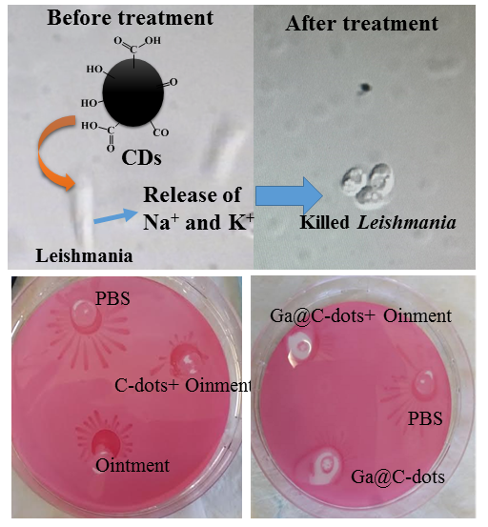
Abstract
The Leishmania species of the trypanosomatid family is an important human pathogen. It is the causative agent of leishmaniasis, affecting millions of individuals worldwide. The current treatment is toxic and parasites develop resistance to the common drugs. Leishmaniasis still relies on potentially serious adverse effects, and there is a need to develop short efficacious non-toxic affordable treatments for the disease. Here, we formulate an anti-parasitic ointment whose activity has been validated against the two life stages of the parasite. The ointment is based on C-dots and doped C-dots (Ga@C-dots). The active components are spherical nanoparticles varying in size from 3 to 7 nm. The anti-parasitic activity of the C-dot-based ointment is evaluated against Leishmania donovani and Leishmania major. Ointments comprising C-dots or Ga@C-dots demonstrate high anti-parasitic activity in these two species of Leishmania. Furthermore, interestingly, we observed that our formulated ointment demonstrates better anti-parasitic activity against Leishmania donovani and Leishmania major than the commercial ointment. These results suggest that C-dot solution and C-dot-based ointments provide a valuable solution for treating leishmaniasis.

Keywords: C-dots, Ga@C-dots, Ointment, Fluorescence, Sonochemistry, leishmaniosis
1. Introduction
Leishmaniasis is one of the most important vector-borne human diseases that is transmitted by sand flies and caused by obligate intracellular protozoa of the genus Leishmania.^{1,2} Leishmaniasis is considered to be one of the six most important global diseases, with more than 350 million people at risk and 14 million people infected in 98 countries (according to World Health Organization (WHO) reports). This parasitic disease can be caused by several species of Leishmania parasites, which are associated with various forms of the disease, such as skin ulcers, nodules and deadly visceral leishmaniasis.¹ A parasite undergoes a complex life cycle and has two main forms in its life, the fly form, named promastigotes, and the mammalian form, named amastigotes. There are about 30 species of Leishmania, including L. donovani, L. amazonensis, L. venezuelensis, L. infantum, L. chagasi, L. Mexicana, L. tropica, L. major, L. aethiopica and L. peruviana,³ which infect mammals, including humans. The different leishmanial species are morphologically similar, but they can be differentiated by several techniques such as isoenzyme analysis, molecular methods and monoclonal antibodies.³ Among all pet animals, dogs are the most important species in the epidemiology of this disease. Skin and visceral diseases have also been occasionally reported in other domesticated animals, captive mammals in zoos and wild animals.^{2,4–6} Moreover, chronic, visceral and acute leishmaniasis is a group of protozoan infections caused by obligate intracellular protozoan parasites. These parasites cause skin disease and damage the visceral organ. Visceral poses a major burden on healthcare systems, as it requires prolonged hospitalization and has a high mortality rate especially in endemic regions in about 90 countries around the world.^{7,8} In fact, a recent study estimated about 2 new million cases of leishmaniasis per year.^{7,9} Various laboratory methods are used to identify leishmaniasis and detect the Leishmania-species parasite.^{10,11} Although epidemiological and clinical findings are necessary, they are insufficient for the identification of the causative agents of leishmaniasis. The most common diagnostic tests for leishmaniasis are performed by light microscopic examination, in vitro culture from biopsy or lymph aspirate, the Montenegro skin test, serological tests, or molecular tests (such as PCR).¹² All these methods are not very sensitive and require culturing the parasites or passage through an experimental animal, which is time-consuming and sometimes unsuccessful. Antibody-based tests cannot detect early infections or distinguish between past and present infections, and cannot detect cross-reactions of antibodies and other pathogens.¹³ No effective safe vaccines are available, leaving chemotherapy as the only method to fight against the disease. All drugs have substantial issues associated with them, including toxicity, emerging resistance and high cost.¹⁴ Thus, there is an urgent need for the development of a new, better therapeutic agent or drug.
Carbon is an extremely versatile material that exists in numerous forms, with diverse physical, chemical, electrical and electrochemical properties.^{15,16} Fluorescent carbon nanoparticles, known as carbon dots, may be a low-cost, biologically friendly alternative to quantum dots for sensing chemicals inside cells.^{17,18} As newly emerging carbon materials, carbon dots (C-dots) have attracted considerable research interest. Over the past few years, C-dots have shown a wide range of potential applications in various research areas, due to their superior optical properties, excellent biocompatibility, small size and low cost of production.^{19,20} The fascinating physical properties of C-dots are responsible for a wide range of potential applications in bioimaging,^{18,21} cell imaging,²¹ dye degradation,¹⁹ chemiluminescence,²² solar cells^{23,24} and gene delivery.²⁵ Until now, carbon dots have typically glowed in the blue to green range. However, researchers have now produced silica-based carbon dots that emit bright blue light across the visible spectrum, depending on the wavelength of light that they absorb.²⁶ Moreover, the multicolor dots have been used to measure pH levels in solutions and inside cells. The results indicate that carbon dots are efficient chemical sensors for use in live cells. Recently, we have also prepared N@C-dots which are stable at various pH levels, for live-cell imaging.²⁷ C-dots and doped C-dots are better candidates for biological applications than semiconductor quantum dots. This is because carbon-dot particles are water-soluble and do not contain any toxic heavy metals such as cadmium or lead.^{28,29}
We have previously reported the formation of C-dots from polyethylene glycol 400 (PEG-400) without any catalyst, by ultrasonication. Sonochemistry was also applied for the deposition of C-dots on a polyethylene surface.³⁰ The same procedure was followed for the formation of Ga-doped C-dots (Ga@C-dots). The particles were used in photodynamic therapy.³¹ Furthermore, we tested the antibacterial activity of Ga@C-dots against Pseudomonas aeruginosa and found complete eradication of the bacteria.³² Moreover, Ga@C-dots decorated on the surface of Ga particles were found to be growth promotors for neuron cells.^{reference} Based on the early results, the various metal-doped carbon dots (such as Ga@C-dots and C-dots) were tested for their antiparasitic activity.
Here we demonstrate, for the first time, the antiparasitic activity of C-dots/Ga@C-dots and their formulated ointment, against the common protozoan parasite, the leishmanial pathogen. We have found that a very low concentration of C-dots (30 µg/ml) can efficiently kill L. donovani which causes visceral leishmaniasis, whereas C-dot-based ointment can kill the cutaneous form of L. major which causes the cutaneous disease.
2. Experimental details
2.1 Required chemicals
PEG-400 (99.98%) and gallium (Ga, 69.7 g/mole, 99.999%) were purchased from Sigma-Aldrich and used as received. The cetomacrogol cream ointment was purchased from Blush Pharmacy, Nexcape Pharmaceuticals Ltd. 15 Martinfield Business Centre, Welwyn Garden City, Hertfordshire. AL7 1HG, the UK.
2.2 Synthesis of C-dots and Ga@C-dots
The synthesis of C-dots and Ga@C-dots was carried out as previously described.^{30,31} Briefly, a granule of gallium (~140 mg) was inserted into a glass test tube containing 20 mL of PEG-400. The tip of an ultrasonic Ti-horn transducer (Sonics and Materials Inc., USA, model VCX 750, frequency 20 kHz, volt 230V AC) was dipped into the solution to a depth of about 1 cm above the bottom of the test tube. When the gallium melted, ultrasonic irradiation was applied for 2.5 h at an amplitude of 70%, causing dispersion of the gallium in the form of particles and the formation of a grey suspension of particles. After the sonication, the grey suspension was separated by centrifugation at 10,000 rpm for 15 min. Ga@C-dots were found in the supernatant, showing a light brown–yellow color. The same procedure was followed for the formation of carbon dots without gallium. After the sonication, a pale-yellow transparent liquid was obtained.
2.3 Preparation of C-dot/Ga@C-dot-based ointment
As described above, C-dots are obtained by sonicating PEG-400 for 2.5 hours. The C-dots are not separated from the solution, which is immediately mixed with the ointment. The amount of C-dots in the PEG-400 is calculated from the absorption of the sonicated solution.
The preparation of C-dot/Ga@C-dot-based antiparasitic ointment was carried out by mixing various weight percentages (1, 2 and 5 wt%) of C-dots suspended in a PEG-400 solution and cetomacrogol cream with bath sonication for 10 minutes at 10 °C (ice-water bath). Cetomacrogol is an emollient or moisturizer used to treat dry skin, and has also been used as an emulsifier in commercial ointments. This base cream does not display any antiparasitic activity of its own.
2.4 Analytical techniques
The characterization of Ga@C-dots has been previously described.³¹ The fluorescence of Ga@C-dots was measured using a Varian Cary Eclipse fluorescence spectrophotometer (Agilent Technologies, Santa Clara, CA, USA). The morphology of the C-dot/Ga@C-dot-ointment nanocomposites was analyzed by a transmission-electron microscope (TEM) (JEOL 2100, with an accelerating voltage of 200 kV). The samples for the TEM were prepared by mixing two drops of a C-dot/Ga@C-dot-ointment suspension (0.2 mL) with isopropanol (5 mL). The resulting solution was then bath-sonicated for two minutes at room temperature. A few droplets of the mixture were applied to a carbon-coated copper TEM grid and dried under vacuum. Dynamic light scattering (DLS) measurements of the C-dots@ointment (C-dots@Oi) were performed on a ZetaSizer Nano-ZS (Malvern Instruments Ltd., Worcestershire, UK) for a study of their size distribution. Fourier-transform infrared (FTIR) spectra of the C-dots and C-dots@Oi were recorded using an FTIR spectrophotometer (Bruker TENSOR 27, platinum ATR diamond F) over the range 4000–400 cm⁻¹.
2.5 Antiparasitic assay
L. donovani parasites (2×10⁶) were treated with C-dots and Ga@C-dots at various concentrations (0–40 µg/mL) and incubated for 24 h. The cells were washed with phosphate buffer saline (PBS) and stained with propidium iodide (PI). Samples of 10,000 cells were analysed by FACS. The data are expressed as the mean ± structural equation modelling (SEM) of three different experiments, according to the results of one-way analysis of variance (ANOVA) with multiple comparison Bonferroni post-hoc analysis.

2.6 Lysosomal bursting analysis
Leishmanial parasites (10⁶) were treated with C-dots at a concentration of 20 µg/ml for 5 min. The cells were washed with PBS and the lysosome was stained with lysotracker (red). They were then photographed by Nikon Eclipse 90i (×63) and the number of cells with a lysosome were counted.
2.7 Culture of plate parasite
Parasites (10⁸) were plated on semi-agar medium and the cells were treated by C-dot/ointment nanocomposites for 72 hours at 27 °C in an incubator. The protein were shifted to a nitrocellulose membrane and stained with Ponso.

2.8 Mitochondrial and inductively coupled plasma (ICP) sample preparation
L. donovani (2×10⁷) parasites were incubated with 30 µg/mL of C-dots and 150 nM of tetramethyl rhodamine methyl-ester (TMRM) for 30 min in serum-free medium. Then the cells were washed from the medium by PBS and analyzed by FACS.
3. Results and discussion

3.1 Physical and chemical C-dot and C-dot/ointment nanocomposites
In our previous papers, the formation and characterization of C-dots³⁰ and Ga@C-dots³¹ were presented, as well as the anti-bacterial properties of Ga@C-dots against Pseudomonas aeruginosa.³² The visualization of the C-dots, Ga@C-dots, Oi, Oi-C-dots and Oi-Ga@C-dots was obtained under daylight. The C-dots, Ga@carbon-dots (Ga@CD), Oi, CD@Oi and Ga@CD@Oi appear as light-yellow-colored materials (Fig. 1a) but, under UV light (365 nm) exposure, the emission turns to whitish-blue (Fig. 1b). There is no change in the fluorescence even after drying the CD@Oi nanocomposites.
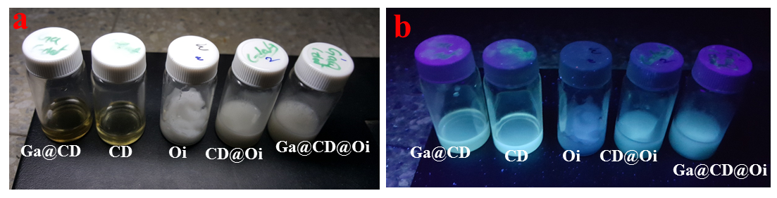.
Fig. 1. (a) Ga@CD, CD, Oi, CD@Oi and Ga@CD@Oi in daylight and (b) under UV light.
Determination of particle size of synthesized CD/Ga@CD-ointment nanocomposites
The particle-size distribution of the synthesized nanocomposite CD/Ga@CD nanoparticles was measured by TEM (Fig. 2). The TEM results reveal the successful dispersion of CD and Ga@CD in the ointment. High-resolution transmission-electron microscopy (HRTEM) results (Fig. 2a) demonstrate that the size of the C-dots is about 4–8 nm. Fig. 2b shows the HRTEM of the Ga@C-dots, which are about 5–9 nm in size. The fluorescence emitted from the C-dots/Ga@C-dots in the supernatant solution was recorded for different excitation wavelengths (330, 350, 370, 390, 410, 430, 450, 470 and 490 nm) and the maximum emission was found at 420–510 nm (centred at 470 nm. See Supporting Information, Fig. S1). To study the antiparasitic activity of the Ga@C-dots, we added CD/Ga@CD to the ointment and cerated a new nanocomposite ointment. Furthermore, the value of d-spacing estimated from the HRTEM and SAED patterns is 0.21 nm. After mixing various concentrations of carbon dots into the ointment, the TEM image was recorded (Figs. 2c and 2d). The figure depicts an almost uniform distribution of the particles in the ointment. Furthermore, no change in the size of the C-dots was observed after the particles were dispersed in the ointment. The TEM images present the micrograph of C-dots incorporated in the ointment (Fig. 2c), and Fig. 1d shows the Ga@CD particles in the ointment. The data in Figs. 2c and 2d show that the CD are homogenously distributed in the ointment. The same information is shown in Fig. 1. The fluorescence and high-resolution TEM images reveal that both the C-dots and Ga@C-dots are highly crystalline, with d-spacing of about 0.21 and 0.22 nm, respectively, as reported in our previous paper.²⁷
The size validation of the CDs/Ga@CD@Oi was further supported by DLS measurements, which show that the nanoparticles are highly monodispersible in the isopropanol medium. The mean hydrodynamic diameters of the CDs/Ga@CD@Oi (Fig. 3 and Table 1) clearly indicate that there is a slight increase in size, as seen in the CD/Ga@CD-incorporated ointment.
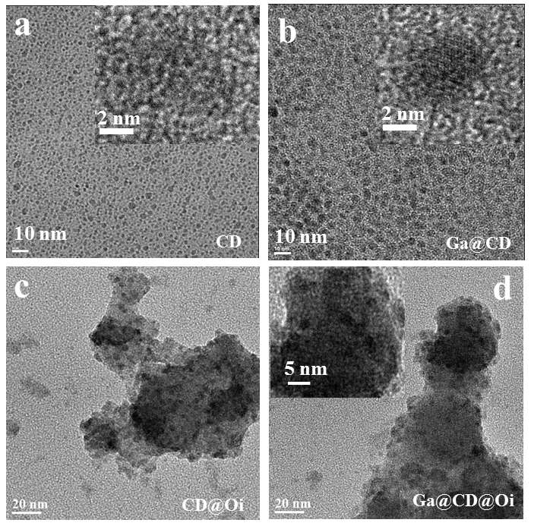
Fig. 2. HRETEM images of (a) C-dots (inset: lattice image), (b) Ga@CD (inset: lattice image, (c) CD@Oi and (d) Ga@CD@Oi.
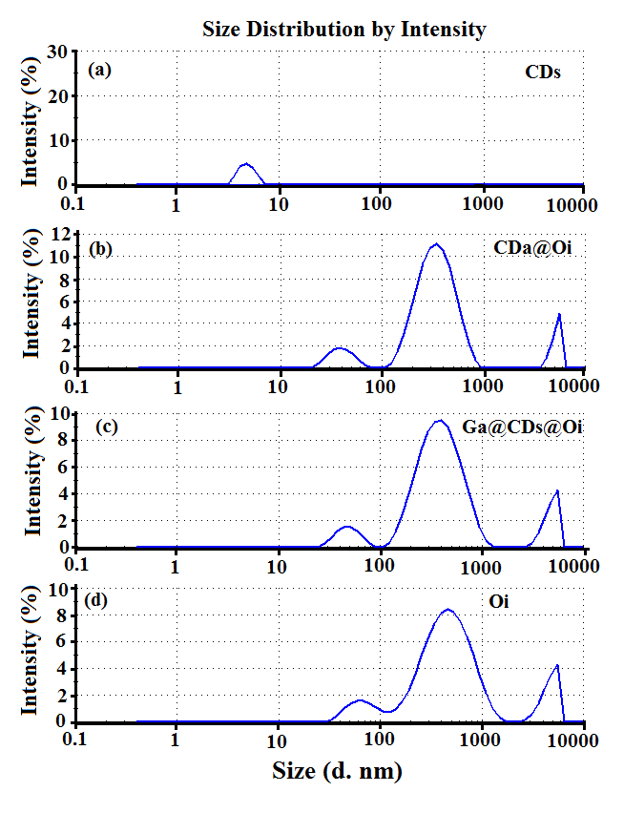
Fig. 3. Size distribution of (a) CDs, (b) CD@ointment, (c) Ga@CDs@ointment and (d) ointment.

Table 1. Summary of size of particles and zeta potentials
Type of material | Size of the particles by DLS (nm) | Size of the particles by TEM (nm) | Zeta potentials (mV)
CDs | ~7 | ~5 | -25
Ga@CDs | ~8 | ~6 | +19
CD@ointment | ~60 and ~500 | ~60, ~300 | +15
Ga@CDs@ointment | ~60 and ~500 | ~60, ~300 | +24
Ointment | ~70 and ~500 | ~60, ~300 | +20
To find out whether any chemical modification of the C-dots has occurred, we have performed FTIR analysis. The CD/Ga@CD-ointment nanocomposite preserves the characteristic peaks of each component, as shown in the FTIR spectra of the pure ointment. FTIR spectroscopic analysis of the CD/Ga@CD-ointment nanocomposites demonstrates that the CDs are, indeed, incorporated into the ointment, or form a hydrogen bond via an amide bond and a free carboxyl group on the surface of the CDs nanoparticles through carbodiimide chemistry (Fig. 4). The peak at about 1,748 cm⁻¹ is characteristic of the stretching of the carbonyl groups (C=O) of the polymer. In the PEG bonding, the peak at 1,084 cm⁻¹ is assigned to the stretching band of the C–O bond. The peaks at 1,650 cm^{-l} and 1,530 cm^{-l} are assigned to the C=O stretching vibration and –OH bending vibration of alcohol, respectively (Fig. 4). Finally, stable hydrogen bonds are formed as a result of the reaction of the carboxyl groups in the CD/Ga@CDs with the ointment.
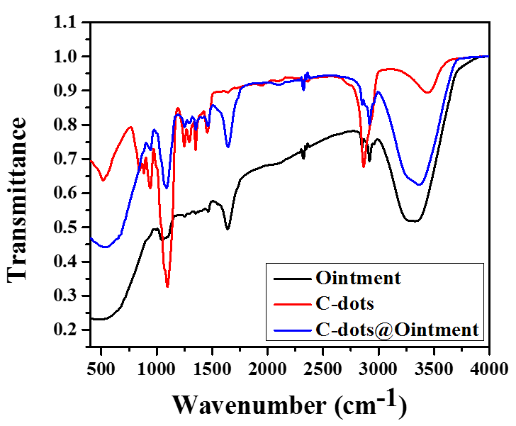
Fig. 4. FTIR spectra of C-dots, ointment, and C-dots@ointment nanocomposites.
Parasitic activity of C-dot-ointment nanocomposites in the plate
Social motility in parasites allows us to culture them on semisolid agarose surfaces, where they form a colony-like pattern. We can use this phenomenon to check the influence of different materials on parasite growth. Here, we compare the C-dot and Ga@C-dot ointment with the bare ointment. Parasites (10⁸) were plated on semisolid agarose surfaces. Then the cells were treated by C-dot and Ga@C-dot ointment. As a control, we used pristine ointment. The cells were incubated for 72 h. Then the proteins were shifted to a nitrocellulose membrane and stained with Ponso. The results suggest that untreated cells (PBS) grow nicely and create colonies (Figs. 5a and 5b). While comparing pristine ointment to C-dot (Fig. 5a) and Ga@C-dot ointment (Fig. 5b), it can be clearly seen that the nanocomposite ointment has a much greater inhibition effect on parasite growth, suggesting that these materials can be used as an anti-parasitic drug. For both C-dot and Ga-doped-C-dot ointments, the results are the same. Therefore, we continued our study using C-dot and C-dots@oinment nanocomposites.
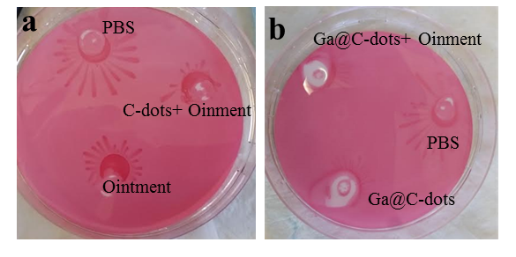
Fig. 5. Antiparasitic activity of (a) C-dot-ointment and (b) Ga@CD-ointment nanocomposites in a plate, compared with CD, PBS and plain ointment.

In vitro drug sensitivity assay
An in vitro drug sensitivity assay was performed on the L. major and L. donovani parasites to compare the efficacy of the C-dots at various concentrations for 24 h. Figs. 6a and 6b show that concentrations between 30 and 40 ug/mL are optimal for killing Leishmania parasites.

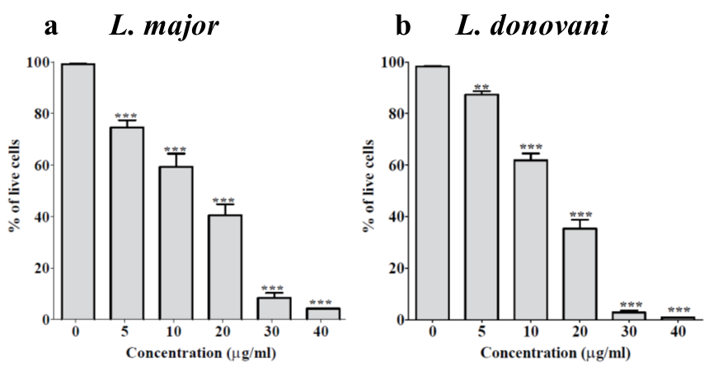

Fig. 6. Parasitic activity of C-dots at various concentrations (0–45 ug/mL) for (a) L. major and (b) L. donovani.

Further examination of the killing of the parasite by C-dots was carried out using fluorescence microscopy. The C-dots were chosen to treat THP-1 cell lines, which are cell lines of a human leukemic cultured from the blood of a boy with acute monocytes leukemia.^{33,34} These cells can be separated into macrophage cells that host leishmanial parasites, by using 12-O-tetradecanoylphorbol-13-acetate (PMA). In this case, THP-1 cells (10⁶) were plated in a 24-well plate and treated with PMA at 37 °C for 48 hours to complete the separation into macrophage cells. Then cells were infected with L. donovani-promastigote (GFP) parasites (5×10⁶). After 24 hours, the wells were washed to remove parasites that failed to infect the microphages. The infected cells were treated overnight with C-dot particles at a concentration of 20 μg/ml. The macrophage nuclei were stained by DAPI (blue). The results were measured by ‘Live Imaging’ microscopy, Observer (×40). As can be seen for the samples treated (Figs. 7b and 7d), there is a significant reduction in the parasite number, suggesting that the C-dots are able to reach the intracellular parasites and kill them in the amastigotes form of Leishmania.

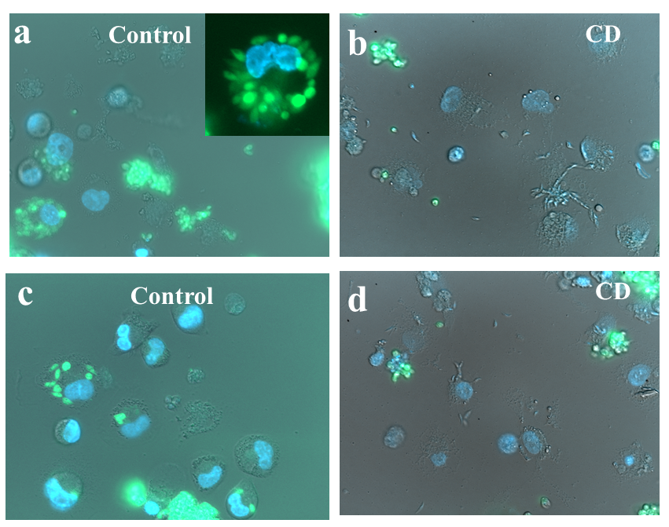
Fig. 7. Effects of C-dots on the parasitic growth of L. donovani.
The toxicity of the C-dots was studied by comparing untreated and treated cells with 40 and 80 µg/ml of C-dot particles. The toxicity was analyzed by measuring the DNA fragmentation at cell-cycle events using flow cytometry. The fragmentation of the DNA to nucleotide units is one of the best markers of apoptosis or necrosis.³⁵ Apoptosis or necrosis are recognized by a ‟sub-G₁ peak/hypodiploid peak” (Fig. 8). The DNA was stained with PI. The results show that even the higher concentration of C-dots (40 and 80 µg/ml) for 24 hours did not increase the number of cells in the sub-G₁ phase of the cell cycle in THP-1 monocytes. Therefore, we can conclude that the particles are not toxic to the monocyte cells, but they are toxic to the Leishmania parasites.

Fig. 8. Effect of (a) C-dots, (b) Ga@CDs and (c) ointment on the THP-1 cell cycle and cytotoxicity. THP-1 cells. The percentage of sub-G₁, G₀/G₁, S and G₂/M fractions were analysed using the CellQuest computer software.

Mechanism of CDs for killing the L. parasite
The unique chemistry of the C-dots helps to address many of the challenges associated with drug administration. The surface of the C-dots has many functional groups, such as OH, COOH and C=O. Here, we hypothesize that carbon dots are internalized by Leishmania. This speculation is based on the confocal microscopy data in vedio-1, which shows that the C-dots cause morphological changes in L. donovani. Vedio-1 compares the untreated cells. It shows that the untreated parasites look normal as far as the division of the cells, whereas treated parasites show under stressCHANGE THIS SENTENCE. To find out the mechanism for killing the parasite, several assays were performed, including lysosomal bursting, depolarization of the mitochondrial membrane and ion leakage from the parasite. Fig. S2 reveals that there is no lysosomal bursting, since the red fluorescence appears both with and without the C-dots. Further analysis of the killing mechanism of the leishmanial parasite was carried out by the depolarization of the mitochondrial membrane using TMRM. During the process of apoptosis, there is a decrease in the mitochondrial-membrane potential (m). The TMRM cationic material can enter the cells and accumulate in the negatively charged matrix of the mitochondria, depending on the mitochondrial membrane potential. In fact, the color intensity of the material is in reverse correlation to the potential difference between the inner and outer membrane of the mitochondria. Thus, when the membrane potential difference is high (inner membrane is more negatively charged), greater color intensity is detected while, during the de-polarization, that is, when there is a lower potential difference (inner membrane is less negative), the color intensity is low.³⁶ TMRM stains the mitochondria selectively, and is identified by using flow cytometry following a change in the membrane voltage.³⁷ This shows that there is no significant difference between the treated and untreated mitochondria of the parasite (Fig. S3). Finally, the leakage of ions (Na⁺, K⁺) was tested by ICP and it was found that higher Na⁺ and K⁺ ion concentrations exist in the treated cells (~11%). It is well-known that the activity of the efflux pumps normally reduces the effective drug concentrations within the parasite by preventing absorption through the esophagus as well as reducing intracellular concentration within the cells (Fig. 9).
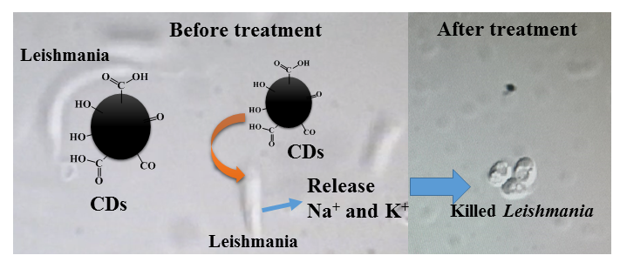
Fig. 9. Effects of C-dots before and after (released Na⁺ and K⁺ ions) treatment on Leishmania.
The ionic concentration was measured using ICP analysis. This analysis is presented in Table 1. Based on our results, we propose that the efficient and rapid direct penetration of the carbon dots through the surface of the parasite can affect the cell membrane and ion imbalance.

Table 1. ICP analysis of ion leakage after treatment with the parasite
Type of material | Na⁺ + std. dev. | K⁺ + std. dev. | Differences in Na⁺ ion = parasite-PBS | Differences in K⁺ ion = parasite-PBS
Untreated cell | 11200+80 ppm | 1070+67 | 350+57 | 170±17
Treated cell | 12800+150 | 1200+10.0 | 1950+30 | 300±10
PBS+NP | 10950+140 | 1000+30 | 100+10 | 100+10
PBS | 10850+150 | 900+50 | 000 | 000

4. Conclusions
The C-dots and Ga@C-dots were synthesized by ultrasonic irradiation of PEG-400 and molten Ga. HRTEM analysis demonstrates that the uniform and crystalline carbon dots were formed over the range of 4–8 nm. We successfully designed C-dot-based ointment nanocomposite. The C-dots were incoporated into the ointment by bath sonication for 5 minutes. TEM analysis demonstrates that the C-dots are uniformly distributed in the ointment. The C-dots@ointment nanocomposite shows better killing of the L. major parasite than plain oinment or C-dots. Furthermore, C-dots and Ga@C-dots were tested against different species of Leishmania (L. donovani, L. major). However, C-dots and Ga@C-dots show similar activity. The C-dots kill the parasites but not the host cells. Therefore, we continued all antiparasitic activity with C-dots. Finally, the killing mechanism of the parasites was studied, examining whether the C-dot disrupts lysosome integrity, mitochondrial membrane or ion hemostasis in the parasite.
Based on our results, we propose that the efficient and rapid direct penetration of the carbon dots through the surface of the parasite disrupts the cell membrane, resulting in ion imbalance. This new material is an effective anti-leishmanial drug which is currently highly needed due to the increasing spread of leishmanial diseases and the development of leishmanial resistance to common drugs.

5. Acknowledgements
The authors are grateful to Ortal Lidor-Shalev for her help with the TEM measurements, to Daniel Raichman for the Raman measurements and to Merav Muallem for the HRSEM measurements, of the Department of Chemistry, Bar-Ilan University, Israel.
List of abbreviations
CDs: carbon dots
DLS: dynamic light scattering
PBS: phosphate buffer saline
G@CDs: gallium-doped carbon dots
Oi: ointment
HRTEM: high-resolution transmission-electron microscope
Competing interests
None of the authors of the manuscript have any competing interests.

References
(1) Dawit, G. A Review on Biology, Epidemiology and Public Health Significance of Leishmaniasis. J. Bacteriol. Parasitol. 2013, 4, 2–7.
(2) Dawit, G.; Girma, Z.; Simenew, K. A Review on Biology , Epidemiology and Public Health Significance of Leishmaniasis. Acta Parasitol. Glob. 2012, 3, 43–53.
(3) Patel, J. A.; Shah, K. G. LEISHMANIASIS : A REVIEW. Pharmacologyonline 2008, 2, 1–11.
(4) Iowa State University/College of Veterinary Medicine. Leishmaniasis (Cutaneous and Visceral). Iowa State Univ. 2009, 1–11.
(5) Mears, E. R.; Modabber, F.; Don, R.; Johnson, G. E. A Review: The Current In Vivo Models for the Discovery and Utility of New Anti-Leishmanial Drugs Targeting Cutaneous Leishmaniasis. PLoS Negl. Trop. Dis. 2015, 9, 1–23.
(6) Metwally, D. M.; Al-Olayan, E. M.; El-Khadragy, M. F.; Alkathiri, B. Anti-Leishmanial Activity (In Vitro and In Vivo) of Allicin and Allicin Cream Using Leishmania Major (Sub-Strain Zymowme LON4) and Balb/c Mice. PLoS One 2016, 11, e0161296.
(7) Rezvan, H.; Moafi, M. An Overview on Leishmania Vaccines: A Narrative Review Article. Vet. Res. forum an Int. Q. J. 2015, 6, 1–7.
(8) Eshetu, E.; Bassa, T. The Public Health Significance of Leishmaniasis : An Overview. 2016, 6, 48–57.
(9) Alvar, J.; Vélez, I. D.; Bern, C.; Herrero, M.; Desjeux, P.; Cano, J.; Jannin, J.; de Boer, M. Leishmaniasis Worldwide and Global Estimates of Its Incidence. PLoS One 2012, 7.
(10) Andrews, K. T.; Fisher, G.; Skinner-Adams, T. S. Drug Repurposing and Human Parasitic Protozoan Diseases. Int. J. Parasitol. Drugs Drug Resist. 2014, 4, 95–111.
(11) Elmahallawy, E. K.; Sampedro Mart??nez, A.; Rodriguez-Granger, J.; Hoyos-Mallecot, Y.; Agil, A.; Navarro Mari, J. M.; Gutierrez Fern??ndez, J. Diagnosis of Leishmaniasis. J. Infect. Dev. Ctries. 2014, 8, 961–972.
(12) Singh, S. New Developments in Diagnosis of Leishmaniasis. Indian J. Med. Res. 2006, 123, 311–330.
(13) Peeling, R.; Artsob, H.; Pelegrino, J. Evaluation of Diagnostic Tests: Dengue. Nat. Rev. … 2010, 8, S30–S37.
(14) Laxminarayan, R.; Bhutta, Z. A.; Duse, A.; Brien, T. O.; Okeke, I. N.; Pablo–Mendez, A.; Klugman, K. P. Chapter 55 Drug Resistance. In Disease Control Priorities in Developing Countries; 2003; pp. 1031–1051.
(15) Shenderova, O. A.; Zhirnov, V. V.; Brenner, D. W. Carbon Nanostructures. Crit. Rev. Solid State Mater. Sci. 2002, 27, 227–356.
(16) Jariwala, D.; Sangwan, V. K.; Lauhon, L. J.; Marks, T. J.; Hersam, M. C. Carbon Nanomaterials for Electronics, Optoelectronics, Photovoltaics, and Sensing. Chem. Soc. Rev. 2013, 42, 2824–2860.
(17) Tan, M.; Li, X.; Wu, H.; Wang, B.; Wu, J. N-Doped Carbon Dots Derived from Bovine Serum Albumin and Formic Acid with One- and Two-Photon Fluorescence for Live Cell Nuclear Imaging. Colloids Surf B Biointerfaces 2015, 136, 141–149.
(18) Mewada, A.; Pandey, S.; Thakur, M.; Jadhav, D.; Sharon, M. Swarming Carbon Dots for Folic Acid Mediated Delivery of Doxorubicin and Biological Imaging. J. Mater. Chem. B 2014, 2, 698–705.
(19) Du, F.; Ming, Y.; Zeng, F.; Yu, C.; Wu, S. A Low Cytotoxic and Ratiometric Fluorescent Nanosensor Based on Carbon-Dots for Intracellular pH Sensing and Mapping. Nanotechnology 2013, 24, 365101.
(20) Krishna, A. S.; Radhakumary, C.; Sreenivasan, K. In Vitro Detection of Calcium in Bone by Modified Carbon Dots. Analyst 2013, 138, 7107–7111.
(21) Algarra, M.; Perez–Martin, M.; Cifuentes–Rueda, M.; Jimenez-Jimenez, J.; Esteves da Silva, J. C. G.; Bandosz, T. J.; Rodriguez–Castellon, E.; Lopez Navarrete, J. T.; Casado, J. Carbon Dots Obtained Using Hydrothermal Treatment of Formaldehyde. Cell Imaging in Vitro. Nanoscale 2014, 6, 9071–9077.
(22) Zhang, P.; Xue, Z.; Luo, D.; Yu, W.; Guo, Z.; Wang, T. Dual-Peak Electrogenerated Chemiluminescence of Carbon Dots for Iron Ions Detection. Anal. Chem. 2014, 86, 5620–5623.
(23) Yang, Z.; Xu, M.; Liu, Y.; He, F.; Gao, F.; Su, Y.; Wei, H.; Zhang, Y. Nitrogen-Doped, Carbon-Rich, Highly Photoluminescent Carbon Dots from Ammonium Citrate. Nanoscale 2014, 6, 1890–1895.
(24) Bian, J.; Huang, C.; Wang, L.; Hung, T.; Daoud, W. A.; Zhang, R. Carbon Dot Loading and TiO₂ Nanorod Length Dependence of Photoelectrochemical Properties in Carbon dot/TiO₂ Nanorod Array Nanocomposites. ACS Appl. Mater. Interfaces 2014, 6, 4883–4890.
(25) Hu, L.; Sun, Y.; Li, S.; Wang, X.; Hu, K.; Wang, L.; Liang, X. J.; Wu, Y. Multifunctional Carbon Dots with High Quantum Yield for Imaging and Gene Delivery. Carbon N. Y. 2014, 67, 508–513.
(26) Chen, J.; Liu, W.; Mao, L. H.; Yin, Y. J.; Wang, C. F.; Chen, S. Synthesis of Silica-Based Carbon Dot/nanocrystal Hybrids toward White LEDs. J. Mater. Sci. 2014, 7391–7398.
(27) Kumar, V. B.; Sheinberger, J.; Porat, Z.; Shav-Tal, Y.; Gedanken, A. A Hydrothermal Reaction of an Aqueous Solution of BSA Yields Highly Fluorescent N Doped C-Dots Used for Imaging of Live Mammalian Cells. J. Mater. Chem. B 2016, 4, 2913–2920.
(28) Fu, M.; Ehrat, F.; Wang, Y.; Milowska, K. Z.; Reckmeier, C.; Rogach, A. L.; Stolarczyk, J. K.; Urban, A. S.; Feldmann, J. Carbon Dots: A Unique Fluorescent Cocktail of Polycyclic Aromatic Hydrocarbons. Nano Lett. 2015, 15, 6030–6035.
(29) Protesescu, L.; Yakunin, S.; Bodnarchuk, M. I.; Krieg, F.; Caputo, R.; Hendon, C. H.; Yang, R. X.; Walsh, A.; Kovalenko, M. V. Nanocrystals of Cesium Lead Halide Perovskites (CsPbX3, X = Cl, Br, and I): Novel Optoelectronic Materials Showing Bright Emission with Wide Color Gamut. Nano Lett. 2015, 15, 3692–3696.
(30) Kumar, V. B.; Porat, Z.; Gedanken, A. Facile One-Step Sonochemical Synthesis of Ultrafine and Stable Fluorescent C-Dots. Ultrason. Sonochem. 2016, 28, 367–375.
(31) Kumar, V. B.; Perelshtein, I.; Lipovsky, A.; Porat, Z.; Gedanken, A. The Sonochemical Synthesis of Ga@C-Dots Particles. RSC Adv. 2015, 5, 25533–25540.
(32) Kumar, V. B.; Natan, M.; Jacobi, G.; Porat, Z.; Banin, E. Ga @ C-Dots as an Antibacterial Agent for the Eradication of Pseudomonas Aeruginosa. Int. J. Nanomedicine 2016, 400, 1–18.
(33) Tsuchiya, S.; Yamabe, M.; Yamaguchi, Y.; Kobayashi, Y.; Konno, T.; Tada, K. Establishment and Characterization of a Human Acute Monocytic Leukemia Cell Line (THP-1). Int. J. Cancer 1980, 26, 171–176.
(34) Auwerx, J. The Human Leukemia Cell Line, THP-1: A Multifacetted Model for the Study of Monocyte-Macrophage Differentiation. Experientia 1991, 47, 22–31.
(35) Zhang, J. H.; Xu, M. DNA Fragmentation in Apoptosis. Cell Res. 2000, 10, 205–211.
(36) Perry, S. W.; Norman, J. P.; Barbieri, J.; Brown, E. B.; Harris, A. Gradient : A Practical Usage Guide. Biotechniques 2011, 50, 98–115.
(37) Floryk, D.; Houštěk, J. Tetramethyl Rhodamine Methyl Ester (TMRM) Is Suitable for Cytofluorometric Measurements of Mitochondrial Membrane Potential in Cells Treated with Digitonin. Biosci. Rep. 1999, 19, 27–34.

