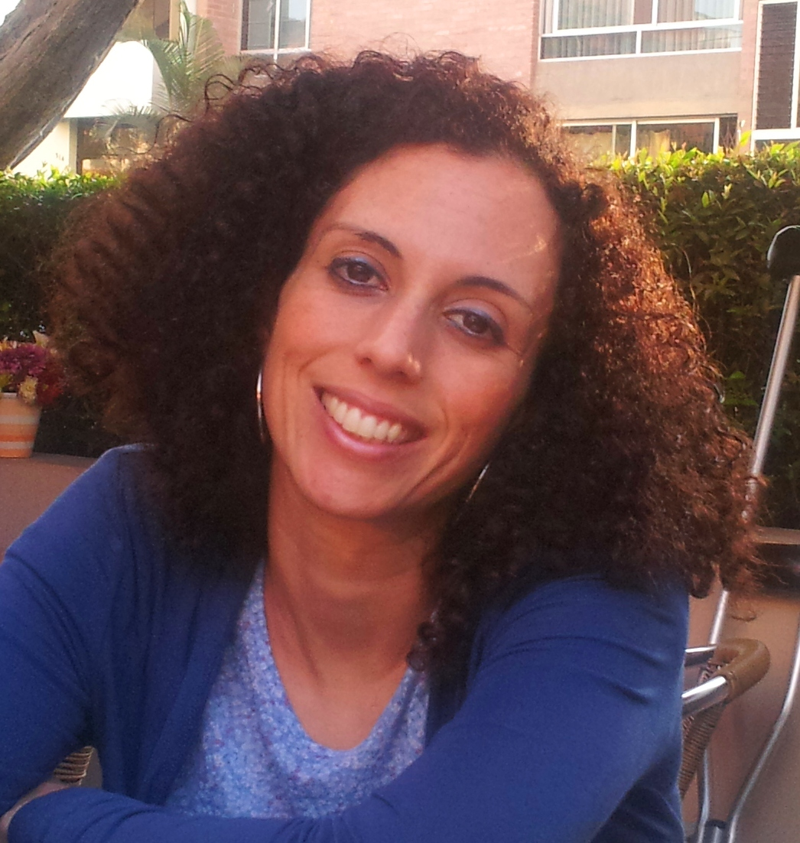
CURRICULUM VITAE

YAEL CEGLA-NEMIROVSKY

Haportzim 21/4, Jerusalem 9254106
Cell Phone: (972)-54-4933256
e-mail: yaelnj@gmail.com

- Personal Data:

Date of birth: 16/7/1981
Place of Birth: Lima-Peru
ID: 332582139
Nationalities: Israeli/Peruvian
Civil state: Married (+1)
Aliyah date : 12/27/2010

- Education

- 2012 - Present: PhD Candidate in Applied Chemistry at The Hebrew University of Jerusalem.

- 2004 – 2006: Master of Science in Human Nutrition. Graduated with honors: Valedictorian. Thesis: Excellent. Universidad Nacional Agraria La Molina (UNALM), Lima-Peru.
Thesis: "Camu-camu (Myrciaria dubia H.B.K MCVAUGH, 1958) effect estimation on iron bioavailability, as a source of vitamin C.

- 1999 – 2003: Bachelor’s degree in Sciences with mention in Biology. Graduated with honors: 3rd Place. Universidad Peruana Cayetano Heredia (UPCH), Lima-Peru.

- 2003 – 2004: Undergraduate Research. Cancer and Cell Signaling (MAPK). The Karyn Kupcinet International Science School at the Weizmann Institute of Science, Biological Regulation Department, Rehovot, Israel.

- 1993 – 1997: Leon Pinelo Jewish Private High School. Graduated with honors: Valedictorian. (Lima-Peru).

- Professional Experience

- 2012 – Present- Freelance: Translations in English-Hebrew-Spanish.

- Dec 2009 – Dec 2010: Researcher (R & D) of anthocyanin natural colorants extraction and production for beverage and food industry. Orginor Chemical S.A.C., Lima-Peru.

- May – Jun 2009: Researcher and supervisor in charge of the Biochemistry Laboratory. Research about serum ferritin and protein C reactive determination. Nutritional Research Institute (IIn), Lima-Peru.

- Sep – Nov 2008: Graduate Research: Camu-camu and iron bioavailability. Department of Food Science and Human Nutrition. Iowa State University (ISU), Ames, Iowa, USA.

- Nov 2008: Graduate Research: Quantification of ferritin from staple food crops. Department of Food Science and Human Nutrition. ISU, Ames, Iowa, USA.

- 2008: Biology Teacher. High School classes at Leon Pinelo Jewish Private School, Lima-Peru.

- 2004 – 2008: Hebrew and Jewish Culture Teacher. Middle and High School classes at Leon Pinelo Jewish Private School, Lima-Peru.
- Scholarships

- 2011-2016: Selected recipient of Kaete Klausner Scholarship for outstanding new immigrants students from The Hebrew University of Jerusalem.
- 2011-2014: Selected recipient for Scholarship program for research students from The Ministry of Immigrant Absorption.
- 2008: Research and Stipend Scholarship for Master’s Thesis from IIN and ISU.

- Publications

- Cegla-Nemirovsky Y., Aserin A., Garti N. Oleogels from glycerol-based lyotropic liquid crystals: Phase diagrams and structural characterization. J Am Oil Chem Soc. 2015, Vol.92, Issue 3, pp. 439-447.
DOI: 10.1007/s11746-015-2594-7.

- Nemirovsky Y., Zavaleta N, Villanueva ME, Armah SM, Iman SA, Reddy MB. Negative effect of Camu-camu (Myrciaria dubia) despite high vitamin C content on iron bioavailability, using a Caco2 cell model. Pol. J. Food Nutr. Sci. 2014, Vol. 64, No. 1, pp. 45-48.
DOI: 10.2478/v10222–012–0088–y http://journal.pan.olsztyn.pl

- Conferences and Seminars

- May 2014: PhD Poster Presentation at 105th Annual Meeting and Expo of American Oil Chemistry Society (AOCS). San Antonio, Texas, USA.
- Oct 2013: PhD Poster Presentation at 5th International Symposium on Delivery of Functionality on Complex Food Systems. Haifa, Israel.
- Nov 2010: Dissertation and member of the Peruvian Nutrition Society (SOPENUT).
- Nov 2009: XV Latinoamerican Nutritional Congress participant. XVI Chilean Nutritional Journal. Nutrition, Food and Development in Latin America.
- May-Jun 2007: National Nutritional Congress organizing committee member. III International Nutritional Course. II Peruvian Chilean Nutritional Journal. SOPENUT, Lima, Peru.
- 2004 – 2009: Human nutrition congresses and courses attendance. Lima, Peru.
- Nov 2004: XXII IVACG Meeting organizing committee member. ILSI Human Nutrition Institute, Health Ministry of Peru, Lima, Peru.
- 1999: Youth leader (madricha) in youth movement "Hanoar Hatzioni".
- Ago-Dec 1998: Participant in Institute for youth leaders from Abroad. Jerusalem-Israel.

- Languages

- Hebrew: Native speaker level
- English: Advanced Level
- Spanish: Native Speaker

- Informatics

- Windows 7
- Microsoft Office
- Origin
- Endnote

- References upon request

