**Purpose**:

This test method describes the method for evaluating the cleanliness of new or remanufactured drums or pails received in the plant. The rinsed solvent is poured through a 25 micron mesh filter and evaluated vs. a dirt standard content. The solvent must then undergo crater testing protocol.

**Scope:**

This method is suitable for the analysis of solvents obtained from a new or remanufactured drum or pail received into the plant. A warehouse associate collects a sample. The sample is to be delivered to the quality assurance laboratory along with documentation on the container type.

Modifications of this test procedure should be noted in the analysis data and documented.

**Method Summary:**

A warehouse associate collects a solvent sample from an empty drum or pail. Quality Control Technician evaluates the sample by performing a filtration and a solvent crater check.

**Safety:**

Personnel using this method should be familiar with safety and handling precautions for both the material to be tested and the reagents used in the testing method.

Chemicals employed in this method and samples tested by this method may be toxic and/or corrosive. Safety glasses with side shields and gloves must be worn while using this procedure.

All work must be performed in a fume hood or an area with adequate ventilation.

**Revision Details:**#001 – (12/15/17) –New Procedure   
 #002 – (1/12/18) – removed reference to GQI RMTCP-001, new logo

**Translation Links**:

**Equipment:**

1. 25-micron nylon mesh filter
2. Oven, forced draft
3. Tweezers
4. Glass Slides
5. Magnifying Flashlight, recommended but not required
6. Cellophane tape

**Procedure**

1. Incoming drum or pail is properly rinsed at the warehouse in accordance to their written procedure. The sample is collected in a glass or plastic container and sent to the Quality Control lab along with the container type.
2. Pour the sample through a 25-micron nylon mesh filter screen. Try to collect any debris in a ½ inch diameter circle.
3. Bake filter until dry for approximately 10 minutes at 110°C.
4. Remove the filter from oven and place the filtered particulate between two glass slides. Trim any excess mesh from the outside of the slide.
5. Tape the slide together with cellophane tape. Label with the date, drum/pail type, and any other available information.
6. Rate this slide against visual control (Figure 1).
7. Test results are recorded on a scale of 1-5, 1 being the best and 5 being the worst.
   1. If the sample fails filter inspection, contact the appropriate personnel for a resample. If a second failure occurs, the wagon should be rejected. All results including re-samples should be recorded and tracked for transport company trend analysis
8. Record final results
   1. If the cleanliness test is returned at a “5” rating, a second sample will be requested. If the second sample also returns a “5” rating, XXX will issue a Supplier Non-Conformance CAIR and require a root cause investigation and track the lot of drums throughout the process to document any issues with the product.
9. Perform solvent crater testing according to local protocol.
   1. If a crater test produces a “FAIL” lot results, the drums will be returned to the supplier and XXX will issue a Supplier Non-Conformance CAIR and require a root cause investigation.

Figure 1: Drum Rinse Mesh Standards

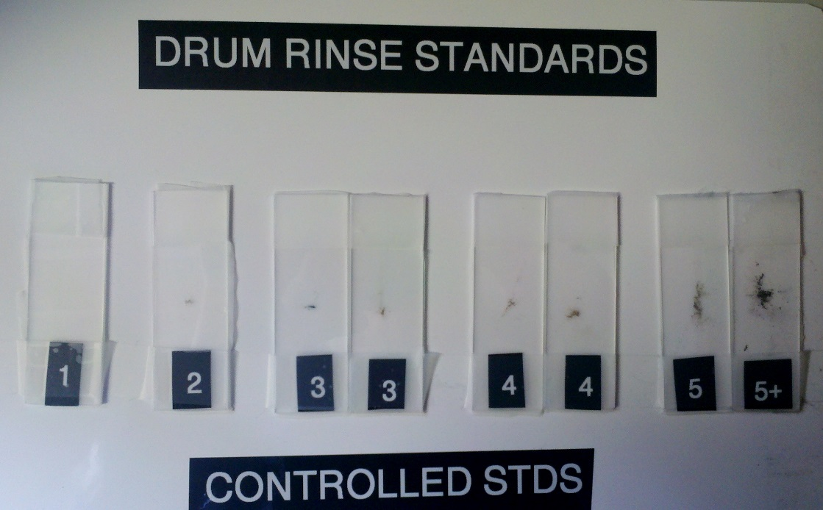

**References:**

* Quality Assurance – Raw Materials QWI-35– “New Container Cleanliness Check”