[Subject] Thoughts of spring…

**Beautiful, delicious and useful...**

...Their delicate scents, flavors and colors once more begin to bloom as sunny days return.

For those who, like us, are already thinking about spring, here are Cibo and Mattioli’s **primroses**.

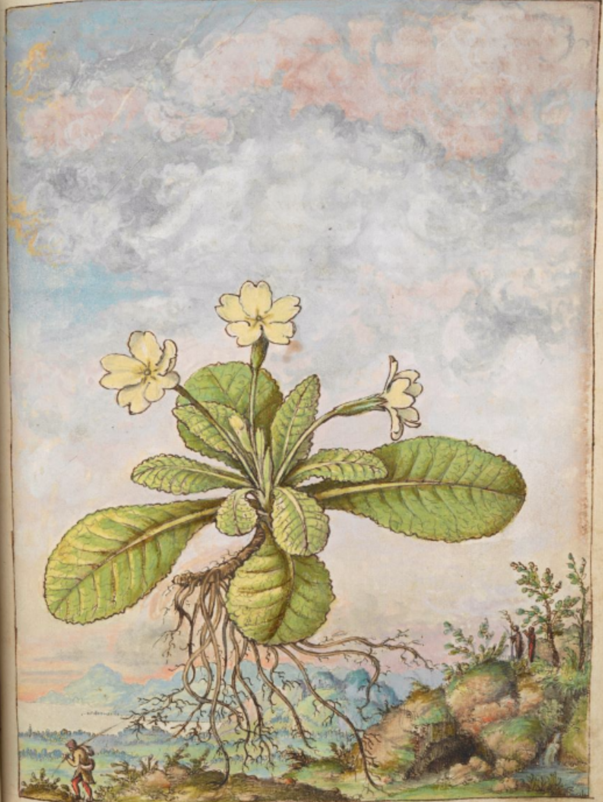

128r, *Primula acaulis* (L.) L., common primrose.

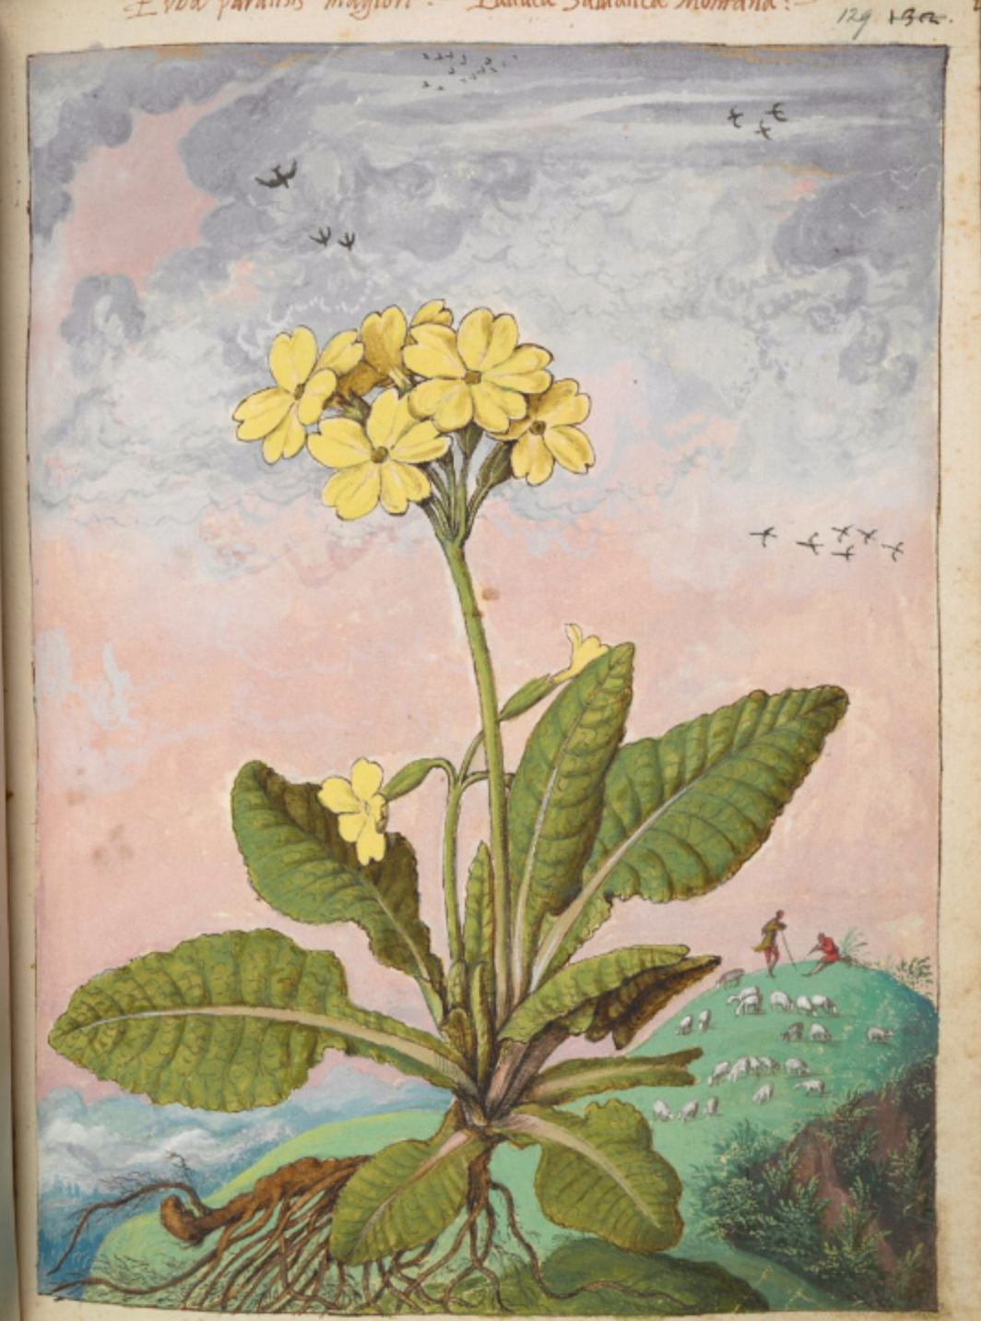

129r, *Primula veris*(L.), cowslip.

“Two quite similar species of plants crop up in spring. They have crinkly leaves, reminiscent of some types of cardoons. One species’ flowers are whitish, while the other’s are yellow, rounded and flat. Some call them spring blossoms, others weeds. Today, both species are used to treat joint pain. It is said that the roots should be cooked and made into a decoction to combat kidney and bladder obstructions when drunk.

The juice of the herb can also be drunk or applied topically as a poultice for bone fractures and sprains. Women often wash their faces with the juice of the flowers as it tightens the skin and eliminates blemishes.

The roots of these two plants are shorter than an index finger and thinner than a pinkie. Myriad other slender, aromatic rootlets grow from them. The one with white flowers and no stem grows in forests, ditches and cool places near woods. The other, which has yellow flowers and a stem, grows in high mountain pastures.”

*The Dioscoride by Cibo and Mattioli*, c. 127v.

The contents of this message are of a historical, artistic and cultural nature. They are not medicinal.