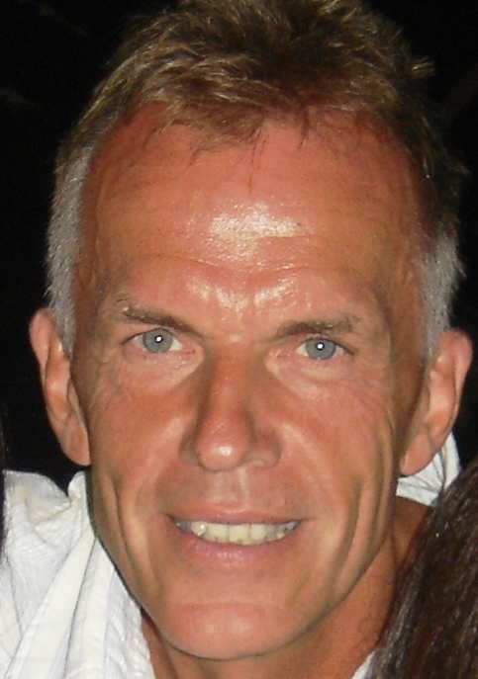

Curriculum Vitae

Name: Manfred Reddig
Date and place of birth: 13.11.54, Frankfurt / Main, Germany
Citizenship: German
Family status: married
Home address: José Darragueira 950
1609 Boulogne / Prov. de Buenos Aires
Argentina
Home telephone: (+54 11) 4737-5709
Cell phone: (+54 911) 4478 5229
e-mail: manfredreddig@gmail.com

Education

  - law study at the University of Bonn / Germany

- first exam of state

- second exam of state (“Assessor Juris”)

Experience

  - Contracts Manager in Dornier GmbH, Friedrichshafen
(Germany)

1992-1994 Assistant to the CEO, Jürgen Schrempp (later to be President of DaimlerChrysler car group), in the Main Secretary of Daimler-Benz Aerospace AG (DASA), Munich (since 2000, “EADS Deutschland GmbH”)

1994- January 2006 Working in a private multinational telecom satellite operator in Buenos Aires, Argentina, commercializing its own satellite system as:

May 1994 – July 1997 Legal Council to the Management

July 1997- January 2006 Ordinary member of the company Management, position Operational Director for Legal, Institutional and Corporate Issues

Since 2006 Since liquidation of the telecom company, full-time free- lance translator (beginning of this activity in 1998 on a part-time basis)

Legal consultant to the Cologne/Germany based software development company Scoop

October 2008 Admitted into the elite translator group of the Certified ProZ.com Network and thereby earning the “ProZ.com Certified PRO” title and seal

Since 2009 First choice external Translator, Proofreader and Quality Manager for the leading UK and US based translation agency TransPerfect Translations (on a daily basis)

Languages

Trilingual German / English / Spanish

TRANSLATIONS:

English to German

