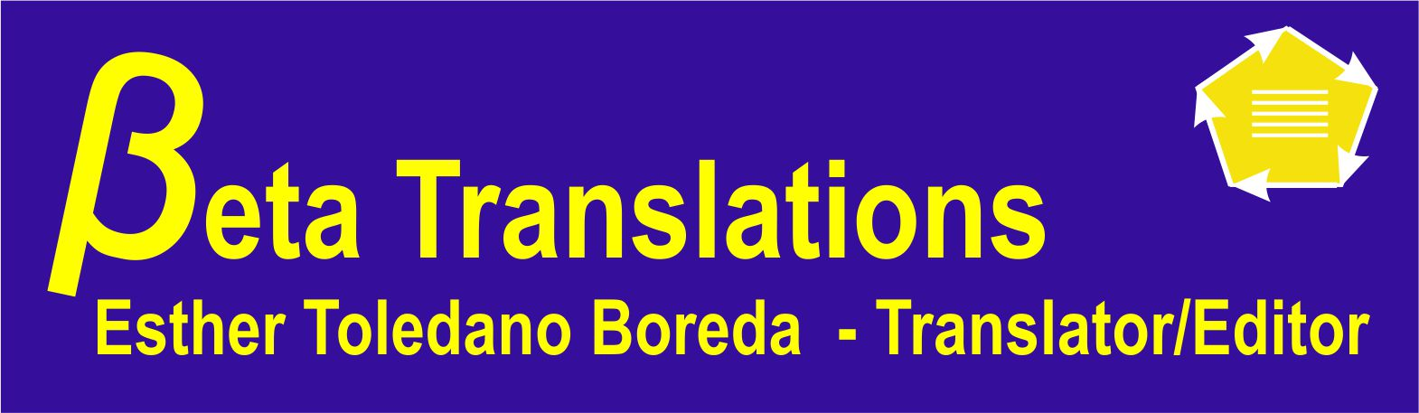
CURRICULUM VITAE

Name: Esther Toledano Boreda

P
E
R
S
O
N
A
L
Address: Hate'ena St., 13/53, Gilo, Jerusalem, Israel
Tel./Fax: 972-2-6763299; Mobile: 972-54-5769198
e-mail: estherboreda@gmail.com; website: estherboreda.wix.com/eboreda-translations
DOB: 11.02.1953
Country: London, England
1962: Family relocated to Lisbon, Portugal – father appointed cantor of Jewish com.
1973: Immigrated to Israel
Status: Widow – 3 married children, 7 grandchildren
Languages: English (mother-tongue), French, Spanish (also knowledge of Ladino),
Portuguese, Hebrew, understanding of Italian
Fields of
Expertise: Humanities (particularly general & Jewish history, linguistics, art,
archaeology, cartography); social sciences. Extensive experience in
education, psychology. Some work in aviation, electricity, mechanics and
information systems.
Computer
skills: Microsoft Office & graphics programs

E
D
U
C
A
T
I
O
N
1958-60 North West London Jewish Day School, London, England
1960-62 Rosh Pinah Primary School, London, England
1962-69 St. Julian's English School, Lisbon, Portugal
1969-71 Godolphin & Latymer Grammar School, London, England (3 A levels)
1971-72 Secretarial course
1973 Pre-academic course for immigrants, Tel Aviv University
1973-76 B.A. degree in General and French Linguistics, Tel Aviv University
(particular emphasis on phonological phenomena in different dialects of Ladino and their
relation to their Spanish and Portuguese origins)
1976-78 Translator's Diploma, The Hebrew University of Jerusalem

1971-72 Simultaneous translating for tourists from English into Portuguese and translations

P
R
O
F
E
S
S
I
O
NAL

for Reuters News Agency, Lisbon, Portugal
1973-75 Journals Dept., Central Library, Tel Aviv University
1976-78 Secretary, Scholarships Section, Public Relations Dept., The Hebrew University
1978-80 Assistant to head of above dept.
1980-84 Translator/Editor/Proofreader in all languages above, The Israel Economist
Publishing House, Jerusalem
1985-89 Special Projects Coordinator, The International Center for University Teaching of
Jewish Civilization, Jerusalem
1991- In-house translator/editor/proofreader/graphic artist, Feuerstein Institute for
Learning Difficulties in Jerusalem (duties incl. preparation of materials in all above
languages for in-house publishing, as well as work in Braille).
1972- Freelance translating, editing, proofreading and typing in all above languages
covering wide range of topics for institutions in Israel and abroad (incl. Jewish Agency, The Hebrew University of Jerusalem, Tel Aviv University, Bar-Ilan University, Sorbonne University, Paris, France, Misgav Yerushalayim, Yad Ben-Tzvi, Israel Aircraft Industries, Koren Publishers, Israel Museum, embassies, translation agencies & publishers) & private individuals. I translated a large part of the French language book L’Exile au Maghreb by Paul Fenton and Jonathan Littman.
EXPERIENCE

