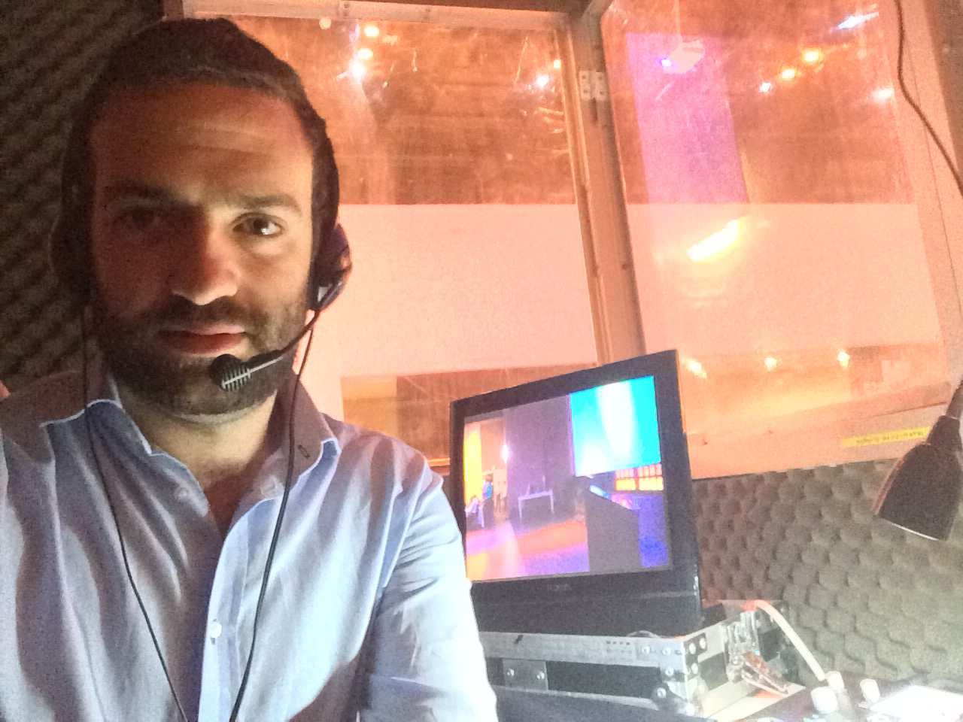CURRICULUM VITAE

**Itamar Rubinstein**

Profile

I define myself as ambitious, intellectual, artistic and creative.

**Address**

Wittenberg 6, ap. 17

Petah-Tiqwa, Israel

**Israeli ID**

332644988

**Phone No.**

(+972) 527563567

**E-mail address:**

[itamar.rubinstein@gmail.com](mailto:itamar.rubinstein@gmail.com)

I believe the most important traits of a worker are commitment, responsibility and competence.

Background

I was born and raised in Mexico City. From an early age I was exposed to and showed interest in several languages: Spanish, English, Hebrew and Yiddish.

At age 18 I immigrated to Israel. I majored in World and Jewish History in Bar-Ilan University (cum laude). During my undergraduate studies I worked as a research assistant and was often required to translate Yiddish newspaper articles into Hebrew.

My graduate studies (cum laude) were in Translation Studies and Interpreting (English-Hebrew and Spanish Hebrew). I am qualified to conduct written and live translations from and into these three languages.

Experience

* Since 2015 I have worked as a freelance translator and interpreter. I have also worked for several outsourcing companies – Bereshit, MGSL, Kol Halashon. Through these I have worked with several large industrial companies, such as Teva and Israel Chemicals. As for politics, I have translated at the World Zionist Congress and the recently-founded Judea and Samaria Chamber of Commerce (JSCOC).

Education

**2005-2008.** Yavne highschool. Mexico City (2005-2008).

**2011-2014.** BA in World and Jewish History (cum laude). Bar-Ilan University.

**2014-2018.** MA in Translation Studies and Interpreting (English <-> Hebrew and Spanish <-> Hebrew).

Languages

Spanish (mother-tongue).

English (completely fluent).

Hebrew (completely fluent).

Yiddish.

Portuguese.

French (basic).