Curriculum Vitae

Dr Wayne Stuart McCALLUM
Freelance Translator
Experience: 31 years
Nationality: New Zealand

Professional Translator (French-English) NAATI (Australian National Accreditation Authority for Translators and Interpreters)
Member of the NZSTI (New Zealand Society of Translators and Interpreters)
Official French to English Translator recognised by NZQA (New Zealand Qualifications Authority)

TRANSLATION - LANGUAGES (INTO ENGLISH)
(Working languages in decreasing order of importance since 1995)

French, Italian, Russian, Spanish, Portuguese, Slovenian, Romanian, Ukrainian, Bulgarian, Croatian, Serbian, German, Czech

TRANSLATION - AREAS OF PROFESSIONAL EXPERIENCE (non-exhaustive list)

Legal (court proceedings, powers of attorney, summonses, laws and decrees (Belgium, France, Switzerland, New Caledonia, French Polynesia, Italy, Russia, Romania, etc.), regulations, judicial acts, Customs declarations, records of divorce proceedings, disputes, wills, leases, notarial deeds etc.)
Advertising (schedules, presentations, brochures, books, leaflets, posters, advertisements)
Aerospace (aviation companies’ balance sheets, technical descriptions of radar installations, specifications (Airbus, helicopters), avionics specifications (communication systems, imaging))
Agriculture (zoosanitary and phytosanitary regulations and certificates, articles, packaging and labels for dairy products and meat)
Banking (balance sheets, general terms and conditions, company policy statements, telegraphic transfers, authorisations for issuing letters of credit, etc.)
Commerce (contracts, correspondence, articles of association, minutes, annual accounts)
Diplomacy (official speeches, international agreements, international treaties, correspondence)
Electronics (operating manuals, user manuals, technical specifications for cameras and video cameras, photocopiers, printers, computers, peripherals and software)
Environment (environmental impact studies, flora & fauna studies, international treaties documentation, oceanographic studies)
Immigration/Births, Deaths & Marriages (birth certificates, death certificates, police reports, passports, degrees and diplomas, academic records, employment records, documentation concerning refugees)
Information Technology (specifications and manuals for hardware and software, operating systems, networks, peripherals)
Medicine (patients’ records, doctors’ registration certificates and CVs, blood, urine and other tests, MRI results, medical certificates, medical and pharmaceutical trial studies, medical journal articles, operating manuals for life support equipment, incubators, etc.)
Metallurgy (documents concerning mining operations, technical documentation for blast furnaces)
Pharmaceutical (packaging, user instructions, reports, pharmacological studies)
Public works (specifications concerning the construction of motorways, dams, sports stadiums, power installations, buildings, factories and plants, etc.)
Sciences (articles on biology, physics, chemistry, meteorology, etc.)
Telecommunications (specifications and manuals for telephones, wired and wireless networks, satellite ground receiving units, switching equipment, etc.)
Tourism (brochures, leaflets, guides, Websites)

EDUCATION

University
1984-1994 University of Canterbury, Christchurch, New Zealand
1995 PhD in French
1991-1994 Preparing a doctoral thesis. Topic: The administrative policy of French Overseas Territories in the South Pacific and France’s external relations in the South Pacific under François Mitterrand’s presidency. Title: French Policy in the South Pacific since 1981.
1990 Master’s in French (first class honours). My Master’s thesis consisted of a study of French loyalists in New Caledonia. Title: “Caldochie” - A State of Mind?
1987 Bachelor of Arts in French. I studied Russian through to the final year.

Miscellaneous
1999 The Russian Federation awarded me the Pushkin Prize for a translation into English of a poem by Alexander Pushkin.
Slovenian Language Course Level II, Arts Faculty, University of Ljubljana, Slovenia.
German Language Course, Level IV, Goethe Institut, Wellington.
1997 German Language Course, Level III, Goethe Institut, Wellington.
German Language Course, Level II, Goethe Institut, Wellington.
1996 German Language Course, Level I, Goethe Institut, Wellington.

PROFESSIONAL EXPERIENCE

1999- Freelance Translator, Wellington/Whanganui, New Zealand.
1995-1999 Translator/Editor/Project Manager, New Zealand Translation Centre, Wellington.
1995 Translator/Speaker, Euronews, Lyons, France.
1994, 1997- Translator, MLT Translation Centre, Christchurch, New Zealand.
1994 Lecturer, French Department, University of Canterbury, Christchurch.
1990 Editor of CANTA (a weekly newspaper), Christchurch.
1989-1994 Freelance Translator, Christchurch.
1986-1989 Journalist, CANTA.
1981-1994 Library Assistant, Canterbury Public Library, Christchurch.

INFORMATION TECHNOLOGY

Word, Excel, PowerPoint, SmartCAT, Across, Wordbee, WordPerfect, Acrobat Reader, WS-FTP, Internet browsing and research, word processing (65 words per minute).

TRANSLATION REFERENCES

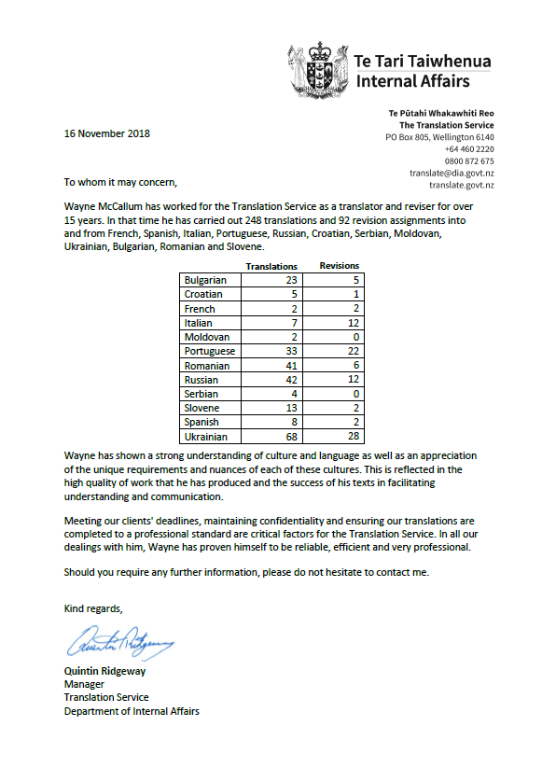

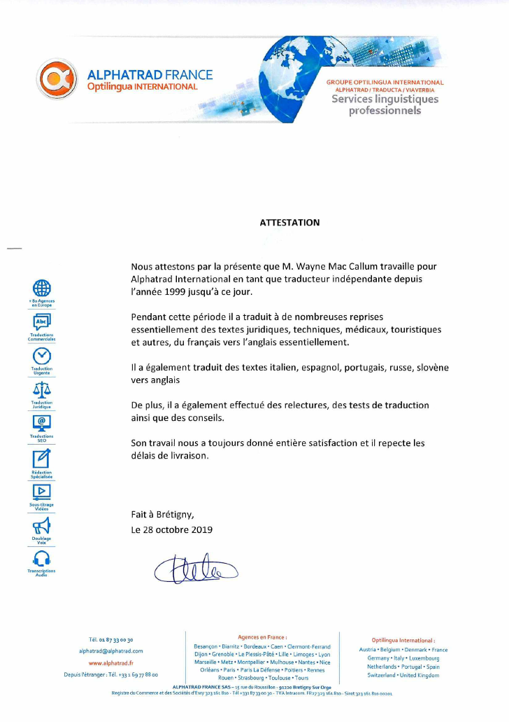
CERTIFICATE

We hereby certify that Mr Wayne McCallum has worked for Alphatrad International as a freelance translator since 1999 through until now.
During that period, on many occasions, he has translated mainly legal, technical, medical, tourism and other texts, mainly from French to English.
He has also translated texts from Italian, Spanish, Portuguese, Russian, and Slovenian to English.
Moreover, he has also done editing, overseen translation tests, and provided advice.
His work has always been completely satisfactory for us and he meets delivery deadlines.

Done in Brétigny
28 October 2019
[signature]

W.S. McCallum
wstmccallum@gmail.com
Tel. +64 (0)27 3059 109

Fee Schedule for Translation Work

Effective as of 4 March 2021

All fees are in EUR

Italian, French, Spanish and Portuguese to English translations

TRANSLATION ONLY | Standard rate  €0.09 per source word
Minimum charge per assignment less than 100 words | €11.00

Romanian, Russian, Slovenian, and other Eastern European Languages to English translations

TRANSLATION ONLY | Standard rate  €0.12 per source word
Minimum charge per assignment less than 100 words | €12.00

