 | G
H | E | B | R | E | W
 | R | 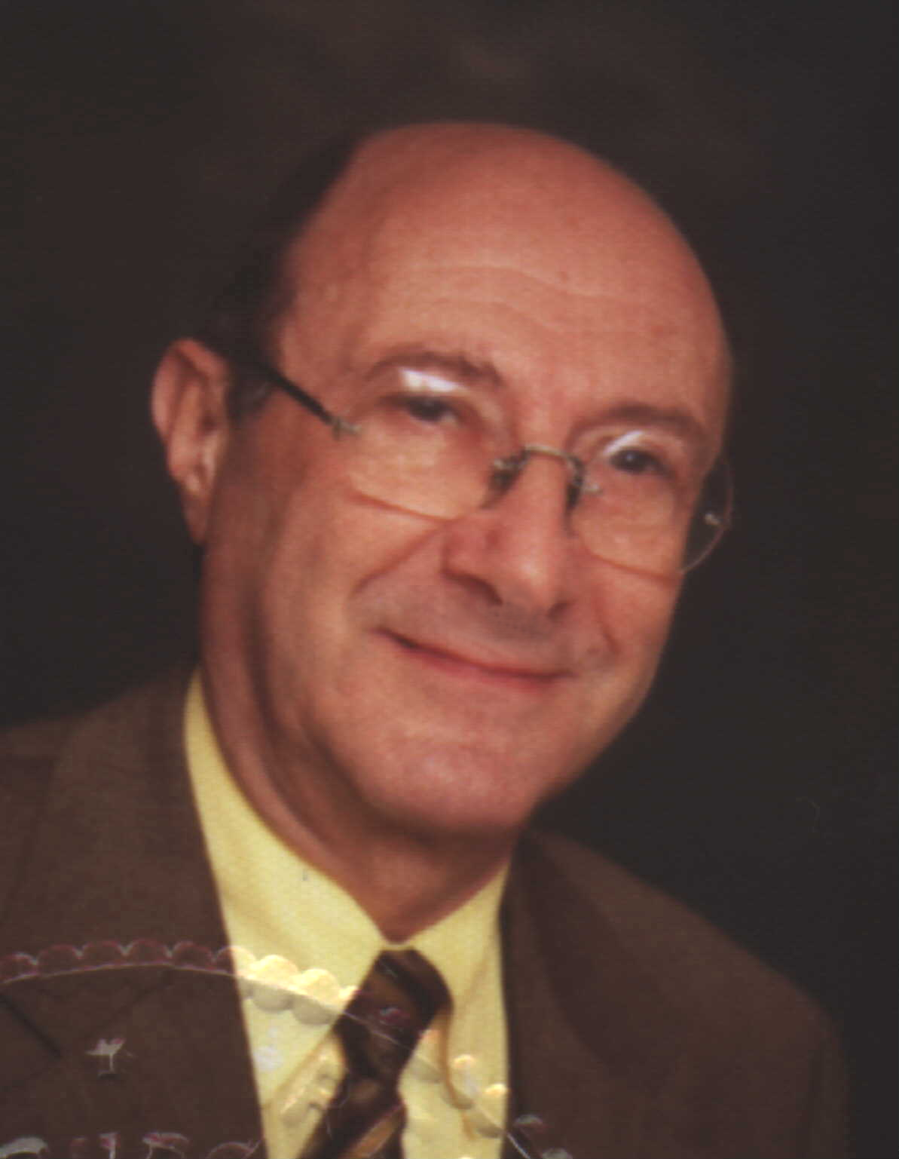  P O L I S |  | N
 | M |  |  | G
 | A |  |  | L
 | N |  |  | I
 |  |  |  | S  H

Dr. Richard R. Fagot

Multilingual translations
7, Modigliani St., Tel-Aviv 646877 Tel: (+972-3) 5235198
4, Floragasse 4, A-1040 Wien
E-mail: drfagot@netvision.net.il
drfagot@web.de

Informal CV and introduction
- My name is Richard R. Fagot. I am medical doctor by profession, graduated from the Medical School of the University of Vienna, Austria.
I was born to a multilingual family in Poland. I lived and went to school there and for short periods also in other European countries (France and Germany). My family settled in Israel in the fifties and I graduated from secondary school in Tel-Aviv.
- German, Polish and Hebrew are practically my mother languages. I have a perfect knowledge of English (although this is not my mother tongue), and have been translating a lot of professional texts (but not literature) into English and have a good working knowledge of French and little less (understanding of written texts) in Italian, Spanish, Portuguese, Russian and other Slavic languages.
The language pair combinations, which I work with, consist of English, German, Polish and Hebrew in any direction as well as from French into any of the above.
- Before studying medicine, I worked as professional translator from English and French into Hebrew. In the years 1955 and 1956, I translated (for the Israeli Defense Forces) published and unpublished military material from English and French into Hebrew, some of it technical, the other part for publication in military press. Later, 1956 through 1957, I translated for several newspapers, periodicals and weekly magazines as well as literary texts for some publishing houses from French and English into Hebrew. At the same time, I attended several translation courses while studying Law and Economics at the then young Tel-Aviv University. After two years I switched to medicine and enrolled in the medical faculty of the University of Vienna.
- Through the university years in Vienna, I made my living as free-lance translator for several newspapers in Israel, Austria and Germany from English and French into Hebrew and German, respectively, maintaining my earlier contacts in Israel and also in collaboration with a free-lance journalist writing in English and German for newspapers in Germany, Austria, U.S. and Japan.
- During my university years, I often visited my family in Poland for sometimes rather extensive periods and once spent a full year there, working as a medical student in a hospital, where I also helped Polish doctors with translating medical articles and publications or presentations from English and German into Polish and vice versa.
- After graduation, I worked for more than one year in hospitals in Vienna, married there and settled again in Tel-Aviv in 1966. I still have family and many friends in Austria, maintain my second residence there and use to spend some parts of each year in Vienna.
- While working as gynecologist and obstetrician in a maternity hospital in Tel-Aviv, Israel (1965-1996), I was, in addition to my other medical activities, responsible for the continuing education of younger colleagues and for the scientific program of the department and as part of these duties assisted in preparing and translating papers for publication in medical journals and for presentations at medical conventions abroad, mainly into English and German, so I never quite quit the translating routine.
- Also, from 1968 through 1975, to improve the hospital salary, I used to translate a vast bulk of medical documents from Hebrew into German for courts and remuneration authorities in Germany, represented by the Israeli Ministry of Finance.
- While now retired from hospital, I have, for the last eighteen years, resumed full-scale activities as free-lance translator.
- I resumed the work for the German courts and remuneration authorities in Germany (Hebrew into German) and started free-lance translator activities (in all the above-mentioned language pairs) for numerous international and local translation agencies, among others (to name only a few):
“Corporate Translations Inc. (CTi)”, Mansfield, Conn., U.S.A. (now
RWS)
“TransPerfect Translations”, N.Y., U.S.A. w. subsidiaries in London,
Stockholm, Prague, Barcelona, Tokyo, Honolulu, Hong-Kong, Berlin, San Francisco, and many other cities around the globe
ASET International, Arlington, VA, U.S.A.
MAPI Research, Lyon, France
“Smallworld”, London, UK,
"JM Communication GmbH", Vienna, Austria
“Kontekst” – Warsaw, Poland
“Tilti” – Riga, Latvia and Vienna, Austria
m-tg Medical Translation, Ulm, Germany
Medical Language Services, Freiburg, Germany
Magnum Group, Philadelphia, PA, USA
Semiotic Transfer, Baden, Switzerland
"Language Professionals", Darlinghurst, NSW, Australia
"Tipping Sprung", New-York, NY, USA
"Ad verbum" Translations, Montreal, Canada,
“Adverbum”, Riga, Latvia
and in Israel: "Kaleidoscope", “SET-Seminars”, "Quality Translations" (MGLS), “Transoffice" – Professional Translations, “Meditext” – Medical Writing and Translation, “Transcom” – Professional Translation Services, “Interlingua” – Language Solutions, Translation & Narration, “Magic Professional Translations”, "Sagir International Translations",
“Financial Professional Translations”, "Istra Trade Link Ltd" – Israel- Switzerland Trade Promotion, “Globus Professional Translation and
Localization”, “Manpower Group Language Slutions”, "Zorro-
Translations" – Multilingual Translation Services, "Top Translations"
and many others.

- In addition, I have been translating, on a free-lance basis:
- press releases, articles and presentations for several pharmaceutical, high-
tech, industrial and commercial companies,
- legal documents for several lawyers and notaries in Israel, from and into
Hebrew, English, Polish and German
- material for some agencies in Vienna, Austria (books or magazines/ literary
texts, legal texts)
- for students or graduates who wish to translate and publish their papers or
dissertations, primarily into English,
- parts of brochures accompanying art exhibitions in major museums in
Zurich and Berlin
- and completed the translation of a Hebrew children theatre play in verses
into Polish.
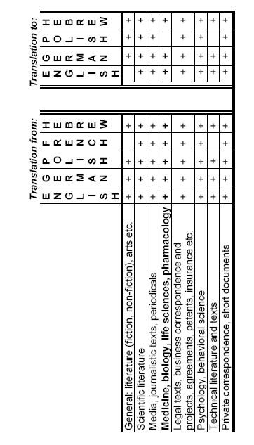
- The following table represents tasks, which I am currently interested in and capable of doing:

Updated January 2015

