

Europass  Curriculum Vitae |  | 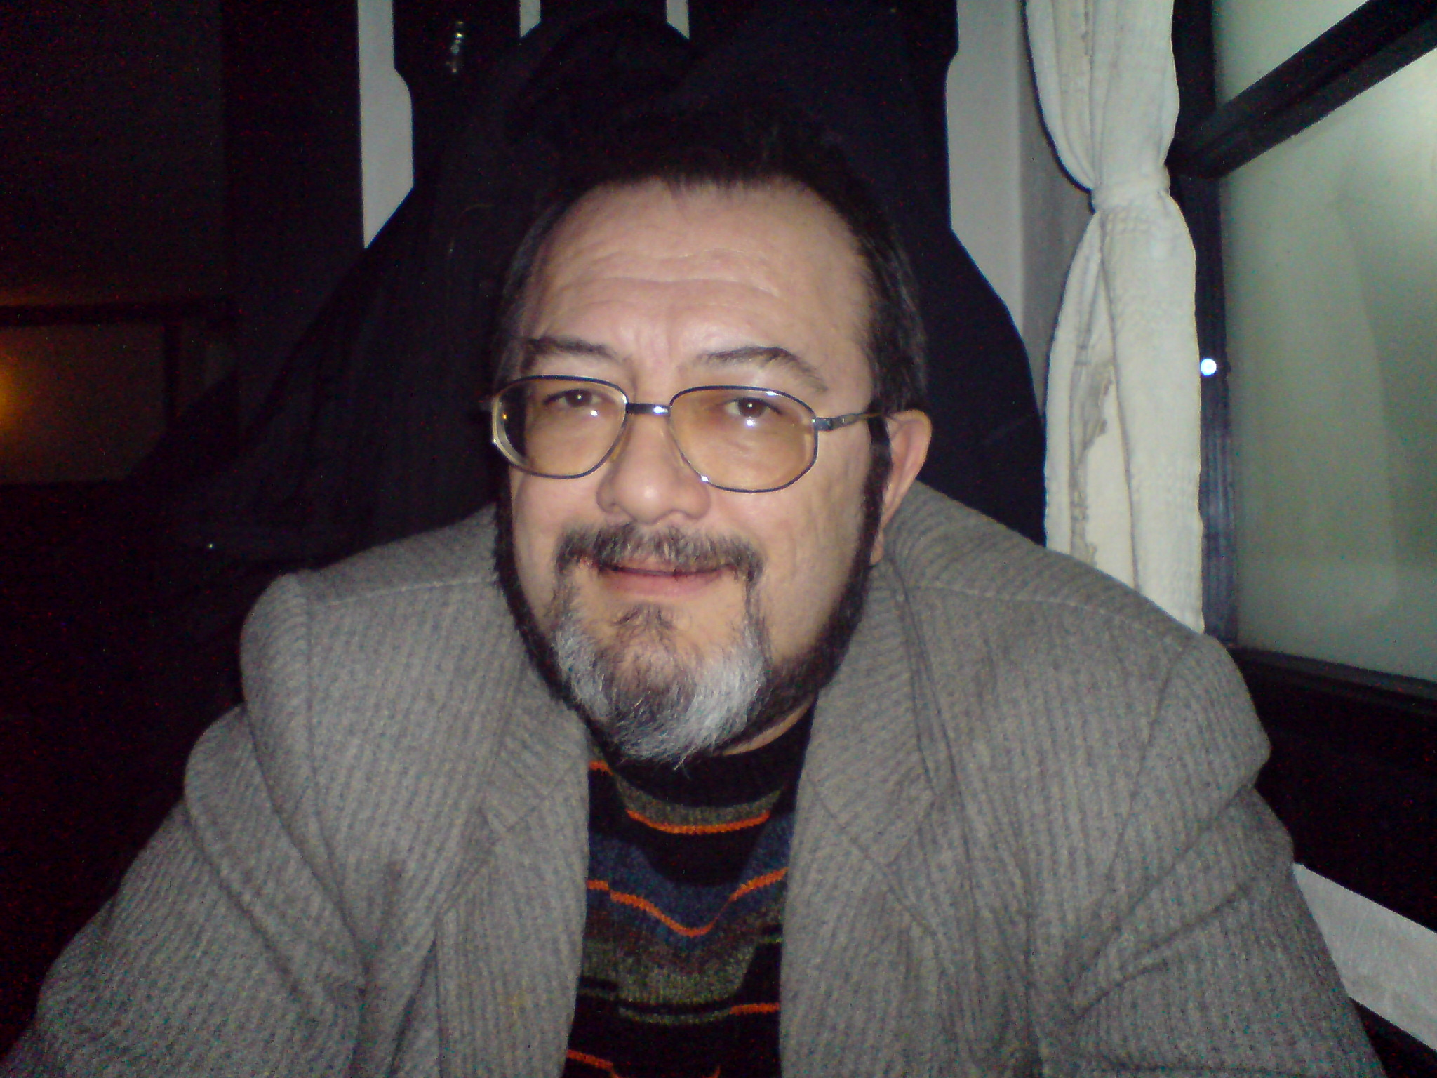
Personal information
Surname(s) / First name(s) |  | Name: BOYKO Patronymic: Totev Surname: MARINOV
Address(es) |  | Residence: 1, Blagorodna street, entr. A, 1111, Sofia, Bulgaria
Telephone(s) |  | Telephone numbers: |  |  |  |  | Mobile: |  |  |  | +359898588903
E-mail |  | marinov.boyko@gmail.com
Nationality |  | Bulgarian
Date of birth |  | 21/09/1960
Gender |  | Male
Desired employment / Occupational field |  | Freelance translator
Work experience |  | 2015-today Translator for own translation company, BORKAS EOOD, Sofia  2006-today Translator for Orchidea-94 EOOD, Sofia  2003-2007 Translator for the Translation and Revision Centre at the Ministry of State Administration and Administrative Reform (responsible for translation of EP, European Commission, EU, EC and EEC legal regulations over Bulgaria’s pre-accession period)  1991-2006 Interpreter at numerous conferences, seminars, congresses, trade negotiations, etc.  1998-99 English teacher and English translator for Union Miniere Pirdop Copper, Pirdop, Bulgaria  1997-2003 Translator from/to English, Spanish, Russian, Portuguese and Czech for BORK, SP, Sofia, Bulgaria  1996-2002 Translator from/to English, Spanish, and Czech for Latina, plc., Jco Limited, Lozanova Translation services Limited, Smart Limited (all of them translation/interpretation offices / agencies)  1996-2006 English and Spanish teacher in New Bulgarian University, Sofia  - Main English translator/interpreter for United Services of America Inc., Sofia  1994-1995 Freight forwarder for Delta Trading Travel International Freight Forwarders, Sofia  1992-1993 Interpreter/translator to a number of PHARE missions in Bulgaria  1992-1993 Interpreter/translator to a number of institutes at the Bulgarian Academy of Sciences  1989-1993 “Boyko Marinov” Language Courses Sofia, Manager, English  1988-90 Portuguese interpreter and teacher for Technoimpex Foreign Trade Company, Sofia  1985-1987 Conference interpreter at the Bulgarian Unions Institute – Portuguese and English  1981-1988 Conference interpreter for the Ministry of People’s Education  1981-1987 Interpreter and tourist guide for Bulgarian Trade Unions – English, Russian, Portuguese and Czech
Translator
Dates |  | Add separate entries for each relevant post occupied, starting from the most recent. (remove if not relevant, see instructions)
Occupation or position held
Main activities and responsibilities
Name and address of employer
Type of business or sector
Education and training |  | Secondary:  1979 Vysoké Mýto Secondary School, Czech Republic  HIGHER:  1979-1980 Charles University, Prague, Czech Republic  Subjects: Spanish and Portuguese Language and Literature  1980-1985 Sofia University, Faculty for Classic and Modern Philology (FCMP)  Subject: Spanish Philology, Master’s Degree in Spanish Philology  Supplementary Subject: English Language, Bachelor’s Degree in English Language  Diploma: 104340, issued 1985 by Sofia University (SU)  Specialisations:  1982-83 Comparative phonetics of Romance languages, SU, FCMP  1982-83 Special course in translation of belles-lettres from English, SU, FCMP  1983-85 SIMULTANEOUS AND CONSECUTIVE INTERPRETING, SPANISH, SU, FCMP  1984-85 Additional specialisation: SIMULTANEOUS AND CONSECUTIVE INTERPRETING, ENGLISH, SU, FCMP  1984 Comparative Linguistics, Havana University, Havana, Cuba  1985 Field Training in Pedagogy, French/Spanish College and English College in Sofia
Dates |  | Add separate entries for each relevant course you have completed, starting from the most recent. (remove if not relevant, see instructions)
Title of qualification awarded
Principal subjects/occupational skills covered |  | Translator, interpreter, English/Spanish teacher
Name and type of organisation providing education and training |  | Sofia University, Faculty for Classic and Modern Philology (FCMP)
Level in national or international classification |  | (remove if not relevant, see instructions)
Personal skills and competences
Mother tongue(s) |  | Bulgarian
Other language(s)
Self-assessment |  |  | Understanding |  |  |  |  | Speaking |  |  |  |  | Writing
European level (*) |  |  | Listening |  | Reading |  |  | Spoken interaction |  | Spoken production
Language |  |  | EN | C2 | EN | C2 |  | EN | C1 | EN |  | C1 | EN | C2
Language |  |  | SP | B2 | SP | С2 |  | SP | B2 | SP |  | B2 | SP | С1
Language |  |  | PT** | B2 | PT | B2 |  | PT | B2 | PT |  | B2 | PT | B1
 |  |  | RU | C2 | RU | C2 |  | RU | C2 | RU |  | C2 | RU | C2
Language |  |  | CZ | C1 | CZ | C1 |  | CZ | B1 | CZ |  | B1 | CZ | B1
(*) Common European Framework of Reference for Languages
(**) Ref.data for European Portuguese only
Social skills and competences |  | Experience in managing a small company, see Work Experience
Organisational skills and competences |  | Experience in managing a small company, see Work Experience
Technical skills and competences
Computer skills and competences |  | Microsoft Office 2010 for Windows7, SDL Trados 2015, Adobe Acrobat
Artistic skills and competences
Other skills and competences
Driving licence |  | B, M, 1.11.1989
Additional information |  | Include here any other information that may be relevant, for example contact persons, references, etc. (Remove heading if not relevant, see instructions)

