David Edward Kennard, BA … translator

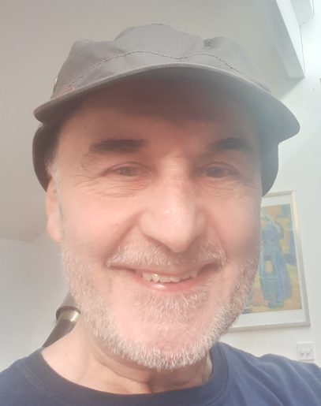

4 Lower Wilton Road, Malvern, Worcestershire WR14 3RJ, U.K.
kennardavalennek@gmail.com
Telephone: 07930-366974

Born in Brighton, Sussex, England, 26 March 1951

1. EDUCATION AND QUALIFICATIONS

Schools and Colleges attended

1962-69 Varndean Grammar School, Brighton, Sussex
1969-71 and 72-73 Birmingham University
1971-72 Milan University, Italy
1977-78 Matthew Boulton Technical College, Birmingham

2. Qualifications

GCE ‘O’ Levels* in: Mathematics, Music, English, French,
Spanish, Italian, Latin and Russian

GCE ‘A’ Levels** in: Spanish, French and Russian

* Examinations taken at age 16
** Examinations taken at age 18

B.A. combined honours degree in Italian and Russian, plus Romance Linguistics

33 years’ translation and editing experience

3. Civil Status … Married, with four children and four grandchildren

4. EMPLOYMENT HISTORY

1981-90 Translator / Office Manager for two Italian law firms and a US
law firm in London (Studio Legale Ardito, Studio Legale Berlingieri,
and Wald Harkrader & Ross)

1990- For the last 33 years I have worked as a full-time freelance translator
in which time I have translated approximately 28 million words.

5. LANGUAGES TRANSLATED FROM INTO ENGLISH
Italian - Spanish - Portuguese - French - Catalan -
Romanian - Dutch - Norwegian - Danish

Specialist areas:
- Law – contracts, court judgments, legislation, experts’ opinions
- Pharmaceutical – product descriptions and trials
- Medical – research, insurance claims, medical records

During my career as a freelance translator I have also translated 12 full-length non-fiction books from Italian, French, Dutch and Danish.

6. INTERESTS
General: international relations, various national cultures
Music: playing piano, guitar, cello; singing
Physical: running, walking
Children: general interest in child psychology and speech development
Languages: Lexicography and studying foreign languages and cultures, especially
minority languages/cultures (e.g. Basque, Faroese, Sami and Maori)

7. PROFESSIONAL DEVELOPMENT
In addition to translating around 600,000 words per year, I take a general interest in world affairs and regularly read articles on foreign language news websites, as well as listening to online radio stations and watching foreign language films.

