Zolotina Darina (Daria)
Translator & Interpreter  Tutor (English, Ukrainian, Russian)  Copywriter | Israel,  2622914,  Haifa, Kiryat Haim,  Shitrit St., 7/3  Tel: + 972 52 730-20-17  E-mail: pereklad2011@yandex.ru  http://perevod.inwebprof.com

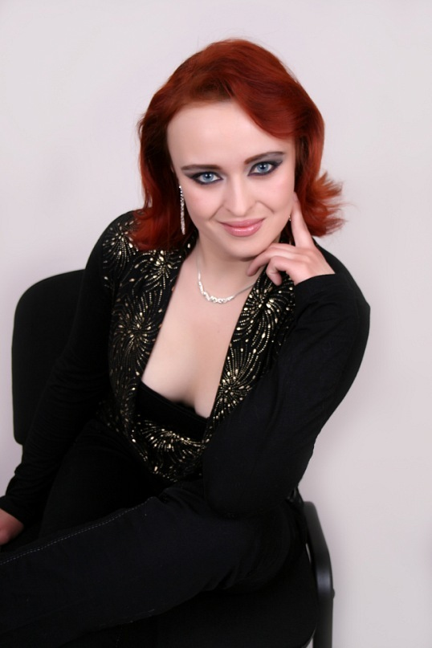
Date of birth: March 26, 1988
Place of birth: The Republic of Crimea
Citizenship: Russia; Israeli residence permit.
Marital status: married
Children: yes
Current place of residence: Haifa, Israel
Professional Association membership: ITA (Israel Translators Association) and NCTA (Northern California Translators Association)
Contact information: Tel: +972 52 730-20-17
WhatsApp/Viber: +972 52 730-20-17
E-mail: pereklad2011@yandex.ru
Skype: darina.af
Web: http://perevod.inwebprof.com

EDUCATION: | 2005-2010 - Taurida Humanitarian & Ecology University (Simferopol, Crimea),  Department of International Policy and Country Studies.  Qualification: translator, country desk officer (field/specialty: the Middle Eastern region; specialization: Israel, Arab-Israeli conflict, Palestianian problem).  I show a special interest for History, Public relations and foreign affairs, Cultural studies, Literature, Foreign languages, Policy, Law, Medicine, Conflict Resolution Studies, History and Culture of different nations and countries of the world).  1995-2005 – Artek High Specialist Language School (Yalta, Crimea).  Advanced curriculum in English and German languages.  In the Upper school the English language was taught by a native speaker from the USA, while the German language was taught by the distinguished teacher of the Republic of Crimea who spent several years living and working in Germany.
LANGUAGE COURSES: | February-May, 2013 – Hebrew for Beginners (Israel).  August-January, 2013 – Hebrew for Pre-Intermediate students (Israel)  March-September, 2014 – Hebrew for Intermediate students (Israel)  August, 2015 – present moment – Hebrew for Upper-Intermediate+ students (Israel)  Current language courses:  Turkish (remote studying)  Spanish (remote studying)
WORK EXPERIENCE: | Current place of employment: Private translator (own business)  Period of employment: March, 2013 – present moment (Israel)  Position held: private translator, interpreter, tutor (English, Russian and Ukrainian), copywriter and rewriter.  Scope of employment: translation, proofreading, copywriting, tutoring, rewriting.  Previous place of employment: Freelance (Ukraine)  Period of employment: October, 2011 – July, 2012  Position held: private translator, interpreter, tutor (English, Russian and Ukrainian), copywriter.  Scope of employment: translation, proofreading, copywriting, tutoring.  Previous place of employment: MAKKAS Ltd (Simferopol, Crimea)  Period of employment: August, 2011 - October, 2011  Position held: Secretary/Translator  Scope of employment: translation of letters, agreements and reports; interpreting at meetings; workflow and records management.  Previous place of employment: TSRTO Ltd Travel Agency (Simferopol, Crimea)  Period of employment: August, 2010 - August, 2011  Position held: Travel Manager, Guide-interpreter  Scope of employment: tours development, hotel vouchers and flight tickets sale, invoicing, Web-administration, paperwork management, conclusion of contracts and negotiations with foreign customers, hotels and travel agents, guide-interpreting.
LANGUAGES: | Main languages:  English (fluent)  German  Russian (native speaker)  Ukrainian (native speaker)  Belorussian  Hebrew  Additional languages:  Serbian  Croatian  Polish  Czech
ADDITIONAL INFORMATION: | Free PC and Internet user.  Knowledge of Web-administration (CMS Joomla and Wordpress).  Knowledge of workflow and records management.  Work experience in VISAs processing and translation of civil documents for their further submission to Embassies and Consulates.  Knowledge of Web-design.  The Member of ITA (Israel Translators Association), NCTA (Northern California Translators Association) and IAPTI (International Association of Professional Translators & Interpreters).  Since May 2016 I translate Complaints to the Committee of Ministers of the Council of Europe under the case “Buntov v. Russia”).  I have added few tens of expressions to English Online Dictionary Multitran (Link: http://www.multitran.ru/c/m.exe?a=116&UserName=Darina%20Zolotina ).  Total work experience as translator: 6 years (since 2010), including translations of different medical, legal, technical, corporate and personal documentation, literary translations, website localization, translation of audio- and video materials.  Clients: The Language Doctors (Washington D.C., USA), MECO Machinery Ltd (Israel), MANOR Medical Center (Israel), Laminine (Russian Department), OVVK Translations (Russia), TransExpress Bureau (Israel), Goa Villa Ltd (Goa), Asia Marine Ltd (Goa), Art Goa Entertainment (Goa), MegaMix Group (Russia), Dental Implant (Russia), Life-24 Ltd (Ukraine) + different Translation Bureaus, notary offices and private customers from Russia, Ukraine, Belorussia, Cyprus, Slovenia, Poland, Kazakhstan, China, Israel, Canada, Germany, Spain, Egypt and the USA.
PERSONAL QUALITIES: | Sociable, honest, responsible, hard-working, goal-seeking, stress-resistant, always ready to learn something new and master new skills.
Additional documents (upon the request): | - University Diploma (original language – Ukrainian; translated to: Russian, English).  - Certificates of Completion (original language: Hebrew)  - NCTA Certificate of Membership (original language: English)  - Letters of recommendation (original languages – Russian, English)  - Translation samples

