J U T T A K I R C H N E R

TRANSLATION, EDITING AND PROOFREADING

CONTACT INFORMATION:

Name: Jutta Kirchner  Address: Sommerstraße 3  D – 86405 Meitingen  Tel.: +49/174/4742293  Email: juttak@gmx.net | 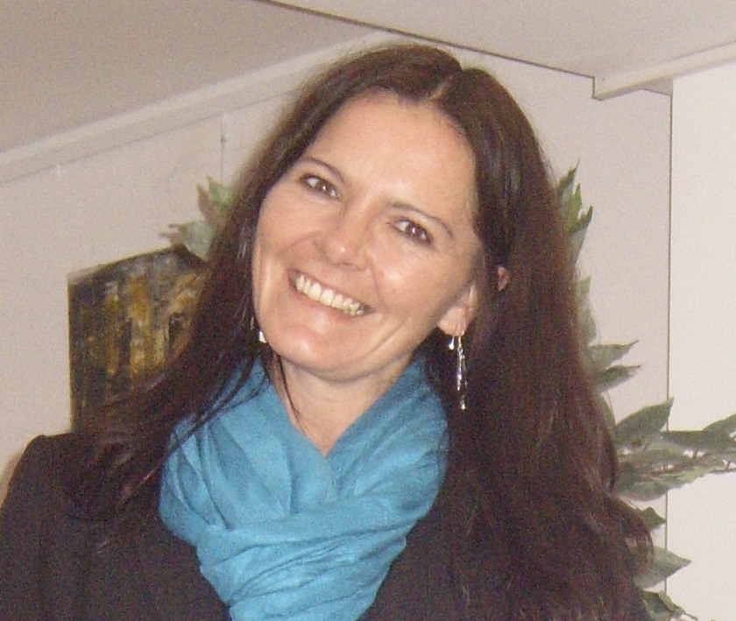

LANGUAGES:

Native Language: German
Working Languages: English, French, Italian

SPECIALIZATIONS:

Legal documents: contracts, EU-documents, decisions, judgments, deeds, certificates, summons, complaints, petitions, work contracts, sales agreements, share sale agreements, service agreements, etc.

Business documents: business correspondence, financial statements, job offers, company
newsletters, etc.

Marketing: advertising texts, brochures, websites, promotional material, etc.

Tourism: websites, hotel offers, travel brochures, etc.

Editing: stylistic and grammatical improvement of all types of text

EDUCATION:

1991 – 1999: Universität des Saarlandes, Saarbrücken, Germany:
Translation and Interpretation
Foreign Languages: English, French, Italian, Specialization: Law

10/1994 – 02/1995 École Supérieure d’Interprètes et de Traducteurs (“ESIT”)
Paris, France

02/1995 – 07/1995: Thames Valley University (“TVU”), London, Ealing, England

07/1999: Translation Diploma (Title: “Diplom-Übersetzerin”)

PROFESSIONAL EXPERIENCE:

1999 – present: Full-time Freelance Translator for English-German, French-German and Italian-German

2003 – 2005: Euroscript, Brussels, Belgium:
Regular Collaboration as Freelance-Translator for the Translation of a daily EU-Bulletin and EU press releases

OVERVIEW OF PAST TRANSLATION PROJECTS:

Court Judgements, Legal Actions, Inheritance Law, Court Orders, Work Contracts, Annual Reviews, Broker Agreements, Birth/Marriage/Death Certificates, Divorce Suits, Company Statutes, Trademark Law, Business Partnership Agreement, Liability Actions, Instruction Manuals, Promotional Material, Pharmaceutical Studies, Study Protocols, Job Offers, Tourism Websites

OVERVIEW OF PAST CLIENTS:
Deutsche Bank AG, Colgate-Palmolive GmbH, TÜV-Rheinland, L’Oréal, Lancôme, 3 Suisses International, Kookai Deutschland GmbH, Société Générale Paris, Banque Privée Edmond de Rothschild Europe, Crédit Agricole Asset Management, Crédit Agricole S.A., United Nations Industrial Development Organization (UNIDO), Electrocomponents plc, Karlsberg Brauerei GmbH, Alcatel, Fendi, Louis Vuitton, C&A, BearingPoint, Arbeitnehmerkammer Luxemburg, Stadt Luxemburg, Stadt Düdelingen (Luxemburg), Luxtrust, Luxcontrol, Post Luxembourg, TNS Ilres (Luxemburg), etc.

IT RESOURCES:

- Windows 7
- MS Office (Word, Excel, Powerpoint, Outlook)
- Adobe Acrobat Reader
- Trados
- Winzip

REFERENCES:
Professional references available on request.

