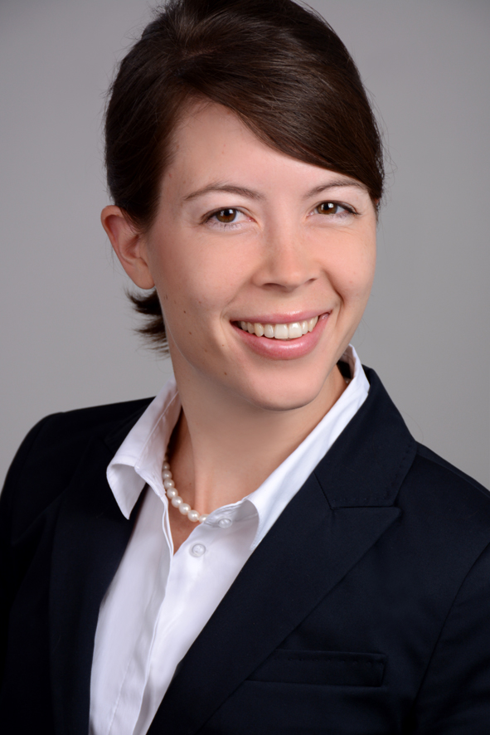
Emily Pickerill

PERSONAL INFORMATION
Address: Stielerstraße 9 80336 Munich
Mobile: +49 (0) 178-1677618
Email: info@epickerill.com
Born: August 26, 1984; St. Louis (Missouri), USA

KEY STRENGTHS
- Highly-qualified translation and editing skills through three-year state-certification program in Germany
- Published writer, adept at fine-tuning and evaluating documents in English
- Fast learner proficient in four languages, curious and eager to embrace new challenges
LANGUAGES AND SKILLS
- Languages: English (native); German (fluent); French (fluent); Modern Standard Arabic (advanced); Moroccan Arabic dialect (conversational)
- Computer: familiar with SDL Trados Translation Software; proficient in Microsoft Office tools (Word, Excel and Powerpoint)
EDUCATION AND COURSES
June 2015 Fremdspracheninstitut der Landeshauptstadt München, Munich, Germany
Abschluss: State-certified translator and interpreter (Staatlich geprüfte Übersetzerin und Dolmetscherin)

June 2006 University of Chicago, Chicago (lllinois) USA (GPA: 3.65/4.0)
B.A. - English Language and Literature, General Honors:

SUPPLEMENTARY COURSES AND EXPERIENCE
Jan 2013, June 2013 University of Zurich, Institute of Asian and Oriental Studies, Advanced-level Arabic (C1)
Two six-week online courses

June- Aug 2010 Middlebury Language School, Mills College, California, USA
Intensive 9-week summer study in Modern Standard Arabic (level 4/Advanced)

Oct 2008 – Dec 2009 U.S. Fulbright Program, Casablanca, Morocco
Language courses (Modern Standard Arabic) and sociological research

June- Aug 2006 Arabic Language Institute of Fez, Fez, Morocco
Six-Week Course in Modern Standard Arabic

Sept 2004- June 2005 Nanterre Université- Paris X, Paris, France
University of Chicago Academic Year Abroad
PROFESSIONAL EXPERIENCE
Sept 2010- present Freelance Translator and Interpreter, Munich, Germany
- Translate documents from German and French into English
- Proof-read and edit English translations of German and French texts
- German-English conference interpreter (Recent Conferences include: Dirty Profits, Friederich-Ebert-Stiftung with Facing Finance e.V. Feb 2016; Jahrestagung des Vorstands der internationalen Korczak-Gesellschaft, Dez 2015; Open Borders Kongress, Münchener Kammerspiele, Okt 2015; Global Playing for Everyone? Positioning Strategies on the Global Book Market, June 2015, Stiftung Lyrikkabinett)

Oct 2010- May 2013 Volunteer Arabic and French Translator, Innere Mission München, Munich, Germany
- Translated for Arabic and French-speaking asylum seekers during interviews with medical staff and social workers
- Organized weekly meeting for women and children

Jan 2010- June 2010 Refugee Resettlement Case Manager, Catholic Charities, Chicago, USA
- Organized reception and general orientation of Iraqi refugees to the United States
- Translated between Arabic and English for staff and refugee clients

Nov 2006- Sept 2008 Executive Assistant, Center for the Homeless, South Bend, USA
- Managed all internal and external communication of the Executive Director
- Coordinated development of a resident-operated, organic produce garden

Sept 2005- June 2008 Volunteer French Translator, Midwest Immigrant & Human Rights Center, Chicago, USA
- Translated personal testimonies of asylum seekers for attorney groups
- Translated supplementary documents and served as translator during official asylum interview

HONORS AND AWARDS
May 2010 Test DAF, German as a Foreign Language, Highest Score (5)
Oct 2008-Dec 2009 Fulbright U.S. Student Fellow, Casablanca, Morocco,
Critical Language Enhancement Award (Arabic) & Independent Research Grant
June 2005 Foreign Language Proficiency Certificate, French, University of Chicago

PUBLICATIONS AND CONFERENCES
Sept 2011 Journal for North African Studies, Informal and Entrepreneurial Strategies among Sub-Saharan Migrants in Morocco, published, Vol. 16, no.3
Dec 2009 Conference Speaker, Transit Migration in Africa, University of Nice- Sophia Antipolis

HOBBIES AND INTERESTS
In my free time, I enjoy getting away to the mountains to hike or ski with my family. I also love to cook, play the piano and relax in the evenings with a great book.

