**CURRICULUM VITAE**

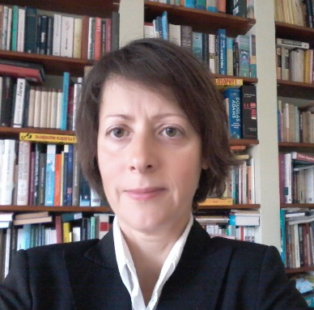

**Virág SZALAI**

Email: vszalai@datatrans.hu; vszalai@hotmail.com

Nationality: Hungarian

Date of birth: 12/06/1972

Address: 1193 Budapest, Vécsey u. 37, Hungary

Mobile: +36 20 97 65 688

EDUCATIONAL HISTORY

2000-2001: Masters in Conference Interpreting, *With Merit*,

***University of Westminster***,London

European Parliament Scholarship

1998-2000: Diploma in Finance and Business,

***Budapest* *College of Economics, Faculty of Finance and Accountancy****,* Zalaegerszeg, Hungary

1996-1997: DESS degree in Conference Interpreting, *Mention Bien*,

***Université de Strasbourg*** *(formerly Université de Marc Bloch, Strasbourg II)****,* *Institut de Traducteurs, d'Interprètes et de Relations Internationales*,** Strasbourg

French Government Scholarship

1991-1996: MA in English and French Studies,

***University of Szeged*** ***(****formerly József Attila University****)*,** Szeged, Hungary,

1993: Six-month TEMPUS Scholarship in Translation and Interpreting Studies,

*Institut Libre Marie Haps*, Brussels, Belgium

PROFESSIONAL EXPERIENCE

1997- : Free-lance technical translator, translation of financial documents, bids, contracts, manuals, studies

1997-: Free-lance conference interpreter, accredited by the EU conference interpreting service since 1998. Simultaneous and consecutive interpreting for ministries, municipalities, international organisations and companies in fields of business, finance, statistics, trade, marketing, law, EU affairs, environmental protection, local administration, medical research, culture, etc.

2010-: Literary translator, translation of a dozen books from French and English into Hungarian, editing of two books translated from English into Hungarian

1997-1998: Assistant teacher, University of Szeged, Faculty of Arts, Department of French

LANGUAGES

**Hungarian:** Mother tongue

**English:** Excellent

**French:** Excellent

**German:** Very good

**Italian:** Beginner