GERMAN STANDARD **December 2016**

|  |  |  |
| --- | --- | --- |
|  | **German standard DIN 51819-3** | D |
| ICS 75.100 Replacement for  DIN 51819-3:2005-03  **Testing of lubricants -**  **Mechanical and dynamic testing in the roller bearing lubricant test apparatus FE8 –**  **Part 3: Test method for lubricating oils - test bearings to be used Axial cylindrical roller bearings**  Testing of lubricants –  Mechanical-dynamic testing in the roller bearing test apparatus FE8 –  Part 3: Test method for lubricating oils – applied test bearing: axial cylindrical roller bearing  Essai des lubrifiants –  Essai mécanique dynamique au banc d’essai à roulement FE8 –  Partie 3: Méthode d’essai pour les huiles lubrifiants – roulements utilisants: munis d’une butée à rouleaux cylindriques  Total number of pages: 12  DIN Standards Committee for Materials Testing (NMP) German Technical Committee for Petroleum and Fuel Standards (Fachausschuss Mineralöl- und Brennstoffnormung, FAM) of the Standards committee for materials testing of the German Standards Institute DIN (Normenausschuss Materialprüfung / NMP) | | |
|  | | |

© DIN Deutsches Institut für Normung e. V. (German Standards Institute) - All types of reproduction, even of excerpts, are only permitted with the approval of DIN Deutsches Institut für Normung e. V., Berlin.

*Standards Download-Beuth-Afton Chemical Ltd-KdNr.7524790-ID.PXLDGGFCFHE8O8IQ8CZ3ZULG.3-2020-06-16 11:22:53*

Standards sold exclusively by the publisher Beuth Verlag GmbH, 10772 Berlin

[www.din.de](http://www.din.de/) [www.beuth.de](http://www.beuth.de/)

!%\ks"

2.577.280

**Contents**

Page

**Introduction 3**

1. **Scope of application 4**
2. **References to other standards 4**
3. **Definition of terms 4**
4. **Brief description of the test 4**
5. **Designation 5**
6. **Test equipment 5**
   1. **Test device 5**
   2. **Test bearing type D 5**
   3. **Measuring equipment 5**
   4. **Materials for cleaning and preparing the test bearings 5**
7. **Chemicals for cleaning the test bearings 5**
8. **Preparation of the test bearings 6**
9. **Carrying out the test 6**
   1. **Setting the test conditions 6**
   2. **Assembly of the test bearings 7**
   3. **Oil lubrication 8**
   4. **Starting the test run, adjusting the temperature 8**
   5. **Changes in the level of friction 8**

*Standards Download-Beuth-Afton Chemical Ltd-KdNr.7524790-ID.PXLDGGFCFHE8O8IQ8CZ3ZULG.3-2020-06-16 11:22:53*

* 1. **Number of tests 8**
  2. **Cleaning the test bearings after the test and determining the amount of wear 8**

1. **Evaluation 9**
2. **Test report 9**
3. **Precision 10**
   1. **General observations 10**
   2. **Repeatability 11**
   3. **Comparability 11**

**List of literature** 12

**2**

# **Introduction**

This document was compiled by the standards working committee NA 062-06--61 AA "Testing of lubricating oils, other oils and paraffins" in the German Technical Committee for Petroleum and Fuel Standards (Fachausschuss Mineralöl- und Brennstoffnormung, FAM) of the Standards committee for materials testing of the German Standards Institute DIN (Normenausschuss Materialprüfung / NMP).

Please note there is the possibility that some elements of this document may touch upon patent rights. DIN is not responsible for identifying some or all relevant patent rights.

This standard DIN 51819 Testing of lubricants - *Mechanical and dynamic testing in the roller bearing lubricant test apparatus FE8* consists of:

* + - *Part 1: General working principles*
    - *Part 2: Method for lubricating grease - test bearings to be used: Angular contact roller bearing or taper roller bearing*
    - *Part 3: Test method for lubricating oils - test bearings to be used: Axial cylindrical roller bearing*

**Changes**

Compared to the previous version of this standard, DIN 51819-3:2005-03, the following changes have been made:

1. The term steady-state or continuous temperature was replaced by 'test temperature';
2. The section on cleaning the test bearings was completely revised;
3. An alternative assembly (set-up) when measuring the level of friction directly on the outer diameter was added;
4. The use of assembly paste was prohibited;

*Standards Download-Beuth-Afton Chemical Ltd-KdNr.7524790-ID.PXLDGGFCFHE8O8IQ8CZ3ZULG.3-2020-06-16 11:22:53*

1. The graphic evaluation using a Weibull diagram was replaced by a software-based Weibull evaluation;
2. The evaluation of the level of friction was deleted;
3. The assessment of the wear on the bearing cage was deleted;
4. The definition of repeatability was added;
5. Definition of comparability revised;
6. Table 1, test points inserted;
7. Figure 1, the schematic diagram, was updated;
8. Figure 2 and Figure 3 are omitted.

**Previous versions of this standard**

DIN 51819-3: 2005-03

**3**

1. **Scope of application**

This standard defines a method for the mechanical and dynamic testing of lubricating oils in the area of mixed friction and the determination of the influence of lubricating oil on the friction and wear affecting axial cylindrical roller bearings in the rolling bearing lubricant testing device FE8 at test temperatures up to 200°C, with a high load on the bearings and a low rotational speed in conditions otherwise similar to use in practice.

1. **References to other standards**

The following documents that are cited in this document are required when using this document. For dated references, only the edition referred to will be applicable. When undated references are given, the latest version of the referenced document will be applicable (including amendments).

DIN 722, Rolling bearings - Axial cylindrical roller bearings, operating in a single direction

DIN 51819-1, Testing of lubricants - Mechanical and dynamic testing in the roller bearing lubricant test apparatus *FE8 - Part 1: General working principles*

ISO 16889:2008, *Hydraulic fluid power — Filters — Multi-pass method for evaluating filtration performance of a filter element*

1. **Definition of terms**

For the use of this document, the terminology defined in the standard DIN 51819-1 is applicable.

1. **Brief description of the test**

The testing is performed with test bearing D (see 6.2) The preferred test conditions are shown in Table 1.

*Standards Download-Beuth-Afton Chemical Ltd-KdNr.7524790-ID.PXLDGGFCFHE8O8IQ8CZ3ZULG.3-2020-06-16 11:22:53*

In the rolling bearing lubricant tester FE8, based on the standard DIN 51819-1, two test bearings type D are installed as test bearings, subjected to the appropriate axial test force F*a*, tested at the appropriate test rotation speed *n* and maintained at a test temperature between room temperature and 200 °C. A comparison of results of different measurements is only allowed if measurements were made at the same test temperature; the test temperature must be an integral multiple of 10 °C.

With the start of the test bearing test, the circulating oil lubrication and the external heating are put into operation, if a heater is used in the test. The test is continued until the friction level reaches the limit value for the switch-off force according to Table 1 for a period of at least 6 seconds, due to inadequate lubrication of the bearing, or the desired duration of the stress or load *t* according to Table 1 is reached. If the above-mentioned limit for the friction force is exceeded, the test stand will be switched off by an automatic switch-off device. If the test is continued for longer than the normal duration of the load test *t*, for example as a result of an interruption due to a power failure, the test run can be continued and treated as a single uninterrupted test run.

**4**

1. **Designation**

Example for the designation of the test for lubricating oils according to this standard using the rolling bearing lubricant test equipment FE8 according to the standard DIN 51819-1 with test bearings type D at a test rotation speed of *n* = 7.5 rpm and an axial test force *F*a = 100 kN and a test temperature of 80°C:

**Testing DIN 51819-3 — D — 7,5/100-80**

1. **Test equipment**
   1. **Test device**

Roller bearing lubricant test apparatus FE8 based on the standard DIN 51819-1.

* 1. **Test bearings D**

Axial cylindrical roller bearings 81212 based on the standard DIN 722, special design for testing on the test apparatus FE8, containing a solid brass cage which can be used up to a temperature of 200°C.

* 1. **Measuring equipment**
     1. Temperature sensor, moderate contact force applied by a spring;
     2. **Force transducer** for measuring the holding force;
     3. **Various calibration weights** for calibrating the measurement section;
     4. **Measurement values recording system** for recording the test temperature and the force of friction;
     5. A **precision weighing scale** for measuring the weight loss of the rolling bearings and their cages, with a mass of the parts to be weighed of about 800 g with a reading precision of 0.001 g and margins of error of ± 0.005 g or better.

*Standards Download-Beuth-Afton Chemical Ltd-KdNr.7524790-ID.PXLDGGFCFHE8O8IQ8CZ3ZULG.3-2020-06-16 11:22:53*

* 1. **Materials for cleaning and preparing the test bearings**
     1. solvent-resistant **protective gloves**;
     2. **Heating device** for mounting the shaft rings;
     3. **Cleaning bowl and brush, alternatively an ultrasonic bath;**
     4. **a lint-free cloth.**

1. **Chemicals for cleaning the test bearings**
   1. Residue-free evaporating, organic, aromatic-free solvent based on hydrocarbons with a flash point above 60°C, for example white spirit as in the standard DIN 51632-E-4[1];
   2. If necessary, aqueous alkaline cleaning solution and tap water.

**5**

1. **Preparation of the test bearings**

The rollers of the test bearings are taken out of their cages.

The pre-cleaning is carried out in residue-free evaporating, organic, aromatic-free solvent based on hydrocarbons with a flash point above 60°C in an ultrasonic bath or in a bowl with a brush.

If insoluble residues remain in the solvent after the test run, the pre-cleaning should be carried out in an aqueous alkaline cleaning solution. In this case, the cleaning agent residues are to be washed off with a sufficient quantity of water and the bearings dried with filtered, dry compressed air.

The final cleaning should always be carried out in a clean residue-free evaporating, organic, aromatic-free solvent based on hydrocarbons with a flash point above 60°C. If the pre-cleaning used an aqueous, alkaline cleaning solution and water (7.2), the final cleaning must be carried out within a few minutes after the pre-cleaning to avoid corrosion.

For drying, the parts of the test bearings are wiped off with a lint-free cloth and the solvent is completely evaporated off at room temperature. If white spirit as in the standard DIN 51632-E-4 [1] is used, the drying time is about 30 minutes.

The safety regulations for handling the solvent and the cleaning solution as well as the ultrasonic bath must be observed. To handle the parts of the test bearings, solvent-proof gloves must be used. The permeation time of the protective gloves must be observed.

The rollers and the metal cages of the test bearings are weighed at room temperature with a precision weighing scale with a precision of 1 mg. At room temperature, the rollers are inserted into the cage pockets. Before they are fitted, the fitting space must be cleaned with solvent and a lint-free cloth. The temperature sensors and friction sensors are to be checked for mobility. Before the test, the functioning of the force transducer must be checked.

1. Carrying out the test

*Standards Download-Beuth-Afton Chemical Ltd-KdNr.7524790-ID.PXLDGGFCFHE8O8IQ8CZ3ZULG.3-2020-06-16 11:22:53*

* 1. **Setting the test conditions**

The preferred combinations of speeds, loads and load durations for testing lubricating oils on the rolling bearing lubricant tester FE8 are shown in Table 1.

**Table 1 - Preferred settings of test conditions**

|  |  |  |  |  |  |  |
| --- | --- | --- | --- | --- | --- | --- |
| **Test point code no.** | **Type of test bearing** | **Test temperature** | **Limit value for friction causing a switch-off** | **Rotation speed** | **Loading force** | **Duration of the stress test** |
|  |  | *n* | *F***a** | *t* |
| in °C | Nm | rpm | kN | hours |
| FE8-03 | D | max. 200°C | 60 | 7.5 | 80 | 80 |
| FE8-04 | D | max. 200°C | 60 | 7.5 | 100 | 80 |

**6**

* 1. **Insertion of the test bearings**

For a better understanding of the test set-up, see Figure 1.

The shaft washers of the test bearings (1) are fitted on the test head shaft (3). The test head shaft is inserted into the frontally mounted housing (6) (loading spring side up). The housing already contains the drive-side bearing support (4), the housing disk and the cage with the rollers of the drive-side bearing. The cage with the rollers is pushed onto the shaft washer of the bearing on the loading spring side. Subsequently, the loading-spring-side bearing support (5) is inserted, which contains the loading-spring-side housing disk. After that, the spacer disk (not shown in Figure 1) and the disk spring set (2) with the spring guide sleeve and the cover (7) are inserted. No assembly paste may be applied to bearing seats and contact surfaces. To facilitate the fitting, wetting with the lubricating oil to be tested is allowed.

Between the front-side support surface of the housing (6) and the cover (7), a load greater than the desired test load is applied by means of a high-pressure press. In the now available form-locking arrangement of the parts which has now been created, the cover (7) must be screwed to the housing (screw tightening torque 40 Nm).

If the test device is equipped with a force measuring system, the spacer disk is not required. The force measuring system is inserted between the cover and the press and loaded using the press to the desired value. The cover is fixed to the housing with screws. For this purpose, the screws are tightened crosswise.

*Standards Download-Beuth-Afton Chemical Ltd-KdNr.7524790-ID.PXLDGGFCFHE8O8IQ8CZ3ZULG.3-2020-06-16 11:22:53*

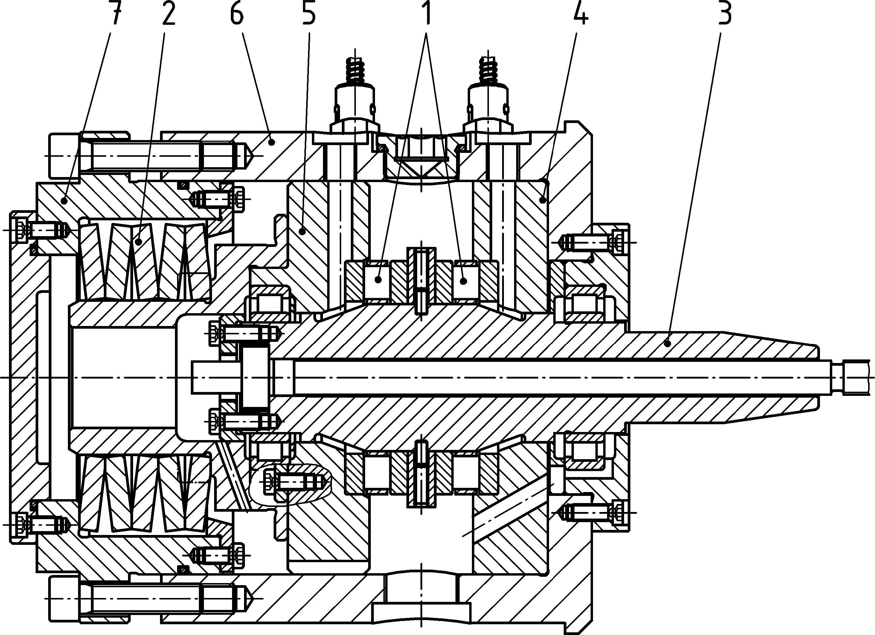

**Key**

1. Test bearings
2. Disk spring set
3. Test head shaft
4. Drive-side bearing seat
5. Load-side bearing seat
6. Housing
7. Cover

**Figure 1 - Schematic diagram of the test head**

**7**

* 1. **Oil lubrication**

The test oil quantity is 4+1 l. By means of a lubricating oil supply, consisting of a container, a pump with a filter and a flow volume control, an oil circulation with a quantity of (0.1 ± 0.02) litres per minute of the test oil per bearing is to be installed. The oil tank may be equipped with a device for pre-heating the oil. The test oil must be supplied by means of an elastic hose via the fittings to be screwed in. The hose should be arranged as free of constraint as possible in order not to falsify the friction torque measurement. The oil supply shall be equipped with a filtration system with a filtration quotient of *β*10(c) = 200 according to ISO 16889. Aster two test runs the filter must be changed. The oil container must be filled with fresh oil before the first test run. The second test run takes place without an oil change.

0

The lubricating oil supply must be suitable for the current test temperature.

* 1. **Starting the test run, adjusting the temperature**

The thermocouples must be checked for ease of movement. The temperature control must be carried out using the temperature sensors and the downstream measured values recording system.

When the test is started, the external heating is switched on at the controller and, if necessary, readjusted until the desired test temperature is reached.

Heating or cooling is used to maintain any test temperature between room temperature and 200 °C. A comparison of results of different measurements is only allowed if measurements were made at the same test temperature; the test temperature must be an integral multiple of 10 °C.

If the desired temperature is above 130°C, a pre-heating phase lasting 15 minutes to bring the temperature up to about 100°C is permitted before starting the test. The test oil can also be pre-heated to about 80°C using the oil pre-heating system. During the starting phase, the friction force limitation is omitted for two minutes. The reference and control temperature is the temperature at the stationary bearing ring. The heating takes place using the external test head heating.

* 1. Changes in the level of friction

*Standards Download-Beuth-Afton Chemical Ltd-KdNr.7524790-ID.PXLDGGFCFHE8O8IQ8CZ3ZULG.3-2020-06-16 11:22:53*

The test must be terminated prematurely if the level of friction exceeds the limit value in Table 1 for at least 6 seconds. The changes in the level of friction should be recorded with a suitable recording system, for example with a paperless plotter or recorder.

* 1. **Number of tests**

The lubricating oil test must be recorded with at least two test runs. The two test runs must be carried out one after the other on a test stand with the same test head and without an oil change.

* 1. **Cleaning the test bearings after the test and determining the amount of wear**

The cleaning of the parts of the bearings after the test run is to be carried out in the same way as before the test run.

The rollers and metal cages of the bearings are to be weighed at room temperature with a precision weighing scale with a margin of error of no more than 1 mg. The amounts of wear recorded ​will be the difference between the weights of the bearings before and after the test run.

**8**

1. **Evaluation**

The wear values in mg recorded in the technical test are to be statistically determined by a Weibull distribution, see for example [2]. This should be done using suitable software.

The calculation of the *m*10and *m*50 values (probability of default for 10 % and 50 %) is performed using the methods Rank Regression X (RRX), Fisher Matrix (FM) and Median Rank (MED), see fro example [3]. The calculated values are to be rounded to whole numbers.

**Note: If individual values for the wear of 0 mg or negative values are recorded in the weighing, the value 1 mg should be recorded for the Weibull calculation. If all the values are 0 mg or negative, there will be no Weibull evaluation. Then an amount of wear of less than 1 mg should be recorded.**

1. **Test report**

The test report must contain at least the following information:

1. The test laboratory and test equipment;
2. All the information required to fully identify the product being tested, e.g. the name of the lubricant, its production batch number;
3. Name of the test according to this standard;
4. Individual values of the amounts of wear for all the metal parts of the bearings;
5. Calculated values for wear *m*w50 of the rolling element set and *m*k50 of the metal cages in mg at 50 % wear probability, specifying the test conditions;
6. Any deviation, agreed or not, from the method specified in this standard or specified as optional;
7. Details of incidents that may have affected the test result;

*Standards Download-Beuth-Afton Chemical Ltd-KdNr.7524790-ID.PXLDGGFCFHE8O8IQ8CZ3ZULG.3-2020-06-16 11:22:53*

1. The start date of the test.

The graphic representation of the wear on the rolling elements (Figure 2) is optional.

EXAMPLE

Test laboratory XY, machine 2, name of the lubricant: ABC, production batch number: 23-2012

Testing DIN 51819-3– D– 7.5/100-80

Individual values of the amounts of wear on the set of rolling elements *m*w: 22 mg; 25 mg; 35 mg; 36 mg

Individual values of cage wear *m*k: 69 mg; 77 mg; 88 mg; 102 mg

Individual values of the amounts of wear on the outer ring: 5 mg; 12 mg; 18 mg; 27 mg

Individual values of the amounts of wear on the inner ring: 3 mg; 7 mg; 11 mg; 25 mg

*m*w50 = 30 mg

*m*k50 = 85 mg

Two test runs, without any breakdown or power cut

24 June 2015

**9**

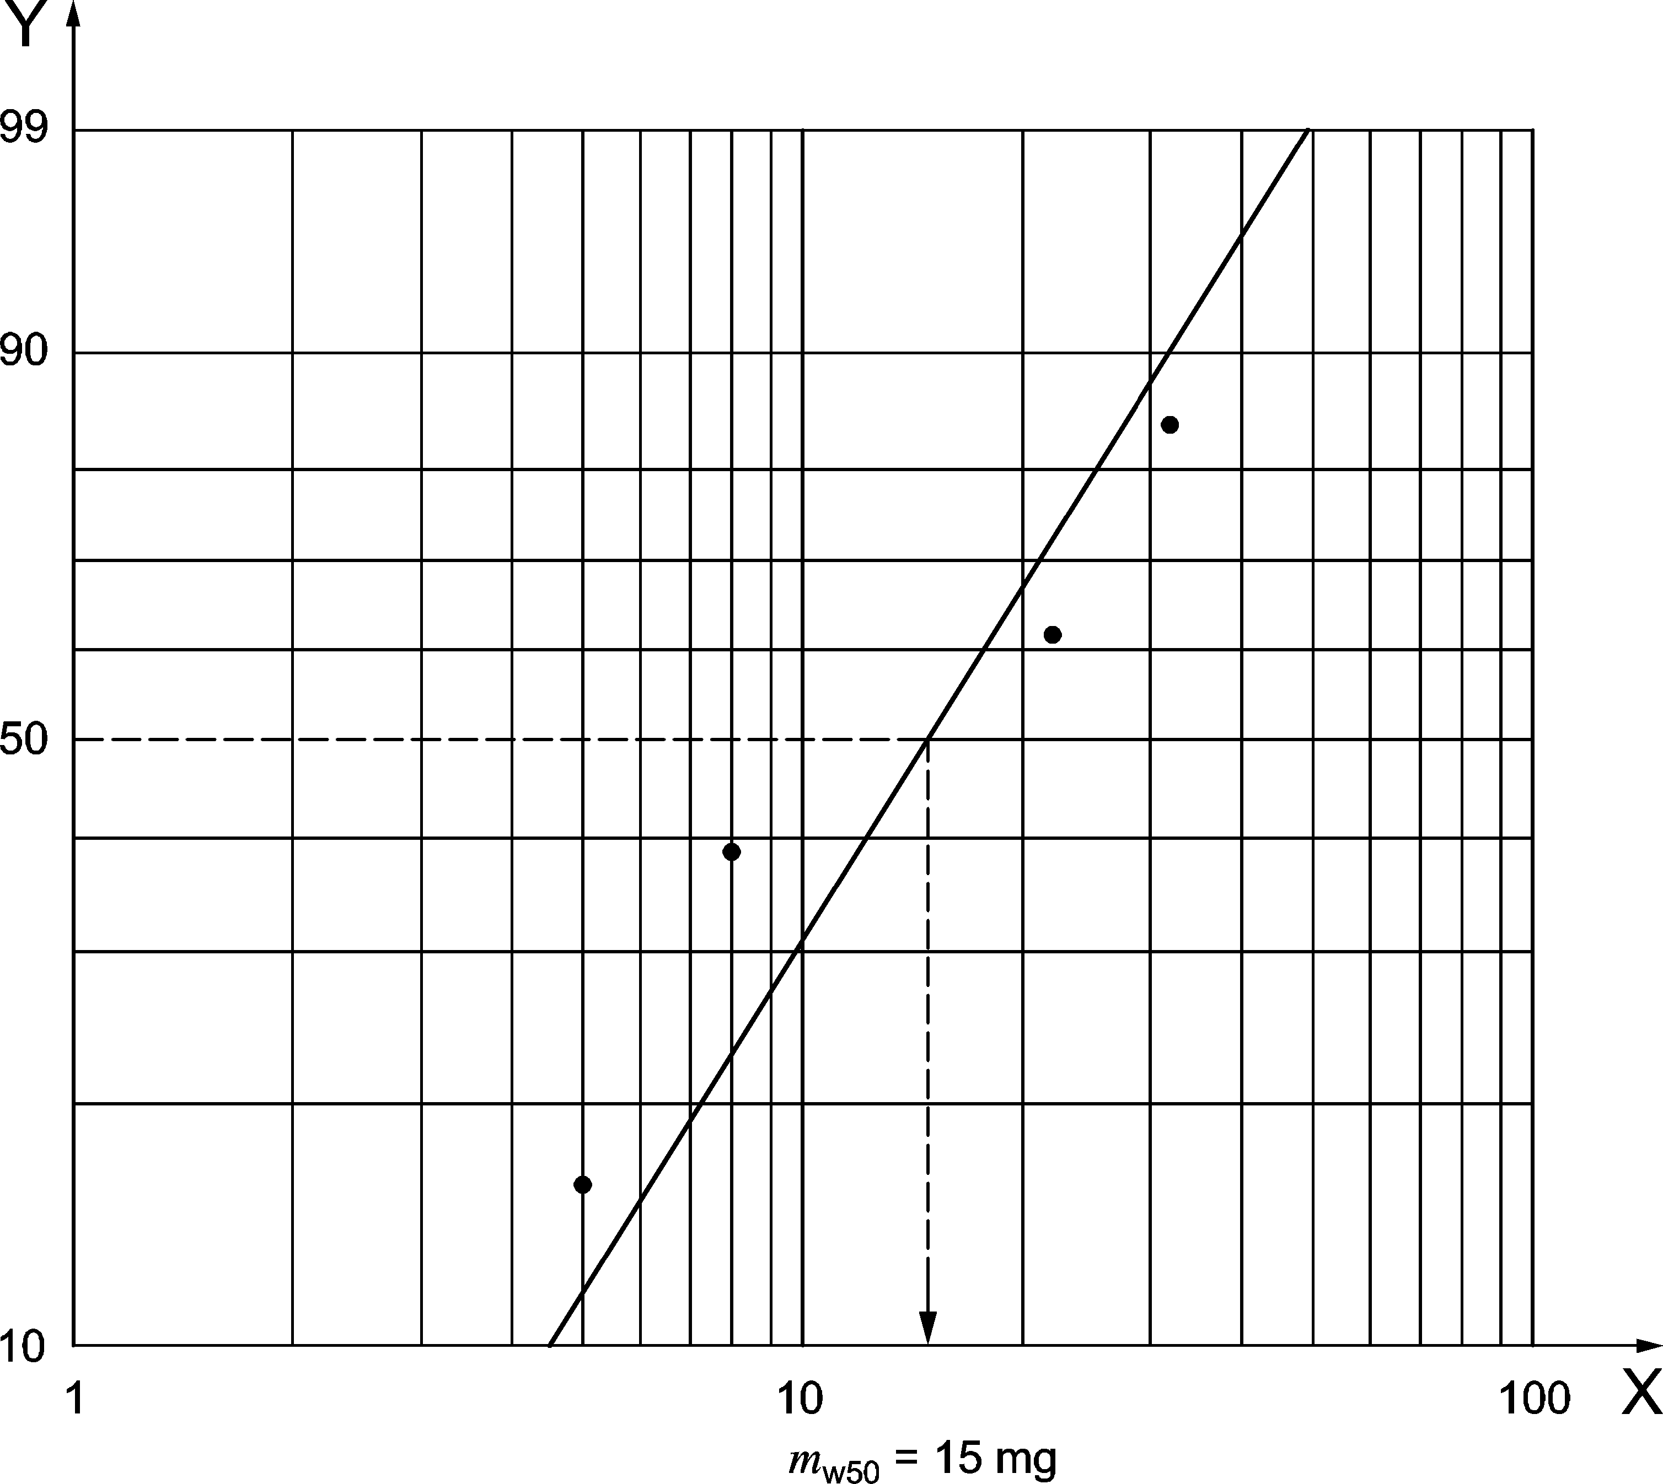

**Key**

1. Amount of wear, in mg
2. Probability of wear, in %

*Standards Download-Beuth-Afton Chemical Ltd-KdNr.7524790-ID.PXLDGGFCFHE8O8IQ8CZ3ZULG.3-2020-06-16 11:22:53*

**Figure 2 - Example of the graphic representation of the probability of wear on the rolling elements**

1. **Precision**
   1. **General observations**

The precision is determined by statistical analyses based on inter-laboratory tests. Due to the very high costs of laboratory tests and the time that they take, the precision data quoted are not recorded from linear measurements of sample materials.

At the time of the publication of the draft version of this standard, only limited results from inter-laboratory tests were available; tests and evaluations are continuing.

NOTE 1: It is known from the practice of technical measurements that wear on rolling elements increases progressively. For practical applications, the wear on rolling elements in the range up to 100 mg is of interest.

The cage wear for metal cages is given for information purposes and is not used to determine the precision of the method.

NOTE 2: Precision data for wear values below 15 mg and above 200 mg are not differentiated in this test standard. For this reason, a threshold value of 15 mg was introduced in order to minimise the influence of unavoidable weighing errors as far as possible.

**10**

* 1. **Repeatability**

The difference between two results which were recorded by the same observer with the same equipment, with constant working conditions and on the same sample, would not differ in the long term, with a standard and correct application of this procedure, by more than the numerical value calculated using the equation (1), where "X" is the average value of the two results to be compared and the characteristic value for the repeatability "w" could be taken from a table. This applies for the value *m*w50

|  |  |  |
| --- | --- | --- |
| Repeatability, r | *r* = *w* ⋅ *X* | (1) |

If values for m*w50* of the set of rolling elements below the threshold value of 15 mg are recorded, these should be considered at first as acceptable and compliant with standards. In this case, values which are to be compared below 15 mg will be set at the threshold value of 15 mg for the further calculation of the modified repeatability.

The test bearings used in the testing will be replaced. The criteria of repeatability will nevertheless be applied for the test method of this standard.

The results of two measurements are considered to be in conformity with the standard if they meet the modified repeatability criterion according to equation (2):

|  |  |  |
| --- | --- | --- |
| Modified Repeatability, *r*mod | (1 − 2)2  mod = 2(1 + 2) | (2) |

The results are considered acceptable if the result thus obtained for *rmod* is below 15 mg.

* 1. **Comparability**

The difference between two single and independent results obtained by different observers in different laboratories with different test bearings on identical samples, would not differ in the long term by more than the numerical value calculated according to equation (3), where "X" is the average of the two results to be compared and the comparability parameter "v" would be taken from a table. This applies for the value *m*w50

*Standards Download-Beuth-Afton Chemical Ltd-KdNr.7524790-ID.PXLDGGFCFHE8O8IQ8CZ3ZULG.3-2020-06-16 11:22:53*

|  |  |  |
| --- | --- | --- |
| Comparability, R | *R* = *v* ⋅ *X* | (3) |

If values for m*w50* of the set of rolling elements below the threshold value of 15 mg are recorded, these should be considered at first as acceptable and compliant with standards. In this case, values which are to be compared below 15 mg will be set at the threshold value of 15 mg for the further calculation of the modified comparability.

Since, by definition, different test bearings will be used in the test, the same conditions apply as for repeatability; the criteria for comparability are also applied in a modified form for the test method defined in this standard.

The results of two measurements are considered to be in conformity with the standard if they meet the modified comparability criterion according to equation (4):

|  |  |  |
| --- | --- | --- |
| Modified Comparability, *R*mod | (1 − 2)2  mod = 2(1 + 2) | (4) |

The results are considered acceptable if the result thus obtained for *Rmod*  is below 15 mg.

**11**

# **List of reference standards**

1. DIN 51632-2, *White spirit (test fuel) - Part* 2: *Dearomatised products; requirements and testing*
2. German Association of the Automotive Industry (VDA): Volume 3 Part 2, Quality management in the automotive industry — Part 2: Reliability assurance for car manufacturers and suppliers, Fourth Edition 20161)
3. Manfred Kühlmeyer, *S**tatistic evaluation methods for engineers with practical examples.* Springer publishing house, edition 20012)
4. Available at [http://www.vda-qmc.de/.](http://www.vda-qmc.de/)
5. Available at [http://www.springer.com/.](http://www.springer.com/)

*Standards Download-Beuth-Afton Chemical Ltd-KdNr.7524790-ID.PXLDGGFCFHE8O8IQ8CZ3ZULG.3-2020-06-16 11:22:53*

## **12**