**Basketball match-induced dehydration is related to a reduced jump height after a match in young basketball players**

Francisco Díaz-Castro 1, Sebastián Astudillo 2, Julio Calleja-González 3, Hermann Zbinden 1 & Mauricio Castro-Sepúlveda 1.

1 Exercise Laboratory, School of Physiology, University Finis Terrae; Santiago, Chile

2 Family Health Centre, El Peral s/n Sector La Pirca; Panquehue, Chile

3 Laboratory of Analysis of Sport Performance, Sport and Physical Education Department,

University of the Basque Country; Vitoria, Spain

**Abstract**

To date, reduced jump performance has not been associated with muscular damage nor the loss of fluids caused by a basketball match.

Objective: Relate the reduced jump height to match-induced muscle damage, loss of fluids, and changes in plasma electrolyte levels in young basketballers.

Methods: 14 basketballers (17.1 ± 3.4 years) were assessed for the following variables pre- and post-match: sodium (Na+), potassium (K+), creatine kinase isoenzymes (CK), urine specific gravity (USG), body mass, and jump height (countermovement jump; CMJ). Results: Post-match values of Na+ (*p*<0.002), CK (*p*<0.0001), USG (*p*<0.0001) were increased, whilst body mass (fluid loss) (*p*<0.0001) and CMJ (*p*<0.0002) values were reduced. The reduced CMJ performance was associated with increased Na+ (r= 0.67, *p*=0.01) but not with reduced K+ (r= 0.36, *p*=0.21) levels. Reduced CMJ performance was also linked to fluid loss (r= 0.067, *p*=0.01), but not with CK levels (r= 0.10, *p*= 0.73). Interestingly, fluid loss is related to pre-match body mass and USG (r= 0.68, *p* = 0.01; r= -0.58, *p* = 0.02 respectively).

Conclusion: A basketball match induces muscular damage and dehydration. However, only dehydration and the increased plasma Na+ levels are associated with a reduced jump height.

**Key Words:** Dehydration, electrolytes, muscle damage, jump height, basketball

**Introduction**

Basketball is one of the world´s most important and physically demanding sports 1. The most competitive leagues, such as the men's NBA and the women´s WNBA, have increased the amount of matches per season so that during play-offs three to four matches are held each week 2. The majority of a basketball match is conducted at a high intensity: over 80% of the maximal heart rate3. Thus, it is critical to identify those variables that reduce performance 4 to introduce effective recovery strategies during and after matches 5.

Performance in basketball depends greatly on the player´s jumping ability. The average CMJ height attained by professional basketballers is 60 cm 6, whilst youth players achieve 34 cm 3, 7. Lindsay et al. (2007), showed jumping performance to be reduced at the end of a match, which could be related to fluid loss, including electrolytes 8. Players lose between 1-4% of their body mass in fluid during a basketball match 8. The reason for this great range of values between subjects is not entirely understood. Physical performance has also been associated with exercise-induced muscle damage, e.g. muscle damage markers are positively associated with race finishing times after a triathlon 9. To our knowledge, this relationship has not been studied in basketball. Nonetheless, a recent study showed that professional basketball players finished a match with an average plasma CK level of 213 UI/L10, indicating that basketball match-induced muscle damage could be the cause of a reduced jumping performance.

To date, no studies relate the reduced jumping performance of basketball players to muscle damage and fluid loss induced by the game. Determining this relationship is key to elaborate strategies that can offset performance reduction. Hence, the objective of this study is to associate the reduced jump height with muscle damage, fluid loss and change in plasma electrolyte levels as caused by a basketball match.

**Materials and Methods**

*Participants*

Fourteen young basketballers (see Table 1 for subjects´ characteristics) voluntarily participated in this study. Subjects with skeletal muscle damage limiting their normal practise of basketball were excluded. An informed consent form was signed after the potential benefits, harm and risks were explained to the participants. The study was approved by the Ethics Commission of the Instituto Nacional de Deporte (IND; National Sports Institute). The protocol is in accordance with the Helsinki Declaration. Players under 18 were required to obtain the signature of their parent/guardian to ensure their informed consent before the participation.

Table 1. Study participants´ characteristics

|  |  |
| --- | --- |
| *N* | 14 |
| Age (Years) | 17.1 ± 3.4 |
| Height (Metres) | 1.77 ± 0.05 |
| Body Mass (Kg) | 72.5 ± 11.3 |
| VO2max (ml/kg/min) | 60.7 ± 5.2 |
| Basketball experience, cadets (Years) | 4.6 ± 1.2 |

*Protocol* Subjects attended the laboratory at 09:00 hours, pre-match, for anthropometric (weight and height) and maximum jump height (CMJ) evaluations, and to give urine (urine specific gravity) and blood samples (Na+,K+ and CK). Following this, a friendly match was played in quarters, each consisting of 10 minutes and separated by a 5 minute break. The match was held on closed grounds with an average of 21ºC and a relative humidity of 72%. Players were instructed not to ingest liquids during the entire match. Immediately after the match, all previous evaluations were repeated (see protocol time chart in Figure 1). After the completion of the protocol, it was recommended to rehydrate by consuming 150% of the lost weight in isotonic drinks.

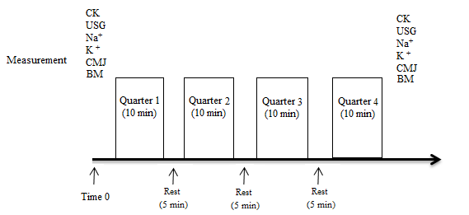 Figure 1. Time chart of study protocol. CK: Creatine Kinase; USG: Urine Specific Gravity; CMJ: countermovement jump; BM: Body Mass.

*Jump Height (CMJ)*

The participants were asked to jump for maximal height, which was assessed using a mobile contact platform (Globus, Codogne, Italy). Prior to assessment, the subjects were taught the correct CMJ technique and familiarised with the contact platform. To calculate the jump height, the height of the centres of gravity at takeoff and landing are considered. Takeoff and landing were standardised with the maximal extension of the knee and ankle joints 11, no specific instructions were given regarding the depth or the speed of the movement. The reliability test-retest intraclass correlation coefficient (ICC) and the standard error of measurement was 0.96 and 2.9%, respectively. Flight time was used to calculate jump height variance. Each player was granted three attempts, separated by 1 min recovery. The highest of the three jumps was used for statistical analysis. Characteristic of CMJ is the very low variability between test jumps (variation coefficient of 3.0%) 12.

*Anthropometry*

Body mass and size were assessed using a high precision mechanical scale (0.1kg) with an incorporated stadiometer (SECA model M20812, Germany). All anthropometric measurements were taken by the same investigator and in accordance with ISAK standards.

*Urine Specific Gravity (USG)*

The USG was determined in triplicate of the same urine sample, using a handheld refractrometer (Robinar model Spx, USA), immediately after its collection. The players were instructed to only open the 100 ml, clean and dry collection receptacle when introducing the urine and to close it immediately after its collection 13.

*Electrolytes (Na + and K +) and Creatine Kinase (CK)*

Blood (4ml) samples were obtained from the anterior cubital vein and placed in lithium heparin collection tubes and then centrifuged at 330g for 10 min (Gelec G-20 digital, Argentina). Sodium and Potassium levels were determined using ion-specific electrodes (IC Laboratory, Wiener, Argentina). CK levels were determined using an enzymatic UV-test (Sistema analítico 1800, Alemania).

*Statistical analysis*

The data are presented as average ± standard deviation. The Shapiro-Wilk normality test (*p*<0.05) was performed alongside parametric test. The paired t-test was used to assess the differences between each variables´s pre- and post-match values. Pearson correlation was used to measure the correlation between variables. Results with a *p*-value <0.05 were considered statistically significant. Statistical analysis was carried out using GraphPad Prism version 6.00 (GraphPad Software, California, USA).

**Results**

The average pre-match USG was 1.021 ± 0.006. According to the Casa et al. (2000) 14 classification only 7.6% of the players were in a euhydrated state, 23% were mildly dehydrated, whilst 53.8% were significantly dehydrated, and 15.3% were seriously dehydrated. Post-match, on average, players increased their plasma CK levels by 38.1%, and sodium levels by 1.4%; whilst they lost 1.3% of body weight and reduced their CMJ height by 10.8% (see Table 2).

Table 2. Effects of basketball match on plasma electrolytes, body weight, urine specific gravity, creatine kinase and countermovement jump height in young basketballers.

|  |  |  |  |
| --- | --- | --- | --- |
|  | Pre-match | Post-match | *p*-value |
| Na+ (mmol/L) | 141.7 ± 1.1 | 142.8 ± 1.1 | 0.002 |
| K + (mmol/L) | 4.6 ± 0.4 | 4.6 ± 0.4 | 0.9 |
| CK (U/L) | 223.6 ± 93.1 | 308.8 ± 96.7 | < 0.0001 |
| Body Mass (Kg) | 72.9 ± 13.71 | 72.0 ± 13.5 | < 0.0001 |
| USG | 1.021 ± 0.006 | 1.026 ± 0.004 | < 0.0001 |
| CMJ (cm) | 37.3 ± 4.9 | 33.9 ± 4.2 | 0.0002 |

The reduction in post-match jump height is related to fluid loss (r= -0.67, *p* = 0.01), but not to plasma CK levels changes (r= -0.10, *p* = 0.73), nor with post-match CK levels (r= -0.50, *p* = 0.08). The reduced jump height is related to increased Na+ levels (r= -0.67, *p* = 0.01), but not with K+ levels changes (r= 0.38, *p* = 0.21; see Figure 1).

Fluid loss as calculated by loss of body weight, is related to the initial weight (r= 0.68, *p* = 0.01) and USG (r= -0.58, *p* = 0.02) (see Figure 2). Upon adjusting for initial body weight, an average of 11.89 ± 3.1 grams per kilogram of initial body weight was lost. Body weight loss is related to the reduction of CMJ jump height (r= -0.59, *p* = 0.03).

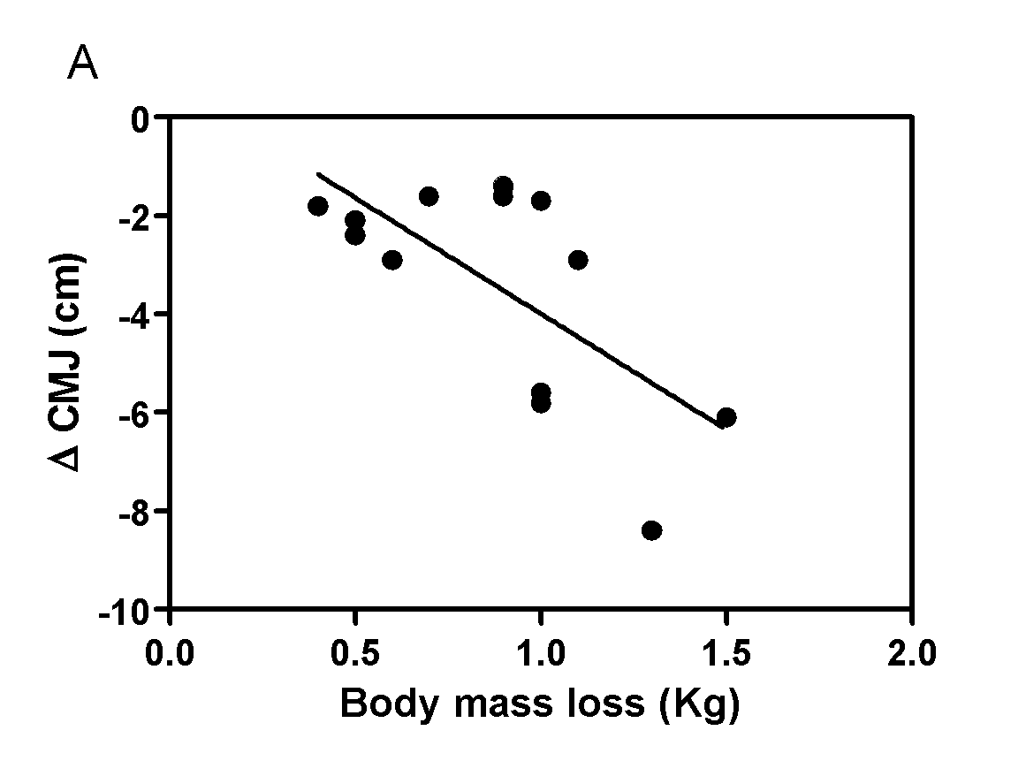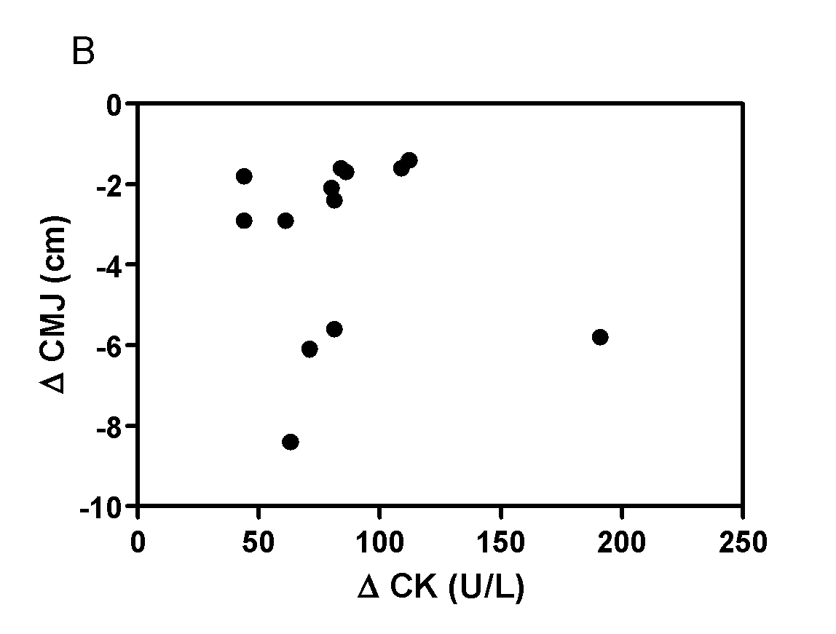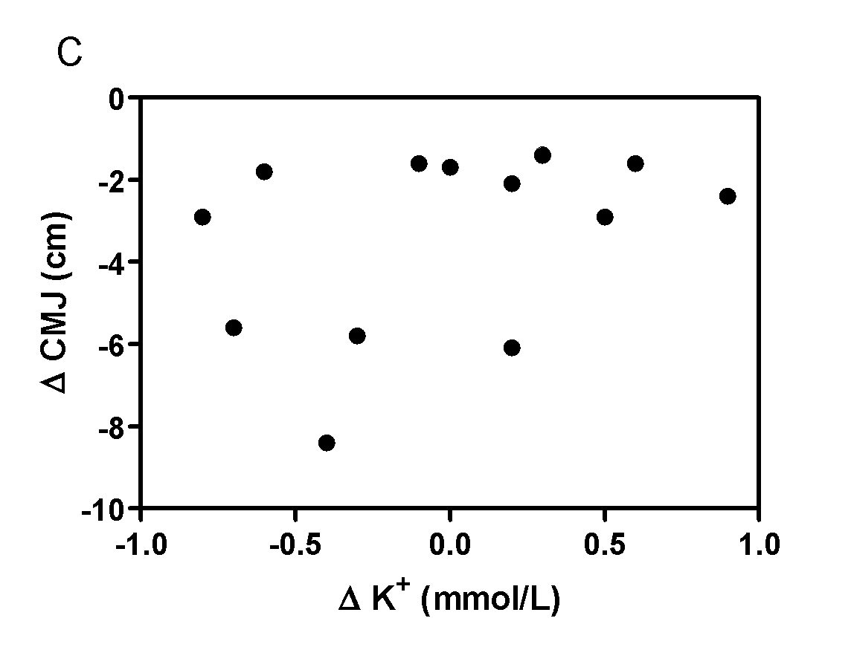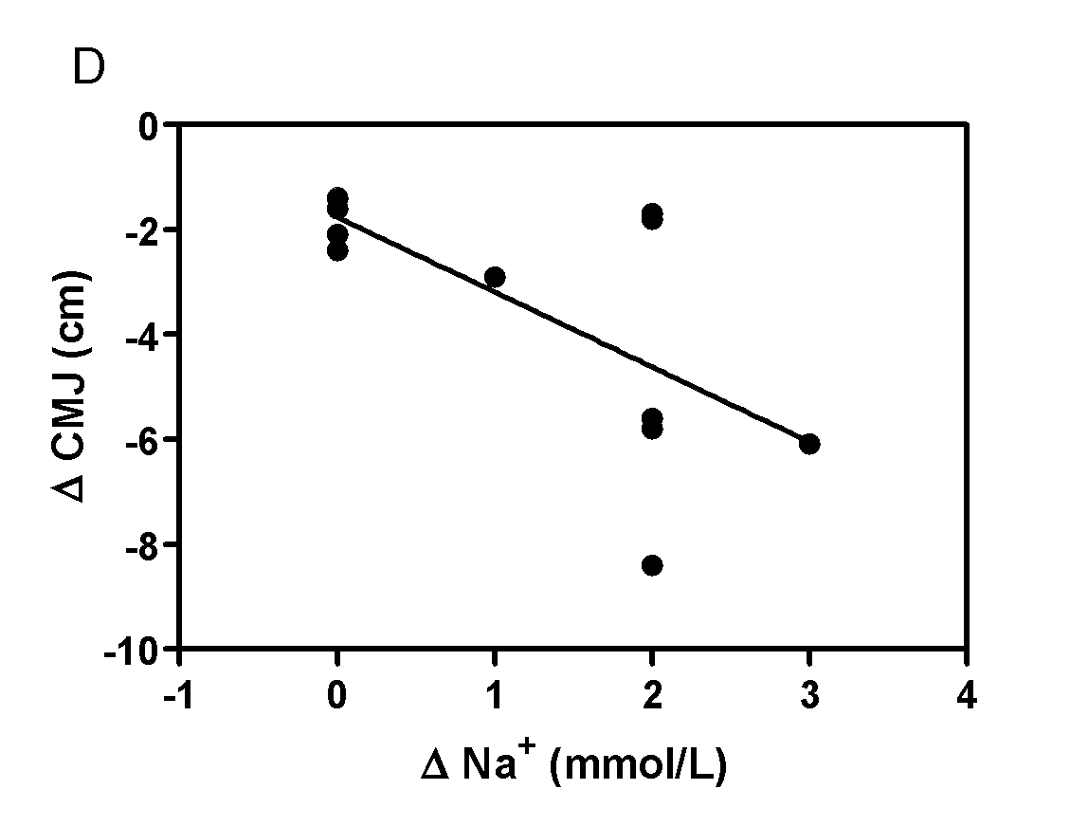

Figure 2. Relationship between match-induced reduction of CMJ height in young basketballers and (A) match-induced dehydration, (B) match-induced muscle damage (C) match-induced K+ level change, (D) match-induced Na+ level change. CMJ; countermovement jump, CK; creatine kinase.

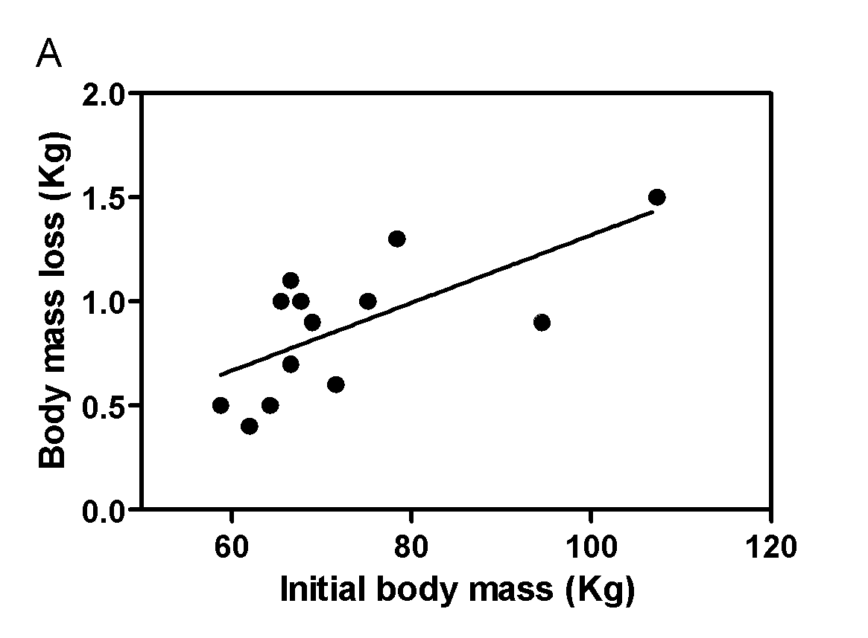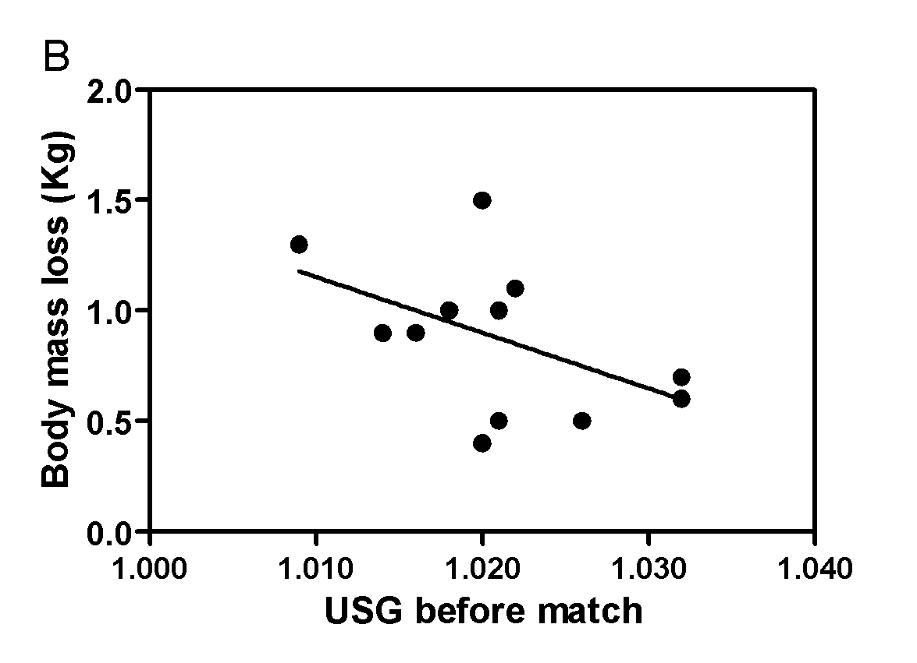

Figure 3. Relationship between (A) initial body mass, (B) pre-match USG and match-induced dehydration in young basketballers. USG; urine specific gravity.

**Discussion**

This study shows that a basketball match induces significant fluid loss, reduces CMJ height and increases plasma Na+ and CK levels. Moreover, the post-match reduction in jump height is related to fluid loss and plasma Na+ levels but not to acute muscle damage as indicated by increased CK levels.

Osterberg et al. (2009) have shown that 52% of basketballers are dehydrated before the start of a match and that this is not recompensated by the fluid intake during the match 15. Thus, during a match, the players are largely in a dehydrated state. In this study, we found 69.1% of the basketballers to have been dehydrated before the start of the match. This higher incidence is not due to differences in temperature or humidity (21 vs 22 °C), rather than to other variables such as the instruction players received regarding water intake, or players´ age since children and adolescents have greater hydration requirements than adults 16.

Hypohydration results in high dehydration levels and hyperthermia following exercise 17. Both induce muscle fatigue: either indirectly by altering the arterial blood pressure or directly by diminishing the nervous impulse to the muscles 18. The observed relationship between fluid loss and the reduced post-match CMJ height may be explained by these mechanisms. Magal et al (2003) demonstrated subjects that lose 3% of their body mass also perform worse in 5 and 10 metre test sprints. Repeating these test sprints following rehydration, the same subjects significantly improved their time. Thus, showing that, just as in our study, dehydration affects lower body strength 19.

Del Coso et al (2014), found a significant increase of plasma CK and myoglobin levels after a triathlon, which was positively related to the finishing time. This suggests muscle damage reduces endurance performance 9. Basketball is known to induce muscle damage. Calleja-González et al., 2007, found highly trained junior basketballers to have increased levels of muscle damage markers like CK and LDH (36% and 59% respectively) after a match 20. We observed a similar trend: a 38% increase in CK levels post-match; however, this was not related to the loss of performance in the CMJ as is the case in endurance sports. To our knowledge, this is the first report that shows the relation between a muscle damage marker like CK and the reduction in jump height in basketballers. These results may be caused by the fact that basketball has a strong eccentric component due to the relatively high amount of deacceleration and braking, which induces immediate muscle damage 21. Nonetheless, recurrent practise of this type of exercise induces a repeat bout effect 22, which refers to the reduced muscular damage incurred by training over time. Considering the basketball experience of our subjects, the reverse bout effect would have limited the muscle damage to levels that do not diminish performance.

Two mechanisms could explain the relationship found between fluid loss and the pre-match USG: 1) A high USG indicates a state of dehydration, which influences the perceived level of exertion and encourages the player to exert himself less 23, thus reducing fluid loss and physical performance. 2) Upon dehydration, antidiuretic hormone is released to regulate fluid loss, this however raises the core body temperature and thus affects the athlete's health 24. This relation is not fully understood. It is key to underline that in our study, fluid loss is related to body weight, meaning that heavier basketball players have greater hydration requirements.

A basketball match induces physiological effects that include an increase in plasma CK and Na+ levels and a significant loss of body weight. Notably, the loss of body mass is negatively related to the post-match reduction in jump height but not to the increased CK levels. This suggests that the hydration strategies used prior and during the match are key to maintain performance levels throughout a basketball match.

**Bibliography**

1. Ostojic SM, Mazic S, Dikic N. Profiling in basketball: physical and physiological characteristics of elite players. J Strength Cond Res. 2006; 20(4):740-4.
2. Sampaio J, McGarry T, Calleja-González J, Jiménez Sáiz S, Schelling I Del Alcázar X, Balciunas M. Exploring Game Performance in the National Basketball Association Using Player Tracking Data. PLoS One. 2015 Jul 14; 10(7):e0132894.
3. Cortis C, Tessitore A, Lupo C, Pesce C, Fossile DE, Figure F, Capranica L. Inter-limb coordination, strength, jump, and sprint performances following a youth men's basketball game. Journal of Strength and Condition Research. 2011; 25(1): 135-42.
4. Pliauga V, Kamandulis S, Dargevičiūtė G, Jaszczanin J, Klizienė I, Stanislovaitienė J, Stanislovaitis A. The Effect of a Simulated Basketball Game on Players' Sprint and Jump Performance, Temperature and Muscle Damage. J Hum Kinet. 2015; 46:167-75.
5. Calleja-González J, Terrados N, Mielgo-Ayuso J, Delextrat A, Jukic I, Vaquera A, Torres L, Schelling X, Stojanovic M, Ostojic SM.Evidence-based post-exercise recovery strategies in basketball. Phys Sportsmed. 2015; 29:1-5.
6. Drinkwater EJ, Hopkins WG, McKenna MJ, Hunt PH, Pyne DB. Modelling Differences in age and fitness secular between basketball players. Journal Sports Science. 2007; 25(8): 869-78.
7. Santos EJ, Janeira MA. The effects of resistance training on explosive strength indicators in adolescent basketball players. Journal of Strength and Condition Research. 2012; 26(10):2641-7
8. Baker LB, Dougherty KA, Chow M, Kenney WL. Progressive dehydration causes a progressive decline in basketball skill performance. Medicine Science and Sports in Exercise. 2007; 39(7):1114-23.
9. Del Coso J, González C, Abian-Vicen J, Salinero Martín JJ, Soriano L, Areces F, Ruiz D, Gallo C, Lara B, Calleja-González J. Relationship between physiological parameters and performance during a half-ironman triathlon in the heat. Journal Sports Science. 2014; 32(18):1680-7.
10. Moreira A, Nosaka K, Nunes JA, Viveiros L, Jamurtas AZ, Aoki MS. Changes in muscle damage markers in female basketball players. Sport Biology. 2014; 31(1):3-7.
11. Ramírez-Campillo R, Meylan CM, Álvarez-Lepín C, Henriquez-Olguín C, Martinez C, Andrade DC, Castro-Sepúlveda M, Burgos C, Baez EI, Izquierdo M. The effects of interday rest on adaptation to 6 weeks of plyometric training in young soccer players. Journal of Strength and Condition Research. 2015; 29 (4):972-9.
12. Bosco C, Luhtanen P, Komi PV. A simple method for measurement of mechanical power in jumping. Eur J Appl Physiol Occup Physiol. 1983; 50(2):273-82.
13. Castro-Sepúlveda M, Astudillo S, Álvarez C, Zapata-Lamana R, Zbinden-Foncea H, Ramírez-Campillo R, Jorquera C. Prevalence of dehydration before training in profesional chilean soccer players. Nutr Hosp. 2015 Jul 1;32(1):308-11.
14. Casa DJ, Armstrong LE, Hillman SK, Montain SJ, Reiff RV, Rich BS, Roberts WO, Stone JA. National athletic trainer’s association position statement: fluid replacement for athletes. J Athl Train. 2000; 35(2): 212-24.
15. Osterberg KL, Horswill CA, Baker LB. Pregame urine specific gravity and fluid intake by National Basketball Association players during competition. J Athl Train. 2009; 44(1):53-7.
16. Petrie HJ, Stover EA, Horswill CA. Nutritional Concerns for the Child and Adolescent Competitor. Nutrition. 2004;20(7/8):620–631
17. Lindsay J. Distefano, Douglas J. Casa, Megan M. Vansumeren, Rachel M. Karslo, Robert A. Huggins, Julie K. Demartini, Rebecca L. Stearns, Lawrence E. Armstrong, and Carl M. Maresh. Hypohydration and Hyperthermia Impair Neuromuscular Control after Exercise. Medicine Science and Sports in Exercise, 2013; 45(6): 1166-73.
18. Cheung SS, and Sleivert GG. Multiple triggers for hyperthermic fatigue and exhaustion. Exerc Sport Sci Rev, 2004; 32: 100-06.
19. Magal M, Webster MJ, Sistrunk LE, et al. Comparison of glycerol and water hydration regimens on tennis-related performance. Med Sci Sports Exerc, 2003; 35(1):150-6.
20. Julio Calleja-González, Jose Antonio Lekue, Xabier Leibar, Jesús Seco, Nicolás Terrados. Enzymatic and metabolic responses to competition in elite junior male basketball. Iberian congress on basketball research 07/2008; 4(1):83-86.
21. KP O'Reilly, Warhol MJ, RA Fielding, Frontera WR Meredith CN, Evans WJ. Eccentric exercise-induced muscle damage impairs muscle glycogen depletion. J Appl Physiol (1985), 1987; 63 (1): 252-6.
22. Chen TC. Variability in muscle damage after eccentric exercise and the repeated bout effect. Res Q Exerc Sport. 2006; 77 (3): 362-71.
23. Logan-Sprenger HM, Heigenhauser GJ, Killian KJ, Spriet LL. During cycling effects of dehydration on skeletal muscle metabolism in females. Med Sci Sports Exerc. 2012; 44 (10): 1949-1957.
24. Walsh RM, Noakes TD, Hawley JA, Dennis SC. Impaired high-intensity cycling performance time at low levels of dehydration. Int J Sports Med 1994; 15 (7):. 392-8.